Achieving High Efficiency and Pure Blue Color in Hyperfluorescence Organic Light Emitting Diodes using Organo-Boron Based Emitters
Kenkera Rayappa Naveen¹, Hyuna Lee¹, Ramanaskanda Braveenth, Durai Karthik, Ki Joon Yang, Soon Jae Hwang and Jang hyuk kwon*
¹Theses authors contributed equally.
Organic Optoelectronic Device Lab (OODL), Department of Information Display, Kyung Hee University, 26, Kyungheedae-ro, Dongdaemun-gu, Seoul, 02447, Republic of Korea

E-mail: jhkwon@khu.ac.kr

Table of contents
1. Experimental Details
1.1 General information | 3
1.2 Device fabrication | 4
1.3 Theoretical Calculation | 4
2. Supplementary Figures
Figure S1 | Molecular simulations of pMDBA-DI and mMDBA-DI | 5
Figure S2 | Molecular simulations of t-Bu-ν-DABNA | 5
Figure S3 | Cyclic-voltammetry measurement curves | 6
Figure S4 | Solvatochromism results in different solvents | 6
Figure S5 | TRPL decay curves in DBFPO host film. | 7
Figure S6 | TGA measurements curves | 7
Figure S7 | DSC measurements curves | 8
Figure S8 | Spectrum overlap | 8
Figure S9 | Comparison of TRPL decay curves with TADF and HF | 9
Figure S10 | Horizontal orientation measurement | 9
Figure S11 | TADF device performances of ν-DABNA and t-Bu-νDABNA | 10
Figure S12 | Angular distribution | 10
3. Supplementary Tables
Table S1 | Calculated rate constants doped film in DBFPO host | 11
Table S2 | Calculated FRET rate | 11
Table S3 | TADF device performances of ν-DABNA and t-Bu-ν-DABNA | 11
4. Synthetic Procedures and NMR analysis
Scheme S1 | Synthesis of of pMDBA-01 | 12
Scheme S2 | Synthesis of pMDBA-Br | 12
Scheme S3 | Synthesis of pMDBA-DI | 13
Scheme S4 | Synthesis of of mMDBA-01 | 14
Scheme S5 | Synthesis of mMDBA-Br | 14
Scheme S6 | Synthesis of mMDBA-DI | 15
Scheme S7 | Synthesis of t-Bu-ν-DABNA-01 | 15
Scheme S8 | Synthesis of t-Bu-ν-DABNA | 16
Figure S13 | ¹H NMR spectrum of pMDBA-01 | 18
Figure S14 | ¹³C NMR spectrum of pMDBA-01 | 18
Figure S15 | ¹H NMR spectrum of pMDBA-Br | 19
Figure S16 | ¹³C NMR spectrum of pMDBA-Br | 19
Figure S17 | ¹H NMR spectrum of pMDBA-DI | 20
Figure S18 | ¹³C NMR spectrum of pMDBA-DI | 20
Figure S19 | ¹H NMR spectrum of mMDBA-01 | 21
Figure S20 | ¹³C NMR spectrum of mMDBA-01 | 21
Figure S21 | ¹H NMR spectrum of mMDBA-Br | 22
Figure S22 | ¹³C NMR spectrum of mMDBA-Br | 22
Figure S23 | ¹H NMR spectrum of mMDBA-DI | 23
Figure S24 | ¹³C NMR spectrum of mMDBA-DI | 23
Figure S25 | ¹H NMR spectrum of t-Bu-ν-DABNA-01 | 24
Figure S26 | ¹³C NMR spectrum of t-Bu-ν-DABNA-01 | 24
Figure S27 | ¹H NMR spectrum of t-Bu-ν-DABNA | 25
Figure S28 | ¹³C NMR spectrum of t-Bu-ν-DABNA | 25

1. Experimental Details
1.1 General information
All reagents were purchased from commercial suppliers, Sigma-Aldrich, TCI (SEJINCI) and used as received otherwise stated. All solvents were used without additional purification. 1,4,5,8,9,11-exaazatriphenylene-hexacarbonitrile (HATCN) was purchased from OSM. 1,1-Bis[(di-4-tolylamino)phenyl]cyclo-hexane (TAPC) and 2,2′,2″-(1,3,5-benzinetriyl)-tris(1-phenyl-1-H-benzimidazole) (TPBi) were purchased from Jilin OLED Material Tech Co., Ltd. 3,5-di(9Hcarbazol-9-yl)-N,N-diphenylaniline(DCDPA)¹ and 2,8-bis(diphenylphosphineoxide) dibenzofuran(DBFPO) were synthesized based on the previously reported methods.² For the characterization of the photophysical properties in solution, all materials were prepared in toluene solution at a concentration of 1×10⁻⁵ M. The UV-vis absorption spectrum was measured by a V-750 spectrophotometer (JASCO). The solution PL spectrum and low temperature (77 K) PL spectrum were measured by a FP-8500 spectrofluorometer (JASCO). The absolute PLQY values in doped films were measured by connecting an integrating sphere to the same spectrofluorometer. These doped films were also used for the measuring transient PL measurements. Transient PL was measured when photon counts were reached until 10,000 or 100,000 in a nitrogen environment using a Quantaurus-Taufluorescence lifetime measurement system (C11367-03, Hamamatsu Photonics Co.). Their thermal properties were investigated by differential scanning calorimetry (DSC) and thermogravimetric analysis (TGA). The glass transition temperatures (T_{g}) were measured by the DSC graph, and the decomposition temperatures (T_{d}) were measured by TGA at 5% weight loss. Electrochemical analysis was performed using an EC epsilon electrochemical analysis equipment. To measure the cyclic voltammetry (CV) characteristics, platinum, material coated 150 nm of ITO glass, and Ag wire in 0.01 M AgNO₃, 0.1 M tetrabutyl ammonium perchlorate (Bu₄NClO₄), and acetonitrile solution were used as counter, working, and reference electrodes, respectively. For supporting electrolyte, 0.1 M tetrabutyl ammonium perchlorate in acetonitrile solution was used. Using an internal ferrocene/ferrocenium (Fc/Fc+) standard, the potential values were converted to the saturated calomel electrode scale. To verify molecular structures of the synthesized materials, ¹H and ¹³C NMR spectrum was measured using Bruker Avance 400 NMR spectrometer. High-resolution mass spectra were performed using JEOL JMS-600W Gas Chromatography Mass spectrometer.

1.2 Device fabrication
Prior to OLED device fabrication, indium-tin-oxide (ITO)-coated glass substrates (50 nm, sheet resistance of 10 Ω/m²) were cleaned in an ultrasonic bath with isopropyl alcohol and acetone sequentially for 10 min each and then rinsed with deionized water. The glass substrates were dried using nitrogen and treated in UV-ozone chamber for 10 min. All organic layers and the metal cathode were deposited on the cleaned ITO glass by a vacuum evaporation technique under a vacuum pressure of ~1 × 10⁻⁷ Torr. The deposition rate of all organic layers was around 0.5 Å/s. The deposition rates of lithium fluoride (LiF) and aluminum (Al) were maintained at 0.1, 4.0 Å/s, respectively. After deposition process, the devices were encapsulated with a glass cover and an UV-curable resin inside a nitrogen-filled glovebox. The emitting areas were 4 mm² for all the samples in this work. J-V and L-V characteristics of the fabricated OLED devices were measured by using Keithley 2635A SMU and Konica Minolta CS-100A, respectively. EL spectra and CIE 1931 color coordinates were obtained using a Konica Minolta CS-2000 spectroradiometer. All measurements were performed in ambient conditions.

1.3 Theoretical Calculation
All the molecular simulations were performed using the Schrödinger 2020-4 program. The optimized geometry of ground state, and HOMO, LUMO distribution were calculated using the “Optimization” tool at the B3LYP/6-31G level. The energy levels of HOMO, LUMO, S₁, and T₁ energies were calculated by “Optoelectronics Calculations” tool at the B3LYP/6-31G level. The optical simulations of OLED devices were performed using SETFOS 4.3 (Fluxim) program. The refractive index value, extinction coefficient, photoluminescence spectrum of EML, and thickness of each layer values were measured by ellipsometry and utilized as input parameters.

2. Supplementary Figures
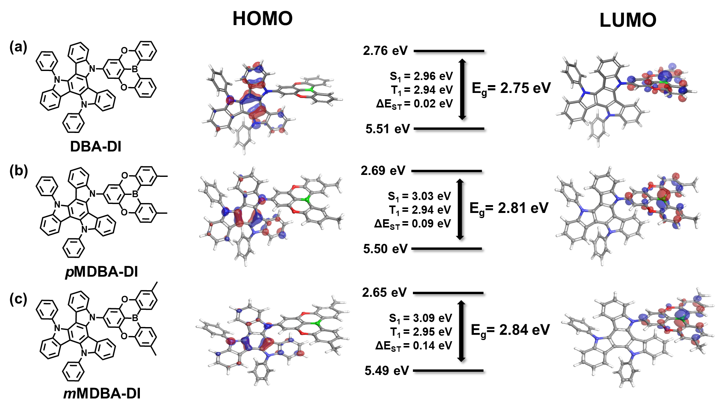
Figure S1. Molecular structure, frontier orbital distributions, and calculated corresponding energy levels of (a) DBA-DI, (b) pMDBA-DI, (c) mMDBA-DI.

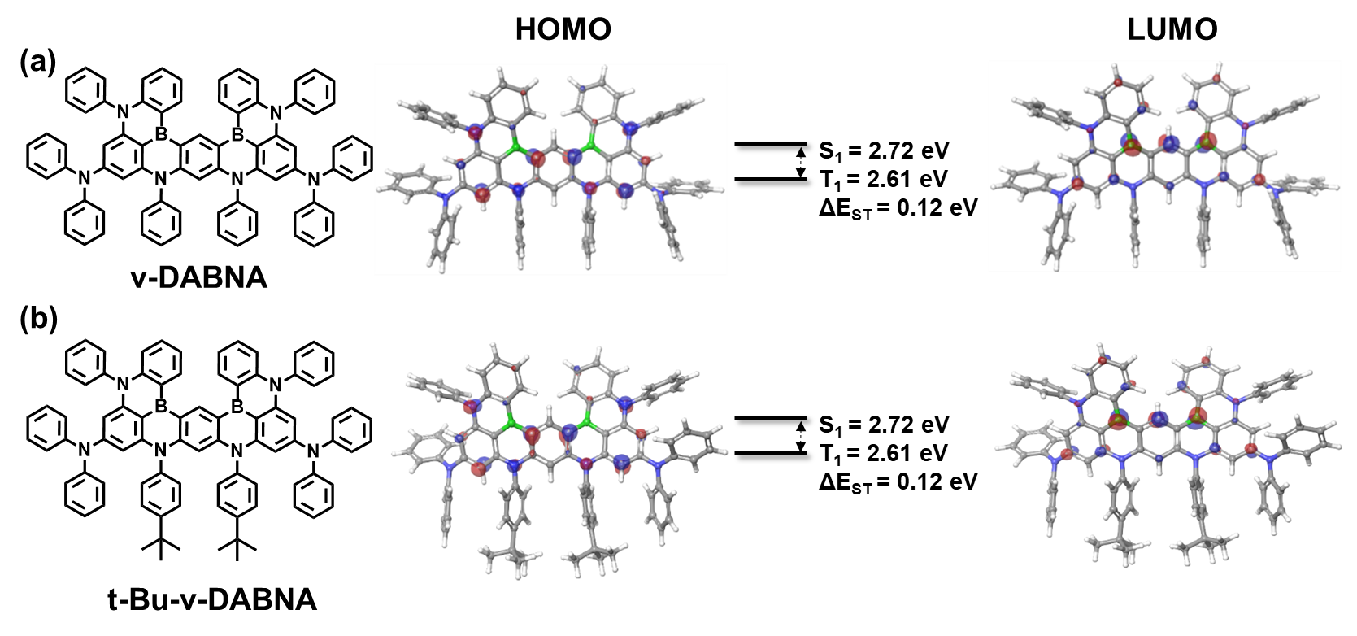
Figure S2. Molecular structure, frontier orbital distributions, and calculated corresponding energy levels of (a) ν-DABNA and (b) t-Bu-ν-DABNA

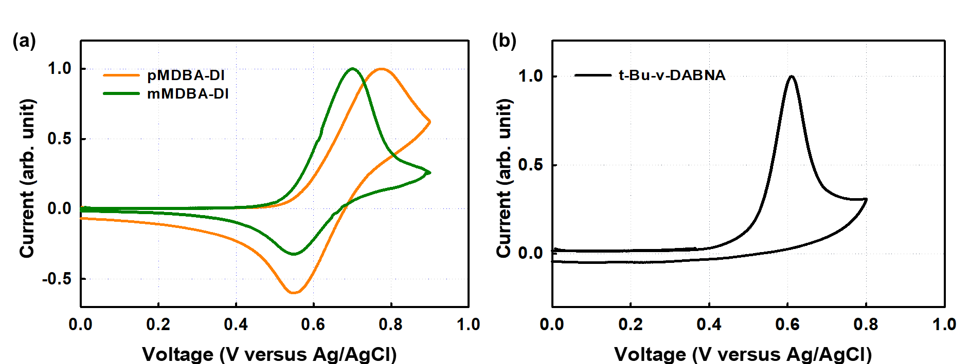
Figure S3. Cyclic Voltammetry (CV) curves of (a) pMDBA-DI, mMDBA-DI and (b) t-Bu-ν-DABNA, respectively.

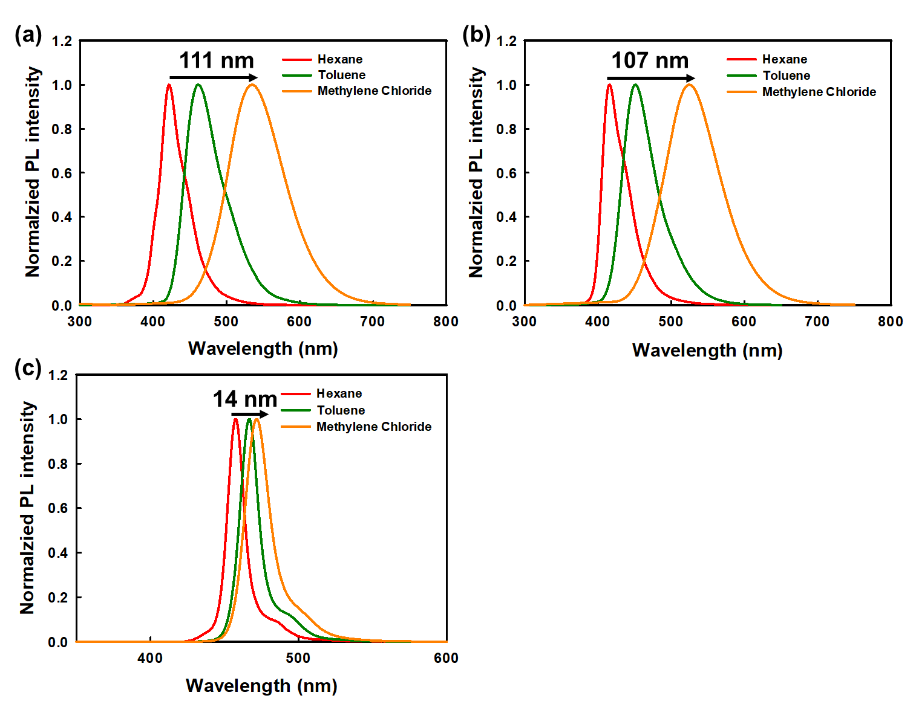
Figure S4. Solvatochromism of (a) pMDBA-DI, (b) mMDBA-DI and (c) t-Bu-ν-DABNA in different solvents.
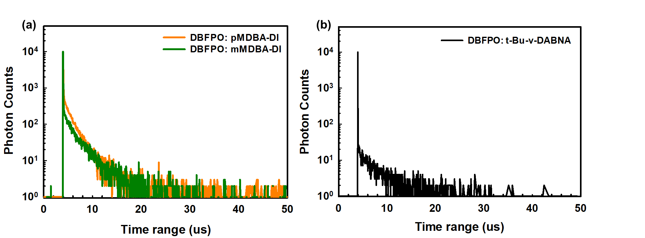
Figure S5. TRPL decay curves of (a) 30% of pMDBA-DI and mMDBA-DI, (b) 5% of t-Bu-v-DABNA in DBFPO host.

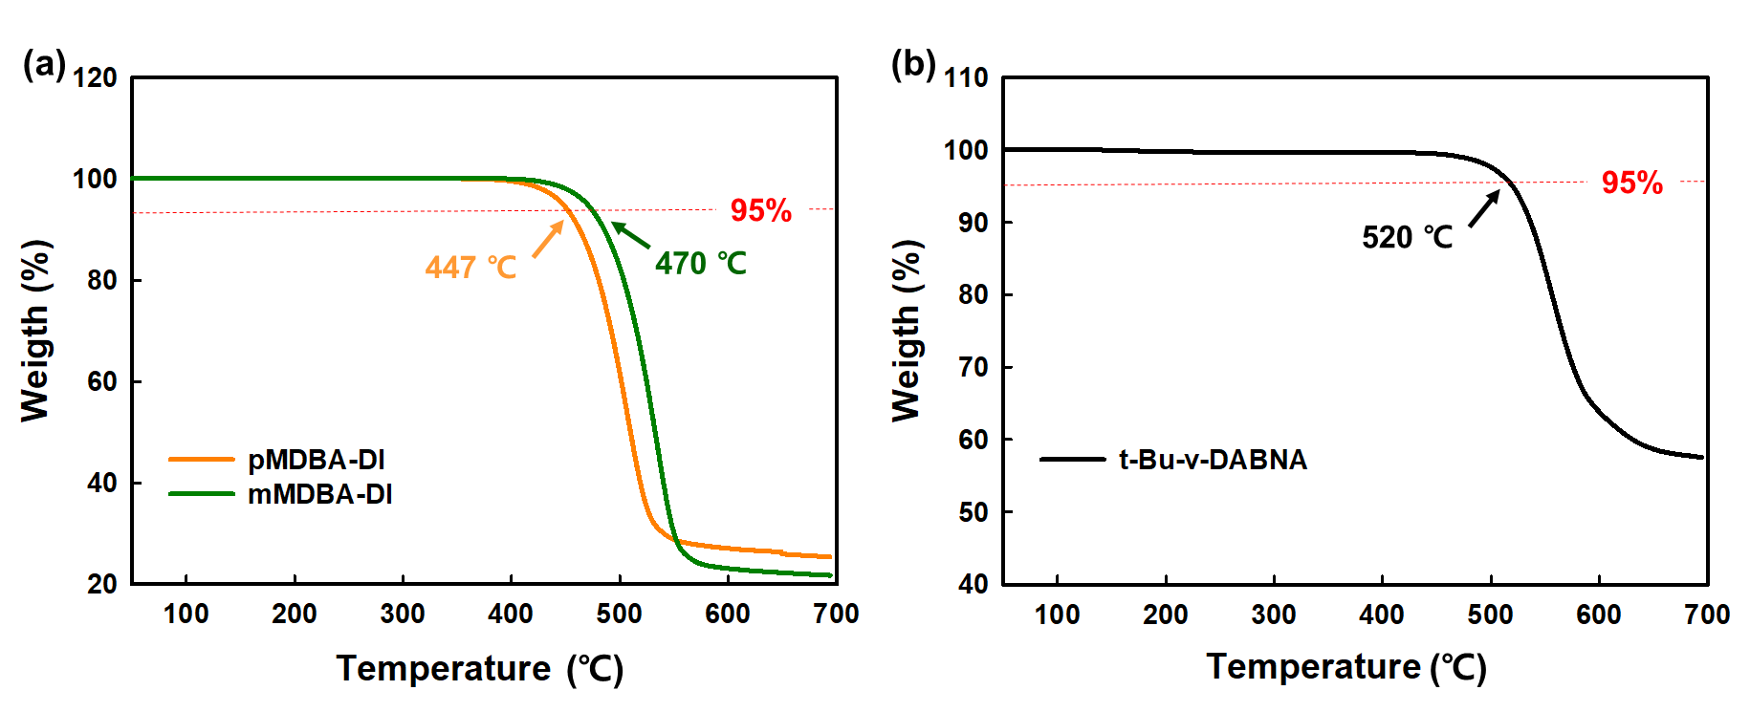
Figure S6. TGA measurements of (a) pMDBA-DI, mMDBA-DI and (b) t-Bu-ν-DABNA, respectively.

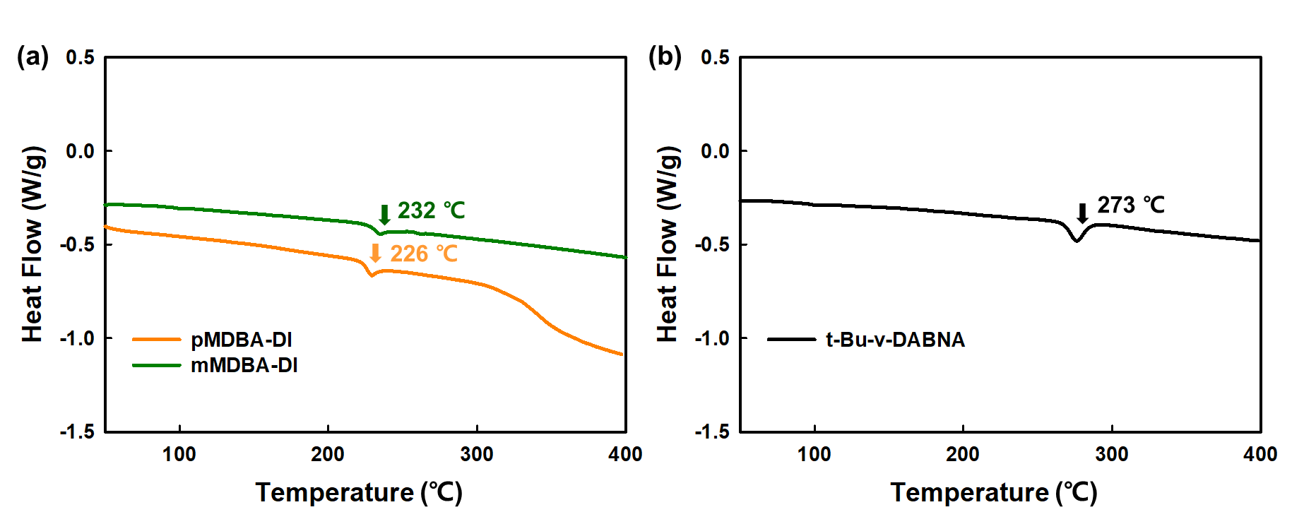
Figure S7. DSC measurements of (a) pMDBA-DI, mMDBA-DI and (b) t-Bu-ν-DABNA, respectively.

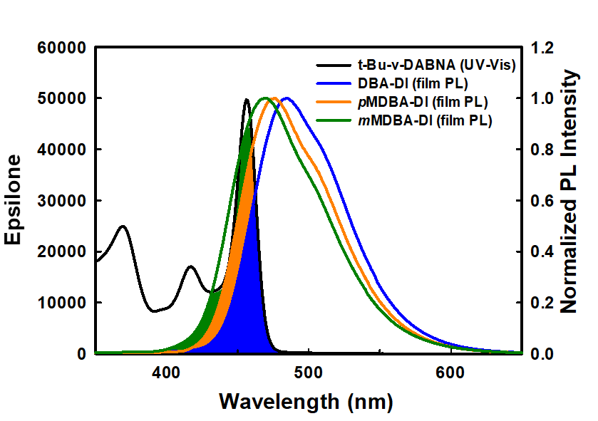
Figure S8. Spectrum overlap between absorption of t-Bu-ν-DABNA and the photoluminescence spectrum of DBA-DI, pMDBA-DI and mMDBA-DI.

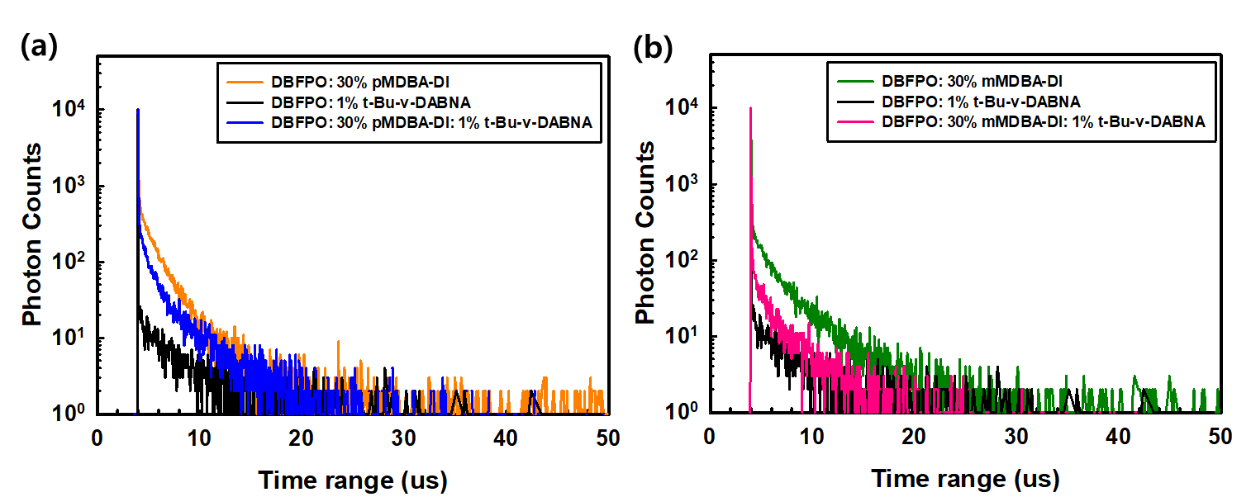
Figure S9. TRPL decay curves of (a) 30% of pMDBA-DI, 1% of t-Bu-ν-DABNA, and 30% of pMDBA-DI and 1% of t-Bu-ν-DABNA in DBFPO film. (b) 30% of mMDBA-DI, 1% of t-Bu-ν-DABNA, and 30% of mMDBA-DI and 1% of t-Bu-ν-DABNA in DBFPO film.

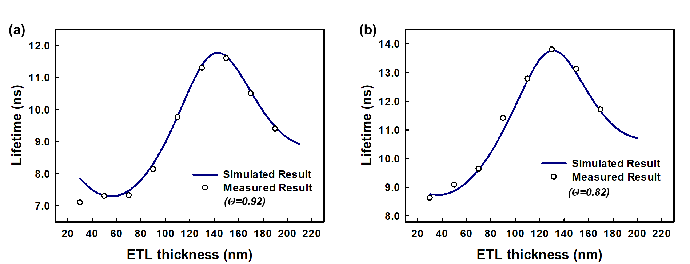
Figure S10. Horizontal orientation measurement of (a) 30% of mMDBA-DI, (b) 1% of t-Bu-v-DABNA in DBFPO film.

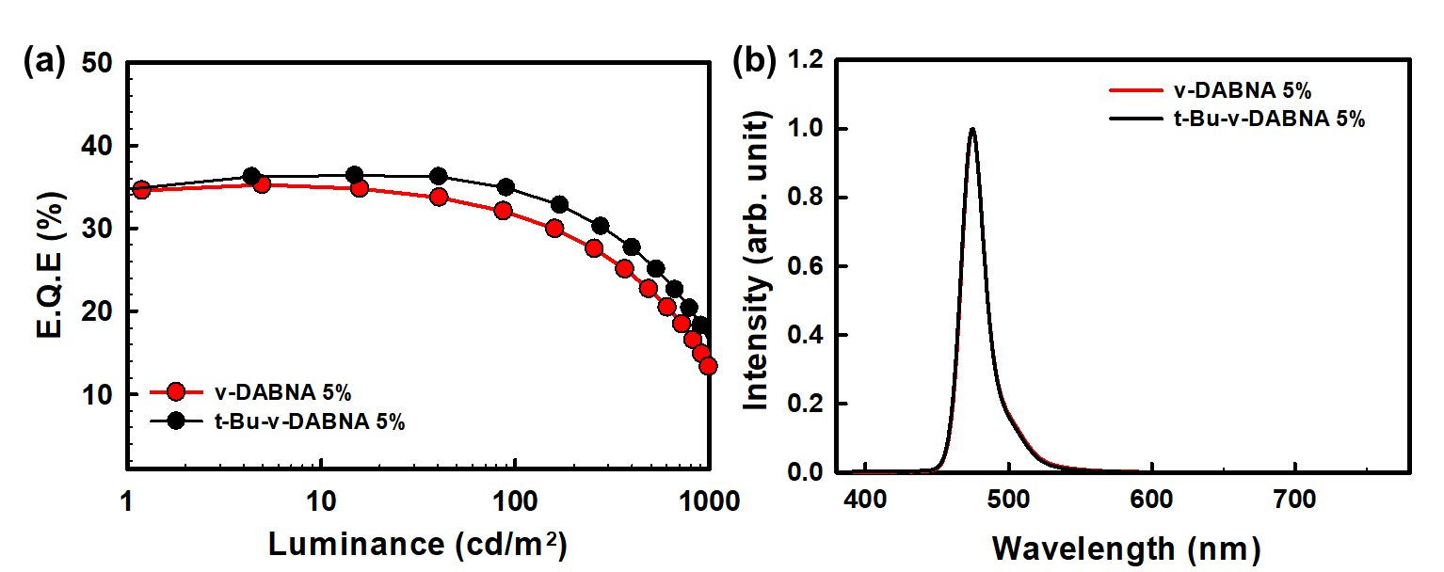
Figure S11. TADF device performances of 5% of ν-DABNA and t-Bu-ν-DABNA in DBFPO host. (a) EQE versus luminance, (b) EL spectrum at 1,000 cd/m².

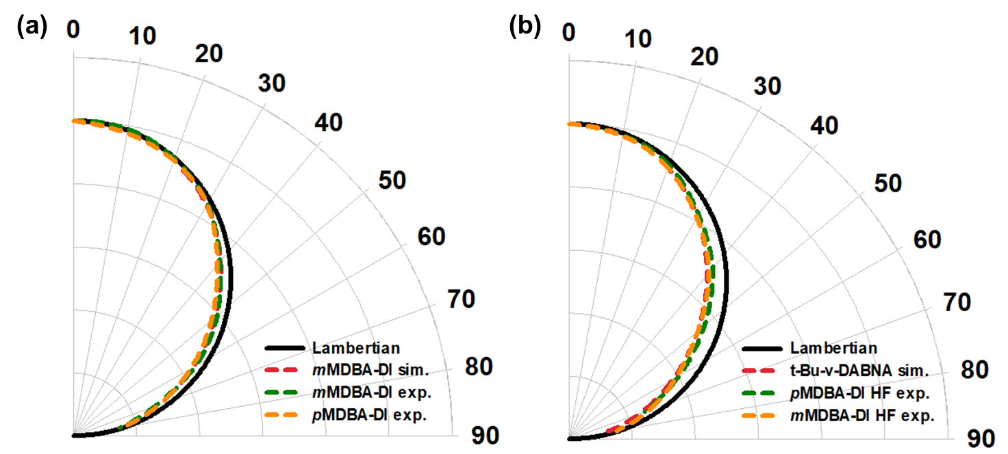
Figure S12. Angular distribution of (a) TADF device, and (b) HF device.

3. Supplementary Tables
Table S1. Calculated rate constant of 30% of pMDBA-DI, mMDBA-DI and 5% of t-Bu-ν-DABNA in DBFPO host film.
 | Φ_{PL} | Φ_{p} | Φ_{d} | Φ_{RISC} | 𝜏_{p} [ns] | 𝜏_{d} [µs] | $$k_{r}^{s}$$  [10⁷ /s] | $$k_{ISC}$$  [10⁷ /s] | $$k_{RISC}$$  [10⁵ /s] | k_{nr}^{T}  [10⁴/s]
pMDBA-DI | 0.978 | 0.468 | 0.510 | 0.959 | 45.6 | 1.80 | 1.03 | 1.17 | 11.4 | 2.98
mMDBA-DI | 0.973 | 0.532 | 0.447 | 0.942 | 47.0 | 2.90 | 1.13 | 0.99 | 6.11 | 2.38
t-Bu-ν-DABNA | 0.919 | 0.800 | 0.119 | 0.595 | 5.79 | 2.93 | 13.8 | 3.45 | 2.54 | 13.4

Table S2. TRPL decay lifetime and calculated rate constant of FRET in pMDBA-DI HF and mMDBA-DI HF system with 1% of t-Bu-ν-DABNA.
 | Dopant concentration [%] | 𝜏_{p} [ns] | $k_{FRET}$[10⁷ /s]
pMDBA-DI | 0 | 45.6
pMDBA-DI | 1 | 15.8 | 4.14
mMDBA-DI | 0 | 47.0
mMDBA-DI | 1 | 10.1 | 7.77

Table S3. TADF Device performances of 5% of ν-DABNA and t-Bu-ν-DABNA in DBFPO host device.
 | Turn on voltage^{(a)} (V) | Driving voltage^{(b)} (V) | Current Efficiency (Cd/A)  (Max / 1,000 cd/m²) |  | EQE (%)  (Max / 1,000 cd/m²) ^{(c)} |  | Max  emission peak  (nm) | FWHM (nm) | CIE coordinates (1,000 cd/m²)
ν-DABNA | 3.5 | 6.3 |  | 31.8 / 10.9 |  | 35.2 / 13.3 | 474 | 18 | (0.11, 0.15)
t-Bu-ν-DABNA | 3.5 | 6.3 |  | 32.5 / 15.3 |  | 36.3 / 16.5 | 474 | 18 | (0.11, 0.15)
(a)Turn on voltage at 1 cd/m², (b) Driving voltage at 1,000 cd/m², (c) Lambertian distribution assumption.

4. Synthetic Procedures and NMR analysis
Scheme S1. Synthesis of 4,4'-((2,5-dibromo-1,3-phenylene)bis(oxy))bis(methylbenzene) [pMDBA-01]
A mixture of 2,5-dibromo-1,3-difluorobenzene(15.0 g, 55.1 mmol) and K₂CO₃(15.3 g, 165.5 mmol) in DMSO (100 mL) was stirred for 15min, then add p-cresol (17.9 g,165.5 mmol) and then stirred at 100 ºC for 24 hours. Then, the reaction mixture was diluted with toluene and poured into cold water. After separation of organic layer, aqueous layer was extracted with toluene twice. Organic layers were washed with water again and dried over MgSO₄, and filtered through silica gel. After concentration, the residue was diluted with ethanol and stirred for 20 min at room temperature and filtered. The resulting residue was dried at 50 ºC under vacuum to give the desired product (21 g, 85%) as a white solid. ¹H NMR (400 MHz, CDCl₃) δ 7.19 (4H, d, J = 8.0 Hz), 6.96 (4H, d, J = 7.6 Hz), 6.66 (2H, s), 2.36 (6H, s); ¹³C NMR (100 MHz, CDCl₃) δ 156.8, 153.4, 134.3, 130.6, 119.4, 115.8, 20.8 ppm
Scheme S2. Synthesis of 7-bromo-2,12-dimethyl-5,9-dioxa-13b-boranaphtho[3,2,1-de] anthracene [pMDBA-Br]
A solution of n-butyllithium in hexane (13.7 mL, 1.6 M, 22.10 mmol) was added slowly to a solution of 4,4'-((2,5-dibromo-1,3-phenylene)bis(oxy))bis(methylbenzene) (9.0 g, 20.08 mmol) in anhydrous m-xylene (90 mL) at -15 ºC under a nitrogen atmosphere. After 20 minute, the mixture was stirred at room temperature for 2 h. Then boron tribromide (2.35 mL, 24.10 mmol) was added slowly at -20 ºC. After 20 minute, the mixture was stirred at room temperature for 30 minute, and at 50ºC for 50 minutes. Then N,N-diisopropylethylamine (6.5 mL, 40.17 mmol) was added at -10 ºC. The reaction mixture was stirred at room temperature for 30 minute, and 120 ºC for 20 h, and then cooled to room temperature. The reaction mixture was filtered through a pad of Florisil® using toluene as an eluent. After the solvent was removed in vacuo, the crude product was purified by column chromatography (hexane) to obtain the desired compound (4.85 g, 64%) as a white solid.¹H NMR (400 MHz, CDCl₃) δ 8.38 (2H, s), 7.50 (2H, d, J = 8.4Hz), 7.40 (2H, d, J = 8.8Hz), 7.33 (2H, s), 2.36 (6H, s); 13C NMR (100 MHz, CDCl₃) δ 158.3, 157.6, 134.9, 134.1, 132.2, 118.1, 111.8, 21.2 ppm
Scheme S3. Synthesis of 5-(2,12-dimethyl-5,9-dioxa-13b-boranaphtho[3,2,1-de]anthracen-7-yl)-10,15-diphenyl-10,15-dihydro-5H-diindolo[3,2-a:3',2'-c]carbazole [pMDBA-DI]
To a solution of 5-phenyl-10,15-dihydro-5H-diindolo[3,2-a:3',2'-c]carbazole (3.48 g, 7.00mmol), 7-bromo-2,12-dimethyl-5,9-dioxa-13b-boranaphtho[3,2,1-de]anthracene (2.4g, 6.36 mmol), and sodium tert-butoxide (1.22 g, 12.73 mmol) in toluene (50 mL) were added tri-tert-butylphosphonium tetrafluoroborate (147.7 mg, 0.50 mmol) and stirred at 80ºC for 15 minute. After purging with nitrogen, Pd₂(dba)₃ (73.2 mg, 0.1273 mmol) was added. After stirring at 120 ºC for 18 hr, the reaction mixture was cooled to room temperature and diluted with CH₂Cl₂. The mixture was filtered through silicagel and concentrated. The residue was purified by column chromatography and recrystallized from CH₂Cl₂ and hexane to give 5-(2,12-dimethyl-5,9-dioxa-13b-boranaphtho[3,2,1-de]anthracen-7-yl)-10,15-diphenyl-10,15-dihydro-5H-diindolo[3,2-a:3',2'-c]carbazole (2.5 g, 50%) as a light yellow solid.1 H NMR (400 MHz, CDCl₃) δ 8.54 (2H, s), 7.63–7.70 (11H, m), 7.53 (2H, d, J = 8.4Hz), 7.5 (2H, s), 7.43(2H,d, J = 8.4Hz),7.36 (1H, d), 7.31 (1H, d), 7.20 (2H, t, J = 7.6 Hz), 7.06 (1H, t, J = 8.0 Hz), 6.81 (2H, t , J = 7.6 Hz), 6.59 (1H, t, J = 7.4 Hz), 6.35 (1H, d, J = 8.0 Hz), 6.07 (2H, d, J = 6.6 Hz), 2.58(6H,s) ; ¹³C NMR (100 MHz, CDCl3) δ158.79, 158.39, 140.80, 134.95, 134.26, 132.28, 129.97, 128.96, 123.18, 118.33, 108.48, 21.23 ppm ; HRMS (FAB⁺) calcd for C₅₆H₃₆BN₃O₂ (M+H) 793.2901, found: 793.2910.
Scheme S4. Synthesis of 3,3'-((2,5-dibromo-1,3-phenylene)bis(oxy))bis(methylbenzene) [mMDBA-01]
Compound mMDBA-01 was synthesized according to the same procedure described above for the synthesis of pMDBA-01, Using 2,5-dibromo-1,3-difluorobenzene(15.0 g,55.1 mmol), K₂CO₃(15.3 g,165.5 mmol) and m-cresol (17.9 g,165.5 mmol) ,yielding mMDBA-01 as a white solid (yield = 21 g, 85%). ¹H NMR (400 MHz, CDCl₃) δ 7.24 (2H, d, J = 7.2 Hz), 6.98 (2H, d, J = 7.6 Hz), 6.84 (4H, t, J = 7.0 Hz), 6.70 (2H, s), 2.34 (6H, s); ¹³C NMR (100 MHz, CDCl₃) δ 156.49, 155.72, 140.42, 129.76, 125.36, 121.09, 119.89, 116.65, 116.19, 105.65, 21.45 ppm
Scheme S5. Synthesis of 7-bromo-3,11-dimethyl-5,9-dioxa-13b-boranaphtho[3,2,1-de] anthracene [mMDBA-Br]
Compound mMDBA-Br was synthesized according to the same procedure described above for the synthesis of pMDBA-Br, Using mMDBA-01 (9.0 g, 20.08 mmol), n-butyl lithium in hexane (13.7 mL, 1.6 M, 22.10 mmol), boron tribromide (2.35 mL, 24.10 mmol) and N,N-diisopropylethylamine (6.5 mL, 40.17 mmol) yielding mMDBA-Br as a white solid (yield = 3.49g, 46%). ¹H NMR (400 MHz, CDCl₃) δ 8.50 (2H, d, J=8.0Hz), 7.33 (4H, d), 7.20 (2H, d, J = 7.2Hz), 2.51 (6H, s); ¹³C NMR (100 MHz, CDCl₃) δ 160.37, 157.57, 144.78, 134.26, 124.55, 118.43, 111.98, 21.94 ppm.
Scheme S6. Synthesis of 5-(3,11-dimethyl-5,9-dioxa-13b-boranaphtho[3,2,1-de]anthracen-7-yl)-10,15-diphenyl-10,15-dihydro-5H-diindolo[3,2-a:3',2'-c]carbazole [mMDBA-DI]
Compound mMDBA-DI was synthesized according to the same procedure described above for the synthesis of pMDBA-DI. Instead of pMDBA-Br, we used mMDBA-Br (2.4 g, 6.36 mmol) and yielding mMDBA-DI (2.3 g, 46%) as a light yellow solid. ¹H NMR (400 MHz, CDCl₃) δ 8.54 (2H, d, J=7.6Hz), 7.63-7.71 (11H, m), 7.49 (2H, s), 7.30-7.38 (4H, m), 7.24 (1H,m),7.20 (2H, t, J =7.4Hz), 7.05 (1H, t , J = 7.6 Hz), 6.80 (2H, t, J = 7.0 Hz), 6.57 (1H, t, J = 7.8 Hz), 6.32 (1H, d, J = 8.4 Hz), 6.08 (2H, t, J=6.6Hz), 2.52 (6H,s) ; ¹³C NMR (100 MHz, CDCl₃) 160.80, 158.33, 146.17, 144.86, 141.63, 141.42, 140.84, 134.41, 130.00, 129.00, 128.27, 124.63, 123.37, 123.22, 122.63, 122.41, 122.32, 120.48, 120.24, 120.00, 118.65, 109.89, 108.73, 21.98 ppm ; HRMS (FAB⁺) calcd for C₅₆H₃₆BN₃O₂ (M+H) 793.2901, found: 793.2900.
Scheme S7. Synthesis of N1,N1'-(1,3-phenylene)bis(N1-(4-(tert-butyl)phenyl)-N3,N3, N5,N5tetraphenylbenzene-1,3,5-triamine) [t-Bu-ν-DABNA-01]
To a solution of N1,N3-bis(4-(tert-butyl)phenyl)benzene-1,3-diamine (150 mg,0.40 mmol), 5-chloro-N1,N1,N3,N3-tetraphenylbenzene-1,3-diamine (369 mg,0.82 mmol) and sodium tert-butoxide (174 mg,1.81 mmol) in toluene (10 mL) were added Xphos (95 mg,0.20 mmol). After purging with nitrogen for 10minutes, Pd₂(dba)₃ (18.4 mg, 0.02 mmol) was added and nitrogen purging continue for 10minutes. Then after stirring at 120 ºC for 6 hr, the reaction mixture was cooled to room temperature and diluted with CH₂Cl₂. The mixture was filtered through silicagel and concentrated. After concentration, the residue was diluted with hexane and stirred for 20 min at room temperature and filtered. The resulting residue was dried at 50ºC under vacuum to give the desired product (360 mg, 75%) as white solid. ¹H NMR (400 MHz, CD₂Cl₂) δ 7.15 (20H, t, J=7.8Hz), 7.00 (17H, d, J=8.0Hz), 6.90 (8H, t, J=7.2Hz), 6.84 (4H, d, J= 8.8Hz), 6.66 (1H, s), 6.55 (2H, dd, J = 2.4, 2.0 Hz), 6.35 (2H, s), 6.31 (4H, d, J = 1.6 Hz), 1.24 (18H, s) ; ¹³C NMR (100 MHz, CDCl₃) 149.36, 149.31, 148.28, 147.65, 145.85, 144.76, 129.58, 129.41, 126.13, 124.38, 123.78, 123.00, 120.67, 118.85, 117.94, 114.51, 114.06, 34.46, 31.52 ppm; HRMS (FAB⁺) calcd for C₈₆H₇₆N₆ (M+H) 1193.6210, found: 1193.6210.
Scheme S8. Synthesis of N7,N7,N13,N13,5,15-hexaphenyl-9,11-bis(4-(tert-butyl)phenyl)-5,9,11,15-tetrahydro-5,9,11,15-tetraaza-19b,20b-diboradinaphtho[3,2,1-de:1',2',3'-jk]pentacene-7,13-diamine [t-Bu-ν-DABNA]
To a solution of N1,N1'-(1,3-phenylene)bis(N1-(4-(tert-butyl)phenyl)-N3,N3,N5,N5-tetraphenylbenzene-1,3,5-triamine) (345 mg, 0.29 mmol) in 1,2-dichlorobenzene (8 mL) were added boron tribromide (0.11 mL,1.15 mmol) under nitrogen atmosphere at room temperature. After stirring at 180ºC for 18hours, the reaction mixture were allowed to cool to room temperature. Then solvent were removed in vacuo, then residue was dissolved in toluene. The mixture was filtered through silicagel and concentrated. After concentration, the crude product was purified by recrystallization from hexane to yielding the title compound (110 mg, 31%) as yellow solid. ¹H NMR (400 MHz, CD₂Cl₂) δ 10.42 (1H, s), 9.16 (2H, d, J = 7.2Hz), 7.50 (4H, t, J = 7.6Hz), 7.37-7.48 (4H, m), 7.31 (2H, t, J = 7.2Hz), 7.24 (8H, J = 8.6Hz), 7.08 (8H, t, J = 8.0Hz), 6.87-6.94 (16H, m), 6.74 (2H, d, J = 8.4Hz), 6.35 (1H, s), 5.61 (2H, d , J = 1.6 Hz), 5.37(2H,s), 1.24 (18H,s) ; ¹³C NMR (100 MHz, CDCl₃) 151.29, 150.34, 149.10, 148.21, 148.02, 146.97, 142.58, 139.48, 135.37, 131.06, 130.82, 130.62, 129.33, 129.21, 128.54, 128.48, 127.37, 125.85, 125.62, 123.94, 120.29, 117.35, 99.58, 99.14, 34.79, 31.65 ppm ; HRMS (FAB⁺) calcd for C₈₆H₇₀B₂N₆ (M+H) 1209.5926, found: 1209.5951.

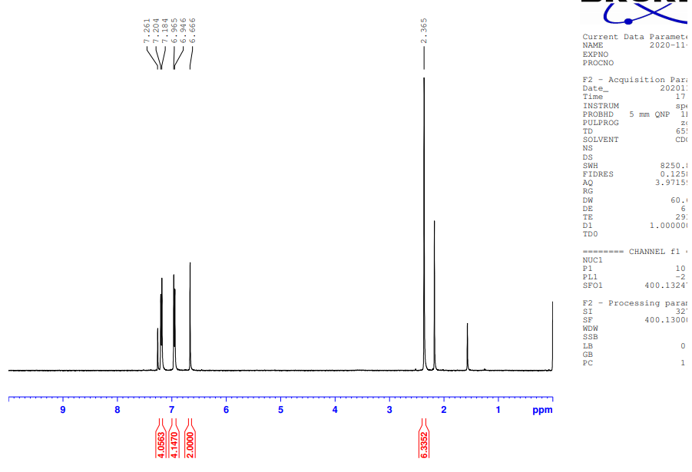
Figure S13. ¹H NMR spectrum of pMDBA-01.

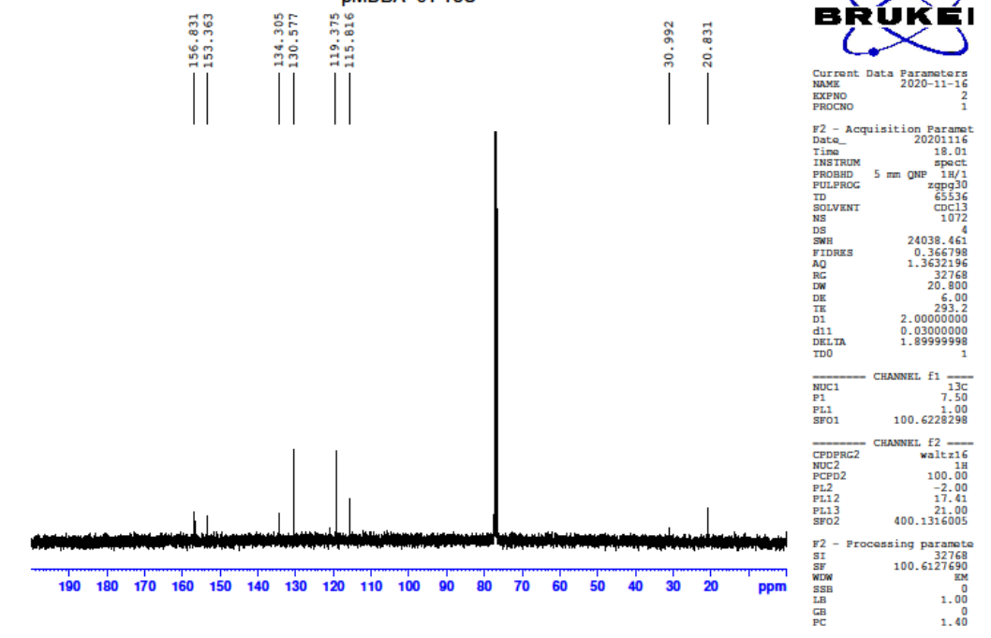
Figure S14. ¹³C NMR spectrum of pMDBA-01.
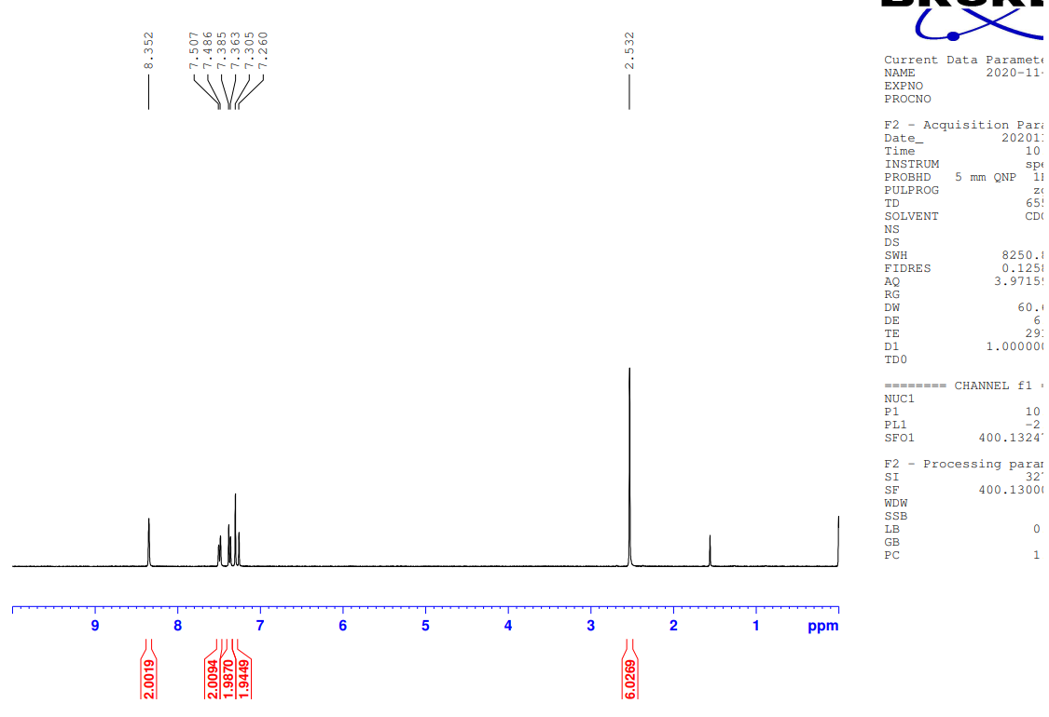
Figure S15. ¹H NMR spectrum of pMDBA-Br.

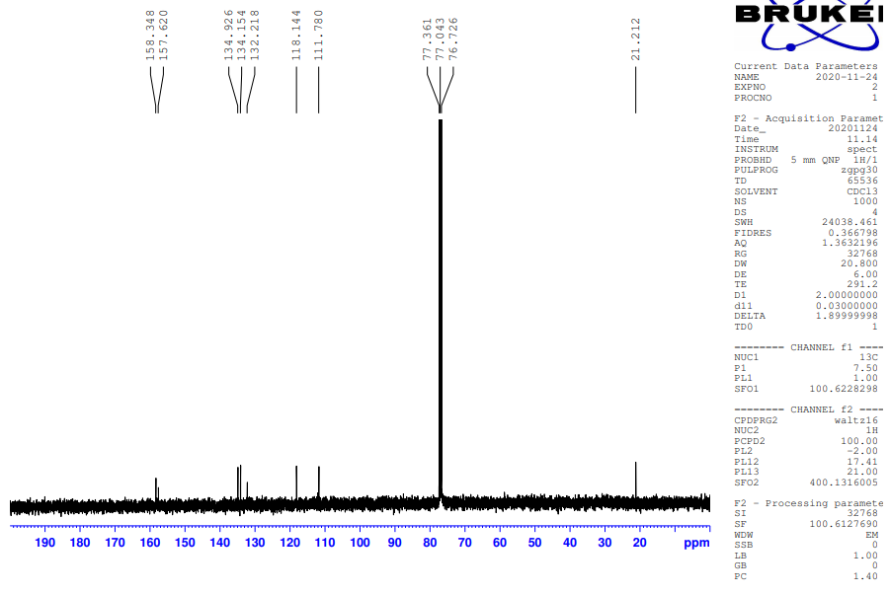
Figure S16. ¹³C NMR spectrum of pMDBA-Br.
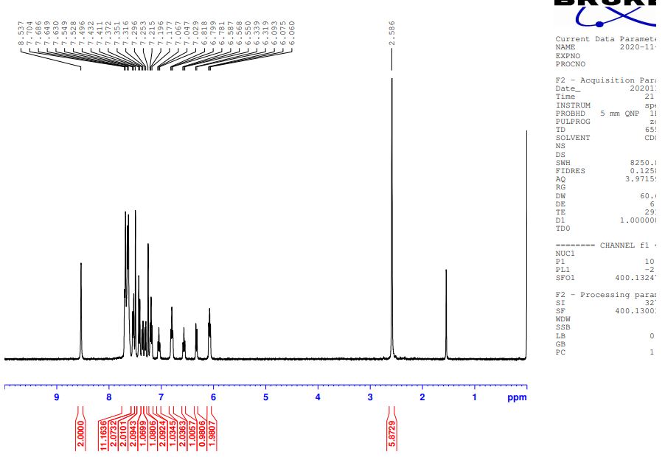
Figure S17. ¹H NMR spectrum of pMDBA-DI.

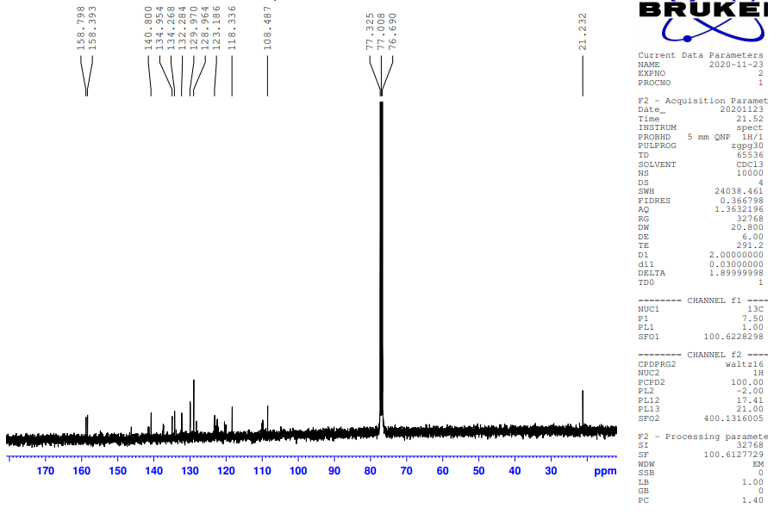
Figure S18. ¹³C NMR spectra of pMDBA-DI.
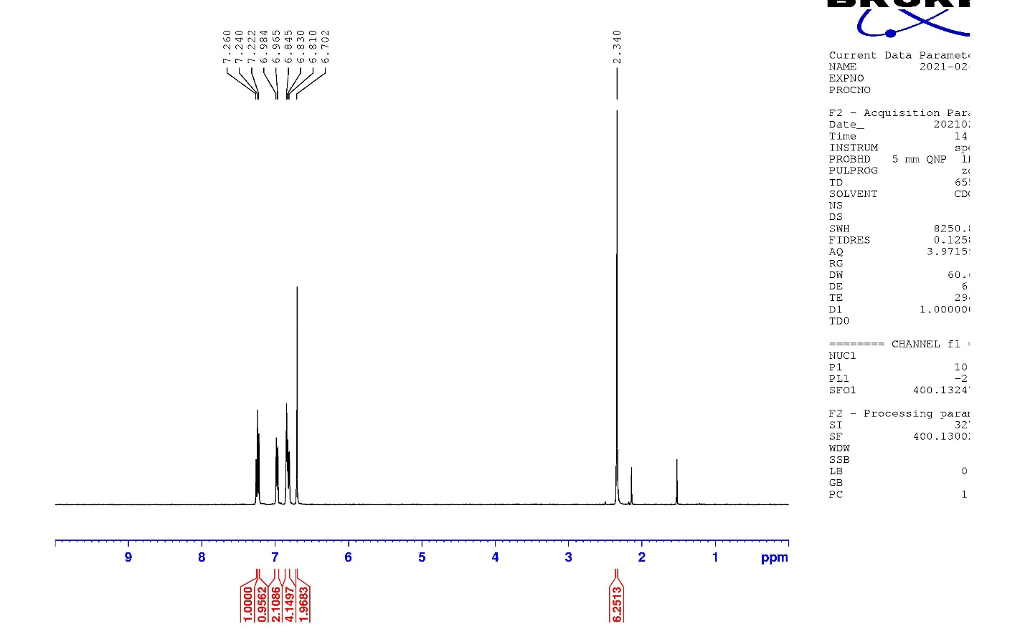
Figure S19. ¹H NMR spectrum of mMDBA-01.
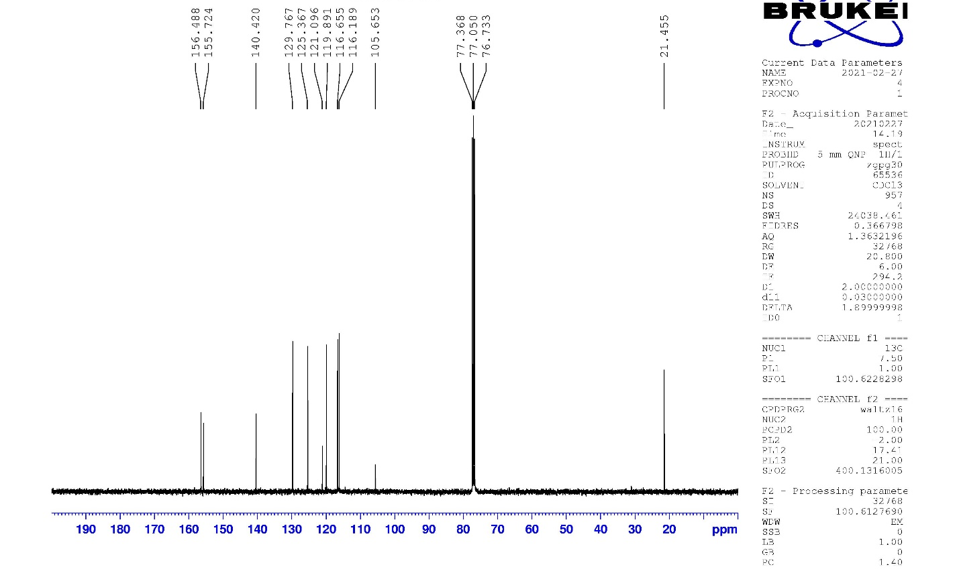
Figure S20. ¹³C NMR spectra of mMDBA-01.
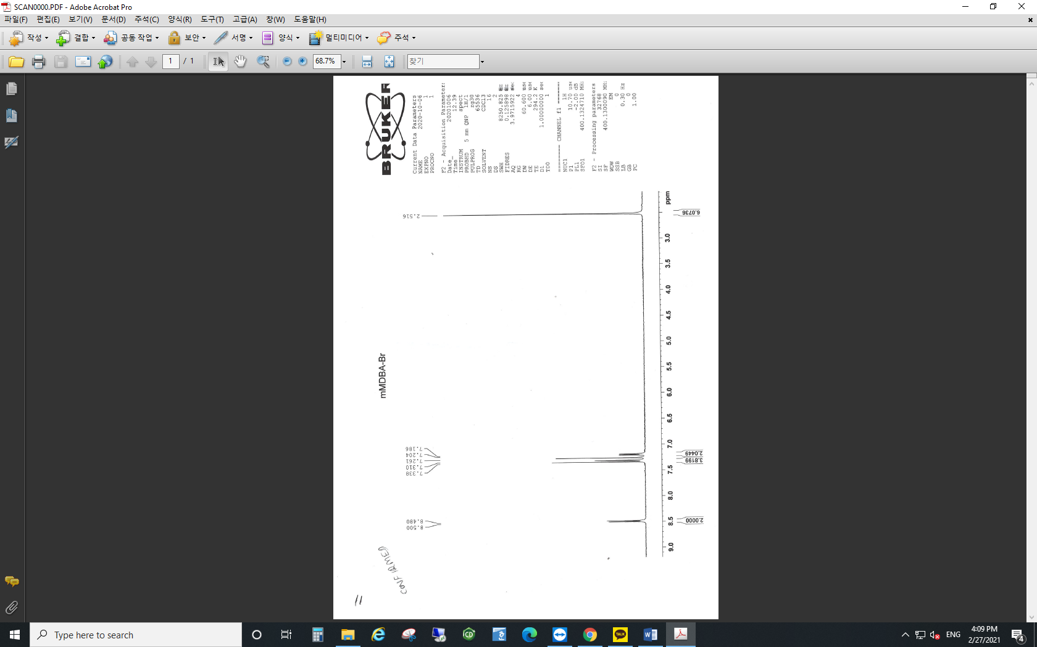
Figure S21. ¹H NMR spectrum of mMDBA-Br.
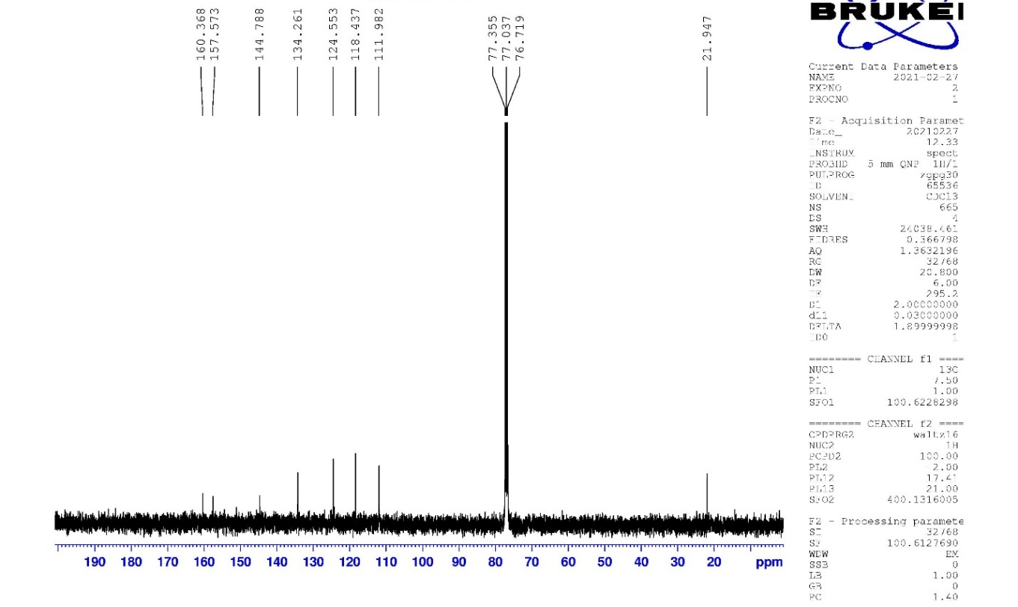
Figure S22. ¹³C NMR spectra of mMDBA-Br.
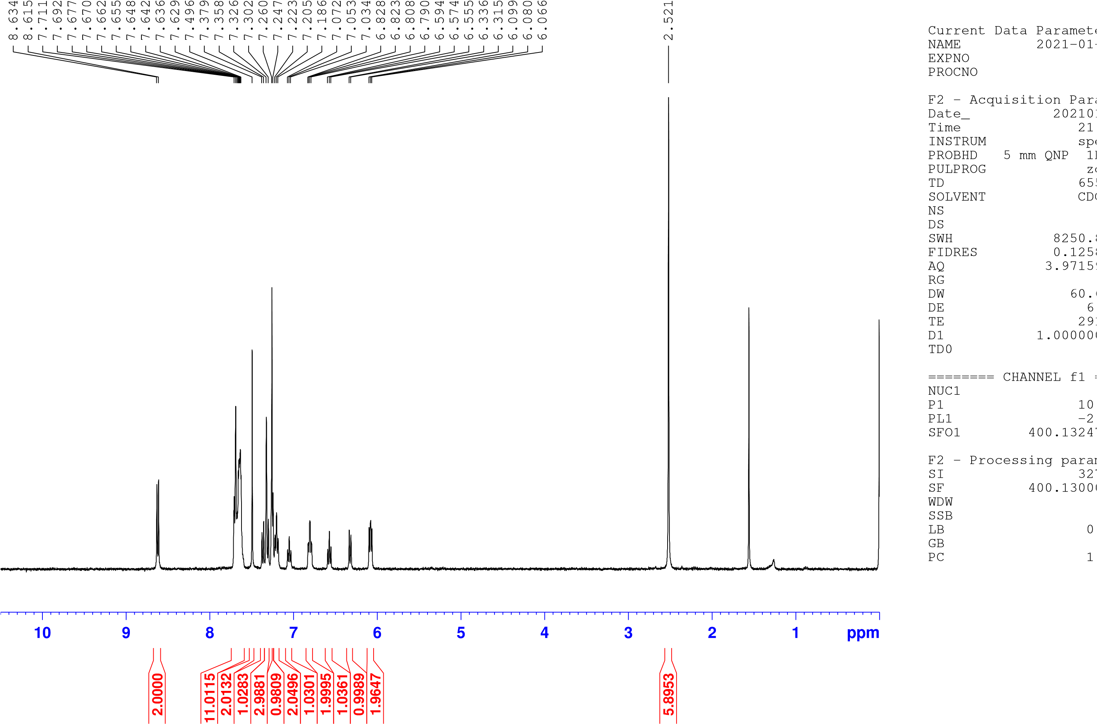
Figure S23. ¹H NMR spectrum of mMDBA-DI.

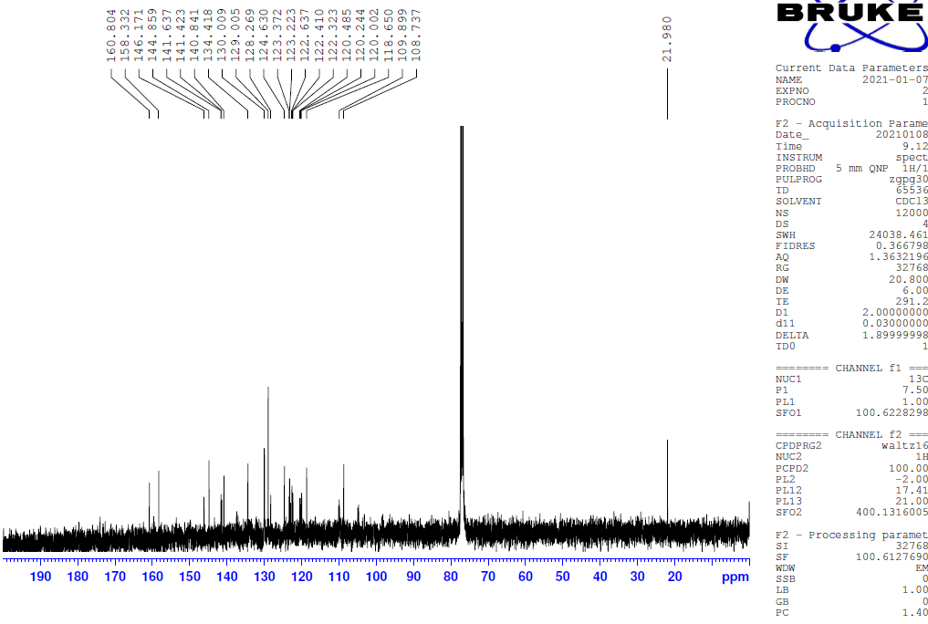
Figure S24. ¹³C NMR spectrum of mMDBA-DI.
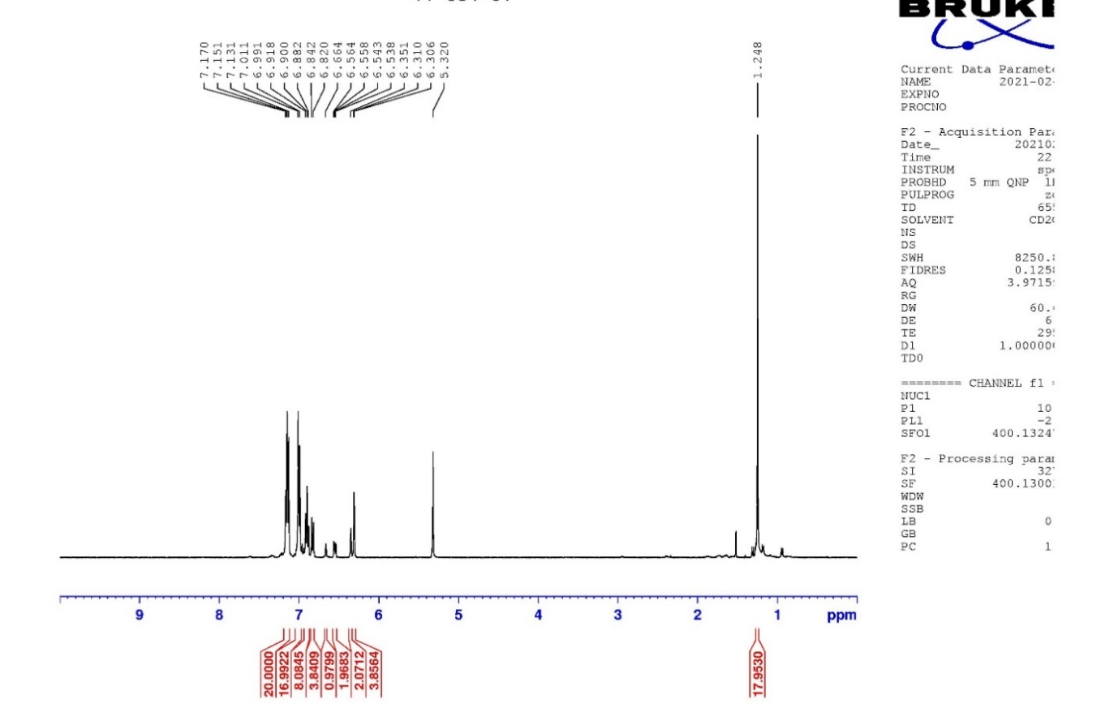
Figure S25. ¹H NMR spectrum of t-Bu-ν-DABNA-01.
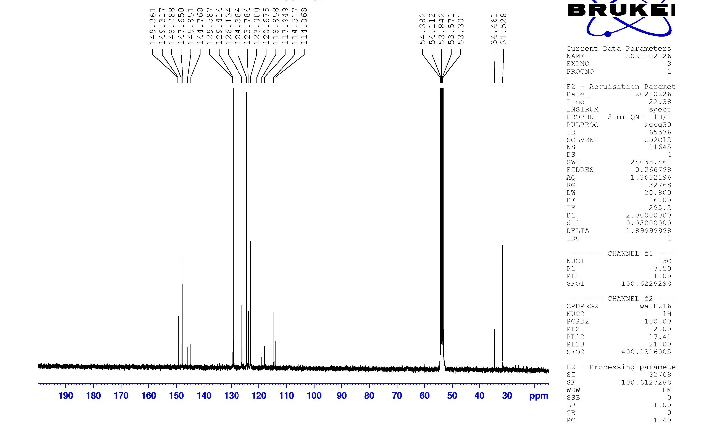
Figure S26. ¹³C NMR spectrum of t-Bu-ν-DABNA-01.
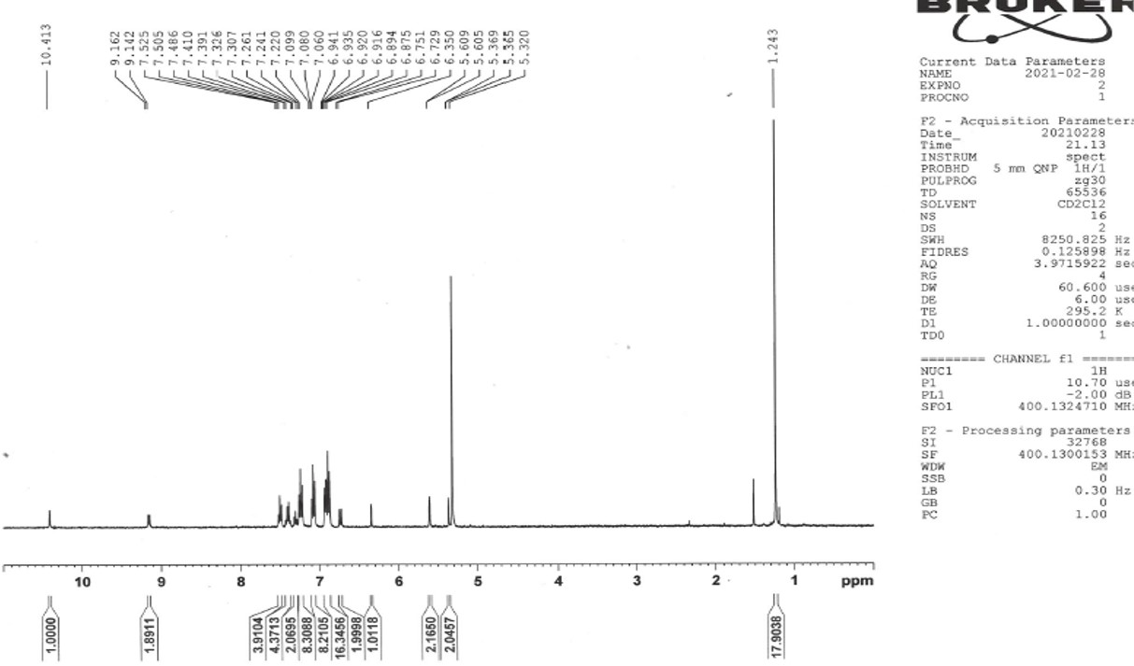
Figure S27. ¹H NMR spectrum of t-Bu-ν-DABNA.
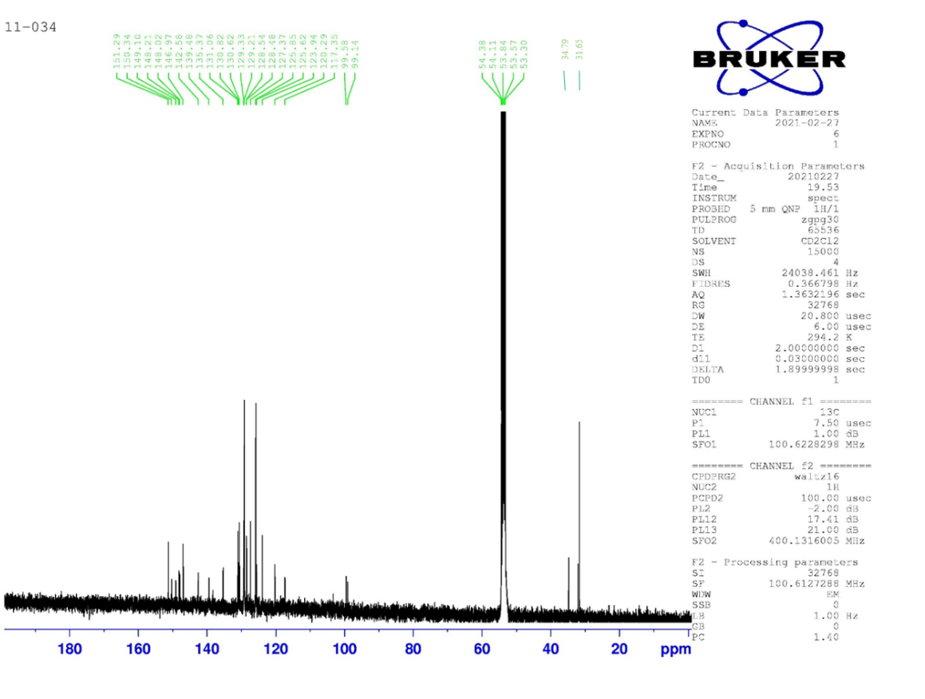
Figure S28. ¹³C NMR spectrum of t-Bu-ν-DABNA.
References:
- Cho, Y. J. & Lee, J. Y. Low Driving Voltage, High Quantum Efficiency, High Power Efficiency, and Little Efficiency Roll-Off in Red, Green, and Deep-Blue Phosphorescent Organic Light-Emitting Diodes Using a High-Triplet-Energy Hole Transport Material. Adv. Mater. 23, 4568-4572 (2011).
- Vecchi, P. A., Padmaperuma ,A. B., Qiao, H., Sapochak, L. S. & Burrows, P. E. A Dibenzofuran-Based Host Material for Blue Electrophosphorescence. Org. Lett. 8, 4211-4214 (2006).

