Supplementary Materials:
- Details of the Data Inclusion Exclusion Criteria and HPV Analysis
- Calculation of the Basic Reproduction Number R₀
- Transgender SICR Model Parameter Settings
- HPV Infection Symptom Outcome Risk Analysis
- Transgender Model Fitting Method
- Results of the Transgender SICR Model Fit for Single-Type HPV Infections
- Single-Type HPV Infection Transmission Capability R0 Wilcoxon Rank Sum Test

References

Details of the Data Inclusion Exclusion Criteria and HPV Analysis
The details of the data inclusion exclusion criteria showing as flow chart.
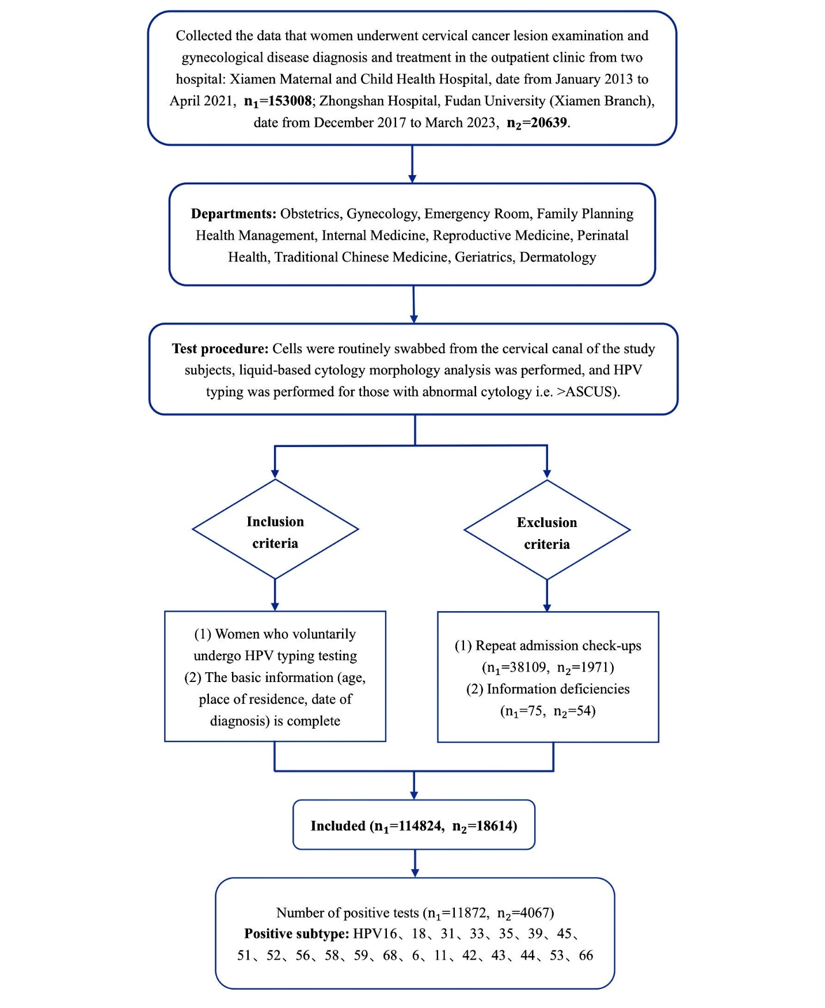
HPV Analysis: DNA was extracted from cervical swab samples using the Cell Lysis Kit (HybriBio) according to the manufacturer’s protocol. Subsequently, 13 oncogenic HPV types (16, 18, 31, 33, 35, 39, 45, 51, 52, 56, 58, 59, 68) and 7 nononcogenic HPV types (6, 11, 42, 43, 44, 53, 66) were examined using the 21 HPV GenoArray Diagnostic Kit (HybriBio) and the HybriMax® hybridization oven (HybriBio) according to the manufacturer’s protocol. As illustrated in previous study (Liu et al., 2010), the amplicon of HPV-DNA was actively directed toward the immobilized probes on membrane fibers, and complementary molecules were captured, forming DNA duplexes. After a stringent wash, the hybrids were detected using a horseradish peroxidase chromogenic system, which generated purple precipitates at the probe dot. After hybridization, the presence of a positive signal for both the “internal control” and “biotin control” on the membrane confirmed the quality of the isolated DNA, the validity of the enzyme conjugate, and the hybridization process.

Calculation of the Basic Reproduction Number R₀
We utilized MATLAB (R2021a) with its symbolic toolbox for symbolic matrix inversion and eigenvalue computations to calculate the basic reproduction number R₀ using the Van den Driessche and Watmough approach. The steps are outlined as follows:
  - We divided all compartments into two categories: non-infected compartments (including susceptible, S, and recovered, R) and infected compartments (infected individuals, I, and cancer patients, C).
  - Based on the model diagram and differential equations, we decomposed the derivative vector of the infected compartments over time into two parts: the first part, F, represents the rate of new infections, and the second part, V, represents the rate of transformation between different compartments excluding new infections.
  - We calculated the partial derivatives of F and V with respect to all infected compartments to obtain the corresponding Jacobian matrices$F$ and $V$.
  - We then calculated the next generation matrix FV ⁻¹ and determined its largest eigenvalue ρ = λ_{max} (FV ⁻¹ ).
  - By substituting the disease-free equilibrium in the expression ρ = λ_{max} (FV ⁻¹), we obtained R₀ as defined by the Next Generation Matrix (NGM).
$\begin{matrix}\frac{d}{dt}\left[\begin{matrix}I_{f} \\ I_{c} \\ I_{m} \\ I_{c}\end{matrix}\right] & =\left[\begin{matrix}βS_{f}I_{m}-d_{r}I_{f}-pr_{f}I_{f}-(1-p)μ_{f}I_{f} \\ (1-p)μ_{f}I_{f}-θ_{f}C_{f} \\ βS_{m}I_{f}-d_{r}I_{m}-pr_{m}I_{m}-(1-p)μ_{m}I_{m} \\ (1-p)μ_{m}I_{m}-θ_{m}C_{m}\end{matrix}\right] \\ & =\left[\begin{matrix}βS_{f}I_{m} \\ 0 \\ βS_{m}I_{f} \\ 0\end{matrix}\right]-\left[\begin{matrix}d_{r}I_{f}+pr_{f}I_{f}+(1-p)μ_{f}I_{f} \\ -(1-p)μ_{f}I_{f}+θ_{f}C_{f} \\ d_{r}I_{m}+pr_{m}I_{m}+(1-p)μ_{m}I_{m} \\ -(1-p)μ_{m}I_{m}+θ_{m}C_{m}\end{matrix}\right] \\ & ≝F-V\end{matrix}$ (1)

In the matrix: $S_{f}^{0}=\frac{b_{r}q}{d_{r}}N_{0}$, $S_{m}^{0}=\frac{b_{r}(1-q)}{d_{r}}N_{0},$ N₀ is the initial population.

$R_{0}=ρ\left(FV^{-1}\right)=\frac{{βN_{0}b}_{r}}{d_{r}}\sqrt{\frac{q(1-q)}{({pγ}_{m}+dr+μ_{m}-pμ_{m})({pγ}_{f}+dr+μ_{f}-pμ_{f})}}$ (2)

$β=\frac{R_{0}d_{r}}{b_{r}N_{0}}\sqrt{\frac{({pγ}_{m}+dr+μ_{m}-pμ_{m})(pγ_{f}+dr+μ_{f}-pμ_{f})}{q(1-q)}}$ (3)

Transgender SICR Model Parameter Settings
Based on the model framework and the parameters of the natural history of the disease, the parameter settings for the model are shown in Table S1.
  - Currently, there is no authoritative research that shows a difference in relative transmission probabilities between males and females. Therefore, this study assumes that the probability of transmission from male to female is equal to that from female to male, denoted β.
  - This study focuses on transgender transmission and does not consider transmission within the same gender.
  - Demographic data were obtained mainly by consulting statistical yearbooks, including the total population (N), natural birth rate (br), and mortality rate (dr). The study period is from 2017 to 2023, with br ranging from (0.00063 - 0.0013833) per month and dr ranging from (0.0002833 - 0.0002583) per month.
  - According to related research, the HPV clearance time in women is 16 months, while in men it is 7.5 months, thus setting γ_{m} = 1/7.5 = 0.1333 per month, γ_{f} = 1/16 = 0.0625 per month.
  - According to recent reports from the World Health Organization, it usually takes 15-20 years for a woman with a normal immune system to develop cancer. Our model mainly considers the general population and temporarily does not consider people with immune deficiencies, thus µ_{f} = 0.0048 per month. Data on men who develop cancer related to HPV infection are too scarce to obtain accurately, so it is also assumed µ_{m} = 0.0048 per month.
  - The mortality rate from cervical cancer in women and cancer attributable to HPV infection in men are indicated as θ_{f} = 0.000002583 and θ_{m} = 0.000000425, respectively.

Table S1: Definitions and Sources of SICR Model

Parameter | Definition | Unit | Value | Source
β | Relative transmission rate from males to females | 1 | - | Model fitting
µ_{f} | Carcinogenic rate of females infected with HPV | 1 | 0.0048 | Reference [2]
µ_{m} | Carcinogenic rate of males infected with HPV | 1 | 0.0048 | Reference [2]
γ_{f} | Relative recovery rate of female infectees | month−1 | 0.0625 | Reference [1]
γ_{m} | Relative recovery rate of male infectees | month−1 | 0.1333 | Reference [4]
br | Natural birth rate of Xiamen’s population | month−1 | [0.00063-0.001383] | Statistical Yearbook
dr | Natural death rate of Xiamen’s population | month−1 | [0.000258-0.000314] | Statistical Yearbook
θ_{f} | Mortality rate of cervical cancer caused by HPV in females | per 100,000 person-years | 0.000002583 | Reference [3]
θ_{m} | Mortality rate of cancer attributable  to HPV infection in males | per 100,000 person-years | 0.000000425 | Reference [3]

HPV Infection Symptom Outcome Risk Analysis
Cumulative link models (CLMs) allow us to establish a cumulative probability model for Y and estimate the influence of X on the cumulative probability. We use the clm() function from the ordinal package in R to fit CLMs, employing the maximum likelihood estimation method to estimate the model parameters. During the model fit process, we select an appropriate link function to connect X to the cumulative probability. We also use structured thresholds to constrain differences between different categories, thus improving the interpretation of the model results. The model equation is as follows:

logit (P (Y ⩽ t / X) ) = θt − (β1 · X1 + β2 · X2) (4)

In the analyzes, the logit function is defined as logit(x) = log ($\frac{x}{1-x}$) . Throughout all the analyzes, a P value of < 0.05 is considered statistically significant.
Based on the risk analysis of symptom outcomes in HPV-infected patients at Hospital 1, the equation can be written as:

logit (P (Y ⩽ 1 level / X)) = −3.01 + (−0.04 · X1 + 0.26 · X2),
logit (P (Y ⩽ 2 level /X)) = 0.52 + (−0.04 · X1 + 0.26 · X2),
logit (P (Y ⩽ 3 level /X)) = 1.28 + (−0.04 · X1 + 0.26 · X2),
logit (P (Y ⩽ 4 level /X)) = 0.52 + (−0.04 · X1 + 0.26 · X2).

And for Hospital 2, the equation can be written as:

logit (P (Y ⩽ 1 level /X)) = −1.20 + (0.03 · X1 + 0.26 · X2),
logit (P (Y ⩽ 2 level /X)) = 2.48 + (−0.04 · X1 + 0.26 · X2),
logit (P (Y ⩽ 3 level /X)) = 3.64 + (−0.04 · X1 + 0.26 · X2),
logit (P (Y ⩽ 4 level /X)) = 4.70 + (−0.04 · X1 + 0.26 · X2).

Transgender Model Fitting Method
This study employs Berkeley Madonna 8.3.18 software for model simulation, developed by Robert Macey and George Oster of the University of California, Berkeley, with copyrights held by Robert I. Macey & George F. Oster (1993-2001). Differential equations are solved using the fourth-order Runge-Kutta method with a tolerance limit set at 0.001. The simulation of the model and the predictive precision are evaluated using the coeﬀicient of determination (R²) and significance tests (P values). The results are organized, analyzed, and visualized using Excel 2016, CorelDRAW 2020, and MATLAB R2023b.

Results of the Transgender SICR Model Fit for Single-Type HPV Infections
We employ a transgender SICR model to fit the positive detection rates of various types of HPV in populations from two hospitals (Hospital 1 and Hospital 2). Data from Hospital 1 span from January 2013 to April 2021, as shown in Figure S1, S2, S3, S4, S5, S6, S7, S8, S9. The HPV16 prevalence curve shows a declining trend; HPV18 and HPV58 exhibit fluctuating declining trends; HPV31, HPV33, HPV6 and HPV11 display significant declining trends; HPV45’s prevalence curve shows an initial decline followed by an increase; and HPV52 shows a gently declining trend. The results of the fit of the model for the prevalence rates for each type of HPV are statistically significant (P<0.05).

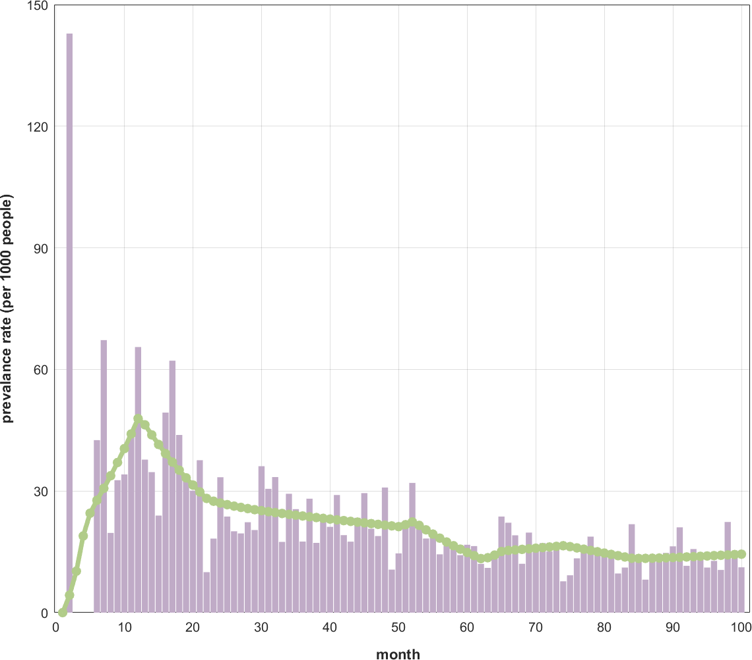

Figure S1: Transgender SICR Model Fit Results for HPV16 in Hospital 1.

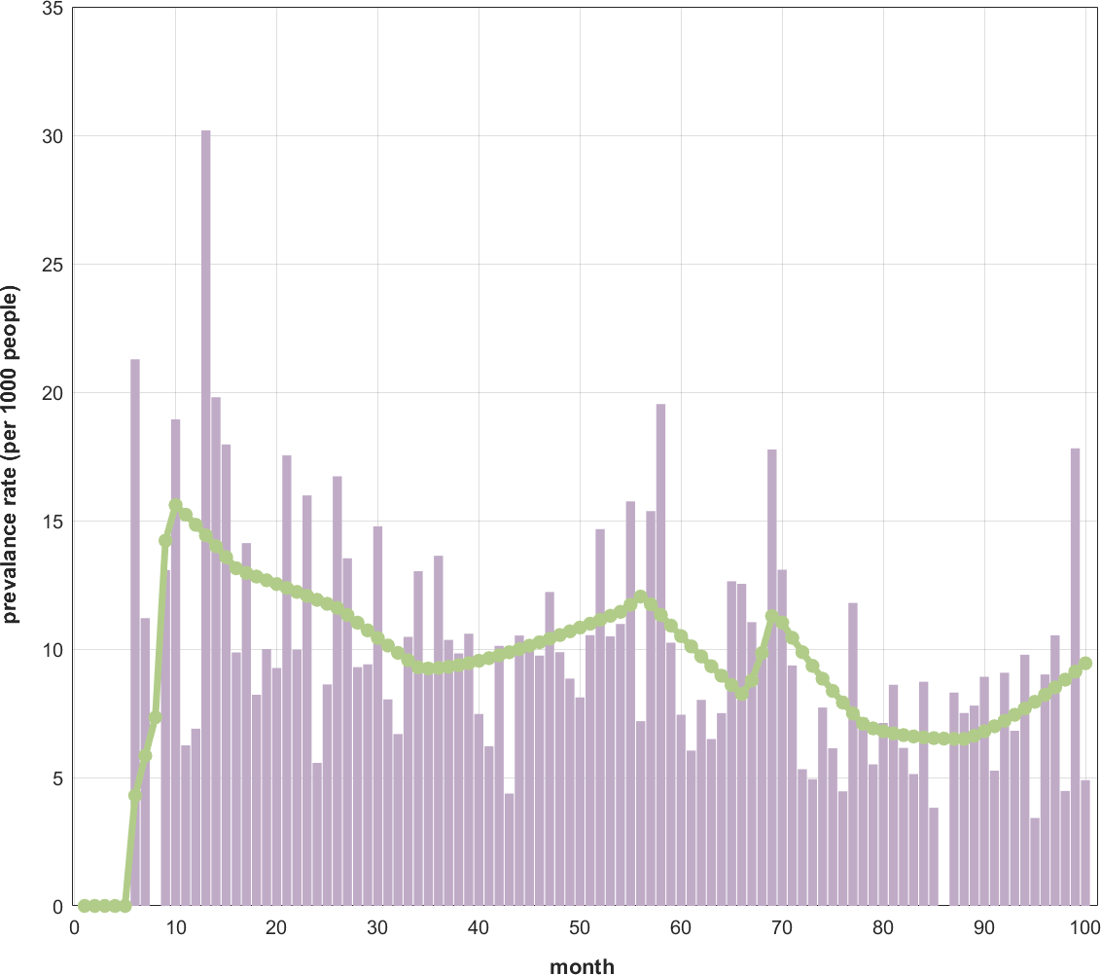

Figure S2: Transgender SICR Model Fit Results for HPV18 in Hospital 1.

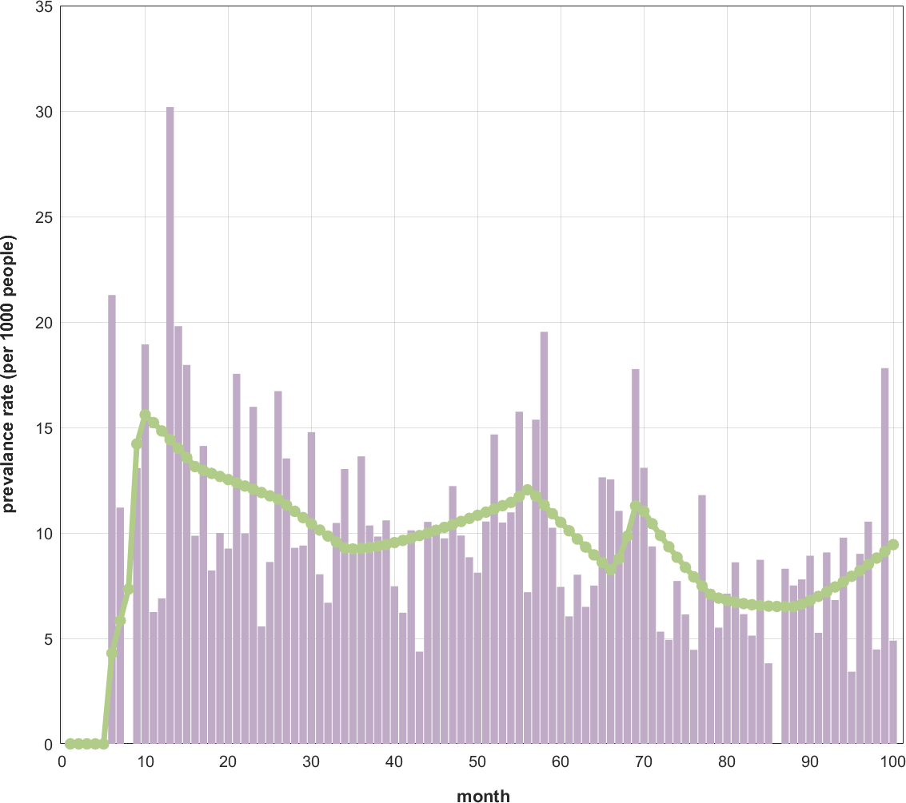

Figure S3: Transgender SICR Model Fit Results for HPV31 in Hospital 1.

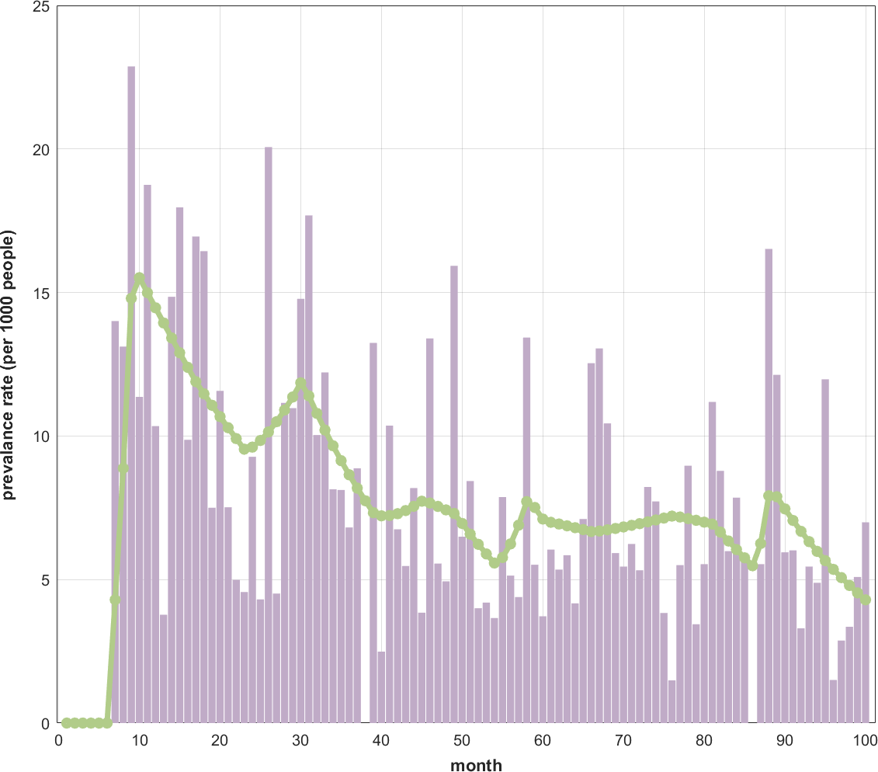

Figure S4: Transgender SICR Model Fit Results for HPV33 in Hospital 1.

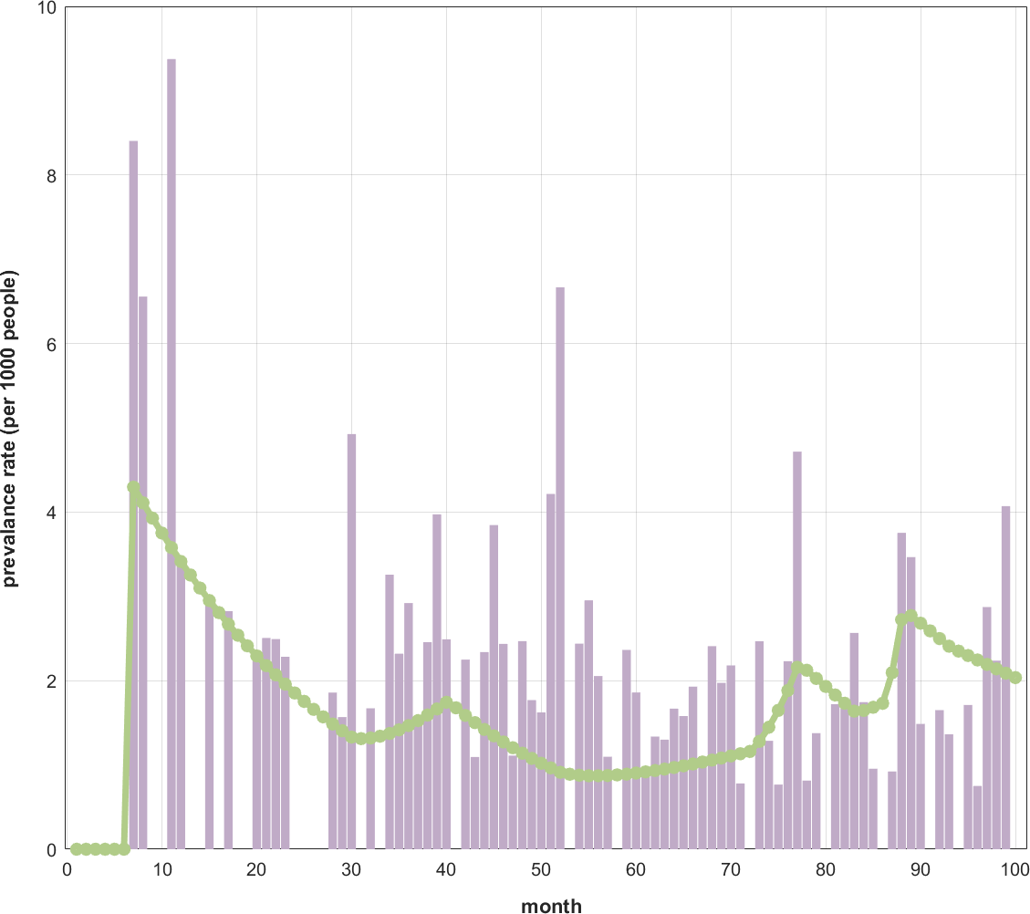

Figure S5: Transgender SICR Model Fit Results for HPV45 in Hospital 1.

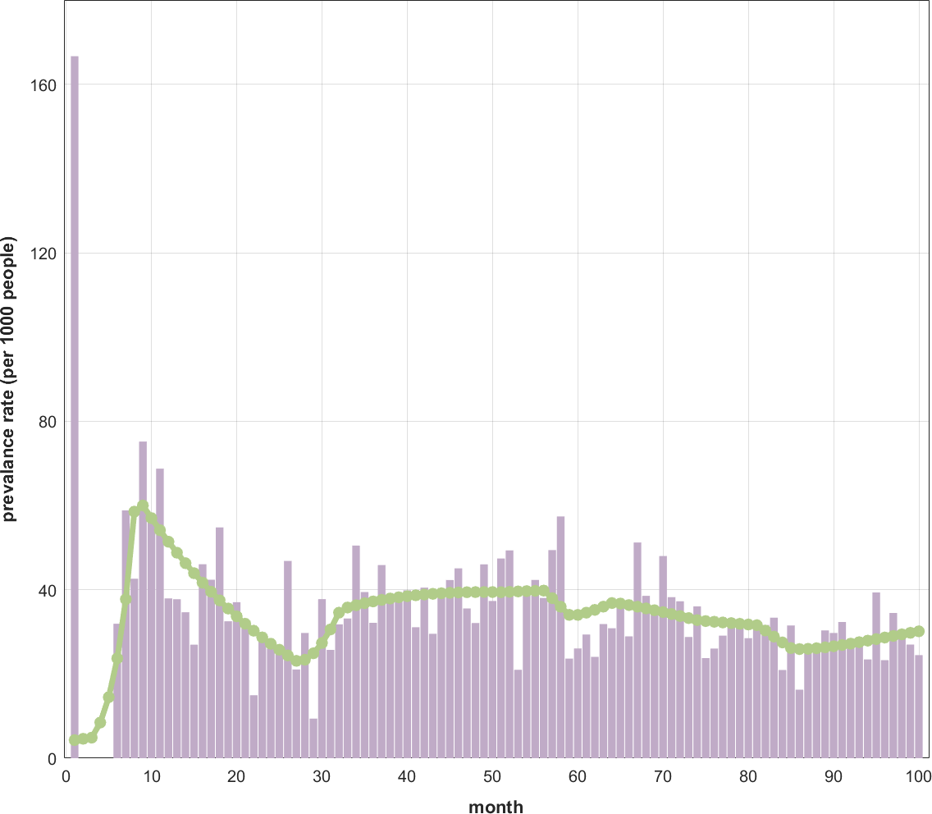

Figure S6: Transgender SICR Model Fit Results for HPV52 in Hospital 1.

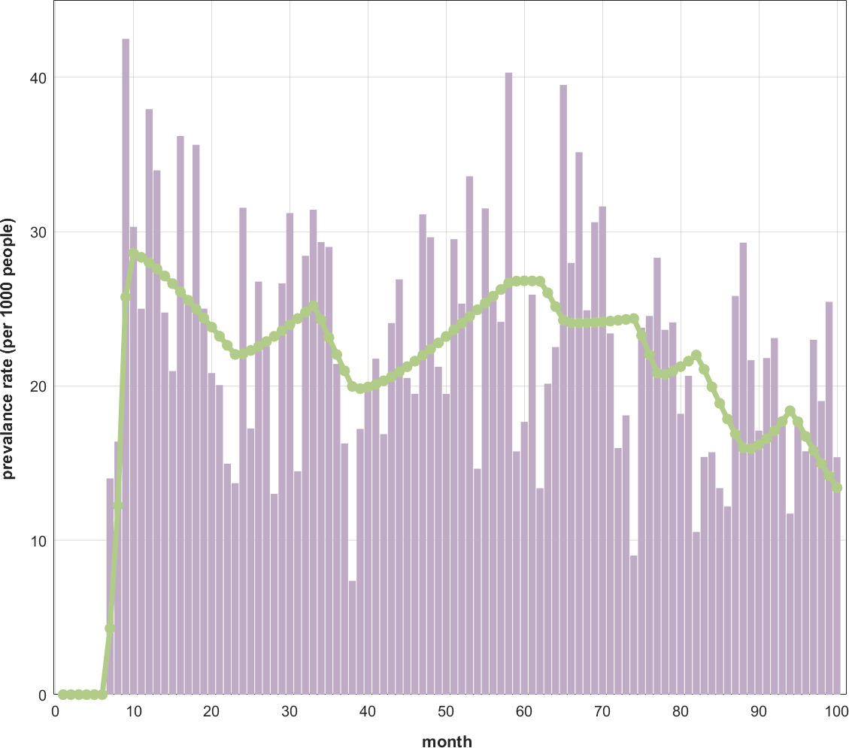

Figure S7: Transgender SICR Model Fit Results for HPV58 in Hospital 1.

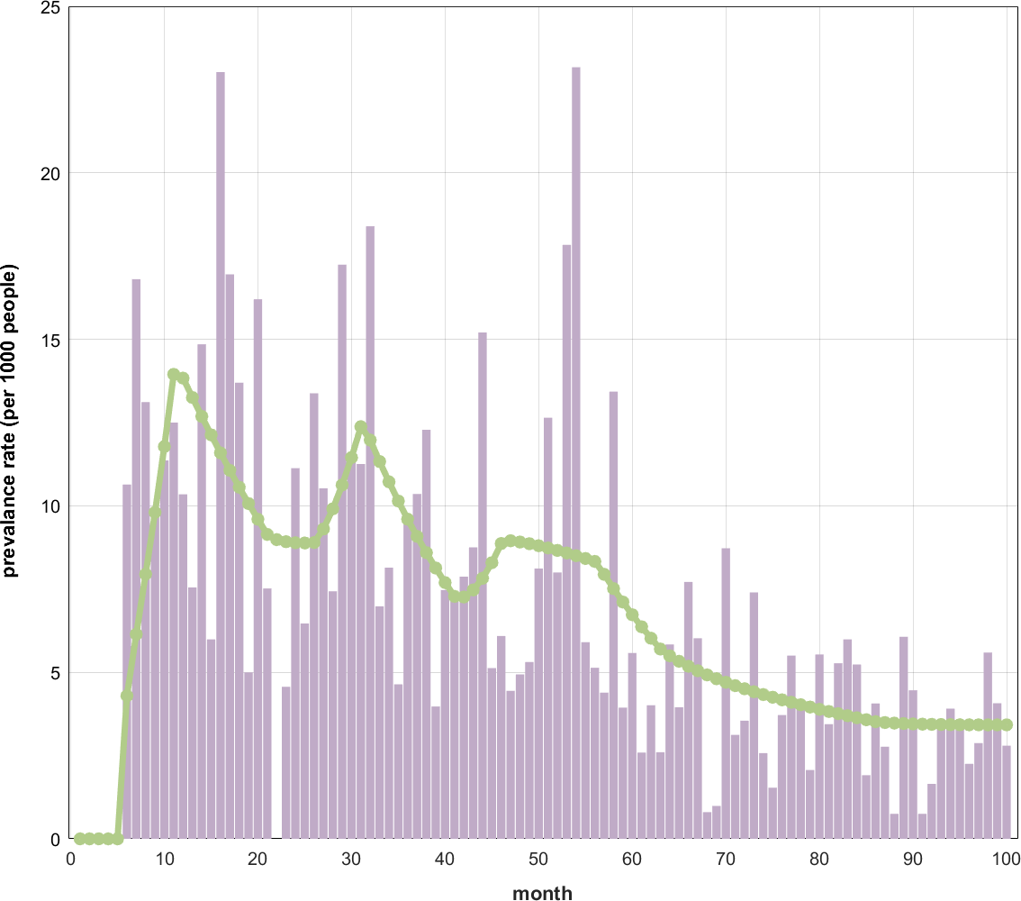

Figure S8: Transgender SICR Model Fit Results for HPV6 in Hospital 1.

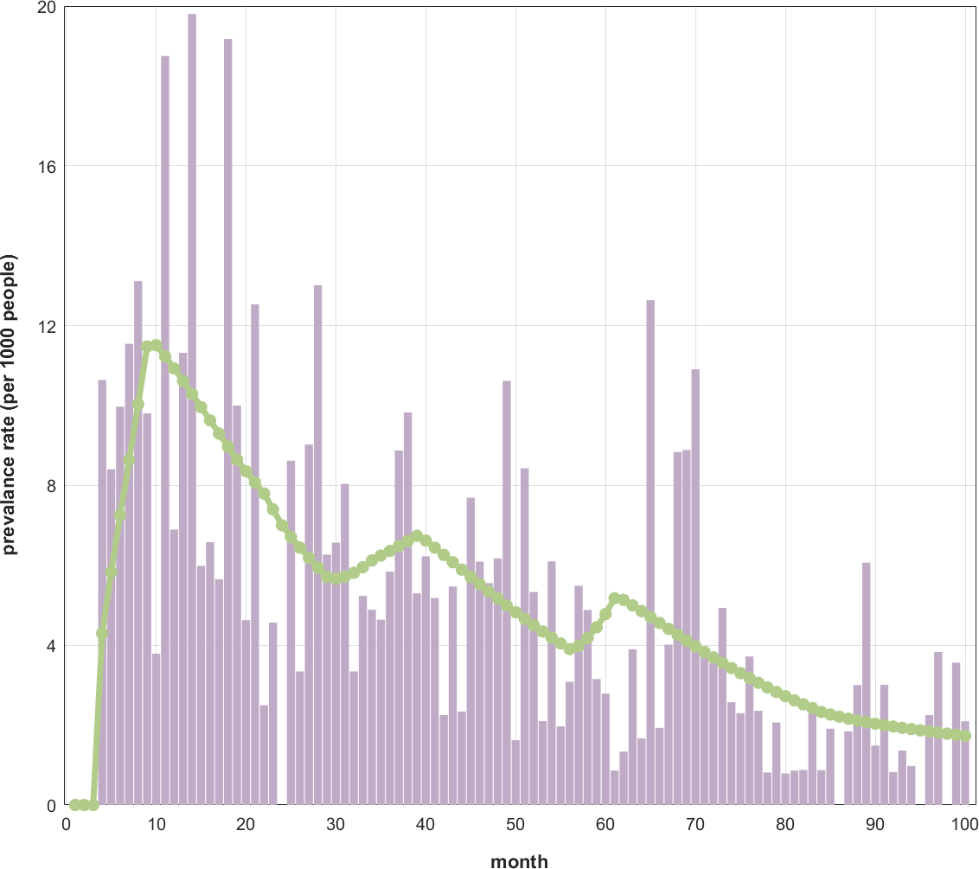

Figure S9: Transgender SICR Model Fit Results for HPV11 in Hospital 1.

Data from Hospital 2, covering the period from December 2017 to March 2023, are illustrated in Figure S10, S11, S12, S13, S14, S15, S16, S17, S18. The HPV16 prevalence curve does not show a significant upward or downward trend; HPV18 and HPV58 exhibit a gentle upward trend; HPV31 and HPV33 show a gentle declining trend; the prevalence curve for HPV45 is relatively smooth with minor fluctuations, overall showing a slight decline; HPV52 and HPV11 display an overall upward trend, while HPV6’s prevalence curve exhibits a rapid rise followed by a rapid decline, and then a gentle upward trend. The results of the fit of the model for the prevalence rates for each type of HPV are statistically significant (P<0.05).

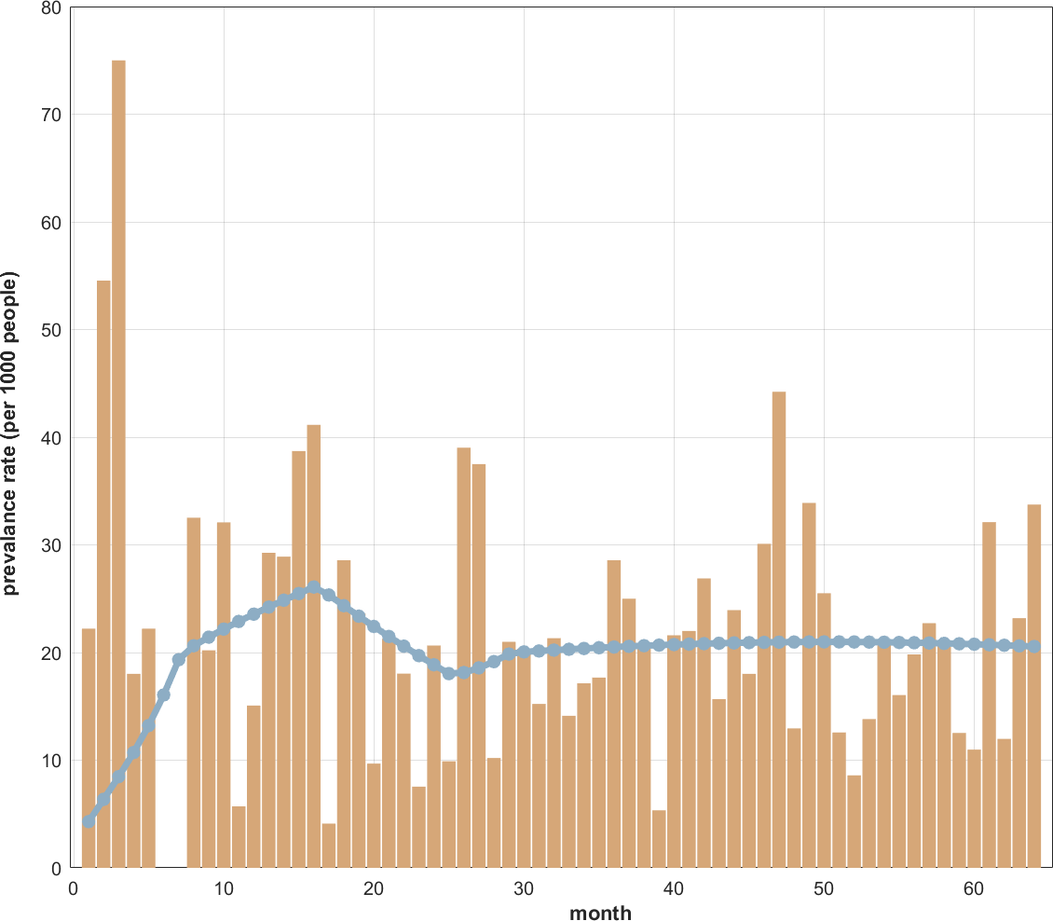

Figure S10: Transgender SICR Model Fit Results for HPV16 in Hospital 2.

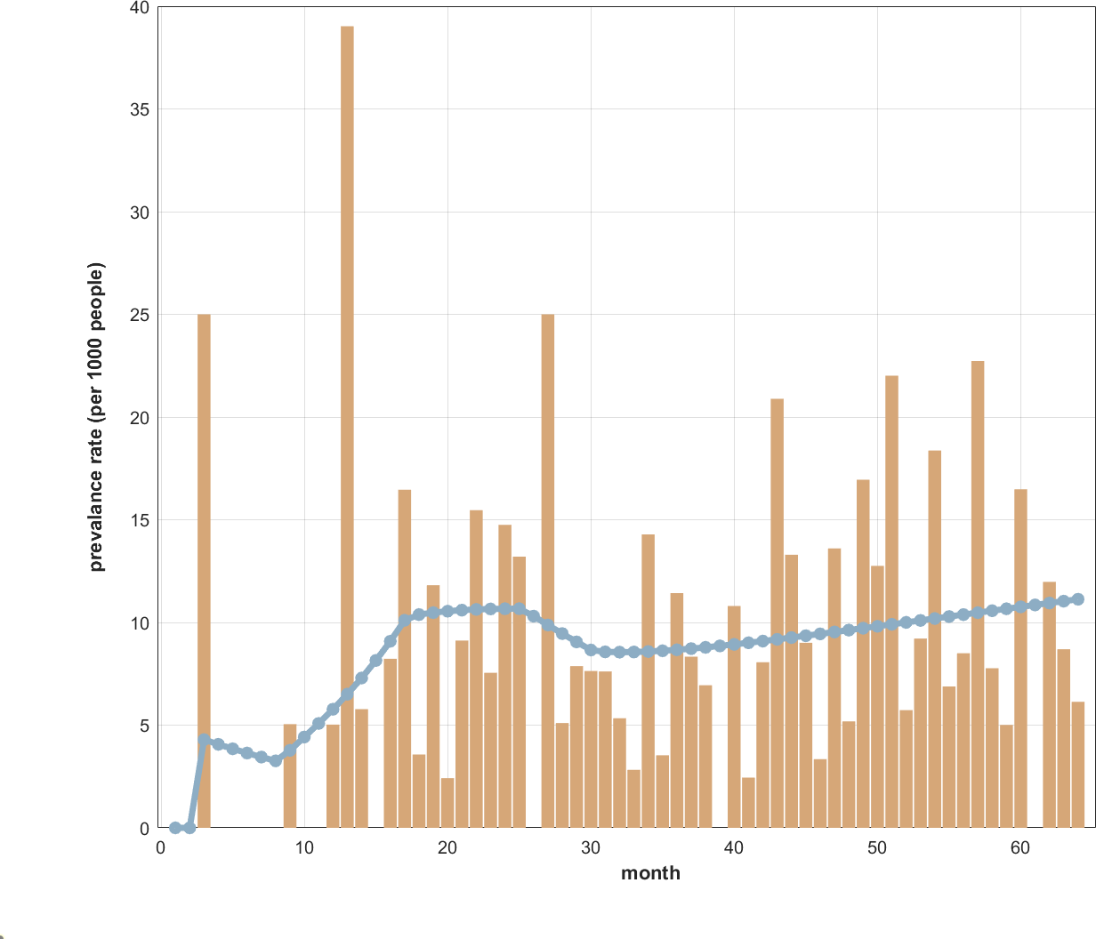

Figure S11: Transgender SICR Model Fit Results for HPV18 in Hospital 2.

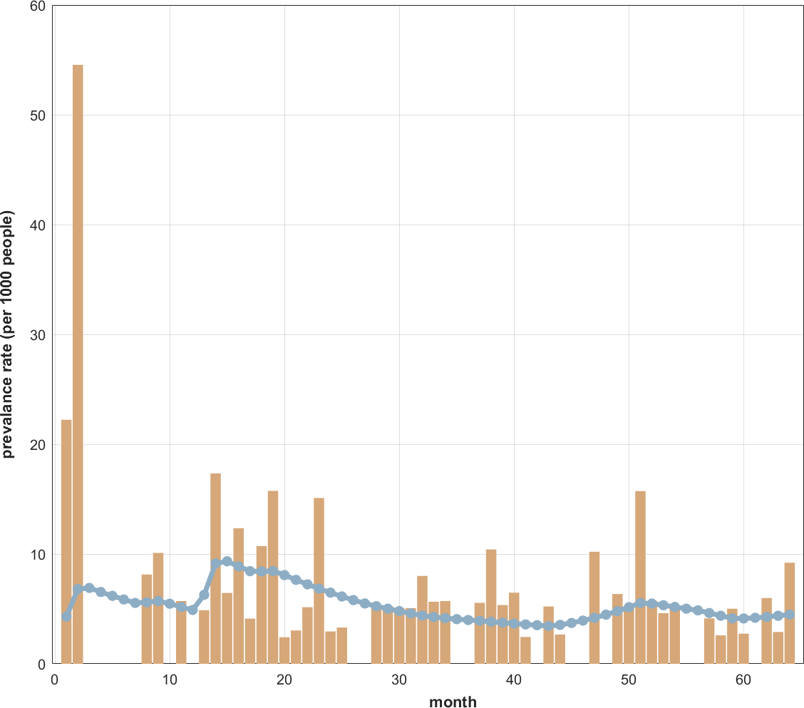

Figure S12: Transgender SICR Model Fit Results for HPV31 in Hospital 2.

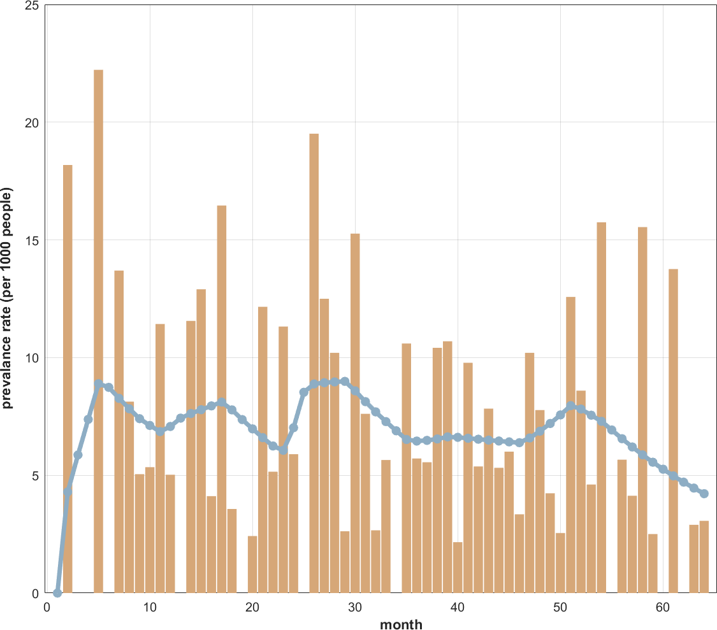

Figure S13: Transgender SICR Model Fit Results for HPV33 in Hospital 2.

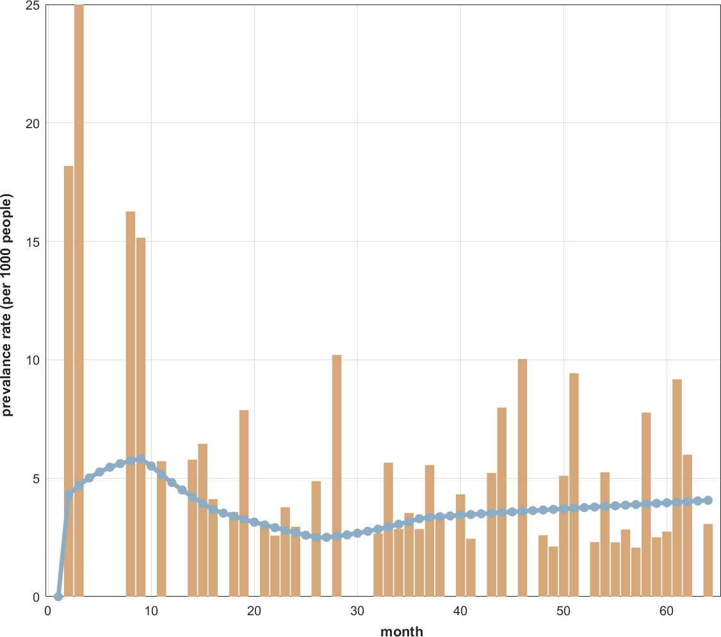

Figure S14: Transgender SICR Model Fit Results for HPV45 in Hospital 2.

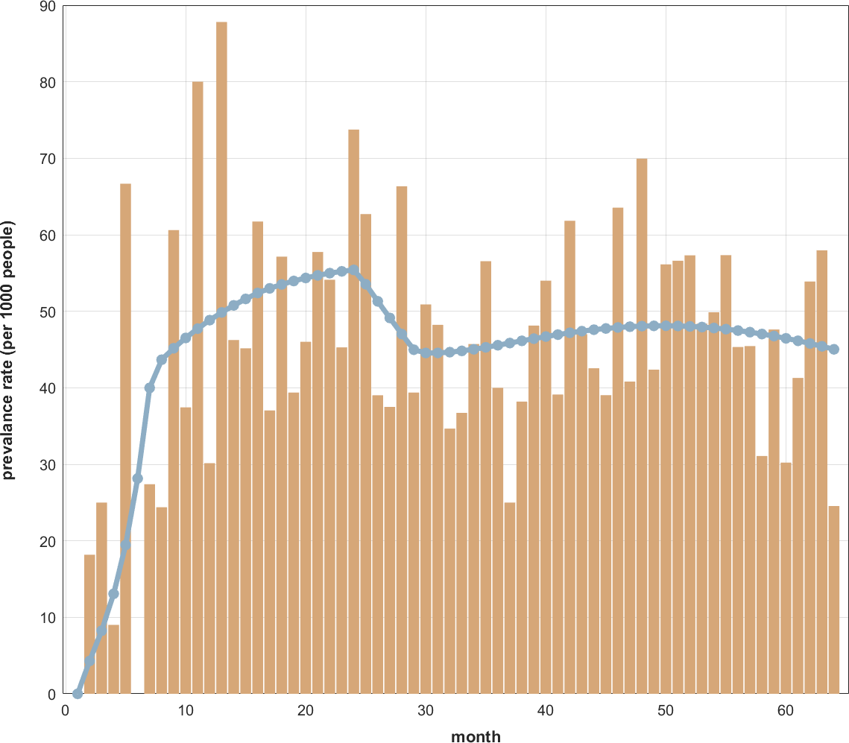

Figure S15: Transgender SICR Model Fit Results for HPV52 in Hospital 2.

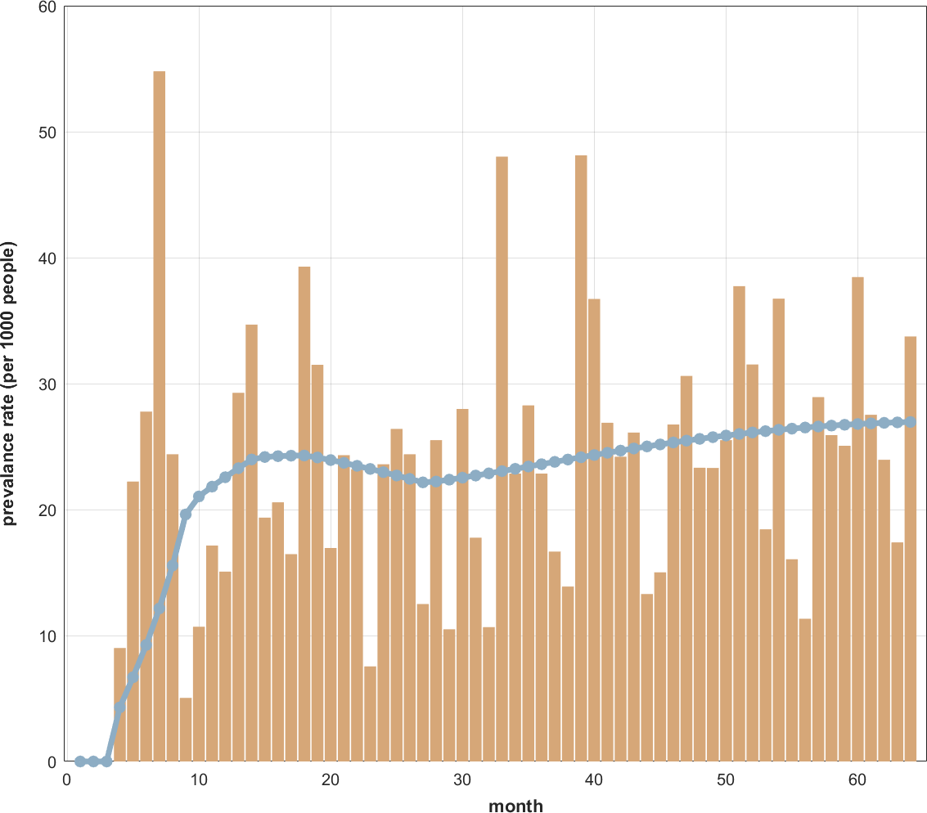

Figure S16: Transgender SICR Model Fit Results for HPV58 in Hospital 2.

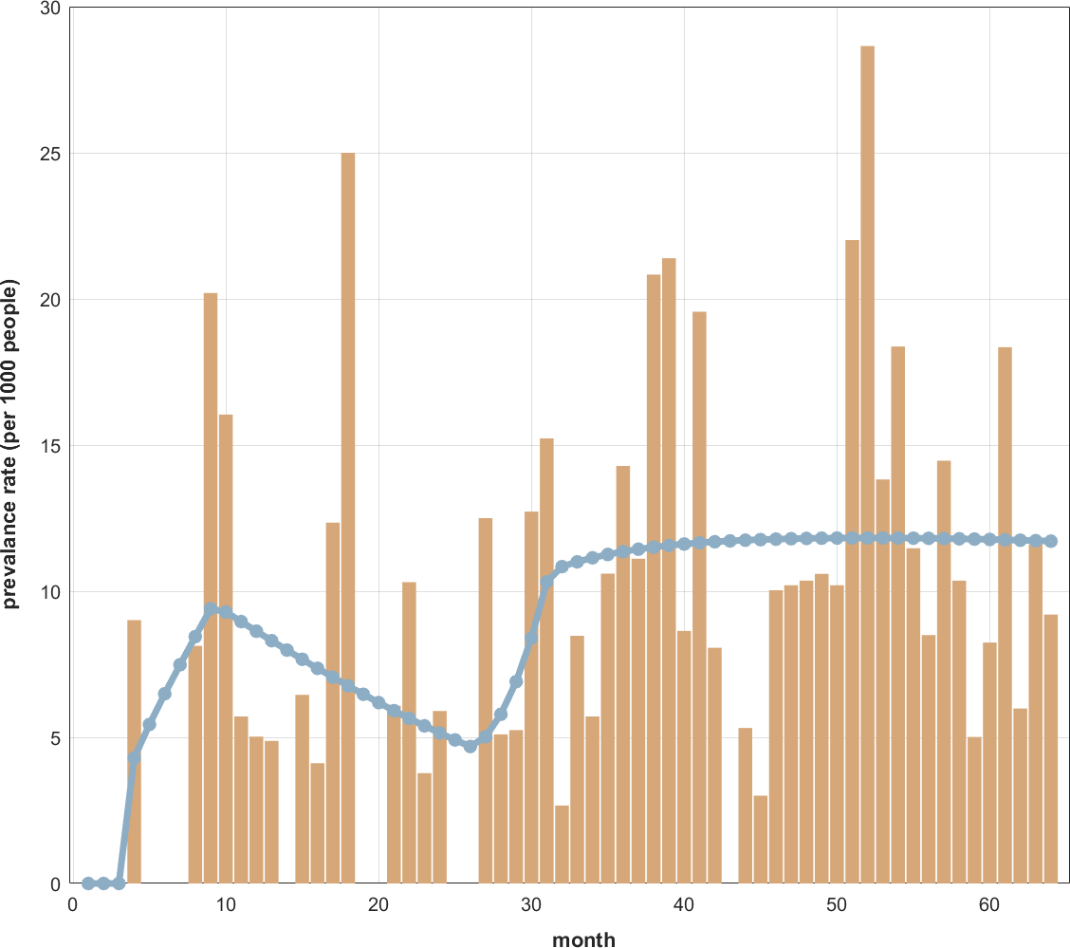

Figure S17: Transgender SICR Model Fit Results for HPV6 in Hospital 2.

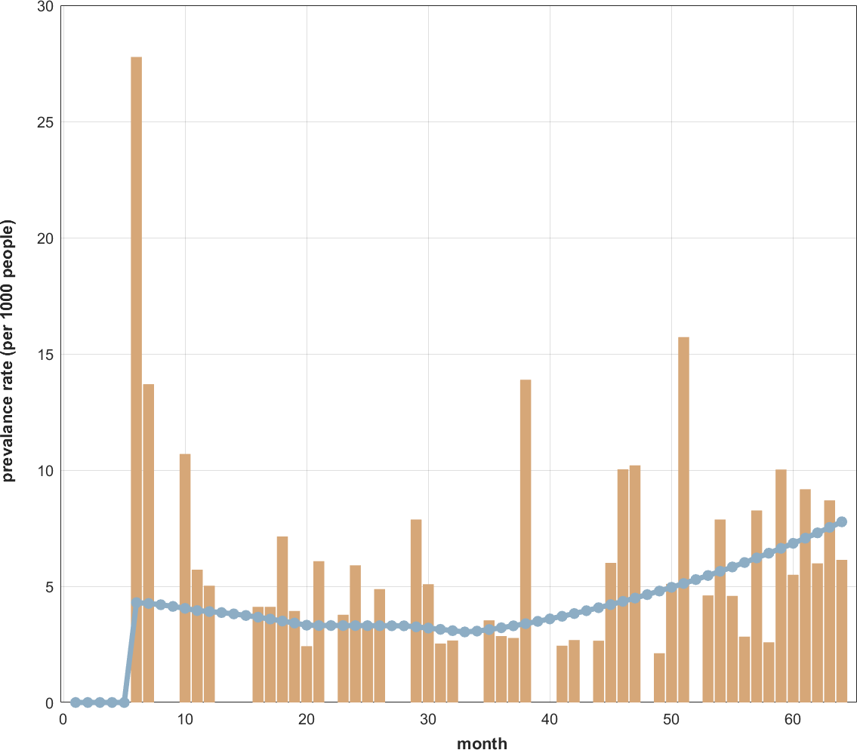

Figure S18: Transgender SICR Model Fit Results for HPV11 in Hospital 2.

Single-Type HPV Infection Transmission Capability R₀ Wilcoxon Rank Sum Test
Due to the non-normality of the R₀ values for different HPV types over time at Hospital 1 and Hospital 2, we conducted a Wilcoxon rank sum test for the R₀ values of nine HPV types at both hospitals. The hypothesis tested was that there are no differences in the median values R₀ of a certain type of HPV between the two hospitals. The results are presented in Table S2.
At a significance level of 0.05, the P values for HPV16, HPV58, HPV6, and HPV11 are less than 0.05, indicating significant differences in R₀ values between the two hospitals. However, HPV18, HPV31, HPV33, HPV45 and HPV52 did not show significant differences in the R₀ values.

Table S2: Single-Type HPV R₀ Wilcoxon Rank Sum Test

Genotype of HPV | P-values
HPV16 | 0.044
HPV18 | 0.059
HPV31 | 0.116
HPV33 | 0.167
HPV45 | 0.116
HPV52 | 0.068
HPV58 | 0.008
HPV6 | 0.001
HPV11 | 0.006

7 Transgender SICR Model Fit Results for HPV Co-Infection
This study used the transgender SICR model to separately identify and fit the univariate time series for specific co-infection ratios at two hospitals (Hospital 1 and Hospital 2).
Hospital 1 (January 2013 - April 2021): Single HPV Infection (SHPV): The prevalence curve initially shows a fluctuating upward trend followed by a slight decline, as shown in Figure S19. Double HPV Infection (DHPV), Triple HPV Infection (THPV), and Quadruple HPV Infection (FHPV): All exhibit fluctuating declining trends. The results of the fit of the model for various multiple HPV infection rates are statistically significant (P < 0.05), as shown in Figure S20, S21, S22.
Hospital 2 (December 2017 - March 2023): Single HPV Infection (SHPV): The prevalence curve shows an initial increase followed by a fluctuating decline, as shown in Figure S23. Double HPV Infection (DHPV): The prevalence curve shows a fluctuating upward trend, as shown in Figure S24. Triple HPV Infection (THPV): The curve generally exhibits a fluctuating decreasing trend, as shown in Figure S25.
The model fitting results for each type of HPV infection rate in both hospitals are statistically significant (P < 0.05), indicating robust fits for the patterns of HPV co-infections in these populations.

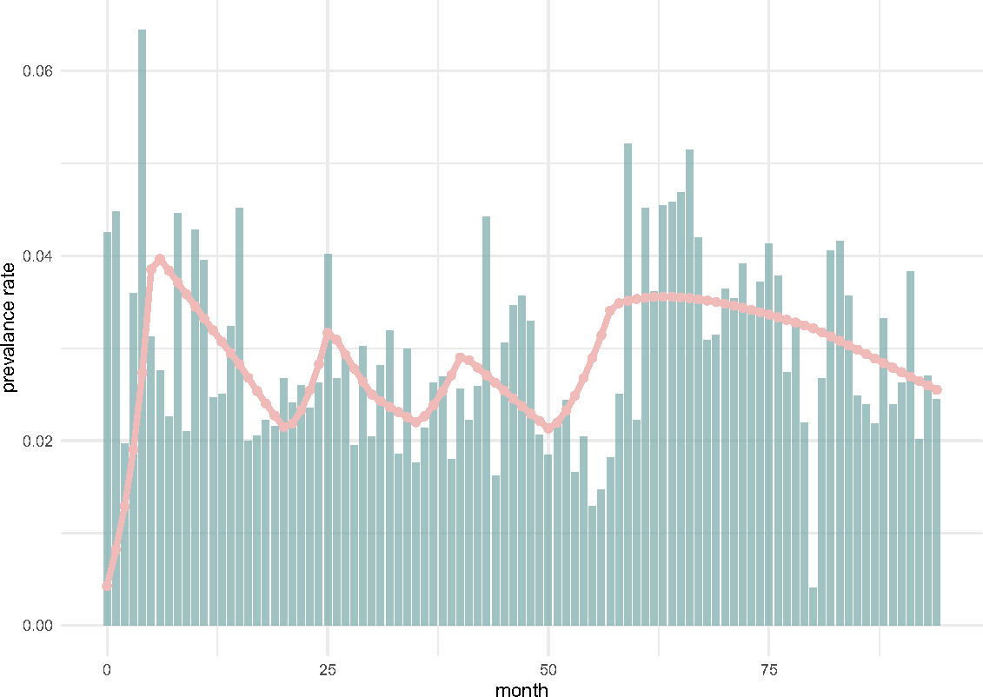

Figure S19: Transgender SICR Model Fit Results for Single-Type HPV Infections at Hospital 1.

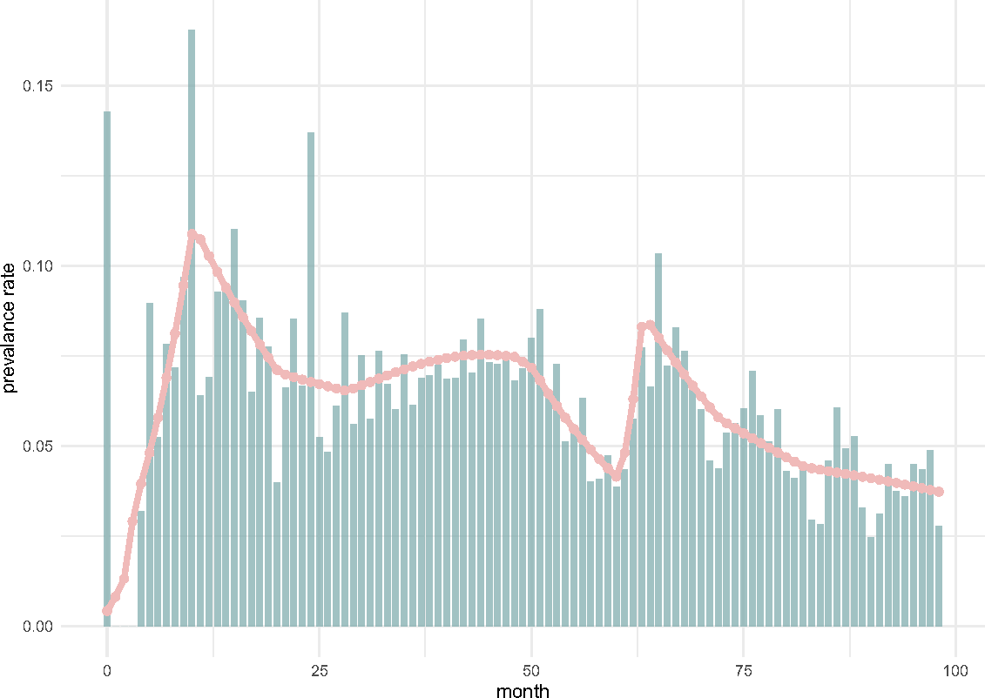

Figure S20: Transgender SICR Model Fit Results for Dual-Type HPV Infections at Hospital 1.

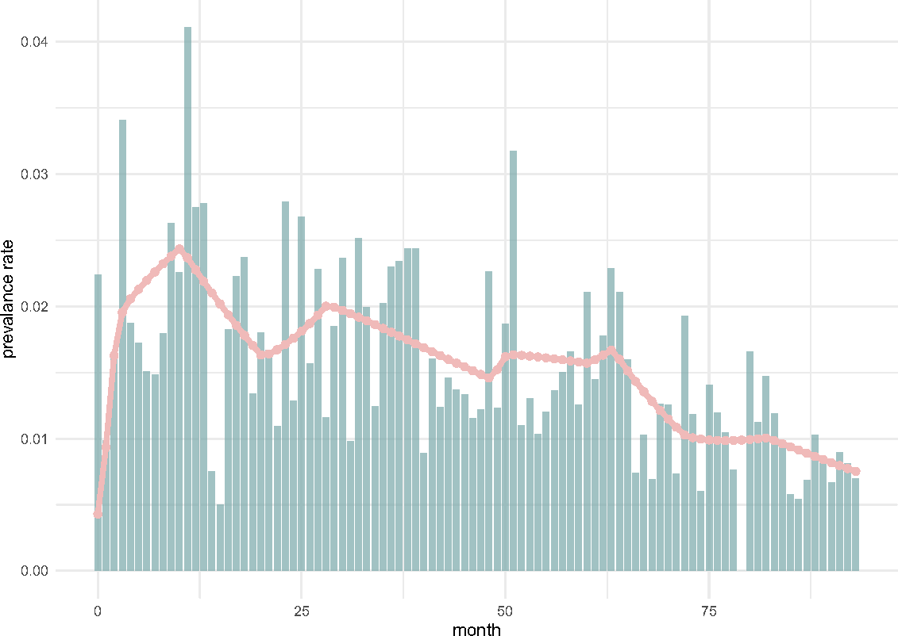

Figure S21: Transgender SICR Model Fit Results for Triple-Type HPV Infections at Hospital 1.

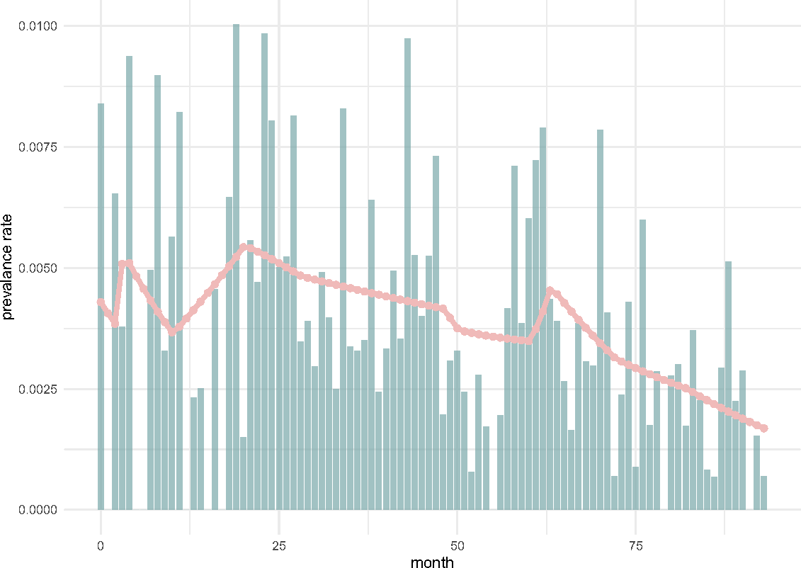

Figure S22: Transgender SICR Model Fit Results for Quadruple-Type HPV Infections at Hospital 1.

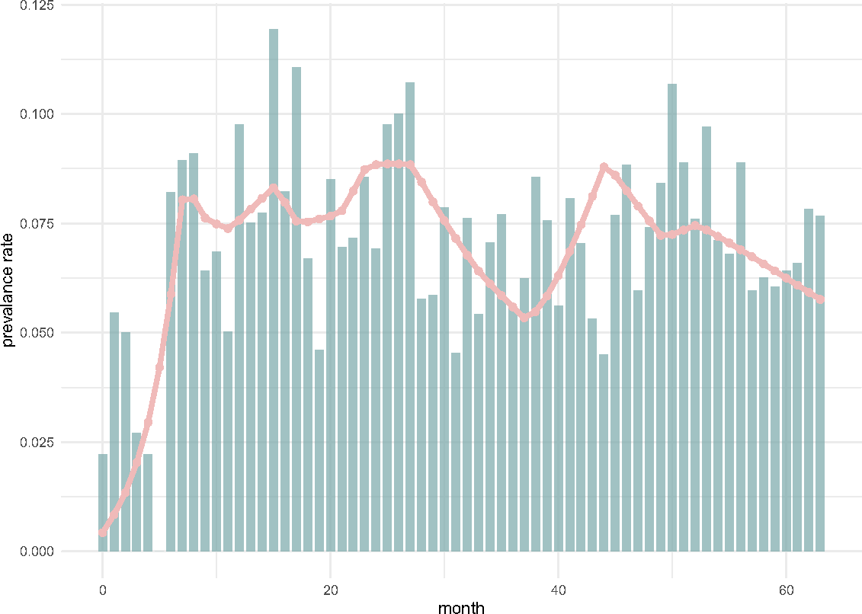

Figure S23: Transgender SICR Model Fit Results for Single-Type HPV Infections at Hospital 2.

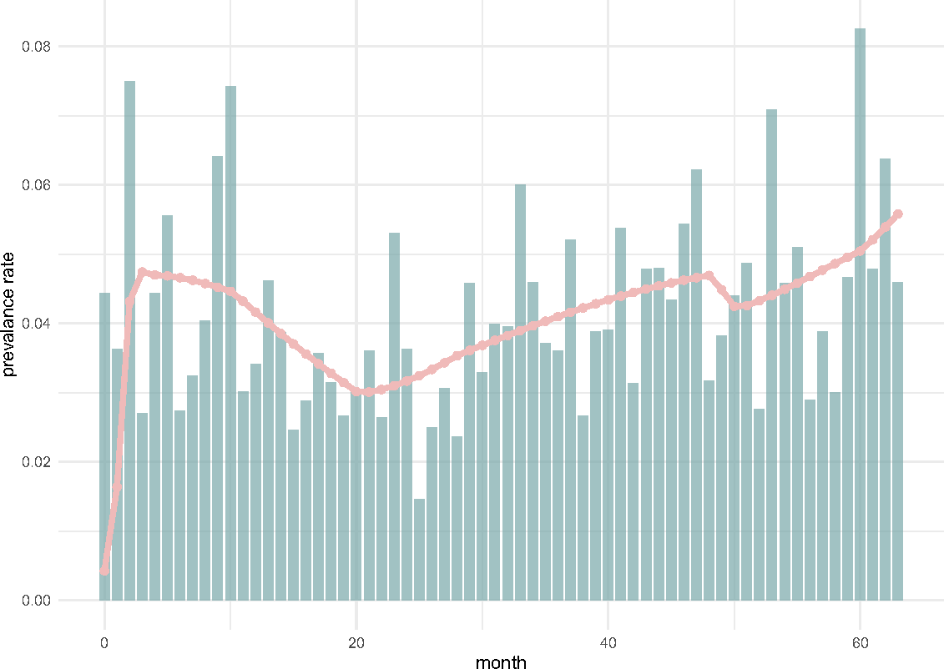

Figure S24: Transgender SICR Model Fit Results for Dual-Type HPV Infections at Hospital 2.

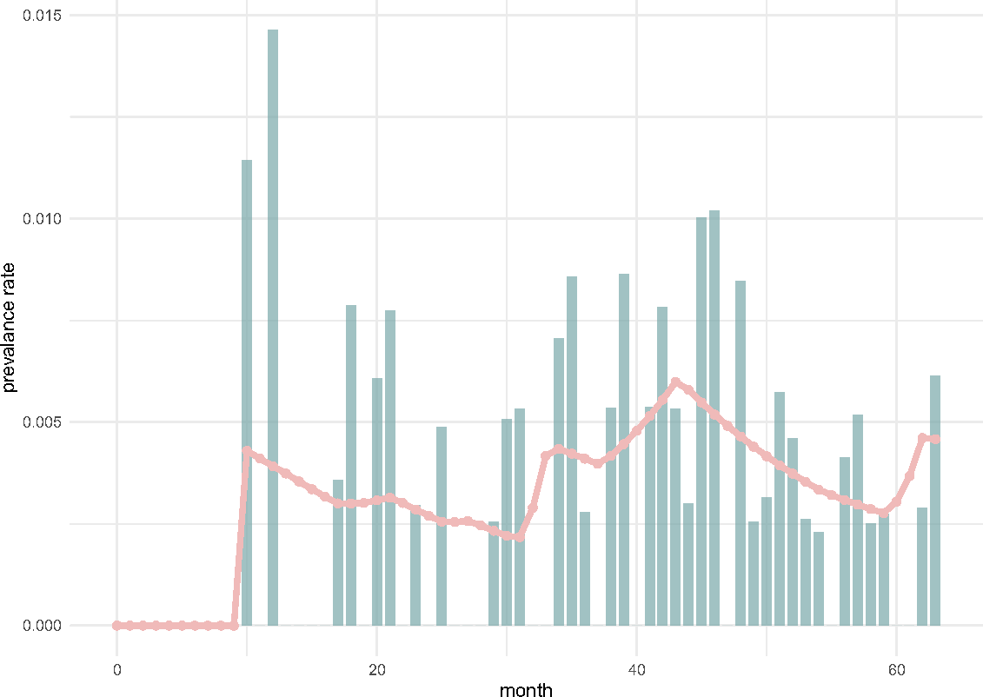

Figure S25: Transgender SICR Model Fit Results for Triple-Type HPV Infections at Hospital 2.

References
- QIN Guangyi and TAO Minfang. Study on detect the natural clearance rate of high-oncogenic risk human papilloma virus in cervical dormant infection. Chinese Journal of Clinical Medicine, 18(03):307–309, 2011.
- ORGANIZATION W H. Cervical cancer., 2023. 2024-03-03.

- Yong Lu, Peiyang Li, Ganfeng Luo, Di Liu, and Huachun Zou. Cancer attributable to human papillomavirus infection in china: Burden and trends. Cancer, 126(16):3719–3732, 2020.
- Edson Duarte Moreira, Jr, Anna R Giuliano, Joe l Palefsky, Carlos Aranda Flores, Stephen Goldstone, Daron Ferris, Richard J Hillman, Harald Moi, Mark H Stoler, Brooke Marshall, Scott Vuocolo, Dalya Guris, and Richard M Haupt. Incidence, clearance, and disease progression of genital human papillomavirus infection in heterosexual men. J Infect Dis, 210(2):192–199, February 2014.

