Nitrogen removal performance and changes in microbial community structure of a single-stage partial nitrification-anammox (PNA) process for treating municipal wastewater with an extremely low carbon-to-nitrogen ratio

Yiqiang Sunª, Yongguang Ma^{a*}, Youwei Caoª, Shiyue Liuª, Xueyong Tianª, Bowen Dai^{b‘}

ªSchool of Environmental and Chemical Engineering, Shenyang University of Technology, Shenyang 110870, China.

^{b}Shengyang Zhenxing Sludge Disposal Co., Ltd., Shenyang 110000, China.

*Corresponding authors.

Mail addresses: 13694131901@163.com, (Yongguang Ma)

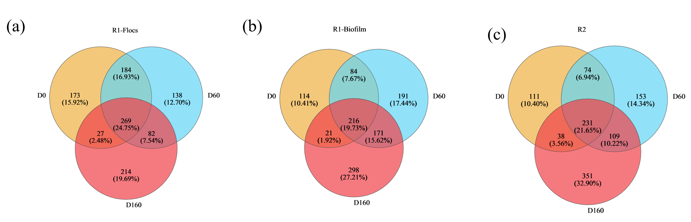

Fig. S1. Venn diagrams of microbial distribution: (a) microbial distribution in R1 suspended sludge; (b) microbial distribution on R1 biofilm; (c) microbial distribution on R2 biofilm.

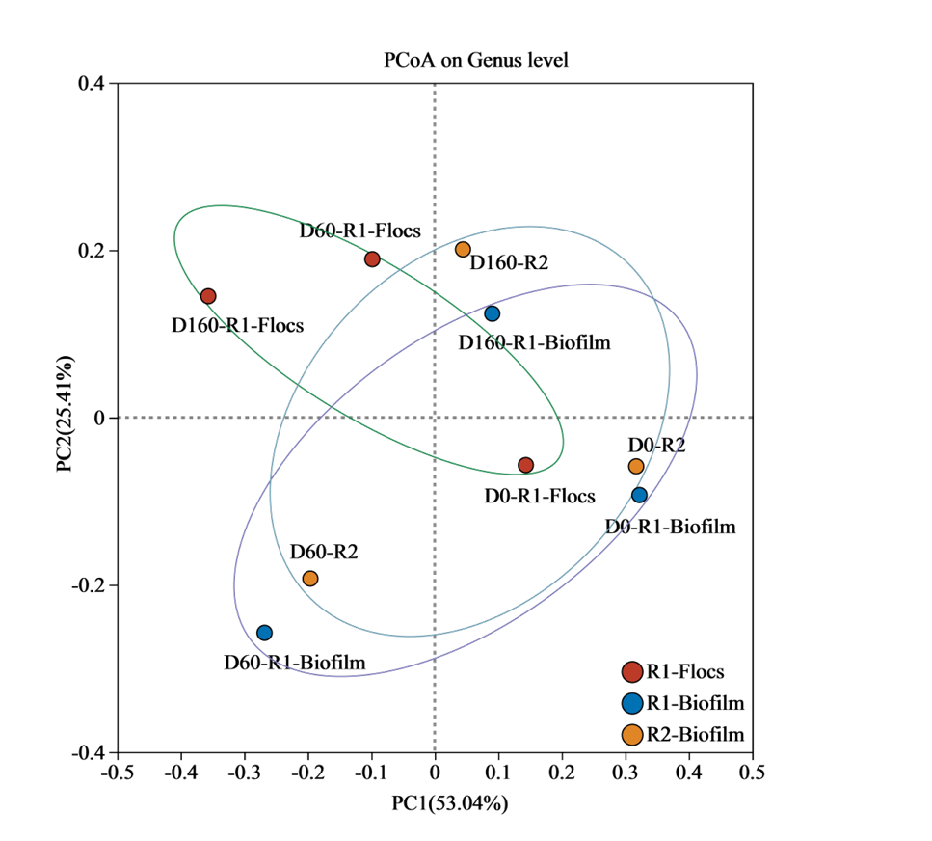
Fig. S2. Principal component analysis (PCoA) of microbial diversity
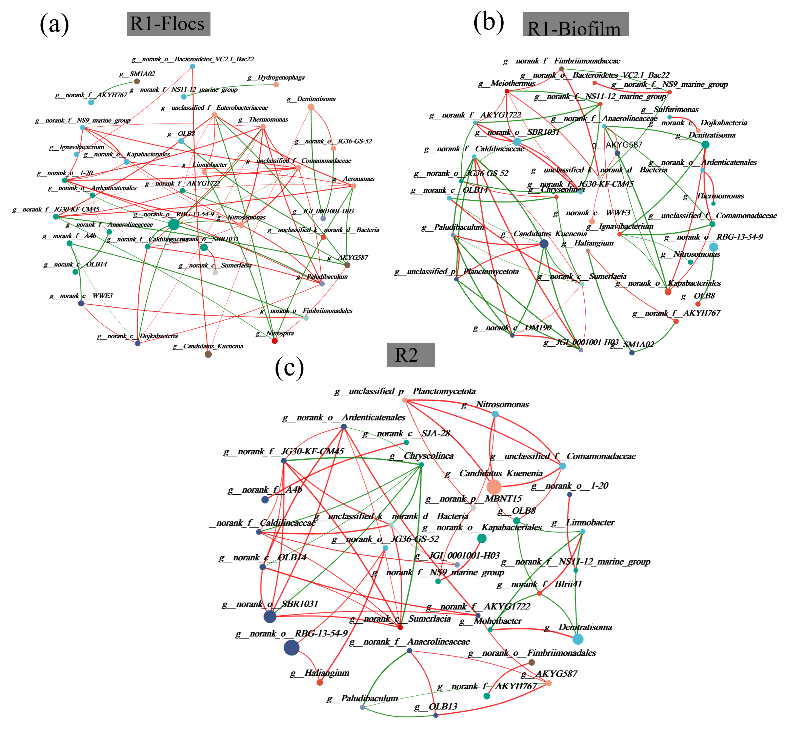

Fig. S3. Network analysis reveals co-occurrence patterns among genera, with each edge representing a strong correlation (Pearson's correlation coefficient ρ ≥ 0.8) and significance (p-value < 0.05). Red lines represent positive correlations and the green line represents a negative correlation. The size of each node is proportional to the number of connections: (a) R1 the relationship between bacteria in suspended sludge, (b) R1 the relationship between bacteria in biofilm, (a) R2s the relationship between bacteria in biofilm.

