Supporting information
Peptide hydrogel platform encapsulating manganese ions and high-density lipoprotein nanoparticle-mimicking nanovaccines for the prevention and treatment of gastric cancer
Xu Huang^{1, a, b}, Lin Hong^{1, c}, Yufan Lv^{1, a, b}, Kejun Li^{d}, Zengxing Zhang^{d}, Junjian Deng*^{, d}，Lei Shen*^{, a, b}
ªDepartment of Gastroenterology, Renmin Hospital of Wuhan University; Hubei Zhang Road (formerly Ziyang Road), Wuchang District No. 99, Jiefang Road 238, Wuhan, Hubei Province, China 430060
^{b}Key Laboratory of Hubei Province for Digestive System Disease, Renmin Hospital of Wuhan University; Hubei Zhang Road (formerly Ziyang Road), Wuchang District No. 99, Jiefang Road 238, Wuhan, Hubei Province, China 430060
^{c}cancer center，Qichun Country People’s hospital，Caohe town，Caohe Road No.198，Qichun County，Huanggang City，Hubei Province, China 430060
^{d}cancer center，Renmin Hospital of Wuhan University，Hubei Zhang Road (formerly Ziyang Road), Wuchang District No. 99, Jiefang Road 238, Wuhan, Hubei Province, China 430060
¹These authors contributed equally: Xu Huang, Lin Hong, Yufan Lv
*corresponding author email: quanshi1989@163.com (J. Deng), szggyx2017@163.com (L. Shen)

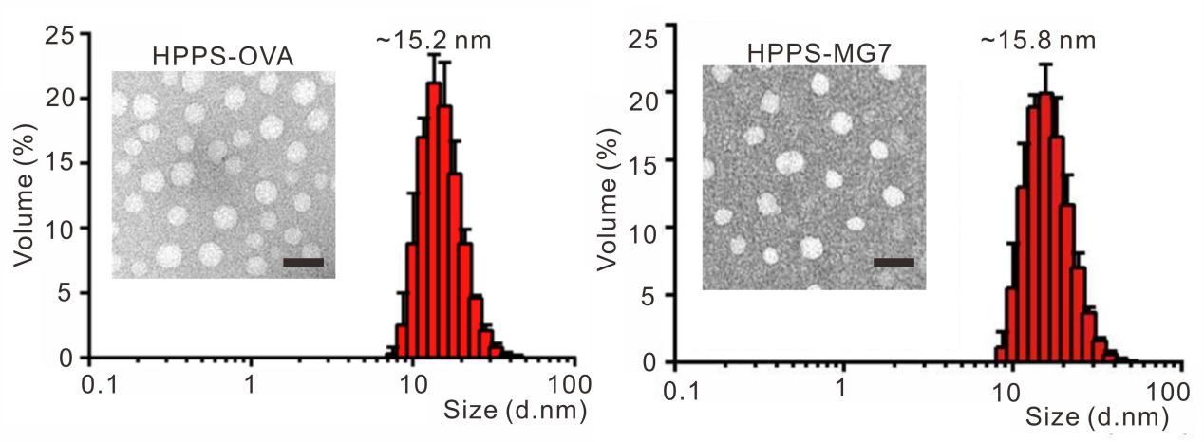
Figure S1. TEM image and DLS size distribution profile of HPPS-OVA and HPPS-MG7. Scale bar: 30 nm.

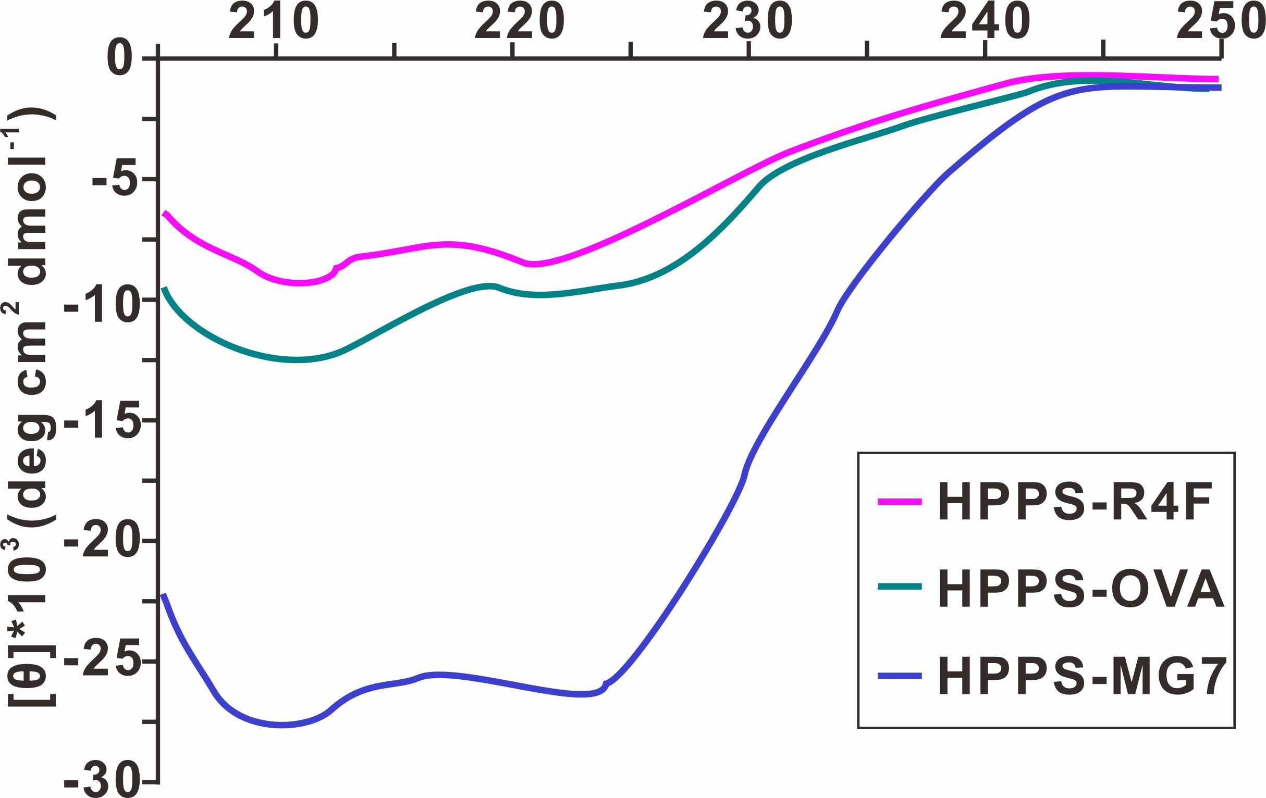
Figure S2. Circular dichroism spectra of HPPS, HPPS-OVA and HPPS-MG7 in PBS solutions.

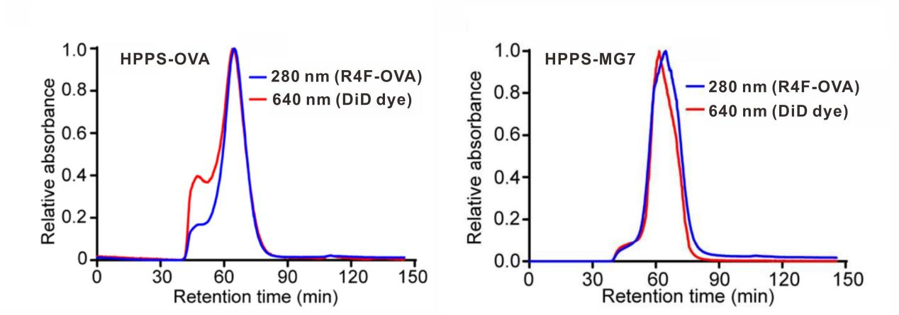
Figure S3. Representative Fast Protein liquid chromatography profile of HPPS-OVA
and HPPS-MG7.

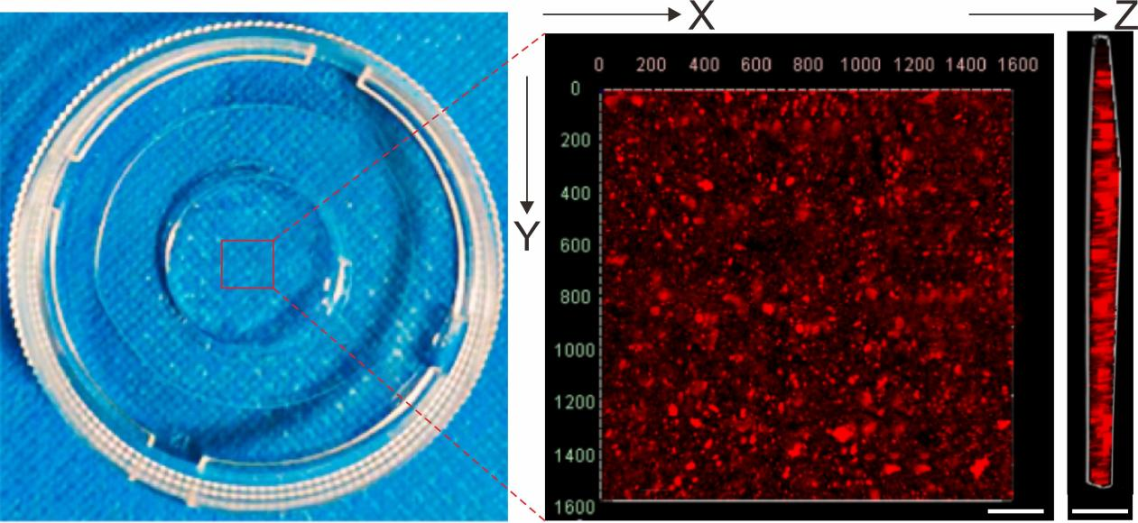
Figure S4. HPPS-AP (R4F-antigen) distribution in RMn peptide hydrogel showed by confocal microscopy, Scale bar is 100 μm.

