Supplementary material:
Sex differences in immune gene expression in the brain of a small shorebird
José O. Valdebenito^{1,2}, Kathryn H. Maher^{1,3,4}, Gergely Zachar⁵, Qin Huang⁶, Zhengwang Zhang⁴, Larry J. Young⁷, Tamás Székely^{1,2,6}, Pinjia Que⁴, Yang Liu⁶, Araxi O. Urrutia^{1,8}
¹Milner Centre for Evolution, Department of Biology and Biochemistry, University of Bath, Bath, United Kingdom
²Department of Evolutionary Zoology and Human Biology, University of Debrecen, Debrecen, Hungary
³Department of Animal and Plant Sciences, University of Sheffield, Sheffield, United Kingdom
⁴Ministry of Education Key Laboratory for Biodiversity Sciences and Ecological Engineering, College of Life Sciences, Beijing Normal University, Beijing, China
⁵Department of Anatomy, Histology and Embryology, Semmelweis University, Budapest, Hungary
⁶State Key Laboratory of Biocontrol, School of Ecology, Sun Yat-sen University, Guangzhou, China
⁷Silvio O. Conte Center for Oxytocin and Social Cognition, Center for Translational Social Neuroscience, Department of Psychiatry and Behavioral Sciences, Yerkes National Primate Research Center, Emory University, Atlanta, USA
⁸Instituto de Ecologia, Universidad Nacional Autonoma de México, Ciudad de México, México
Correspondence: José O. Valdebenito, j.valdebenito.ch@gmail.com

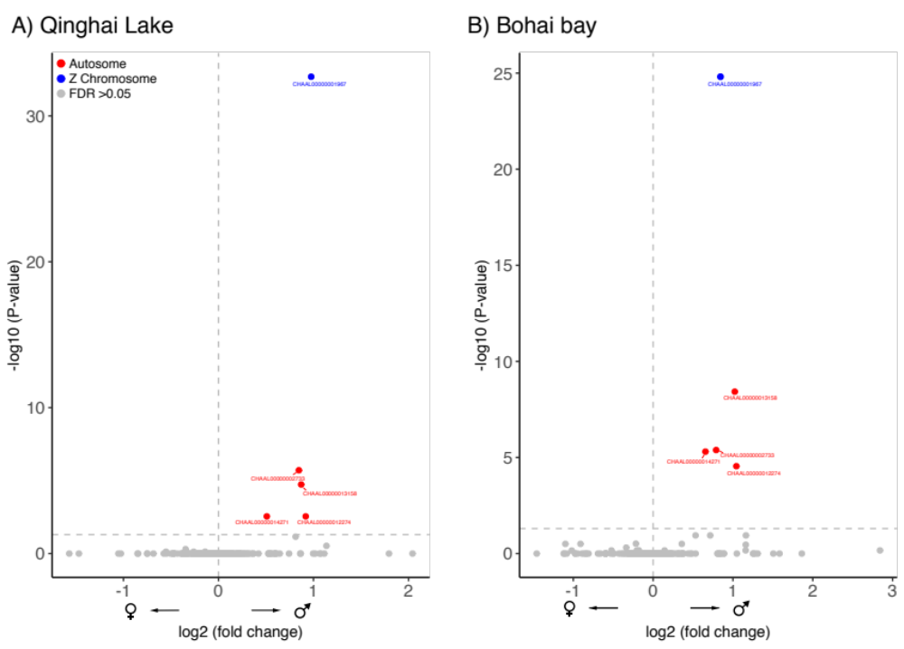
Figure S1. Differential expression of sex-biased immune genes in Qinghai Lake and Bohai Bay, China. Colours indicate chromosomal location of the differentially expressed genes. The horizontal dashed line indicates a false discovery rate (FDR) threshold of 0.05. Note that in both locations the same genes are overexpressed.
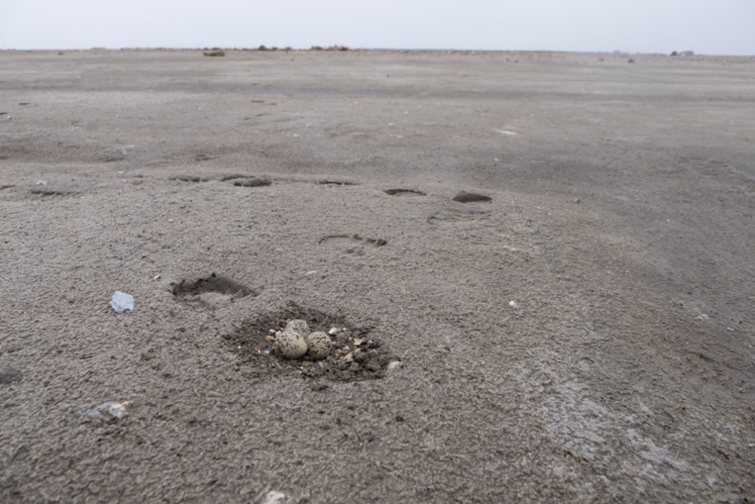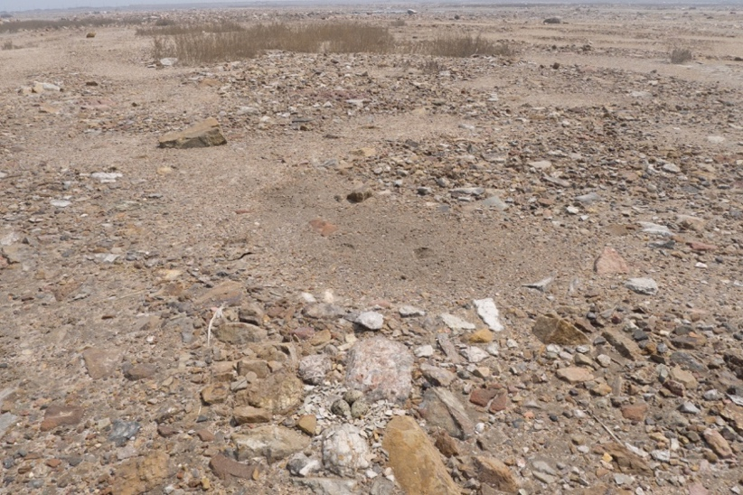
B)
A)
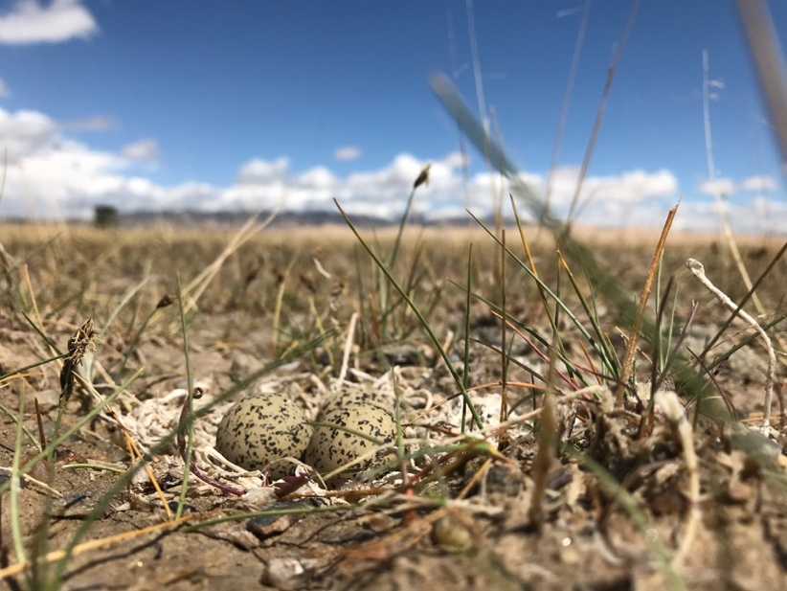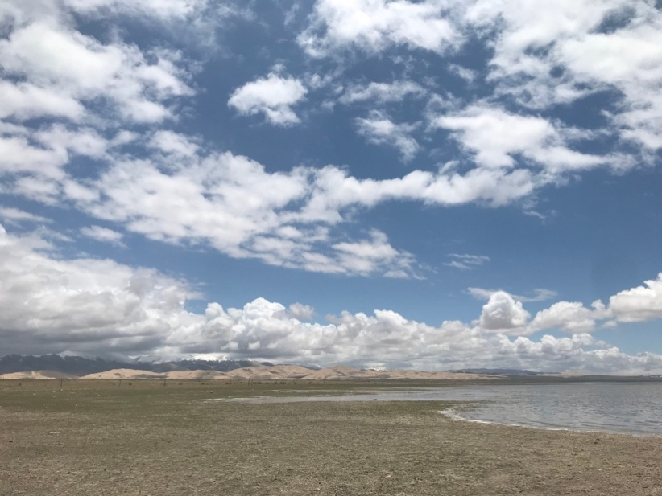
D)
C)
Figure S2. Comparison of the two environments studied. A) and B) depict two nests at Bohai Bay. C) shows a nest and D) a panoramic view of the steppe landscape at Qinghai Lake.
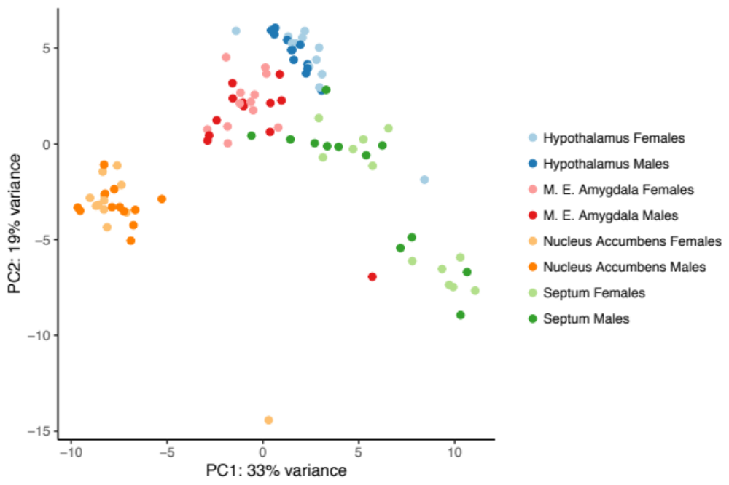
Figure S3. Principal components analysis of four brain regions sampled in Qinghai Lake and Bohai Bay, China. M. E. Amygdala = medial extended amygdala.

Table S1. Differential gene expression of 379 immune genes according to (a) sex, (b) habitat and (c) their interaction in brain tissue of Kentish plover (n = 24). P-values refer to Fisher’s exact test. The number of differentially expressed genes in each category (e.g. male- and female-biased) was obtained from their fold change (in Log2 scale) values being either positive or negative.
a) Sex | Male-biased genes | Female-biased genes | Up males | Up females | P-value
 | 165 | 214 | 10 | 1 | 0.001
b) Habitat | Bohai Bay-biased | Qinghai Lake-biased | Up Bohai Bay | Up Qinghai Lake | P-value
 | 186 | 193 | 9 | 8 | 0.807
c) Sex*habitat | Male-biased genes | Female-biased genes | Up males | Up females | P-value
Bohai Bay | 180 | 199 | 5 | 0 | 0.024
Qinghai Lake | 175 | 204 | 5 | 0 | 0.020

Table S2. Genes upregulated by sex in Kentish plover and its function according to Gene Ontology (GO).
Gene ID | Sex upregulated | Chromosomal location | GO biological functions
CHAAL00000003424 | Females | Autosome | -Macrophage activation  -T-cell differentiation in thymus  -Erythrocyte development
CHAAL00000001967 | Males | Autosome | -Activation-induced cell death of T cells  -Negative regulation of apoptotic process  -Positive regulation of apoptotic process  -T-cell differentiation in thymus  -T-cell proliferation involved in immune response  -TOR signalling  -Viral transcription  -Erythrocyte development  -G1/S transition of mitotic cell cycle  -Gastrulation  -Glucose homeostasis  -Mitotic cell cycle checkpoint  -Mitotic nuclear division  -Nuclear-transcribed mRNA catabolic process  -Nonsense-mediated decay  -Oogenesis stage  -Ribosomal small subunit biogenesis  -rRNA processing  -Placenta development  -Translational initiation  -SRP-dependent co-translational protein targeting to membrane
CHAAL00000002488 | Males | Z chromosome | -Positive regulation of lymphocyte proliferation  -Thymus development  -Spleen development
CHAAL00000002733 | Males | Z chromosome | -Immune response  -Regulation of transcription, DNA-templated  -Transcription from RNA polymerase II promoter  -Circadian rhythm
CHAAL00000007024 | Males | Z chromosome | -Leukocyte tethering or rolling
CHAAL00000007046 | Males | Z chromosome | -Haematopoietic progenitor cell differentiation
CHAAL00000012274 | Males | Z chromosome | -Innate immune response  -Negative regulation of viral transcription  -Positive regulation of NF-kappaB transcription factor activity
CHAAL00000012457 | Males | Z chromosome | -Epidermal cell differentiation  -Negative regulation of cell proliferation  -Negative regulation of cysteine-type endopeptidase activity involved in apoptotic process  -Negative regulation of heterotypic cell-cell adhesion  -Negative regulation of interleukin-8 biosynthetic process  -Negative regulation of NF-kappaB transcription factor activity  -Negative regulation of response to cytokine stimulus  -Positive regulation of nitric oxide biosynthetic process  -Positive regulation of transcription regulatory region DNA binding  -Stem cell population maintenance  -Canonical Wnt signalilng pathway  -Cellular response to growth factor stimulus  -Cellular response to laminar fluid shear stress  -Epidermis morphogenesis  -Fat cell differentiation  -Negative regulation of cell migration involved in sprouting angiogenesis  -Negative regulation of chemokine (C-X-C motif) ligand 2 production  -Negative regulation of transcription from RNA polymerase II promoter  -Positive regulation of cellular protein metabolic process  -Positive regulation of haemoglobin biosynthetic process  -Positive regulation of telomerase activity  -Positive regulation of transcription from RNA polymerase II promoter  -Post-embryonic camera-type eye development  -Post-embryonic haemopoiesis  -Regulation of axon regeneration  -Response to retinoic acid  -Transcription from RNA polymerase II promoter
CHAAL00000012612 | Males | Z chromosome | -B-cell homeostasis  -B-cell proliferation  -B-cell receptor signalling pathway  -Germinal centre formation  -Humoral immune response  -Monocyte differentiation  -Platelet formation  -Positive regulation of B-cell proliferation  -Regulation of germinal centre formation  -Regulation of megakaryocyte differentiation
CHAAL00000013158 | Males | Z chromosome | -Antigen processing and presentation
CHAAL00000014271 | Males | Z chromosome | -Cellular response to interferon-gamma  -Extrinsic apoptotic signalling pathway via death domain receptors  -Intracellular signal transduction  -Negative regulation of extrinsic apoptotic signalling pathway via death domain receptors  -Negative regulation of translation  -Positive regulation of cysteine-type endopeptidase activity involved in apoptotic process  -Protein autophosphorylation  -Regulation of N-methyl-D-aspartate selective glutamate receptor activity

Table S3. Genes upregulated by environment in Kentish plover and their function according to Gene Ontology (GO).
Gene ID | Environment upregulated | Chromosomal location | GO biological functions
CHAAL00000000238 | Bohai Bay: Coastal | Autosomes | - immune response  - inactivation of MAPKK activity  - insulin-like growth factor receptor signaling pathway  - negative regulation of apoptotic process  - peptidyl-tyrosine autophosphorylation  - phosphatidylinositol-mediated signaling  - positive regulation of cell migration  - positive regulation of DNA replication  - protein tetramerization  - regulation of JNK cascade
CHAAL00000001793 | Qinghai Lake: Tibetan plateau | Autosomes | - Dephosphorylation  - hematopoietic progenitor cell differentiation
CHAAL00000002897 | Bohai Bay: Coastal | Autosomes | - CD4-positive, alpha-beta T cell differentiation  - cellular response to calcium ion  - cellular response to drug  - establishment of protein localization to membrane  - face development  - glucose transport  - head morphogenesis  - intracellular signal transduction  - long-term synaptic potentiation  - myeloid progenitor cell differentiation  - negative regulation of endothelial cell apoptotic process  - negative regulation of fibroblast migration  - negative regulation of neuron apoptotic process  - negative regulation of synaptic vesicle exocytosis  - positive regulation of axon regeneration  - positive regulation of axonogenesis  - positive regulation of ERK1 and ERK2 cascade  - positive regulation of gene expression  - positive regulation of peptidyl-serine phosphorylation  - positive regulation of stress fiber assembly  - positive regulation of substrate adhesion-dependent cell spreading  - positive T cell selection  - protein phosphorylation  - regulation of cell proliferation  - somatic stem cell population maintenance  - thymus development  - thyroid gland development  - visual learning
CHAAL00000004570 | Qinghai Lake: Tibetan plateau | Autosomes | - apoptotic process  - cellular oxidant detoxification  - cellular response to reactive oxygen species  - hydrogen peroxide catabolic process  - mitochondrion organization  - myeloid cell differentiation  - negative regulation of cysteine-type endopeptidase activity involved in apoptotic process  - negative regulation of kinase activity  - peptidyl-cysteine oxidation  - positive regulation of cell proliferation  - positive regulation of NF-kappaB transcription factor activity  - regulation of mitochondrial membrane potential  - response to hydrogen peroxide  - response to lipopolysaccharide
CHAAL00000004722 | Bohai Bay: Coastal | Autosomes | - antral ovarian follicle growth  - cellular response to oxidative stress  - DNA damage response, signal transduction by p53 class mediator  - extrinsic apoptotic signaling pathway in absence of ligand  - glucose homeostasis  - initiation of primordial ovarian follicle growth  - negative regulation of canonical Wnt signaling pathway  - negative regulation of transcription from RNA polymerase II promoter  - neuronal stem cell population maintenance  - oocyte maturation  - ovulation from ovarian follicle  - positive regulation of erythrocyte differentiation  - positive regulation of neuron apoptotic process  - positive regulation of transcription from RNA polymerase II promoter  - regulation of neural precursor cell proliferation  - regulation of reactive oxygen species metabolic process  - regulation of translation  - transcription from RNA polymerase II promoter  - tumor necrosis factor-mediated signaling pathway
CHAAL00000005676 | Bohai Bay: Coastal | Autosomes | - adrenal gland development  - anterior/posterior pattern specification  - branching involved in ureteric bud morphogenesis  - embryonic hemopoiesis  - embryonic limb morphogenesis  - embryonic skeletal system development  - negative regulation of neuron differentiation  - negative regulation of sequence-specific DNA binding transcription factor activity  - positive regulation of cell proliferation  - positive regulation of G2/M transition of mitotic cell cycle  - positive regulation of transcription from RNA polymerase II promoter  - proximal/distal pattern formation  - regulation of ossification  - spleen development  - thymus development  - transcription from RNA polymerase II promoter
CHAAL00000008647 | Bohai Bay: Coastal | Autosomes | - blood vessel endothelial cell proliferation involved in sprouting angiogenesis  - negative regulation of Notch signaling pathway involved in somitogenesis  - negative regulation of T cell differentiation  - negative regulation of transcription from RNA polymerase II promoter  - Notch signaling pathway  - patterning of blood vessels  - positive regulation of canonical Wnt signaling pathway  - positive regulation of endothelial cell proliferation  - somite rostral/caudal axis specification
CHAAL00000008726 | Qinghai Lake: Tibetan plateau | Autosomes | - oxidation-reduction process  - regulation of erythrocyte differentiation
CHAAL00000009009 | Bohai Bay: Coastal | Autosomes | - BMP signaling pathway  - cellular response to gamma radiation  - interleukin-1-mediated signaling pathway  - motor learning  - negative regulation of canonical Wnt signaling pathway  - negative regulation of transcription from RNA polymerase II promoter  - positive regulation of transcription from RNA polymerase II promoter  - regulation of apoptotic process  - regulation of protein sumoylation  - regulation of transcription from RNA polymerase II promoter in response to hypoxia  - response to auditory stimulus  - response to glucose  - response to insulin  - skeletal muscle cell differentiation  - T cell differentiation  - transcription from RNA polymerase II promoter
CHAAL00000010987 | Qinghai Lake: Tibetan plateau | Autosomes | - cell aging  - cell proliferation  - cell surface receptor signaling pathway  - DNA damage response, signal transduction by p53 class mediator  - histone acetylation  - inflammatory response  - innate immune response  - negative regulation of cell aging  - negative regulation of cell cycle arrest  - negative regulation of cellular protein metabolic process  - negative regulation of DNA damage response, signal transduction by p53 class mediator  - negative regulation of gene expression  - negative regulation of intrinsic apoptotic signaling pathway in response to DNA damage by p53 class mediator  - negative regulation of mature B cell apoptotic process  - negative regulation of myeloid cell apoptotic process  - positive chemotaxis  - positive regulation of arachidonic acid secretion  - positive regulation of B cell proliferation  - positive regulation of chemokine (C-X-C motif) ligand 2 production  - positive regulation of cytokine secretion  - positive regulation of ERK1 and ERK2 cascade  - positive regulation of fibroblast proliferation  - positive regulation of lipopolysaccharide-mediated signaling pathway  - positive regulation of MAP kinase activity  - positive regulation of myeloid leukocyte cytokine production involved in immune response  - positive regulation of peptidyl-serine phosphorylation  - positive regulation of peptidyl-tyrosine phosphorylation  - positive regulation of prostaglandin secretion involved in immune response  - positive regulation of protein kinase A signaling  - prostaglandin biosynthetic process  - protein homotrimerization  - regulation of transcription, DNA-templated
CHAAL00000012589 | Qinghai Lake: Tibetan plateau | Autosomes | - cellular response to interleukin-4  - GMP biosynthetic process  - lymphocyte proliferation  - oxidation-reduction process
CHAAL00000013053 | Qinghai Lake: Tibetan plateau | Autosomes | - erythrocyte homeostasis  - gluconeogenesis  - glucose homeostasis  - glycolytic process  - mesoderm formation
CHAAL00000014900 | Bohai Bay: Coastal | Autosomes | - cardiac muscle cell differentiation  - cardiovascular system development  - immunoglobulin V(D)J recombination  - interleukin-21 secretion  - lung secretory cell differentiation  - motor neuron axon guidance  - negative regulation of lung goblet cell differentiation  - negative regulation of transcription from RNA polymerase II promoter  - positive regulation of cardiac muscle cell differentiation  - positive regulation of epithelial cell proliferation  - positive regulation of immunoglobulin production  - positive regulation of mesenchymal cell proliferation  - positive regulation of transcription from RNA polymerase II promoter  - pre-B cell differentiation  - regulation of cardiac muscle cell proliferation  - sarcomere organization  - skeletal muscle tissue development  - smooth muscle tissue development  - T follicular helper cell differentiation  - transcription, DNA-templated  - ventral spinal cord development
CHAAL00000014682 | Bohai Bay: Coastal | Autosomes | bone trabecula formation  canonical Wnt signaling pathway  cellular response to BMP stimulus  cellular response to estradiol stimulus  cellular response to estrogen stimulus  cellular response to fibroblast growth factor stimulus  cellular response to heparin  cellular response to hypoxia  cellular response to interleukin-1  cellular response to prostaglandin E stimulus  cellular response to starvation  cellular response to transforming growth factor beta stimulus  cellular response to tumor necrosis factor  cellular response to vitamin D  cellular response to X-ray  convergent extension involved in somitogenesis  digestive tract morphogenesis  dopaminergic neuron differentiation  dorsal/ventral axis specification  female gonad development  hematopoietic stem cell differentiation  male gonad development  midbrain morphogenesis  negative regulation of androgen receptor signaling pathway  negative regulation of B cell differentiation  negative regulation of BMP signaling pathway  negative regulation of bone remodeling  negative regulation of canonical Wnt signaling pathway involved in controlling type B pancreatic cell proliferation  negative regulation of cell growth  negative regulation of cell migration  negative regulation of epithelial cell proliferation  negative regulation of epithelial to mesenchymal transition  negative regulation of fibroblast apoptotic process  negative regulation of fibroblast proliferation  negative regulation of insulin secretion  negative regulation of JUN kinase activity  negative regulation of osteoblast differentiation  negative regulation of osteoblast proliferation  negative regulation of osteoclast differentiation  negative regulation of peptidyl-tyrosine phosphorylation  negative regulation of planar cell polarity pathway involved in axis elongation  negative regulation of transcription, DNA-templated  negative regulation of Wnt signaling pathway involved in dorsal/ventral axis specification  neural crest cell fate commitment  osteoblast differentiation  planar cell polarity pathway involved in neural tube closure  positive regulation of canonical Wnt signaling pathway  positive regulation of cell growth  positive regulation of epithelial cell proliferation  positive regulation of extrinsic apoptotic signaling pathway via death domain receptors  positive regulation of fat cell differentiation  positive regulation of fibroblast apoptotic process  positive regulation of non-canonical Wnt signaling pathway  positive regulation of smoothened signaling pathway  positive regulation of transcription, DNA-templated  prostate epithelial cord arborization involved in prostate glandular acinus morphogenesis  proteolysis  regulation of branching involved in prostate gland morphogenesis  regulation of cell cycle process  regulation of dopaminergic neuron differentiation  response to drug  somatic stem cell population maintenance  stromal-epithelial cell signaling involved in prostate gland development  ureteric bud development  Wnt signaling pathway involved in somitogenesis
CHAAL00000009359 | Qinghai Lake: Tibetan plateau | Autosomes | adherens junction assembly  anterior/posterior axis specification  bicellular tight junction assembly  bone resorption  branching involved in ureteric bud morphogenesis  canonical Wnt signaling pathway involved in negative regulation of apoptotic process  canonical Wnt signaling pathway involved in positive regulation of cardiac outflow tract cell proliferation  canonical Wnt signaling pathway involved in positive regulation of epithelial to mesenchymal transition  cell fate specification  cell maturation  cell morphogenesis involved in differentiation  cell-matrix adhesion  cellular response to growth factor stimulus  cellular response to indole-3-methanol  central nervous system vasculogenesis  chemical synaptic transmission  chromatin-mediated maintenance of transcription  cranial ganglion development  dopaminergic neuron differentiation  dorsal root ganglion development  dorsal/ventral axis specification  ectoderm development  embryonic axis specification  embryonic brain development  embryonic cranial skeleton morphogenesis  embryonic digit morphogenesis  embryonic foregut morphogenesis  embryonic forelimb morphogenesis  embryonic heart tube development  embryonic hindlimb morphogenesis  embryonic skeletal limb joint morphogenesis  endodermal cell fate commitment  endothelial tube morphogenesis  epithelial cell differentiation involved in prostate gland development  epithelial tube branching involved in lung morphogenesis  fungiform papilla formation  gastrulation with mouth forming second  genitalia morphogenesis  glial cell fate determination  hair follicle morphogenesis  hair follicle placode formation  hindbrain development  in utero embryonic development  layer formation in cerebral cortex  lens morphogenesis in camera-type eye  lung cell differentiation  lung induction  lung-associated mesenchyme development  male genitalia development  mesenchymal cell proliferation involved in lung development  metanephros morphogenesis  midbrain development  negative regulation of apoptotic signaling pathway  negative regulation of cell proliferation  negative regulation of chondrocyte differentiation  negative regulation of mesenchymal to epithelial transition involved in metanephros morphogenesis  negative regulation of mitotic cell cycle, embryonic  negative regulation of neuron death  negative regulation of oligodendrocyte differentiation  negative regulation of osteoclast differentiation  negative regulation of protein sumoylation  negative regulation of transcription from RNA polymerase II promoter  nephron tubule formation  neural plate development  neuron migration  odontogenesis of dentin-containing tooth  oocyte development  osteoclast differentiation  oviduct development  pancreas development  patterning of blood vessels  positive regulation of chromatin-mediated maintenance of transcription  positive regulation of determination of dorsal identity  positive regulation of DNA-templated transcription, initiation  positive regulation of endothelial cell differentiation  positive regulation of epithelial cell proliferation involved in prostate gland development  positive regulation of fibroblast growth factor production  positive regulation of fibroblast growth factor receptor signaling pathway  positive regulation of heparan sulfate proteoglycan biosynthetic process  positive regulation of I-kappaB kinase/NF-kappaB signaling  positive regulation of MAPK cascade  positive regulation of mesenchymal cell proliferation  positive regulation of neuroblast proliferation  positive regulation of neuron apoptotic process  positive regulation of osteoblast differentiation  positive regulation of sequence-specific DNA binding transcription factor activity  positive regulation of skeletal muscle tissue development  positive regulation of telomerase activity  positive regulation of telomere maintenance via telomerase  positive regulation of transcription from RNA polymerase II promoter  protein localization to cell surface  proximal/distal pattern formation  regulation of calcium ion import  regulation of centriole-centriole cohesion  regulation of centromeric sister chromatid cohesion  regulation of core promoter binding  regulation of euchromatin binding  regulation of myelination  regulation of nephron tubule epithelial cell differentiation  regulation of protein localization to cell surface  regulation of secondary heart field cardioblast proliferation  regulation of smooth muscle cell proliferation  regulation of T cell proliferation  renal inner medulla development  renal outer medulla development  renal vesicle formation  response to drug  response to estradiol  smooth muscle cell differentiation  sympathetic ganglion development  synapse organization  synaptic vesicle transport  T cell differentiation in thymus  thymus development  trachea formation  transcription, DNA-templated
CHAAL00000006167 | Qinghai Lake: Tibetan plateau | Autosomes | ATP hydrolysis coupled transmembrane transport  ATP metabolic process  cardiac muscle contraction  cellular calcium ion homeostasis  cellular potassium ion homeostasis  cellular sodium ion homeostasis  establishment or maintenance of transmembrane electrochemical gradient  membrane repolarization  mitophagy in response to mitochondrial depolarization  positive regulation of ATPase activity  positive regulation of calcium:sodium antiporter activity  positive regulation of defense response to virus by host  positive regulation of potassium ion import  positive regulation of potassium ion transmembrane transporter activity  positive regulation of sodium ion export from cell  potassium ion import  protein localization to plasma membrane  protein stabilization  regulation of cardiac muscle contraction by calcium ion signaling  regulation of gene expression  relaxation of cardiac muscle  sodium ion export from cell  xenophagy
CHAAL00000006574 | Bohai Bay: Coastal | Autosomes | positive regulation of activated T cell proliferation  regulation of cell growth  regulation of insulin-like growth factor receptor signaling pathway

