Table S1 ASIR per 100,000 population for cancer groups at Global and China in 2021. ASIR data from Global were used to rank the order of cancer sites excluding nonmelanoma skin cancer.
 | Global |  |  | China
Cancer Type | Rank | ASIR  per 100,00 | 95% UI | Rank | ASIR  per 100,00 | 95% UI
Lung | 1 | 26.43 | 23.9, 29.07 | 1 | 44.01 | 35.45, 53.35
Colon and rectum | 2 | 25.61 | 23.32, 27.52 | 2 | 31.44 | 25.53, 37.97
Breast | 3 | 24.56 | 22.93, 26.26 | 4 | 19.36 | 15, 24.3
Prostate | 4 | 15.37 | 14.13, 16.25 | 14 | 4.22 | 3.01, 5.73
Stomach | 5 | 14.33 | 12.23, 16.41 | 3 | 29.05 | 22.42, 36.2
Cervical | 6 | 7.79 | 7.16, 8.48 | 8 | 6.67 | 4.8, 8.72
Non-Hodgkin lymphoma | 7 | 7.14 | 6.58, 7.66 | 12 | 5.53 | 4.36, 6.68
Esophageal | 8 | 6.65 | 5.88, 7.45 | 5 | 15.04 | 12.04, 18.43
Bladder | 9 | 6.35 | 5.8, 6.85 | 13 | 5.14 | 4.08, 6.62
Liver | 10 | 6.15 | 5.58, 6.9 | 6 | 9.52 | 7.72, 11.78
Pancreatic | 11 | 5.96 | 5.39, 6.42 | 10 | 5.64 | 4.52, 6.84
Leukemia | 12 | 5.63 | 4.83, 6.17 | 7 | 7.21 | 4.93, 9.05
Uterine | 13 | 5.41 | 4.9, 5.87 | 16 | 3.35 | 2.48, 4.65
Other malignant neoplasms | 14 | 5 | 4.51, 5.49 | 11 | 5.6 | 4.35, 6.97
Lip and oral cavity | 15 | 4.88 | 4.52, 5.2 | 18 | 2.68 | 2.15, 3.3
Kidney | 16 | 4.52 | 4.26, 4.75 | 17 | 3.32 | 2.73, 3.98
Brain, central nervous system | 17 | 4.28 | 3.71, 4.88 | 9 | 6.12 | 4.76, 7.67
Malignant skin melanoma | 18 | 3.56 | 3.31, 3.75 | 24 | 0.68 | 0.37, 0.91
Ovarian | 19 | 3.48 | 3.15, 3.78 | 21 | 2.03 | 1.49, 2.69
Thyroid | 20 | 2.91 | 2.61, 3.21 | 20 | 2.47 | 1.99, 3.09
Gallbladder and biliary tract | 21 | 2.56 | 2.16, 2.89 | 19 | 2.49 | 1.71, 3.21
Larynx | 22 | 2.29 | 2.13, 2.47 | 22 | 1.79 | 1.4, 2.26
Other pharynx | 23 | 1.93 | 1.82, 2.05 | 25 | 0.56 | 0.44, 0.7
Multiple myeloma | 24 | 1.74 | 1.54, 1.89 | 23 | 0.81 | 0.52, 1.07
Nasopharynx | 25 | 1.38 | 1.22, 1.58 | 15 | 3.42 | 2.77, 4.23
Testicular | 26 | 1.12 | 1.08, 1.18 | 26 | 0.42 | 0.32, 0.53
Hodgkin lymphoma | 27 | 0.79 | 0.64, 0.94 | 27 | 0.23 | 0.14, 0.3
Mesothelioma | 28 | 0.37 | 0.35, 0.4 | 28 | 0.15 | 0.12, 0.18
Abbreviations: ASIR, age-standardized incidence rates.

Table S2 ASMR per 100,000 population for cancer groups at Global and China in 2021.ASMR data from Global were used to rank the order of cancer sites excluding nonmelanoma skin cancer.
 | Global |  |  | China
Cancer Type | Rank | ASMR  per 100,00 | 95% UI | Rank | ASMR  per 100,00 | 95% UI
Lung | 1 | 23.5 | 21.22, 25.85 | 1 | 38.98 | 31.4, 47.06
Colon and rectum | 2 | 12.4 | 11.24, 13.31 | 4 | 13.64 | 11.09, 16.31
Stomach | 3 | 11.2 | 9.62, 12.73 | 2 | 21.51 | 16.66, 26.61
Breast | 4 | 7.9 | 7.27, 8.44 | 7 | 4.4 | 3.45, 5.46
Esophageal | 5 | 6.25 | 5.53, 7 | 3 | 14.13 | 11.36, 17.18
Pancreatic | 6 | 5.95 | 5.4, 6.41 | 6 | 5.72 | 4.59, 6.91
Liver | 7 | 5.65 | 5.13, 6.3 | 5 | 8.35 | 6.8, 10.29
Prostate | 8 | 5.26 | 4.65, 5.64 | 14 | 1.99 | 1.47, 2.68
Leukemia | 9 | 3.89 | 3.34, 4.25 | 9 | 3.42 | 2.51, 4.26
Cervical | 10 | 3.44 | 3.16, 3.73 | 10 | 2.39 | 1.77, 3.08
Non-Hodgkin lymphoma | 11 | 3.19 | 2.93, 3.44 | 12 | 2.13 | 1.68, 2.57
Brain, central nervous system | 12 | 3.06 | 2.62, 3.5 | 8 | 3.63 | 2.74, 4.6
Bladder | 13 | 2.68 | 2.42, 2.93 | 11 | 2.34 | 1.89, 2.94
Other malignant neoplasms | 14 | 2.65 | 2.38, 2.88 | 13 | 2.04 | 1.6, 2.51
Lip and oral cavity | 15 | 2.42 | 2.23, 2.6 | 19 | 1.15 | 0.92, 1.42
Ovarian cancer | 16 | 2.16 | 1.95, 2.34 | 18 | 1.18 | 0.87, 1.55
Gallbladder and biliary tract | 17 | 2.04 | 1.7, 2.29 | 15 | 1.85 | 1.29, 2.4
Kidney | 18 | 1.91 | 1.78, 2.01 | 17 | 1.25 | 1.03, 1.48
Multiple myeloma | 19 | 1.37 | 1.22, 1.52 | 22 | 0.62 | 0.4, 0.81
Larynx | 20 | 1.35 | 1.26, 1.45 | 20 | 0.94 | 0.74, 1.17
Uterine | 21 | 1.14 | 1.01, 1.26 | 21 | 0.64 | 0.47, 0.88
Other pharynx | 22 | 1.13 | 1.05, 1.21 | 24 | 0.28 | 0.22, 0.35
Nasopharynx | 23 | 0.87 | 0.78, 0.97 | 16 | 1.51 | 1.23, 1.84
Malignant skin melanoma | 24 | 0.73 | 0.65, 0.79 | 25 | 0.27 | 0.14, 0.36
Thyroid | 25 | 0.53 | 0.47, 0.57 | 23 | 0.39 | 0.31, 0.47
Mesothelioma | 26 | 0.35 | 0.32, 0.38 | 26 | 0.15 | 0.12, 0.18
Hodgkin lymphoma | 27 | 0.34 | 0.25, 0.43 | 27 | 0.13 | 0.08, 0.17
Testicular | 28 | 0.14 | 0.13, 0.15 | 28 | 0.07 | 0.06, 0.09
Abbreviations: ASMR, age-standardized mortality rates.

Table S3 The burden of Lung cancer DALYs and ASDR attributable to behavioral, metabolic factors in 1990 and 2021 and percentage changes from 1990 to 2021.
Regions | Risk Factors | 1990 |  | 2021 |  | Percentage Changes, 1990-2021
Regions | Risk Factors | DALYs  (persons, 95% UI) | ASDR  (95% UI) | DALYs  (persons, 95% UI) | ASDR  (95% UI) | DALYs  (%, 95% UI) | ASDR  (%, 95% UI)
Global | Smoking
Global | Male | 16483435  (15356337,17770216) | 854.09  (796.48,920.94) | 22933513  (19793991,26526588) | 553.82  (479.27,639.64) | 39.13  (15.84,63.97) | -35.16  (-45.86,-23.86)
Global | Female | 2873528  (2617006,3137842) | 133.69  (121.53,145.86) | 4780177  (4165306,5493258) | 103.13  (89.95,118.38) | 66.35  (50.21,83.37) | -22.86  (-30.19,-15.1)
Global | Both | 19356963  (18071733,20777680) | 471.15  (438.8,505.43) | 27713689  (24404593,31596581) | 315.67  (278.19,359.86) | 43.17  (23.41,64.74) | -33  (-42.18,-22.98)
Global | Secondhand smoke
Global | Male | 1020918  (120602,1938069) | 51.88  (6.11,98.51) | 1359557  (158640,2596453) | 32.88  (3.85,62.82) | 33.17  (7.72,62.1) | -36.63  (-48.59,-22.9)
Global | Female | 577953  (76274,1045073) | 26.56  (3.5,48.03) | 996309  (135988,1907079) | 21.81  (2.98,41.75) | 72.39  (40.55,109.97) | -17.88  (-32.85,-0.17)
Global | Both | 1598871  (196922,2982788) | 38.4  (4.72,71.68) | 2355866  (290211,4442996) | 26.93  (3.32,50.83) | 47.35  (26.29,71.3) | -29.89  (-39.75,-18.58)
Global | Diet low in fruits
Global | Male | 1059479  (534061,1599532) | 53.64  (27.01,80.74) | 1097920  (566433,1597499) | 26.48  (13.66,38.5) | 3.63  (-16.18,21.38) | -50.63  (-59.88,-42.39)
Global | Female | 375897  (196209,560466) | 17.22  (8.98,25.64) | 513347  (261759,754496) | 11.26  (5.74,16.55) | 36.57  (16.5,59.96) | -34.57  (-44.06,-23.23)
Global | Both | 1435375  (721499,2119984) | 34.39  (17.24,50.7) | 1611267  (828054,2347369) | 18.46  (9.49,26.9) | 12.25  (-4.84,27.46) | -46.31  (-54.48,-39.2)
Global | High fasting plasma glucose
Global | Male | 345027  (-69880,758152) | 18.64  (-3.78,41.19) | 741593  (-147697,1701245) | 18.21  (-3.63,41.86) | 114.94  (83.27,147.91) | -2.31  (-16.36,12.07)
Global | Female | 110652  (-24011,250055) | 5.16  (-1.12,11.66) | 343430  (-68765,777315) | 7.41  (-1.48,16.77) | 210.37  (172.67,254.21) | 43.58  (26.13,63.87)
Global | Both | 455679  (-93891,1006143) | 11.33  (-2.34,25.05) | 1085023  (-216349,2493471) | 12.43  (-2.48,28.54) | 138.11  (110.18,166.37) | 9.74  (-2.98,22.46)
China | Smoking
China | Male | 4333263  (3418978,5279791) | 999.29  (795.75,1210.55) | 10488621  (7795251,13847105) | 997.59  (745.69,1311.8) | 142.05  (60.65,246.65) | -0.17  (-32.96,41.04)
China | Female | 545478  (420325,685790) | 128.46  (99.64,161.04) | 1453722  (1081203,1937566) | 128.26  (95.06,170.92) | 166.5  (87.66,276.36) | -0.16  (-29.04,38.94)
China | Both | 4878741  (3965760,5824792) | 551.47  (450.07,654.5) | 11942343  (9241436,15292270) | 545.41  (422.5,697.76) | 144.78  (71.32,240.86) | -1.1  (-30.38,36.95)
China | Secondhand smoke
China | Male | 284109  (31936,565491) | 66.47  (7.23,133.63) | 702929  (76262,1405418) | 68.42  (7.44,137.97) | 147.42  (54.97,269.93) | 2.93  (-34.34,51.51)
China | Female | 297444  (40678,550556) | 65.4  (8.96,120.79) | 656800  (89732,1262538) | 59.78  (8.19,114.91) | 120.81  (59.67,205.11) | -8.59  (-33.59,25.8)
China | Both | 581552  (72614,1097292) | 65.04  (8.06,122.56) | 1359730  (170188,2537368) | 63.32  (7.95,117.85) | 133.81  (79.24,207.91) | -2.65  (-25.05,27.32)
China | Diet low in fruits
China | Male | 352769  (167109,564172) | 78.59  (36.81,125.07) | 308391  (150699,502492) | 30.23  (14.9,49.16) | -12.58  (-45.35,34.6) | -61.53  (-75.71,-41.96)
China | Female | 162183  (80506,256472) | 35.36  (17.56,55.53) | 136650  (65606,222253) | 12.61  (6.14,20.47) | -15.74  (-43.92,20.43) | -64.35  (-76.16,-49.43)
China | Both | 514952  (252181,772460) | 56.27  (27.46,85.02) | 445041  (224120,701687) | 20.98  (10.59,32.9) | -13.58  (-38.6,19.93) | -62.72  (-73.34,-49.05)
China | High fasting plasma glucose
China | Male | 85434  (-17595,195663) | 20.55  (-4.27,46.64) | 263428  (-49601,620751) | 25.22  (-4.76,59.08) | 208.34  (102.37,346.54) | 22.73  (-19.21,73.76)
China | Female | 35916  (-7873,84090) | 8.27  (-1.82,19.27) | 123112  (-24655,287454) | 10.94  (-2.2,25.51) | 242.78  (145.75,380.05) | 32.27  (-4.54,83.84)
China | Both | 121350  (-25942,277307) | 14.1  (-3.02,32.24) | 386539  (-76908,886111) | 17.73  (-3.54,40.61) | 218.53  (136.14,320.42) | 25.71  (-6.42,64.92)
Abbreviations: DALYs, disability adjusted life years; ASDR, age-standardized DALYs rates; UI: uncertainty interval.

Table S4 Changes in Lung cancer Deaths and DALYs at Global and China levels from 1990 to 2021,decomposed by three population-level determinants:population aging,population growth and epidemiological changes.
Measure | Risk Factor | Global |  |  |  | China
Measure | Risk Factor | Overall  Difference | Aging  (Percent %) | Population  (Percent %) | Epidemiological  Change (Percent %) | Overall  Difference | Aging  (Percent %) | Population  (Percent %) | Epidemiological  Change (Percent %)
Deaths | Smoking | 457869.96 | 160788.03  (35.12) | 619020.52  (135.2) | -321938.586  (-70.31) | 337617.53 | 119854.28  (35.5) | 202144.41  (59.87) | 15618.85  (4.63)
Deaths | Secondhand smoke | 40292.42 | 16224.76  (40.27) | 45158.21  (112.08) | -21090.55  (-52.34) | 37276.19 | 17166.60  (46.05) | 18917.91  (50.75) | 1191.69  (3.2)
Deaths | Diet low in fruits | 14424.08 | 12657.90  (87.76) | 35951.28  (249.24) | -34185.10  (-237) | 1452.62 | 9124.81  (628.16) | 10640.70  (732.52) | -18312.88  (-1260.68)
Deaths | High fasting plasma glucose | 31570.29 | 7780.32  (24.64) | 18696.96  (59.22) | 5093.01  (16.13) | 12649.83 | 4911.32  (38.83) | 5086.30  (40.21) | 2652.20  (20.97)
DALYs | Smoking | 8356726.04 | 3155859.29  (37.76) | 15384409.47  (184.1) | -10183542.72  (-121.86) | 7063602.73 | 2331093.21  (33) | 4995012.71  (70.71) | -262503.19  (-3.72)
DALYs | Secondhand smoke | 756995.04 | 337977.47  (44.65) | 1175095.75  (155.23) | -756078.19  (-99.88) | 778177.1 | 342313.31  (43.99) | 478890.75  (61.54) | -43026.95  (-5.53)
DALYs | Diet low in fruits | 175891.89 | 258407.77  (146.91) | 948333.39  (539.16) | -1030849.27  (-586.07) | -69910.51 | 181482.59  (-259.59) | 282738.77  (-404.43) | -534131.87  (764.02)
DALYs | High fasting plasma glucose | 629343.61 | 148235.54  (23.55) | 422522.74  (67.14) | 58585.34  (9.31) | 265189.41 | 97280.82  (36.68) | 119153.65  (44.93) | 48754.93  (18.38)
Abbreviations: DALYs, disability adjusted life years.

Table S5 Prediction of the trend value of Lung cancer ASMR attributed to behavioral and metabolic risk factors in Male at Global and China from 2022 to 2036 using the BAPC model.
Location | Year | Smoking |  | Secondhand smoke |  | Diet low in fruits |  | High fasting plasma glucose
Location | Year | Mean | SD | Mean | SD | Mean | SD | Mean | SD
Global | 2022 | 24.403 | 0.291 | 1.428 | 0.017 | 1.116 | 0.013 | 0.877 | 0.011
 | 2023 | 24.107 | 0.421 | 1.411 | 0.026 | 1.102 | 0.02 | 0.865 | 0.016
 | 2024 | 23.805 | 0.584 | 1.394 | 0.037 | 1.088 | 0.029 | 0.854 | 0.023
 | 2025 | 23.494 | 0.77 | 1.377 | 0.05 | 1.074 | 0.039 | 0.842 | 0.031
 | 2026 | 23.175 | 0.975 | 1.359 | 0.063 | 1.059 | 0.049 | 0.83 | 0.039
 | 2027 | 22.851 | 1.195 | 1.342 | 0.078 | 1.045 | 0.061 | 0.818 | 0.048
 | 2028 | 22.526 | 1.425 | 1.324 | 0.093 | 1.03 | 0.072 | 0.806 | 0.058
 | 2029 | 22.194 | 1.662 | 1.305 | 0.109 | 1.016 | 0.085 | 0.794 | 0.067
 | 2030 | 21.856 | 1.905 | 1.287 | 0.125 | 1.002 | 0.097 | 0.782 | 0.077
 | 2031 | 21.518 | 2.153 | 1.27 | 0.142 | 0.987 | 0.11 | 0.77 | 0.087
 | 2032 | 21.183 | 2.407 | 1.252 | 0.159 | 0.973 | 0.123 | 0.758 | 0.098
 | 2033 | 20.85 | 2.664 | 1.235 | 0.176 | 0.959 | 0.137 | 0.746 | 0.108
 | 2034 | 20.515 | 2.921 | 1.217 | 0.194 | 0.945 | 0.15 | 0.734 | 0.118
 | 2035 | 20.177 | 3.178 | 1.2 | 0.212 | 0.931 | 0.164 | 0.722 | 0.129
 | 2036 | 19.845 | 3.437 | 1.184 | 0.23 | 0.918 | 0.178 | 0.711 | 0.14
China | 2022 | 46.279 | 1.205 | 3.321 | 0.117 | 1.406 | 0.029 | 1.203 | 0.03
 | 2023 | 45.941 | 1.539 | 3.296 | 0.159 | 1.382 | 0.046 | 1.163 | 0.05
 | 2024 | 45.587 | 1.978 | 3.269 | 0.201 | 1.359 | 0.066 | 1.124 | 0.074
 | 2025 | 45.217 | 2.496 | 3.243 | 0.244 | 1.335 | 0.088 | 1.087 | 0.099
 | 2026 | 44.828 | 3.076 | 3.215 | 0.292 | 1.312 | 0.112 | 1.05 | 0.126
 | 2027 | 44.422 | 3.704 | 3.186 | 0.345 | 1.287 | 0.138 | 1.015 | 0.153
 | 2028 | 44.005 | 4.37 | 3.156 | 0.403 | 1.263 | 0.164 | 0.98 | 0.18
 | 2029 | 43.58 | 5.068 | 3.125 | 0.464 | 1.24 | 0.191 | 0.947 | 0.208
 | 2030 | 43.148 | 5.792 | 3.095 | 0.529 | 1.216 | 0.219 | 0.915 | 0.235
 | 2031 | 42.708 | 6.539 | 3.065 | 0.597 | 1.192 | 0.247 | 0.884 | 0.262
 | 2032 | 42.263 | 7.305 | 3.034 | 0.668 | 1.169 | 0.275 | 0.854 | 0.288
 | 2033 | 41.817 | 8.088 | 3.003 | 0.741 | 1.145 | 0.303 | 0.825 | 0.314
 | 2034 | 41.372 | 8.885 | 2.973 | 0.815 | 1.122 | 0.332 | 0.797 | 0.339
 | 2035 | 40.928 | 9.694 | 2.943 | 0.892 | 1.099 | 0.36 | 0.771 | 0.364
 | 2036 | 40.483 | 10.513 | 2.914 | 0.969 | 1.077 | 0.388 | 0.745 | 0.387
Abbreviations: ASMR, age-standardized mortality rates; BAPC, Bayesian age-period-cohort.

Table S6 Prediction of the trend value of Lung cancer ASDR attributed to behavioral and metabolic risk factors in Male at Global and China from 2022 to 2036 using the BAPC model.
Location | Year | Smoking |  | Secondhand smoke |  | Diet low in fruits |  | High fasting plasma glucose
Location | Year | Mean | SD | Mean | SD | Mean | SD | Mean | SD
Global | 2022 | 545.063 | 7.479 | 31.917 | 0.559 | 26.216 | 0.36 | 18.12 | 0.206
 | 2023 | 536.803 | 10.155 | 31.356 | 0.724 | 25.887 | 0.515 | 17.897 | 0.305
 | 2024 | 528.362 | 13.601 | 30.792 | 0.938 | 25.553 | 0.712 | 17.67 | 0.429
 | 2025 | 519.708 | 17.57 | 30.223 | 1.187 | 25.215 | 0.938 | 17.437 | 0.571
 | 2026 | 511.024 | 21.933 | 29.668 | 1.461 | 24.878 | 1.187 | 17.201 | 0.726
 | 2027 | 502.431 | 26.613 | 29.129 | 1.756 | 24.545 | 1.453 | 16.971 | 0.894
 | 2028 | 493.96 | 31.498 | 28.601 | 2.063 | 24.217 | 1.733 | 16.746 | 1.07
 | 2029 | 485.42 | 36.518 | 28.072 | 2.379 | 23.888 | 2.025 | 16.517 | 1.253
 | 2030 | 476.748 | 41.634 | 27.542 | 2.701 | 23.559 | 2.325 | 16.284 | 1.44
 | 2031 | 468.169 | 46.85 | 27.03 | 3.03 | 23.233 | 2.632 | 16.051 | 1.632
 | 2032 | 459.881 | 52.174 | 26.544 | 3.366 | 22.914 | 2.948 | 15.828 | 1.83
 | 2033 | 451.912 | 57.566 | 26.08 | 3.706 | 22.604 | 3.269 | 15.614 | 2.032
 | 2034 | 444.054 | 62.976 | 25.622 | 4.047 | 22.296 | 3.595 | 15.401 | 2.236
 | 2035 | 436.181 | 68.376 | 25.165 | 4.388 | 21.989 | 3.923 | 15.186 | 2.442
 | 2036 | 428.491 | 73.792 | 24.728 | 4.731 | 21.687 | 4.254 | 14.972 | 2.648
China | 2022 | 990.164 | 27.946 | 67.824 | 1.694 | 30.023 | 0.885 | 25.305 | 0.726
 | 2023 | 980.3 | 33.993 | 67.139 | 2.285 | 29.514 | 1.187 | 24.749 | 1.061
 | 2024 | 970.219 | 42.033 | 66.446 | 3.056 | 29.003 | 1.574 | 24.202 | 1.481
 | 2025 | 959.954 | 51.614 | 65.749 | 3.954 | 28.488 | 2.02 | 23.666 | 1.956
 | 2026 | 949.503 | 62.392 | 65.047 | 4.949 | 27.972 | 2.505 | 23.136 | 2.468
 | 2027 | 938.946 | 74.109 | 64.345 | 6.02 | 27.455 | 3.021 | 22.619 | 3.005
 | 2028 | 928.393 | 86.548 | 63.646 | 7.153 | 26.941 | 3.558 | 22.115 | 3.562
 | 2029 | 917.874 | 99.569 | 62.953 | 8.338 | 26.43 | 4.111 | 21.624 | 4.133
 | 2030 | 907.384 | 113.079 | 62.265 | 9.567 | 25.922 | 4.675 | 21.146 | 4.713
 | 2031 | 896.939 | 127.016 | 61.587 | 10.835 | 25.416 | 5.246 | 20.679 | 5.299
 | 2032 | 886.651 | 141.336 | 60.929 | 12.141 | 24.915 | 5.822 | 20.227 | 5.89
 | 2033 | 876.658 | 155.986 | 60.297 | 13.481 | 24.424 | 6.402 | 19.792 | 6.485
 | 2034 | 866.946 | 170.925 | 59.689 | 14.851 | 23.94 | 6.981 | 19.374 | 7.081
 | 2035 | 857.441 | 186.117 | 59.098 | 16.249 | 23.461 | 7.559 | 18.97 | 7.677
 | 2036 | 848.129 | 201.545 | 58.527 | 17.673 | 22.987 | 8.132 | 18.578 | 8.271
Abbreviations: DALYs, disability adjusted life years; ASDR, age-standardized DALYs rates; BAPC, Bayesian age-period-cohort.

Table S7 Prediction of the trend value of Lung cancer ASMR attributed to behavioral and metabolic risk factors in Female at Global and China from 2022 to 2036 using the BAPC model.
Location | Year | Smoking |  | Secondhand smoke |  | Diet low in fruits |  | High fasting plasma glucose
Location | Year | Mean | SD | Mean | SD | Mean | SD | Mean | SD
Global | 2022 | 4.671 | 0.051 | 0.895 | 0.011 | 0.472 | 0.006 | 0.359 | 0.005
 | 2023 | 4.601 | 0.072 | 0.898 | 0.017 | 0.47 | 0.009 | 0.36 | 0.007
 | 2024 | 4.529 | 0.098 | 0.9 | 0.025 | 0.469 | 0.013 | 0.361 | 0.01
 | 2025 | 4.455 | 0.127 | 0.902 | 0.034 | 0.467 | 0.017 | 0.361 | 0.013
 | 2026 | 4.379 | 0.159 | 0.904 | 0.044 | 0.465 | 0.021 | 0.362 | 0.017
 | 2027 | 4.3 | 0.194 | 0.905 | 0.054 | 0.463 | 0.026 | 0.362 | 0.021
 | 2028 | 4.217 | 0.229 | 0.905 | 0.066 | 0.461 | 0.032 | 0.362 | 0.025
 | 2029 | 4.132 | 0.265 | 0.906 | 0.078 | 0.459 | 0.037 | 0.362 | 0.03
 | 2030 | 4.044 | 0.301 | 0.906 | 0.091 | 0.457 | 0.043 | 0.362 | 0.035
 | 2031 | 3.956 | 0.337 | 0.905 | 0.105 | 0.454 | 0.049 | 0.361 | 0.04
 | 2032 | 3.864 | 0.373 | 0.905 | 0.119 | 0.451 | 0.055 | 0.361 | 0.045
 | 2033 | 3.77 | 0.409 | 0.903 | 0.133 | 0.449 | 0.062 | 0.36 | 0.05
 | 2034 | 3.675 | 0.444 | 0.902 | 0.149 | 0.446 | 0.068 | 0.359 | 0.056
 | 2035 | 3.579 | 0.478 | 0.9 | 0.164 | 0.443 | 0.075 | 0.358 | 0.061
 | 2036 | 3.484 | 0.511 | 0.898 | 0.18 | 0.44 | 0.082 | 0.357 | 0.067
China | 2022 | 6.373 | 0.167 | 2.542 | 0.041 | 0.567 | 0.013 | 0.528 | 0.013
 | 2023 | 6.412 | 0.227 | 2.56 | 0.067 | 0.568 | 0.021 | 0.526 | 0.022
 | 2024 | 6.451 | 0.306 | 2.577 | 0.099 | 0.569 | 0.031 | 0.525 | 0.032
 | 2025 | 6.488 | 0.4 | 2.593 | 0.136 | 0.569 | 0.042 | 0.524 | 0.043
 | 2026 | 6.523 | 0.506 | 2.609 | 0.177 | 0.569 | 0.055 | 0.522 | 0.056
 | 2027 | 6.556 | 0.624 | 2.623 | 0.223 | 0.569 | 0.068 | 0.52 | 0.069
 | 2028 | 6.588 | 0.752 | 2.637 | 0.273 | 0.569 | 0.083 | 0.519 | 0.083
 | 2029 | 6.62 | 0.888 | 2.651 | 0.326 | 0.569 | 0.098 | 0.517 | 0.098
 | 2030 | 6.65 | 1.034 | 2.665 | 0.382 | 0.568 | 0.114 | 0.515 | 0.114
 | 2031 | 6.679 | 1.187 | 2.678 | 0.442 | 0.567 | 0.131 | 0.513 | 0.131
 | 2032 | 6.706 | 1.349 | 2.69 | 0.505 | 0.566 | 0.148 | 0.511 | 0.148
 | 2033 | 6.732 | 1.518 | 2.702 | 0.571 | 0.565 | 0.166 | 0.509 | 0.166
 | 2034 | 6.756 | 1.694 | 2.713 | 0.64 | 0.564 | 0.185 | 0.507 | 0.184
 | 2035 | 6.78 | 1.878 | 2.725 | 0.712 | 0.562 | 0.204 | 0.505 | 0.203
 | 2036 | 6.801 | 2.067 | 2.736 | 0.786 | 0.561 | 0.224 | 0.503 | 0.222
Abbreviations: ASMR, age-standardized mortality rates;BAPC, Bayesian age-period-cohort.

Table S8 Prediction of the trend value of Lung cancer ASDR attributed to behavioral and metabolic risk factors in Female at Global and China from 2022 to 2036 using the BAPC model.
Location | Year | Smoking |  | Secondhand smoke |  | Diet low in fruits |  | High fasting plasma glucose
Location | Year | Mean | SD | Mean | SD | Mean | SD | Mean | SD
Global | 2022 | 100.27 | 1.258 | 21.787 | 0.295 | 11.304 | 0.173 | 7.463 | 0.069
 | 2023 | 98.043 | 1.664 | 21.761 | 0.447 | 11.269 | 0.24 | 7.472 | 0.11
 | 2024 | 95.796 | 2.186 | 21.727 | 0.641 | 11.23 | 0.326 | 7.479 | 0.161
 | 2025 | 93.513 | 2.78 | 21.669 | 0.865 | 11.186 | 0.427 | 7.481 | 0.22
 | 2026 | 91.211 | 3.425 | 21.596 | 1.114 | 11.138 | 0.54 | 7.479 | 0.285
 | 2027 | 88.85 | 4.104 | 21.52 | 1.387 | 11.087 | 0.663 | 7.475 | 0.358
 | 2028 | 86.464 | 4.798 | 21.445 | 1.68 | 11.034 | 0.794 | 7.47 | 0.435
 | 2029 | 84.08 | 5.496 | 21.36 | 1.987 | 10.978 | 0.932 | 7.462 | 0.517
 | 2030 | 81.684 | 6.192 | 21.248 | 2.306 | 10.917 | 1.076 | 7.45 | 0.603
 | 2031 | 79.303 | 6.882 | 21.125 | 2.638 | 10.853 | 1.225 | 7.434 | 0.693
 | 2032 | 76.913 | 7.561 | 21.006 | 2.983 | 10.787 | 1.38 | 7.417 | 0.787
 | 2033 | 74.541 | 8.223 | 20.891 | 3.341 | 10.721 | 1.54 | 7.399 | 0.884
 | 2034 | 72.209 | 8.865 | 20.767 | 3.707 | 10.653 | 1.704 | 7.38 | 0.985
 | 2035 | 69.909 | 9.482 | 20.619 | 4.076 | 10.582 | 1.871 | 7.359 | 1.088
 | 2036 | 67.672 | 10.08 | 20.464 | 4.451 | 10.509 | 2.041 | 7.336 | 1.194
China | 2022 | 126.482 | 3.712 | 59.448 | 1.149 | 12.637 | 0.388 | 10.97 | 0.249
 | 2023 | 126.905 | 4.805 | 59.704 | 1.832 | 12.657 | 0.559 | 10.946 | 0.401
 | 2024 | 127.309 | 6.271 | 59.957 | 2.71 | 12.672 | 0.781 | 10.923 | 0.592
 | 2025 | 127.682 | 8.031 | 60.2 | 3.737 | 12.683 | 1.04 | 10.898 | 0.813
 | 2026 | 128.008 | 10.032 | 60.425 | 4.89 | 12.689 | 1.331 | 10.871 | 1.057
 | 2027 | 128.292 | 12.239 | 60.642 | 6.156 | 12.69 | 1.648 | 10.844 | 1.323
 | 2028 | 128.551 | 14.627 | 60.864 | 7.529 | 12.688 | 1.989 | 10.817 | 1.607
 | 2029 | 128.784 | 17.178 | 61.09 | 9.001 | 12.682 | 2.351 | 10.792 | 1.908
 | 2030 | 128.979 | 19.879 | 61.312 | 10.566 | 12.672 | 2.733 | 10.767 | 2.226
 | 2031 | 129.124 | 22.718 | 61.526 | 12.22 | 12.657 | 3.133 | 10.742 | 2.558
 | 2032 | 129.226 | 25.686 | 61.74 | 13.963 | 12.638 | 3.549 | 10.717 | 2.905
 | 2033 | 129.302 | 28.778 | 61.967 | 15.794 | 12.617 | 3.981 | 10.694 | 3.266
 | 2034 | 129.356 | 31.985 | 62.205 | 17.71 | 12.591 | 4.427 | 10.673 | 3.64
 | 2035 | 129.381 | 35.3 | 62.444 | 19.709 | 12.562 | 4.886 | 10.654 | 4.027
 | 2036 | 129.373 | 38.717 | 62.682 | 21.789 | 12.529 | 5.357 | 10.635 | 4.426
Abbreviations: DALYs, disability adjusted life years; ASDR, age-standardized DALYs rates; BAPC, Bayesian age-period-cohort.

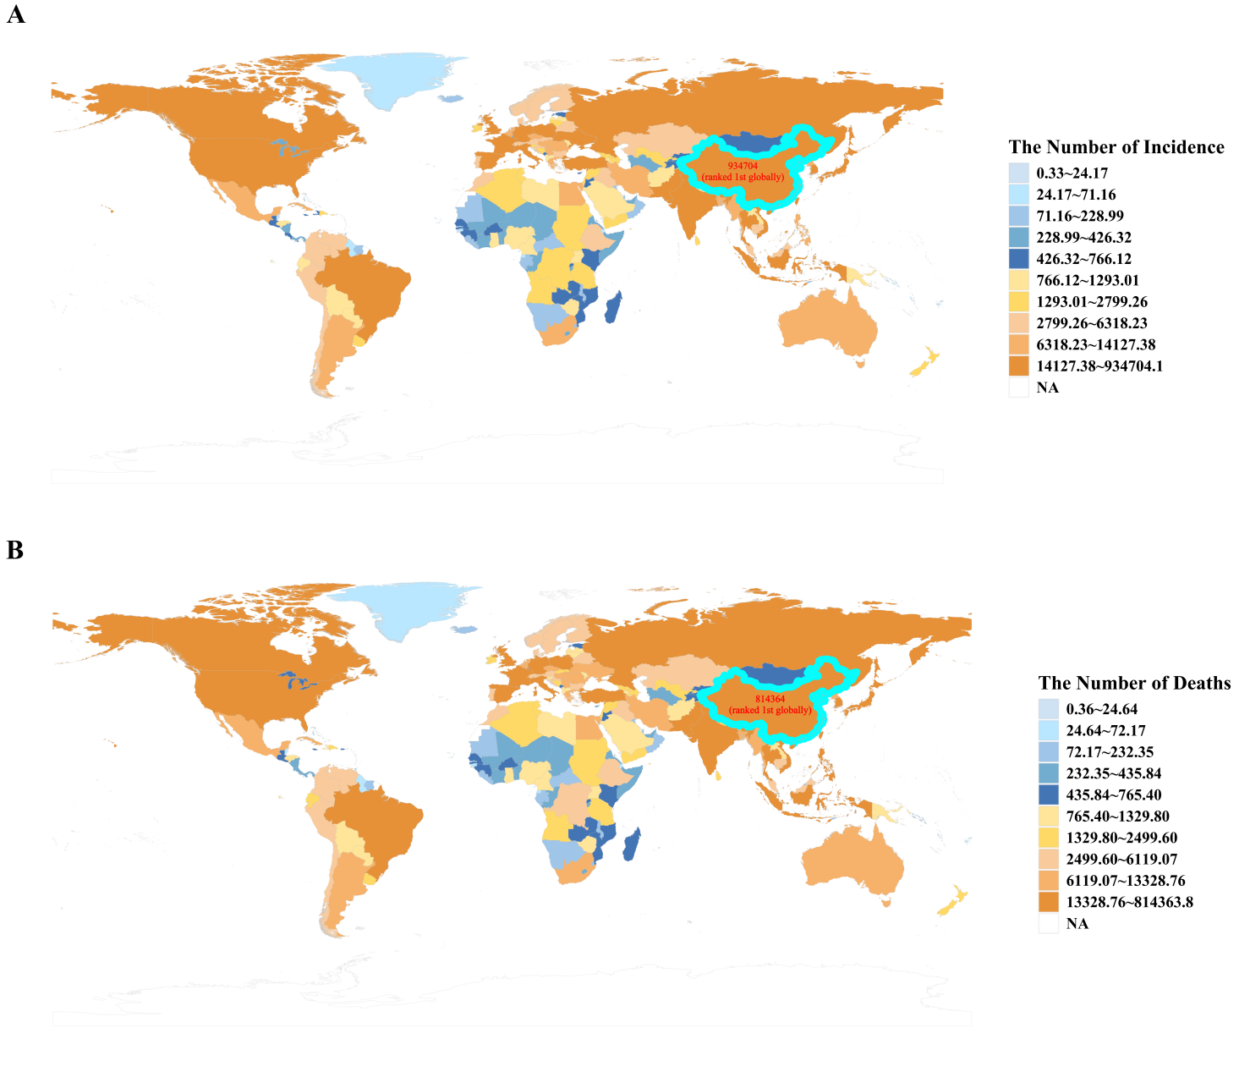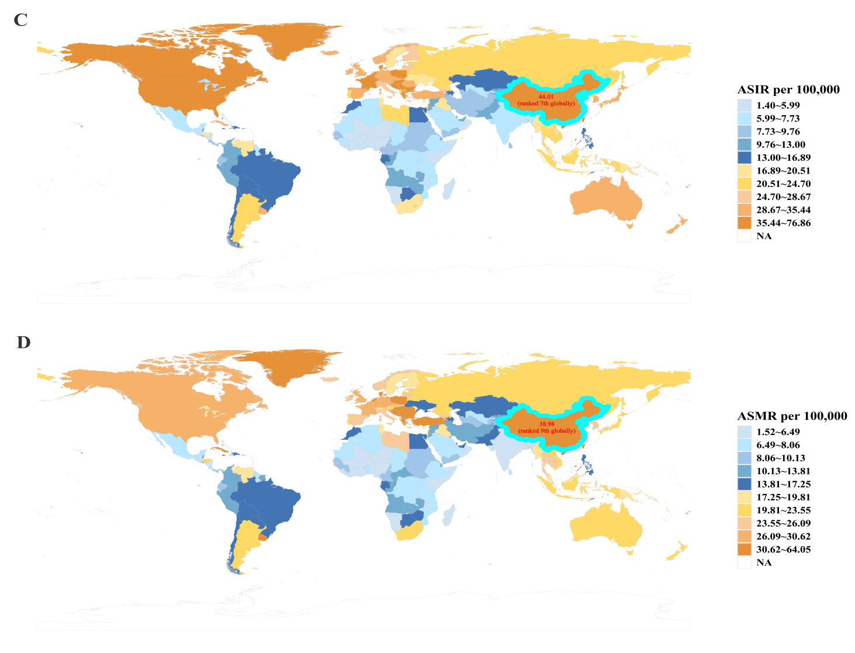
Figure S1 The global disease burden of Lung cancer in 204 countries and territories. (A)The Number of Incidence; (B)The Number of Deaths; (C)ASIR; (D)ASMR. Abbreviations:ASIR, age-standardized incidence rates; ASMR, age-standardized mortality rates.

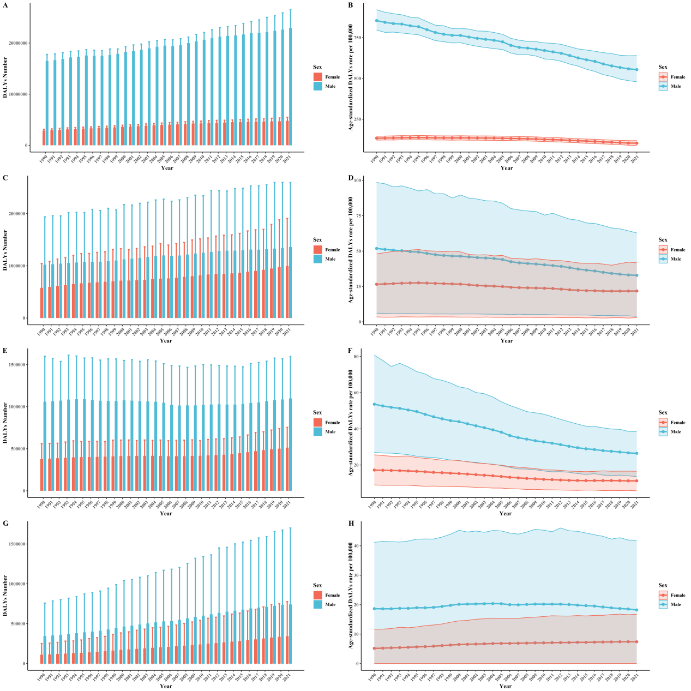
Figure S2 Disease burden of Lung cancer DALYs and ASDR in male and female attributable to behavioral and metabolic risks at Global from 1990 to 2021. (A)the DALYs attributable to smoking; (B)the ASDR attributable to smoking; (C)the DALYs attributable to secondhand smoke; (D)the ASDR attributable to secondhand smoke; (E)the DALYs attributable to diet low in fruits; (F)the ASDR attributable to diet low in fruits; (G)the DALYs attributable to high fasting plasma glucose; (H)the ASDR attributable to high fasting plasma glucose.
Abbreviations:DALYs, Disability adjusted life years; ASDR, age-standardized DALYs rates.

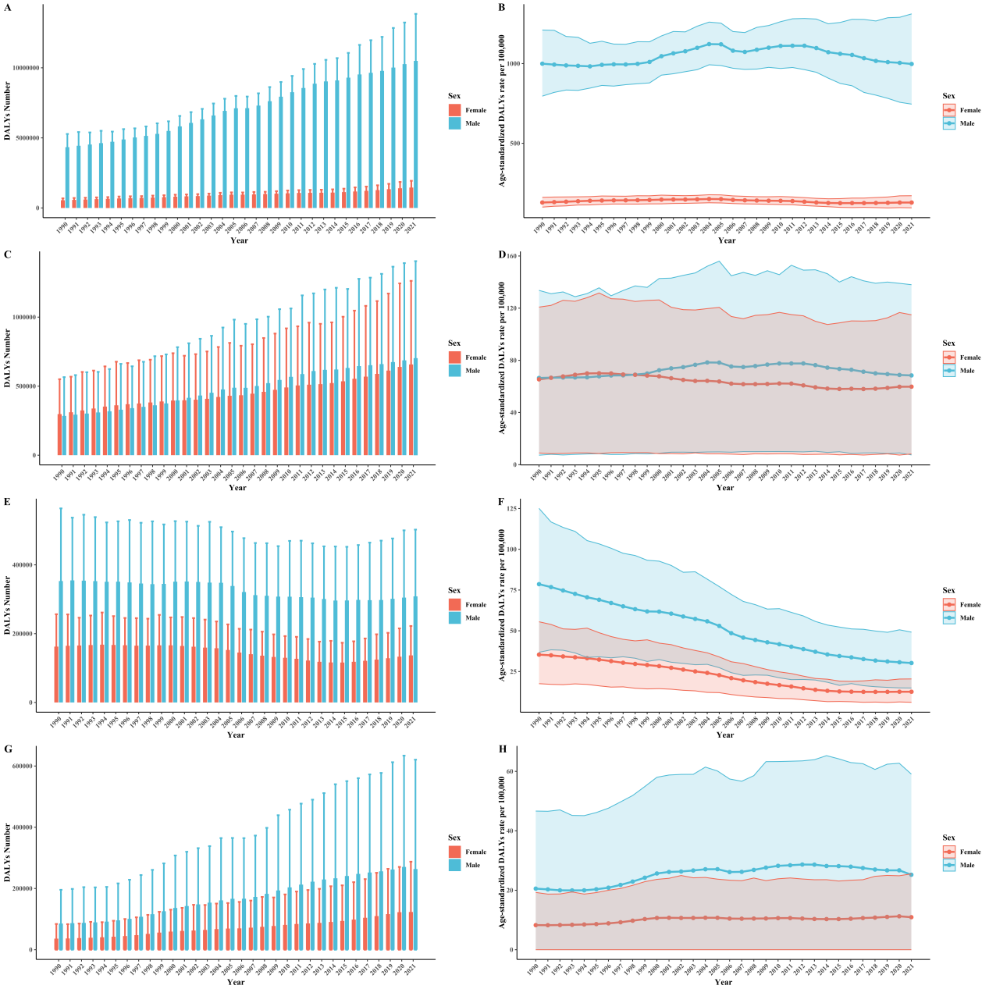
Figure S3 Disease burden of Lung cancer DALYs and ASDR in male and female attributable to behavioral and metabolic risks in China from 1990 to 2021. (A)the DALYs attributable to smoking; (B)the ASDR attributable to smoking; (C)the DALYs attributable to secondhand smoke; (D)the ASDR attributable to secondhand smoke; (E)the DALYs attributable to diet low in fruits; (F)the ASDR attributable to diet low in fruits; (G)the DALYs attributable to high fasting plasma glucose; (H)the ASDR attributable to high fasting plasma glucose.
Abbreviations:DALYs, Disability adjusted life years; ASDR, age-standardized DALYs rates.

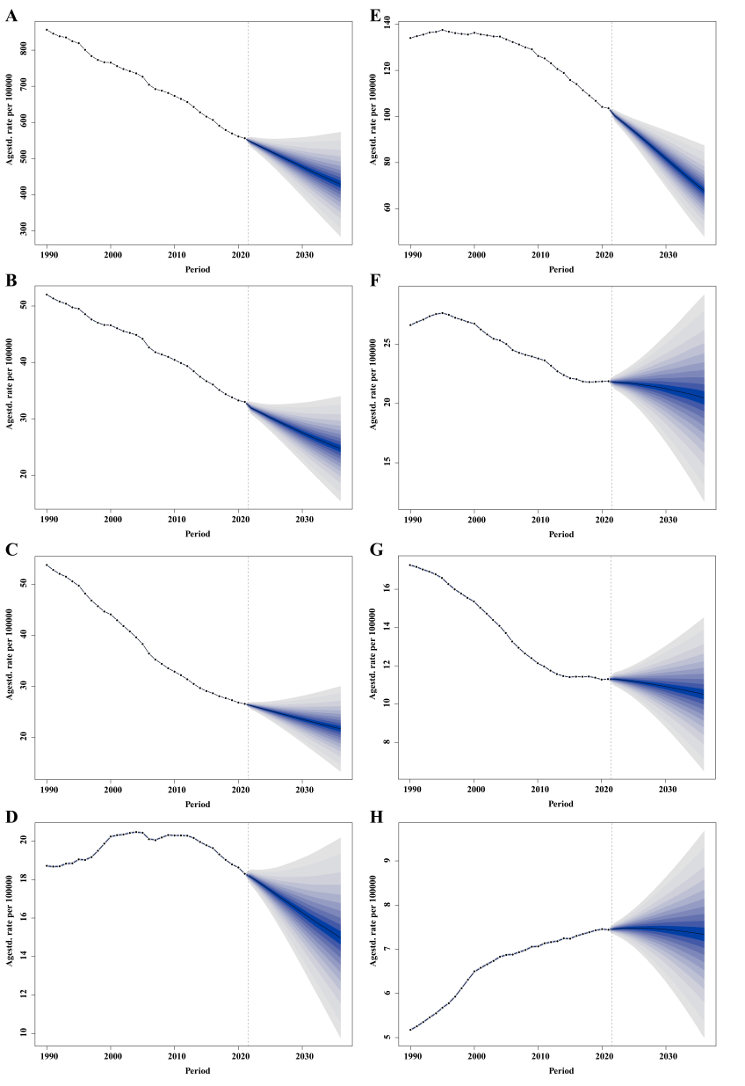
Figure S4 Observed and predicted trends of Lung cancer ASDR attributable to behavioral and metabolic risks in male and female at global from 2022 to 2036 using the BAPC model. (A)Smoking in male; (B)Secondhand smoke in male; (C)Diet low in fruits in male; (D)High fasting plasma glucose in male; (E)Smoking in female; (F)Secondhand smoke in female; (G)Diet low in fruits in female; (H)High fasting plasma glucose in female.
Abbreviations: DALYs, disability adjusted life years; ASDR, age-standardized DALYs rates; BAPC, Bayesian age-period-cohort.
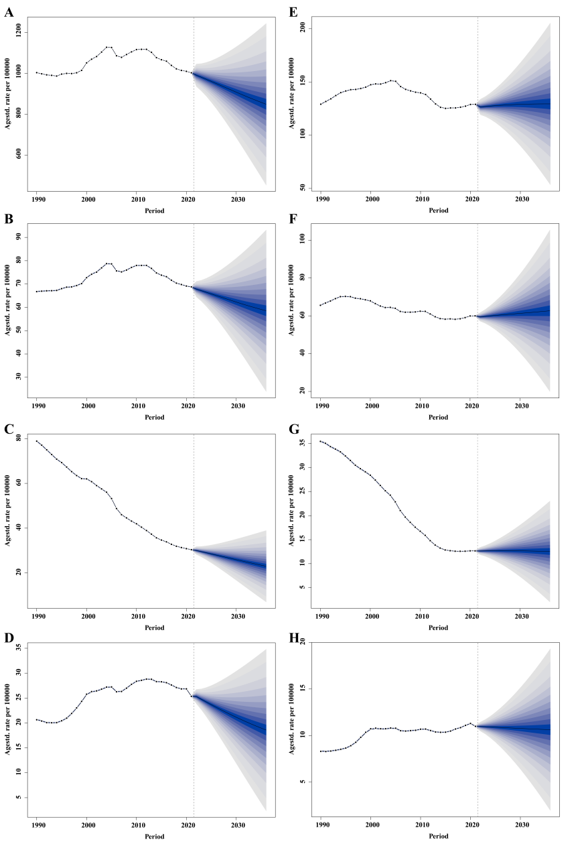
Figure S5 Observed and predicted trends of Lung cancer ASDR attributable to behavioral and metabolic risks in male and female in China from 2022 to 2036 using the BAPC model. (A)Smoking in male; (B)Secondhand smoke in male; (C)Diet low in fruits in male; (D)High fasting plasma glucose in male; (E)Smoking in female; (F)Secondhand smoke in female; (G)Diet low in fruits in female; (H)High fasting plasma glucose in female.
Abbreviations: DALYs, disability adjusted life years; ASDR, age-standardized DALYs rates; BAPC, Bayesian age-period-cohort.

