Supplementary Information
Supplementary Figures
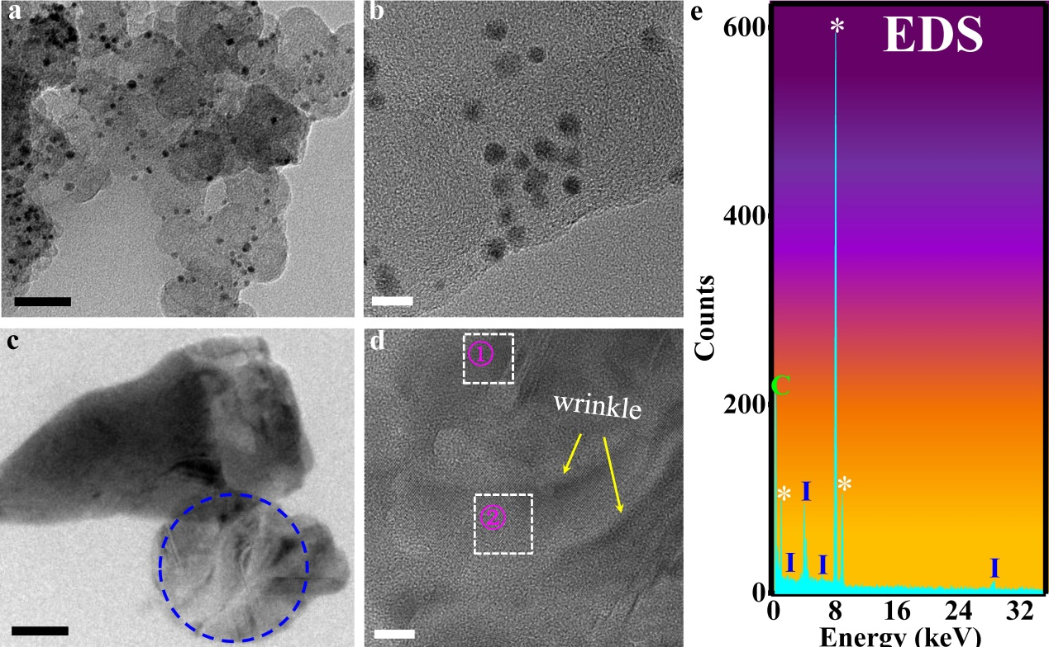
Supplementary Fig. 1 TEM images of GQDs and liquid-phase catalytic graphene, and energy dispersive spectroscopy (EDS) characterization of graphene. a TEM image of GQDs (scale bar, 50 nm). b High resolution TEM image of GQDs (scale bar, 5 nm). c TEM image of graphene flakes produced by the liquid-phase catalytic method (scale bar, 50 nm). d The high resolution TEM image of the graphene flakes exhibiting wrinkles (scale bar, 10 nm). e EDS measurement of region ② in Fig. 2a. Iodine element was presented in the graphene solution. The white * in the EDS spectrum represent copper element from the TEM support grids.
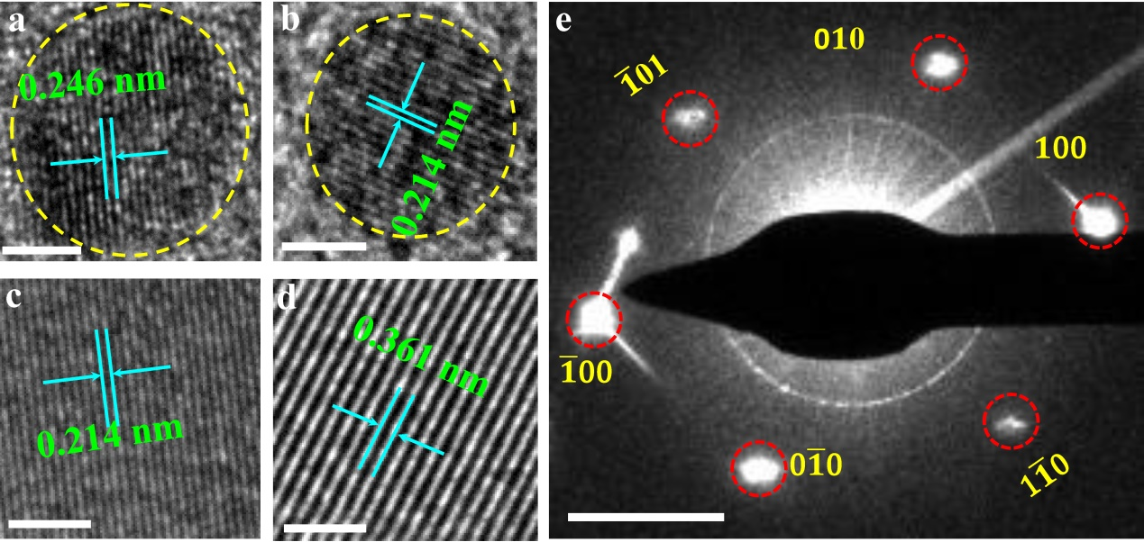
Supplementary Fig. 2 TEM images of GQDs and structural characterization of liquid-phase catalytic graphene. a and b High-resolution TEM images of GQDs with lattice spacing of 0.246 nm and 0.214 nm, respectively, which are characteristic spacing of graphene (scale bar, a and b, 2 nm). c and d Local amplification images of region ① and ② in Supplementary Fig. 1d, which show the lattice fridges of graphene flakes. The spacing of 0.214 nm and 0.361 are characteristic spacing of graphene at in-plane and c-axial directions respectively. This indicates that the graphene flakes prepared by liquid-phase catalysis is of layered structure (scale bar, c and d, 2 nm). e Selective area electron diffraction (SAED) pattern from the blue dotted circle area in Supplementary Fig. 1c. The hexagonal pattern is the characteristic diffraction spots of graphene, suggesting that the liquid-phase catalytic graphene exhibited excellent crystallinity (scale bar, 2 1/nm).
.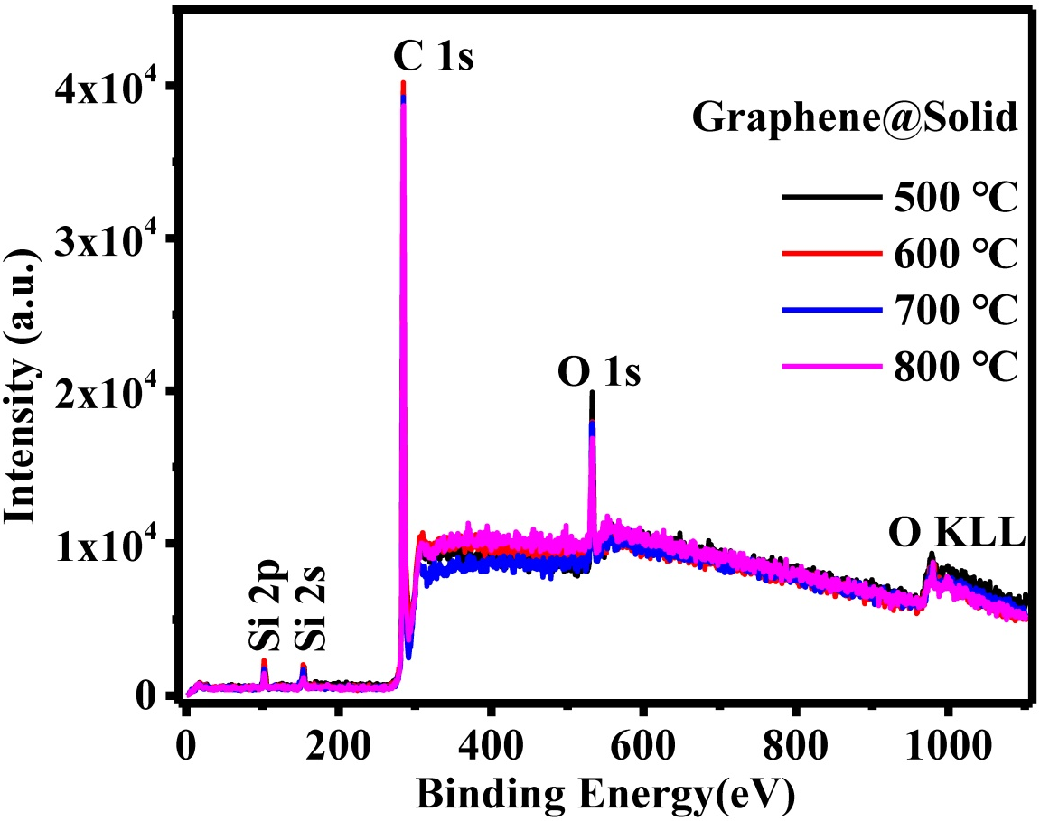
Supplementary Fig. 3 XPS full spectra of solid graphene films annealed at different temperatures (500℃,600℃,700℃ and 800℃). Iodine was not found on the graphene film after the annealing treatment, which had successfully removed the catalyst.

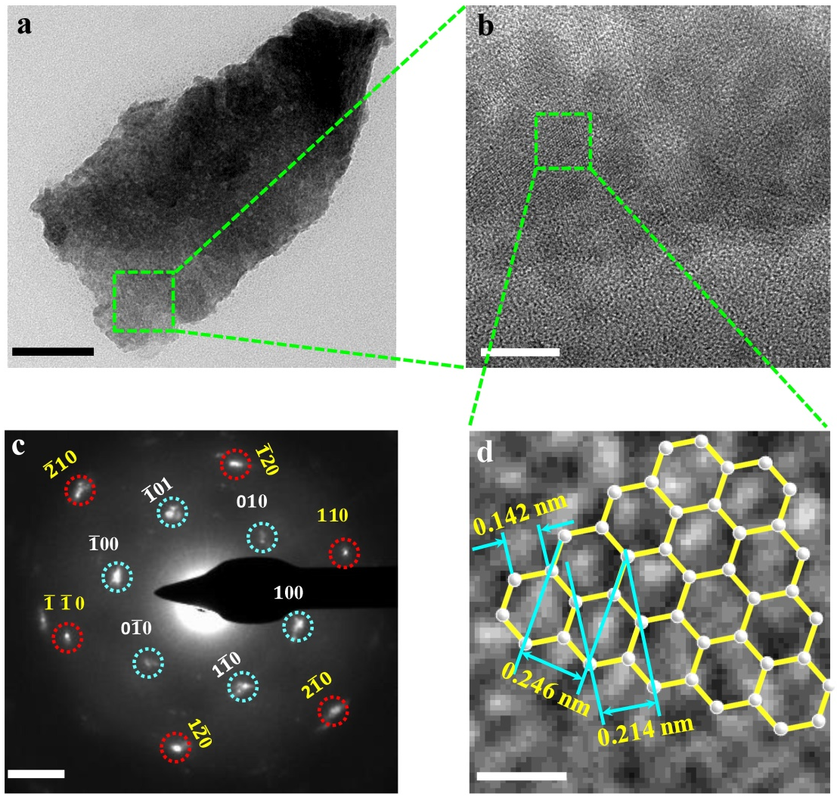
Supplementary Fig. 4 TEM characterization of solid graphene film prepared by annealing at 600℃. a TEM image of graphene film, which exhibited layered structure and good homogeneity (scale bar, 100 nm). b An enlarged TEM image of the green square area in Fig. a revealing good crystallinity at the graphene film (scale bar, 10 nm). c Selective area electron diffraction (SAED) pattern from the green square region in Fig. a and a hexagonal pattern demonstrated good crystallinity and homogeneity of the graphene film (scale bar, 2 1/nm). d High-resolution TEM image on the green square area of Fig. b. The white dots show the honeycomb-shaped graphene structure consisting of six carbon atoms, as shown in the inset (scale bar, 0.5 nm).

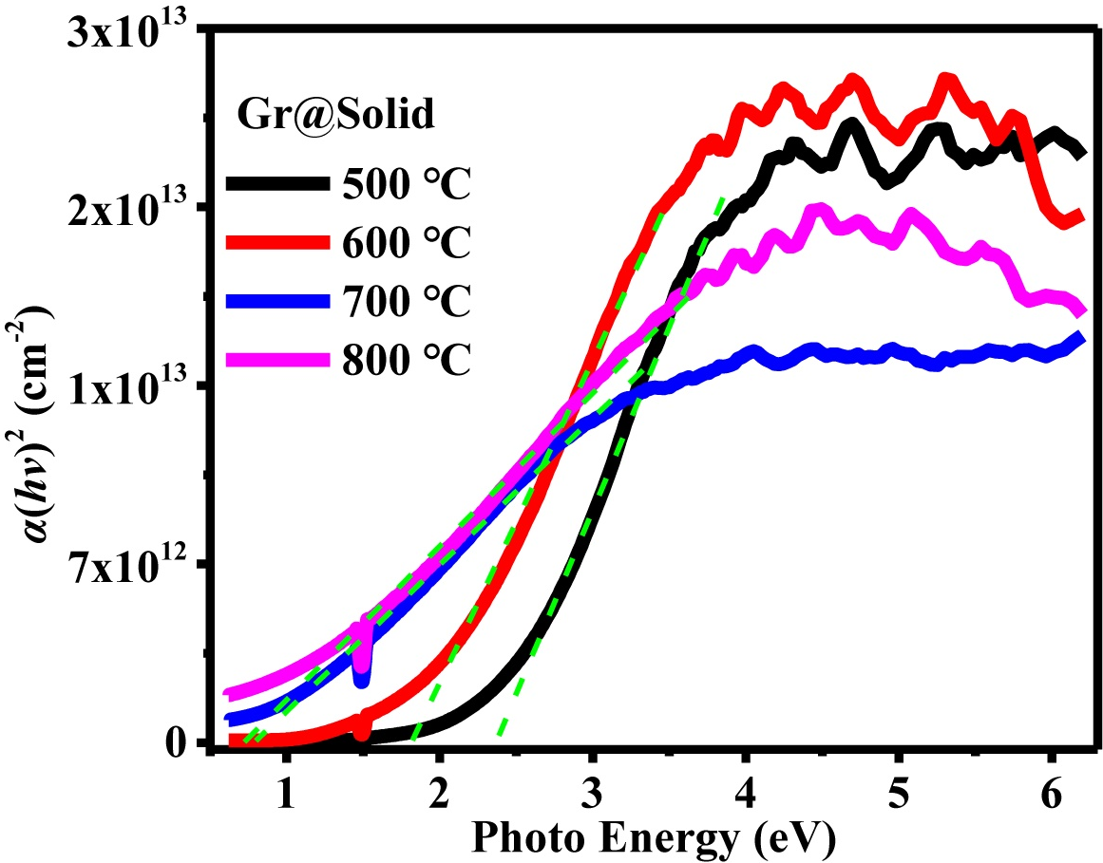
Supplementary Fig. 5 Plots of optical absorption against photon energy of solid graphene film annealed at different temperatures (500℃, 600℃, 700℃ and 800℃). Optical absorption coefficient and optical bandgap of the graphene film was calculated using the plots. The plots also show bandgap modulation of the film due to different annealing temperatures.
Supplementary Fig. 6 Performance of photodetector based on liquid-phase catalytic graphene under light illumination by LEDs with different wavelength (365-940 nm) at certain power density. a and b The detectivity and responsivity vs applied voltage curves of the photodetector, respectively.
Supplementary Table 1. Parameters used in the calculation of the optical bandgap from the plots in Supplementary Fig 5.
Annealing Temperature(℃) | Intercept | Slope | Optical gap (eV)
500  600  700  800 | -5.013  -4.123  -0.820  -0.742 | 2.282  2.308  1.061  1.101 | 2.20  1.78  0.77  0.67

Supplementary Notes
Samples preparation for TEM characterization
TEM characterization on Gr@solid: The Gr@solid was etched using HF solution, and the sample was separated from substrate in deionized water. Finally, the sample was coated on the copper nets without the use of carbon thin film for measurement.
TEM characterization on precursor solution: The solution was mixed with a mixture of alcohol and deionized water (having a volume ratio of 10:3). The final mixture has a volume ratio 13:2 of precursor solution and alcohol-water mixture. It was drop-casted on the copper nets with carbon thin film for measurement.
Supplementary Discussion
The relationship between the absorption and absorption coefficient of the material is as follows:
A= α · c · d (1)
where A is absorption, α is absorption coefficient, c is concentration and d is thickness. The concentration (c) of the solid graphene film was denoted as 1. The thickness of the film was obtained from the AFM measurement in Fig. 3b. Thus the relationship between absorption coefficient and wavelength can be calculated from the UV-Visible-near-infrared absorption spectroscopy, where wavelength (λ) = 1240 (nm)/hν.
Considering graphene is a direct bandgap material, the optical bandgap (E_{g}) of the material can be calculated if the photon energy (hν)≥E_{g} using equation (2).

α( hν ) =C ( hν-E_{g} )^{1/2} (2)

where, C is a constant, α is absorption coefficient and hν is photon energy.

