Supplementary
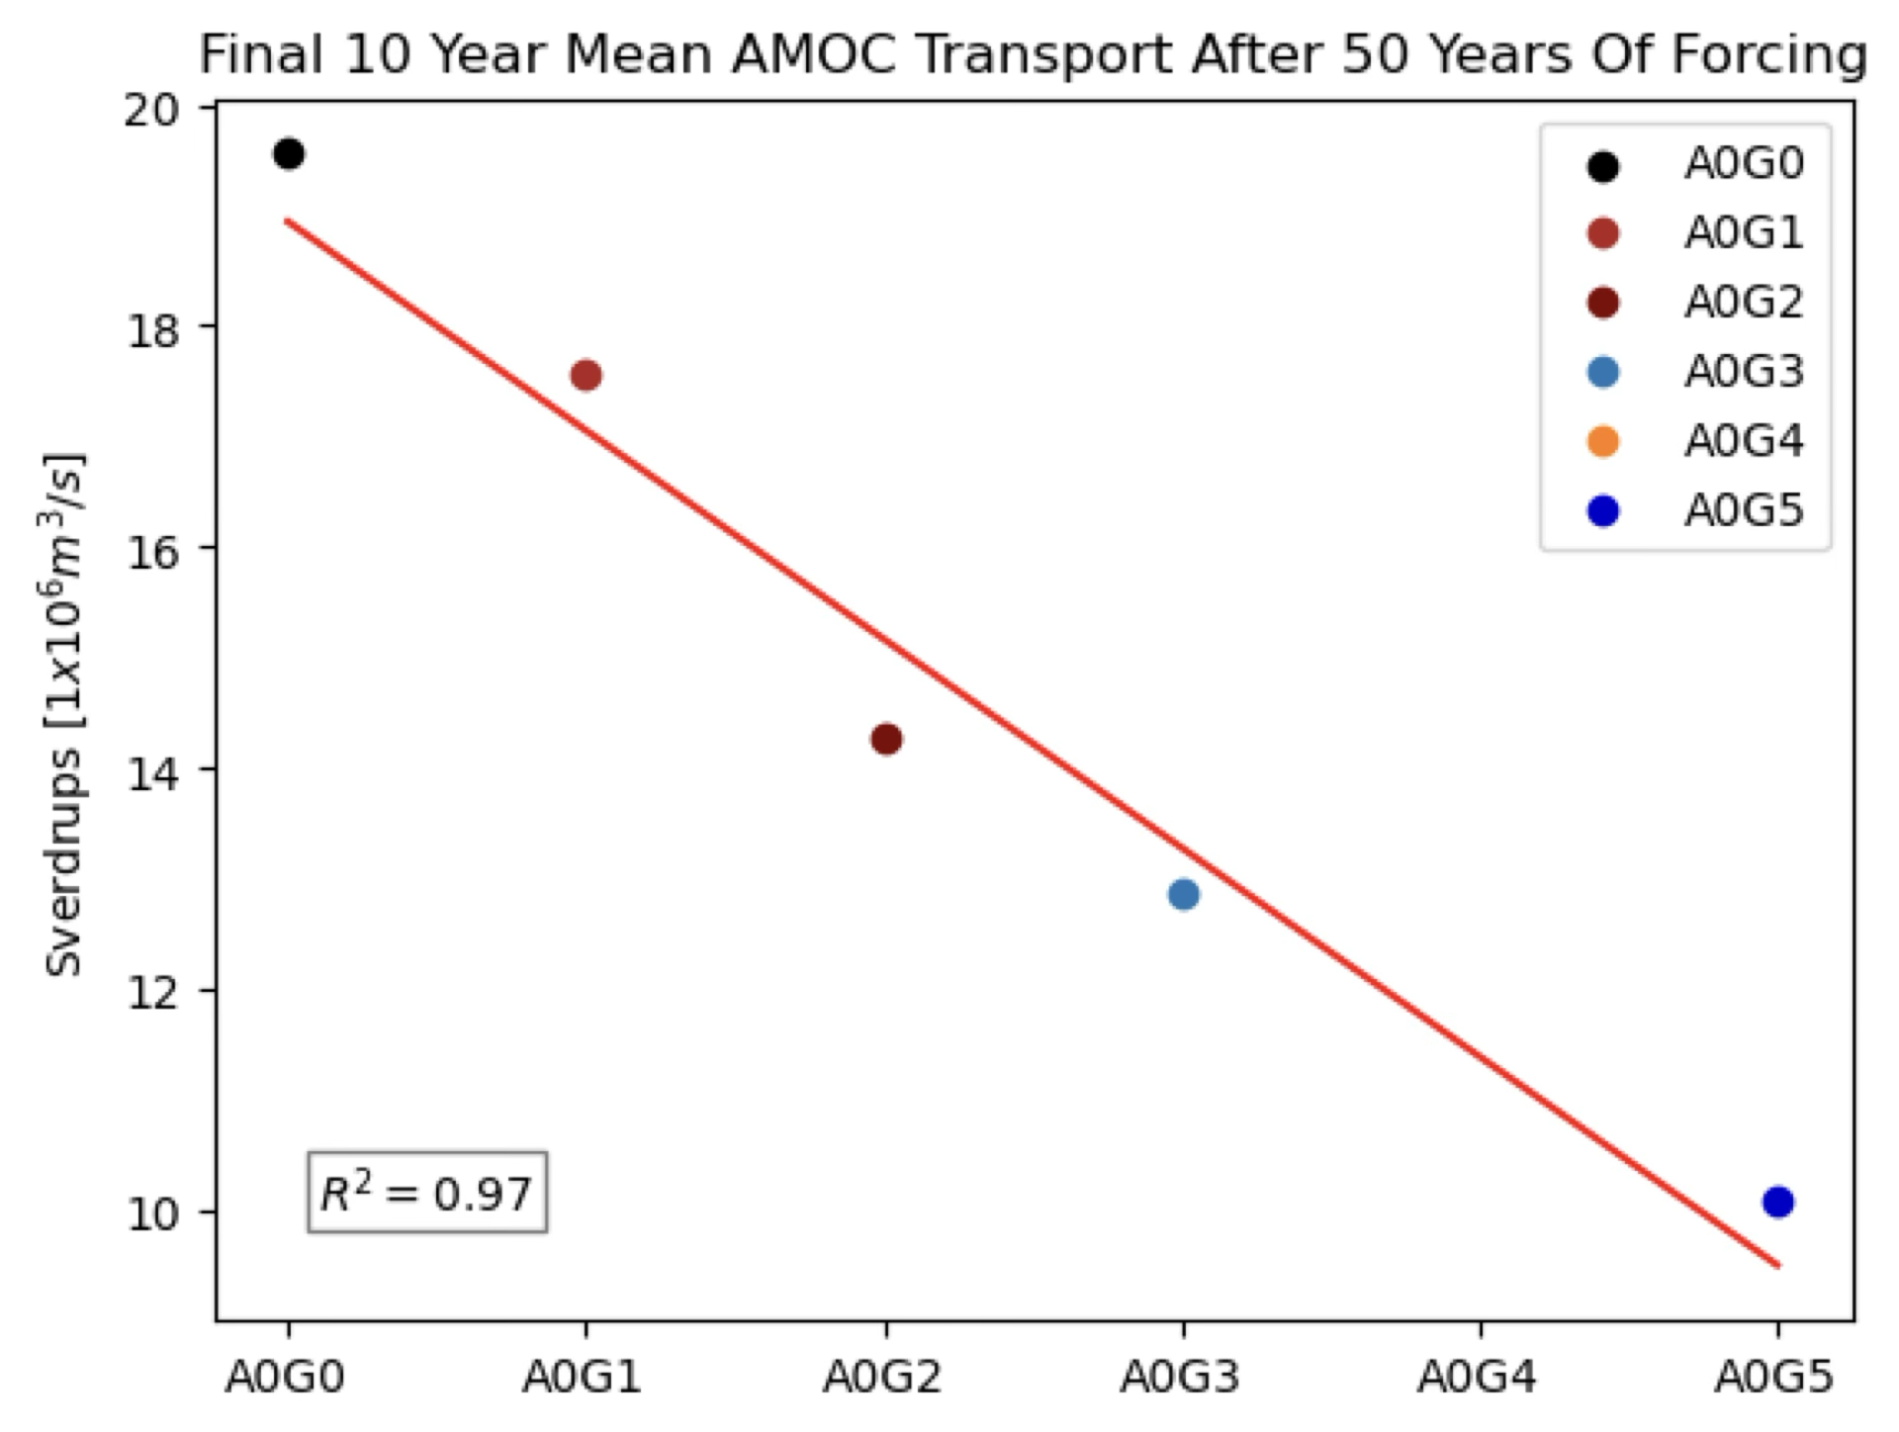
Figure S1: Final ten year mean of AMOC transport at 26ºN caused by increasing Greenland freshwater discharge from 1000Gt/yr to 5000 Gt/yr (G1-G5) Note that the black dot is the Control. A linear regression through the means gives an R²=0.97.

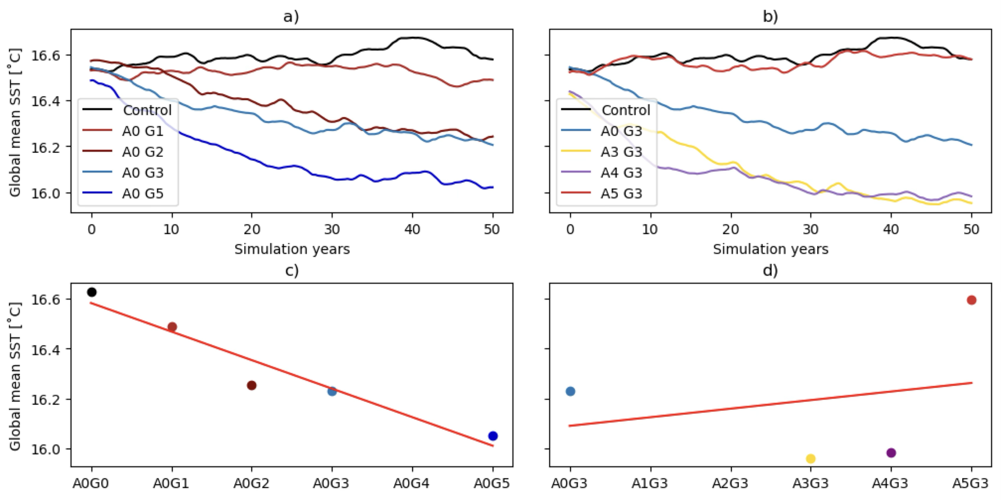
Figure S2: Panels a-b: 10 year rolling mean of global mean Sea Surface Temperature. Pannel a: Simulations with increasing Greenland FWF at 1000Gt/yr, G0-G5 (1-5000Gt/yr) holding Antarctic FWF off. Pannel b: simulations holding Greenland FWF constant at 3000Gt/yr (G3) and increasing Antarctic FW at 1000Gt/yr, A0-A5 (1-5000Gt/yr). Panels c and d: Final ten year mean of global mean SST for a/b respectively, a linear regression through the means yields an R²=0.93 /0.06, note the shared x axis and A0G0 is the mean of the Control.

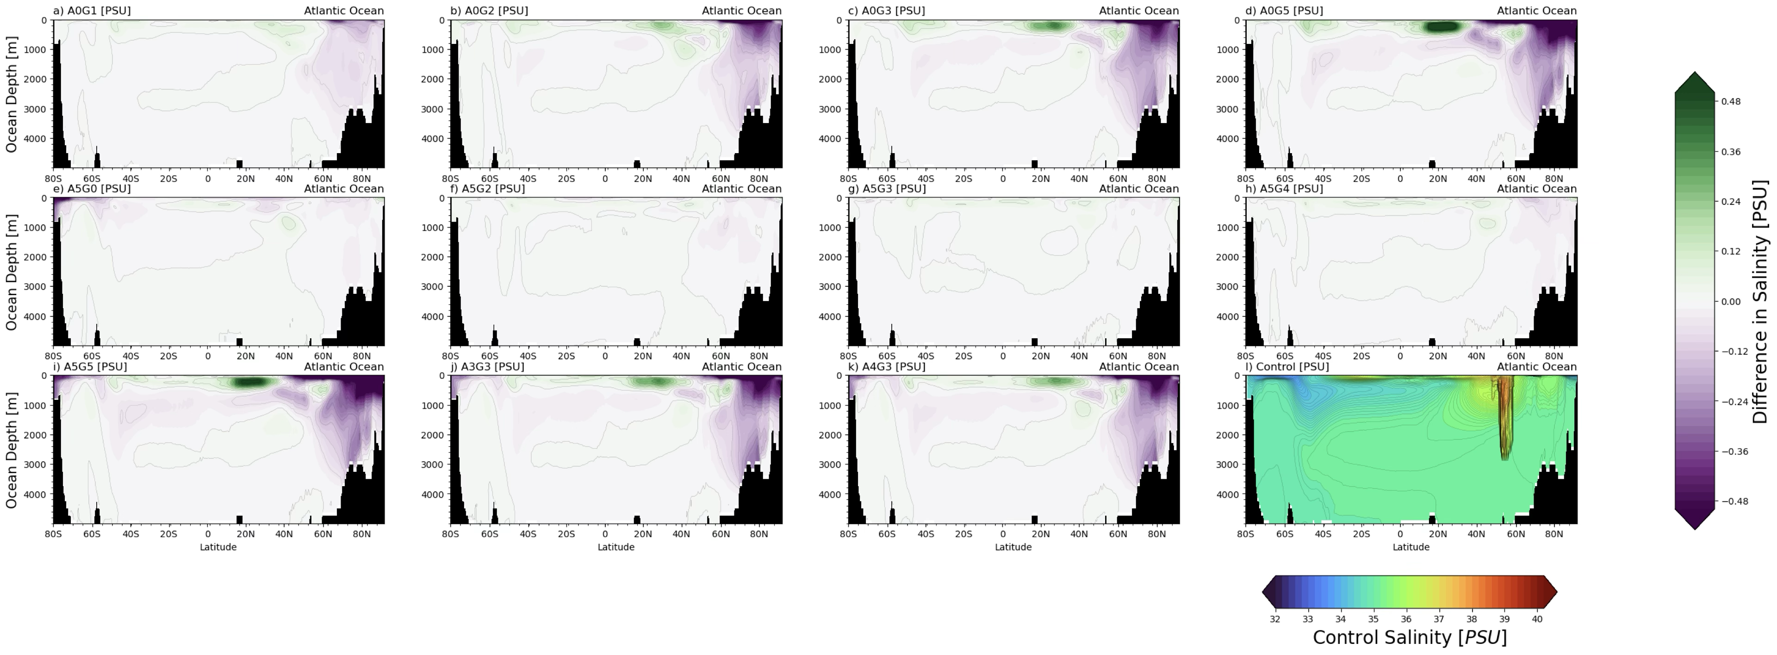
Figure S3: Average salinity anomaly plots of simulations found in figure 1. Pannels A-D) effect of increasing Greenland fresh water forcing at intervals of 1000Gt/yr (G1-5) whilst Antarctic forcing is off (A0). Pannels E-I) Holding Antarctic forcing constant at 5000 Gt/yr (A5) and increasing Greenland forcing from 0-5000Gt/yr (G0-5). Pannels E-H) AMOC remains stable in spite of forcing. Pannels J and K) holding Greenland forcing constant at 3000Gt/yr (G3) and increasing Antarctic forcing from 3000-4000Gt/yr (A3-4). Pannel L) Control simulation.

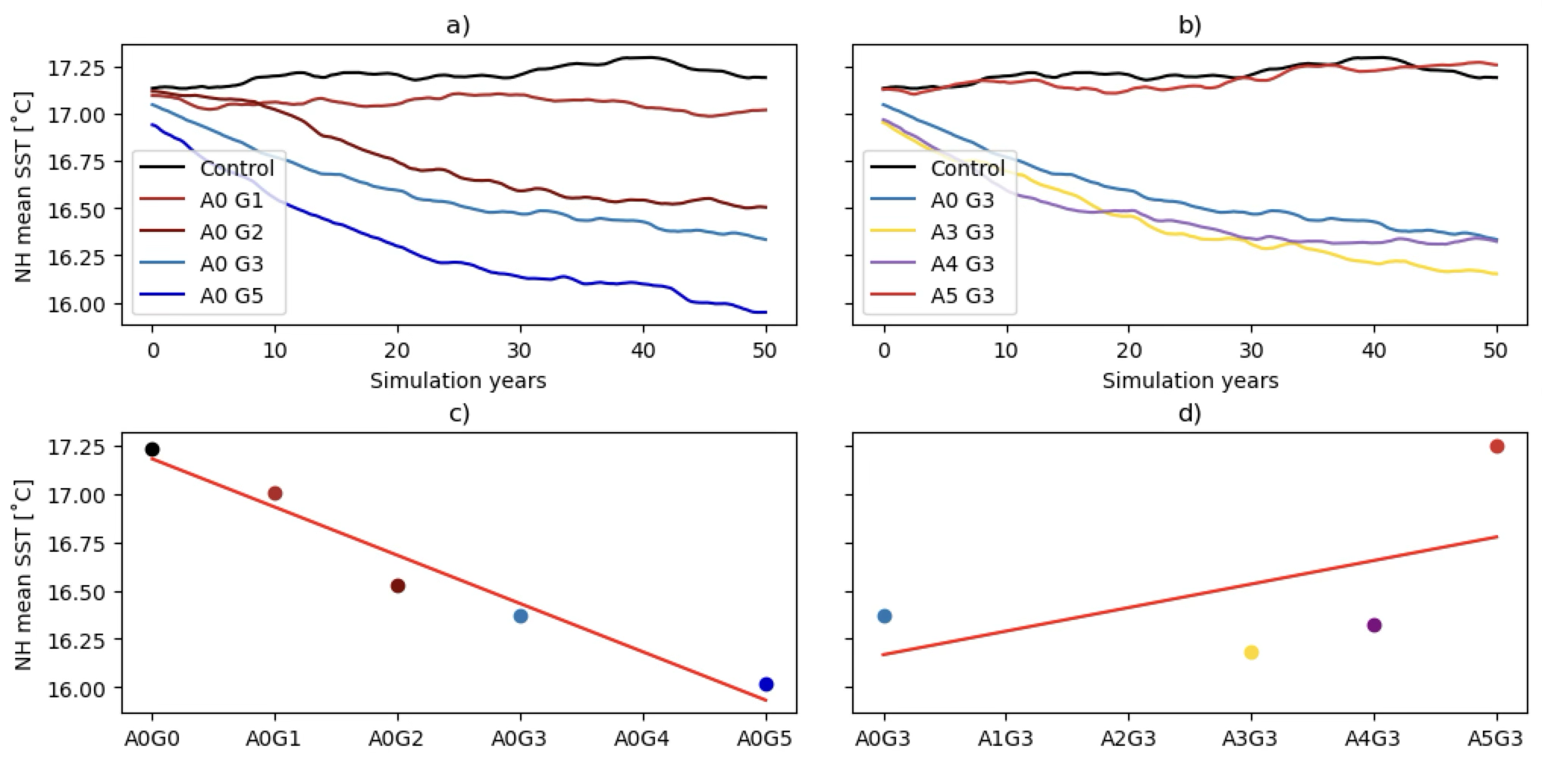
Figure S4: Pannel a and b: 10 year rolling mean of Northern Hemisphere mean Sea Surface Temperature (SST). Pannel a: Simulations increasing Greenland FWF by 1000Gt/yr, G0-G5 (1-5000Gt/yr) holding Antarctic FW off. Pannel b: simulations holding Greenland constant at 3000Gt/yr (G3) and increasing Antarctic FWF at 1000Gt/yr, A0-A5 (1-5000Gt/yr). Panels c and d: Final ten year mean of Northern Hemisphere mean SST for a/b respectively, a linear regression through the means yields an R²=0.95 /0.29.

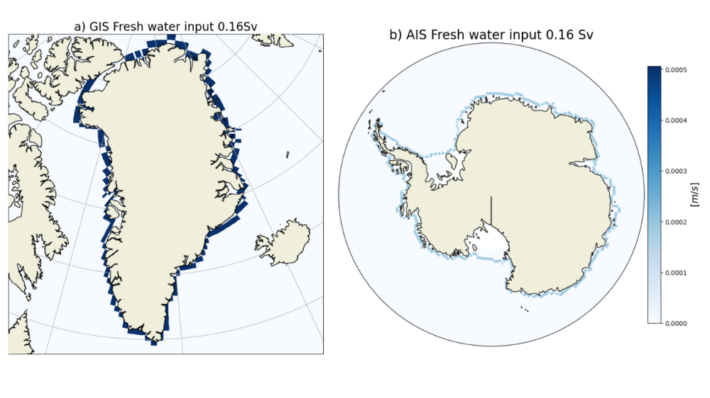
Figure S5: Weighted inputs of our maximum fresh water forcing (FWF) of 5000Gt/yr (0.16sv) for both Greenland (a) and Antarctica (b).

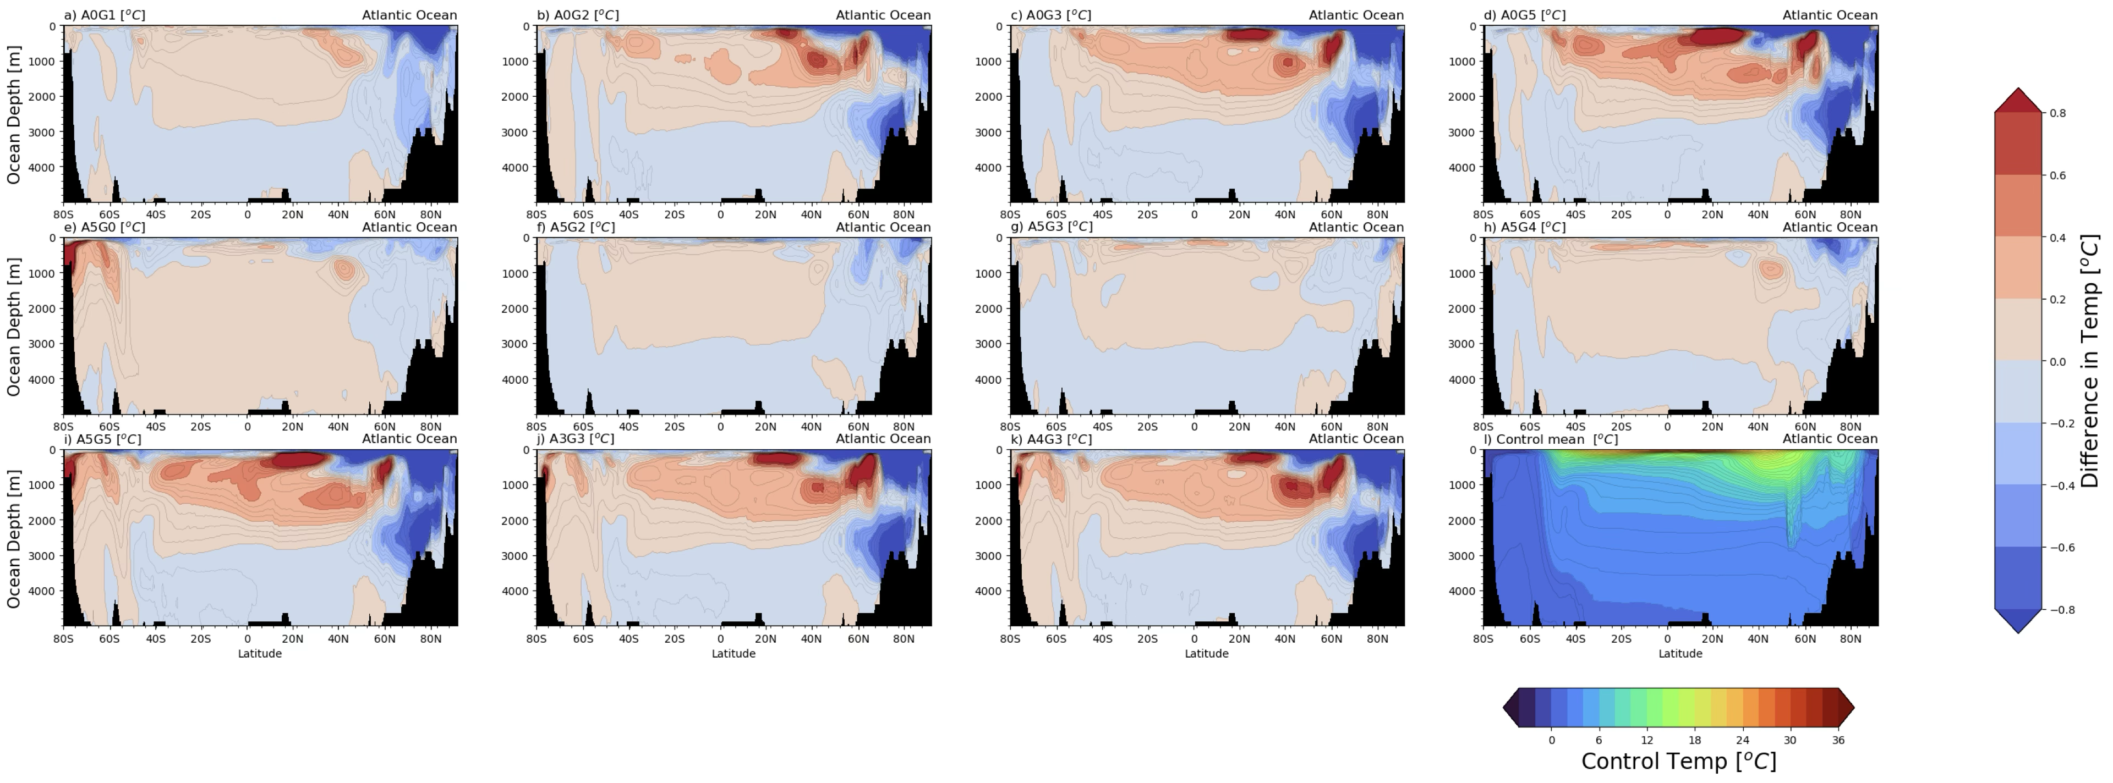
Figure S6: Potential temperature anomaly plots of simulations found in figure 1. Pannels A-D) effect of increasing Greenland fresh water forcing at intervals of 1000Gt/yr (G1-5) whilst Antarctic forcing is off (A0). Pannels E-I) Holding Antarctic forcing constant at 5000 Gt/yr (A5) and increasing Greenland forcing from 0-5000Gt/yr (G0-5). Pannels E-H) AMOC remains stable despite forcing. Pannels J and K) holding Greenland forcing constant at 3000Gt/yr (G3) and increasing Antarctic forcing from 3000-4000Gt/yr (A3-4). Pannel L) Control simulation.
Table of input freshwater values from current literature
Paper | Min AIS [Gt/yr] | Max AIS | Min GIS | Max GIS
Bintanja et. al 2013²² | - | 2650 | - | -
Muntjewerf 2020⁷ | - | - | 712 | 2492
Seroussi et. al 2020³¹ | -381 | 1323 | - | -
Aiken and England 2008³³ | 126 | 12614 | - | -
DeConto and Pollard 2016¹⁰ | 6037 (RCP4.5) | 18922 (RCP8.5) | - | -
Lenaerts et. al 2015⁴³ | - | - | 1500 | 2400
Golledge et. al 2019⁵ | 473 | 5046 | 473 | 1325
Gorte et. al 2023⁸. | 2775 | 9098 | 788 | 6344
Averages [Gt/yr] | 1806 | 8276 | 868 | 3140
Table S1: A brief grouping of predicted melt rates from a variety of papers, from which the values from Golledge et. al 2019 were checked against. Data has been changed from original units to Gt/yr. Our maximum forcing value is taken from Golledge et. al 2019, for sake of comparison with other simulation literature. Our minimum input of 1000Gt/yr is rounded up from the average of Min GIS. This is not a comprehensive list of inputs.

