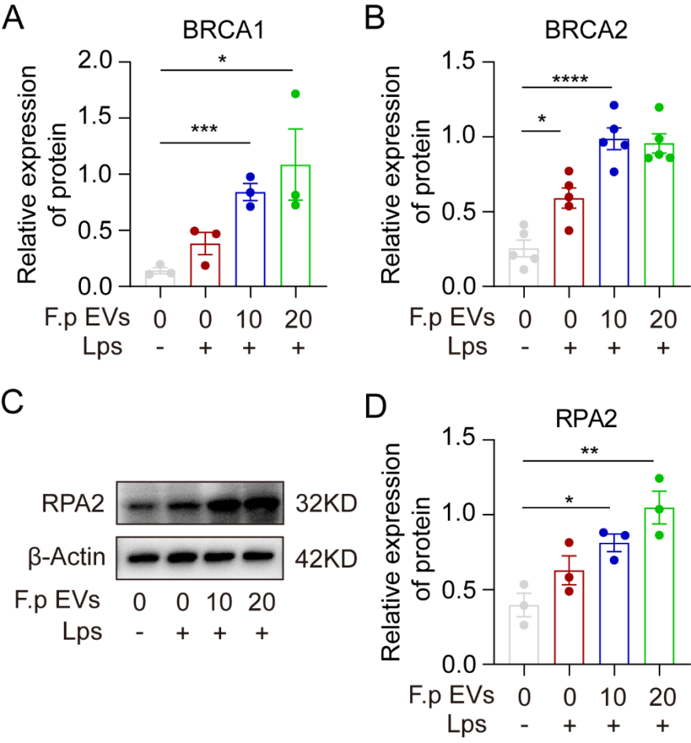
Figure S13. F.p EVs enhance the expression of homologous recombination relative proteins BRCA1 and BRCA2. Quantification of the expression of BRCA1(A) and BRCA2 (B) in the BMDMs. (C) Western blot analysis of RPA2 in BMDMs with different treatments. (D) Quantification of the expression of RPA2 in the BMDMs. Three independent experiments were performed. One-way ANOVA was used to calculate p values ns, not significant; *P < 0.05, **P < 0.01, ***P < 0.001 and ****P < 0.0001.

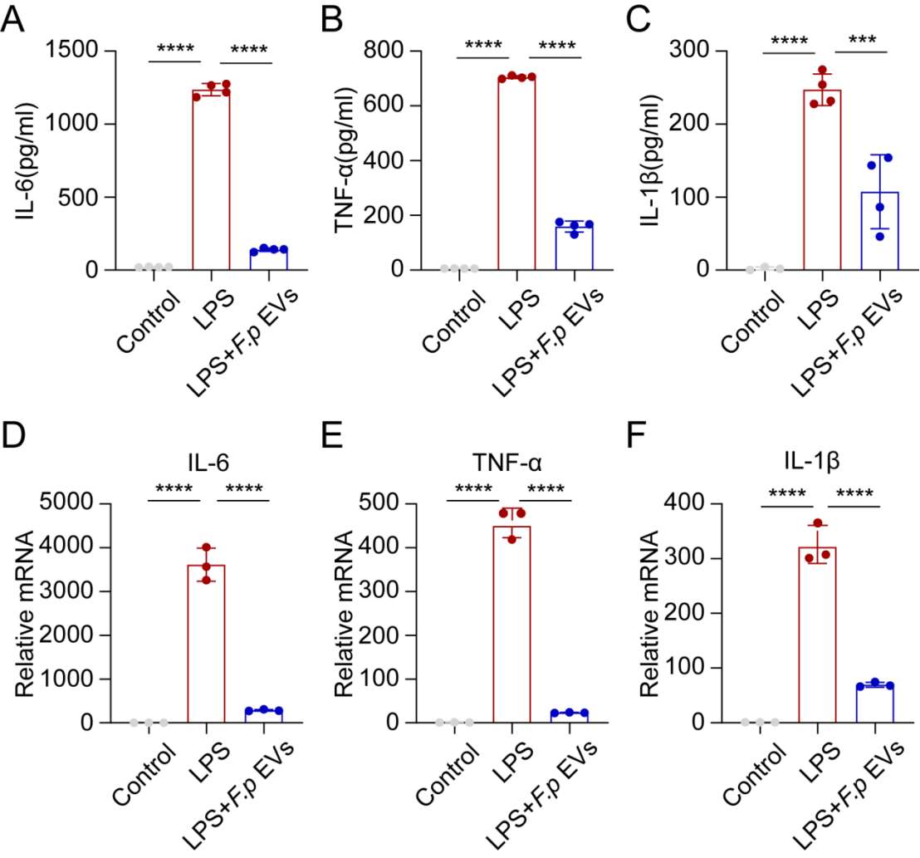
Figure S14. Expression of and anti- inflammatory cytokines upon treatment with F.p EVs in BMDMs. The supernatants and cells were harvested from BMDMs with different treatments. The Supernatants levels of pro-inflammatory cytokines including IL-6(A), TNF-α(B), IL-1β(C). (n=4). mRNA expression of pro-inflammatory cytokines in BMDMs including IL-6 (D), TNF-α(E), IL-1β(F). GAPDH was used as the reference gene. One-way ANOVA was used to calculate p values ns, not significant; *P < 0.05, **P < 0.01, ***P < 0.001 and ****P < 0.0001.

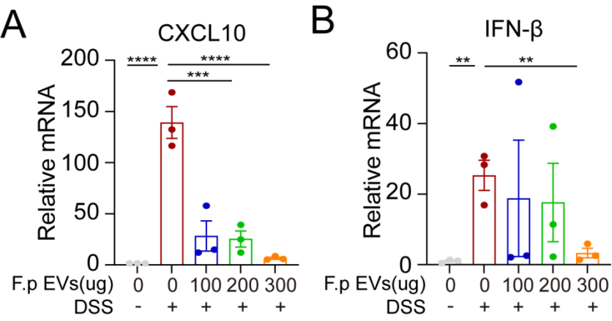
Figure S15. F.p EVs inhibit Type I Interferon Response in the DSS-induced mice. mRNA expression levels of interferon-stimulated genes including CXCL10(A), IFNβ (B) in the colon. n = 3 mice per group. GAPDH was used as the reference gene. One-way ANOVA was used to calculate p values ns, not significant; **P < 0.01, ***P < 0.001, and ****P < 0.0001.

