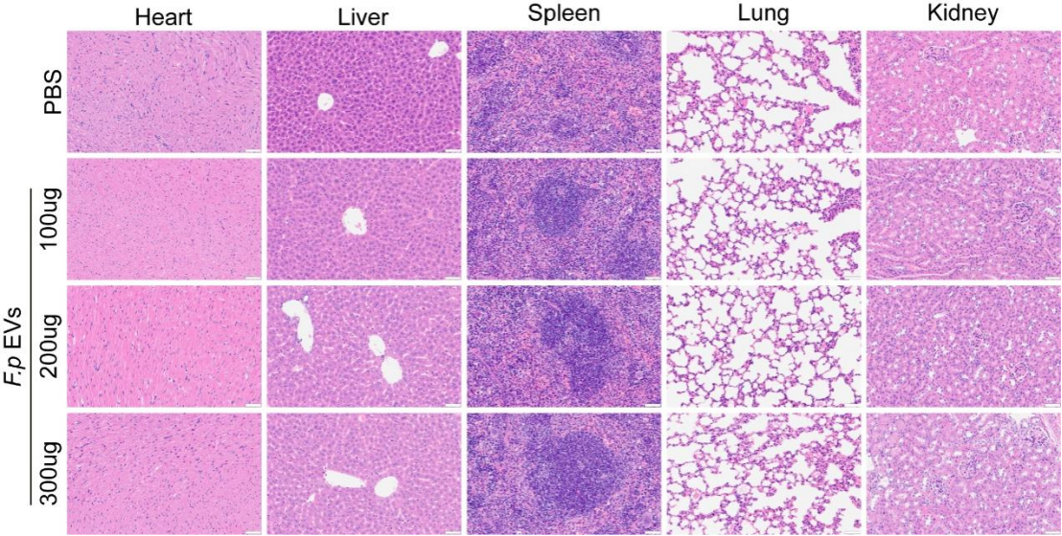
Figure S4. The biological safety of F.p EVs in vivo. DSS-induced mice were treated with PBS and 300μl F.p EVs via intragastric administration. H&E staining of heart, liver, spleen, lung, and kidney of mice. Scale bar, 50μm.
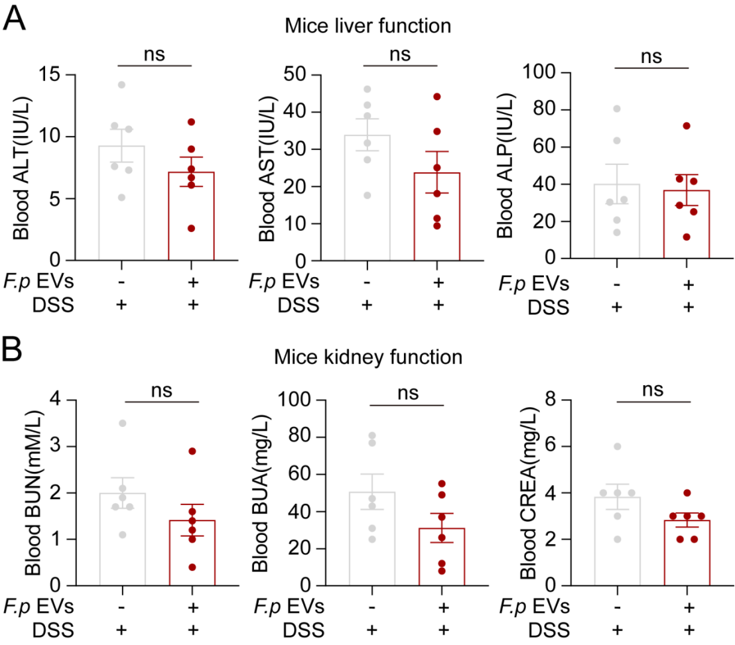
Figure S5. The biological safety of F.p EVs in vivo. DSS-induced mice were treated with PBS and 300μl F.p EVs via intragastric administration. Blood alanine transaminase (ALT) and blood aspartate transaminase (AST), blood alkaline phosphatase (ALP) (A), blood urea nitrogen (BUN), blood uric acid (BUA), blood Creatinine (CREA) (B) of mice were evaluated (n=6). Unpaired t test was used to calculate p values. ns, not significant; *P < 0.05, **P < 0.01, ***P < 0.001 and ****P < 0.001.

