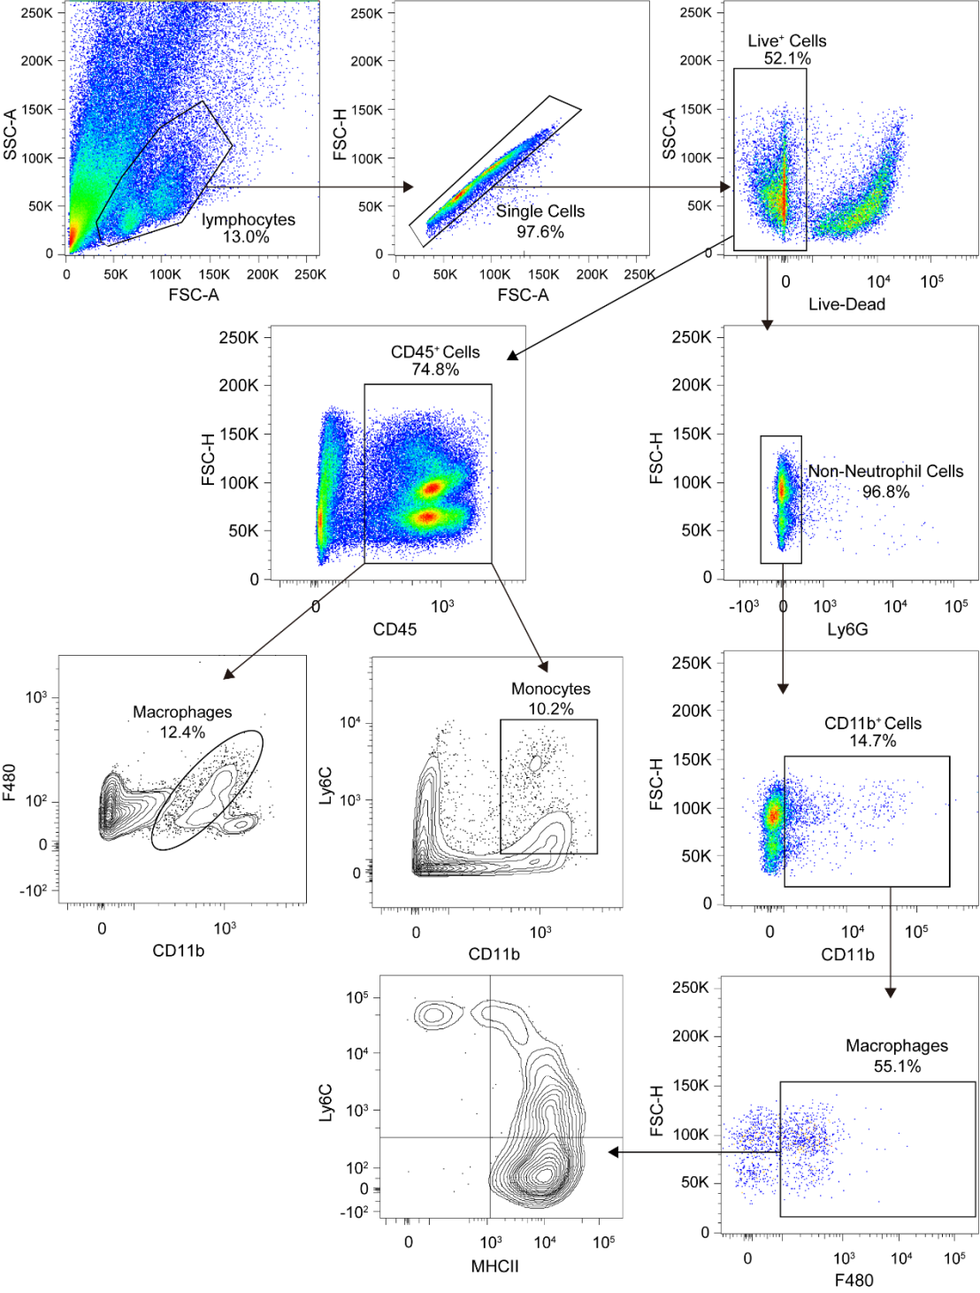
Figure S11. Representative FACS plots illustrating the gating stratege. Gates for lymphocytes/single cells/live cells/CD45⁺ cells/ D11b⁺Ly6c⁺monocyte/CD11b⁺F480⁺ macrophages and lymphocytes/single cells/live cells/Ly6G⁻ Non-Neutrophil cells/CD11b⁺ cells/F480⁺ cells/MHCII⁺Ly6c⁻ cells are indicated, as well as the percentage of events.

