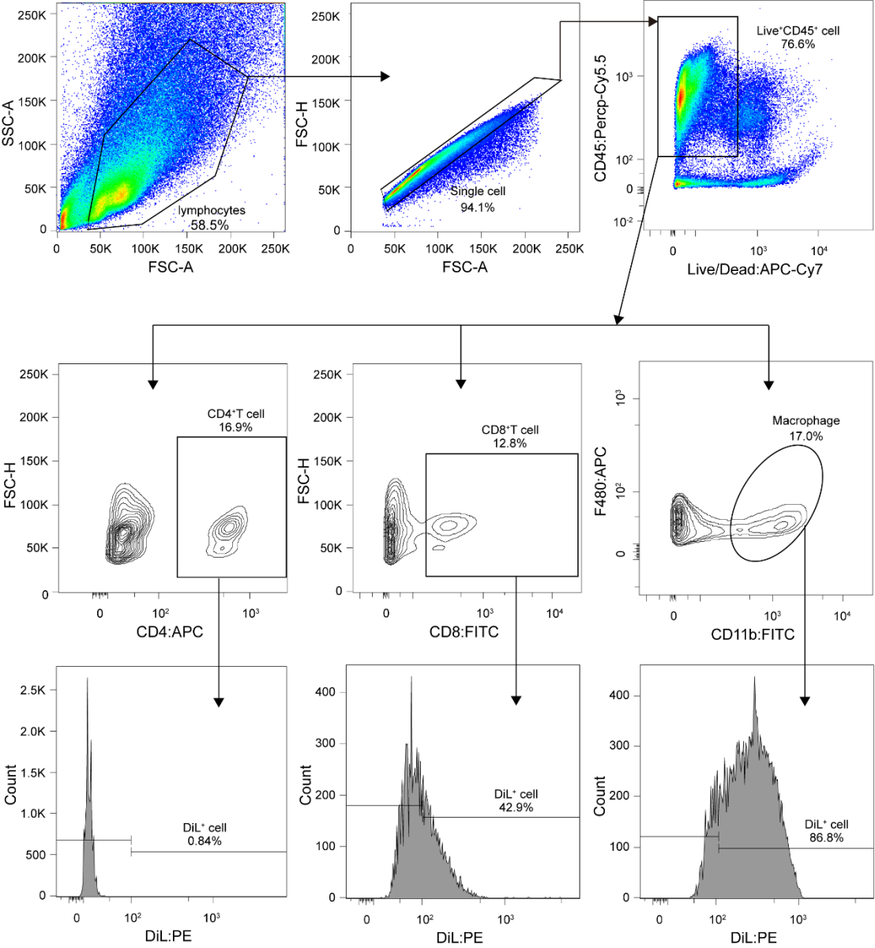
Figure S8. Representative FACS plots illustrating the gating strategy. Gates for lymphocytes/single cells/live cells/CD45⁺ cells/CD4⁺T cells/CD8⁺T cells/CD11b⁺F480⁺ cells/Dil+ cells are indicated, as well as the percentage of events.

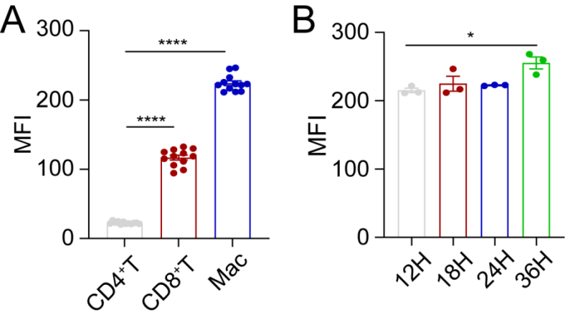
Figure S9. The uptake capacity of F.p EVs by immune cells in the cLP. (A) Mean Fluorescence Intensity (MFI) analysis shows the different uptake capacities of F.p EVs by CD4⁺T cells, CD8⁺T cells, and CD11b⁺F480⁺ macrophages. (B) MFI analysis shows the F.p EVs uptake ratio of macrophages of 12/18/24/36 hours post-intragastric injection. One-way ANOVA was used to calculate p values ns, not significant; *P < 0.05, **P < 0.01, ***P < 0.001 and ****P < 0.0001.

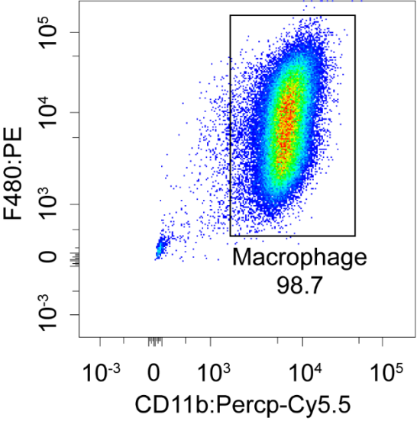
Figure S10. Flow cytometric analysis of bone marrow-derived macrophages (BMDMs). Fluorescence-activated cell sorting (FACS) analysis showing the percentage of CD11b⁺F480⁺ cells in the BMDMs.

