Supplementary information
Faecalibacterium Prausnitzii Extracellular Vesicles Regulating Macrophage Differentiation via Homologous Recombination Repair in Inflammatory Bowel Disease
Yinya Pan^{1*}, Xinlu Zhao^{3†}, Qiongyun Chen^{4†}, Tao Zhao⁴, Yichun Ma⁵, Hai Wu¹, Ying Xiang⁵, Ping Jiang¹, Wenjun Li¹, Qiong Yan⁵, Shangtao Mao¹, Yufei Tao¹ Lei wang^{1#}, Yun Zhu^{1,2#}, Guifang Xu^{1,3,4,5#}
1*. Department of Gastroenterology, Department of Pharmacy, Nanjing Drum Tower Hospital, Affiliated Hospital of Medical School, Nanjing University, Nanjing 210008, China
2. Nanjing Medical Center for Clinical Pharmacy, Nanjing 210008, China
3. Department of Gastroenterology, Nanjing Drum Tower Hospital, Affiliated Hospital of Nanjing Medical University, Nanjing 210008, China
4. Department of Gastroenterology, Taikang Xianlin Drum Tower Hospital, Nanjing 21008, Jiangsu Province, China.
5. Department of Gastroenterology, Nanjing Drum Tower Hospital Clinical College of Traditional Chinese and Western Medicine, Nanjing University of Chinese Medicine, Nanjing 21008, Jiangsu Province, China.
*Corresponding author Email: leiwang9631@nju.edu.cn (Lei Wang); njglyyzhuy@cpu.edu.cn (Yun Zhu); 13852293376@163.com (Guifang Xu)
†These authors contributed equally to this work.

Figure S1. Faecalibacterium prausnitzii Depletion in IBD patients. (A). The abundance of Faecalibacterium prausnitzii in the feces of healthy and IBD patients in the GMrepo database. (B) The abundance of Faecalibacterium prausnitzii in the feces of healthy and UC patients in the GMrepo database. (C)Bacteria genomic DNA was extracted from the stool of the health(n=11) and UC patients(n=13) and the expression of Faecalibacterium prausnitzii was tested by qPCR. (D)Schematic illustration of the process of isolation of Faecalibacterium prausnitzii extracellular vesicles (F.p EVs); Representative transmission electron microscope (TEM) images of F,p EVs and Size distribution of F.p EVs described via Nanoparticle tracking analysis (NTA). (E) Size distribution of F.p EVs before and after undergoing the ex vivo gastric juice. Unpaired t test and one-way ANOVA were used to calculate p values. ns, not significant; **P < 0.01, ***P < 0.001 and ****P < 0.001.

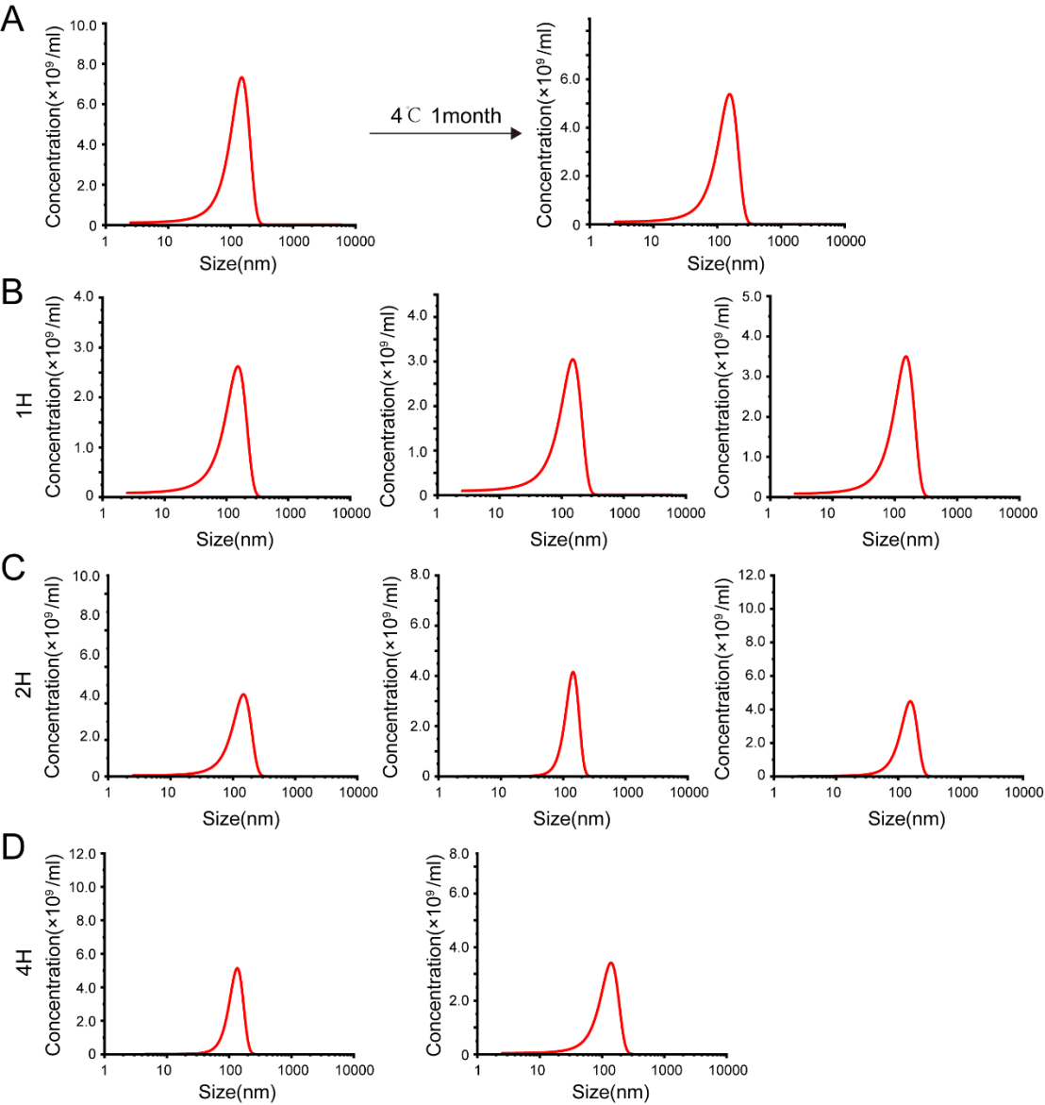
Figure S2. Resistance of F.p EVs to the long-term storage and the in vivo gastric juice. (A). Size distribution of F.p EVs at 37℃ for a month. Equal amounts of F.p EVs were incubated with gastric juice and PBS at 37℃. At the indicated time points, the size distribution of F.p EVs in PBS and gastric juice, including (B) 1h, (C) 2h, and (D) 4h.

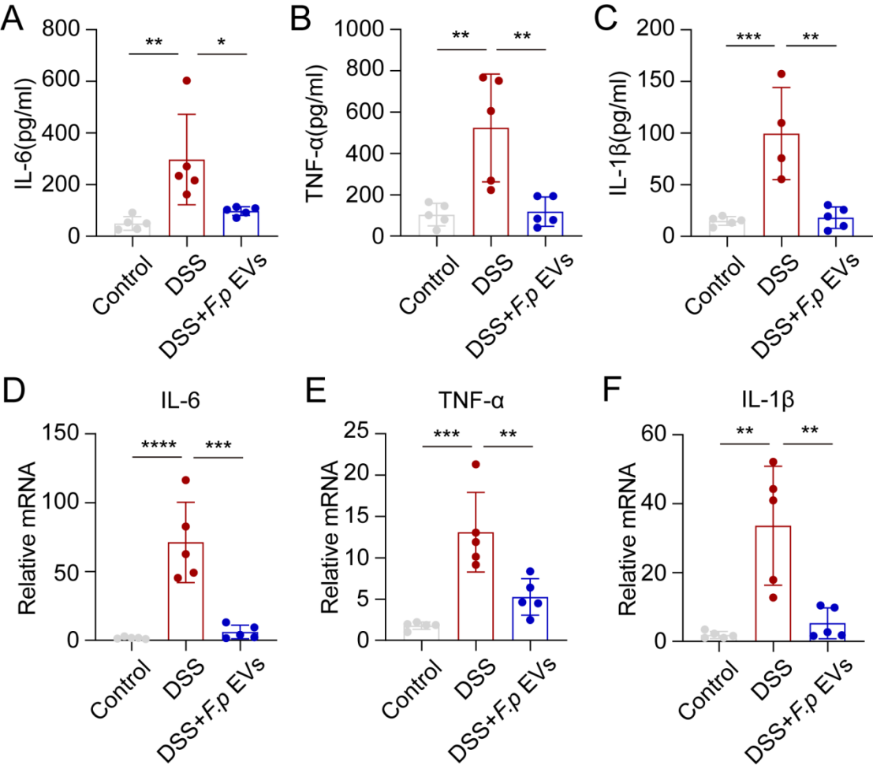
Figure S3. Expression of pro-inflammatory cytokines upon treatment with F.p EVs in the mice. The colon tissue and serum were harvested from WT mice, DSS-induced mice, and DSS-induced mice with intragastric delivery of 300μl F.p EVs for 5 days. Serum levels of pro-inflammatory cytokines including IL-6(A), TNF-α(B), IL-1β(C). Colon tissue mRNA expression of pro-inflammatory cytokines including IL-6(D), TNF-α(E), IL-1β(F). (n=4-5). GAPDH was used as the reference gene. One-way ANOVA was used to calculate p values ns, not significant; *P < 0.05, **P < 0.01, ***P < 0.001 and ****P < 0.0001.

