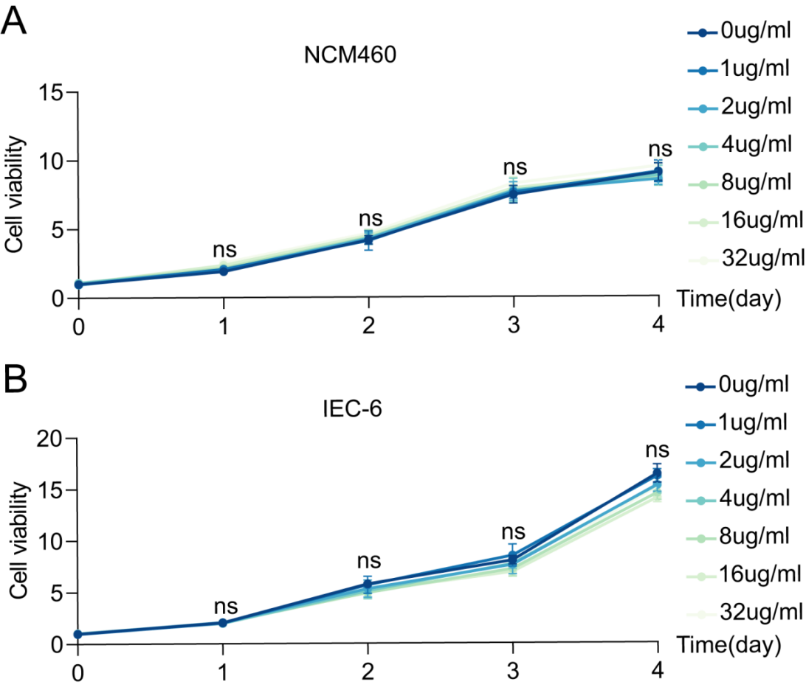

Figure S6. The biological safety of F.p EVs in vitro. Normal colonic epithelial cells (NCM460) and crypt cells (IEC-6) were cocultured with varying concentrations of F.p EVs. The viability of NCM460 cells (A) and IEC-6 cells (B) were evaluated. (n=5). One-way ANOVA was used to calculate p values ns, not significant; *P < 0.05, **P < 0.01, ***P < 0.001 and ****P < 0.0001.

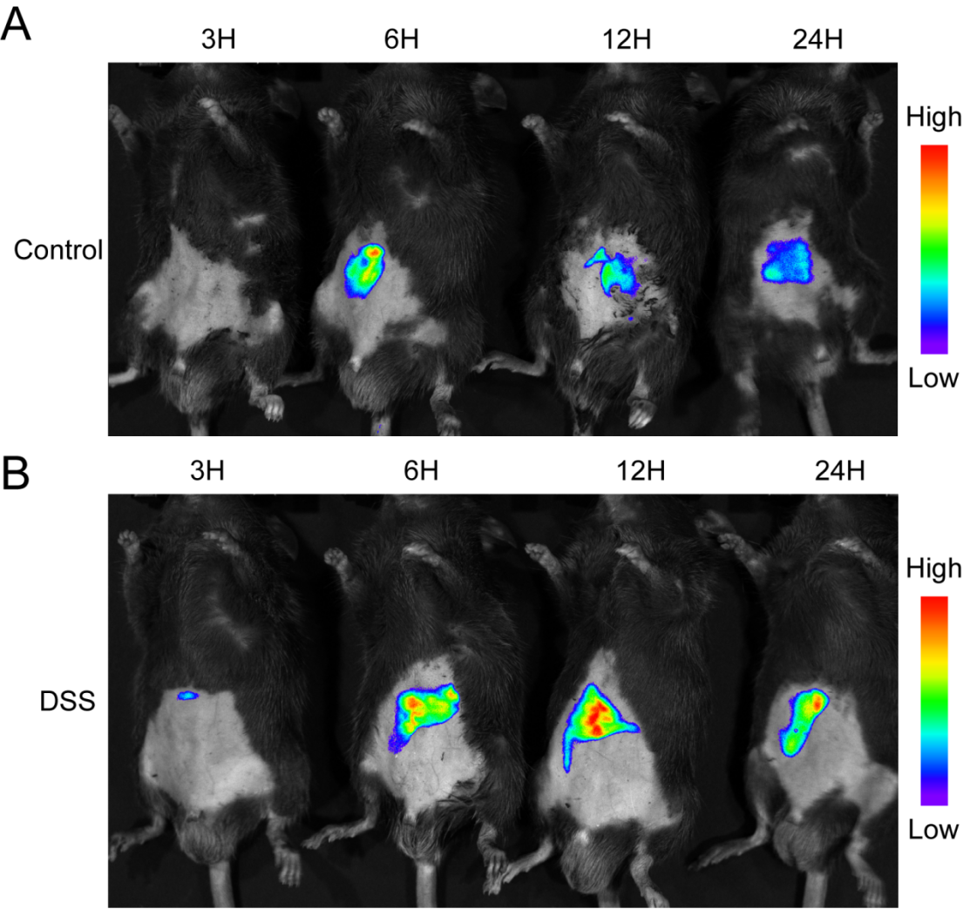
Figure S7. Enhanced intestinal retention of IR780-labeled F.p EVs was in DSS-induced mice. In vivo, the distribution of IR780-labeled F.p EVs in healthy (A) and colitis (B) mice was monitored via in vivo imaging of 3/6/12/24 hours post-intragastric injection.

