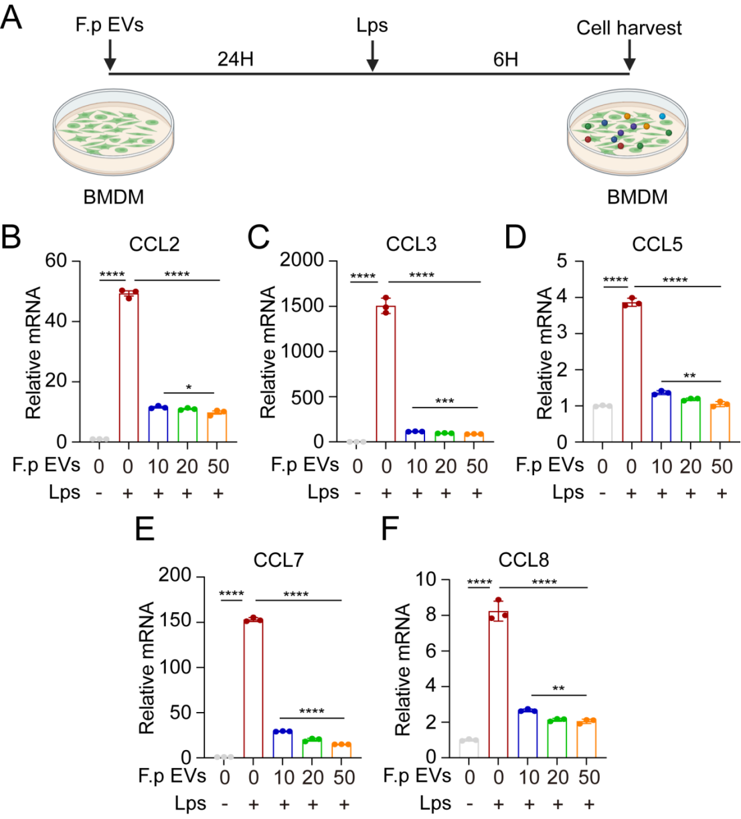
Figure S12. F.p EVs inhibit the expression of Monocyte Chemotactic chemokines in BMDMs. (A) Schematic illustration showing that BMDMs were cultured with 10/20/50ug F.p EVs for 24h and then stimulated with 1μg/ml LPS for 6h. mRNA expression levels of chemotactic including CCL2 (B), CCL3 (C), CCL5(D), CCL7(E), CCL8(F) in BMDMs. GAPDH was used as the reference gene. One-way ANOVA was used to calculate p values ns, not significant; *P < 0.05, **P < 0.01, ***P < 0.001 and ****P < 0.0001.

