Coronavirus Disease 2019 Rebound in Nirmatrelvir Plus Ritonavir Treatment and Control Groups: A Prospective Cohort Study
Jacqueline K. Kueper¹, Kalyani Kottilil¹, Giorgio Quer¹, Danielle C. Chiang¹, Emily G. Spencer¹, Jyothi Purushotham^{1,2}, Edward Ramos ^{1,3}, Leila Roumani⁴, Kristian G. Andersen^{1,2}, Eric J. Topol¹, Jay A. Pandit^{1*}, Michael J. Mina^{4,5*}
*Co senior authors
¹ Scripps Research Translational Institute, La Jolla, California, USA
² Scripps Research, Department of Immunology and Microbiology, La Jolla, California, USA
³CareEvolution, Ann Arbor, Michigan, USA
⁴ eMed, Miami, Florida, USA
⁵Immune Observatory, Boston, USA

Corresponding authors:
Michael J. Mina, MD PhD, eMed <mmina@emed.com>
Jacqueline K. Kueper, PhD, Scripps Research Translational Institute <jkueper@scripps.edu>

SUPPLEMENTARY MATERIAL
Supplementary Figures
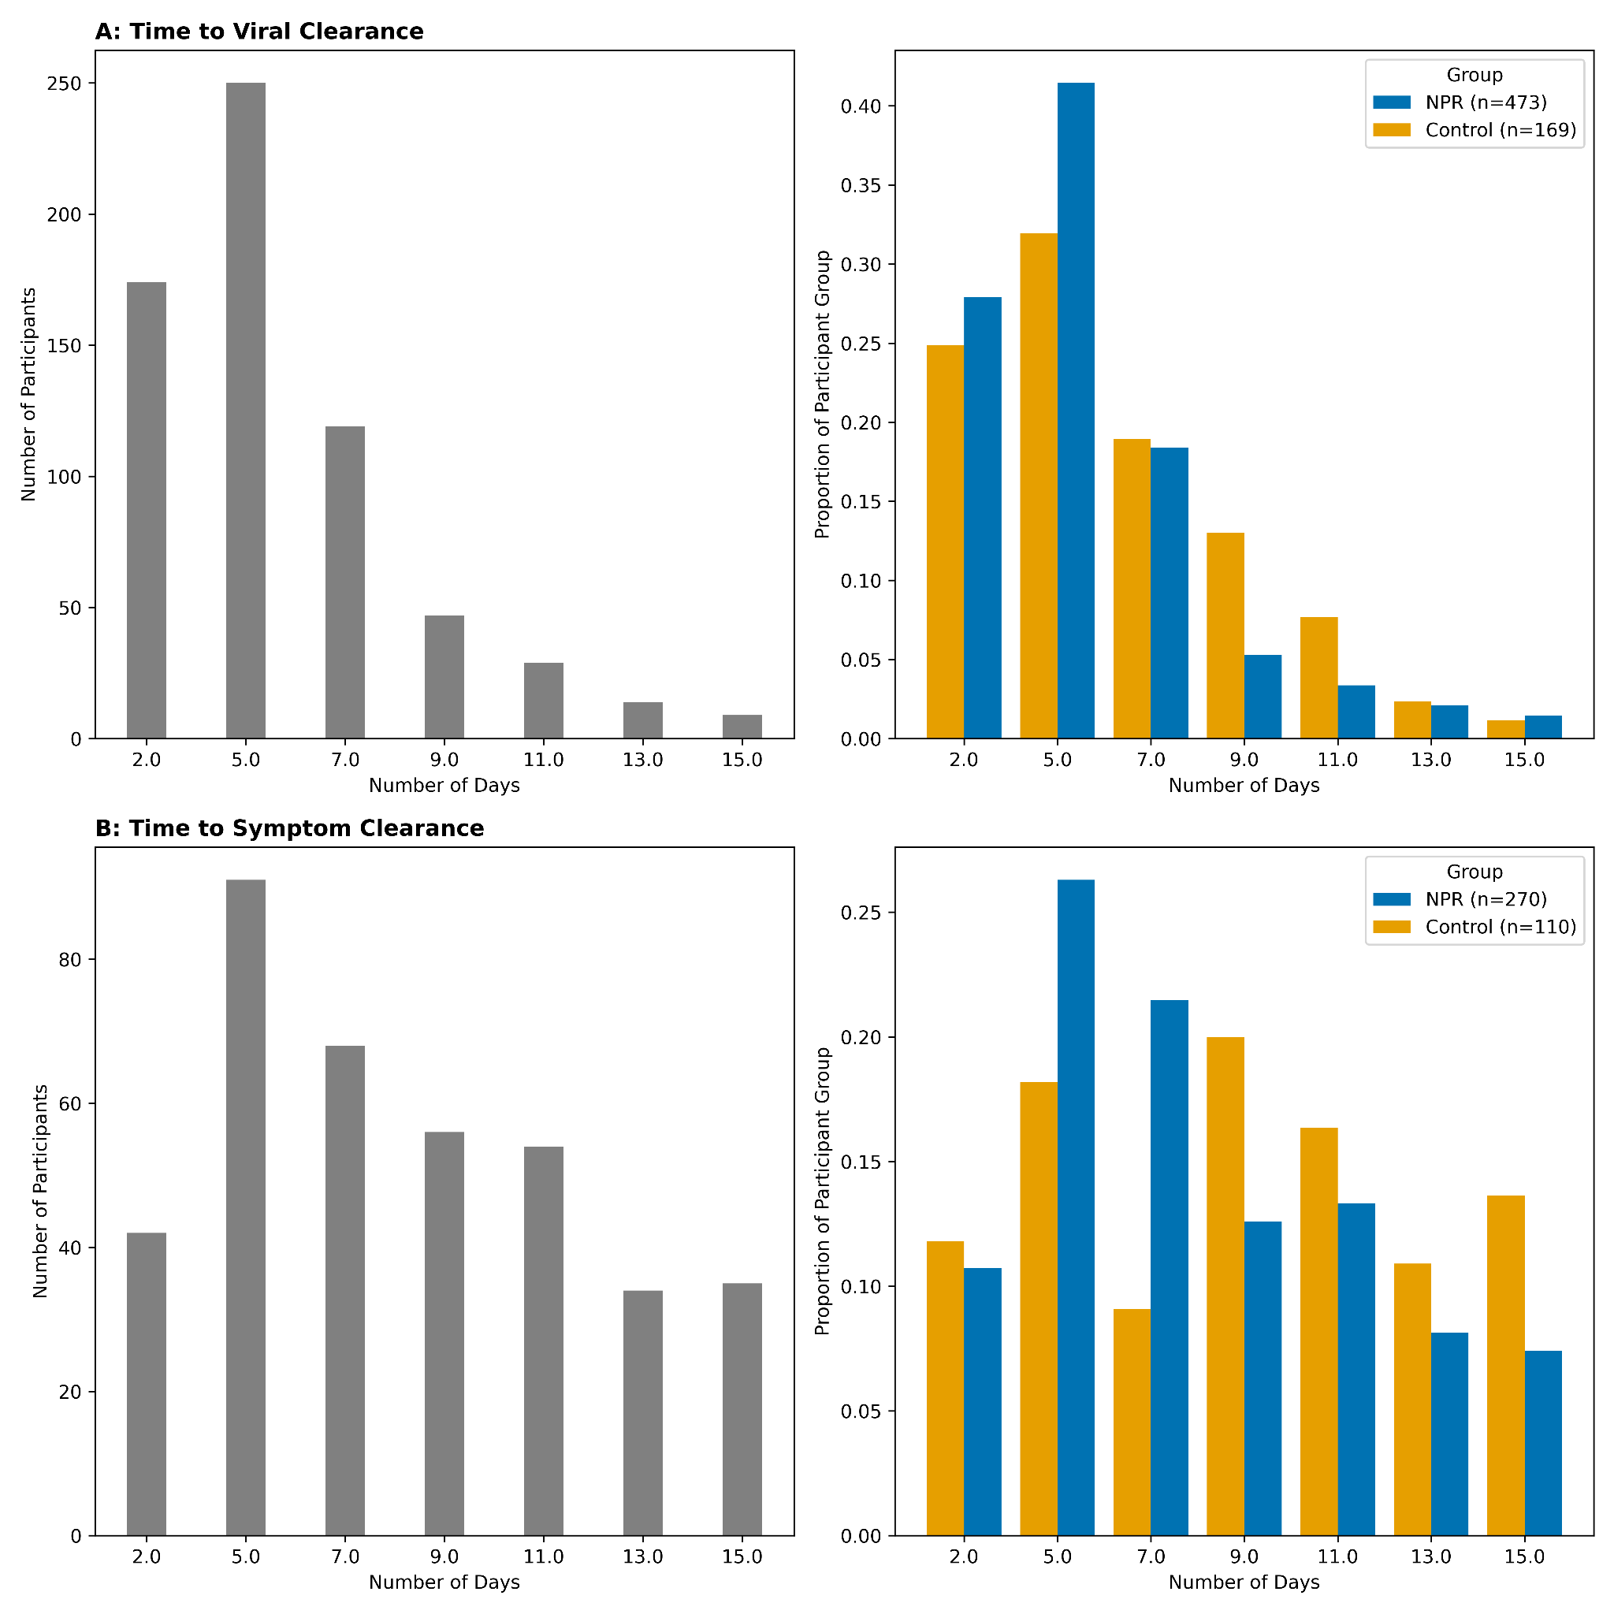
Figure S1 Time from study enrollment to initial clearance. A: Time to first negative rapid antigen test among the subset of participants (n = 642) who reached viral clearance within the 15-day acute phase, overall (left) and by study group (right). B: Time to initial report of no symptoms among the subset of participants (n = 380) who reported symptom clearance within the 15-day acute phase, overall (left) and by study group (right).
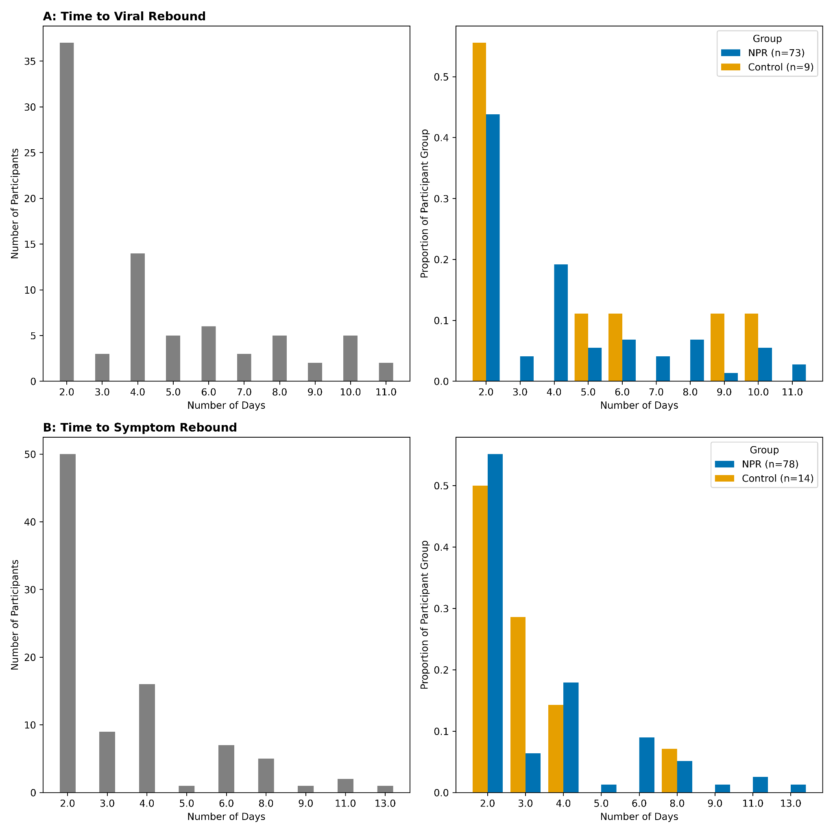
Figure S2 Time from initial clearance to rebound. A: Time from first negative to rebound positive rapid antigen test among the 82 participants who experienced viral rebound within the 15-day acute phase, overall (left) and by study group (right). B: Time from initial report of no symptoms to report of at least one rebound symptom among the 92 participants who experienced symptom rebound within the 15-day acute phase, overall (left) and by study group (right).
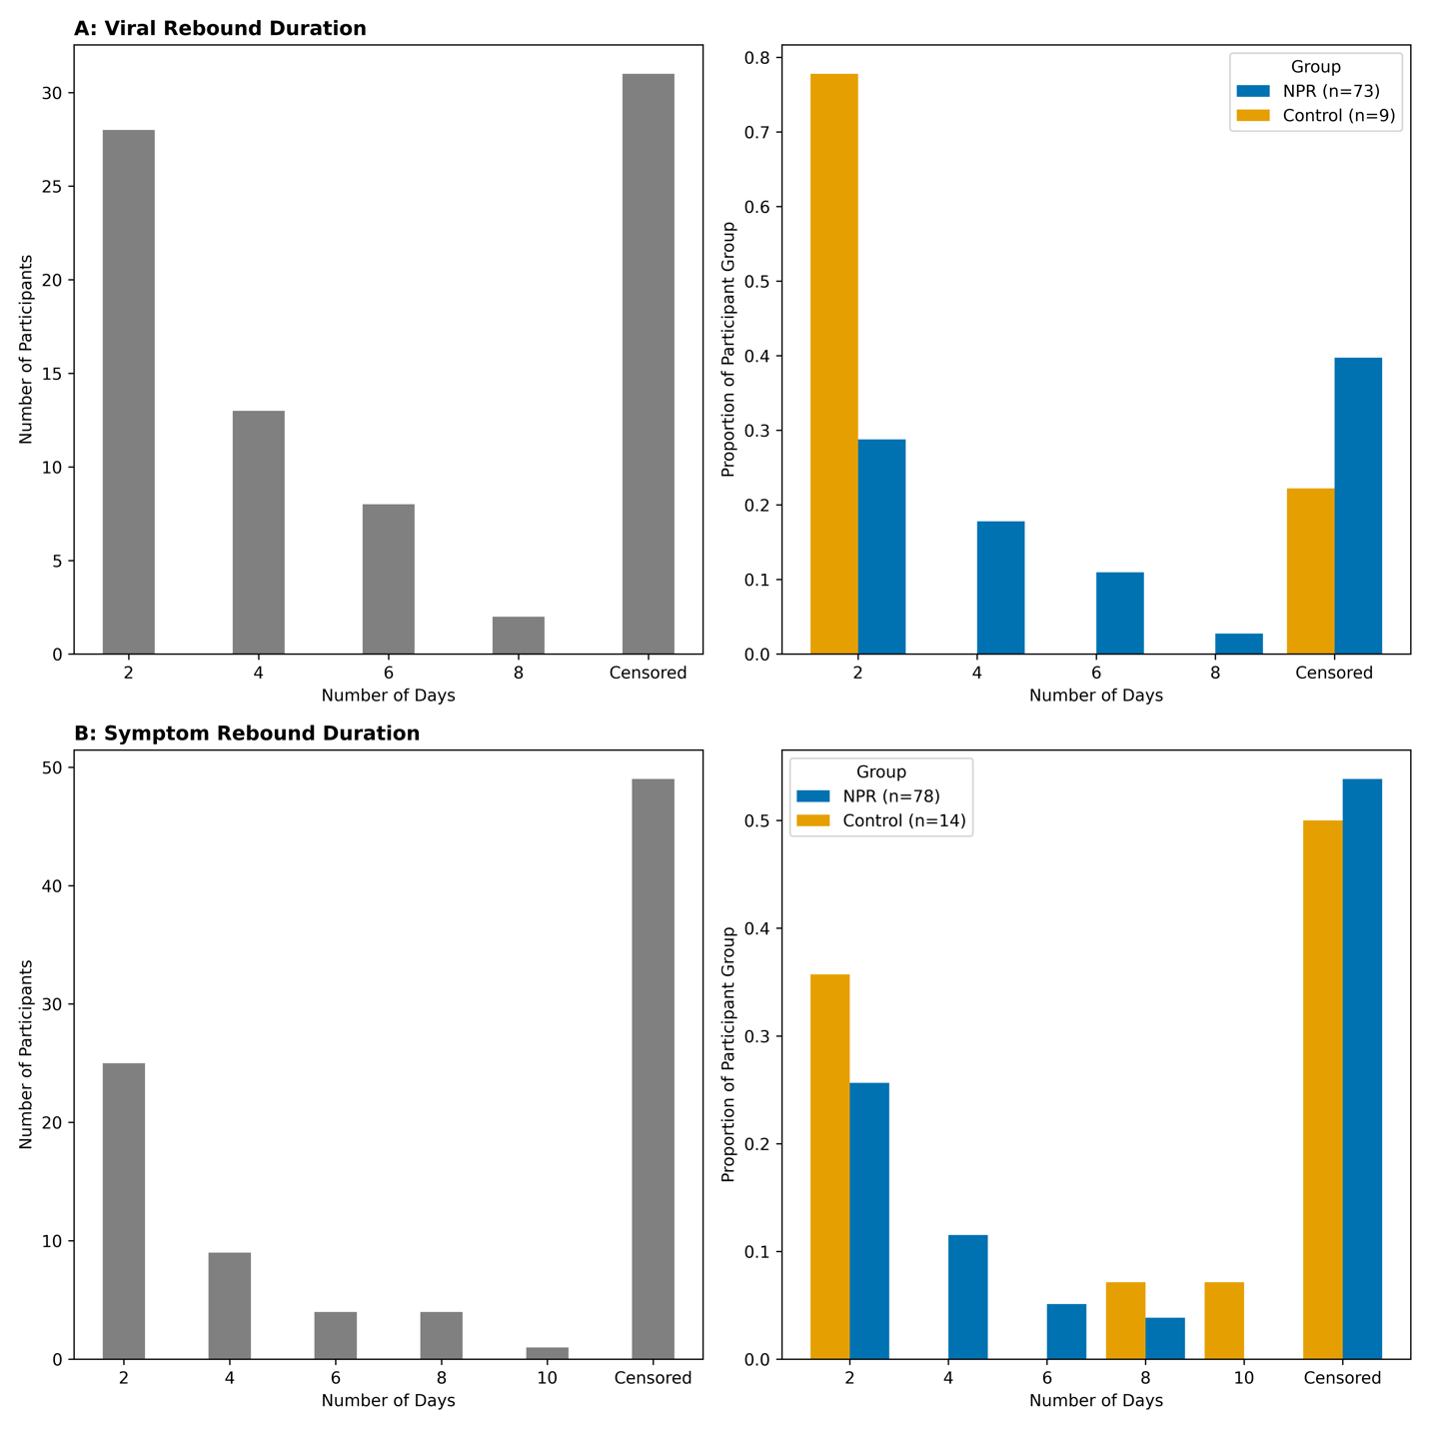
Figure S3 Duration of rebound. A: Time from rebound positive test to subsequent negative rapid antigen test overall (left) and by study group (right). B: Time from rebound symptoms to subsequent report of zero symptoms overall (left) and by study group (right). The censored bar includes participants that did not clear rebound virus or symptoms by Day 15 or were censored for missingness after rebound.

Supplementary Tables

NPR treatment intention recorded on baseline survey | Reported taking NPR during acute phase follow-up surveys | NPR or Control group in primary analysis | NPR or Control group in sensitivity analysis
Yes | Yes | NPR | Full or Partial NPR
Yes | No | NPR | Control
Not Sure | Yes | NPR | Full or Partial NPR
Not Sure | No | Control | Control
No | Yes | NPR | Full or Partial NPR
No | No | Control | Control

Table S1 Treatment and control group assignments. Primary analysis treatment group classifications are based on baseline reported intent to take NPR and report of taking NPR during the 15-day acute study phase. The sensitivity analysis compares main outcomes by amount of NPR reported, regardless of intention at baseline.

 | Lower Limit | Primary | Upper Limit
Description | Censor at the first missing value. | Censor after two sequentially missing values. | Do not censor.
Viral Test Rebound
Number of Eligible Participants | 561 | 669 | 675
Number of Rebound Events | 74 | 82 | 83
Symptom Rebound
Number of Eligible Participants | 561 | 669 | 675
Number of Rebound Events | 79 | 92 | 93

Table S2 Sensitivity analyses on rebound counts (numerator). Primary represents the rebound definition used for the primary reported incidence rate. Lower limit eligibility required at least baseline and Day 2 and 5 surveys, which is the minimum number of surveys to capture rebound without any missingness. Upper limit eligibility required at least baseline survey and two acute phase surveys, but the two acute phase surveys could have any number of missing responses in between.

 | No Missing Responses | Censor at First Missing | Base Censor: Primary Estimate | Base Censor: Lower Bound | Base Censor: Upper Bound | 11-Day Estimate | Post Clearance Conditional Incidence
Overall
n Eligible | 458 | 560 | 669 | 669 | 669 | 669 | 633
n Rebound | 74 | 74 | 82 | 82 | 82 | 66 | 82
Incidence Rate | 0.01143 | 0.00991 | 0.00879 | 0.00878 | 0.00879 | 0.00923 | 0.014964
NPR Group
n Eligible | 342 | 416 | 493 | 493 | 493 | 493 | 466
n Rebound | 66 | 66 | 73 | 73 | 73 | 61 | 73
Incidence Rate | 0.01386 | 0.01204 | 0.01073 | 0.01072 | 0.01074 | 0.01163 | 0.018132
Control Group
n Eligible | 116 | 144 | 176 | 176 | 176 | 176 | 167
n Rebound | 8 | 8 | 9 | 9 | 9 | 5 | 9
Incidence Rate | 0.00467 | 0.00402 | 0.00356 | 0.00356 | 0.00356 | 0.00262 | 0.00619
Incidence Rate Ratio | 2.97 | 2.99 | 3.01 | 3.01 | 3.02 | 4.43 | 2.93
Table S3 Sensitivity analyses on viral test rebound incidence rate. Incidence rates are in events per person-days at risk. No Missing Responses restricts the sample to participants with complete survey days up until the point of rebound or Day 15 for those who do not experience rebound (i.e. most accurate). Censor at First Missing censored people at their first missing result (i.e. not counting any missing responses towards person-time at risk). Base Censor was the primary censoring technique used, where participants were censored at the point of more than two sequentially missing surveys (i.e. maximum of two sequentially missing responses counted towards person-time at risk), and the numerator bounds alter the time of a rebound event when there was a missing survey immediately prior to rebound: best estimate assumes the rebound started at the time of missingness (i.e. middle day between available data), lower bound assumes rebound started the day after the missing survey, and upper bound assumes rebound occurred on the reported survey day. 11-Day Estimate: the Base Censor: Primary Estimate criteria applied to survey data up until Day 11. Post Clearance Conditional Incidence: Base Censor: Primary Estimate criteria applied to the subgroup that experienced initial viral test clearance before Day 15, and counting person-days since the initial clearance day instead of since the enrollment date.

 | No Missing Responses | Censor at First Missing | Base Censor: Primary Estimate | Base Censor: Lower Bound | Base Censor: Upper Bound | 11-Day Estimate | Post Clearance Conditional Incidence
Overall
n Eligible | 459 | 558 | 664 | 664 | 664 | 664 | 345
n Rebound | 79 | 79 | 92 | 92 | 92 | 69 | 92
Incidence Rate | 0.01222 | 0.01062 | 0.00997 | 0.00997 | 0.00998 | 0.00976 | 0.045054
NPR Group
n Eligible | 345 | 414 | 490 | 490 | 490 | 490 | 250
n Rebound | 69 | 69 | 78 | 78 | 78 | 61 | 78
Incidence Rate | 0.01432 | 0.01255 | 0.01155 | 0.01155 | 0.01156 | 0.01172 | 0.052738
Control Group
n Eligible | 114 | 144 | 174 | 174 | 174 | 174 | 95
n Rebound | 10 | 10 | 14 | 14 | 14 | 8 | 14
Incidence Rate | 0.00607 | 0.00515 | 0.00566 | 0.00566 | 0.00567 | 0.00428 | 0.024867
Incidence Rate Ratio | 2.36 | 2.43 | 2.04 | 2.04 | 2.04 | 2.74 | 2.12
Table S4 Sensitivity analyses on symptom rebound incidence rate. Incidence rate is in events per person-days at risk. No Missing Responses restricts the sample to participants with complete survey days up until the point of rebound or Day 15 for those who do not experience rebound (i.e. most accurate). Censor at First Missing censored people at their first missing result (i.e. not counting any missing responses towards person-time at risk). Base Censor was the primary censoring technique used, where participants were censored at the point of more than two sequentially missing surveys (i.e. maximum of two sequentially missing responses counted towards person-time at risk), and the numerator bounds alter the time of a rebound event when there was a missing survey immediately prior to rebound: best estimate assumes the rebound started at the time of missingness (i.e. middle day between available data), lower bound assumes rebound started the day after the missing survey, and upper bound assumes rebound occurred on the reported survey day. 11-Day Estimate: the Base Censor: Primary Estimate applied to survey data up until Day 11. Post Clearance Conditional Incidence: Base Censor: Primary Estimate criteria applied to the subgroup that experienced initial symptom clearance before Day 15, and counting person-days since the initial clearance day instead of since the enrollment date.

 | Hazard Ratio | Lower 95% | Upper 95% | P-value
NPR | 2.39 | 1.17 | 4.90 | 0.02
Age (years) | 1.01 | 0.99 | 1.03 | 0.24
Number of Vaccines (count) | 1.37 | 1.15 | 1.65 | <0.005
Male (vs Female) | 0.87 | 0.54 | 1.40 | 0.55
Race: Black | 2.19 | 0.24 | 19.97 | 0.49
Race: Latino | 2.61 | 0.31 | 22.04 | 0.38
Race: Asian | 1.61 | 0.18 | 14.57 | 0.67
Race: White | 1.19 | 0.26 | 13.88 | 0.78
Preexisting Cardiovascular Condition | 0.85 | 0.49 | 1.48 | 0.57
Preexisting Lung Condition | 0.80 | 0.44 | 1.45 | 0.47
Preexisting Autoimmune Condition | 0.82 | 0.39 | 1.75 | 0.61
Preexisting Diabetes | 1.47 | 0.69 | 3.14 | 0.32
Preexisting Cancer | 1.61 | 0.77 | 3.36 | 0.21
Table S5 Cox’s proportional hazard regression for viral test rebound. Secondary analysis to examine whether the association between NPR and viral rebound remains after adjustment for potential confounders. The unadjusted Hazard Ratio for NPR was 3.09 (95% CI: 1.54, 6.17. P-value < 0.005).

 | Hazard Ratio | Lower 95% | Upper 95% | P-value
NPR | 1.83 | 1.01 | 3.32 | 0.04
Age (years) | 1.00 | 0.98 | 1.02 | 0.75
Number of Vaccines (count) | 1.29 | 1.08 | 1.54 | <0.005
Male (vs Female) | 1.41 | 0.91 | 2.17 | 0.12
Race: Black | 3.33 | 0.73 | 15.27 | 0.12
Race: Latino | 0.47 | 0.08 | 2.85 | 0.41
Race: Asian | 0.47 | 0.08 | 2.83 | 0.41
Race: White | 0.95 | 0.23 | 3.89 | 0.94
Preexisting Cardiovascular Condition | 0.96 | 0.57 | 1.59 | 0.86
Preexisting Lung Condition | 0.79 | 0.45 | 1.39 | 0.41
Preexisting Autoimmune Condition | 0.62 | 0.26 | 1.44 | 0.27
Preexisting Diabetes | 1.66 | 0.81 | 3.41 | 0.17
Preexisting Cancer | 1.21 | 0.51 | 2.87 | 0.66
Table S6 Cox’s proportional hazard regression for symptom rebound. Secondary analysis to examine whether the association between NPR and symptom rebound remains after adjustment for potential confounders. Participants reporting no symptoms at baseline were excluded from analysis (n=5). The unadjusted Hazard Ratio for NPR was 2.05 (95% CI: 1.16, 3.63, P-value = 0.01).

 | Overall | Control  (0 days) | Partial NPR  (1-4 days) | Completed NPR  (5 days) | P-Value
Number of Participants | 669 | 226 | 246 | 197
Treatment Group in Primary Analyses |  |  |  |  | <0.001
Control | 176 (26.3) | 176 (77.9)
NPR | 493 (73.7) | 50 (22.1) | 246 (100.0) | 197 (100.0)
Baseline Characteristics
Race, n (%) |  |  |  |  | 0.002
AI/AN | 2 (0.3) | 1 (0.4) | 1 (0.4) | 0 (0.0)
AS | 42 (6.3) | 19 (8.4) | 14 (5.7) | 9 (4.6)
BL | 41 (6.1) | 20 (8.8) | 12 (4.9) | 9 (4.6)
HI/LA | 50 (7.5) | 29 (12.8) | 11 (4.5) | 10 (5.1)
Other | 15 (2.2) | 5 (2.2) | 3 (1.2) | 7 (3.6)
WH | 519 (77.6) | 152 (67.3) | 205 (83.3) | 162 (82.2)
Sex, n (%) |  |  |  |  | 0.333
Female | 419 (62.6) | 143 (63.3) | 161 (65.4) | 115 (58.4)
Male | 249 (37.2) | 83 (36.7) | 85 (34.6) | 81 (41.1)
Intersex | 1 (0.1) | 0 (0.0) | 0 (0.0) | 1 (0.5)
Age, n (%) |  |  |  |  | <0.001
18-44 | 344 (51.4) | 146 (64.6) | 103 (41.9) | 95 (48.2)
45-64 | 258 (38.6) | 69 (30.5) | 108 (43.9) | 81 (41.1)
> 65 | 67 (10.0) | 11 (4.9) | 35 (14.2) | 21 (10.7)
Received at least one COVID-19 vaccine | 637 (95.2) | 208 (92.0) | 237 (96.3) | 192 (97.5) | 0.019
Preexisting Conditions
Asthma, n (%) | 117 (17.5) | 34 (15.0) | 43 (17.5) | 40 (20.3) | 0.365
Autoimmune Condition, n (%) | 63 (9.4) | 17 (7.5) | 22 (8.9) | 24 (12.2) | 0.249
Cancer, n (%) | 35 (5.2) | 5 (2.2) | 18 (7.3) | 12 (6.1) | 0.037
Chronic Bronchitis, n (%) | 10 (1.5) | 3 (1.3) | 3 (1.2) | 4 (2.0) | 0.758
Chronic Obstructive Pulmonary Disease, n (%) | 3 (0.4) | 3 (1.3) | 0 (0.0) | 0 (0.0) | 0.052
Diabetes, n (%) | 44 (6.6) | 10 (4.4) | 20 (8.1) | 14 (7.1) | 0.252
Emphysema, n (%) | 1 (0.1) | 1 (0.4) | 0 (0.0) | 0 (0.0) | 0.375
Heart Disease, n (%) | 21 (3.1) | 5 (2.2) | 9 (3.7) | 7 (3.6) | 0.616
Heart Failure, n (%) | 3 (0.4) | 1 (0.4) | 1 (0.4) | 1 (0.5) | 0.987
High Blood Pressure, n (%) | 132 (19.7) | 40 (17.7) | 48 (19.5) | 44 (22.3) | 0.487
Other Lung Condition, n (%) | 7 (1.0) | 1 (0.4) | 3 (1.2) | 3 (1.5) | 0.522
None, n (%) | 340 (50.8) | 137 (60.6) | 118 (48.0) | 85 (43.1) | 0.001
Acute Phase Symptoms
Days with Systemic Symptoms, mean (SD) | 3.5 (2.4) | 3.2 (2.2) | 3.3 (2.3) | 4.1 (2.5) | <0.001
Days with Respiratory Symptoms, mean (SD) | 4.7 (2.4) | 4.5 (2.4) | 4.7 (2.4) | 4.8 (2.4) | 0.269
Days with Gastrointestinal Symptoms, mean (SD) | 1.0 (1.4) | 0.9 (1.3) | 1.0 (1.4) | 1.3 (1.7) | 0.031
Days with Neurological Symptoms, mean (SD) | 0.4 (1.0) | 0.3 (0.7) | 0.4 (1.1) | 0.5 (1.3) | 0.048
Days with Other Symptoms, mean (SD) | 0.4 (0.9) | 0.3 (0.8) | 0.4 (1.1) | 0.4 (0.9) | 0.149
Table S7 Sensitivity analysis for different treatment groupings. Participants were grouped by the maximum number of days that NPR was reported to be taken during the acute phase period. Legend: AI/AN = American Indian or Alaska Native, AS = Asian, BL = African American, HI/LA = Latino, J&J = Johnson & Johnson, WH = White, n = number of participants, NPR = Nirmatrelvir Plus Ritonavir; SD = standard deviation.

 | Overall | Cohort 1 | Cohort 2 | P-Value
Number of participants | 669 | 251 | 418
Treatment Group, n (%) |  |  |  | <0.001
Control | 176 (26.3) | 45 (17.9) | 131 (31.3)
NPR | 493 (73.7) | 206 (82.1) | 287 (68.7)
Baseline Characteristics
Race, n (%) |  |  |  | 0.022
AI/AN | 2 (0.3) | 2 (0.8) | 0 (0.0)
AS | 42 (6.3) | 10 (4.0) | 32 (7.7)
BL | 41 (6.1) | 22 (8.8) | 19 (4.5)
HI/LA | 50 (7.5) | 23 (9.2) | 27 (6.5)
WH | 519 (77.6) | 189 (75.3) | 330 (78.9)
Other | 15 (2.2) | 5 (2.0) | 10 (2.4)
Sex, n (%) |  |  |  | 0.089
Female | 419 (62.6) | 145 (57.8) | 274 (65.6)
Male | 249 (37.2) | 106 (42.2) | 143 (34.2)
Intersex | 1 (0.1) | 0 (0.0) | 1 (0.2)
Age, n (%) |  |  |  | 0.037
18-44 | 344 (51.4) | 113 (45.0) | 231 (55.3)
45-64 | 258 (38.6) | 109 (43.4) | 149 (35.6)
> 65 | 67 (10.0) | 29 (11.6) | 38 (9.1)
Received at least one COVID-19 vaccine | 637 (95.2) | 236 (94.0) | 401 (95.9) | 0.351
Preexisting Conditions
Asthma, n (%) | 117 (17.5) | 36 (14.3) | 81 (19.4) | 0.120
Autoimmune Condition, n (%) | 63 (9.4) | 19 (7.6) | 44 (10.5) | 0.258
Cancer, n (%) | 35 (5.2) | 14 (5.6) | 21 (5.0) | 0.895
Chronic Bronchitis, n (%) | 10 (1.5) | 3 (1.2) | 7 (1.7) | 0.751
Chronic Obstructive Pulmonary Disease, n (%) | 3 (0.4) | 2 (0.8) | 1 (0.2) | 0.560
Diabetes, n (%) | 44 (6.6) | 17 (6.8) | 27 (6.5) | 0.998
Emphysema, n (%) | 1 (0.1) | 1 (0.4) | 0 (0.0) | 0.375
Heart Disease, n (%) | 21 (3.1) | 6 (2.4) | 15 (3.6) | 0.528
Heart Failure, n (%) | 3 (0.4) | 1 (0.4) | 2 (0.5) | 1.000
High Blood Pressure, n (%) | 132 (19.7) | 63 (25.1) | 69 (16.5) | 0.009
Other Lung Condition, n (%) | 7 (1.0) | 2 (0.8) | 5 (1.2) | 0.717
None, n (%) | 340 (50.8) | 127 (50.6) | 213 (51.0) | 0.992
COVID-19 Recovery Characteristics
Test Rebound, n (%) | 82 (12.3) | 37 (14.7) | 45 (10.8) | 0.163
Symptom Rebound, n (%) | 92 (13.8) | 40 (15.9) | 52 (12.4) | 0.248
Days with Systemic Symptoms, mean (SD) | 3.5 (2.4) | 3.4 (2.3) | 3.6 (2.4) | 0.201
Days with Respiratory Symptoms, mean (SD) | 4.7 (2.4) | 4.8 (2.4) | 4.6 (2.4) | 0.155
Days with Gastrointestinal Symptoms, mean (SD) | 1.0 (1.4) | 0.9 (1.3) | 1.1 (1.5) | 0.175
Days with Neurological Symptoms, mean (SD) | 0.4 (1.0) | 0.4 (0.9) | 0.4 (1.1) | 0.294
Days with Other Symptoms, mean (SD) | 0.4 (0.9) | 0.2 (0.7) | 0.4 (1.1) | 0.004
Table S8 Sensitivity analysis to compare the two study cohorts. Cohort 1 was recruited from August 2022 to August 2023; Cohort 2 was recruited from August 2023 to December 2023. Tasks for data used in this study were the same between the two cohorts, but Cohort 2 had additional blood sample and test swab tasks that will presented in a follow-up report. Legend: AI/AN = American Indian or Alaska Native, AS = Asian, BL = African American, HI/LA = Latino, J&J = Johnson & Johnson, WH = White, n = number of participants, NPR = Nirmatrelvir Plus Ritonavir; SD = standard deviation.

 | Both Positive | Both Negative | Test Positive & Symptom Negative | Symptom Positive & Test Negative
All 15 Acute Phase Days
All | 1680 (34.76 %) | 1172 (24.25 %) | 110 (2.28 %) | 1871 (38.71 %)
NPR | 1247 (34.89 %) | 839 (23.48 %) | 85 (2.38 %) | 1403 (39.26 %)
Control | 433 (34.39 %) | 333 (26.45 %) | 25 (1.99 %) | 468 (37.17 %)
Positive Viral Test Rebound Days
All | 151 (82.51 %) |  | 32 (17.49 %)
NPR | 145 (83.82 %) |  | 28 (16.18 %)
Control | 6 (60.0 %) |  | 4 (40.0 %)
Table S9 Congruence of viral test and symptoms report. The number of person-days where viral test and symptom reports are positive or negative and whether they agree. Empty cells represent scenarios that are not applicable. Legend: NPR = Nirmatrelvir Plus Ritonavir.

 | Overall | Excluded | Included | P-Value
Number of Participants | 917 | 248 | 669
Treatment Group, n (%) |  |  |  | <0.001
Control | 284 (31.0) | 108 (43.5) | 176 (26.3)
NPR | 633 (69.0) | 140 (56.5) | 493 (73.7)
Cohort Version, n (%) |  |  |  | <0.001
1 | 310 (33.8) | 59 (23.8) | 251 (37.5)
2 | 607 (66.2) | 189 (76.2) | 418 (62.5)
Baseline Characteristics
Race, n (%) |  |  |  | <0.001
AI/AN | 5 (0.5) | 3 (1.2) | 2 (0.3)
AS | 62 (6.8) | 20 (8.1) | 42 (6.3)
BL | 68 (7.4) | 27 (10.9) | 41 (6.1)
HI/LA | 78 (8.5) | 28 (11.3) | 50 (7.5)
NHLPI | 3 (0.3) | 3 (1.2) | 0 (0.0)
WH | 677 (73.8) | 158 (63.7) | 519 (77.6)
Other | 24 (2.6) | 9 (3.6) | 15 (2.2)
Sex, n (%) |  |  |  | 0.747
Female | 572 (62.4) | 153 (61.7) | 419 (62.6)
Male | 343 (37.4) | 94 (37.9) | 249 (37.2)
Intersex | 2 (0.2) | 1 (0.4) | 1 (0.1)
Age, n (%) |  |  |  | 0.005
18-44 | 496 (54.1) | 152 (61.3) | 344 (51.4)
45-64 | 343 (37.4) | 85 (34.3) | 258 (38.6)
> 65 | 78 (8.5) | 11 (4.4) | 67 (10.0)
Received at least one COVID-19 vaccine | 852 (92.9) | 215 (86.7) | 637 (95.2) | <0.001
Preexisting Conditions
Asthma, n (%) | 155 (16.9) | 38 (15.3) | 117 (17.5) | 0.498
Autoimmune Condition, n (%) | 85 (9.3) | 22 (8.9) | 63 (9.4) | 0.900
Cancer, n (%) | 40 (4.4) | 5 (2.0) | 35 (5.2) | 0.053
Chronic Bronchitis, n (%) | 12 (1.3) | 2 (0.8) | 10 (1.5) | 0.530
Chronic Obstructive Pulmonary Disease, n (%) | 3 (0.3) | 0 (0.0) | 3 (0.4) | 0.567
Diabetes, n (%) | 75 (8.2) | 31 (12.5) | 44 (6.6) | 0.006
Emphysema, n (%) | 1 (0.1) | 0 (0.0) | 1 (0.1) | 1.000
Heart Disease, n (%) | 26 (2.8) | 5 (2.0) | 21 (3.1) | 0.493
Heart Failure, n (%) | 5 (0.5) | 2 (0.8) | 3 (0.4) | 0.616
High Blood Pressure, n (%) | 178 (19.4) | 46 (18.5) | 132 (19.7) | 0.758
Other Lung Condition, n (%) | 8 (0.9) | 1 (0.4) | 7 (1.0) | 0.690
None, n (%) | 474 (51.7) | 134 (54.0) | 340 (50.8) | 0.430
Table S10 Characteristics of included and excluded participants. Comparison of baseline characreristics between participants that were and were not eligible for inclusion in analyses. Legend: AI/AN = American Indian or Alaska Native, AS = Asian, BL = African American, HI/LA = Latino, J&J = Johnson & Johnson, WH = White, NHLPI = , n = number of participants, NPR = Nirmatrelvir Plus Ritonavir; SD = standard deviation.

