Figure 7: Agarose electrophoretic pattern of pUC19 plasmid DNA with and without the treatment of pure compound and standard gallic acid.

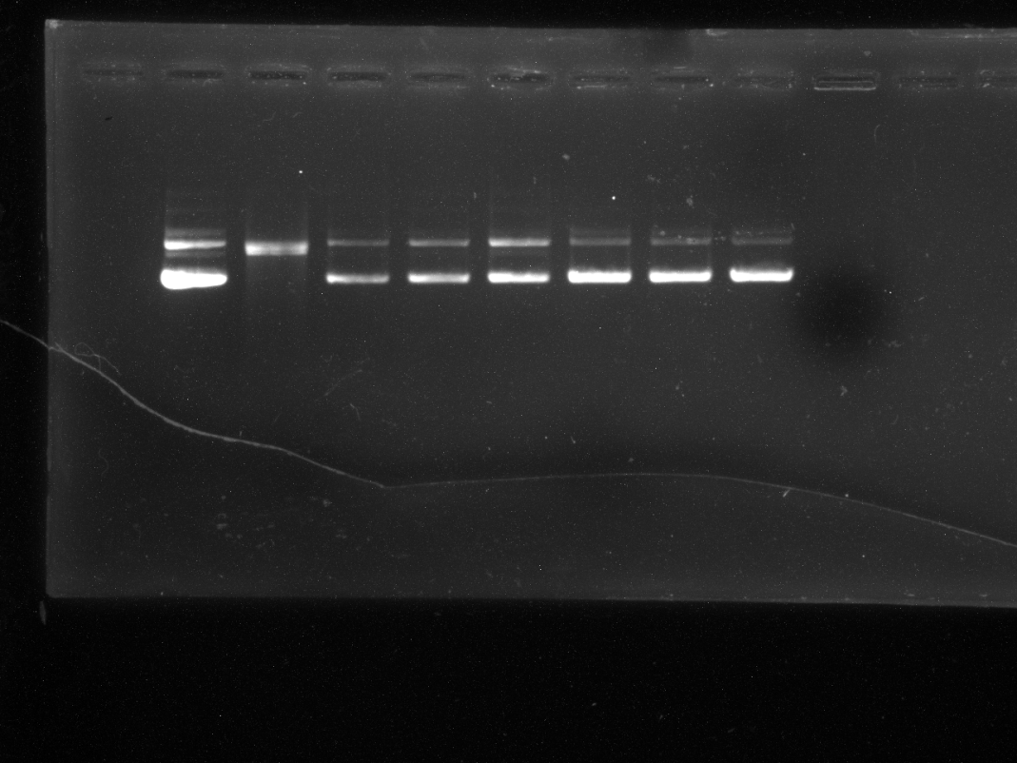
 | L1 | L2 | L3 | L4 | L5 | L6 | L7 |  | L8
DNA | + | + | + | + | + | + | + | +
AAPH | - | + | + | + | + | + | + | +
Compound/GA | - | - | 5 | 10 | 20 | 40 | 50 | GA (50) µg/ml

Lane 1: untreated DNA; Lane 2: DNA treated with AAPH; Lane 3: DNA+ AAPH + 5µg compound; Lane 4: DNA + AAPH + 10µg compound; Lane 5: DNA+AAPH+20µg compound; Lane 6: DNA+ AAPH+40µg compound; Lane 6: DNA+ AAPH+50µg compound; Lane 7: DNA+ AAPH+40µg gallic acid (GA).

