Effects of polylactic acid microplastics on nutrient and microbial community changes in meadow soil
Shuming Liu^{1,2,3}, Binglin Chen¹, Kaili Wang¹, Jinghuizi Wang¹, Kaili Wang¹, Yan Suo¹, Xiaoyu Yang¹, Yaokun Zhu¹, Jiaxing Zhang¹, Mengchu Lu^{1,2,3}, Yunqing Liu^{1,2,3}*
1 School of Resources and Environment, Yili Normal University, Yining 835000, China
2 Institute of Resources and Ecology, Yili Normal University, Yining 835000, China
3 Xinjiang Key Laboratory of Clean Conversion and High Value Utilization of Biomass Resources, Yining 835000, China
*Corresponding Author: Yunqing Liu (liuyq151@nenu.edu.cn)

Table S1 The relative abundances at phylum in the five groups
Phylum | CK | L465 | L490 | J465 | J490
Proteobacteria | 32.53a | 32.25a | 29.04b | 31.49a | 29.81b
Acidobacteriota | 15.83d | 16.09d | 17.88c | 19.84b | 21.36a
Bacteroidota | 10.51a | 10.97a | 11.10a | 10.33a | 10.30a
Actinobacteriota | 10.02a | 9.29b | 9.29b | 5.49c | 4.65d
Chloroflexi | 9.70b | 10.04b | 11.06a | 11.24a | 11.27a
Gemmatimonadota | 6.43d | 6.65cd | 7.22bc | 7.65b | 8.77a
Patescibacteria | 6.08a | 3.64b | 4.05b | 2.69c | 1.65d
unclassified_Bacteria | 3.48c | 4.20b | 4.32b | 4.67b | 5.21a
Myxococcota | 1.64c | 2.53a | 2.11b | 1.57c | 1.73c
Bdellovibrionota | 1.01b | 1.16a | 0.89b | 0.93b | 0.55c
Table S2 The relative abundances at genus in the five groups
Genus | CK | L465 | L490 | J465 | J490
Pseudomonas | 6.43a | 3.78b | 3.60b | 0.75c | 0.64c
Vicinamibacterales | 4.15c | 4.3bc | 4.72b | 4.57bc | 5.57a
Gemmatimonadaceae | 3.78c | 4.54b | 4.93b | 4.76b | 5.58a
Sphingomonas | 3.68a | 2.59c | 3.19b | 3.52ab | 3.64a
unclassified_Bacteria | 3.48c | 4.2b | 4.32b | 4.67b | 5.21a
Vicinamibacteraceae | 2.84c | 3.1bc | 3.5a | 3.41ab | 3.74a
Lysobacter | 2.52bc | 2.11d | 2.34cd | 2.77ab | 2.88a
Chloroflexi | 2.27a | 2.21a | 2.47a | 2.17a | 1.81b
uncultured_soil_bacterium | 2.05b | 2.12ab | 2.35a | 2.15ab | 2.22ab
Blastocatellaceae | 1.95b | 1.77b | 1.92b | 2.39a | 1.81b
Table S3 Major topological properties of empirical MENs microbial communities in the five groups
Network Indexes | CK | L465 | L490 | J465 | J490
Total nodes | 500 | 500 | 500 | 500 | 500
Total links | 1351 | 1301 | 1325 | 1289 | 1333
Positive links | 769 (56.92%) | 684 (52.57%) | 716 (54.04%) | 684 (53.06%) | 700 (52.51%)
Negative links | 582 (43.08%) | 617 (47.43%) | 609 (45.96%) | 605 (46.94%) | 633 (47.49%)
Average degree | 2.702 | 2.602 | 2.650 | 2.578 | 2.666
Average weighted degree | 2.702 | 2.602 | 2.650 | 2.578 | 2.666
Average path length | 1.316 | 1.460 | 1.407 | 1.384 | 1.403
Density (D) | 0.005 | 0.05 | 0.005 | 0.005 | 0.005
Weakly connected components | 50 | 42 | 37 | 41 | 44
Strongly connected components | 500 | 500 | 500 | 500 | 500
Modularity | 0.954 | 0.953 | 0.944 | 0.952 | 0.949
Module | 54 | 53 | 44 | 47 | 47
Statistical inference | 4951.768 | 4976.943 | 5015.396 | 4912.468 | 5004.411
Average clustering coefficient | 0.384 | 0.370 | 0.356 | 0.363 | 0.374
Eigenvector centrality | 0.065 | 0.076 | 0.046 | 0.049 | 0.048
Table S4 Abundance of metabolic pathways in five different treatment groups
Genus | CK | L465 | L490 | J465 | J490
Cellular Processes | 6.38 | 6.40 | 6.36 | 6.54 | 6.50
Environmental Information Processing | 2.33 | 2.36 | 2.36 | 2.42 | 2.42
Genetic Information Processing | 10.30 | 10.16 | 10.25 | 10.24 | 9.96
Human Diseases | 4.93 | 4.99 | 4.93 | 5.06 | 5.04
Metabolism | 73.69 | 73.71 | 73.68 | 73.32 | 73.65
Organismal Systems | 2.37 | 2.37 | 2.41 | 2.42 | 2.44

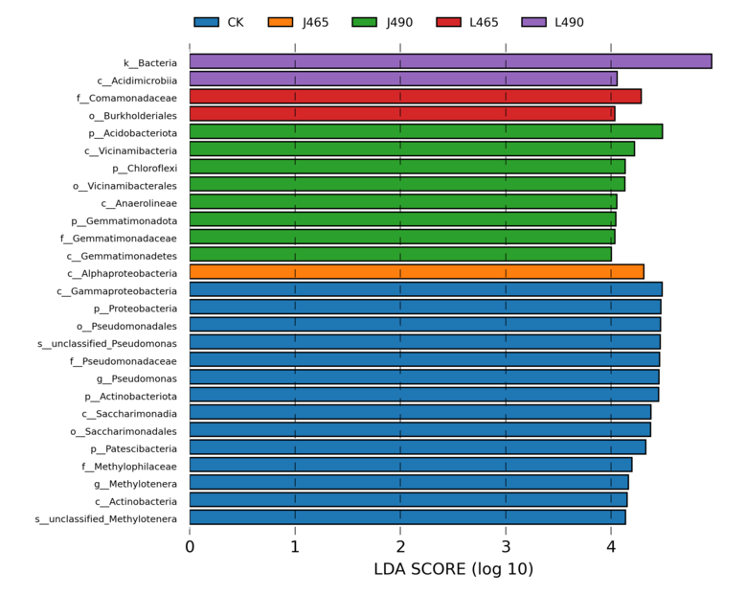
Figure S1 Histogram of distribution of LDA values

