Supplementary Information

Individual building based net-zero emission transition pathways for global cities

Yuxin Chen¹, Zhenyu Wang¹, Jing Meng², Jun Bi³, Jingwen Huo¹, Shuping Li¹, Li Zhou⁴,Peipei Chen⁵, Diling Liang², Dabo Guan^{1*}

1 Department of Earth System Science, Tsinghua University, Beijing
2 The Bartlett School of Sustainable Construction, University College London, London
3 School of the Environment, Nanjing University, Jiangsu
4 China Renewable Energy Engineering Institute, Beijing
5 Cambridge Judge Business School, University of Cambridge, Cambridge

Supplementary Figures
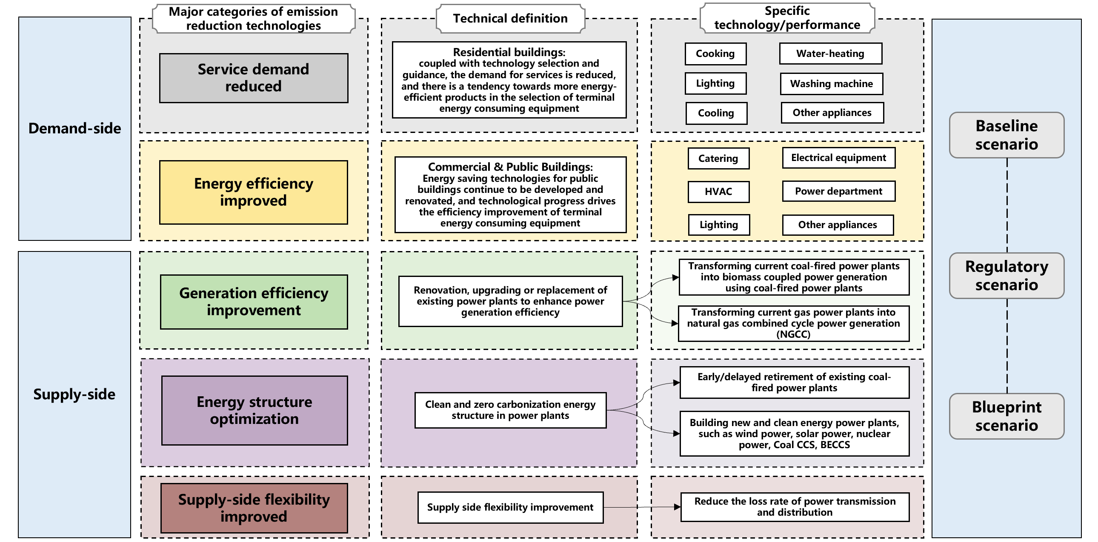
Basing on the CEADs-building model, we combine a series of macro- and micro-level parameters to assess the contributions of various emission reduction technologies under three scenarios: baseline, regulatory, and blueprint. Each scenario incorporates both demand-side and supply-side CO₂ emission reduction strategies. Given that China has the largest coal power infrastructure globally, achieving global net-zero emissions targets necessitates the rapid phasing out of coal-fired power plants within the next few decades. According to Cui et al. (2021), China's coal-fired power plants must be fully decommissioned by 2045 or 2055 to meet the climate goal of limiting temperature rise to 1.5°C or 2°C, respectively^{[1]}. Currently, coal-fired power plants are the dominant energy source and the largest emitters in Nanjing. In this study, the regulatory scenario aligns with the 2°C temperature control target, involving the complete phase-out of coal-fired power plants by 2055. The blueprint scenario, aligned with the 1.5°C target, envisions an accelerated phase-out, with all coal-fired power plants retiring by 2045.

Supplementary Figure 1 | Pathways for future emission reduction technologies and scenario framework during the operational phase of buildings in Nanjing

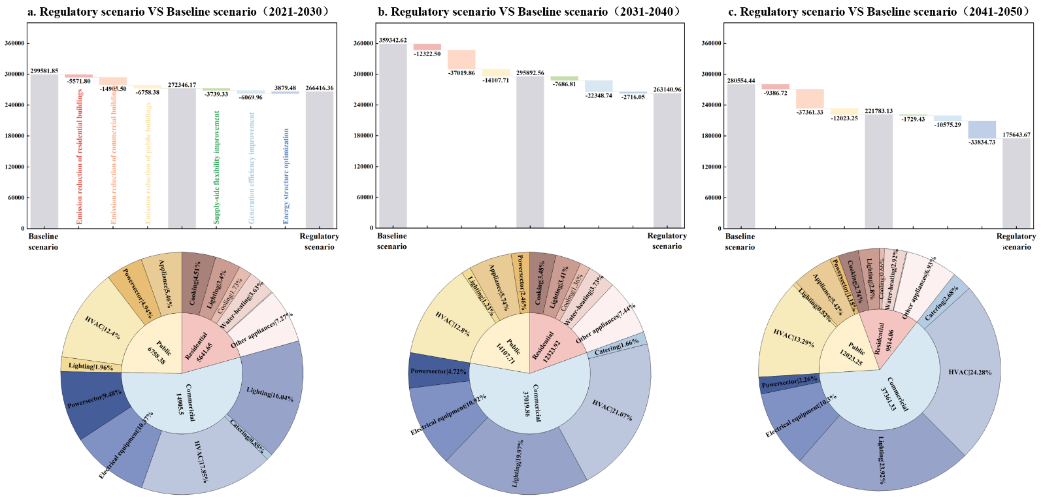
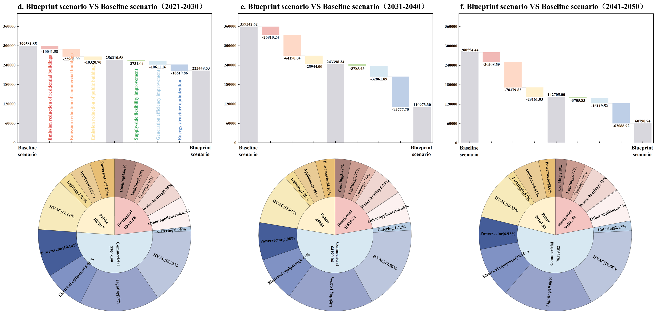
Supplementary Figure 2 | Comparison of cumulative emissions and technological contribution of each scenario under demand and supply side emission reduction technologies
(Legend: Figures 2-a, 2-b, and 2-c present a comparison of cumulative CO2 emissions resulting from energy consumption during the operational phase of buildings under the regulatory and baseline scenarios for the periods 2021-2030, 2031-2040, and 2041-2050. The waterfall charts illustrate the emission reduction technologies required to transition from the baseline to the regulatory scenario within each respective period, along with the contributions of each technology. The left half of the waterfall chart focuses on demand-side emission reduction measures, while the right half addresses supply-side measures. The sunrise plot highlights the CO2 emission reduction potential for different building types on the demand-side, as well as for various end-use energy devices within those building types. Similarly, Figures 2-d to 2-f follow the same structure, but they compare the blueprint scenario with the baseline scenario.)

In terms of demand-side emissions reduction, commercial buildings consistently demonstrate the highest absolute reductions across all time periods. Notably, the proportion of emissions reductions from commercial buildings is projected to be greater in 2041-2050 compared to 2021-2030 and 2031-2040, underscoring their substantial potential for emissions mitigation and the extended timeline required to achieve these reductions. Within this category, commercial HVAC systems, lighting, and electrical equipment are particularly significant contributors to emissions reductions. Specifically, improvements in energy efficiency and reductions in CO2 emissions per unit of electricity consumption in the commercial HVAC sector have led to emissions reductions of 4,872.96, 13,369.44, and 14,298.41 thousand metric tons of CO2 equivalent over the three decades, highlighting the critical role of HVAC systems in future energy-saving strategies. On the supply-side, the early retirement of coal-fired power plants plays the most significant role in reducing CO2 emissions between 2041 and 2050. Phasing out outdated capacity as quickly as possible facilitates the adjustment of the energy mix and the deployment of more efficient power generation technologies. Additionally, during the 2031-2040 period, significant emissions reductions are achieved by enhancing the efficiency of coal-fired power plants, specifically through their conversion to biomass-coupled facilities and the transformation of traditional gas power plants into natural gas combined cycle (NGCC) plants. This approach accounts for 68.24% of the supply-side emissions reductions during this period.

The comparison of cumulative emissions between the blueprint scenario and the baseline scenario across three time periods is illustrated in Figures 6-d, 6-e, and 6-f. In the blueprint scenario, demand-side emission reductions play a particularly significant role compared to the regulatory scenario. For example, improvements in energy efficiency for commercial lighting in the blueprint scenario result in a cumulative emission reduction of 54,835.89 thousand metric tons of CO2 equivalent from 2021 to 2050, whereas the regulatory scenario achieves a cumulative reduction of 31,137.49 thousand metric tons. This difference is likely due to the blueprint scenario's aggressive advancement of energy-saving technologies, which substantially reduces energy consumption intensity and CO2 emissions in commercial and public buildings. From a supply-side perspective, under the 2°C target, the mandated retirement of all coal-fired power plants by 2045 leads to significant emission reduction impacts, particularly between 2031 and 2050. During this period, the transition from outdated to more efficient energy sources and the restructuring of the energy mix are projected to achieve a cumulative CO2 emission reduction of 155,866.62 thousand metric tons of CO2 equivalent.

Overall, the best practice for energy consumption and CO₂ emission reduction during the operation phase of buildings is for both the demand and supply sides to exert efforts simultaneously. It can be seen that the higher the CO₂ emission reduction standards and stronger the emission reduction technologies adopted by the demand and supply sides, the greater the CO₂ emission reduction amplitude. Therefore, high standards of demand-side management, early retirement of coal-fired power plants, and other supply-side emission reduction technologies are of great importance. In the blueprint scenario, coal-fired power plants are gradually retired before reaching 30 years of operation, and when combined with transformative CO2 reduction technologies, this approach emerges as the most effective strategy for minimizing CO2 emissions associated with building operations.

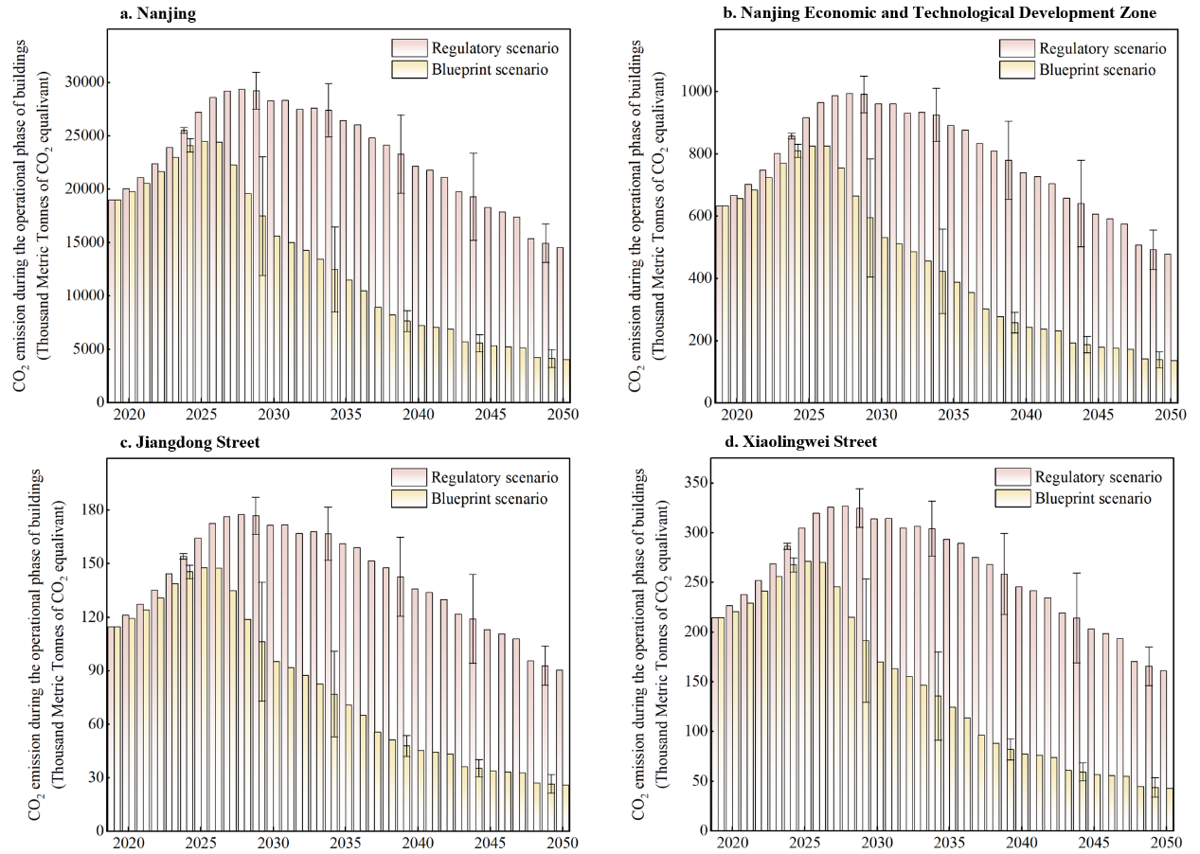
Supplementary Figure 3 | Uncertainty analysis of carbon emission in different street during the operational phase of buildings

Supplementary Tables

Supplementary Table 1 | Energy consumption level of cooking and other terminal energy use equipments in residential buildings
Scenario | Year | Final Energy Intensity（kgce/m2） |  |  |  | Share（%）
Scenario | Year | Coal | Natural Gas | LPG | Electricity | Coal | Natural Gas | LPG | Electricity
Base Year | 2019 | 2.12 | 2.12 | 2.12 | 1.86 | 8.77 | 39.5 | 34.13 | 17.6
Baseline scenario | 2030 | 1.95 | 1.95 | 1.95 | 1.25 | 7.75 | 43.75 | 29.75 | 18.75
Baseline scenario | 2060 | 0.99 | 0.99 | 0.99 | 0.35 | 4.53 | 50.36 | 5.06 | 40.05
Regulatory scenario | 2030 | 1.87 | 1.87 | 1.87 | 0.95 | 6.75 | 48.75 | 25.75 | 18.75
Regulatory scenario | 2060 | 0.87 | 0.87 | 0.87 | 0.25 | 4.007 | 51.87 | 4.19 | 40.03
Blueprint scenario | 2030 | 1.78 | 1.78 | 1.78 | 0.75 | 5.75 | 51.75 | 23.75 | 18.75
Blueprint scenario | 2060 | 0.77 | 0.77 | 0.77 | 0.15 | 3.254 | 53.38 | 3.35 | 40.02

Equipment | Year | Indicator |  | Scenario
Equipment | Year |  |  | Baseline scenario | Regulatory scenario | Blueprint scenario
Lighting | 2019 | Share(%) |  | 100 | 100 | 100
Lighting | 2019 | EF(kwh/m2) |  | 5.1 | 5.1 | 5.1
Lighting | 2050 | Share(%) |  | 100 | 100 | 100
Lighting | 2050 | EF(kwh/m2) |  | 7.3 | 6.1 | 5.3
Cooling | 2019 | Share(%) |  | 100.75 | 100.75 | 100.75
Cooling | 2019 | EF(kgce/m2) |  | 0.3394 | 0.3394 | 0.3394
Cooling | 2030 | Share(%) |  | 0.3374 | 0.3254 | 0.3174
Cooling | 2030 | EF(kgce/m2) |  | 115 | 110 | 107
Cooling | 2040 | Share(%) |  | 0.3265 | 0.3155 | 0.3015
Cooling | 2040 | EF(kgce/m2) |  | 125 | 120 | 116
Cooling | 2050 | Share(%) |  | 0.3250 | 0.3050 | 0.2900
Cooling | 2050 | EF(kgce/m2) |  | 132.5 | 127.5 | 123
Water heating | 2019 | Share(%) |  | 100 | 100 | 100
Water heating | 2019 | EF(kwh/m2) |  | 3.9 | 3.9 | 3.9
Water heating | 2050 | Share(%) |  | 100 | 100 | 100
Water heating | 2050 | EF(kwh/m2) |  | 10.4 | 9.1 | 6.2
Washing machine | 2019 | Share(%) | Drum | 55 | 55 | 55
Washing machine | 2019 | Share(%) | Wave | 45 | 45 | 45
Washing machine | 2019 | EF(tce/台) | Drum | 0.0147 | 0.0147 | 0.0147
Washing machine | 2019 | EF(tce/台) | Wave | 0.0024 | 0.0024 | 0.0024
Washing machine | 2050 | Share(%) | Drum | 27 | 24 | 15
Washing machine | 2050 | Share(%) | Wave | 73 | 76 | 85
Washing machine | 2050 | EF(tce/台) | Drum | 0.015 | 0.016 | 0.02
Washing machine | 2050 | EF(tce/台) | Wave | 0.0025 | 0.0028 | 0.0035
Other Appliances | 2019 | Share(%) |  | 100 | 100 | 100
Other Appliances | 2019 | EF(kwh/m2) |  | 7.3525 | 7.3525 | 7.3525
Other Appliances | 2050 | Share(%) |  | 100 | 100 | 100
Other Appliances | 2050 | EF(kwh/m2) |  | 12.7 | 9.9 | 9

Supplementary Table 2 | Energy consumption level of catering and other terminal energy use equipments in commercial and public buildings
Scenario | Year | Share（%） |  |  | Final Energy Intensity（kgce/m2）
Scenario | Year | Coal | Natural Gas | LPG | Coal | Natural Gas | LPG
Base Year | 2019 | 13.55 | 0.32 | 5.55 | 16.84 | 17.01 | 16.94
Baseline scenario | 2030 | 10 | 2 | 4.5 | 16 | 16.2 | 16.2
Baseline scenario | 2040 | 9.5 | 2.5 | 4 | 15.5 | 15.8 | 15.7
Baseline scenario | 2060 | 4 | 3 | 3.5 | 14.5 | 15.1 | 15
Regulatory scenario | 2030 | 9.85 | 3 | 4.45 | 15.5 | 16 | 16
Regulatory scenario | 2040 | 8 | 4 | 3.85 | 14 | 15.5 | 15.6
Regulatory scenario | 2060 | 3 | 5 | 3.05 | 13.5 | 14.6 | 14.5
Blueprint scenario | 2030 | 9.5 | 3.5 | 4.4 | 15 | 15.85 | 15
Blueprint scenario | 2040 | 6.5 | 5 | 3.65 | 13.5 | 15.2 | 15.4
Blueprint scenario | 2060 | 2 | 5.5 | 3 | 13 | 14 | 14.2

Equipment | Year | Indicator |  | Scenario
Equipment | Year |  |  | Baseline scenario | Regulatory scenario | Blueprint scenario
HVAC | 2019 | Share(%) |  | 100 | 100 | 100
HVAC | 2019 | EF(kgce/m2) |  | 42 | 42 | 42
HVAC | 2050 | Share(%) |  | 100 | 100 | 100
HVAC | 2050 | EF(kgce/m2) |  | 42 | 25 | 18
Lighting | 2019 | Share(%) |  | 100 | 100 | 100
Lighting | 2019 | EF(kwh/m2) |  | 16.6 | 16.6 | 16.6
Lighting | 2050 | Share(%) |  | 100 | 100 | 100
Lighting | 2050 | EF(kwh/m2) |  | 43.6 | 24.5 | 20
Electrical equipment | 2019 | Share(%) |  | 100 | 100 | 100
Electrical equipment | 2019 | EF(kwh/m2) |  | 13.7725 | 13.7725 | 13.7725
Electrical equipment | 2050 | Share(%) |  | 100 | 100 | 100
Electrical equipment | 2050 | EF(kwh/m2) |  | 37.1 | 29.8 | 27.9
Powersector | 2019 | Share(%) |  | 100 | 100 | 100
Powersector | 2019 | EF(kgce/m2) |  | 2.56 | 2.56 | 2.56
Powersector | 2030 | Share(%) |  | 100 | 100 | 100
Powersector | 2030 | EF(kgce/m2) |  | 2.16 | 1.87 | 1.65
Powersector | 2040 | Share(%) |  | 100 | 100 | 100
Powersector | 2040 | EF(kgce/m2) |  | 1.73 | 1.64 | 1.07
Powersector | 2050 | Share(%) |  | 100 | 100 | 100
Powersector | 2050 | EF(kgce/m2) |  | 1.36 | 1.08 | 0.11
Lighting-Public | 2019 | Share  (%) | Ordinary | 60 | 60 | 60
Lighting-Public | 2019 | Share  (%) | Energy-saving | 40 | 40 | 40
Lighting-Public | 2019 | EF  (kgce/m2) | Ordinary | 0.9 | 0.9 | 0.9
Lighting-Public | 2019 | EF  (kgce/m2) | Energy-saving | 0.3 | 0.3 | 0.3
Lighting-Public | 2030 | Share  (%) | Ordinary | 50 | 40 | 30
Lighting-Public | 2030 | Share  (%) | Energy-saving | 50 | 60 | 70
Lighting-Public | 2030 | EF  (kgce/m2) | Ordinary | 1 | 1 | 0.8
Lighting-Public | 2030 | EF  (kgce/m2) | Energy-saving | 0.3 | 0.2 | 0.14
Lighting-Public | 2045 | Share  (%) | Ordinary | 40 | 30 | 20
Lighting-Public | 2045 | Share  (%) | Energy-saving | 60 | 70 | 80
Lighting-Public | 2045 | EF  (kgce/m2) | Ordinary | 1.2 | 1.5 | 0.7
Lighting-Public | 2045 | EF  (kgce/m2) | Energy-saving | 0.2 | 0.12 | 0.02
Lighting-Public | 2060 | Share  (%) | Ordinary | 25 | 15 | 0
Lighting-Public | 2060 | Share  (%) | Energy-saving | 75 | 85 | 100
Lighting-Public | 2060 | EF  (kgce/m2) | Ordinary | 1.6 | 1.8 | 1
Lighting-Public | 2060 | EF  (kgce/m2) | Energy-saving | 0.1 | 0.04 | -0.1

Supplementary Notes

Supplementary Notes 1
Building on the baseline scenario and incorporating five key CO2 reduction strategies, we developed two additional scenarios: the regulatory scenario and the blueprint scenario. These scenarios differ based on the maturity and implementation intensity of the technological solutions employed. Both scenarios are designed to align with China's energy conservation and emission reduction targets. Consequently, the technical parameters used in this study were drawn from government policy documents and supplemented by relevant literature. The primary difference between these two scenarios lies in the specific emission reduction measures adopted, as well as variations in macroeconomic factors such as total population and GDP, which are integrated into the model. These distinctions lead to differing outcomes in terms of emission reduction effectiveness. The definitions and key distinctions among the three scenarios are as follows:
- The baseline scenario refers to the current development scenario, which takes into account various policy measures that have been issued based on the current level of social and economic development in China. The macroeconomic indicators such as the population and GDP in China continue to develop according to the current situation. The energy consumption intensity and level of public buildings are determined by the energy-saving technology level of buildings driven by China's future socio-economic development. In this scenario, the CO₂ emissions from energy use during the operation phase of buildings in Nanjing will reach 5325.45 Thousand Metric Tonnes of CO₂ equivalent by 2050.
- The regulatory scenario is positioned towards green and sustainable development, promoting the design and energy-saving renovation of public buildings in China, and completing energy-saving renovation work of large public buildings with renovation value as soon as possible. The total population and GDP of China have increased at a moderate rate, and the industrial structure has been optimized. The energy consumption intensity and level have decreased compared to the baseline scenario. Under these settings, the CO₂ emissions from energy use during the operation phase of buildings in Nanjing will be 3225.55 Thousand Metric Tonnes CO₂ equivalent.
- The blueprint scenario is the optimization scenario, which is based on achieving the "carbon neutrality" goal and further expanding the development of energy-saving technologies. The GDP growth rate has decreased and is even lower than the first two scenarios. The total population in China has reached its peak ahead of schedule and has shown a downward trend. The energy use structure has been optimized, and the energy consumption intensity and CO₂ emissions of public buildings have significantly decreased. In this scenario, CO₂ emissions will decrease to 2055.29 Thousand Metric Tonnes CO₂ equivalent by 2050.

Supplementary Notes 2
This work integrates both macro and micro-level data from device-based sources(Supplementary Tables), developing baseline, regulatory, and blueprint scenarios to forecast future energy demand and CO2 emissions during the operational phase of buildings. Based on these scenarios, we incorporate relevant emission reduction technologies from both the demand and supply sides to analyze potential emission reduction pathways, with a focus on differentiated strategies for various street types. For "Commercial and Industrial building-base streets," which are dominated by manufacturing and trade services, there is a need to enhance technological innovation to meet higher emission reduction targets. This includes improving the operational efficiency of end-use energy equipment to lower the CO2 emission intensity of commercial and service buildings. In contrast, "Life service building-base streets," characterized by high-value-added consumer services and predominantly residential buildings, should prioritize accelerating the electrification of residential energy use. For example, adopting advanced cooking technologies such as induction cookers and microwaves to replace traditional coal-fired and biomass stoves can significantly reduce emissions^{[2]}. Overall, it is essential to systematically evaluate the emission reduction priorities of different streets based on their economic development characteristics, functional roles, architectural features, and other relevant factors. This approach enables the formulation of differentiated and customized emission reduction strategies tailored to the unique needs of each area.

In addition to reducing emissions in the energy-consuming sectors on the demand-side, the implementation of supply-side emission reduction technologies is crucial for decarbonizing the operational phase of buildings (Supplementary Figure 2). Firstly, to meet climate targets, it is imperative to gradually phase out coal-fired power plants, which are major sources of emissions^{[3]}. Our findings suggest that promoting the early retirement of these coal-fired power plants can significantly alleviate future emission reduction pressures in the building sector and substantially decrease cumulative CO2 emissions from coal-based power generation. For instance, under the blueprint scenario, delaying the retirement of coal-fired power plants by just 10 years would result in an additional 158,406.4 thousand metric tons of CO2 equivalent emissions. Secondly, transforming the energy structure on the power generation side is essential for decarbonization. This involves significantly increasing the share of zero-carbon energy sources, such as wind power, photovoltaics^{[4,5]}, and nuclear power. Additionally, the deployment of zero-emission power plants, such as coal-biomass combined combustion power plants (CBECCS), should be accelerated^{[6,7]}. Our study shows that as existing coal-fired power plants are retired, the integration of zero-carbon energy plants will yield substantial emission reduction benefits. In the blueprint scenario, solar energy, wind energy, and CBECCS are projected to constitute 48.56%, 29.13%, and 8.09% of the power supply structure by 2050. Furthermore, improving the efficiency of existing coal-fired and gas-fired power plants, as well as other power generation units, will contribute significantly to reducing carbon emissions.

Supplementary Reference
[1] Cui, R. et al. A plant-by-plant strategy for high-ambition coal power phaseout in China. Nature Communications 12, 10, doi:10.1038/s41467-021-21786-0 (2021).
[2] Tang, B. J., Guo, Y. Y., Yu, B. Y. & Harvey, L. D. D. Pathways for decarbonizing China's building sector under global warming thresholds. Applied Energy 298, 15, doi:10.1016/j.apenergy.2021.117213 (2021).
[3] Jakob, M. et al. The future of coal in a carbon-constrained climate. Nature Climate Change 10, 704-707, doi:10.1038/s41558-020-0866-1 (2020).
[4] Skandalos, N. & Karamanis, D. An optimization approach to photovoltaic building integration towards low energy buildings in different climate zones. Applied Energy 295, 24, doi:10.1016/j.apenergy.2021.117017 (2021).
[5] Zhang, K. et al. Model predictive control for demand flexibility: Real-world operation of a commercial building with photovoltaic and battery systems. Advances in Applied Energy 7, 16, doi:10.1016/j.adapen.2022.100099 (2022).
[6] Xing, X. F. et al. Spatially explicit analysis identifies significant potential for bioenergy with carbon capture and storage in China. Nature Communications 12, 12, doi:10.1038/s41467-021-23282-x (2021).
[7] Fan, J. L. et al. Co-firing plants with retrofitted carbon capture and storage for power-sector emissions mitigation. Nature Climate Change 13, 807-+, doi:10.1038/s41558-023-01736-y (2023).

