Supporting Information
Synergistic Pd/Cu-Catalyzed Enantioselective Csp²–F Bond Alkylation of Fluoro-1,3-Dienes with Aldimine Esters

Huimin Yu, Qinglong Zhang and Weiwei Zi*
State Key Laboratory and Institute of Elemento-Organic Chemistry, College of Chemistry, Nankai University, Tianjin 300071, China
Table of Contents
Materials and Methods..............................................................................................................S2
Preparation and Characterization of Substrates .......................................................................S2
Reaction Condition Optimization............................................................................................S11
General Procedure for Coupling of Dienyl Flurides and Aldimine Esters..............................S14
Control Experiments...............................................................................................................S15
Characterization of Products...................................................................................................S20
References...............................................................................................................................S59
Copies of NMR Spectra .........................................................................................................S60
General Information for Computation ...................................................................................S92

Materials and Methods
Unless otherwise noted, all reactions were assembled on a Schlenk vacuum line or in a glovebox using oven-dried glassware and were stirred with Teflon-coated magnetic stirring bars. All the ligands were purchased from Strem Chemicals or Sinocompound Catalysts Co., Ltd. and were used as received. Unless otherwise noted, reagents were obtained from commercial sources and used without further purification. THF, Toluene were distilled with Na before using. Dichloromethane was distilled with CaH₂ before using. All other dried solvents (DMF, CH₃CN, 1,4-dioxane, Et₃N, DIPEA, DBU) were purchased from MERYER (Shanghai) Chemical Technology Co., Ltd. TLC analysis of reaction mixtures was performed on huanghai silica gel 60 F254 TLC plates and visualized by UV, I₂/silica, and/or ceric ammonium molybdate stain. All work-up and purification procedures were carried out with reagent grade solvents in air. Reaction temperatures above 23 °C refer to temperatures of an aluminum heating block or a silicon oil bath, which were controlled by an electronic temperature modulator from IKA. Flash chromatography was carried out with silica gel 200–300 or 300–400 mesh. ¹H and ¹³C NMR spectra were recorded with Bruker AV-400 spectrometers and were referenced to residual ¹H and ¹³C signals of the deuterated solvents respectively (δ H 7.26, δ C 77.00 for chloroform). Abbreviations are as follows: s (singlet), d (doublet), t (triplet), q (quartet), m (multiplet), br (broad). The ee value was determined on Shimadzu LC-20A HPLC workstation (Daicel chiral columns Chiralpak IA, IC, ID, IE, IF (4.6 x 250 mm)). HRMS was performed on a Varian QFT-ESI instrumental. Optical rotation were determined on a IP-digi 300/2 apparatus. Melting points were determined on an X-4B melting point apparatus.
Preparation and Characterization of Substrates
The dienyl fluride 1a¹, 4a, 4b² were known compounds. The aldimine esters used in this work were known compounds and were prepared according to literature procedure³. Among the substrates used in this work, 1b, 1c, 1d, 1e, 1f, 1g, 1h, 1i, 1j, 1k, 1l, 1m, 1n, 1o, 1p and 2g, were prepared for the first time and their preparation and characterization were given as below.
Typical procedure A for the synthesis of (Z and E)-mixtures of Dienyl Flurides 1i-1o
To a 100 ml three-neck flask , S-1 (16 mmol, 1.6 equiv) and LiBr (16 mmol, 1.6 equiv) were added. And then 30 mL THF was added under argon. The slurry was cooled to -50 °C and 6.7 mL (16 mmol, 1.6 equiv) of 2.4 M n-butyllithium solution in hexanes was added slowly by syringe (ca. 10 min). After the addition was complete, the reaction was stirred at -50 °C for 1 h, and the addition funnel was charged with the 2-fluoroacrylaldehyde S-2 (10 mmol, 1.0 equiv) and 5 ml THF. The aldehyde solution was added dropwise over 15 min and the reaction was stirred at -50 °C for 2h. The reaction was quenched with water (50 mL) and the aqueous phase was extracted with diethyl ether (3 x 20 mL). The combined organic phases were treated with brine (50 mL) and dried with MgSO₄. The organics were filtered and concentrated in vacuo. Purification by silica gel flash column chromatography afforded dienyl flurides as colorless oil.
1-(3-fluorobuta-1,3-dien-1-yl)-4-methoxybenzene
Prepared according to typical procedure A from bromo(4-methoxybenzyl)triphenylphosphorane and 2-fluoroacrylaldehyde, Colorless oil, Z/E = 2:1, 998 mg, 56% yield.
¹H NMR (400 MHz, CDCl₃) δ 7.33 – 7.27 (m, 2H), 6.86 – 6.80 (m, 2H), 6.43 (d, J = 12.7 Hz, 1H), 5.82 (dd, J = 26.7, 12.6 Hz, 1H), 4.72 (dd, J = 16.4, 0.8 Hz, 1H), 4.53 (d, J = 47.6 Hz, 1H), 3.76 (s, 3H).
¹³C NMR (101 MHz, CDCl₃) δ 162.2 (d, J = 254.7 Hz), 159.3, 132.3, 130.6 (d, J = 5.1 Hz), 128.3, 118.7 (d, J = 25.3 Hz), 113.4, 95.5 (d, J = 21.7 Hz), 55.2.
¹⁹F NMR (376 MHz, CDCl₃) δ -99.1.
1-(3-fluorobuta-1,3-dien-1-yl)naphthalene
Prepared according to typical procedure A from bromo(naphthalen-1-ylmethyl)triphenylphosphorane and 2-fluoroacrylaldehyde, Colorless oil, Z/E = 5:4, 811 mg, 41% yield.
¹H NMR (400 MHz, CDCl₃) δ 7.82 – 7.73 (m, 4H), 7.52 – 7.40 (m, 3H), 6.68 (d, J = 12.6 Hz, 1H), 6.01 (dd, J = 26.2, 12.6 Hz, 1H), 4.80 (d, J = 16.1 Hz, 1H), 4.59 (d, J = 47.7 Hz, 1H).
¹³C NMR (101 MHz, CDCl₃) δ 162.0 (d, J = 255.1 Hz), 133.6, 133.3, 132.8, 132.7, 128.4 (d, J = 3.9 Hz), 128.2, 127.7, 127.6, 126.9 (d, J = 5.4 Hz), 126.2 (d, J = 8.6 Hz), 123.4, 120.7 (d, J = 25.6 Hz), 96.3 (d, J = 21.4 Hz).
¹⁹F NMR (376 MHz, CDCl₃) δ -102.1.
2-(3-fluorobuta-1,3-dien-1-yl)furan
Prepared according to typical procedure A from bromo(furan-2-ylmethyl)triphenylphosphorane and 2-fluoroacrylaldehyde, Colorless oil, Z/E = 1:2, 621 mg, 45% yield.
¹H NMR (400 MHz, CDCl₃) δ 7.43 (d, J = 10.3 Hz, 1H), 6.76 (d, J = 11.0 Hz, 1H), 6.59 – 6.47 (m, 1H), 6.39 (d, J = 18.8 Hz, 1H), 5.77 (dd, J = 29.2, 13.3 Hz, 1H), 4.88 (d, J = 15.9 Hz, 1H), 4.71 (d, J = 48.8 Hz, 1H).
¹³C NMR (101 MHz, CDCl₃) δ 161.9 (d, J = 253.7 Hz), 151.9 (d, J = 118.2 Hz), 142.1 (d, J = 9.4 Hz), 133.8 (d, J = 19.4 Hz), 116.4 (d, J = 28.5 Hz), 114.0, 108.8, 96.1 (d, J = 22.6 Hz).
¹⁹F NMR (376 MHz, CDCl₃) δ -100.92.
2-(3-fluorobuta-1,3-dien-1-yl)thiophene
Prepared according to typical procedure A from bromotriphenyl(thiophen-2-ylmethyl)phosphorane and 2-fluoroacrylaldehyde, Colorless oil, Z/E = 2:3, 723 mg, 47% yield.
¹H NMR (400 MHz, CDCl₃) δ 7.28 (d, J = 5.1 Hz, 1H), 7.22 – 7.18 (m, 1H), 7.14 – 7.09 (m, 1H), 6.50 (d, J = 12.9 Hz, 1H), 5.74 (dd, J = 28.3, 12.9 Hz, 1H), 4.81 (d, J = 15.9 Hz, 1H), 4.62 (d, J = 46.9 Hz, 1H).
¹³C NMR (101 MHz, CDCl₃) δ 161.8 (d, J = 251.4 Hz), 138.9 (d, J = 40.4 Hz), 133.8 (d, J = 19.5 Hz), 127.9, 126.9 (d, J = 13.3 Hz), 122.9, 117.1 (d, J = 27.1 Hz), 96.2 (d, J = 22.1 Hz).
¹⁹F NMR (376 MHz, CDCl₃) δ -99.1.
3-(3-fluorobuta-1,3-dien-1-yl)-1-tosyl-1H-indole
Prepared according to typical procedure A from 3-((bromotriphenylphosphoranyl)methyl)-1-tosyl-1H-indole and 2-fluoroacrylaldehyde, Colorless oil, Z/E = 3:2, 1.7 g, 51% yield.
¹H NMR (400 MHz, CDCl₃) δ 8.02 (d, J = 10.7 Hz, 1H), 7.81 – 7.73 (m, 3H), 7.45 (t, J = 7.0 Hz, 1H), 7.34 – 7.20 (m, 2H), 7.15 – 7.09(d, J = 7.0 Hz, 2H), 6.42 (dd, J = 12.5, 6.3 Hz, 1H), 5.98 (ddd, J = 29.8, 12.6, 6.7 Hz, 1H), 4.82 (d, J = 16.3 Hz, 1H), 4.59 (d, J = 47.4 Hz, 1H), 2.22 (s, 3H).
¹³C NMR (101 MHz, CDCl₃) δ 162.3 (d, J = 255.1 Hz), 145.1, 134.8 (d, J = 64.4 Hz), 129.9, 126.9, 125.9 (d, J = 18.9 Hz), 125.2 (d, J = 12.5 Hz), 124.8, 123.5, 121.3 (d, J = 4.4 Hz), 120.6, 120.3, 119.3, 117.5, 113.6, 96.9 (d, J = 21.7 Hz), 21.5.
¹⁹F NMR (376 MHz, CDCl₃) δ -102.1.
(3-fluorobuta-1,3-dien-1-yl)cyclohexane
Prepared according to typical procedure A from bromo(cyclohexylmethyl)triphenylphosphorane and 2-fluoroacrylaldehyde, Colorless oil, Z/E = 8:1, 862 mg, 56% yield.
¹H NMR (400 MHz, CDCl₃) δ 5.60 (dd, J = 28.5, 12.0 Hz, 1H), 5.36 (dd, J = 31.8, 20.6 Hz, 1H), 4.64 (d, J = 16.9 Hz, 1H), 4.38 (d, J = 48.4 Hz, 1H), 2.31 – 2.16 (m, J = 5.2, 1H), 1.77 – 1.53 (m, 5H), 1.38 – 0.96 (m, 5H).
¹³C NMR (101 MHz, CDCl₃) δ 163.1 (d, J = 254.7 Hz), 141.5 (d, J = 2.0 Hz), 117.9 (d, J = 24.9 Hz), 93.9 (d, J = 22.1 Hz), 36.6, 33.8, 26.1, 26.0.
¹⁹F NMR (377 MHz, CDCl₃) δ -102.4.
(((4-fluoropenta-2,4-dien-1-yl)oxy)methyl)benzene
Prepared according to typical procedure A from (2-(benzyloxy)ethyl)bromotriphenylphosphorane and 2-fluoroacrylaldehyde, Colorless oil, Z/E = 2:1, 1.2 g, 65% yield.
¹H NMR (400 MHz, CDCl₃) δ 7.36 – 7.26 (m, 5H), 6.17 – 6.10 (m, 1H), 5.75 (dd, J = 11.8, 5.4 Hz, 1H), 4.67 (dd, J = 16.1, 2.6 Hz, 1H), 4.52 (s, 2H), 4.51 – 4.48 (m, 1H), 4.38 (d, J = 4.6 Hz, 2H).
¹³C NMR (101 MHz, CDCl₃) δ 162.4 (d, J = 253.8 Hz), 138.1, 132.4 (d, J = 3.3 Hz), 128.5, 127.8, 127.7, 120.8 (d, J = 26.5 Hz), 95.6 (d, J = 21.5 Hz), 72.6, 67.6 (d, J = 9.9 Hz).
¹⁹F NMR (377 MHz, CDCl₃) δ -102.6.
Typical procedure B for the synthesis of (E)-Dienyl Flurides 1a-1h
A 500 mL oven-dried round-bottom flask was charged with NaH (60% dispersion in oil, 1.2 equiv). Dry DMSO (1 M) were added to the flask and the resulting slurry solution was cooled to 0 °C. Trimethylsulfonium iodide (1.15 equiv) and DMSO (15 mL) were added to a separate oven-dried round-bottom flask. The solution was transferred slowly to the NaH solution via cannula. After the transfer was complete, acrylaldehyde S-3 (1.0 equiv) was then added to the reaction mixture in one portion. The resulting mixture was stirred at 0 °C for 1 h, then at room temperature for another 1 h and quenched with distilled water. The resulting mixture was then diluted with diethyl ether (40 mL) and brine (30 mL). The two layers were separated, and the aqueous layer was back extracted with diethyl ether (2 x 100 mL). The combined organic layer was dried with MgSO₄, filtered, and concentrated in vacuo to afford S-4 without further purification.
A 250 mL oven-dried round-bottom flask was charged with S-4 (1.0 equiv). Dry CH₂Cl₂ (0.5 M) were added to the flask and the resulting solution was cooled to 0°C. Et₃N.3HF (2.0 equiv) were added dropwise. The resulting mixture was stirred at 50 °C for 8 h, and then cooled to the room temperature . The reaction mixture was quenched by the addition of NaHCO₃ (aq.) and diluted with CH₂Cl₂. The two layers were separated, and the aqueous layer was back extracted with CH₂Cl₂ (2 x 30 mL). The combined organic layer was dried with MgSO₄, filtered, and concentrated in vacuo to afford S-5 without further purification.
To a solution of S-5 (1.0 equiv) and pyridine (1M) , TsCl (1.0 equiv) was added stepwise at room temperature and stirred 24 h. The reaction mixture was quenched by the addition of 4N HCl and diluted with CH₂Cl₂. The two layers were separated, and the aqueous layer was back extracted with CH₂Cl₂ (2 x 30 mL). The combined organic layer was dried with MgSO₄, filtered, and concentrated in vacuo. Purification by silica gel flash column chromatography afforded S-6 as a yellow oil.
In a 25 ml oven-dried Schlenk flask, S-6 (5 mmol, 1.0 equiv) and DBU (5mmol, 1.0 equiv) were added. The resulting mixture was stirred at room temperature for 9 h. Water was added and diluted with diethyl ether (3 x 10 mL). The combined organic layer was dried with MgSO₄, filtered, and concentrated in vacuo. Purification by silica gel flash column chromatography afforded dienyl fluride as colorless oil.
(E)-1-(3-fluorobuta-1,3-dien-1-yl)-4-methylbenzene
Prepared according to typical procedure B from 3-(p-tolyl)acrylaldehyde, Colorless oil, 566 mg, 70% yield.
¹H NMR (400 MHz, CDCl₃) δ 7.32 (d, J = 7.0 Hz, 2H), 7.15 (d, J = 7.4 Hz, 2H), 6.87 (d, J = 16.0 Hz, 1H), 6.48 (ddd, J = 24.9, 16.0, 1.2 Hz, 1H), 4.74 (d, J = 16.1 Hz, 1H), 4.53 (d, J = 48.5 Hz, 1H), 2.35 (s, 3H).
¹³C NMR (101 MHz, CDCl₃) δ 162.4 (d, J = 251.3 Hz), 138.5, 133.1, 130.5 (d, J = 4.0 Hz), 129.5, 126.9, 118.6 (d, J = 24.2 Hz), 93.4 (d, J = 21.7 Hz), 21.3.
¹⁹F NMR (376 MHz, CDCl₃) δ -111.9.
(E)-1-(3-fluorobuta-1,3-dien-1-yl)-3-methylbenzene
Prepared according to typical procedure B from 3-(m-tolyl)acrylaldehyde, Colorless oil, 501 mg, 62% yield.
¹H NMR (400 MHz, CDCl₃) δ 7.22 (d, J = 4.9 Hz, 3H), 7.09 (s, 1H), 6.86 (d, J = 16.0 Hz, 1H), 6.50 (dd, J = 24.8, 16.0 Hz, 1H), 4.75 (d, J = 16.1 Hz, 1H), 4.54 (dd, J = 48.5, 1.8 Hz, 1H), 2.34 (s, 3H).
¹³C NMR (101 MHz, CDCl₃) δ 162.4 (d, J = 251.6 Hz), 138.3, 135.8, 130.7 (d, J = 3.8 Hz), 130.7, 129.3, 128.7, 124.1, 119.4 (d, J = 24.1 Hz), 93.8 (d, J = 21.7 Hz), 21.4.
¹⁹F NMR (376 MHz, CDCl₃) δ -111.9.

(E)-1-fluoro-2-(3-fluorobuta-1,3-dien-1-yl)benzene
Prepared according to typical procedure B from 3-(2-fluorophenyl)acrylaldehyde, Colorless oil, 648 mg, 78% yield.
¹H NMR (400 MHz, CDCl₃) δ 7.43 (t, J = 7.4 Hz, 1H), 7.23 (dd, J = 13.2, 6.1 Hz, 1H), 7.12 – 6.99 (m, 3H), 6.62 (dd, J = 24.6, 16.2 Hz, 1H), 4.80 (dd, J = 15.9, 2.7 Hz, 1H), 4.59 (dd, J = 48.1, 2.7 Hz, 1H).
¹³C NMR (101 MHz, CDCl₃) δ 162.1 (d, J = 252.0 Hz), 160.8 (d, J = 251.2 Hz), 129.7 (d, J = 8.5 Hz), 128.0 (d, J = 3.4 Hz), 124.3 (d, J = 3.6 Hz), 123.8 (d, J = 11.8 Hz), 123.4 (dd, J = 4.5, 3.0 Hz), 122.1 (dd, J = 23.8, 6.7 Hz), 115.9 (d, J = 22.1 Hz), 94.8 (d, J = 21.4 Hz).
¹⁹F NMR (376 MHz, CDCl₃) δ -112.4, -116.4.
(E)-1-fluoro-3-(3-fluorobuta-1,3-dien-1-yl)benzene
Prepared according to typical procedure B from 3-(3-fluorophenyl)acrylaldehyde, Colorless oil, 621 mg, 75% yield.
¹H NMR (400 MHz, CDCl₃) δ 7.36 – 7.25 (m, 1H), 7.16 (dd, J = 25.0, 8.6 Hz, 2H), 6.98 (t, J = 8.2 Hz, 1H), 6.86 (d, J = 16.0 Hz, 1H), 6.52 (ddd, J = 24.5, 16.1, 2.1 Hz, 1H), 4.82 (d, J = 16.0 Hz, 1H), 4.61 (d, J = 48.2 Hz, 1H).
¹³C NMR (101 MHz, CDCl₃) δ163.1 (d, J = 245.2 Hz), 162.3 (d, J = 251.2 Hz), 138.1 (d, J = 7.2 Hz), 130.2 (d, J = 8.4 Hz), 129.4 (dd, J = 6.4, 3.2 Hz), 122.9 (d, J = 2.7 Hz), 120.9 (d, J = 27.0 Hz), 115.3 (d, J = 21.4 Hz), 113.2 (d, J = 21.9 Hz), 94.9 (d, J = 21.3 Hz).
¹⁹F NMR (376 MHz, CDCl₃) δ -116.9, -117.9.
(E)-1-fluoro-4-(3-fluorobuta-1,3-dien-1-yl)benzene
Prepared according to typical procedure B from 3-(4-fluorophenyl)acrylaldehyde, Colorless oil, 563 mg, 68% yield.
¹H NMR (400 MHz, CDCl₃) δ 7.39 (dd, J = 7.9, 5.7 Hz, 2H), 7.03 (t, J = 8.5 Hz, 2H), 6.85 (d, J = 16.0 Hz, 1H), 6.44 (dd, J = 24.6, 16.0 Hz, 1H), 4.77 (dd, J = 16.1, 2.4 Hz, 1H), 4.56 (dd, J = 48.4, 2.4 Hz, 1H).
¹³C NMR (101 MHz, CDCl₃) δ 162.8 (d, J = 248.6 Hz), 162.0 (d, J = 251.5 Hz), 132.0 (d, J = 3.4 Hz), 129.4 (d, J = 4.3 Hz), 128.5 (d, J = 8.1 Hz), 119.4 (dd, J = 24.3, 2.4 Hz), 115.8 (d, J = 21.8 Hz), 94.0 (d, J = 20.9 Hz).
¹⁹F NMR (376 MHz, CDCl₃) δ -116.8, -117.5.
(E)-1-chloro-4-(3-fluorobuta-1,3-dien-1-yl)benzene
Prepared according to typical procedure B from 3-(3- chlorophenyl)acrylaldehyde, Colorless oil, 746 mg, 82% yield.
¹H NMR (400 MHz, CDCl₃) δ 7.39 – 7.27 (m, 4H), 6.83 (d, J = 16.0 Hz, 1H), 6.48 (dd, J = 24.6, 16.0 Hz, 1H), 4.79 (dd, J = 16.0, 2.9 Hz, 1H), 4.57 (dd, J = 48.2, 2.8 Hz, 1H).
¹³C NMR (101 MHz, CDCl₃) δ 161.9 (d, J = 251.6 Hz), 134.3, 134.1, 129.3 (d, J = 4.1 Hz), 128.9, 128.1, 120.2 (d, J = 24.4 Hz), 94.5 (d, J = 21.3 Hz).
¹⁹F NMR (376 MHz, CDCl₃) δ -112.0.
(E)-1-(3-fluorobuta-1,3-dien-1-yl)-4-(trifluoromethyl)benzene
Prepared according to typical procedure B from 3-(3-(trifluoromethyl)phenyl)acrylaldehyde, Colorless oil, 831 mg, 77% yield.
¹H NMR (400 MHz, CDCl₃) δ 7.59 (d, J = 8.3 Hz, 2H), 7.50 (d, J = 8.2 Hz, 2H), 6.90 (d, J = 16.0 Hz, 1H), 6.59 (dd, J = 24.4, 16.0 Hz, 1H), 4.85 (dd, J = 15.8, 2.9 Hz, 1H), 4.64 (dd, J = 48.0, 2.9 Hz, 1H).
¹³C NMR (101 MHz, CDCl₃) δ 161.7 (d, J = 251.9 Hz), 139.3, 130.1 (q, J = 32.5 Hz), 129.0 (d, J = 3.8 Hz), 127.0, 125.7 (q, J = 3.8 Hz), 124.1 (d, J = 272.0 Hz), 122.0 (d, J = 24.4 Hz), 95.6 (d, J = 21.3 Hz).
¹⁹F NMR (376 MHz, CDCl₃) δ -62.6, -112.1.
Typical procedure C for the synthesis of Dienyl Fluride 1p
A mixture of diethylsulfide S-7 (100 mmol, 1.0 equiv.) and diethylsulfate (100mmol, 1.0 equiv.) in acetonitrile (20 ml) is heated to reflux during 2.5 hours. Acetonitrile is evaporated under vacuum and the remaining oil is washed several times with dry ether. Residual solvents are removed under vacuum. The salt S-8 was used directly for the epoxidations.
A 500 mL oven-dried round-bottom flask was charged with NaH (60% dispersion in oil, 1.2 equiv). Dry DMSO (1 M) were added to the flask and the resulting slurry solution was cooled to 0 °C. S-8 (1.15 equiv) and DMSO (15 mL) were added to a separate oven-dried round-bottom flask. The solution was transferred slowly to the NaH solution via cannula. After the transfer was complete, (E)-cinnamaldehyde (1.0 equiv ) was then added to the reaction mixture in one portion. The resulting mixture was stirred at 0 °C for 1 h, then at room temperature for another 1 h and quenched with distilled water. The resulting mixture was then diluted with diethyl ether (40 mL) and brine (30 mL). The two layers were separated, and the aqueous layer was back extracted with diethyl ether (2 x 100 mL). The combined organic layer was dried with MgSO₄, filtered, and concentrated in vacuo to afford S-9 without further purification.
A 250 mL oven-dried round-bottom flask was charged with S-9 (1.0 equiv). Dry CH₂Cl₂ (0.5 M) were added to the flask and the resulting solution was cooled to 0 °C. Et₃N.3HF (2.0 equiv) were added dropwise. The resulting mixture was stirred at 50 °C for 8 h, and then cooled to the room temperature. The reaction mixture was quenched by the addition of NaHCO₃ (aq.) and diluted with CH₂Cl₂. The two layers were separated, and the aqueous layer was back extracted with CH₂Cl₂ (2 x 30 mL). The combined organic layer was dried with MgSO₄, filtered, and concentrated in vacuo to afford S-10 without further purification.
To a solution of S-10 (1.0 equiv) and pyridine (1M), TsCl (1.0 equiv) was added stepwise at room temperature and stirred 24 h. The reaction mixture was quenched by the addition of 4N HCl and diluted with CH₂Cl₂. The two layers were separated, and the aqueous layer was back extracted with CH₂Cl₂ (2 x 30 mL). The combined organic layer was dried with MgSO₄, filtered, and concentrated in vacuo. Purification by silica gel flash column chromatography afforded S-11 as a yellow oil.
In a 25 ml oven-dried Schlenk flask, S-11 (5 mmol, 1.0 equiv) and DBU (5 mmol, 1.0 equiv) were added. The resulting mixture was stirred at room temperature for 9 h. Water was added and diluted diethyl ether (3 x 10 mL). The combined organic layer was dried with MgSO₄, filtered, and concentrated in vacuo. Purification by silica gel flash column chromatography afforded 1p as colorless oil.
((1E)-3-fluoropenta-1,3-dien-1-yl)benzene
Prepared according to typical procedure C, Colorless oil, 550 mg, 68% yield.
¹H NMR (400 MHz, CDCl₃) δ 7.39 – 7.34 (m, 2H), 7.30 (m, 7.32-7.28, 3H), 6.93 – 6.68 (m, 2H), 4.89 (dq, J = 36.0, 7.2 Hz, 1H), 1.72 (t, J = 2.5 Hz, 3H).
¹³C NMR (101 MHz, CDCl₃) δ 157.5 (d, J = 247.6 Hz), 136.5, 128.7, 127.9, 127.5 (d, J = 3.6 Hz), 126.7, 120.4 (d, J = 24.0 Hz), 106.2 (d, J = 17.5 Hz), 9.8 (d, J = 5.8 Hz).
¹⁹F NMR (377 MHz, CDCl₃) δ -125.2.
Aldimine ester 2g is a new compound, and its NMR data is as follows.
(E)-methyl 3-(tert-butoxy)-2-((4-fluorobenzylidene)amino)propanoate
¹H NMR (400 MHz, CDCl₃) δ 8.42 (s, 1H), 7.98 – 7.90 (m, 2H), 7.24 (t, J = 8.4 Hz, 2H), 4.29 (t, J = 6.4 Hz, 1H), 4.07 (dd, J = 8.7, 5.8 Hz, 1H), 3.91 (s, 3H), 3.77 (t, J = 8.2 Hz, 1H), 1.30 (s, 9H).
¹³C NMR (101 MHz, CDCl₃) δ 171.2, 164.6 (d, J = 251.2 Hz), 163.1, 132.1 (d, J = 2.4 Hz), 130.5 (d, J = 8.7 Hz), 115.7 (d, J = 21.9 Hz), 73.6, 73.3, 62.9, 52.1, 27.5.
¹⁹F NMR (376 MHz, CDCl₃) δ -108.8.

Reaction Condition Optimization

Table S1. Investigation of the Bases ª
entry | Pd cat. | Base | yield (%)^{b} | ee (%)^{c}
1 | Pd-1 | Et₃N | 53 | 96
2 | Pd-1 | ^{i}Pr₂NEt | trace | N.D
3 | Pd-1 | DBU | NR | -
4 | Pd-1 | DABCO | 40 | 96
5 | Pd-1 | Cs₂CO₃ | NR | -
ªReaction conditions: i) 1a (0.2 mmol), 2a (0.1 mmol), Pd cat. (4 mol%), Cu(MeCN)₄PF₆ (5 mol %), (S,S_{p})-L (5.5 mol%), base (200 mol %), THF (0.5 mL), 30 °C, 24 h; ii) citric acid (10%, 4 mL). ^{b}Isolated yields. NR, no reaction. N.D, not determined. ^{c}Determined by HPLC.
Table S2. Investigation of the Solvents ª
entry | Pd cat. | Solvent | yield (%)^{b} | ee (%)^{c}
1 | Pd-1 | THF | 53 | 96
2 | Pd-1 | 1,4-Dioxane | 38 | 98
3 | Pd-1 | DMF | trace | N.D
4 | Pd-1 | Toluene | trace | N.D
5  6 | Pd-1  Pd-1 | MeCN  DCM | trace  40 | N.D  96
ªReaction conditions: i) 1a (0.2 mmol), 2a (0.1 mmol), Pd cat. (4 mol%), Cu(MeCN)₄PF₆ (5 mol %), (S,S_{p})-L (5.5 mol%), base (200 mol %), THF (0.5 mL), 30 °C, 24 h; ii) citric acid (10%, 4 mL). ^{b}Isolated yields. N.D, not determined. ^{c}Determined by HPLC
Table S3. Investigation of the Ligands for Pd ª
entry | Pd cat. | Cu ligand L | yield (%)^{b} | ee (%)^{c}
1 | L4-Pd | (S,S_{p})-L1 | trace | N.D
2 | L5-Pd | (S,S_{p})-L1 | trace | N.D
3 | L6-Pd | (S,S_{p})-L1 | trace | N.D
4 | L7-Pd | (S,S_{p})-L1 | trace | N.D
5 | L8-Pd | (S,S_{p})-L1 | 53 | 96
6 | L9-Pd | (S,S_{p})-L1 | 50 | 98
7 | L10-Pd | (S,S_{p})-L1 | 73 | 99
8 | L11-Pd | (S,S_{p})-L1 | 87 | 96
9 | L12-Pd | (S,S_{p})-L1 | 81 | 99
10 | L13-Pd | (S,S_{p})-L1 | 70 | 94
ªReaction conditions: i) 1a (0.2 mmol), 2a (0.1 mmol), Pd cat. (4 mol%), Cu(MeCN)₄PF₆ (5 mol %), (S,S_{p})-L (5.5 mol%), Et₃N (200 mol %), THF (0.5 mL), 30 °C, 24 h; ii) citric acid (10%, 4 mL). ^{b}Isolated yields. NR, no reaction. N.D, not determined. ^{c}Determined by HPLC.
Table S4. Investigation of the Ligands for Cu ª

entry | Pd cat. | Cu ligand L | yield (%)^{b} | ee (%)^{c}
1 | L11-Pd | (S,S_{p})-L1 | 87 | 96
2 | L11-Pd | (S,S_{p})-L3 | 86 | 99
3 | L11-Pd | (S,S_{p})-L2 | 75 | 98
4 | ent-L11-Pd | (S,S_{p})-L1 | 86 | 95
5 | ent-L11-Pd | (S,S_{p})-L3 | 82 | 93
6 | ent-L11-Pd | (S,S_{p})-L2 | 82 | 97
7 | - | (S,S_{p})-L3 | NR | -
8 | L11-Pd | - | NR | -

ªReaction conditions: i) 1a (0.2 mmol), 2a (0.1 mmol), L11-Pd, ent-L11-Pd-(4 mol%), Cu(MeCN)₄PF₆ (5 mol %), (S,S_{p})-L (5.5 mol%), Et₃N (200 mol %), solvent (0.5 mL), 30 °C, 24 h; ii) citric acid (10%, 4 mL). ^{b}Isolated yields. NR, no reaction. ^{c}Determined by HPLC.

General Procedure for Coupling of Dienyl Flurides with Aldimine Esters
Pd catalyst preparation: In an Ar-filled glove box, to a dried Schlenk tube were added (S)-DT-Biphep(0.6 mmol) and [Pd(η³-allyl)Cl]₂ (0.3 mmol), dry DCM (5 mL) was then added and the mixture was stirred at room temperature for 1 h, then AgBF₄ (0.6 mmol) was added and the mixture was stirred for another 1 h. The mixture was removed from the glove box. The solution was filtered through a pad of celite eluting with CH₂Cl₂ (5 mL x 3) and the filtrate was concentrated in vacuo to afford catalyst L11-Pd as a yellow solid, which was stored at -20 °C under inert atmosphere. The palladium catalyst was used without further purification. The ent-L11-Pd catalyst was prepared using the same procedure but employing (R)-DT-Biphep as the ligand.
Coupling reaction procedure A: In glove box, Cu(MeCN)₄PF₆ (3.7 mg, 0.01 mmol, 5 mol%) and chiral ligand (S,S_{p})-L3 (5.3 mg, 0.011 mmol, 5.5 mol%) were dissolved in dry THF (0.4 M, 0.5 mL) and stirred at room temperature for 0.5 h. To the solution, substrate aldimine esters 2 (0.2 mmol), Et₃N (0.4 mmol), dienes (0.4 mmol) and palladium catalyst L11-Pd or ent-L11-Pd (10.1 mg, 0.008 mmol, 4 mol%) were added sequentially. The reaction mixture was stirred at 30 °C for 24h. To the reaction mixture was added citric acid solution (4 mL, 10 wt.%) and the mixture was stirred for 2 h. The mixture was neutralized with solid K₂CO₃ and extracted with EtOAc (10 mL x 3). The combined extracts were dried over MgSO₄ and concentrated in vacuo to afford a residue. The residue was then purified by SiO₂ column chromatography (PE/EA = 5:1 to 1:1) to give the desired product.
Reactions in Table 1 and Table 2 were performed using the above procedure A.
Coupling reaction procedure B: In glove box, Cu(MeCN)₄PF₆ (3.7 mg, 0.01 mmol, 5 mol%) and chiral ligand (S,S_{p})-L3 (5.3 mg, 0.011 mmol, 5.5 mol%) were dissolved in dry THF (0.4M, 0.5 mL) and stirred at room temperature for 0.5 h. To the solution, substrate aldimine esters 2 (0.2 mmol), Et₃N (0.4 mmol), dienes (0.4 mmol) and L11-Pd (10.1 mg, 0.008 mmol, 4 mol%) were added sequentially. The reaction mixture was stirred at 30 °C for 48 h. To the reaction mixture was added citric acid solution (4 mL, 10 wt.%) and the mixture was stirred for 2 h. The mixture was neutralized with solid K₂CO₃ and extracted with EtOAc (10 mL x 3). The combined extracts were dried over MgSO₄ and concentrated in vacuo to afford a residue. The residue was then purified by SiO₂ column chromatography (PE/EA = 5:1 to 1:1) to give the desired product.
Reactions in Table 3 were performed using the above procedure B.
Coupling reaction procedure C: In glove box, Cu(MeCN)₄PF₆ (3.7 mg, 0.02 mmol, 10 mol%) and chiral ligand (S,S_{p})-L3 (5.3 mg, 0.022 mmol, 11 mol%) were dissolved in dry THF (1M, 0.2 mL) and stirred at room temperature for 0.5 h. To the solution, substrate aldimine ester 2 (0.2 mmol), Et₃N (0.4 mmol), diene (0.4 mmol) and L11-Pd (20.2 mg, 0.016 mmol, 8 mol%) were added sequentially. The reaction mixture was stirred at 40 °C for 96 h. To the reaction mixture was added citric acid solution (4 mL, 10 wt.%) and the mixture was stirred for 2 h. The mixture was neutralized with solid K₂CO₃ and extracted with EtOAc (10 mL x 3). The combined extracts were dried over MgSO₄ and concentrated in vacuo to afford a residue. The residue was then purified by SiO₂ column chromatography (PE/EA = 5:1 to 1:1) to give the desired product.
Control Experiments
In glove box, Cu(MeCN)₄PF₆ (3.7 mg, 0.01 mmol, 5 mol%) and chiral ligand (S,S_{p})-L3 (5.3 mg, 0.011 mmol, 5.5 mol%) were dissolved in dry THF (0.4 M, 0.5 mL) and stirred at room temperature for 0.5 h. To the solution, substrate aldimine ester 2a (0.2 mmol), Et₃N (0.4 mmol), >20:1 or 1:1 E/Z-1a (0.4 mmol) and palladium catalyst L11-Pd (10.1 mg, 0.008 mmol, 4 mol%) were added sequentially. The reaction mixture was stirred at 30 °C for 24h. To the reaction mixture was added citric acid solution (4 mL, 10 wt.%) and the mixture was stirred for 24 h. The mixture was neutralized with solid K₂CO₃ and extracted with EtOAc (10 mL x 3). The combined extracts were dried over MgSO₄ and concentrated in vacuo to afford a residue. The residue was then purified by SiO₂ column chromatography (PE/EA = 5:1 to 1:1) to give > 20:1 E/Z-3aa. (Figure S1)
Figure S1
In glove box, Cu(MeCN)₄PF₆ (3.7 mg, 0.01 mmol, 5 mol%) and chiral ligand (S,S_{p})-L3 (5.3 mg, 0.011 mmol, 5.5 mol%) were dissolved in dry THF (0.4 M, 0.5 mL) and stirred at room temperature for 0.5 h. To the solution, substrate aldimine ester 2a (0.2 mmol), Et₃N (0.4 mmol), 1:1 E/Z-1a (0.4 mmol) and palladium catalyst L11-Pd (10.1 mg, 0.008 mmol, 4 mol%) were added sequentially. The reaction mixture was stirred at 30 °C. Aliquots(10ul) were taken every 3 hour and the Z/E of 1a was monitored by GC-MS. (Figure S2)
Figure S2

In glove box, Cu(MeCN)₄PF₆ (3.7 mg, 0.01 mmol, 5 mol%) and chiral ligand (S,S_{p})-L3 (5.3 mg, 0.011 mmol, 5.5 mol%) were dissolved in dry THF (0.4 M, 0.5 mL) and stirred at room temperature for 0.5 h. To the solution, substrate aldimine ester 2 (0.2 mmol), Et₃N (0.4 mmol), dienyl bromide 4a or dienyl chloride 4b (0.4 mmol) and palladium catalyst L11-Pd (10.1 mg, 0.008 mmol, 4 mol%) were added sequentially. The reaction mixture was stirred at 30 °C for 24h. Almost none of the coupling product 3aa was observed. (Figure S3)
Figure S3
To a 50 ml three-neck flask, 2a (10 mmol, 1 equiv) and K₂CO₃ (15 mmol, 1.5 equiv) were added. And then 5 mL CH₃OD (98% D) was added under argon. The reaction was stirred at room temperature for 24 h. The organics were filtered and concentrated in vacuo afforded 2a-d as yellow oil. Deuterium rate was determined by ¹H NMR analysis in CD₂Cl₂. (Figure S4)
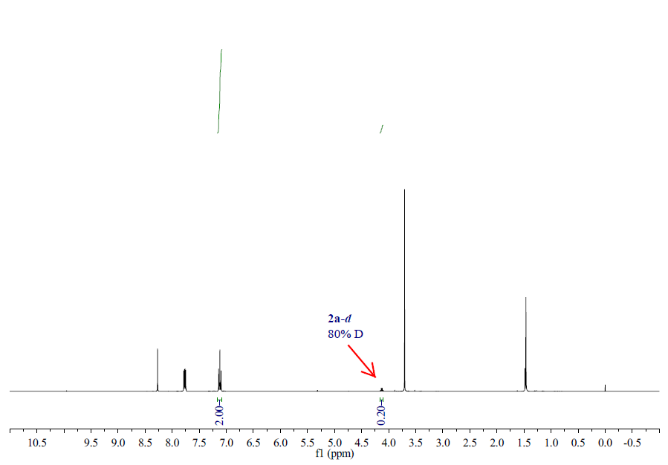
Figure S4
In glove box, Cu(MeCN)₄PF₆ (3.7 mg, 0.01 mmol, 5 mol%) and chiral ligand (S,S_{p})-L3 (5.3 mg, 0.011 mmol, 5.5 mol%) were dissolved in dry THF (0.4 M, 0.5 mL) and stirred at room temperature for 0.5 h. To the solution, substrate deuterium-labeled 2a (80% D, 0.2 mmol), Et₃N (0.4 mmol), 1a (0.4 mmol) and palladium catalyst L11-Pd (10.1 mg, 0.008 mmol, 4 mol%) were added sequentially. The reaction mixture was stirred at 30 °C for 24h. To the reaction mixture was added citric acid solution (4 mL, 10 wt.%) and the mixture was stirred for 2 h. The mixture was neutralized with solid K₂CO₃ and extracted with EtOAc (10 mL x 3). The combined extracts were dried over MgSO₄ and concentrated in vacuo to afford a residue. The residue was then purified by SiO₂ column chromatography (PE/EA = 5:1 to 1:1) to give 3aa (30% D). (Figure S5)
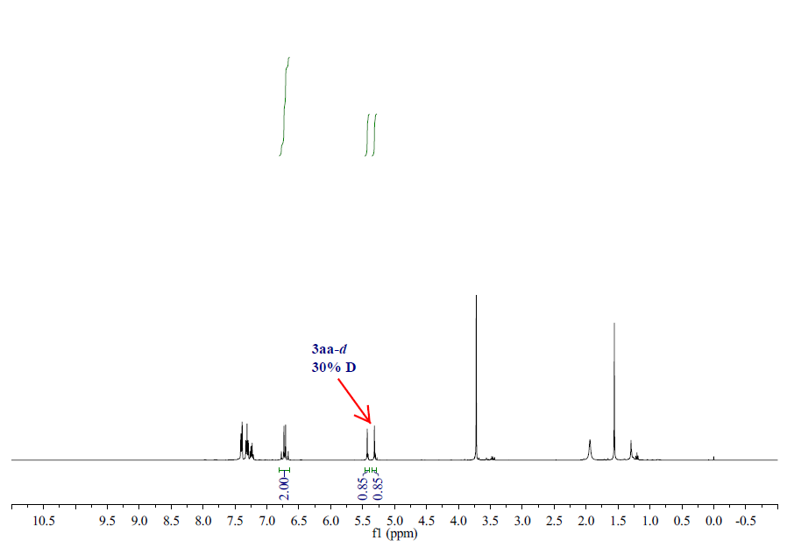
Figure S5
In glove box, Cu(MeCN)₄BF₄ (15.7 mg, 0.05 mmol, 1.0 equiv) and chiral ligand (S,S_{p})-L3 (24.1 mg, 0.05 mmol, 1.0 equiv ) were dissolved in d⁸-THF (0.5 mL) and stirred at room temperature for 0.5 h. Cu-3 was used to determined by ³¹P NMR analysis. (Figure S6)
³¹P NMR (162 MHz, THF) δ -20.48.
Figure S6
In glove box, Cu(MeCN)₄BF₄ (15.7 mg, 0.05 mmol, 1.0 equiv) and chiral ligand (S,S_{p})-L3 (24.1 mg, 0.05 mmol, 1.0 equiv) were dissolved in d⁸-THF (0.5 mL) and stirred at room temperature for 0.5 h. To the solution, substrate 2a (10.5mg, 0.05 mmol, 1.0 equiv) was added. The reaction mixture was stirred at 30 °C for 2h. Cu-Nu was used to determined by ³¹P NMR analysis.(Figure S7)
³¹P NMR (162 MHz, THF) δ -20.87.
Figure S7
In glove box, Cu(MeCN)₄BF₄ (15.7 mg, 0.05 mmol, 1.0 equiv) and chiral ligand (S,S_{p})-L3 (24.1 mg, 0.05 mmol, 1.0 equiv ) were dissolved in d⁸-THF (0.5 mL) and stirred at room temperature for 0.5 h. To the solution, substrate 2a (10.5 mg, 0.05 mmol, 1.0 equiv), DBU ( 7 uL, 0.05 mmol, 1.0 equiv) were added sequentially. The reaction mixture was stirred at 30°C for 2h. Cu-azomethine ylide was used to determined by ³¹P NMR analysis. (Figure S8)
³¹P NMR (162 MHz, THF) δ -16.09, -21.17.
Figure S8
Characterization of Products
(S,E)-methyl 2-amino-2-methyl-3-methylene-5-phenylpent-4-enoate
Prepared according to General Procedure A using L11-Pd and (S,S_{p})-L3-Cu, Purification by flash chromatography (PE/EA = 5:1 to 1:1) afforded the product, pale yellow oil, 86% yield , 99% ee, R_{f} = 0.4 (PE/EA, 1:1).
[α]²⁵_{D} = 19.1 (c 1.0, CHCl₃)
¹H NMR (400 MHz, CDCl₃) δ 7.40 (d, J = 7.4 Hz, 2H), 7.31 (t, J = 7.5 Hz, 2H), 7.27 – 7.19 (m, 1H), 6.72 (q, J = 16.3 Hz, 2H), 5.43 (s, 1H), 5.31 (s, 1H), 3.72 (s, 3H), 2.01 (s, 2H), 1.56 (s, 3H).
¹³C NMR (101 MHz, CDCl₃) δ 176.6, 148.7, 136.9, 130.5, 128.6, 127.8, 126.8, 126.6, 112.3, 60.50, 52.6, 25.7.
HRMS (ESI) calcd. for C₁₄H₂₀NO₂⁺ (M + H)⁺: 232.1338, Found: 232.1331
the ee value was 99%, t_{r} (major) = 25.016 min, t_{r} (minor) = 34.565 min, (Chiralcel IC, λ = 220 nm, hexanes : ^{i}PrOH = 98 : 2, flow rate = 1.0 mL/min).
(检测器 A = detector A, 总计 = total)
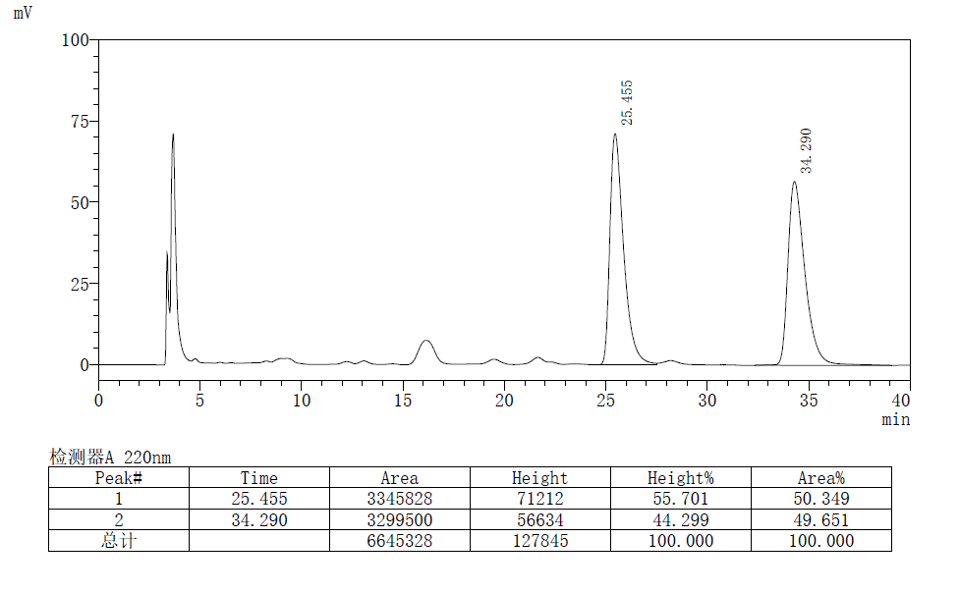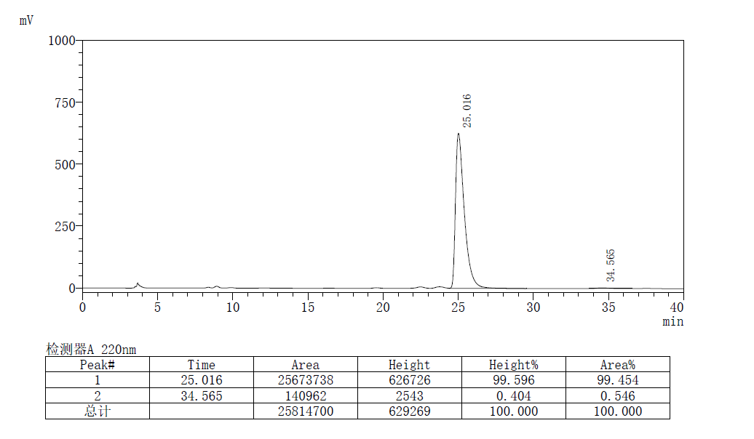
(S,E)-methyl 2-amino-2-methyl-3-methylene-5-(p-tolyl)pent-4-enoate
Prepared according to General Procedure A using L11-Pd and (S,S_{p})-L3-Cu, Purification by flash chromatography (PE/EA = 5:1 to 1:1) afforded the product as a pale yellow oil, 39.5 mg, 81 % yield, 98% ee, R_{f} = 0.4 (PE/EA, 1:1).
[α]²⁵_{D} = 5.3 (c 1.0, CHCl₃)
¹H NMR (400 MHz, CDCl₃) δ 7.29 (d, J = 8.0 Hz, 2H), 7.12 (d, J = 7.9 Hz, 2H), 6.68 (q, J = 16.2 Hz, 2H), 5.40 (s, 1H), 5.29 (s, 1H), 3.72 (s, 3H), 2.33 (s, 3H), 1.96 (s, 2H), 1.55 (s, 3H).
¹³C NMR (101 MHz, CDCl₃) δ 176.6, 148.8, 137.7, 134.2, 130.4, 129.3, 126.5, 125.7, 111.8, 60.54, 52.6, 25.8, 21.2.
HRMS (ESI) calcd. for C₁₄H₂₀NO₂⁺ (M + H)⁺: 246.1494, Found: 246.1486
the ee value was 98%, t_{r} (major) = 16.486 min, t_{r} (minor) = 23.556 min (Chiralcel IC, λ = 220 nm, hexanes : ^{i}PrOH = 95 : 5, flow rate = 1.0 mL/min).
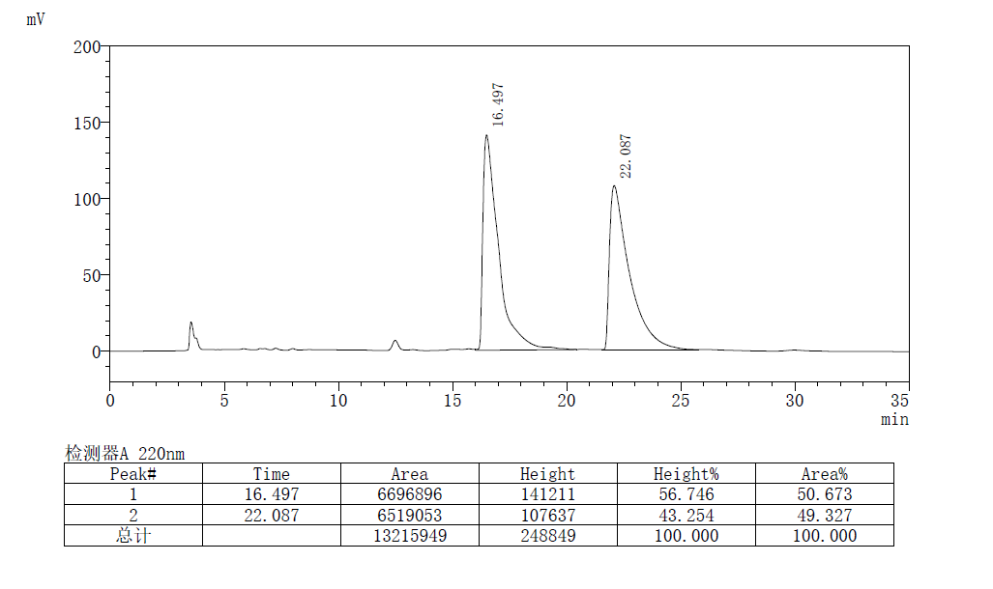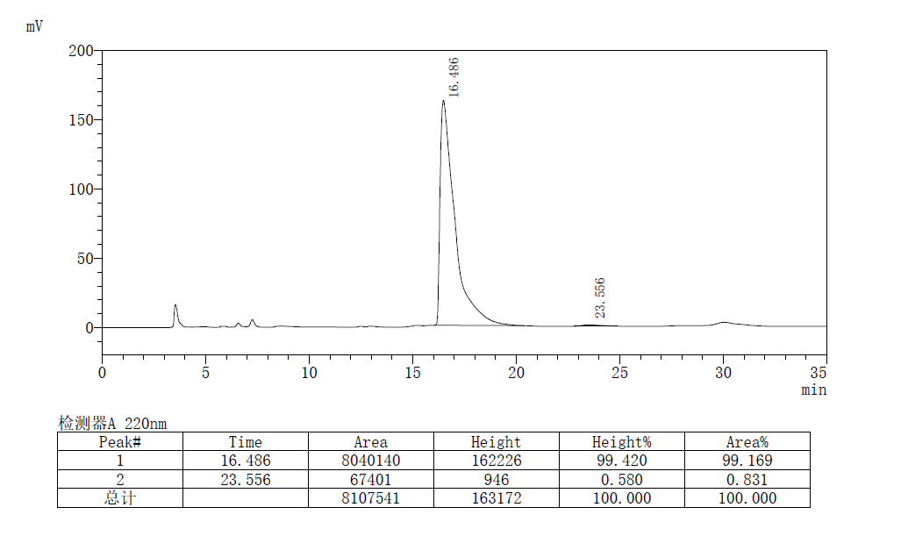
(S,E)-methyl 2-amino-2-methyl-3-methylene-5-(m-tolyl)pent-4-enoate
Prepared according to General Procedure A using L11-Pd and (S,S_{p})-L3-Cu, Purification by flash chromatography (PE/EA = 5:1 to 1:1) afforded the product as a pale yellow oil, 38 mg, 79% yield, >99% ee, R_{f} = 0.4 (PE/EA, 1:1).
[α]²⁵_{D} = 20.7 (c 1.0, CHCl₃)
¹H NMR (400 MHz, CDCl₃) δ 7.20 (d, J = 4.8 Hz, 3H), 7.05 (s, 1H), 6.79 – 6.63 (m, 2H), 5.41 (s, 1H), 5.30 (s, 1H), 3.72 (s, 3H), 2.34 (s, 3H), 1.94 (s, 2H), 1.56 (s, 3H).
¹³C NMR (101 MHz, CDCl₃) δ 176.6, 148.8, 138.2, 136.9, 130.6, 128.6, 128.5, 127.3, 126.5, 123.8, 112.1, 60.5, 52.6, 25.8, 21.4.
HRMS (ESI) calcd. for C₁₄H₂₀NO₂⁺ (M + H)⁺: 246.1494, Found: 246.1485
the ee value was > 99%, t_{r} (major) = 14.677 min, t_{r} (minor) = 18.779 min (Chiralcel IC, λ = 220 nm, hexanes : ^{i}PrOH = 95 : 5, flow rate = 1.0 mL/min).
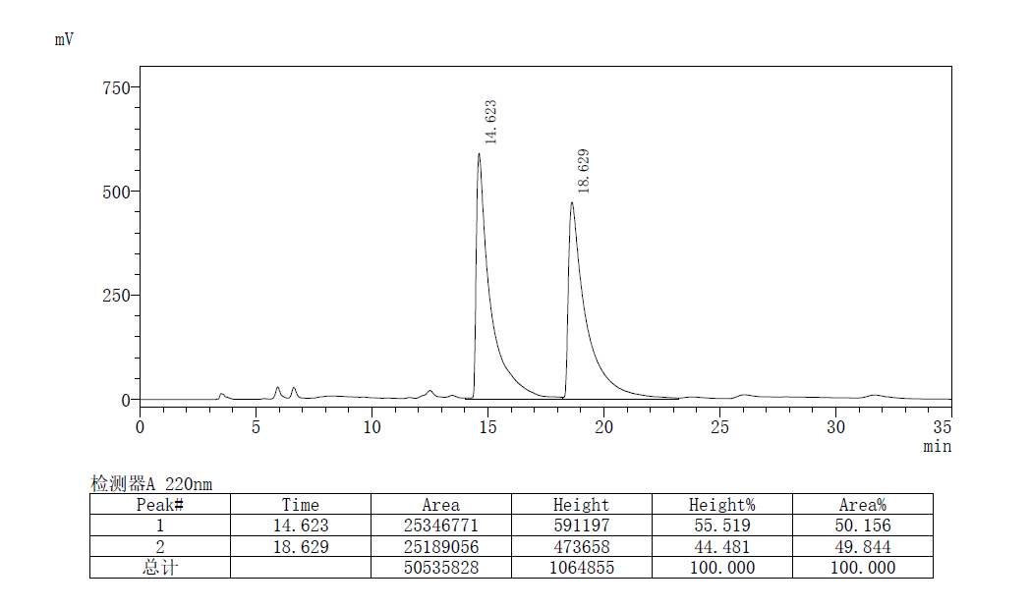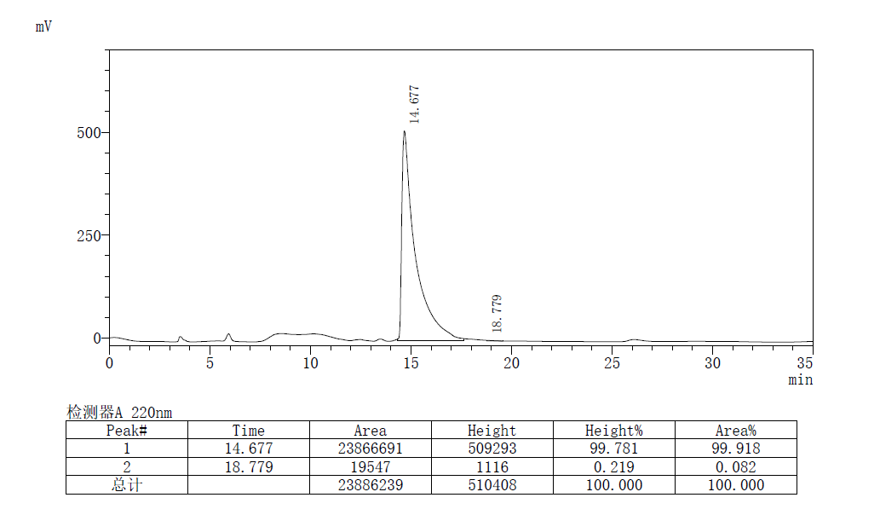
(S,E)-methyl 2-amino-5-(2-fluorophenyl)-2-methyl-3-methylenepent-4-enoate
Prepared according to General Procedure A using L11-Pd and (S,S_{p})-L3-Cu, Purification by flash chromatography (PE/EA = 5:1 to 1:1) afforded the product as a pale yellow oil, 40 mg, 80% yield, 98% ee, R_{f} = 0.4 (PE/EA, 1:1).
[α]²⁵_{D} = 7.0 (c 1.0, CHCl₃)
¹H NMR (400 MHz, CDCl₃) δ 7.47 (t, J = 7.5 Hz, 1H), 7.20 (dd, J = 12.9, 6.6 Hz, 1H), 7.09 (t, J = 7.4 Hz, 1H), 7.06 – 6.99 (m, 1H), 6.84 (dd, J = 61.6, 16.4 Hz, 2H), 5.46 (s, 1H), 5.34 (s, 1H), 3.74 (s, 3H), 1.89 (s, 2H), 1.56 (s, 3H).
¹³C NMR (101 MHz, CDCl₃) δ 176.4, 160.4 (d, J = 249.7 Hz), 148.9, 129.0, 129.0 (d, J = 14.3 Hz), 127.2 (d, J = 3.3 Hz), 124.9 (d, J = 12.1 Hz), 124.1 (d, J = 3.4 Hz), 122.8 (d, J = 3.7 Hz), 115.7 (d, J = 22.1 Hz), 112.7, 60.5, 52.6, 25.8.
¹⁹F NMR (376 MHz, DMSO) δ -122.5.
HRMS (ESI) calcd. for C₁₄H₂₀NO₂⁺ (M + H)⁺: 250.1243, Found: 250.1237
the ee value was 98%, t_{r} (major) = 15.914 min, t_{r} (minor) = 19.070 min (Chiralcel IC, λ = 220 nm, hexanes : ^{i}PrOH = 95 : 5, flow rate = 1.0 mL/min).
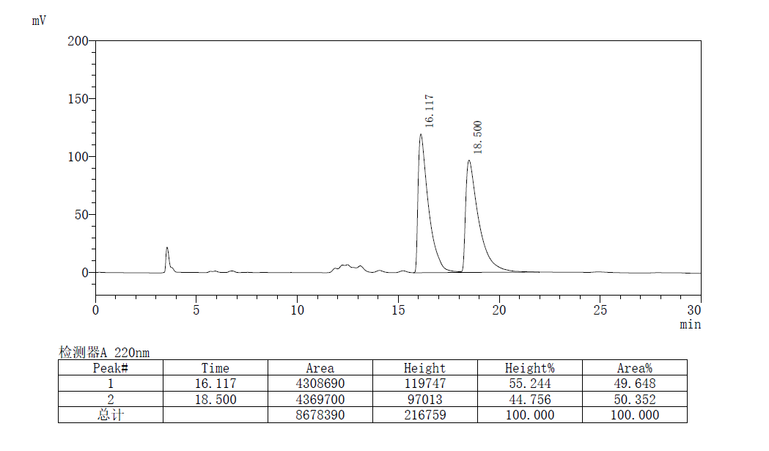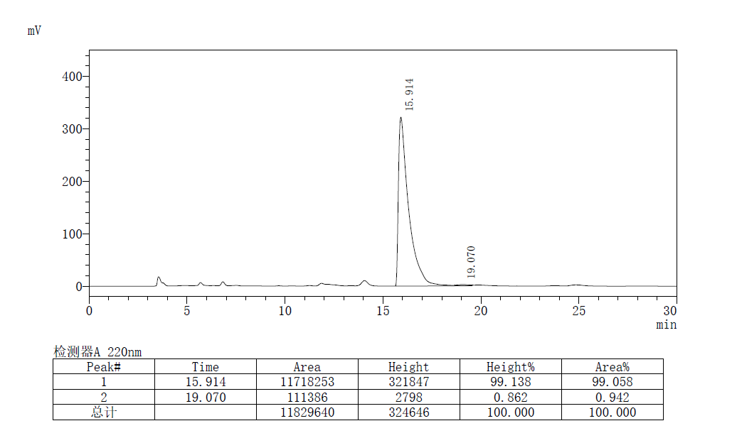
(S,E)-methyl 2-amino-5-(3-fluorophenyl)-2-methyl-3-methylenepent-4-enoate
Prepared according to General Procedure A using L11-Pd and (S,S_{p})-L3-Cu, Purification by flash chromatography (PE/EA = 5:1 to 1:1) afforded the product as a pale yellow oil, 40.2 mg, 81% yield, 98% ee, R_{f} = 0.4 (PE/EA, 1:1).
[α]²⁵_{D} = 8.6 (c 0.5, CHCl₃)
¹H NMR (400 MHz, CDCl₃) δ 7.27 (dd, J = 13.8, 7.9 Hz, 1H), 7.13 (dd, J = 21.7, 8.9 Hz, 2H), 6.93 (t, J = 8.2 Hz, 1H), 6.71 (s, 2H), 5.44 (s, 1H), 5.35 (s, 1H), 3.73 (s, 3H), 1.91 (s, 2H), 1.56 (s, 3H).
¹³C NMR (101 MHz, CDCl₃) δ 176.4, 163.1 (d, J = 245.3 Hz), 148.4, 139.4 (d, J = 7.6 Hz), 130.0 (d, J = 8.4 Hz), 129.3 (d, J = 2.4 Hz), 128.2 (s), 122.5 (d, J = 2.4 Hz), 114.6 (d, J = 21.4 Hz), 113.1, 112.9 (d, J = 21.9 Hz), 60.5, 52.7, 25.8.
¹⁹F NMR (377 MHz, CDCl₃) δ -113.4.
HRMS (ESI) calcd. for C₁₄H₂₀NO₂⁺ (M + H)⁺: 250.1243, Found: 250.1236
the ee value was 98%, t_{r} (major) = 13.172 min, t_{r} (minor) = 15.572 min (Chiralcel IC, λ = 220 nm, hexanes : ^{i}PrOH = 95 : 5, flow rate = 1.0 mL/min).
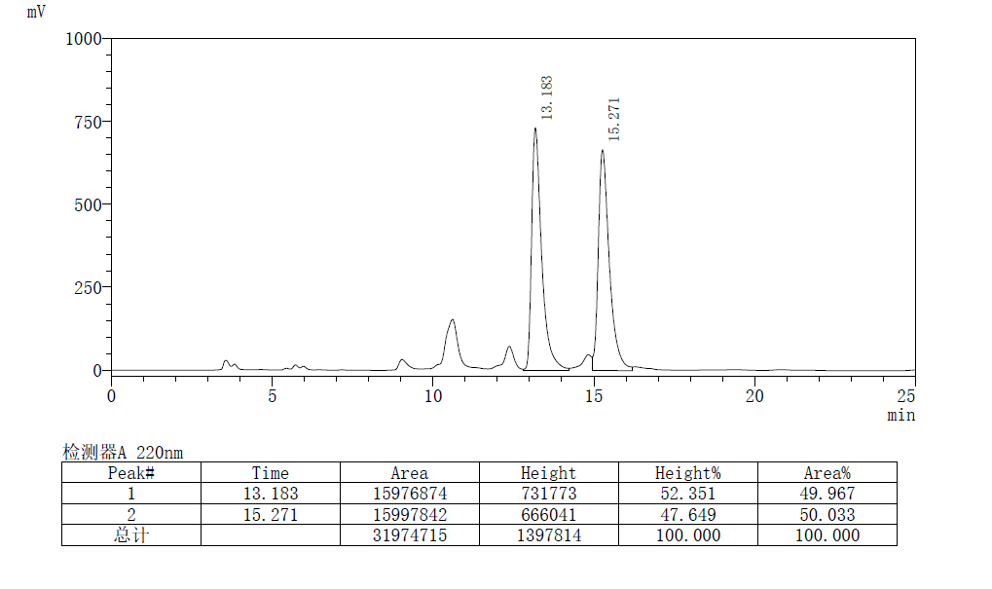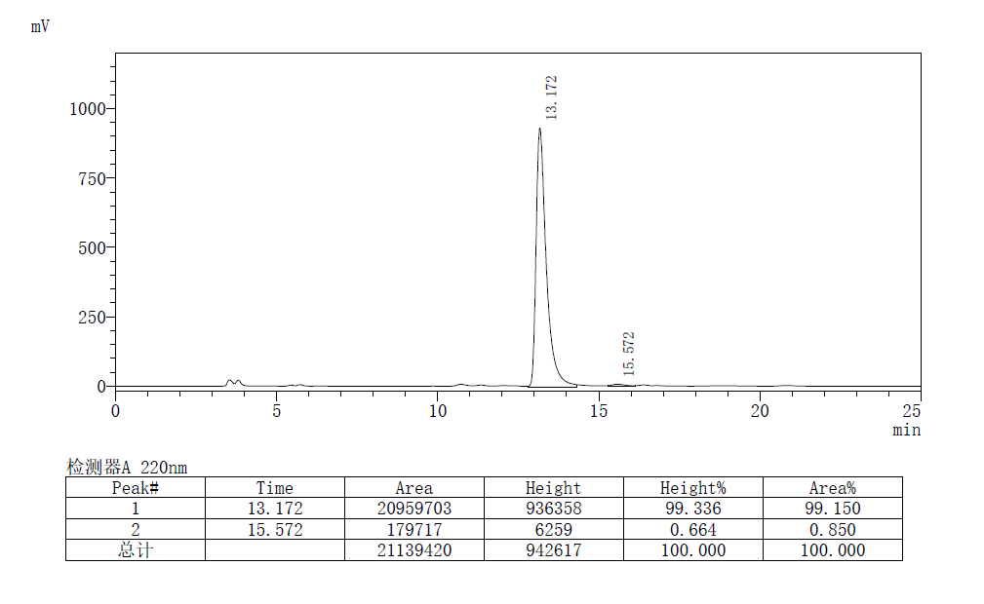
(S,E)-methyl 2-amino-5-(4-fluorophenyl)-2-methyl-3-methylenepent-4-enoate
Prepared according to General Procedure A using L11-Pd and (S,S_{p})-L3-Cu, Purification by flash chromatography (PE/EA = 5:1 to 1:1) afforded the product as a pale yellow oil 43.5mg, 87% yield, 99% ee, R_{f} = 0.4 (PE/EA, 1:1).
[α]²⁵_{D} = 13.3 (c 1.0, CHCl₃)
¹H NMR (400 MHz, CDCl₃) δ 7.36 (dd, J = 8.6, 5.5 Hz, 2H), 7.00 (t, J = 8.7 Hz, 2H), 6.66 (dd, J = 45.1, 16.2 Hz, 2H), 5.41 (s, 1H), 5.31 (s, 1H), 3.73 (s, 3H), 1.88 (s, 2H), 1.56 (s, 3H).
¹³C NMR (101 MHz, CDCl₃) δ 176.5, 162.4 (d, J = 247.5 Hz), 148.6, 133.2 (d, J = 3.3 Hz), 129.3, 128.1 (d, J = 7.9 Hz), 126.6 (d, J = 2.0 Hz), 115.5 (d, J = 21.7 Hz), 112.3, 60.5, 52.6, 25.8.
¹⁹F NMR (377 MHz, CDCl₃) δ -113.9.
HRMS (ESI) calcd. for C₁₄H₂₀NO₂⁺ (M + H)⁺:250.1243, Found: 250.1235
the ee value was 99%, t_{r} (major) = 13.830 min, t_{r} (minor) = 16.528 min (Chiralcel IC, λ = 220 nm, hexanes : ^{i}PrOH = 95 : 5, flow rate = 1.0 mL/min).
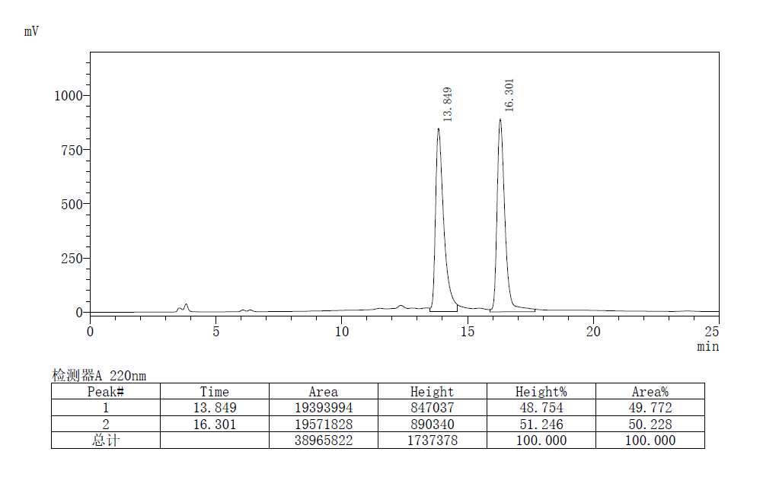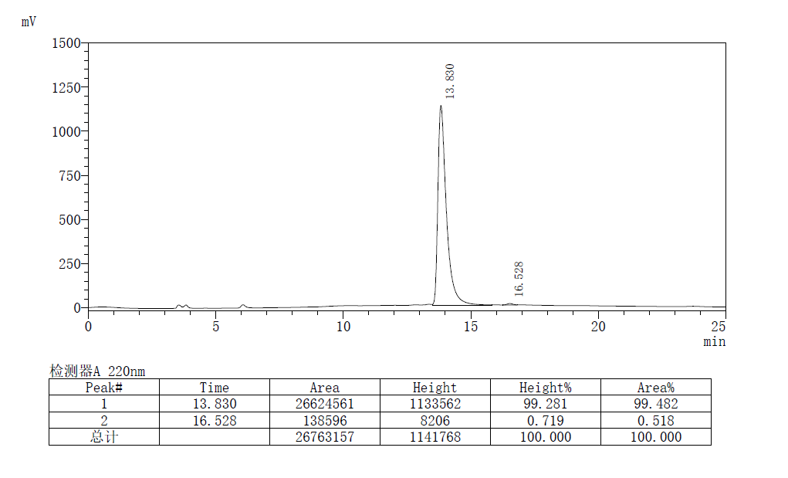
(S,E)-methyl 2-amino-5-(4-chlorophenyl)-2-methyl-3-methylenepent-4-enoate
Prepared according to General Procedure A using L11-Pd and (S,S_{p})-L3-Cu, Purification by flash chromatography (PE/EA = 5:1 to 1:1) afforded the product as a pale yellow solid, 43.4 mg, 82% yield, m.p. 92–93 °C, 99% ee, R_{f} = 0.4 (PE/EA, 1:1).
[α]²⁵_{D} = 12.2 (c 1.0, CHCl₃)
¹H NMR (400 MHz, CDCl₃) δ 7.32 (d, J = 8.4 Hz, 2H), 7.28 (d, J = 8.0 Hz, 2H), 6.78 – 6.62 (m, 2H), 5.43 (s, 1H), 5.33 (s, 1H), 3.73 (s, 3H), 1.92 (s, 2H), 1.56 (s, 3H).
¹³C NMR (101 MHz, CDCl₃) δ 176.5, 148.5, 135.5, 133.4, 129.2, 128.8, 127.8, 127.4, 112.7, 60.49, 52.7, 25.8.
HRMS (ESI) calcd. for C₁₄H₂₀NO₂⁺ (M + H)⁺: 266.0948, Found: 266.0940
the ee value was 99%, t_{r} (major) = 14.062 min, t_{r} (minor) = 17.129 min (Chiralcel IC, λ = 220 nm, hexanes : ^{i}PrOH = 95 : 5, flow rate = 1.0 mL/min).
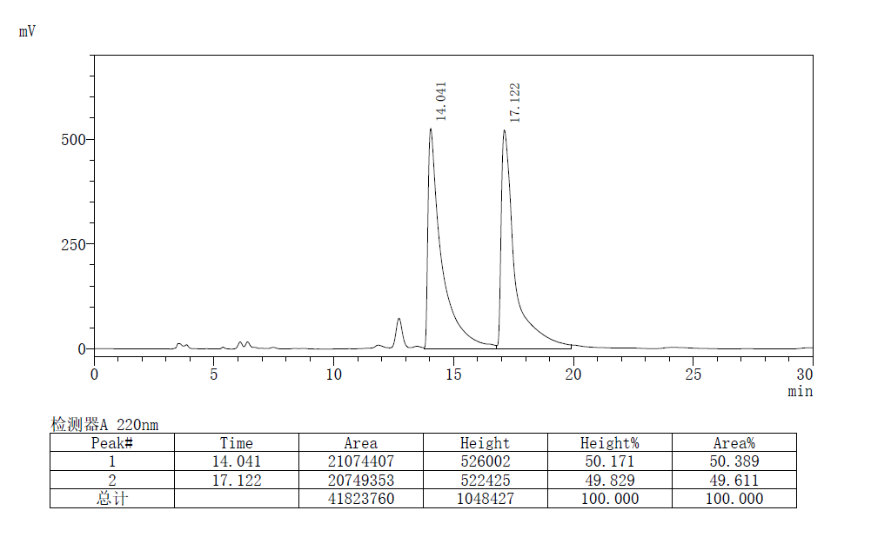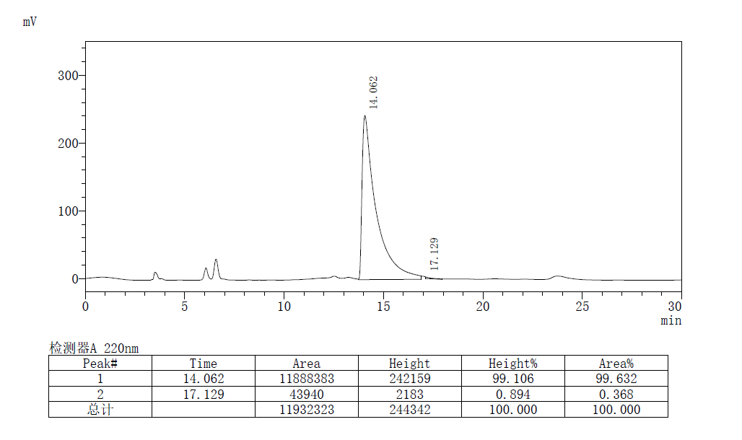
(S,E)-methyl 2-amino-2-methyl-3-methylene-5-(4-(trifluoromethyl)phenyl)pent-4-enoate
Prepared according to General Procedure A using L11-Pd and (S,S_{p})-L3-Cu, Purification by flash chromatography (PE/EA = 5:1 to 1:1) afforded the product as a pale yellow oil, 42.4 mg, 71% yield , 98% ee, R_{f} = 0.3 (PE/EA, 1:1).
[α]²⁵_{D} = 5.9 (c 1.0, CHCl₃)
¹H NMR (400 MHz, CDCl₃) δ 7.56 (d, J = 8.1 Hz, 2H), 7.49 (d, J = 8.2 Hz, 2H), 6.88 – 6.73 (m, 2H), 5.48 (s, 1H), 5.39 (s, 1H), 3.73 (s, 3H), 1.90 (s, 2H), 1.57 (s, 3H).
¹³C NMR (101 MHz, CDCl₃) δ 176.4, 144.4 (d, J = 794.4 Hz), 129.7 (dd, J = 56.7, 24.2 Hz), 129.4, 129.0, 126.7, 125.6 (dd, J = 7.2, 3.4 Hz), 122.8, 113.6, 60.5, 52.6, 25.9.
¹⁹F NMR (376 MHz, DMSO) δ -67.2.
HRMS (ESI) calcd. for C₁₄H₂₀NO₂⁺ (M + H)⁺: 300.1211, Found: 300.1202
the ee value was 98%, t_{r} (major) = 10.155 min, t_{r} (minor) = 12.021 min (Chiralcel IC, λ = 220 nm, hexanes : ^{i}PrOH = 95 : 5, flow rate = 1.0 mL/min).
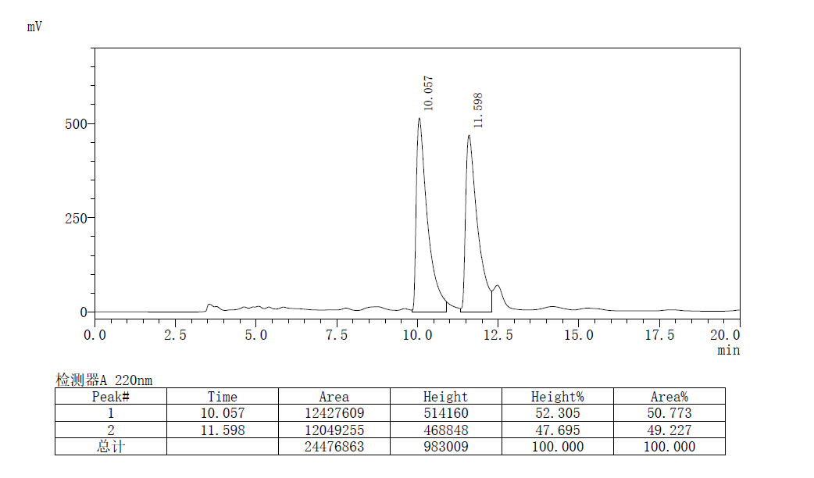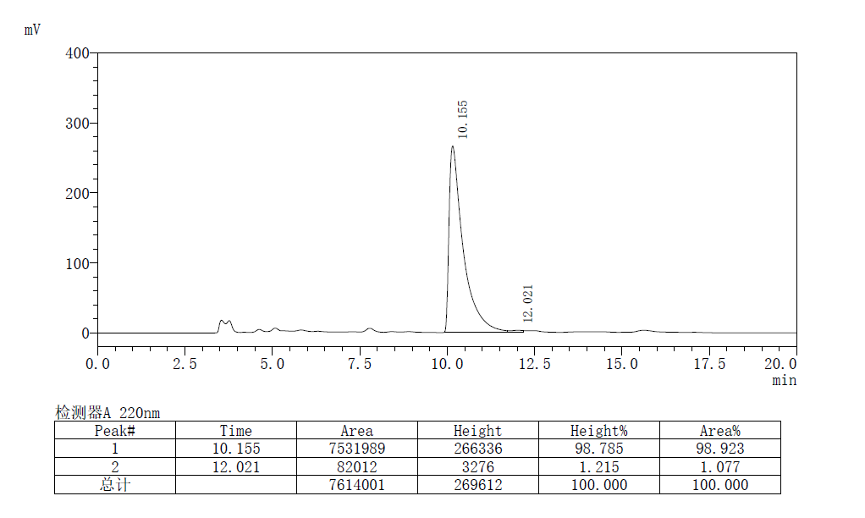
(S,E)-methyl 2-amino-5-(4-methoxyphenyl)-2-methyl-3-methylenepent-4-enoate
Prepared according to General Procedure A using L11-Pd and (S,S_{p})-L3-Cu, Purification by flash chromatography (PE/EA = 5:1 to 1:2) afforded the product as a pale yellow solid, 41.5 mg, 80% yield, m.p. 74–76 °C, >99% ee, R_{f} = 0.2 (PE/EA, 1:1).
[α]²⁵_{D} =10.1 (c 1.0, CHCl₃)
¹H NMR (400 MHz, CDCl₃) δ 7.33 (d, J = 8.3 Hz, 2H), 6.85 (d, J = 8.3 Hz, 2H), 6.63 (dd, J = 63.1, 16.2 Hz, 2H), 5.38 (s, 1H), 5.26 (s, 1H), 3.80 (s, 3H), 3.72 (s, 3H), 1.98 (s, 2H), 1.55 (s, 3H).
¹³C NMR (101 MHz, CDCl₃) δ 176.6, 159.4, 148.9, 130.0, 129.8, 127.8, 124.6, 114.1, 111.3, 60.6, 55.3, 52.6, 25.8.
HRMS (ESI) calcd. for C₁₄H₂₀NO₂⁺ (M + H)⁺: 262.1443, Found: 262.1435
the ee value was > 99%, t_{r} (major) = 17.395 min, t_{r} (minor) = 23.754 min (Chiralcel IC, λ = 220 nm, hexanes : ^{i}PrOH = 90 : 10, flow rate = 1.0 mL/min).
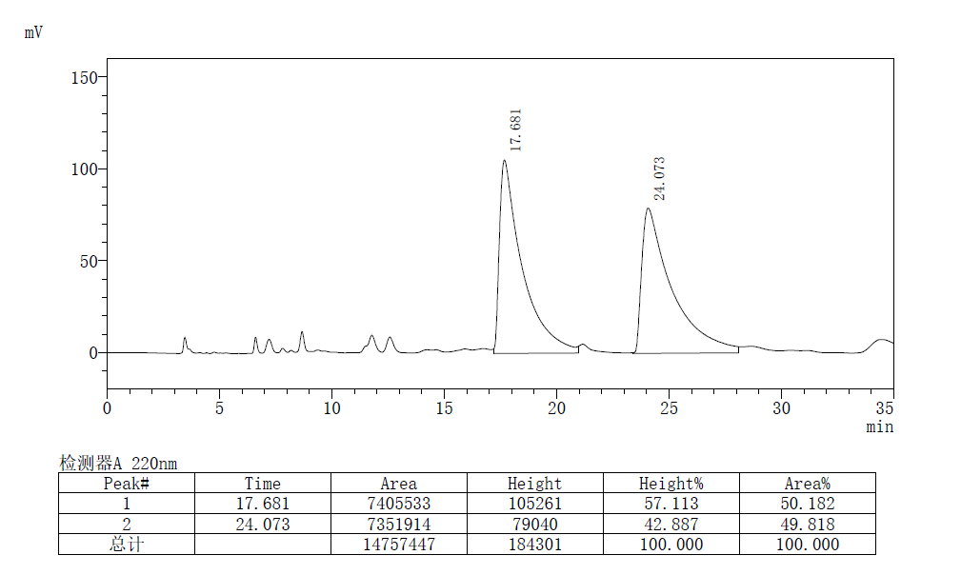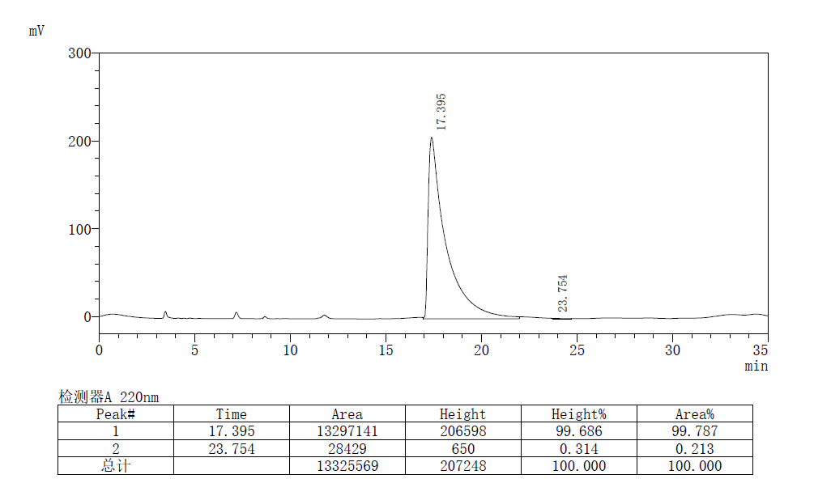
(S,E)-methyl 2-amino-2-methyl-3-methylene-5-(naphthalen-2-yl)pent-4-enoate
Prepared according to General Procedure A using L11-Pd and (S,S_{p})-L3-Cu, Purification by flash chromatography (PE/EA = 5:1 to 1:1) afforded the product as a pale yellow solid, 42.6 mg, 76% yield, m.p.103–104°C, >99% ee, R_{f} = 0.3 (PE/EA, 1:1).
[α]²⁵_{D} =1.3 (c 1.0, CHCl₃)
¹H NMR (400 MHz, CDCl₃) δ 7.85 – 7.70 (m, 4H), 7.60 (d, J = 8.6 Hz, 1H), 7.50 – 7.36 (m, 2H), 6.87 (dd, J = 40.0, 16.2 Hz, 2H), 5.48 (s, 1H), 5.35 (s, 1H), 3.74 (s, 3H), 1.88 (s, 2H), 1.59 (s, 3H).
¹³C NMR (101 MHz, CDCl₃) δ 176.7, 148.8, 134.5, 133.6, 133.1, 130.6, 128.3, 128.0, 127.7, 127.1, 126.8, 126.4, 126.0, 123.5, 112.4, 60.6, 52.7, 25.9.
HRMS (ESI) calcd. for C₁₄H₂₀NO₂⁺ (M + H)⁺: 282.1494, Found: 282.1486
the ee value was > 99%, t_{r} (major) = 19.590 min, t_{r} (minor) = 27.329 min (Chiralcel IC, λ = 220 nm, hexanes : ^{i}PrOH = 95 : 5, flow rate = 1.0 mL/min).
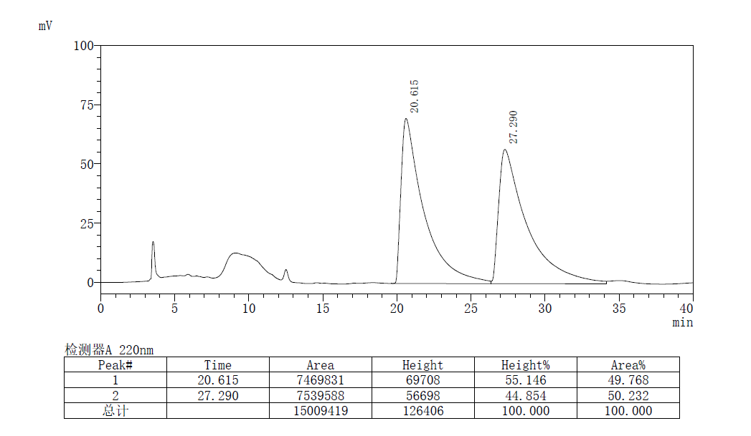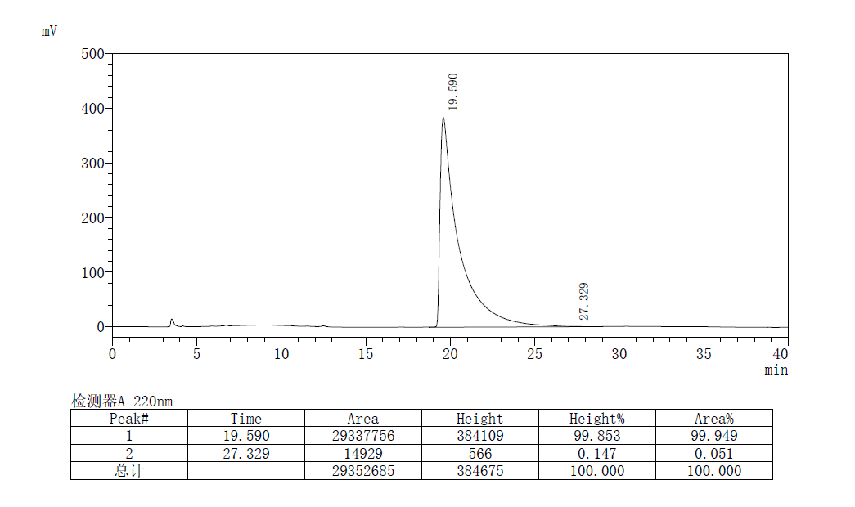

(S,E)-methyl 2-amino-5-(furan-2-yl)-2-methyl-3-methylenepent-4-enoate
Prepared according to General Procedure A using L11-Pd and (S,S_{p})-L3-Cu, Purification by flash chromatography (PE/EA = 5:1 to 1:1) afforded the product as a pale yellow oil, 31.2 mg, 70% yield, 97% ee, R_{f} = 0.3 (PE/EA, 1:1).
[α]²⁵_{D} = 4.9 (c 0.8, CHCl₃)
¹H NMR (400 MHz, CDCl₃) δ 7.36 (s, 1H), 6.59 (q, J = 16.2 Hz, 2H), 6.40 – 6.37 (m, 1H), 6.28 (d, J = 2.8 Hz, 1H), 5.40 (s, 1H), 5.31 (s, 1H), 3.73 (s, 3H), 2.02 (s, 2H), 1.55 (s, 3H).
¹³C NMR (101 MHz, CDCl₃) δ 176.6, 152.7, 148.4, 142.3, 125.2, 118.3, 112.4, 111.6, 109.0, 60.4, 52.7, 25.8.
HRMS (ESI) calcd. for C₁₄H₂₀NO₂⁺ (M + H)⁺: 222.1130, Found: 222.1124
the ee value was 97%, t_{r} (major) = 31.875 min, t_{r} (minor) = 35.959 min (Chiralcel IE, λ = 220 nm, hexanes : ^{i}PrOH = 98 : 2, flow rate = 1.0 mL/min).
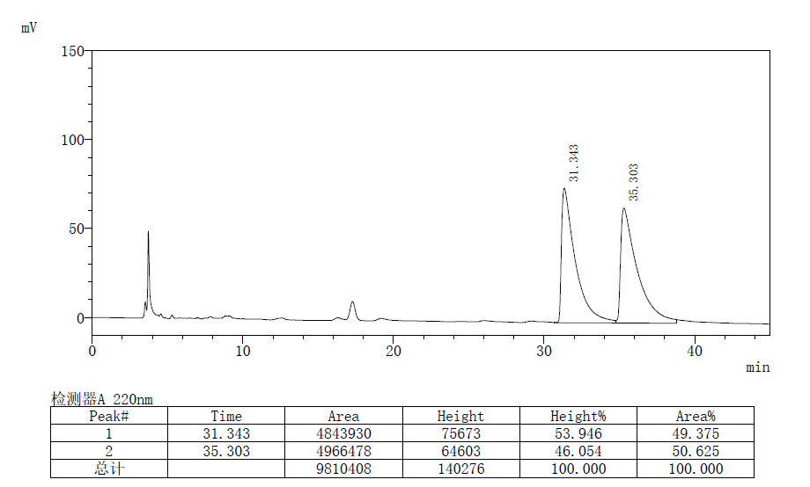
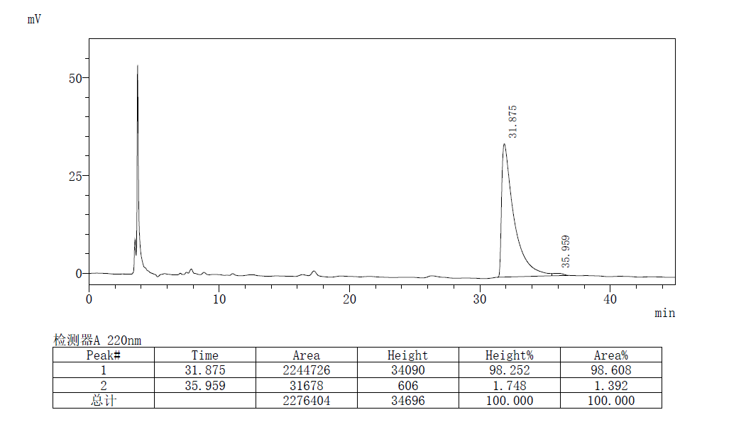
(S,E)-methyl 2-amino-2-methyl-3-methylene-5-(thiophen-2-yl)pent-4-enoate
Prepared according to General Procedure A using L11-Pd and (S,S_{p})-L3-Cu, Purification by flash chromatography (PE/EA = 5:1 to 1:1) afforded the product as a pale yellow oil, 33.4 mg, 70% yield, >99% ee, R_{f} = 0.3 (PE/EA, 1:1).
[α]²⁵_{D} = -1.1 (c 0.8, CHCl₃)
¹H NMR (400 MHz, CDCl₃) δ 7.17 (d, J = 4.7 Hz, 1H), 7.02 – 6.94 (m, 2H), 6.87 (d, J = 16.1 Hz, 1H), 6.52 (d, J = 16.1 Hz, 1H), 5.39 (s, 1H), 5.31 (s, 1H), 3.73 (s, 3H), 1.97 (s, 2H), 1.55 (s, 3H).
¹³C NMR (101 MHz, CDCl₃) δ 177.4, 148.3, 142.5, 127.5, 126.5, 126.4, 124.6, 123.6, 112.6, 60.4, 52.7, 25.9.
HRMS (ESI) calcd. for C₁₄H₂₀NO₂⁺ (M + H)⁺: 238.0902, Found: 238.0895
the ee value was > 99%, t_{r} (major) = 18.849 min, t_{r} (minor) = 23.771 min (Chiralcel IC, λ = 220 nm, hexanes : ^{i}PrOH = 95 : 5, flow rate = 1.0 mL/min).
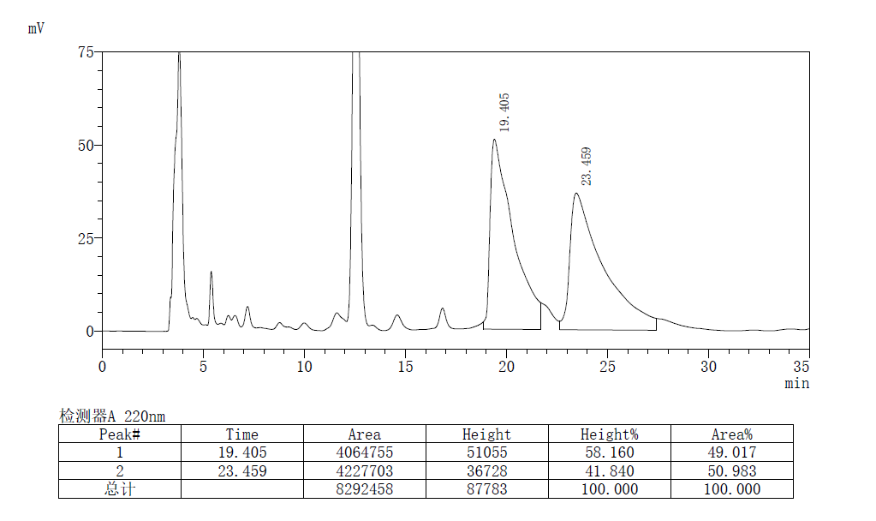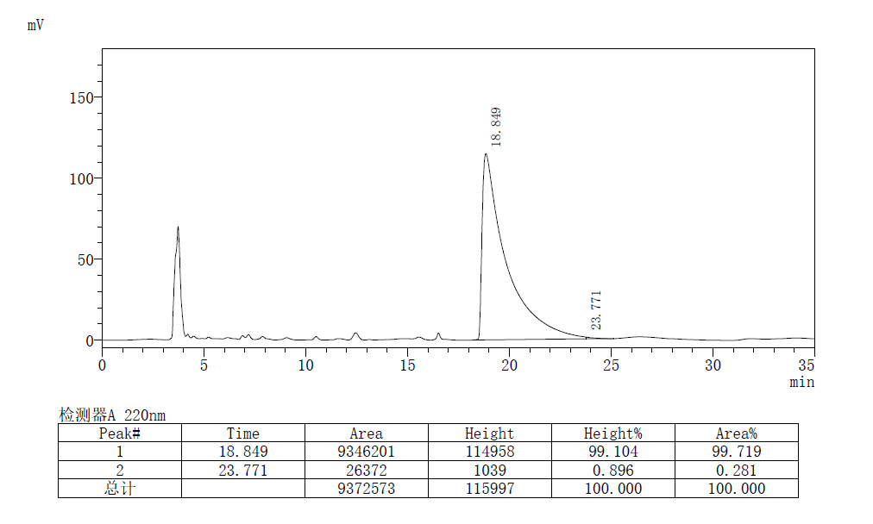
(S,E)-methyl 2-amino-2-methyl-3-methylene-5-(1-tosyl-1H-indol-3-yl)pent-4-enoate
Prepared according to General Procedure A using L11-Pd and (S,S_{p})-L3-Cu, Purification by flash chromatography (PE/EA = 5:1 to 1:2) afforded the product as a pale yellow oil, 57.3 mg, 68 % yield, 99% ee, R_{f} = 0.2 (PE/EA, 1:1).
[α]²⁵_{D} = -8.4 (c 1.0, CHCl₃)
¹H NMR (400 MHz, CDCl₃) δ 7.99 (d, J = 8.2 Hz, 1H), 7.77 (d, J = 8.2 Hz, 2H), 7.70 (d, J = 7.8 Hz, 1H), 7.63 (s, 1H), 7.33 (t, J = 7.6 Hz, 1H), 7.29 – 7.24 (m, 1H), 7.21 (d, J = 8.1 Hz, 2H), 6.80 (q, J = 16.4 Hz, 2H), 5.43 (s, 1H), 5.32 (s, 1H), 3.74 (s, 3H), 2.33 (s, 3H), 1.58 (s, 3H).
¹³C NMR (101 MHz, CDCl₃) δ 176.6, 148.9, 145.1, 135.5, 135.1, 129.9, 129.0, 127.8, 126.9, 125.0, 124.0, 123.6, 121.0, 120.5, 120.3, 113.8, 112.0, 60.5, 52.7, 25.9, 21.6.
HRMS (ESI) calcd. for C₁₄H₂₀NO₂⁺ (M + H)⁺: 425.1535, Found: 425.1527
the ee value was 99%, t_{r} (major) = 41.029 min, t_{r} (minor) = 49.988 min (Chiralcel IC, λ = 220 nm, hexanes : ^{i}PrOH = 80 : 20, flow rate = 1.0 mL/min).

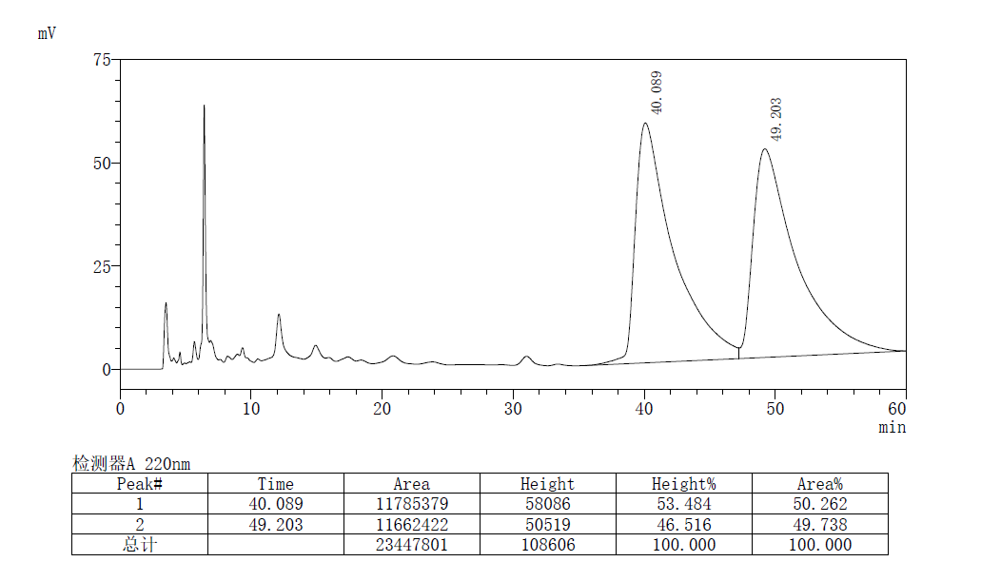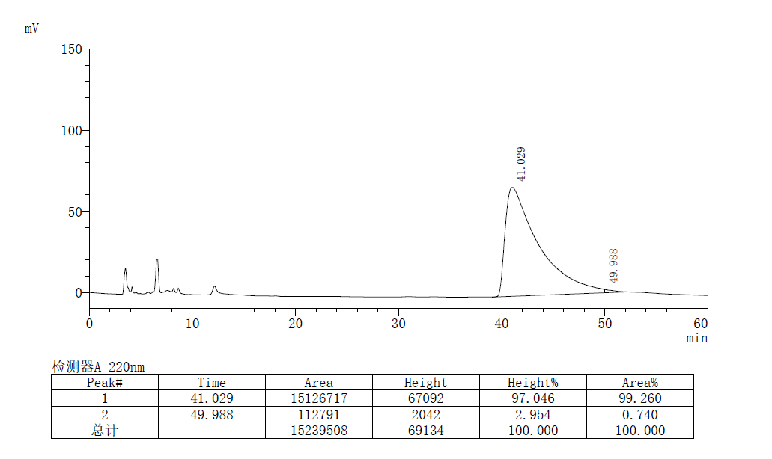

(S,E)-methyl 2-amino-5-cyclohexyl-2-methyl-3-methylenepent-4-enoate
Prepared according to General Procedure B using L11-Pd and (S,S_{p})-L3-Cu, Purification by flash chromatography (PE/EA = 5:1 to 1:2) afforded the product as a pale yellow oil, 29.8 mg, 63% yield, 94% ee, R_{f} = 0.2 (PE/EA, 1:1).
[α]²⁵_{D} = 7.4 (c 0.8, CHCl₃)
¹H NMR (400 MHz, CDCl₃) δ 5.89 (d, J = 15.9 Hz, 1H), 5.77 (dd, J = 15.9, 6.8 Hz, 1H), 5.18 (s, 1H), 5.14 (s, 1H), 3.70 (s, 3H), 1.98 (dt, J = 10.7, 9.1 Hz, 1H), 1.79 (s, 2H), 1.72 – 1.63 (m, 5H), 1.48(s, 3H), 1.33 – 1.19 (m, 3H), 1.13 – 1.04 (m, 2H).
¹³C NMR (101 MHz, CDCl₃) δ 176.8, 149.1, 138.7, 125.4, 110.5, 60.4, 52.4, 41.1, 32.8 (d, J = 2.3 Hz), 26.1, 25.9, 25.5.
HRMS (ESI) calcd. for C₁₄H₂₀NO₂⁺ (M + H)⁺: 238.1807, Found: 238.1799
the ee value was 94%, t_{r} (major) = 14.269 min, t_{r} (minor) = 16.302 min (Chiralcel IF, λ = 220 nm, hexanes : ^{i}PrOH = 99 : 1, flow rate = 1.0 mL/min).
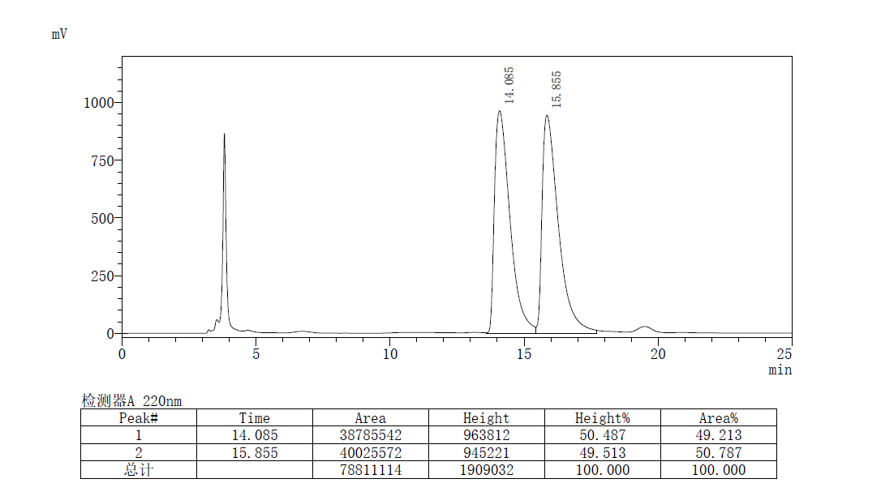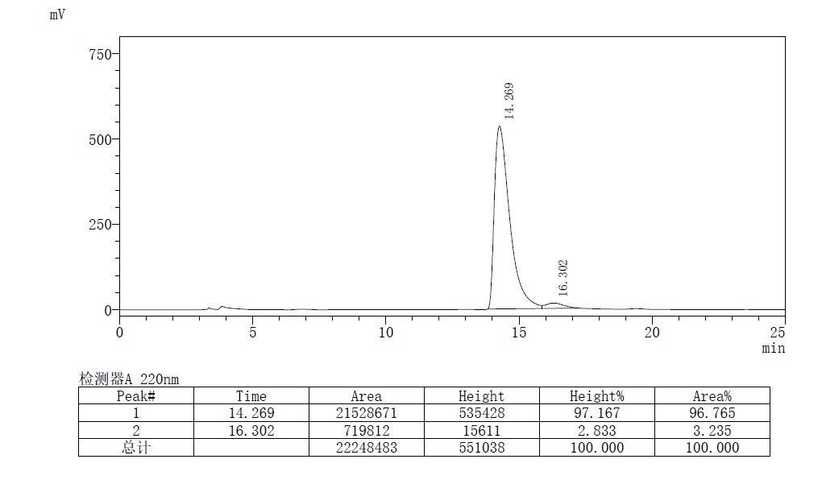
(S,E)-methyl 2-amino-6-(benzyloxy)-2-methyl-3-methylenehex-4-enoate
Prepared according to General Procedure A using L11-Pd and (S,S_{p})-L3-Cu, Purification by flash chromatography (PE/EA = 5:1 to 1:2) afforded the product as a pale yellow oil, 33.1 mg, 60% yield, 99% ee, R_{f} = 0.2 (PE/EA, 1:1).
[α]²⁵_{D} = 7.7 (c 0.5, CHCl₃)
¹H NMR (400 MHz, CDCl₃) δ 7.61 – 7.07 (m, 5H), 6.21 (d, J = 16.0 Hz, 1H), 5.96 (dt, J = 15.9, 5.9 Hz, 1H), 5.27 (d, J = 21.2 Hz, 2H), 4.51 (s, 2H), 4.06 (dd, J = 5.9, 1.2 Hz, 2H), 3.70 (s, 3H), 1.83 (s, 2H), 1.50 (s, 3H).
¹³C NMR (101 MHz, CDCl₃) δ 176.5, 148.1, 138.2, 130.5, 128.4, 128.1, 127.8, 127.7, 112.6, 72.1, 70.6, 60.3, 52.6, 25.6.
HRMS (ESI) calcd. for C₁₄H₂₀NO₂⁺ (M + H)⁺: 276.1600, Found: 276.1596
the ee value was 99%, t_{r} (major) = 10.914 min, t_{r} (minor) = 11.846 min (Chiralcel IA, λ = 220 nm, hexanes : ^{i}PrOH = 95 : 5, flow rate = 1.0 mL/min).
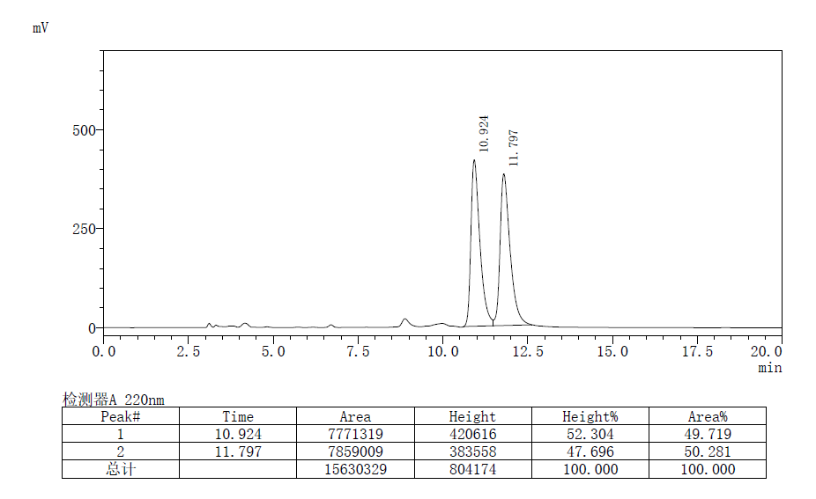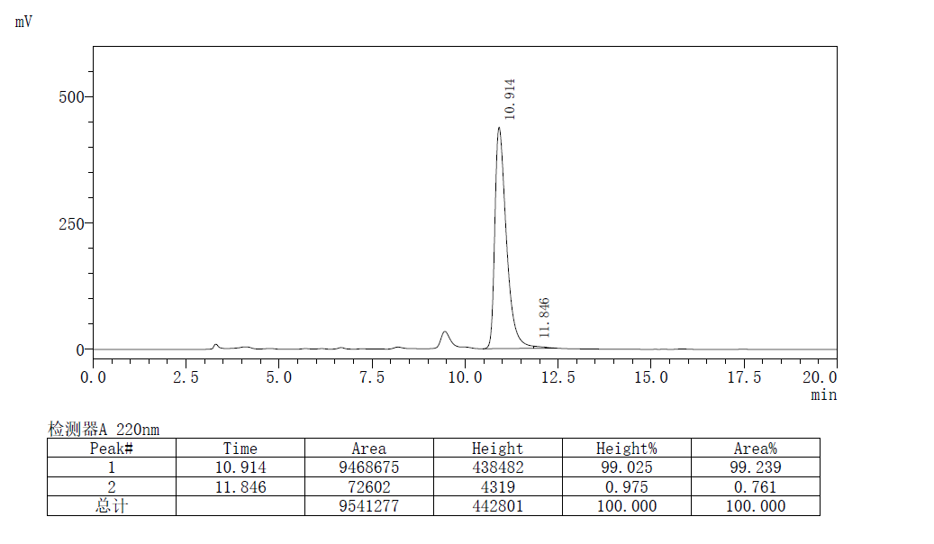
(S,E)-methyl 2-amino-2-methyl-3-((E)-styryl)pent-3-enoate
Prepared according to General Procedure C using L11-Pd ( 0.08 equiv )and (S,S_{p})-L3-Cu, Purification by flash chromatography (PE/EA = 5:1 to 1:2) afforded the product as a pale yellow oil, 24.5 mg, 50% yield, >99% ee, R_{f} = 0.2 (PE/EA, 1:1).
[α]²⁵_{D} = -58.2 (c 0.5, CHCl₃)
¹H NMR (400 MHz, CDCl₃) δ 7.40 (d, J = 7.4 Hz, 2H), 7.32 (t, J = 7.5 Hz, 2H), 7.23 (t, J = 7.3 Hz, 1H), 6.75 (d, J = 16.7 Hz, 1H), 6.51 (d, J = 16.7 Hz, 1H), 5.94 (q, J = 7.0 Hz, 1H), 3.70 (s, 3H), 1.89 – 1.87 (m, 5H), 1.52 (s, 3H).
¹³C NMR (101 MHz, CDCl₃) δ 177.5, 139.8, 137.4, 131.9, 128.6, 127.6, 126.3, 123.7, 123.5, 60.9, 52.5, 26.0, 14.6.
HRMS (ESI) calcd. for C₁₄H₂₀NO₂⁺ (M + H)⁺: 246.1494, Found: 246.1486
the ee value was >99%, t_{r} (major) = 39.345 min, t_{r} (minor) = 34.958 min (Chiralcel IC, λ = 220 nm, hexanes : ^{i}PrOH = 98 : 2, flow rate = 1.0 mL/min).
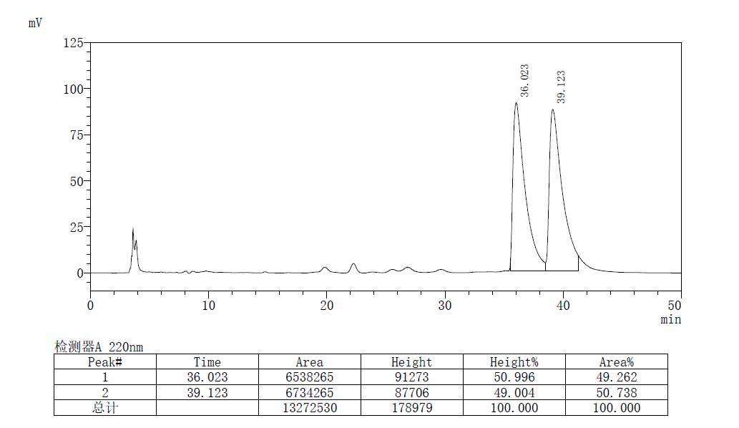
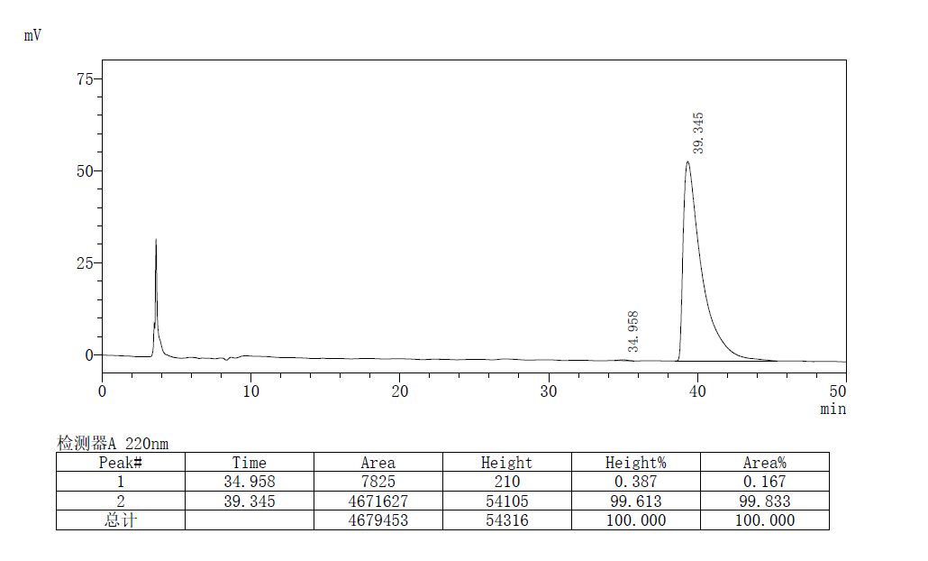

(S,E)-methyl 2-amino-2-ethyl-3-methylene-5-phenylpent-4-enoate
Prepared according to General Procedure B using L11-Pd and (S,S_{p})-L3-Cu, Purification by flash chromatography (PE/EA = 5:1 to 1:1) afforded the product as a pale yellow oil, 35 mg, 71% yield, 92% ee, R_{f} = 0.4 (PE/EA, 1:1).
[α]²⁵_{D} = 6.9 (c 0.8, CHCl₃)
¹H NMR (400 MHz, CDCl₃) δ 7.40 (d, J = 7.3 Hz, 2H), 7.32 (t, J = 7.5 Hz, 2H), 7.26 – 7.24 (m, 1H), 6.74 (q, J = 16.1 Hz, 2H), 5.48 (s, 1H), 5.29 (s, 1H), 3.73 (s, 3H), 2.05 – 1.88 (m, 4H), 0.89 (t, J = 7.4 Hz, 3H).
¹³C NMR (101 MHz, CDCl₃) δ 175.9, 148.0, 137.0, 130.5, 128.6, 127.8, 126.9, 126.6, 112.5, 64.1, 52.5, 30.2, 8.0.
HRMS (ESI) calcd. for C₁₄H₂₀NO₂⁺ (M + H)⁺: 246.1494, Found: 246.1486
the ee value was 92%, t_{r} (major) = 12.140 min, t_{r} (minor) = 13.877 min (Chiralcel IC, λ = 220 nm, hexanes : ^{i}PrOH = 95 : 5, flow rate = 1.0 mL/min).
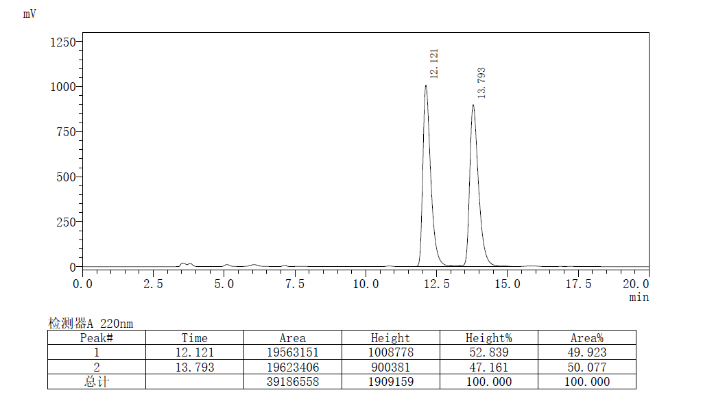
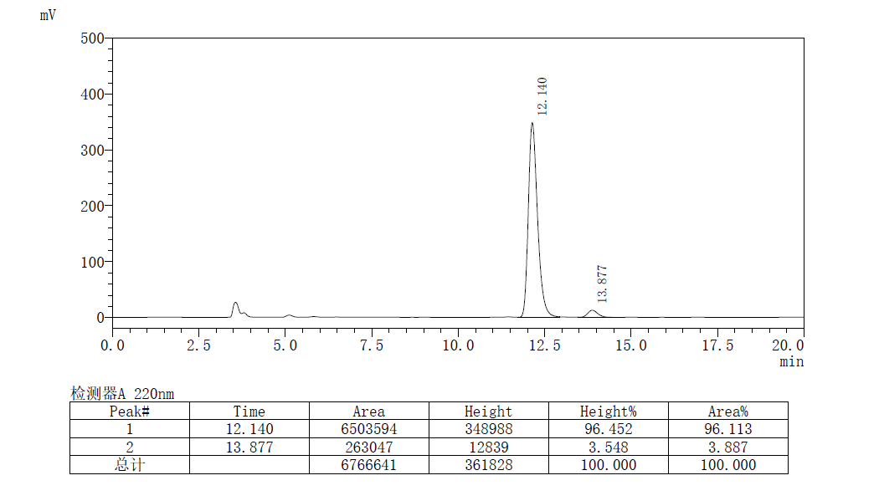
(S,E)-methyl 2-amino-2-(4-phenylbuta-1,3-dien-2-yl)hexanoate
Prepared according to General Procedure B using L11-Pd and (S,S_{p})-L3-Cu, Purification by flash chromatography (PE/EA = 5:1 to 1:1) afforded the product as a pale yellow oil, 38.9 mg, 69% yield, dr, 96% ee, R_{f} = 0.4 (PE/EA, 1:1).
[α]²⁵_{D} = 6.2 (c 1.0, CHCl₃)
¹H NMR (400 MHz, CDCl₃) δ 7.40 (d, J = 7.3 Hz, 2H), 7.32 (t, J = 7.5 Hz, 2H), 7.24 (dd, J = 12.1, 4.9 Hz, 1H), 6.74 (q, J = 16.1 Hz, 2H), 5.46 (s, 1H), 5.29 (s, 1H), 3.73 (s, 3H), 1.99 – 1.81(m, 4H), 1.39 – 1.26 (m, 4H), 0.90 (t, J = 7.0 Hz, 3H).
¹³C NMR (101 MHz, CDCl₃) δ 176.0, 148.3, 137.1, 130.5, 128.1, 127.8, 126.9, 126.6, 112.3, 63.8, 52.5, 37.2, 25.9, 23.0, 14.0.
HRMS (ESI) calcd. for C₁₄H₂₀NO₂⁺ (M + H)⁺: 274.1807, Found: 274.1801
the ee value was 96%, t_{r} (major) = 18.100 min, t_{r} (minor) = 21.493 min (Chiralcel IC, λ = 220 nm, hexanes : ^{i}PrOH = 95 : 5, flow rate = 1.0 mL/min).

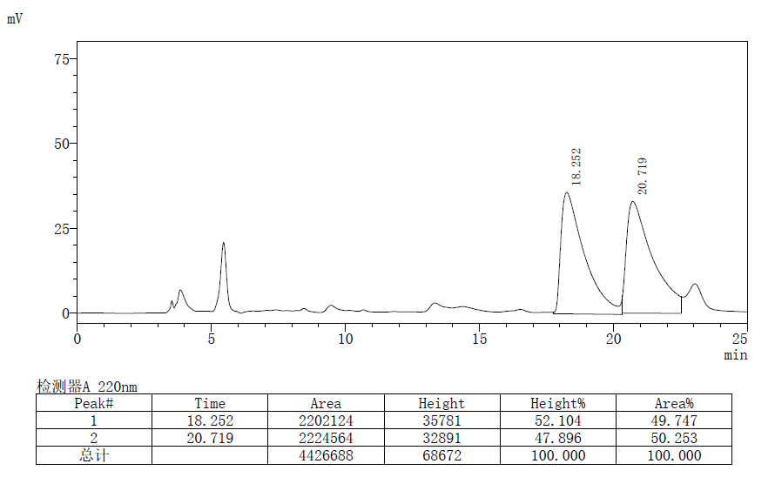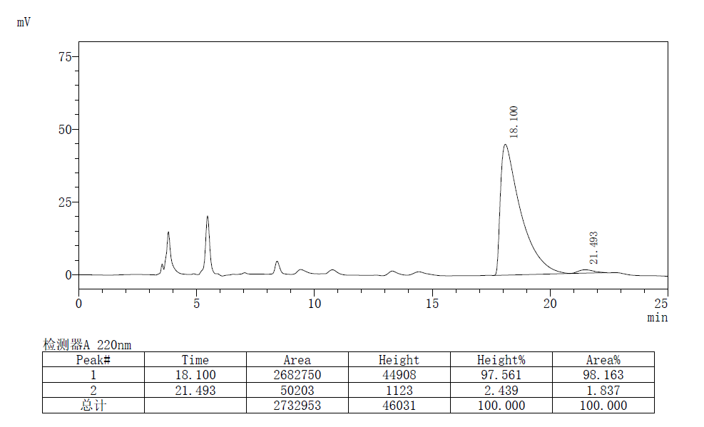
(S,E)-methyl 2-amino-3-methylene-2-phenethyl-5-phenylpent-4-enoate
Prepared according to General Procedure B using L11-Pd and (S,S_{p})-L3-Cu, Purification by flash chromatography (PE/EA = 5:1 to 1:1) afforded the product as a pale yellow oil, 37.4 mg, 58% yield, 92% ee, R_{f} = 0.4 (PE/EA, 1:1).
[α]²⁵_{D} = 8.2 (c 1.0, CHCl₃)
¹H NMR (400 MHz, CDCl₃) δ 7.40 (d, J = 7.4 Hz, 2H), 7.32 (t, J = 7.5 Hz, 2H), 7.29 – 7.23 (m, 3H), 7.22 – 7.15 (m, 3H), 6.77 (q, J = 16.1 Hz, 2H), 5.50 (s, 1H), 5.33 (s, 1H), 3.74 (s, 3H), 2.69 (td, J = 12.6, 5.2 Hz, 1H), 2.60 – 2.51 (m, 1H), 2.22 (tdd, J = 25.5, 13.6, 5.1 Hz, 2H), 1.89 (s, 2H).
¹³C NMR (101 MHz, CDCl₃) δ 175.6, 147.9, 141.8, 137.0, 130.8, 128.6, 128.5, 127.9, 126.7, 126.6, 126.0, 112.5, 63.8, 52.6, 39.4, 30.3.
HRMS (ESI) calcd. for C₁₄H₂₀NO₂⁺ (M + H)⁺: 322.1807, Found: 322.1799
the ee value was 92%, t_{r} (major) = 19.189 min, t_{r} (minor) = 15.555 min (Chiralcel IC, λ = 220 nm, hexanes : ^{i}PrOH = 95 : 5, flow rate = 1.0 mL/min).
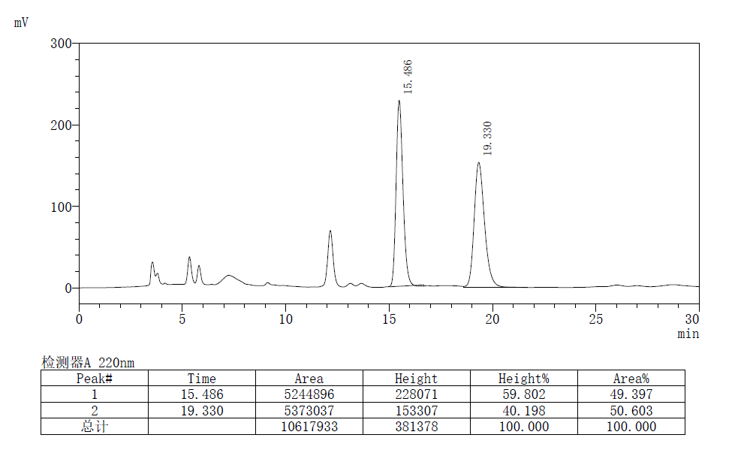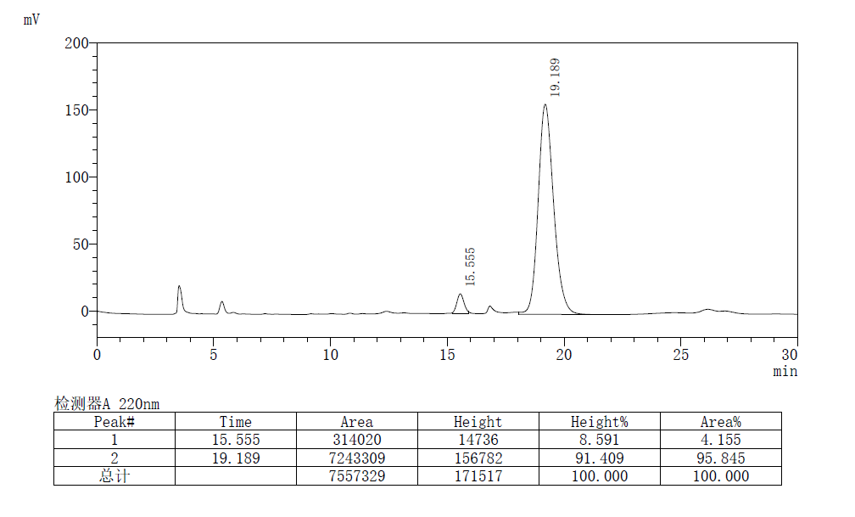
(S,E)-methyl 2-amino-3-methylene-2-(2-(methylthio)ethyl)-5-phenylpent-4-enoate
Prepared according to General Procedure B using L11-Pd and (S,S_{p})-L3-Cu, Purification by flash chromatography (PE/EA = 5:1 to 1:1) afforded the product as a pale yellow oil, 39 mg, 67% yield, 95% ee, R_{f} = 0.3 (PE/EA, 1:1).
[α]²⁵_{D} = -2.1 (c 1.0, CHCl₃)
¹H NMR (400 MHz, CDCl₃) δ 7.40 (d, J = 7.2 Hz, 2H), 7.32 (t, J = 7.2 Hz, 2H), 7.28 – 7.22 (m, 1H), 6.72 (dd, J = 43.4, 16.1 Hz, 2H), 5.49 (s, 1H), 5.32 (s, 1H), 3.74 (s, 3H), 2.59 – 2.41 (m, 2H), 2.25 – 2.16 (m, 2H), 2.09 (s, 3H), 1.86 (s, 2H).
¹³C NMR (101 MHz, CDCl₃) δ 175.3, 147.4, 136.9, 130.9, 128.7, 127.9, 126.6, 126.3, 112.6, 63.61, 52.7, 36.8, 28.7, 15.6.
HRMS (ESI) calcd. for C₁₄H₂₀NO₂⁺ (M + H)⁺: 292.1371, Found: 292.1361
the ee value was 95%, t_{r} (major) = 27.541 min, t_{r} (minor) = 37.019 min (Chiralcel IE, λ = 220 nm, hexanes : ^{i}PrOH = 98 : 2, flow rate = 1.0 mL/min).
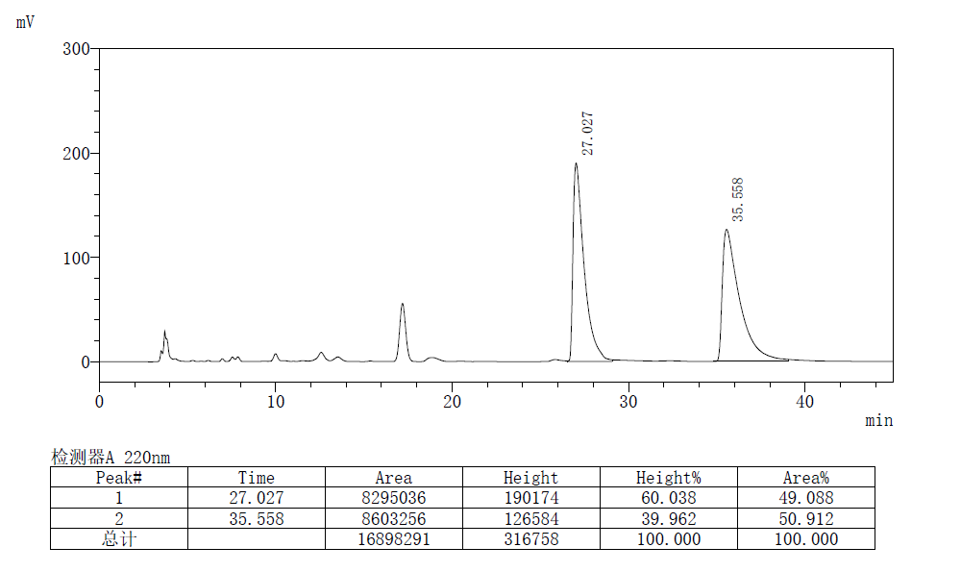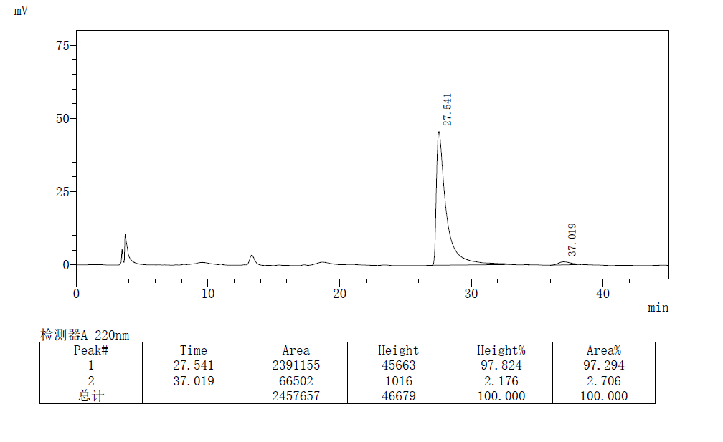
(S,E)-methyl2-amino-2-(2-(((benzyloxy)carbonyl)amino)ethyl)-3-methylene-5-phenylpent-4-enoate
Prepared according to General Procedure B using L11-Pd and (S,S_{p})-L3-Cu, Purification by flash chromatography (PE/EA = 5:1 to 1:3) afforded the product as a pale yellow oil, 35.6 mg, 45 % yield, 88% ee, R_{f} = 0.3 (PE/EA, 1:2).
[α]²⁵_{D} = 3.4 (c 1.0, CHCl₃)
¹H NMR (400 MHz, CDCl₃) δ 7.38 (d, J = 7.4 Hz, 2H), 7.34 – 7.29 (m, 7H), 7.26– 7.22 (m, 1H), 6.69 (dd, J = 52.8, 16.1 Hz, 2H), 5.61 (s, 1H), 5.48 (s, 1H), 5.33 (s, 1H), 5.07 (s, 2H), 3.70 (s, 3H), 3.30 (d, J = 5.7 Hz, 2H), 2.20 – 2.07 (m, 2H), 1.91 (s, 2H).
¹³C NMR (101 MHz, CDCl₃) δ 175.3, 156.3, 147.2, 136.8, 136.7, 131.1, 128.7, 128.5, 128.1, 128.0, 128.0, 126.7, 126.1, 112.6, 66.6, 63.3, 52.7, 37.1, 36.2.
HRMS (ESI) calcd. for C₁₄H₂₀NO₂⁺ (M + H)⁺: 395.1971, Found: 395.1963
the ee value was 88%, t_{r} (major) = 36.764 min, t_{r} (minor) = 33.605 min (Chiralcel IC, λ = 220 nm, hexanes : ^{i}PrOH = 85 : 15, flow rate = 1.0 mL/min).
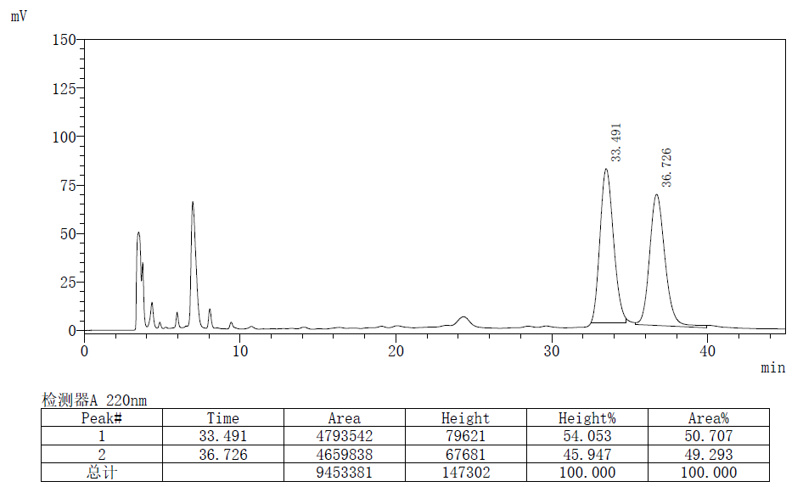
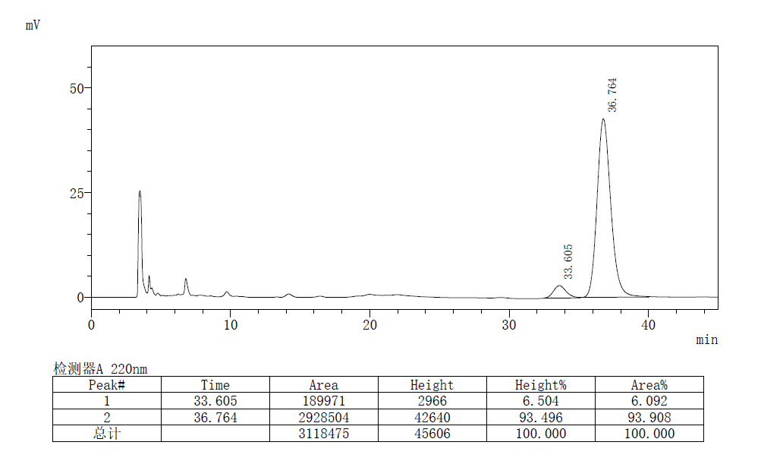
(S,E)-methyl 2-amino-2-(tert-butoxymethyl)-3-methylene-5-phenylpent-4-enoate
Prepared according to General Procedure B using L11-Pd and (S,S_{p})-L3-Cu, Purification by flash chromatography (PE/EA = 5:1 to 1:1) afforded the product as a pale yellow oil, 29 mg, 48% yield , 96% ee, R_{f} = 0.3 (PE/EA, 1:1).
[α]²⁵_{D} = -11.1 (c 0.5, CHCl₃)
¹H NMR (400 MHz, CDCl₃) δ 7.41 (d, J = 7.6 Hz, 2H), 7.32 (t, J = 7.4 Hz, 2H), 7.23 (d, J = 6.9 Hz, 1H), 6.78 (t, J = 9.1 Hz, 2H), 5.46 (s, 1H), 5.19 (s, 1H), 3.90 (d, J = 8.0 Hz, 1H), 3.74 (s, 3H), 3.47 (d, J = 7.9 Hz, 1H), 2.24 (s, 2H), 1.17 (s, 9H).
¹³C NMR (101 MHz, CDCl₃) δ 175.1, 146.2, 137.1, 130.8, 128.6, 127.8, 126.7, 126.5, 112.6, 73.3, 66.3, 65.0, 52.4, 27.4.
HRMS (ESI) calcd. for C₁₄H₂₀NO₂⁺ (M + H)⁺: 304.1913, Found: 304.1906
the ee value was 96%, t_{r} (major) = 17.026 min, t_{r} (minor) = 20.895 min (Chiralcel IC, λ = 220 nm, hexanes : ^{i}PrOH = 98 : 2, flow rate = 1.0 mL/min).
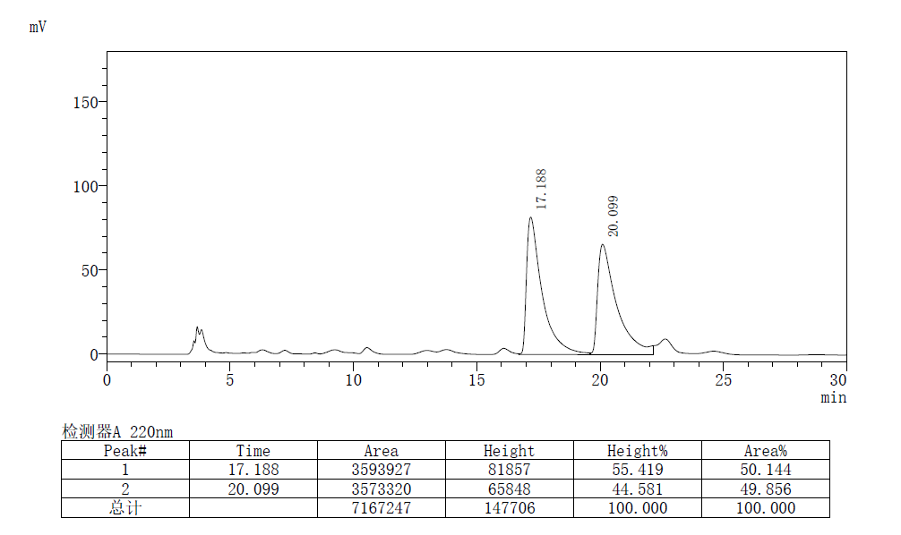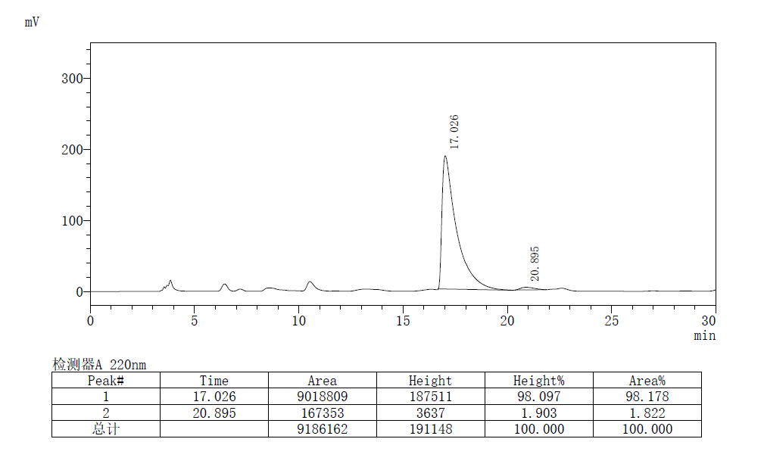
(S,E)-ethyl 2-amino-2-methyl-3-methylene-5-phenylpent-4-enoate
Prepared according to General Procedure B using L11-Pd and (S,S_{p})-L3-Cu, Purification by flash chromatography (PE/EA = 5:1 to 1:1) afforded the product as a pale yellow oil, 32.9 mg, 65% yield, >99% ee, R_{f} = 0.4 (PE/EA, 1:1).
[α]²⁵_{D} = 5.2 (c 1.0, CHCl₃)
¹H NMR (400 MHz, CDCl₃) δ 7.39 (d, J = 7.8 Hz, 2H), 7.31 (t, J = 7.5 Hz, 2H), 7.26 – 7.21 (m, 1H), 6.79 – 6.67 (m, 2H), 5.42 (s, 1H), 5.32 (s, 1H), 4.19 (q, J = 7.1 Hz, 2H), 1.86 (s, 2H), 1.55 (s, 3H), 1.24 (t, J = 7.1 Hz, 3H).
¹³C NMR (101 MHz, CDCl₃) δ 176.1, 148.8, 137.0, 130.4, 128.6, 127.8, 126.9, 126.6, 112.3, 61.4, 60.4, 25.8, 14.2.
HRMS (ESI) calcd. for C₁₄H₂₀NO₂⁺ (M + H)⁺: 246.1494, Found: 246.1486
the ee value was > 99%, t_{r} (major) = 14.083 min, t_{r} (minor) = 18.497 min (Chiralcel IC, λ = 220 nm, hexanes : ^{i}PrOH = 95 : 5, flow rate = 1.0 mL/min).
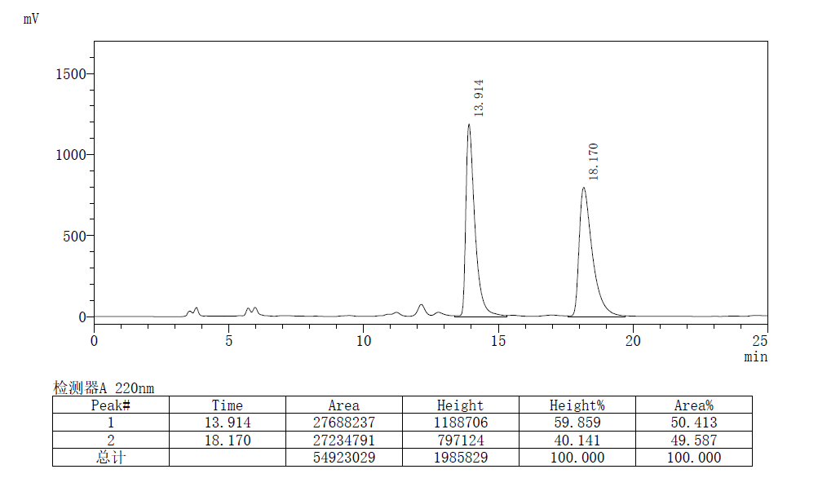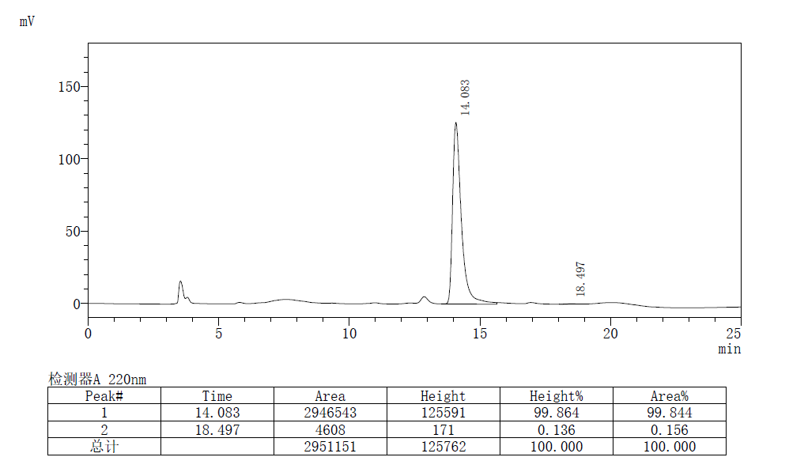
(S,E)-isopropyl 2-amino-2-methyl-3-methylene-5-phenylpent-4-enoate
Prepared according to General Procedure B using L11-Pd and (S,S_{p})-L3-Cu, Purification by flash chromatography (PE/EA = 5:1 to 1:1) afforded the product as a pale yellow oil, 40.2 mg, 77% yield, 97% ee, R_{f} = 0.5 (PE/EA, 1:1).
[α]²⁵_{D} = 4.3 (c 1.0, CHCl₃)

¹H NMR (400 MHz, CDCl₃) δ 7.39 (d, J = 7.3 Hz, 2H), 7.31 (t, J = 7.5 Hz, 2H), 7.23 (t, J = 7.2 Hz, 1H), 6.77 – 6.65 (m, 2H), 5.41 (s, 1H), 5.32 (s, 1H), 5.10 – 4.99 (m, 1H), 1.87 (s, 2H), 1.54 (s, 3H), 1.21 (t, J = 5.9 Hz, 6H).
¹³C NMR (101 MHz, CDCl₃) δ 175.6, 148.9, 137.1, 130.3, 128.6, 127.7, 127.1, 126.5, 112.3, 68.8, 60.4, 25.7, 21.6, 21.6.
HRMS (ESI) calcd. for C₁₄H₂₀NO₂⁺ (M + H)⁺: 260.1651, Found: 260.1643
the ee value was 97%, t_{r} (major) = 11.964 min, t_{r} (minor) = 15.942 min (Chiralcel IC, λ = 220 nm, hexanes : ^{i}PrOH = 95 : 5, flow rate = 1.0 mL/min).
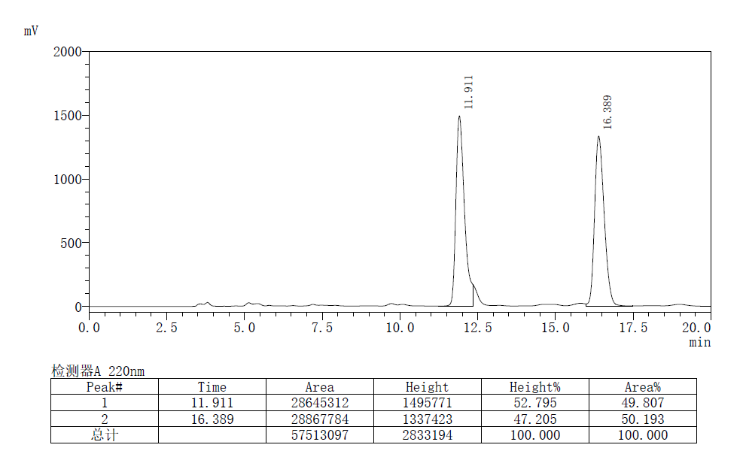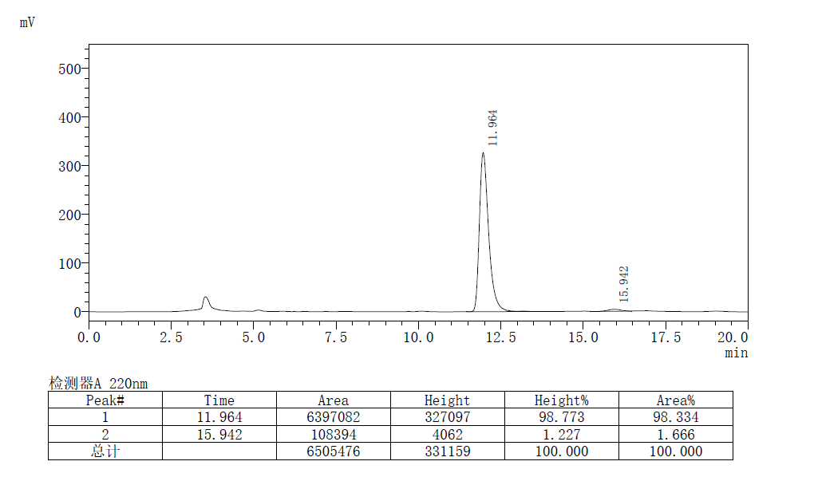
(S,E)-tert-butyl 2-amino-2-methyl-3-methylene-5-phenylpent-4-enoate
Prepared according to General Procedure B using L11-Pd and (S,S_{p})-L3-Cu, Purification by flash chromatography (PE/EA = 10:1 to 5:1) afforded the product as a pale yellow oil, 46.3 mg, 85% yield, 91% ee, R_{f} = 0.3 (PE/EA, 5:1).
[α]²⁵_{D} = 8.0 (c 1.0, CHCl₃)
¹H NMR (400 MHz, CDCl₃) δ 7.39 (d, J = 7.6 Hz, 2H), 7.31 (t, J = 7.1 Hz, 2H), 7.23 (t, J = 7.0 Hz, 1H), 6.79 – 6.67 (m, 2H), 5.39 (s, 1H), 5.32 (s, 1H), 2.05 (s, 2H), 1.52 (s, 3H), 1.43 (s, 9H).
¹³C NMR (101 MHz, CDCl₃) δ 175.3, 149.1, 137.2, 130.2, 128.6, 127.7, 127.4, 126.5, 112.3, 81.3, 60.7, 27.8, 25.7.
HRMS (ESI) calcd. for C₁₄H₂₀NO₂⁺ (M + H)⁺: 274.1807, Found: 274.1799
the ee value was 91%, t_{r} (major) = 9.473 min, t_{r} (minor) = 14.874 min (Chiralcel IC, λ = 220 nm, hexanes : ^{i}PrOH = 95 : 5, flow rate = 1.0 mL/min).
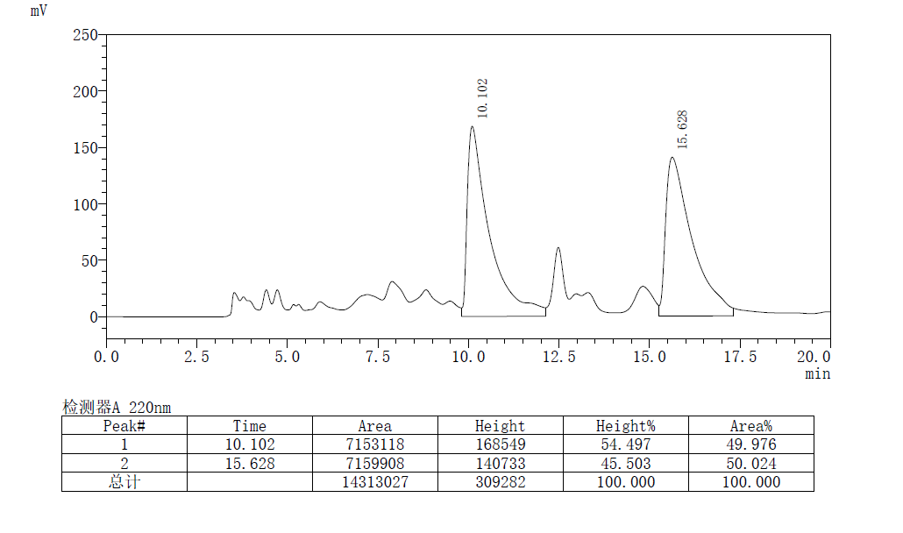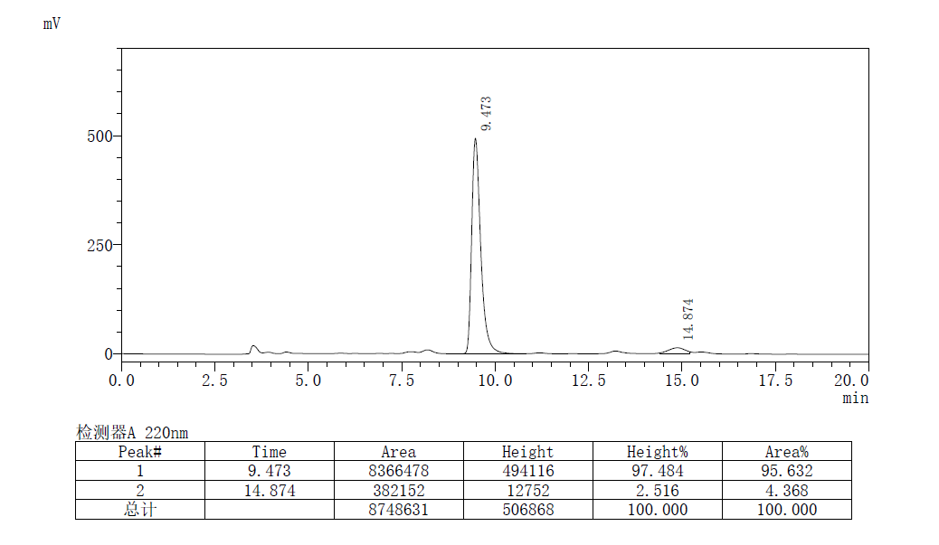
(S,E)-methyl 5-oxo-2-(4-phenylbuta-1,3-dien-2-yl)pyrrolidine-2-carboxylate
Prepared according to General Procedure B using L11-Pd and (S,S_{p})-L3-Cu, Purification by flash chromatography (PE/EA = 5:1 to 1:3) afforded the product as a pale yellow solid, 31.6 mg, 58% yield, 92% ee, R_{f} = 0.4 (PE/EA, 1:2).
[α]²⁵_{D} = -20.1 (c 0.8, CHCl₃)
¹H NMR (400 MHz, CDCl₃) δ 7.40 (d, J = 7.3 Hz, 2H), 7.33 (t, J = 7.4 Hz, 2H), 7.26 (t, J = 7.2 Hz, 1H), 6.82 (s, 1H), 6.70 (q, J = 16.4 Hz, 2H), 5.46 (s, 1H), 5.31 (s, 1H), 3.76 (s, 3H), 2.96 (ddd, J = 13.1, 9.1, 6.5 Hz, 1H), 2.52 – 2.34 (m, 2H), 2.25 (ddd, J = 13.1, 9.0, 7.1 Hz, 1H).
¹³C NMR (101 MHz, CDCl₃) δ 177.0, 171.9, 145.4, 136.5, 131.4, 128.7, 128.2, 126.7, 125.1, 112.9, 68.2, 53.2, 30.1, 29.5.
HRMS (ESI) calcd. for C₁₄H₂₀NO₂⁺ (M + H)⁺: 272.1287, Found: 272.1278
the ee value was 92%, t_{r} (minor) = 25.970 min, t_{r} (major) = 46.271 min (Chiralcel IC, λ = 220 nm, hexanes : ^{i}PrOH = 85 : 15, flow rate = 1.0 mL/min).

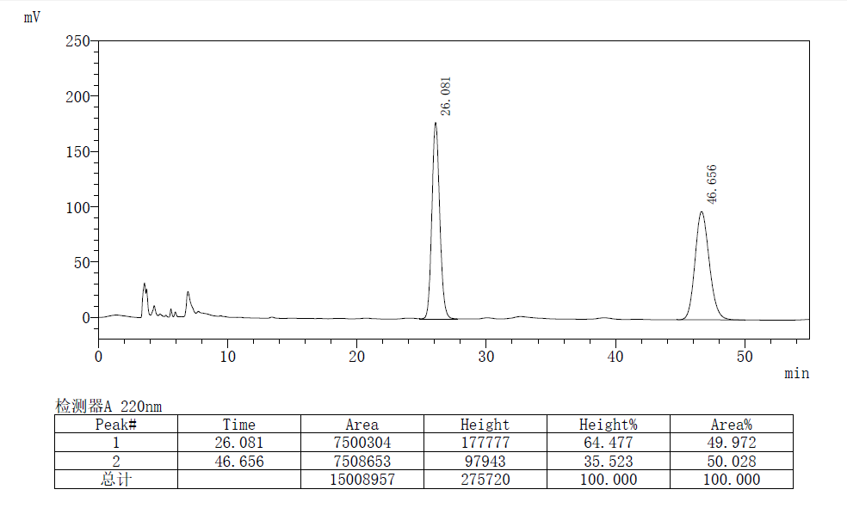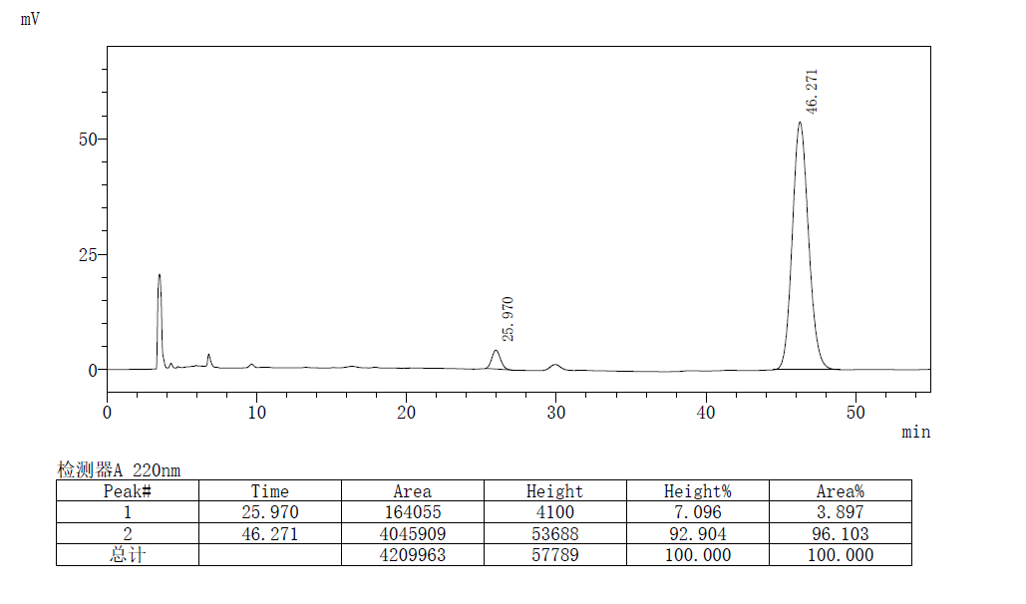
(S,E)-3-amino-3-(4-phenylbuta-1,3-dien-2-yl)dihydrofuran-2(3H)-one
Prepared according to General Procedure B using L11-Pd and (S,S_{p})-L3-Cu, Purification by flash chromatography (PE/EA = 5:1 to 1:3) afforded the product as a pale yellow solid, 25.2 mg, 55% yield, 98% ee, R_{f} = 0.3 (PE/EA, 1:2). m. p. 98-100 ℃.
[α]²⁵_{D} = -35.0 (c 0.8, CHCl₃)
¹H NMR (400 MHz, CDCl₃) δ 7.44 (d, J = 7.3 Hz, 2H), 7.34 (t, J = 7.5 Hz, 2H), 7.26 (dd, J = 7.6, 6.9 Hz, 1H), 6.88 (dd, J = 77.5, 16.2 Hz, 2H), 5.50 (s, 1H), 5.15 (s, 1H), 4.42 – 4.30 (m, 1H), 4.16 (td, J = 9.5, 6.1 Hz, 1H), 2.65 (ddd, J = 13.0, 6.1, 2.5 Hz, 1H), 2.24 (ddd, J = 13.0, 9.8, 8.2 Hz, 1H), 1.78 (s, 2H).
¹³C NMR (101 MHz, CDCl₃) δ 179.4, 144.7, 136.7, 132.3, 128.7, 128.1, 126.7, 125.2, 113.9, 64.7, 62.6, 36.6.
HRMS (ESI) calcd. for C₁₄H₂₀NO₂⁺ (M + H)⁺: 230.1181, Found: 230.1174
the ee value was 98%, t_{r} (major) = 28.922 min, t_{r} (minor) = 31.593 min (Chiralcel IC, λ = 220 nm, hexanes : ^{i}PrOH = 85 : 15, flow rate = 1.0 mL/min).
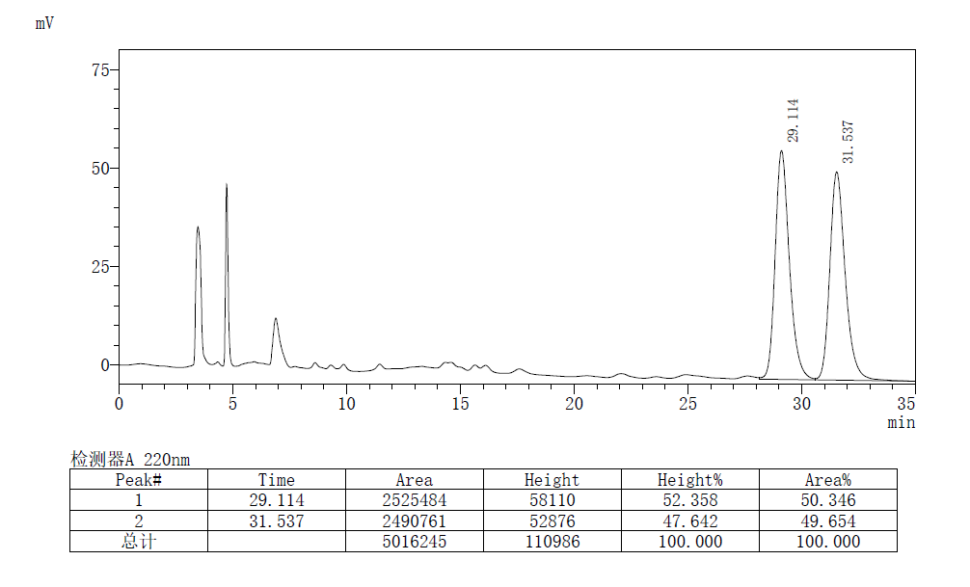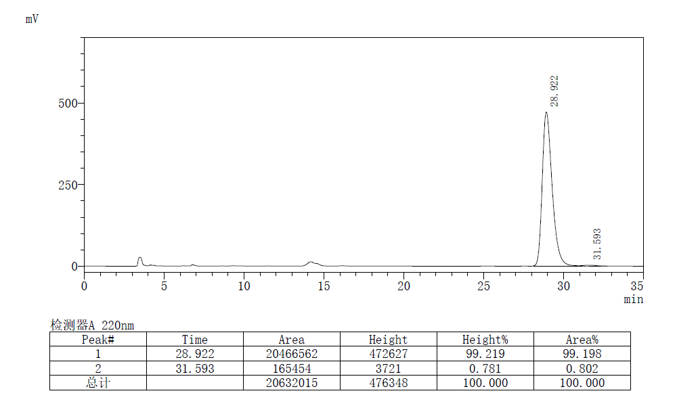
(S,E)-methyl 5-phenyl-2-(4-phenylbuta-1,3-dien-2-yl)-3,4-dihydro-2H-pyrrole-2-carboxylate
Prepared according to General Procedure B using L11-Pd and (S,S_{p})-L3-Cu, Purification by flash chromatography (PE/EA = 30:1 to 15:1) afforded the product as a pale yellow solid, 59.1 mg, 89% yield, 99% ee, R_{f} = 0.3 (PE/EA, 15:1). m. p. 96-98 ℃.
[α]²⁵_{D} = -180.2 (c 1.5, CHCl₃)
¹H NMR (400 MHz, CDCl₃) δ 7.81 – 7.74 (m, 2H), 7.32 – 7.21 (m, 5H), 7.14 (t, J = 7.5 Hz, 2H), 7.06 (dd, J = 8.4, 6.1 Hz, 1H), 6.55 (dd, J = 71.7, 16.6 Hz, 2H), 5.27 (s, 1H), 5.21 (s, 1H), 3.56 (s, 3H), 3.09 – 2.83 (m, 3H), 1.93 (ddd, J = 12.0, 9.3, 5.9 Hz, 1H).
¹³C NMR (101 MHz, CDCl₃) δ 175.5, 173.3, 147.4, 137.2, 133.9, 131.2, 129.56, 128.7, 128.5, 128.3, 128.2, 127.8, 126.6, 115.3, 85.6, 53.1, 35.8, 32.2.
HRMS (ESI) calcd. for C₁₄H₂₀NO₂⁺ (M + H)⁺: 332.1651, Found: 332.1643
the ee value was 99%, t_{r} (major) = 13.730 min, t_{r} (minor) = 17.041 min (Chiralcel IC, λ = 220 nm, hexanes : ^{i}PrOH = 98 : 2, flow rate = 1.0 mL/min).
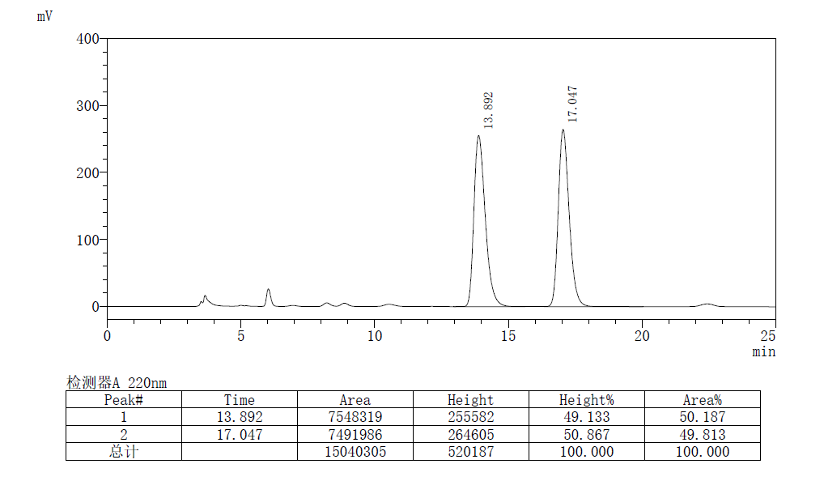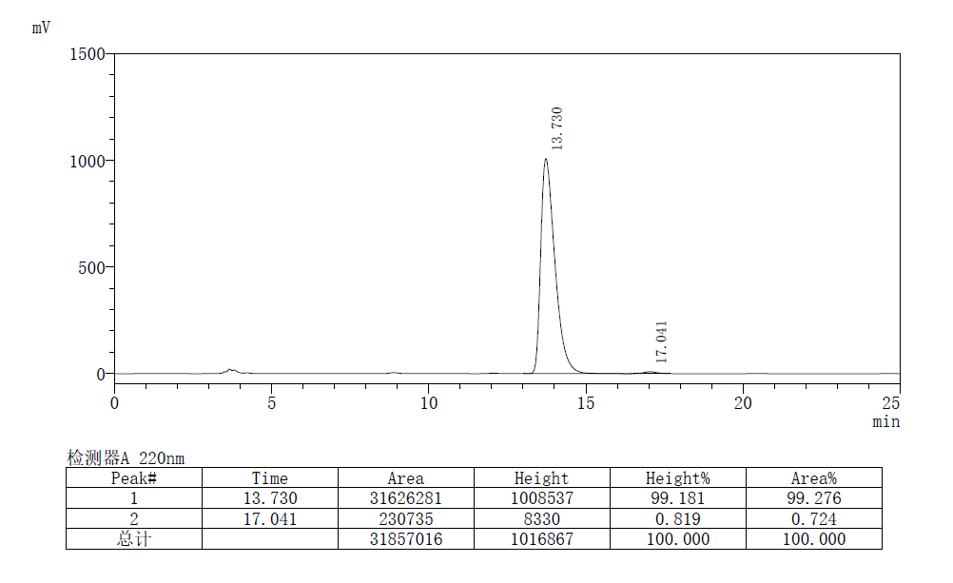
(S,E)-methyl 2-phenyl-4-(4-phenylbuta-1,3-dien-2-yl)-4,5-dihydrooxazole-4-carboxylate
Prepared according to General Procedure B using L11-Pd and (S,S_{p})-L3-Cu, Purification by flash chromatography (PE/EA = 30:1 to 15:1) afforded the product as a pale yellow solid, 50.9 mg, 76% yield, >99% ee, R_{f} = 0.3 (PE/EA, 15:1). m. p. 148-149 ℃.
[α]²⁵_{D} = -350.5 (c 0.5, CHCl₃)
¹H NMR (400 MHz, CDCl₃) δ 8.06 (d, J = 7.3 Hz, 2H), 7.52 (t, J = 7.3 Hz, 1H), 7.43 (dd, J = 12.6, 7.5 Hz, 4H), 7.33 (t, J = 7.5 Hz, 2H), 7.26 (t, J = 7.2 Hz, 1H), 6.80 (d, J = 16.8 Hz, 1H), 6.35 (d, J = 16.8 Hz, 1H), 5.70 (s, 1H), 5.48 (s, 1H), 5.46 (d, J = 8.6 Hz, 1H), 4.33 (d, J = 8.6 Hz, 1H), 3.79 (s, 3H).
¹³C NMR (101 MHz, CDCl₃) δ 172.1, 165.2, 145.9, 136.7, 132.0, 129.4, 128.8, 128.7, 128.4, 128.1, 127.4, 127.0, 126.6, 117.6, 79.8, 74.9.
HRMS (ESI) calcd. for C₁₄H₂₀NO₂⁺ (M + H)⁺: 334.1443, Found: 334.1434
the ee value was > 99%, t_{r} (major) = 12.575 min, t_{r} (minor) = 13.910 min (Chiralcel IC, λ = 220 nm, hexanes : ^{i}PrOH = 98 : 2, flow rate = 1.0 mL/min).
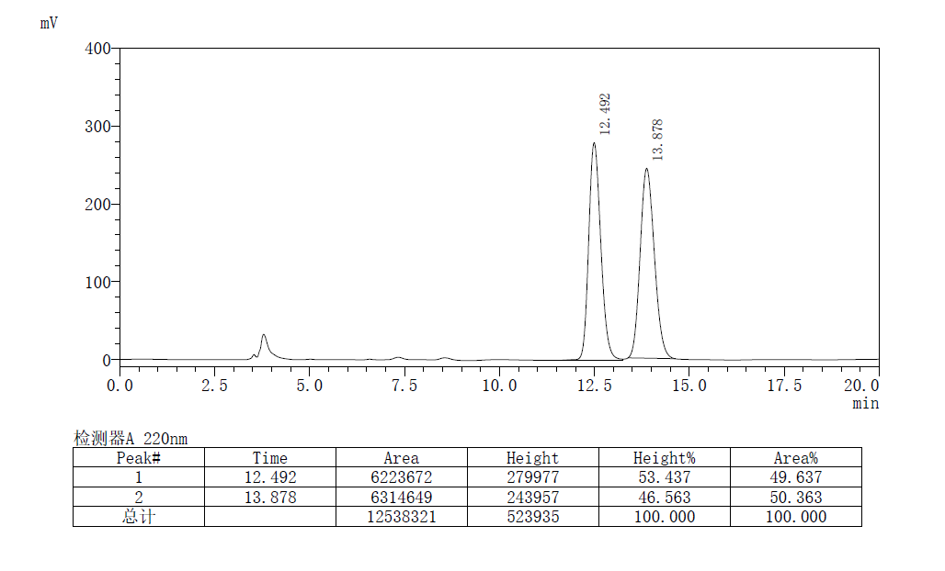
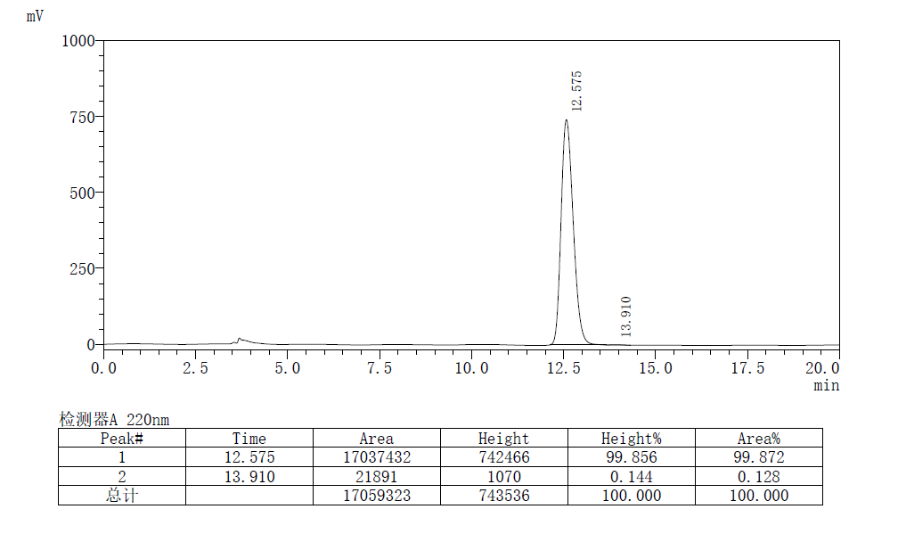

References
1. A. Hedhli, A. Baklouti. Tetrahedron. Letters. 1995, 25, 4433-4436.
2.De, S.; Day, C.; Welker, M. E. Tetrahedron. 2007, 63, 10939-10948.
3. a) Huo, X.; He, R.; Fu, J.; Zhang, J.; Yang, G.; Zhang, W. J. Am. Chem. Soc. 2017, 139, 9819-9822. b) Liu, P.; Huo, X.; Li, B.; He, R.; Zhang, J.; Xie, F.; Zhang, W. Org. Lett. 2018, 20, 6564-6568. c) Guerrero-Corella, A.; Esterban, F.; Iniesta, M.; Martín-Somer, A.; Parra, M.; Díaz-Tendero, S.; Fraile, A.; Alemán, J. Angew. Chem., Int. Ed. 2018, 57, 5350- 5354.

Copies of NMR Spectra

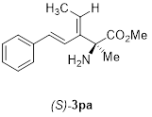
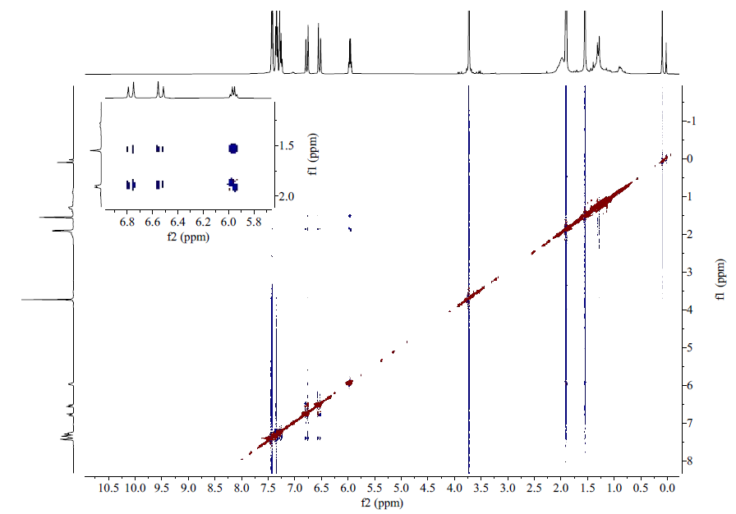

General Information for Computation
All calculations were performed with the Gaussian 16 program. (Full citation of Gaussian 16: M. J. Frisch, G. W. Trucks, H. B. Schlegel, G. E. Scuseria, M. A. Robb, J. R. Cheeseman, G. Scalmani, V. Barone, G. A. Petersson, H. Nakatsuji, X. Li, M. Caricato, A. V. Marenich, J. Bloino, B. G. Janesko, R. Gomperts, B. Mennucci, H. P. Hratchian, J. V. Ortiz, A. F. Izmaylov, J. L. Sonnenberg, D. Williams-Young, F. Ding, F. Lipparini, F. Egidi, J. Goings, B. Peng, A. Petrone, T. Henderson, D. Ranasinghe, V. G. Zakrzewski, J. Gao, N. Rega, G. Zheng, W. Liang, M. Hada, M. Ehara, K. Toyota, R. Fukuda, J. Hasegawa, M. Ishida, T. Nakajima, Y. Honda, O. Kitao, H. Nakai, T. Vreven, K. Throssell, J. A. Montgomery, Jr., J. E. Peralta, F. Ogliaro, M. J. Bearpark, J. J. Heyd, E. N. Brothers, K. N. Kudin, V. N. Staroverov, T. A. Keith, R. Kobayashi, J. Normand, K. Raghavachari, A. P. Rendell, J. C. Burant, S. S. Iyengar, J. Tomasi, M. Cossi, J. M. Millam, M. Klene, C. Adamo, R. Cammi, J. W. Ochterski, R. L. Martin, K. Morokuma, O. Farkas, J. B. Foresman, and D. J. Fox, Gaussian, Inc., Wallingford CT, 2016. Gaussian 16, Revision A.03).
Geometry optimizations were conducted with the Gaussian 16 software package, B3LYP functional [with gd3(BJ) dispersion correction], and LANL2DZ basis set for Pd and 6-31g(d) basis set for all other atoms. Single-point energy calculations were conducted with the M06-2X functional and def2-TZVP basis set for atoms, along with the SMD CH2ClCH2Cl solvent correction. Concentration was corrected from 1 atm to 1 mol/L by addition 1.89 kcal/mol to the Gibbs energy of each species. Reaction paths were traced by the intrinsic reaction coordinate method for all transition states. All energetics reported throughout the text are in kcal/mol

Coordinates and Energies of Stationary Points

Total SCF energy (M06-2X/def2TZVP/SMD(THF)): -292.373547 a.u.
Thermal correction to Gibbs Free Energy at 298.15 K: 0.173245 a.u
Gibbs free energy at 298.15 K (M06-2X/def2TZVP/SMD(THF)): -292.200302 a.u.
N -0.00002300 -0.00002700 0.01868900
C -0.05205400 1.40072800 0.44709700
H -1.09371500 1.73179300 0.39399400
H 0.25075500 1.50746100 1.50756600
C 0.78955400 2.31857800 -0.43841200
H 0.45328200 2.24825300 -1.47767600
H 0.69841400 3.35968400 -0.10795600
H 1.85263700 2.05613100 -0.41158400
C 1.23900000 -0.65538700 0.44726200
H 2.04651400 0.08125900 0.39469400
H 1.17970200 -0.97133900 1.50761300
C 1.61350600 -1.84283200 -0.43850900
H 1.72098800 -1.51610500 -1.47763900
H 2.56067400 -2.28440800 -0.10791700
H 0.85481100 -2.63239900 -0.41213800
C -1.18711000 -0.74549000 0.44699400
H -0.95298600 -1.81312900 0.39374900
H -1.43093700 -0.53675600 1.50750100
C -2.40288300 -0.47556600 -0.43841800
H -3.25884100 -1.07515900 -0.10791500
H -2.70726100 0.57627300 -0.41146500
H -2.17395800 -0.73154800 -1.47772800

Total SCF energy (M06-2X/def2TZVP/SMD(THF)): -292.836445 a.u.
Thermal correction to Gibbs Free Energy at 298.15 K: 0.188695 a.u
Gibbs free energy at 298.15 K (M06-2X/def2TZVP/SMD(THF)): --292.647550 a.u.
N -0.00004100 -0.00006000 0.01484000
C -0.19412300 1.44193500 0.45782500
H -1.26491000 1.64351000 0.40957200
H 0.11440100 1.47679200 1.50579500
C 0.57882900 2.42077800 -0.41236100
H 0.25237800 2.37150800 -1.45724400
H 0.38199000 3.43576600 -0.05580200
H 1.66062200 2.26527700 -0.37217200
C 1.34577000 -0.55297400 0.45796200
H 2.05566000 0.27366000 0.41015300
H 1.22148900 -0.83793700 1.50581400
C 1.80738700 -1.71144100 -0.41248700
H 1.92813500 -1.40371900 -1.45723900
H 2.78478800 -2.04841800 -0.05581600
H 1.13197000 -2.57068500 -0.37274200
C -1.15181800 -0.88912800 0.45777000
H -0.79102500 -1.91725100 0.40945200
H -1.33628100 -0.63944900 1.50576000
C -2.38603200 -0.70912700 -0.41239100
H -3.16657900 -1.38715700 -0.05588200
H -2.79230800 0.30546600 -0.37210800
H -2.18013500 -0.96710300 -1.45730100
H 0.00001400 -0.00008900 -1.01202200

Total SCF energy (M06-2X/def2TZVP/SMD(THF)): -392.857439 a.u.
Thermal correction to Gibbs Free Energy at 298.15 K: 0.184634 a.u
Gibbs free energy at 298.15 K (M06-2X/def2TZVP/SMD(THF)): --392.672805 a.u.
N -0.00000900 -0.00025900 -0.38080900
C -1.37558600 -0.33737000 -0.80502100
H -1.97504800 0.57282400 -0.72164400
H -1.38411400 -0.62853100 -1.86884600
C -2.00154200 -1.41989000 0.07395000
H -1.91269800 -1.13520500 1.12590900
H -3.05976000 -1.54494000 -0.17816200
H -1.51482300 -2.39214800 -0.05597800
C 0.97971600 -1.02327900 -0.80432900
H 0.49143500 -1.99749900 -0.71918500
H 1.23530100 -0.88653300 -1.86855000
C 2.23087900 -1.02258000 0.07365100
H 1.94076200 -1.08619800 1.12596000
H 2.86806300 -1.87694100 -0.17752700
H 2.82943100 -0.11518500 -0.05835300
C 0.39609300 1.35950300 -0.80499700
H 1.48397500 1.42365100 -0.72040200
H 0.14937100 1.51213300 -1.86914300
C -0.22955500 2.44297300 0.07300300
H 0.19163600 3.42188900 -0.17868300
H -1.31472700 2.50762800 -0.05840800
H -0.02881300 2.22379100 1.12525300
H -0.00008200 0.00027600 1.20208900
F 0.00001300 0.00074000 2.19153300

Total SCF energy (M06-2X/def2TZVP/SMD(THF)): -486.281668 a.u.
Thermal correction to Gibbs Free Energy at 298.15 K: 0.123624 a.u
Gibbs free energy at 298.15 K (M06-2X/def2TZVP/SMD(THF)): -486.158044 a.u.
C 2.77259600 1.33224200 -0.00000900
C 1.39695800 1.13272800 -0.00000700
C 0.85623300 -0.16710900 0.00000200
C 1.74898700 -1.25354500 0.00001300
C 3.12732200 -1.05459100 0.00001100
C 3.64586700 0.24027100 -0.00000200
H 3.16856000 2.34397600 -0.00001600
H 0.73566300 1.99380000 -0.00000800
H 1.34796300 -2.26400200 0.00002300
H 3.79608700 -1.91068500 0.00001800
H 4.72018600 0.40015300 -0.00000800
C -0.57941100 -0.43962900 0.00000700
H -0.85568600 -1.49123200 0.00004400
C -1.57804900 0.46549600 -0.00001600
H -1.37758000 1.53323100 -0.00004600
C -2.98111500 0.10756800 -0.00000100
C -4.02221400 0.94728900 0.00003100
H -3.85796200 2.01797400 0.00005100
H -5.03987500 0.57652300 0.00003700
F -3.21782300 -1.22934000 -0.00003000

Total SCF energy (M06-2X/def2TZVP/SMD(THF)): -731.432683 a.u.
Thermal correction to Gibbs Free Energy at 298.15 K: 0.170752 a.u
Gibbs free energy at 298.15 K (M06-2X/def2TZVP/SMD(THF)): -731.261931 a.u.
C 4.06128000 -0.24294900 0.07788500
C 3.44246700 0.85355100 0.67550700
C 2.06060900 0.96453400 0.59680900
C 1.30152900 -0.00997100 -0.07234000
C 1.95691600 -1.09948700 -0.66196200
C 3.34267800 -1.22517200 -0.59203300
H 4.04815600 1.59389500 1.18717600
H 1.54168000 1.80299200 1.04853000
H 1.37447200 -1.85540900 -1.18250400
H 3.86656200 -2.06085100 -1.04293300
C -0.16220500 0.08847700 -0.16812300
H -0.65270600 -0.72824600 -0.71248100
N -0.80187400 1.06478200 0.34721400
C -2.25513900 1.18497800 0.21756800
C -2.56639500 2.24435200 -0.84762100
H -3.63346800 2.49074100 -0.85331100
H -1.99222200 3.15082600 -0.63782100
H -2.28871700 1.86467700 -1.83478000
C -2.97160500 -0.11912600 -0.11982700
O -2.92467500 -0.68275000 -1.19524800
O -3.64353100 -0.60356900 0.94421000
C -4.31773600 -1.85439600 0.72535200
H -4.80928200 -2.09094400 1.66885700
H -5.05036300 -1.75765300 -0.07993300
H -3.59854300 -2.63299400 0.45820800
F 5.40258900 -0.35269700 0.15351700
H -2.62449800 1.52556300 1.18986500

Total SCF energy (M06-2X/def2TZVP/SMD(THF)): -1117.262544 a.u.
Thermal correction to Gibbs Free Energy at 298.15 K: 0.304616 a.u
Gibbs free energy at 298.15 K (M06-2X/def2TZVP/SMD(THF)): -1116.957928 a.u.
C -0.71142900 -0.90460100 -0.51135600
C -2.14831000 -0.60151600 -0.56976900
H -2.46582500 0.13282100 -1.30564100
C -3.06356600 -1.12232400 0.26961600
H -2.71265900 -1.77486900 1.06758300
C -4.50574500 -0.86806400 0.25517700
C -5.28139800 -1.28869700 1.34949800
C -5.15990100 -0.21399100 -0.80558900
C -6.65348400 -1.05268100 1.39447800
H -4.79310800 -1.80102100 2.17480700
C -6.52925900 0.02413700 -0.76068000
H -4.59283000 0.09629000 -1.67793400
C -7.28400200 -0.39195900 0.34001500
H -7.23027000 -1.38552500 2.25292000
H -7.01419400 0.52891800 -1.59179600
H -8.35417300 -0.20843100 0.36984500
C 6.54517700 -0.63376900 0.32942500
C 5.67077600 -1.44654000 -0.38971400
C 4.34255500 -1.05863700 -0.50556200
C 3.88912000 0.12952900 0.09119400
C 4.79657400 0.92358800 0.80528000
C 6.13231200 0.54830000 0.93125400
H 6.04244200 -2.35932200 -0.84300800
H 3.63215300 -1.66236300 -1.05981300
H 4.45050000 1.84283600 1.27080600
H 6.84774500 1.14922400 1.48185700
C 2.48662800 0.55738600 -0.01857300
H 2.25468000 1.51658100 0.45739500
N 1.61812600 -0.15725400 -0.61603300
C 0.24143200 0.27491300 -0.80482800
C 0.12969500 0.68951800 -2.28928400
H -0.89676300 0.92200400 -2.57548300
H 0.74692400 1.57256700 -2.47973700
H 0.49796900 -0.13635300 -2.90249100
C -0.21248500 1.39874700 0.15540200
O 0.08739300 1.46915000 1.32693700
O -1.04441200 2.27577400 -0.44593300
C -1.63598700 3.25138700 0.42943600
H -2.26825100 3.86929900 -0.20796300
H -2.23120900 2.75211200 1.19804500
H -0.86183500 3.85401700 0.91019800
F 7.83515200 -1.00797500 0.44252300
C -0.23946500 -2.12081700 -0.20812200
H 0.82410200 -2.30366200 -0.12158900
H -0.91791000 -2.95542500 -0.06030900

Total SCF energy (M06-2X/def2TZVP/SMD(THF)): -3686.139686 a.u.
Thermal correction to Gibbs Free Energy at 298.15 K: 1.382068 a.u
Gibbs free energy at 298.15 K (M06-2X/def2TZVP/SMD(THF)): -3684.757618 a.u.
Pd -0.01273000 0.01409000 -1.92441800
P -1.89323300 0.03969400 -0.63358300
P 1.86338800 -0.02045600 -0.62815200
O 0.96244800 1.16021300 3.61206500
O -0.99146000 -1.02613600 3.64420200
C -3.55319000 0.71091500 -1.07030500
C -4.77066900 0.20884200 -0.59144100
H -4.76056500 -0.64243800 0.07338800
C -5.98348200 0.78337000 -0.97564400
C -5.95113700 1.88964200 -1.84169800
C -4.75643400 2.41178400 -2.34391600
C -3.56143900 1.78794400 -1.95972000
H -2.60999400 2.14026900 -2.34955500
C -7.33507500 0.25056600 -0.47918100
C -7.17408400 -0.95397400 0.46376700
H -6.60271400 -0.69145000 1.36097600
H -8.16016400 -1.30425000 0.78816300
H -6.66727400 -1.79052900 -0.02944200
C -8.18455400 -0.19398400 -1.68956200
H -7.67725100 -0.98856600 -2.24770900
H -9.15669500 -0.57597300 -1.35507900
H -8.36929600 0.63506100 -2.38022100
C -8.07564200 1.36738500 0.28800700
H -8.25887400 2.24136500 -0.34523700
H -9.04588800 1.00491100 0.64856800
H -7.48976700 1.69722000 1.15321700
C -4.70238800 3.62120600 -3.28713100
C -4.03196800 3.20460600 -4.61441300
H -4.60399300 2.40955200 -5.10536700
H -3.97591200 4.06007800 -5.29833700
H -3.01418200 2.83478900 -4.45487900
C -3.87103400 4.74056900 -2.62188100
H -2.84869300 4.41372300 -2.40933000
H -3.81398700 5.61680500 -3.27903500
H -4.32655600 5.05215000 -1.67500700
C -6.09887600 4.17981000 -3.60483400
H -6.61659300 4.51637000 -2.69957200
H -6.00754200 5.04139200 -4.27528500
H -6.72910700 3.43547600 -4.10428000
C -2.22552100 -1.61110900 0.08926300
C -1.69554600 -2.70658500 -0.58990600
H -1.09543700 -2.51345500 -1.47447600
C -1.89724600 -4.01544400 -0.13263500
C -2.67762300 -4.18670700 1.01175000
C -3.22221000 -3.10437100 1.72654900
C -2.96789800 -1.81359100 1.26203700
H -3.32101800 -0.95108200 1.81206600
C -4.09298800 -3.37723700 2.96056400
C -3.35319700 -4.31993600 3.93329800
H -2.38422300 -3.89984700 4.21862200
H -3.94628600 -4.47151200 4.84291200
H -3.16981900 -5.30380000 3.49076300
C -5.40408700 -4.05382100 2.50305900
H -5.20560800 -4.99666200 1.98232700
H -6.04685300 -4.27064100 3.36528500
H -5.95783300 -3.40238600 1.81850800
C -4.44754800 -2.08274100 3.71182500
H -5.06930800 -1.41991100 3.10022200
H -5.01560500 -2.32262500 4.61755900
H -3.54889000 -1.53027200 4.00062300
C -1.25816900 -5.18056600 -0.89935400
C 0.27311900 -4.98042000 -0.93575400
H 0.68712700 -4.97226600 0.07696500
H 0.74915500 -5.79017500 -1.50257000
H 0.54574600 -4.03016000 -1.40510300
C -1.80587700 -5.20020200 -2.34293200
H -1.58563800 -4.26565000 -2.86854100
H -1.35393700 -6.02176000 -2.91187600
H -2.89294100 -5.33838900 -2.34514500
C -1.55230400 -6.54116700 -0.24798200
H -2.62659500 -6.75656500 -0.22474700
H -1.06656800 -7.33834100 -0.82147200
H -1.17028200 -6.58809200 0.77808600
C 2.23563200 1.63271900 0.06907900
C 2.98368400 1.83448500 1.23825400
H 3.31746900 0.97176000 1.79989500
C 3.26813800 3.12550000 1.68459300
C 2.74630500 4.20975800 0.95602800
C 1.96041600 4.04031100 -0.18501400
C 1.72950600 2.73031000 -0.62467100
H 1.12474100 2.53861000 -1.50629500
C 3.50257000 -0.73540400 -1.07040000
C 4.73014700 -0.26726500 -0.59407500
H 4.74485000 0.58524700 0.06930200
C 5.92949900 -0.87906000 -0.97621200
C 5.86092600 -1.98159600 -1.83659900
C 4.64883600 -2.47300100 -2.34135100
C 3.47470000 -1.81909200 -1.95932500
H 2.51179100 -2.13946600 -2.34225600
C 4.15092600 3.39434300 2.91096900
C 5.48292100 4.01547500 2.43530000
H 5.31435400 4.95319600 1.89507100
H 6.13604000 4.22847300 3.29069300
H 6.01149700 3.33114900 1.76307100
C 4.46268200 2.10410300 3.68827100
H 5.06232000 1.40885600 3.09075100
H 5.03825400 2.34307100 4.58947900
H 3.54611200 1.58745400 3.98722500
C 3.44887100 4.38257900 3.86616500
H 2.46628200 4.00403900 4.16278300
H 4.05019500 4.53040000 4.77093300
H 3.30035800 5.36368700 3.40490100
C 1.34738500 5.20902400 -0.96717600
C 1.90928900 5.20633700 -2.40546500
H 1.68021300 4.26964200 -2.92359000
H 1.47553700 6.02891400 -2.98700800
H 2.99831700 5.32799400 -2.39832900
C -0.18664300 5.03468400 -1.01660700
H -0.61047000 5.03746000 -0.00790900
H -0.64448200 5.84934000 -1.59091600
H -0.47125800 4.08715500 -1.48465000
C 1.65814400 6.57023400 -0.32478700
H 2.73534800 6.76989900 -0.29665700
H 1.18800800 7.36999600 -0.90757400
H 1.27066200 6.63081500 0.69852100
C 7.29532300 -0.38478600 -0.47847700
C 8.15944600 0.03187500 -1.68828200
H 7.67666800 0.83965200 -2.24920400
H 9.14188900 0.38585900 -1.35313100
H 8.32060700 -0.80380600 -2.37685800
C 7.16761300 0.82620300 0.46139200
H 6.58693900 0.58296900 1.35810800
H 8.16283600 1.14829700 0.78701000
H 6.68666500 1.67598200 -0.03508200
C 8.00091700 -1.52133900 0.29253500
H 8.15950700 -2.40153400 -0.33878800
H 8.98064500 -1.18710800 0.65470200
H 7.40358300 -1.83235300 1.15685600
C 4.64875400 -3.68720000 -3.28033500
C 5.49844100 -3.37135000 -4.53004800
H 6.53494000 -3.13608100 -4.26767300
H 5.51160300 -4.23155300 -5.21012800
H 5.08658600 -2.51256300 -5.07142900
C 3.23168300 -4.06562000 -3.74318800
H 2.75353400 -3.24892900 -4.29527400
H 3.28213900 -4.93361100 -4.40988000
H 2.58587600 -4.33151400 -2.89956900
C 5.25331400 -4.89870400 -2.53763200
H 5.26924600 -5.77910400 -3.19133300
H 6.28013700 -4.70299200 -2.21198400
H 4.66041900 -5.14275300 -1.64894100
C -0.35539900 0.70851800 1.69830900
C -1.39290100 1.08946800 0.81556000
C -1.99254600 2.35142000 0.96322100
H -2.78807800 2.64947200 0.29235200
C -1.58414800 3.22770300 1.96112500
H -2.05731500 4.20167100 2.05300100
C -0.58251000 2.85861100 2.85449300
C 0.00537800 1.60078100 2.73129300
C 0.86481200 1.61983100 4.95002700
H -0.16538100 1.53871600 5.31730100
H 1.52001000 0.97485100 5.54011700
C 1.36239500 -1.03413300 0.84584400
C 1.96747500 -2.28815600 1.03244400
H 2.76211800 -2.60449600 0.36887100
C 1.56496800 -3.13320500 2.05951400
H 2.04252500 -4.10160700 2.18245100
C 0.56311600 -2.73971000 2.94201600
C -0.03117900 -1.48942300 2.77876800
C 0.32535300 -0.62895500 1.71812100
C -0.88950800 -1.43666000 4.99790400
H -1.54485500 -0.77210500 5.56572500
H 0.14131700 -1.33949500 5.35926400
H 1.20430000 2.65594100 5.06202200
H 0.24999000 -3.39630600 3.74546000
H -1.22636500 -2.46882600 5.14813500
H -0.26484800 3.53972300 3.63539000
H -2.86791900 -5.18999400 1.37253500
H 2.95929200 5.21343300 1.30264200
H -6.88961400 2.34423300 -2.13474200
H 6.78412100 -2.46985100 -2.13271600

Total SCF energy (M06-2X/def2TZVP/SMD(THF)): -3978.967124 a.u.
Thermal correction to Gibbs Free Energy at 298.15 K: 1.588981 a.u
Gibbs free energy at 298.15 K (M06-2X/def2TZVP/SMD(THF)): -3977.378143 a.u.
Pd 0.08513500 0.89991200 -1.32875400
P -1.82141500 -0.04423900 -0.11582900
P 1.81338600 -0.11710400 -0.30487700
O 1.06628000 -2.50381000 3.38389900
O -1.06347000 -3.91153300 1.80766300
C -3.20601400 1.14623400 0.04006000
C -4.54084600 0.74974800 0.16218400
H -4.78010400 -0.30374500 0.13270800
C -5.55864400 1.69820600 0.31375100
C -5.19474100 3.04974300 0.33656100
C -3.87087900 3.48797500 0.19948200
C -2.87993900 2.51177400 0.04678600
H -1.83717500 2.79672200 -0.05495800
C -7.03468900 1.30605000 0.46083300
C -7.23718700 -0.21609200 0.39192300
H -6.70412900 -0.73470600 1.19688100
H -8.30117300 -0.45264600 0.49462100
H -6.89621400 -0.62513200 -0.56538200
C -7.85187900 1.95484100 -0.67767200
H -7.49485600 1.61510600 -1.65615200
H -8.90968700 1.68372700 -0.58655100
H -7.78494100 3.04719300 -0.65574900
C -7.55817700 1.80658100 1.82475400
H -7.47874200 2.89457900 1.91608800
H -8.61313700 1.53705900 1.94824500
H -6.99187000 1.35759800 2.64831200
C -3.57201600 4.99351200 0.23583700
C -4.40831200 5.71515300 -0.84334500
H -5.48306300 5.58853700 -0.68405600
H -4.19554100 6.79009000 -0.83042200
H -4.17017200 5.33098400 -1.84194200
C -2.09168200 5.30445800 -0.03237500
H -1.79201300 4.97170700 -1.03182000
H -1.92652000 6.38584000 0.01674100
H -1.43183500 4.83771700 0.70442600
C -3.94081300 5.54193800 1.63176900
H -3.35055700 5.04844300 2.41140400
H -3.74574800 6.61928900 1.68279300
H -4.99902100 5.38099700 1.86019900
C -2.54614900 -1.60202200 -0.72638300
C -2.25778400 -1.97190300 -2.03869700
H -1.56398900 -1.36249600 -2.61063300
C -2.83811800 -3.11307700 -2.61157700
C -3.72586900 -3.85011300 -1.82489600
C -4.03081600 -3.51240200 -0.49295600
C -3.40634800 -2.39014300 0.05510700
H -3.57997500 -2.10925200 1.08626300
C -5.09591800 -4.31425300 0.27140100
C -4.84220300 -5.83250000 0.16615500
H -3.88778300 -6.11264800 0.62111700
H -5.63492000 -6.37853600 0.68928400
H -4.83568100 -6.18059500 -0.87086100
C -6.47172900 -4.00376200 -0.36214300
H -6.49881800 -4.29685400 -1.41692300
H -7.26508500 -4.54942400 0.16181500
H -6.69618400 -2.93449500 -0.30382800
C -5.14352900 -3.93121800 1.76055100
H -5.45574800 -2.89096400 1.90312100
H -5.86860800 -4.56371300 2.28296100
H -4.16864400 -4.06069100 2.24308200
C -2.48940900 -3.49132800 -4.05717600
C -0.97534500 -3.77909800 -4.15026500
H -0.70371000 -4.62483200 -3.51017400
H -0.69725700 -4.02407400 -5.18191000
H -0.37808300 -2.91925600 -3.83017100
C -2.84750100 -2.31543000 -4.99254300
H -2.29191300 -1.40767900 -4.73383600
H -2.60727000 -2.56993600 -6.03111800
H -3.91654800 -2.08316900 -4.93568200
C -3.25023800 -4.73800600 -4.53662000
H -4.33492400 -4.58521300 -4.51553700
H -2.96818100 -4.96692700 -5.56955000
H -3.01416000 -5.61724400 -3.92702700
C 2.03893300 0.60200700 1.36164000
C 2.88091200 -0.00551700 2.30379100
H 3.35586200 -0.94421500 2.06370200
C 3.09338300 0.58309500 3.54748400
C 2.45032400 1.80337800 3.82101600
C 1.60475700 2.43329200 2.90709800
C 1.40596500 1.80660000 1.66745000
H 0.74865100 2.24872600 0.92446800
C 3.51929800 -0.37244000 -0.91555500
C 4.29240600 -1.41356200 -0.37065300
H 3.83404600 -2.10072300 0.32646000
C 5.62043500 -1.58952000 -0.74544400
C 6.15926800 -0.69631600 -1.68901400
C 5.41580800 0.33215300 -2.26805600
C 4.07619000 0.48252900 -1.86262200
H 3.45537100 1.26293800 -2.29022600
C 4.01093600 -0.04494600 4.60379200
C 5.21152000 0.89396300 4.85139400
H 4.88814100 1.87820200 5.20560800
H 5.87984000 0.46722100 5.60813900
H 5.78625200 1.04013500 3.93016500
C 4.54650800 -1.41582300 4.15739500
H 5.17807300 -1.32919300 3.26586900
H 5.15995000 -1.85108700 4.95303500
H 3.73076000 -2.11153800 3.93436500
C 3.22595800 -0.23308900 5.91937600
H 2.34906900 -0.86725400 5.75650100
H 3.85969300 -0.70799300 6.67665700
H 2.87697700 0.72007800 6.32841800
C 0.90345700 3.76599400 3.20689200
C 1.25523600 4.78720600 2.10422000
H 0.92911900 4.44307200 1.11841900
H 0.76391100 5.74666900 2.30208600
H 2.33659200 4.95747500 2.06015500
C -0.62302700 3.54319200 3.23026800
H -0.90049300 2.85288200 4.03205200
H -1.14317800 4.49393900 3.39682800
H -0.98745200 3.11396300 2.29247600
C 1.32560200 4.35882700 4.56101200
H 2.40390600 4.54764700 4.60321700
H 0.81371600 5.31373600 4.71988700
H 1.05797200 3.69967700 5.39387200
C 6.49459500 -2.70759900 -0.16318200
C 7.64589800 -2.06875700 0.64402600
H 7.25396000 -1.46411600 1.46984300
H 8.29228200 -2.84649900 1.06624600
H 8.26647800 -1.41939800 0.01795600
C 5.70102200 -3.63882000 0.76932400
H 4.86223900 -4.11535200 0.24920000
H 6.35800000 -4.43252100 1.13949700
H 5.30648000 -3.10669000 1.64172300
C 7.07717800 -3.56012600 -1.31136900
H 7.69999400 -2.96713000 -1.98819800
H 7.70155900 -4.36354900 -0.90495200
H 6.27612200 -4.01656700 -1.90335600
C 6.00574400 1.27304400 -3.32771900
C 5.91837300 2.72795500 -2.82172400
H 6.49543200 2.85624500 -1.89963100
H 6.31580900 3.41912600 -3.57374500
H 4.88602300 3.01791800 -2.60841100
C 5.19504400 1.12732000 -4.63339900
H 4.13618600 1.35121300 -4.47651800
H 5.57696200 1.81201300 -5.39946900
H 5.26407200 0.10569100 -5.02247900
C 7.47870500 0.96191300 -3.63999000
H 7.84745000 1.66088200 -4.39784600
H 8.11385400 1.06976000 -2.75407200
H 7.60598300 -0.05150300 -4.03568500
C -0.31921800 -1.34676200 1.87796700
C -1.33382500 -0.40191400 1.62302200
C -1.91902600 0.29785300 2.68561300
H -2.70182600 1.02123000 2.49235600
C -1.50272700 0.06002300 3.99364300
H -1.96512700 0.60127400 4.81395500
C -0.50075700 -0.86878000 4.26224000
C 0.08184300 -1.57268100 3.20628300
C 1.01062200 -3.29615800 4.56583200
H -0.00257400 -3.68332300 4.72205200
H 1.70302000 -4.12427300 4.40378200
C 1.17101100 -1.83227200 -0.16148900
C 1.56227900 -2.72999700 -1.17378400
H 2.26113300 -2.41282800 -1.93869200
C 1.07596000 -4.02856900 -1.18260200
H 1.38624000 -4.71695700 -1.96247500
C 0.19783400 -4.46358500 -0.19007500
C -0.21165100 -3.57264500 0.80203500
C 0.24264100 -2.23134900 0.81392600
C -1.40884300 -5.28061600 1.94977200
H -2.05651000 -5.33655200 2.82559000
H -0.51675400 -5.89929500 2.10855500
H 1.33097200 -2.73749300 5.45231900
H -0.16341900 -5.48386900 -0.20389100
H -1.95416800 -5.64550200 1.07350700
H -0.17813300 -1.04383600 5.28197600
H -4.21009700 -4.71603300 -2.25755400
H 2.62531600 2.27102900 4.78151000
H -5.97504100 3.79275300 0.46030800
H 7.19230900 -0.82567300 -1.98452800
H 1.09980000 1.90796300 -2.08657200
N 0.78821200 3.24219000 -2.93902100
C 1.68958000 3.13671400 -4.10406300
H 1.64632300 4.06365800 -4.69505700
H 2.70604400 3.05893500 -3.71327500
C 1.13136400 4.35074300 -2.02040100
H 0.37886600 4.33391500 -1.22769400
H 1.03049400 5.31207200 -2.54446600
C -0.65976600 3.24305200 -3.29306500
H -1.21297700 3.24462000 -2.34924700
H -0.87762800 2.29350200 -3.78804400
C 2.51888700 4.24170400 -1.39797600
H 3.31738800 4.40105000 -2.12626400
H 2.66430300 3.26915800 -0.91838900
H 2.62353800 5.01277800 -0.62943800
C -1.13055200 4.40640800 -4.16810000
H -0.96499900 5.37541500 -3.68793600
H -2.20632600 4.30462200 -4.34516200
H -0.63445800 4.41553400 -5.14346700
C 1.39605700 1.92246900 -4.97975800
H 2.18720700 1.81478600 -5.72717800
H 0.44786500 2.01225000 -5.51743000
H 1.36958800 1.00871300 -4.37510200

Total SCF energy (M06-2X/def2TZVP/SMD(THF)): -3686.584807 a.u.
Thermal correction to Gibbs Free Energy at 298.15 K: 1.390238 a.u
Gibbs free energy at 298.15 K (M06-2X/def2TZVP/SMD(THF)): -3685.194569 a.u.
Pd -0.04570600 0.17603000 -1.91267100
P -1.72780400 0.17131000 -0.22229700
P 1.69926600 -0.03641100 -0.51951400
O 1.32233600 1.55165400 3.69134700
O -0.68541300 -0.54763000 4.05970800
C -3.24482100 0.85362000 -0.95624000
C -4.52051600 0.40611700 -0.60522900
H -4.62033900 -0.36965700 0.14106700
C -5.65433200 0.94781800 -1.21998100
C -5.46195400 1.93835800 -2.19282300
C -4.19579100 2.40334600 -2.57615600
C -3.08446400 1.83996600 -1.94236600
H -2.08271200 2.17832800 -2.19282100
C -7.07437500 0.49133600 -0.86071300
C -7.07544100 -0.58970300 0.23432200
H -6.62450000 -0.22571400 1.16491800
H -8.10585300 -0.88291400 0.45923200
H -6.53576000 -1.48990400 -0.08066400
C -7.75381900 -0.08994800 -2.11984500
H -7.19621300 -0.95222900 -2.50156800
H -8.77201500 -0.41828500 -1.88298000
H -7.82044500 0.65017700 -2.92359100
C -7.88308500 1.70293900 -0.34779300
H -7.95658300 2.49250300 -1.10234800
H -8.90186900 1.39474400 -0.08772900
H -7.41758800 2.13349900 0.54573800
C -4.07087100 3.49159300 -3.65019200
C -4.72774700 2.99679600 -4.95708500
H -5.78953100 2.77000200 -4.81951800
H -4.64898500 3.76547200 -5.73384000
H -4.23467000 2.08930300 -5.32286100
C -2.60483900 3.84745400 -3.94935800
H -2.04267900 2.98247600 -4.32081900
H -2.56553400 4.62122900 -4.72259100
H -2.09101900 4.23981500 -3.06505300
C -4.78960700 4.76748400 -3.15900100
H -4.33666700 5.13844700 -2.23267900
H -4.71800200 5.55753700 -3.91481000
H -5.85131700 4.58586100 -2.96445200
C -2.15390700 -1.40956400 0.55081000
C -1.73050700 -2.56873100 -0.09726100
H -1.11004800 -2.47569100 -0.98356300
C -2.09000800 -3.83510700 0.38437100
C -2.88880200 -3.88398200 1.52882000
C -3.31859800 -2.73181800 2.21487200
C -2.93048600 -1.48849600 1.71605000
H -3.21525100 -0.57401600 2.22105500
C -4.22562200 -2.87358600 3.44386100
C -3.60204400 -3.86110100 4.45299500
H -2.60479800 -3.53011400 4.76225800
H -4.23026500 -3.93450400 5.34731700
H -3.50293400 -4.86816800 4.03711400
C -5.59633500 -3.41738100 2.98244000
H -5.49708100 -4.39298700 2.49533000
H -6.26894300 -3.53450100 3.83984300
H -6.06694200 -2.73140300 2.26961100
C -4.44633700 -1.52597900 4.15187500
H -4.98668600 -0.81732300 3.51437900
H -5.04688400 -1.67617300 5.05475200
H -3.49809600 -1.06311500 4.44515700
C -1.60615200 -5.08751500 -0.35977000
C -0.06258400 -5.12883200 -0.33271600
H 0.30586300 -5.21126600 0.69472500
H 0.30374900 -5.99182900 -0.90058700
H 0.37604200 -4.22553700 -0.76866600
C -2.08842500 -5.02679000 -1.82606600
H -1.68972400 -4.15218100 -2.35086700
H -1.75873800 -5.91932100 -2.36952300
H -3.18155000 -4.98009900 -1.87676300
C -2.13715500 -6.38375900 0.27259200
H -3.23189000 -6.42257700 0.25930400
H -1.76860300 -7.24652900 -0.29166400
H -1.80032900 -6.49831300 1.30889400
C 2.27462200 1.59268800 0.01029100
C 3.20467800 1.69738900 1.05229100
H 3.53083200 0.80405600 1.56791200
C 3.68831500 2.95141800 1.43688500
C 3.15932700 4.07915700 0.79403900
C 2.17698000 4.00528300 -0.20308400
C 1.76360700 2.73587100 -0.61047800
H 1.02795800 2.61461400 -1.39547900
C 3.05057300 -1.00443500 -1.24800200
C 4.37978400 -0.79868300 -0.87112100
H 4.62898300 0.02775800 -0.22155300
C 5.38519300 -1.64803500 -1.34724400
C 5.00725500 -2.70316400 -2.18752000
C 3.68234600 -2.92671900 -2.59037300
C 2.70632600 -2.04911800 -2.11367200
H 1.67050800 -2.16125600 -2.41053500
C 4.79674400 3.10316700 2.48734600
C 6.11088100 3.44594900 1.74990400
H 6.01594300 4.37758200 1.18198600
H 6.93144700 3.56626200 2.46656100
H 6.38375700 2.65008400 1.04843100
C 5.00212100 1.80701100 3.29153200
H 5.38337500 0.99400300 2.66389500
H 5.73926600 1.97581000 4.08298100
H 4.06844900 1.47149100 3.75476900
C 4.46314700 4.24002900 3.47516300
H 3.50514100 4.06119600 3.97285100
H 5.23993400 4.30667200 4.24430600
H 4.40926900 5.21561100 2.98323600
C 1.59740100 5.28633300 -0.81541000
C 0.40889500 4.98676100 -1.74598700
H -0.38733800 4.45308000 -1.21354900
H -0.00888000 5.92546700 -2.12403400
H 0.70631000 4.38846000 -2.61426100
C 1.09645300 6.21516900 0.31182200
H 1.90542900 6.52264500 0.98154000
H 0.65930200 7.12396000 -0.11631700
H 0.33138000 5.71385500 0.91346500
C 2.69970100 6.00107500 -1.62582700
H 3.06317900 5.36243100 -2.43826200
H 2.31101300 6.92682100 -2.06507600
H 3.55554500 6.26191800 -0.99433900
C 6.86145600 -1.45523000 -0.97551200
C 7.68052700 -1.21562300 -2.26267100
H 7.33123300 -0.31919800 -2.78645500
H 8.73959100 -1.07839100 -2.01741300
H 7.60470800 -2.06017900 -2.95482600
C 7.07086800 -0.25431500 -0.03728800
H 6.53324800 -0.37945000 0.90992100
H 8.13484300 -0.15365600 0.19913600
H 6.74424200 0.68452000 -0.49863800
C 7.37575300 -2.72435800 -0.26161500
H 7.29480600 -3.61094400 -0.89838000
H 8.43054200 -2.60437000 0.00941900
H 6.80670500 -2.91489000 0.65520300
C 3.34456400 -4.10813500 -3.50876500
C 4.18776800 -4.01881400 -4.79894900
H 5.26151700 -4.05324300 -4.59028000
H 3.95189000 -4.85872900 -5.46165300
H 3.97889100 -3.08845800 -5.33812400
C 1.85823500 -4.12930000 -3.90534300
H 1.56638700 -3.21507500 -4.43480000
H 1.67043100 -4.97469000 -4.57496600
H 1.20393300 -4.25016900 -3.03494700
C 3.66975900 -5.42201300 -2.76425200
H 3.44672900 -6.28496300 -3.40170200
H 4.72634700 -5.47692200 -2.48276600
H 3.07228200 -5.50935200 -1.84941600
C -0.14373800 1.00063600 1.93757100
C -1.19912700 1.35004200 1.07524000
C -1.74957500 2.63821300 1.11328800
H -2.56528100 2.90094000 0.45030300
C -1.25503400 3.57598700 2.01588900
H -1.68578900 4.57218800 2.04973900
C -0.22090200 3.24515400 2.88907300
C 0.32443100 1.95920300 2.85809600
C 1.42044100 2.19024300 4.95968400
H 0.44701200 2.19986400 5.46358700
H 2.13318600 1.59977400 5.53737200
C 1.23909400 -0.95347900 0.99998100
C 1.71074800 -2.26902500 1.14200600
H 2.33710300 -2.71045800 0.37848700
C 1.38530200 -3.00623200 2.27432300
H 1.75867100 -4.01964700 2.38235200
C 0.58812600 -2.45679700 3.27446900
C 0.11033600 -1.15139400 3.13685500
C 0.42236900 -0.37955000 1.99608200
C -0.71389700 -1.08563300 5.37654100
H -1.26704300 -0.36413100 5.97936400
H 0.30161300 -1.20140000 5.77360100
H 1.79741000 3.21499200 4.87523600
H 0.33655900 -3.04562300 4.14803100
H -1.23268900 -2.04955800 5.41069400
H 0.15418300 3.98335400 3.58755000
H -3.19575900 -4.84983800 1.90910700
H 3.51920100 5.05815900 1.08894000
H -6.33485500 2.36340000 -2.67645900
H 5.77770700 -3.37365100 -2.55255400
H 1.15080600 0.33162500 -2.96638400

Total SCF energy (M06-2X/def2TZVP/SMD(THF)): -4172.897087 a.u.
Thermal correction to Gibbs Free Energy at 298.15 K: 1.546972 a.u
Gibbs free energy at 298.15 K (M06-2X/def2TZVP/SMD(THF)): -4171.350115 a.u.
Pd -0.33537800 0.04159400 -1.82261000
P 1.20409500 -0.49181200 -0.03177100
P -2.13384300 0.16810300 -0.39665800
O -2.13132600 -1.64343800 3.78084000
O 0.06980600 0.16133000 4.30680600
C 2.74423200 -1.36614300 -0.48615200
C 3.97534700 -1.11763200 0.13299600
H 4.05913100 -0.30520300 0.83884900
C 5.09179300 -1.90204800 -0.16429000
C 4.94196400 -2.92997400 -1.10979800
C 3.73193900 -3.19523300 -1.75837100
C 2.63295300 -2.38609200 -1.43538900
H 1.67264800 -2.56314700 -1.90991900
C 6.42794600 -1.73007600 0.57202400
C 6.47178300 -0.42964800 1.39270300
H 5.72794300 -0.43356000 2.19701900
H 7.45548800 -0.32439400 1.86190100
H 6.30027500 0.45140100 0.76829900
C 7.60591100 -1.71348900 -0.42388600
H 7.50846000 -0.88343800 -1.12831300
H 8.54961200 -1.58946800 0.11874600
H 7.67852900 -2.64347300 -0.99587900
C 6.59535300 -2.92715500 1.53548800
H 6.60581600 -3.87828100 0.99269800
H 7.53778700 -2.84229600 2.08880700
H 5.77393200 -2.96208500 2.25992700
C 3.55831500 -4.37329300 -2.72763400
C 2.86541900 -3.91134800 -4.02639000
H 3.45562200 -3.14291000 -4.53575200
H 2.74936200 -4.76138000 -4.70761600
H 1.86926200 -3.49939600 -3.84050300
C 2.68062400 -5.43724200 -2.03039900
H 1.69832200 -5.03349700 -1.76651500
H 2.52521600 -6.29839000 -2.69062400
H 3.15827700 -5.79367500 -1.11085100
C 4.90150800 -5.01960700 -3.10672300
H 5.40405200 -5.46187400 -2.23998800
H 4.72986400 -5.82423700 -3.82895400
H 5.58229200 -4.29556900 -3.56833500
C 1.66813100 1.03091800 0.85625700
C 1.30911600 2.24495200 0.26760900
H 0.70460500 2.22480400 -0.63397400
C 1.71005900 3.46921900 0.82044600
C 2.46847900 3.42507300 1.99317000
C 2.80723100 2.22142500 2.63880000
C 2.39145400 1.02340600 2.05720500
H 2.60652200 0.07668400 2.53472300
C 3.63481200 2.26016800 3.92989600
C 2.96991200 3.21110000 4.94808900
H 1.94186200 2.89925300 5.15959400
H 3.53010400 3.20963500 5.88945000
H 2.93558500 4.24328300 4.58659300
C 5.05154500 2.77892700 3.59853900
H 5.01902000 3.79466700 3.18955800
H 5.67019200 2.80209300 4.50291700
H 5.54224000 2.13436000 2.86197100
C 3.75803600 0.86873100 4.57380300
H 4.31725900 0.17461200 3.93720000
H 4.29799900 0.94742300 5.52284100
H 2.77519700 0.42976300 4.77311300
C 1.31585700 4.78186100 0.12583800
C -0.21476900 4.95828900 0.21363400
H -0.53898500 5.02931400 1.25625600
H -0.52267200 5.87221900 -0.30765200
H -0.74318100 4.11306600 -0.23811600
C 1.73010100 4.73374400 -1.36159600
H 1.20889400 3.93625200 -1.90255500
H 1.47575800 5.67846400 -1.85428200
H 2.80828200 4.57393000 -1.46961300
C 1.98984700 6.00382600 0.77030700
H 3.08253100 5.92827000 0.73466400
H 1.70146400 6.91142700 0.23038600
H 1.68659400 6.13283900 1.81480300
C -2.87270600 -1.45464700 -0.08634900
C -3.80319300 -1.64722900 0.94664400
H -4.02455200 -0.82914300 1.61943300
C -4.41091500 -2.88999000 1.11639200
C -4.02937500 -3.93626000 0.25576400
C -3.07821000 -3.78078200 -0.75401500
C -2.51385100 -2.50916400 -0.92233100
H -1.78071200 -2.32910900 -1.70227200
C -3.42790100 1.27719900 -1.04717000
C -4.77086200 1.11535300 -0.70046000
H -5.06971900 0.25331500 -0.12148700
C -5.72601300 2.05220100 -1.11170900
C -5.28601200 3.15202500 -1.86006700
C -3.94614900 3.33716900 -2.22978400
C -3.02321800 2.37432100 -1.81554100
H -1.97832000 2.46181900 -2.08477100
C -5.48424400 -3.13890800 2.18330400
C -6.82804900 -3.42118300 1.47564600
H -6.76204900 -4.29525500 0.81954200
H -7.61513000 -3.61185300 2.21422600
H -7.13301700 -2.56398100 0.86515700
C -5.66595900 -1.92588500 3.11121400
H -6.03740600 -1.05202800 2.56427400
H -6.40154800 -2.16173800 3.88711900
H -4.72667700 -1.64887400 3.59939900
C -5.09307400 -4.36035600 3.04214200
H -4.11232100 -4.21132600 3.50483500
H -5.82971700 -4.51641200 3.83789700
H -5.04545500 -5.28027900 2.45163000
C -2.63152800 -4.92348000 -1.67371000
C -2.99500800 -4.57006600 -3.13254000
H -2.51157200 -3.64188200 -3.45578400
H -2.67328400 -5.37015300 -3.80891500
H -4.07700400 -4.44182400 -3.24470400
C -1.10126900 -5.09402300 -1.55413900
H -0.81221900 -5.32700200 -0.52401400
H -0.75748800 -5.90677200 -2.20360400
H -0.56941900 -4.18306300 -1.84838600
C -3.29824300 -6.25997100 -1.31167600
H -4.38757100 -6.21269300 -1.41739400
H -2.93636100 -7.04560400 -1.98285800
H -3.06389700 -6.56489500 -0.28557000
C -7.21396800 1.90618900 -0.76604800
C -8.03259100 1.82078900 -2.07266300
H -7.72605800 0.95445100 -2.66893900
H -9.09983400 1.72000500 -1.84545100
H -7.90558800 2.71567100 -2.69018400
C -7.49493500 0.64254000 0.06544100
H -6.96231800 0.66013800 1.02333900
H -8.56549100 0.57748200 0.28455900
H -7.20983100 -0.26989400 -0.47041800
C -7.66833400 3.13524900 0.05123600
H -7.53470000 4.06727700 -0.50704900
H -8.73051000 3.04892300 0.30619100
H -7.09838100 3.21639400 0.98357300
C -3.53153700 4.56806500 -3.04631700
C -4.37428700 4.64411900 -4.33746000
H -5.44388100 4.73185600 -4.12400100
H -4.08157800 5.51920600 -4.92829700
H -4.22655500 3.75009700 -4.95316600
C -2.04581200 4.52588900 -3.44607400
H -1.81568300 3.63911800 -4.04874600
H -1.80247600 5.40806700 -4.04700400
H -1.38625000 4.53263200 -2.57165200
C -3.77176600 5.83298900 -2.19319200
H -3.49257700 6.73152100 -2.75520100
H -4.82346700 5.92991700 -1.90500300
H -3.17300200 5.80290600 -1.27557000
C -0.57217700 -1.20141600 2.07001100
C 0.42769800 -1.64410600 1.18504200
C 0.77262600 -3.00439900 1.15189800
H 1.54944100 -3.35489100 0.48655500
C 0.13182000 -3.91433900 1.98579800
H 0.40702700 -4.96416500 1.94792500
C -0.84852400 -3.49033400 2.87874500
C -1.18828800 -2.13872500 2.92708500
C -2.30989300 -2.31418800 5.02395700
H -1.34259300 -2.50492800 5.50279300
H -2.90549300 -1.64137100 5.64340100
C -1.73291000 0.91737800 1.23585800
C -2.14527200 2.23726900 1.48006600
H -2.72728300 2.77274700 0.74244100
C -1.82023200 2.86163400 2.67890900
H -2.15107900 3.87918700 2.86258900
C -1.07580400 2.19464000 3.64791600
C -0.66465300 0.88171800 3.41317600
C -0.98673600 0.22335000 2.20697400
C 0.00388400 0.53534400 5.67798700
H 0.47975600 -0.27605500 6.23091900
H -1.03765000 0.64603200 6.00189200
H -2.85266600 -3.25828400 4.90810300
H -0.82012200 2.69453500 4.57442200
H 0.54844400 1.46504200 5.87567800
H -1.34185500 -4.20446900 3.52737500
H 2.80556600 4.35477300 2.43333100
H -4.49277600 -4.90520600 0.39102300
H 5.79928200 -3.55119000 -1.33267100
H -6.01696800 3.88918400 -2.17470200
H -1.51733800 0.25381900 -2.85946200
C 0.63258300 0.74691100 -3.89567600
H 0.34271200 1.78469000 -3.77375900
H 0.10805000 0.16095100 -4.64061100
C 1.87919900 0.35337100 -3.48428300
C 2.84035900 1.13157600 -2.74830300
H 2.49139000 2.09283200 -2.38994600
C 4.11544100 0.73301700 -2.54738900
H 4.43611200 -0.21597100 -2.96920200
C 5.12002500 1.50067200 -1.81951500
C 4.76552500 2.39873100 -0.79652000
C 6.47964300 1.34286700 -2.13819400
C 5.74143800 3.13345900 -0.13137300
H 3.72970800 2.48890300 -0.49747100
C 7.45528700 2.08646600 -1.47745700
H 6.76470800 0.64564600 -2.92131800
C 7.08929400 2.98509000 -0.47277800
H 5.44943800 3.81088700 0.66479500
H 8.50076400 1.96059900 -1.74171500
H 7.85044400 3.55720200 0.04900200
F 2.31265400 -0.85228500 -3.89617600

Total SCF energy (M06-2X/def2TZVP/SMD(THF)): -4172.893826 a.u.
Thermal correction to Gibbs Free Energy at 298.15 K: 1.545518 a.u
Gibbs free energy at 298.15 K (M06-2X/def2TZVP/SMD(THF)): -4171.348308 a.u.
Pd 0.23680300 -0.12867600 -1.73133100
P -1.21215800 0.49335900 0.06242500
P 2.10361200 -0.21015300 -0.32239200
O 2.13905600 1.58502800 3.86293600
O -0.11492500 -0.20846500 4.36104500
C -2.73731600 1.36732500 -0.42997000
C -3.99547700 1.08345400 0.11198800
H -4.10504000 0.25317700 0.79320500
C -5.10832200 1.85427700 -0.23553900
C -4.92490800 2.89779500 -1.15560000
C -3.68546900 3.19446400 -1.73375700
C -2.59125900 2.40557100 -1.35630300
H -1.61124900 2.60182200 -1.77628100
C -6.48121200 1.64524400 0.41876000
C -6.54885200 0.32579100 1.20606100
H -5.85216000 0.32327000 2.05156700
H -7.55548000 0.19368800 1.61622800
H -6.32694300 -0.53720900 0.57214600
C -7.60087900 1.63249100 -0.64231800
H -7.44758200 0.82204500 -1.35936700
H -8.57065400 1.47875500 -0.15618400
H -7.65973700 2.57518700 -1.19485900
C -6.72205100 2.81726900 1.39735400
H -6.71677200 3.78035400 0.87586600
H -7.69291100 2.70594200 1.89393500
H -5.94384900 2.84783400 2.16832700
C -3.49048700 4.39060300 -2.67658400
C -2.56809900 4.01998200 -3.85638100
H -2.97598600 3.18082000 -4.42872300
H -2.46789500 4.87788500 -4.52998700
H -1.56132100 3.74537200 -3.52829600
C -2.84264200 5.53236300 -1.86080200
H -1.87916500 5.22307900 -1.44341000
H -2.67168800 6.40958700 -2.49580500
H -3.49056900 5.83298500 -1.02996300
C -4.82430600 4.89375700 -3.25686100
H -5.48521500 5.29843900 -2.48350100
H -4.63247400 5.70055300 -3.97159700
H -5.35941300 4.09629900 -3.78460900
C -1.68586400 -1.03496600 0.93541500
C -1.30255800 -2.25046400 0.36480600
H -0.66269100 -2.23322700 -0.51158500
C -1.73012200 -3.47371600 0.89812100
C -2.54317600 -3.42744500 2.03321000
C -2.90881700 -2.22329400 2.66256400
C -2.46070100 -1.02556900 2.10402100
H -2.69953200 -0.07817100 2.56895900
C -3.81537400 -2.26158000 3.89931500
C -3.23200400 -3.22672500 4.95316100
H -2.22143000 -2.92294400 5.24581400
H -3.86096900 -3.23145400 5.84997900
H -3.17617500 -4.25546600 4.58479500
C -5.21219100 -2.76294100 3.46853700
H -5.16157500 -3.77627800 3.05556600
H -5.89186700 -2.78448500 4.32805000
H -5.64442900 -2.10967000 2.70378800
C -3.96434900 -0.87323100 4.54440200
H -4.47083200 -0.16633100 3.87843900
H -4.56660300 -0.95153500 5.45515800
H -2.99125500 -0.44863500 4.81352400
C -1.31018000 -4.78784400 0.22091000
C 0.21286200 -4.97443500 0.38312200
H 0.48673200 -5.04288400 1.44021900
H 0.53881700 -5.89274900 -0.11937000
H 0.76769600 -4.13412300 -0.04535000
C -1.64939200 -4.73672100 -1.28537000
H -1.09821200 -3.94058700 -1.79800500
H -1.37335600 -5.68211600 -1.76504900
H -2.71946200 -4.57168800 -1.44874200
C -2.02288200 -6.00624600 0.82961400
H -3.11196800 -5.92324500 0.74108900
H -1.71456200 -6.91488900 0.30258900
H -1.77149300 -6.13902600 1.88731300
C 2.81071000 1.43403100 -0.04398800
C 3.76054600 1.66743300 0.96195900
H 4.02281700 0.86321400 1.63698500
C 4.33338200 2.93010400 1.10410900
C 3.90401000 3.95304500 0.23776100
C 2.93468100 3.75682100 -0.74739300
C 2.39991700 2.46828300 -0.88164000
H 1.64522400 2.26108400 -1.63467300
C 3.41915700 -1.28042000 -0.99587700
C 4.76991100 -1.05110800 -0.72521300
H 5.05695200 -0.16618100 -0.17545800
C 5.74574900 -1.94920800 -1.17242300
C 5.32052800 -3.07958400 -1.88293800
C 3.97351600 -3.33342300 -2.17819600
C 3.02888800 -2.40875900 -1.72662000
H 1.97591000 -2.55788400 -1.93075000
C 5.41518100 3.22655700 2.15000800
C 6.73396500 3.56209700 1.41926000
H 6.62160400 4.43084800 0.76242400
H 7.52468400 3.78723600 2.14408900
H 7.06386800 2.71628400 0.80579800
C 5.66302400 2.02555400 3.07816800
H 6.05595300 1.16403200 2.52654600
H 6.40503000 2.29301900 3.83755300
H 4.74590300 1.71462700 3.58779900
C 4.98638900 4.43291100 3.01241000
H 4.02304000 4.24080100 3.49567900
H 5.73120100 4.62647500 3.79221800
H 4.88377700 5.34661100 2.41914100
C 2.43671200 4.87300900 -1.67352000
C 2.75072100 4.49516900 -3.13778200
H 2.26550800 3.55620900 -3.42573700
H 2.39515900 5.27839300 -3.81689100
H 3.82918800 4.37601900 -3.28759000
C 0.90968800 5.02373000 -1.50181400
H 0.65496100 5.27747300 -0.46752600
H 0.52949900 5.81486000 -2.15752600
H 0.38142900 4.09830200 -1.75407800
C 3.09551700 6.22668000 -1.36486500
H 4.18142100 6.19129500 -1.50486200
H 2.70066600 6.99131200 -2.04170500
H 2.89016800 6.55273900 -0.33912300
C 7.24082400 -1.72880200 -0.90604500
C 7.98562300 -1.62072300 -2.25452600
H 7.60785800 -0.77691800 -2.84226300
H 9.05718700 -1.46705700 -2.08453200
H 7.86956400 -2.52804600 -2.85590800
C 7.50340900 -0.44314400 -0.10254100
H 7.02127500 -0.47372900 0.88140600
H 8.57944200 -0.32566700 0.06084100
H 7.14886500 0.44846800 -0.63194000
C 7.79545900 -2.92486700 -0.10186000
H 7.67830900 -3.86898300 -0.64329300
H 8.86399500 -2.78488800 0.09628900
H 7.27917100 -3.02176900 0.85972000
C 3.57596700 -4.59689100 -2.95257900
C 4.36356200 -4.66642300 -4.27837500
H 5.44408400 -4.70810500 -4.11175700
H 4.08041700 -5.56421100 -4.83899200
H 4.15374600 -3.79169000 -4.90392400
C 2.07386300 -4.62484900 -3.28662500
H 1.78158300 -3.76091800 -3.89620200
H 1.84154500 -5.52798400 -3.86003000
H 1.45284400 -4.64000400 -2.38479200
C 3.90549400 -5.83263700 -2.08651300
H 3.64157000 -6.75382900 -2.61839500
H 4.97160600 -5.87863000 -1.84211000
H 3.34533100 -5.80804200 -1.14471000
C 0.56956700 1.16875600 2.15743200
C -0.43190200 1.62839900 1.28349600
C -0.77951100 2.98861300 1.27282400
H -1.56001900 3.34719800 0.61604400
C -0.13665100 3.88467400 2.11932600
H -0.41338800 4.93461600 2.10174400
C 0.84918600 3.44608000 2.99954800
C 1.19082100 2.09419200 3.02436700
C 2.34835600 2.24905600 5.10472500
H 1.39227800 2.45204900 5.60093200
H 2.94430500 1.56515900 5.71149500
C 1.75016200 -0.94482800 1.32560800
C 2.18376900 -2.25515500 1.58117800
H 2.78722000 -2.78105300 0.85318700
C 1.84942900 -2.88222500 2.77617500
H 2.19677400 -3.89251800 2.96950700
C 1.07132200 -2.22899800 3.72837300
C 0.64495200 -0.92232600 3.48479100
C 0.98196700 -0.25893300 2.28495600
C -0.14334800 -0.62889100 5.71882400
H -0.65560200 0.16454100 6.26514400
H 0.87290900 -0.75449300 6.11121900
H 2.90294500 3.18557900 4.98171300
H 0.80612800 -2.73382700 4.64929300
H -0.70045600 -1.56384100 5.84497400
H 1.34460800 4.15011200 3.65751300
H -2.90717400 -4.35578100 2.45406300
H 4.34302200 4.93629500 0.34934700
H -5.78078800 3.50445800 -1.42030500
H 6.06835100 -3.78663200 -2.22564800
H 1.20318500 -0.55210900 -2.95044000
C -0.22080400 -0.81260300 -3.88850000
H -0.08622000 -1.88906700 -3.89984100
H 0.25241800 -0.26130600 -4.69433000
C -1.42503300 -0.30407600 -3.37196500
C -2.50422800 -1.08244500 -2.80512200
H -2.23548500 -2.08484800 -2.48949100
C -3.77193900 -0.63776500 -2.67588500
H -4.02407700 0.34936200 -3.05364900
C -4.85386400 -1.41343100 -2.06981700
C -4.60652500 -2.33681400 -1.03820000
C -6.17664700 -1.23525400 -2.50768300
C -5.64529700 -3.07829900 -0.48318500
H -3.60443200 -2.44007400 -0.64383400
C -7.21516300 -1.98557300 -1.95862500
H -6.38389100 -0.51526200 -3.29480700
C -6.95376300 -2.91151300 -0.94599700
H -5.43323700 -3.77344500 0.32384200
H -8.23028900 -1.84334700 -2.31698700
H -7.76525500 -3.48768500 -0.51190900
F -1.75956300 0.94740600 -3.78140500
Total SCF energy (M06-2X/def2TZVP/SMD(THF)): -4172.943991 a.u.
Thermal correction to Gibbs Free Energy at 298.15 K: 1.548342 a.u
Gibbs free energy at 298.15 K (M06-2X/def2TZVP/SMD(THF)): -4172.395649 a.u.
Pd -0.09246600 0.10422700 -1.40060600
P -1.80346700 0.36940400 0.16287900
P 1.50993200 -0.50047600 0.17744300
O 0.93420800 0.32724300 4.51880100
O -1.54294300 -1.30166500 4.26859100
C -3.03438900 1.49869700 -0.56821700
C -4.39142000 1.16481700 -0.64081900
H -4.73734300 0.26350100 -0.15472500
C -5.28370900 1.97098100 -1.35253700
C -4.77976700 3.12294700 -1.97860800
C -3.43117600 3.49295900 -1.91138900
C -2.56312000 2.65318700 -1.20196000
H -1.50363900 2.88590000 -1.15111300
C -6.77134000 1.61958200 -1.48379000
C -7.14066100 0.35648900 -0.68670600
H -6.93518500 0.47941400 0.38278900
H -8.21033700 0.15200900 -0.79773300
H -6.59689200 -0.52657000 -1.04054400
C -7.09675200 1.37048200 -2.97301800
H -6.50175900 0.53900300 -3.36793200
H -8.15636400 1.11908200 -3.09408400
H -6.89006700 2.25371400 -3.58595700
C -7.62633900 2.79193700 -0.95564600
H -7.44595400 3.71458500 -1.51605500
H -8.69170400 2.55207600 -1.04437200
H -7.40750800 2.99023600 0.09934000
C -2.88450000 4.77120900 -2.56212100
C -1.65008100 4.43483500 -3.42743900
H -1.90739200 3.71893200 -4.21734900
H -1.26502500 5.34115900 -3.90706600
H -0.83661900 4.01218400 -2.82874600
C -2.46849600 5.74980600 -1.44143000
H -1.70076500 5.31391100 -0.79449300
H -2.06381500 6.67353600 -1.87084300
H -3.32894800 6.01230800 -0.81651200
C -3.92524700 5.46170000 -3.45853700
H -4.79698100 5.79661300 -2.88672700
H -3.48033100 6.34681700 -3.92442700
H -4.27213300 4.80034100 -4.26046500
C -2.69005800 -1.14698600 0.60347500
C -2.48438200 -2.26762600 -0.19894800
H -1.75928600 -2.21078800 -1.00406300
C -3.19779100 -3.45276700 0.03029100
C -4.12295500 -3.45732000 1.07570500
C -4.34430800 -2.34405000 1.90882600
C -3.60511100 -1.18678300 1.66572900
H -3.72275100 -0.31068100 2.29072000
C -5.40540500 -2.42175000 3.01384800
C -5.17278900 -3.67320900 3.88670300
H -4.17324300 -3.65936100 4.33336500
H -5.90885500 -3.71013000 4.69717900
H -5.26817300 -4.60001800 3.31321200
C -6.79799500 -2.51784600 2.35162000
H -6.87835100 -3.40497800 1.71471800
H -7.58130400 -2.57823300 3.11589300
H -6.99474500 -1.63833700 1.72874600
C -5.37660900 -1.18146200 3.92294400
H -5.64171300 -0.27066500 3.37466200
H -6.10397000 -1.29891300 4.73271000
H -4.38774700 -1.03305000 4.36935500
C -2.92473100 -4.67309200 -0.85727700
C -1.45208300 -5.09827200 -0.66909200
H -1.26166200 -5.38856300 0.36932900
H -1.21580100 -5.95040200 -1.31677500
H -0.76399000 -4.28324400 -0.91361200
C -3.16784000 -4.29698200 -2.33580000
H -2.51542800 -3.48352100 -2.66570000
H -2.97491600 -5.16135100 -2.98127600
H -4.20659100 -3.98353700 -2.49024900
C -3.82556300 -5.86715000 -0.50488100
H -4.88678500 -5.62632100 -0.63267500
H -3.59535700 -6.70931500 -1.16553600
H -3.67008200 -6.20403400 0.52601900
C 2.31113200 0.87633000 1.04065000
C 3.18681100 0.65757000 2.11062500
H 3.35062800 -0.35407200 2.45966200
C 3.83498000 1.73590200 2.72119200
C 3.53265800 3.02450200 2.25827100
C 2.61873700 3.27541800 1.22676300
C 2.02886500 2.17346100 0.60345000
H 1.33387100 2.30201700 -0.21644100
C 2.80407200 -1.51086700 -0.61469500
C 4.16529900 -1.30436600 -0.38791500
H 4.47390000 -0.53859900 0.30880500
C 5.12402300 -2.06022000 -1.07666900
C 4.67098300 -3.00964500 -1.99933600
C 3.30936000 -3.23267400 -2.26051500
C 2.38286000 -2.46904400 -1.54936800
H 1.32102700 -2.59372700 -1.72882800
C 4.88973600 1.53962000 3.81888800
C 6.27870600 1.83837400 3.21073500
H 6.33638800 2.86742300 2.84029600
H 7.06357500 1.70406900 3.96408000
H 6.49078800 1.16784600 2.37159200
C 4.88409000 0.10115600 4.36460200
H 5.17969900 -0.62647200 3.60065700
H 5.59867400 0.01463500 5.18945100
H 3.89366600 -0.18167000 4.73814700
C 4.64347300 2.50548000 4.99627700
H 3.65373300 2.34819600 5.43562900
H 5.39204200 2.34025200 5.77871900
H 4.71333400 3.55452900 4.69415800
C 2.31208000 4.71712300 0.80354900
C 3.57217900 5.32206100 0.14798300
H 3.87679000 4.73091300 -0.72135100
H 3.37821100 6.35009100 -0.17998800
H 4.41279400 5.34620400 0.84955100
C 1.14715900 4.77926200 -0.19984400
H 0.24157600 4.32780000 0.22143700
H 0.92273600 5.82300700 -0.44319000
H 1.38839100 4.26450500 -1.13457500
C 1.91876500 5.55296600 2.04009100
H 2.72795600 5.60663300 2.77471100
H 1.67739000 6.57885100 1.74001900
H 1.04210500 5.12224100 2.53423600
C 6.62913100 -1.88828000 -0.83008300
C 7.36465500 -1.65195400 -2.16630500
H 6.99753800 -0.74836900 -2.66443400
H 8.43827300 -1.52786300 -1.98745100
H 7.24073900 -2.48948600 -2.85933800
C 6.92759200 -0.70121600 0.10126000
H 6.49487900 -0.84937500 1.09678800
H 8.00976600 -0.59384700 0.22709900
H 6.54075700 0.24089200 -0.30387100
C 7.16834100 -3.17790000 -0.17203500
H 7.01130500 -4.05116700 -0.81363400
H 8.24381300 -3.08791100 0.01854700
H 6.66587800 -3.36754000 0.78291600
C 2.88982700 -4.25309900 -3.32637700
C 3.44223600 -3.79540400 -4.69435200
H 4.53418200 -3.71978500 -4.68643800
H 3.16048600 -4.50911200 -5.47656400
H 3.03972000 -2.81321300 -4.96835000
C 1.36141900 -4.38329600 -3.43847000
H 0.88312400 -3.43961200 -3.72290700
H 1.11284700 -5.12128200 -4.20806600
H 0.91402300 -4.72327600 -2.49864800
C 3.46796800 -5.63937500 -2.96967800
H 3.17920500 -6.37574500 -3.72785600
H 4.56114200 -5.62630400 -2.91874100
H 3.08994900 -5.98161400 -1.99987300
C -0.38041400 0.43284300 2.57807600
C -1.21110200 1.15819200 1.70447000
C -1.49140900 2.51010900 1.95240300
H -2.14551300 3.06214100 1.28920300
C -0.94408700 3.13895900 3.06614700
H -1.16984500 4.18300500 3.26120800
C -0.11738700 2.43976500 3.94322800
C 0.15442500 1.09013700 3.70565300
C 1.13468400 0.77040800 5.85430400
H 0.17558300 0.97111100 6.34684500
H 1.65065600 -0.04426300 6.36448100
C 0.76045300 -1.57604200 1.46493400
C 0.98372700 -2.96035500 1.42525600
H 1.66002700 -3.38235500 0.69317800
C 0.34702300 -3.79657200 2.33649300
H 0.52565600 -4.86699400 2.30117500
C -0.51064400 -3.27450500 3.30152000
C -0.72866100 -1.89611200 3.35241800
C -0.10784900 -1.02852400 2.42872600
C -1.81464400 -2.00673200 5.47316000
H -2.31704600 -1.29380000 6.12873400
H -0.88490100 -2.35201800 5.94083100
H 1.75959800 1.66878900 5.89634800
H -1.00141300 -3.93636800 4.00472800
H -2.47784700 -2.86229400 5.30529000
H 0.30507500 2.94427400 4.80343100
H -4.69823400 -4.35587800 1.25851800
H 4.02850000 3.86935400 2.72289400
H -5.46573700 3.74552100 -2.53868800
H 5.40363600 -3.59456300 -2.54450000
C -2.72045400 0.04401700 -3.61611600
H -2.90357400 1.11347000 -3.50142600
H -3.03746900 -0.27383400 -4.61779200
C -1.27948900 -0.26899700 -3.41756500
C -0.19162600 0.58624200 -3.57069100
H -0.43853800 1.63394800 -3.70908700
C 1.14019600 0.18228200 -3.26394200
H 1.38955100 -0.86562800 -3.39686000
C 2.28218900 1.10425100 -3.22499700
C 2.13246400 2.50344400 -3.22636200
C 3.58166800 0.57346600 -3.14184000
C 3.24104600 3.33929800 -3.14167000
H 1.14435500 2.94737700 -3.29292500
C 4.68817100 1.41285400 -3.03928100
H 3.71904600 -0.50244800 -3.15060800
C 4.52595400 2.79877800 -3.03683500
H 3.10296400 4.41633400 -3.15494700
H 5.68200400 0.98190400 -2.97009600
H 5.38969800 3.45262600 -2.96458600
F -1.02751100 -1.61617900 -3.45069000
H -3.33021100 -0.49073000 -2.88285100

Total SCF energy (M06-2X/def2TZVP/SMD(THF)): -4459.180587 a.u.
Thermal correction to Gibbs Free Energy at 298.15 K: 0.428591 a.u
Gibbs free energy at 298.15 K (M06-2X/def2TZVP/SMD(THF)): -4458.751996 a.u.
Fe -0.35690400 -2.11283400 0.84455600
P 1.22420600 0.69920200 -0.34756800
N -2.16758000 1.13846100 0.06125600
C -0.79989700 -0.26934900 1.58227900
C -0.83366700 -1.22101100 2.65886000
H -1.70930200 -1.45828000 3.24451000
C 0.44468500 -1.82079100 2.76594100
H 0.71448400 -2.61356000 3.44975000
C 1.28982500 -1.25890400 1.77073600
H 2.31136800 -1.54534100 1.56792700
C 0.54798600 -0.29252100 1.01781900
C -0.24998000 -4.14140900 0.42953600
H 0.28485200 -4.85282400 1.04364400
C 0.30110200 -3.38559200 -0.64682900
H 1.32384900 -3.41910500 -0.99459400
C -0.72378600 -2.52422600 -1.14568500
H -0.61841200 -1.80894300 -1.94887800
C -1.90373100 -2.74897900 -0.37568800
H -2.84261300 -2.22262400 -0.48455200
C -1.61160200 -3.74776900 0.59913800
H -2.28827200 -4.11033500 1.36060600
C 2.53202200 -0.32507400 -1.08659800
C 2.27978000 -0.98748900 -2.29496700
H 1.33039000 -0.84201600 -2.80209200
C 3.24769100 -1.82378500 -2.85086200
H 3.04880100 -2.33346400 -3.78859400
C 4.47542600 -1.99183300 -2.20648900
H 5.23095600 -2.63920300 -2.64082200
C 4.74178300 -1.31131900 -1.01525800
H 5.70451100 -1.42583500 -0.52671100
C 3.77680200 -0.47421300 -0.45697100
H 3.99310900 0.07263900 0.45595600
C 2.06808500 2.09933500 0.45953000
C 2.36852300 2.11014200 1.82837000
H 2.08490000 1.27262900 2.45700800
C 3.03012700 3.20511000 2.38621400
H 3.25947200 3.21103800 3.44745000
C 3.39487200 4.28805000 1.58499500
H 3.90917000 5.13791100 2.02293100
C 3.09367100 4.28244200 0.22051000
H 3.37293100 5.12584600 -0.40338800
C 2.42643900 3.19582500 -0.34043600
H 2.18752600 3.19585100 -1.40142200
Cu -0.71043600 1.32285700 -1.23153000
C -2.00521700 0.40924600 1.12196700
O -3.09891700 0.22813100 1.87787700
C -4.22048700 0.84015800 1.17816500
H -4.89058400 0.03259200 0.86862200
H -4.73352600 1.49199500 1.88491100
C -3.57116800 1.57902700 -0.01710200
H -3.59701800 2.66683400 0.13094500
C -4.20268700 1.26008000 -1.38244400
H -4.21314700 0.16534700 -1.49090200
C -5.64699900 1.77695700 -1.42612500
H -6.12244100 1.51776400 -2.37675400
H -6.25950300 1.34931100 -0.62449600
H -5.67380400 2.86853700 -1.32409800
C -3.38433300 1.85317800 -2.53672800
H -2.39250600 1.37405500 -2.63464700
H -3.88724900 1.69344500 -3.49549900
H -3.23607800 2.93254800 -2.41045100

Total SCF energy (M06-2X/def2TZVP/SMD(THF)): -5190.179708 a.u.
Thermal correction to Gibbs Free Energy at 298.15 K: 0.616009 a.u
Gibbs free energy at 298.15 K (M06-2X/def2TZVP/SMD(THF)): -5189.563699 a.u.
Fe 2.98113200 -0.91068700 -1.32152400
P 0.09917900 -1.28983000 0.50298000
N 0.01151200 1.25714700 -1.61631500
C 1.12974300 -0.87994000 -2.17099000
C 2.04517200 -1.49855700 -3.08399800
H 2.29694200 -1.11847300 -4.06338700
C 2.60585500 -2.63543300 -2.44289300
H 3.37629300 -3.27497000 -2.85168800
C 2.03233400 -2.74517300 -1.14446600
H 2.28164400 -3.48235200 -0.39527900
C 1.11319400 -1.66602100 -0.95243100
C 4.99280400 -0.84717200 -0.84978900
H 5.66597700 -1.68081100 -0.99818400
C 4.20620700 -0.59972600 0.31608200
H 4.17095000 -1.21411500 1.20484900
C 3.41021300 0.56223800 0.07854700
H 2.68364700 1.00195400 0.74820800
C 3.70255700 1.02621300 -1.23798200
H 3.21690700 1.85890500 -1.72893800
C 4.68030100 0.15988100 -1.81369600
H 5.07594100 0.22306100 -2.81853300
C 1.05921300 -2.01251600 1.88312000
C 1.73326000 -1.13178900 2.74141900
H 1.63047700 -0.05948000 2.59487800
C 2.52134900 -1.63687200 3.77738600
H 3.04298500 -0.95176200 4.44007600
C 2.62979000 -3.01579800 3.96960600
H 3.24080500 -3.40612600 4.77877500
C 1.93609400 -3.89468100 3.13303300
H 2.00371500 -4.96714100 3.29380300
C 1.14874000 -3.39534800 2.09595400
H 0.59223600 -4.07553900 1.45719400
C -1.34473100 -2.40214400 0.32806000
C -1.49526800 -3.31211700 -0.72427000
H -0.69730600 -3.43958100 -1.44909800
C -2.67766300 -4.04582100 -0.85393200
H -2.79191400 -4.74083100 -1.68129700
C -3.70959600 -3.88244900 0.06910600
H -4.63473900 -4.43968200 -0.04417100
C -3.56049600 -2.98076300 1.12684500
H -4.36974000 -2.83193200 1.83486500
C -2.39081600 -2.23759300 1.25022800
H -2.29819100 -1.49860100 2.04140700
Cu -0.26673900 0.92137800 0.46332700
C -5.12921900 -0.88815300 -1.00033300
C -3.83982600 -0.53060100 -1.37285000
C -3.14487600 0.38902100 -0.59633700
C -3.71143900 0.95818000 0.56275200
C -5.03865800 0.59712900 0.87690900
C -5.74675600 -0.32374600 0.11009400
H -3.38482700 -0.99384700 -2.24178300
H -2.13389700 0.65324000 -0.87655700
H -5.50920000 1.03093300 1.75583500
H -6.75936100 -0.61720300 0.36721100
C -3.00762500 1.86803400 1.45532700
H -3.63797300 2.40869800 2.16302500
N -1.70535700 2.00222200 1.51140800
C -1.09379200 2.84615600 2.40308100
C -1.89141300 3.74288700 3.30267400
H -1.23225800 4.37915900 3.89368000
H -2.56868800 4.39080100 2.72452200
H -2.52547500 3.17261600 4.00036900
C 0.31137800 2.77922600 2.44759800
O 1.04698400 2.02494100 1.73885800
O 0.91139600 3.61733900 3.34611900
C 2.33277400 3.55509500 3.39613800
H 2.63178400 4.29545200 4.14077100
H 2.67766800 2.56057500 3.69908100
H 2.77755300 3.79620600 2.42560000
C 0.43448700 0.37328200 -2.45190700
O 0.23808900 0.62733300 -3.76869500
C -0.53873000 1.85082600 -3.84244600
H -0.03964700 2.51512200 -4.55065400
H -1.53092100 1.59095900 -4.22178500
C -0.55228300 2.38581100 -2.38844000
H -1.57505700 2.56506600 -2.03751000
C 0.25779200 3.68632500 -2.21841900
H 1.24249600 3.51399800 -2.68167800
C -0.44241300 4.83045100 -2.96543400
H 0.14865700 5.74976100 -2.89850400
H -0.59658500 4.61334800 -4.02910100
H -1.42410700 5.03271000 -2.51882800
C 0.46717200 4.05405500 -0.74828100
H 1.05084000 3.30237100 -0.21503400
H 0.98741300 5.01616400 -0.67148900
H -0.49178600 4.14780300 -0.22520900
F -5.79764000 -1.81199800 -1.73036500

Total SCF energy (M06-2X/def2TZVP/SMD(THF)): -5197.173440 a.u.
Thermal correction to Gibbs Free Energy at 298.15 K: 0.614379 a.u
Gibbs free energy at 298.15 K (M06-2X/def2TZVP/SMD(THF)): -5196.559061 a.u.
Fe -2.74208100 1.30843300 -1.23791100
P 0.38518800 1.36804900 0.22679200
N 0.23855500 -1.09637500 -2.02771200
C -1.00905800 1.04964300 -2.29499200
C -1.95895200 1.76646800 -3.09934400
H -2.36568300 1.41478700 -4.03541100
C -2.29896100 2.96618100 -2.42226500
H -3.03141500 3.69115800 -2.75030300
C -1.57107500 3.00899800 -1.19986700
H -1.65158300 3.77036800 -0.43810900
C -0.75988700 1.83408900 -1.09980700
C -3.83831000 1.22925400 0.51330000
H -3.64673100 1.87027000 1.36266200
C -3.21309500 -0.02900700 0.26819600
H -2.48536200 -0.51343700 0.89758200
C -3.67930300 -0.51749000 -0.98760000
H -3.35055300 -1.42709200 -1.47201200
C -4.59539700 0.43670300 -1.52268000
H -5.08830200 0.37784000 -2.48365300
C -4.69388100 1.51723100 -0.59260800
H -5.27465600 2.41945700 -0.72959300
C -0.47495000 1.89408400 1.75652600
C -0.96570800 0.89108400 2.60209000
H -0.77511800 -0.14914100 2.36549500
C -1.68969700 1.22472800 3.74727200
H -2.06852200 0.43350600 4.38771100
C -1.91453200 2.56577900 4.06308000
H -2.47767900 2.82915700 4.95406900
C -1.39443700 3.57285100 3.24336200
H -1.54679000 4.61713000 3.50216200
C -0.67008900 3.23959400 2.09921200
H -0.24126400 4.02233200 1.47983500
C 1.76596200 2.56422200 0.08117100
C 1.77943500 3.65766500 -0.79237900
H 0.91923100 3.86144200 -1.42167700
C 2.90504800 4.48186900 -0.86886800
H 2.90743000 5.32671800 -1.55231200
C 4.02238000 4.22065000 -0.07566200
H 4.89758300 4.86116400 -0.13998800
C 4.01703500 3.12580400 0.79374000
H 4.88960800 2.90391400 1.40140100
C 2.89940100 2.29868700 0.86743100
H 2.91386500 1.42603300 1.51482100
Cu 1.12683100 -0.72119200 -0.19963400
C -2.72281300 -3.20855000 2.54053700
C -2.02781100 -3.04980500 3.73544600
C -0.67481300 -2.72702200 3.68989400
C 0.00543500 -2.54074100 2.46537100
C -0.73893100 -2.72404100 1.27824600
C -2.08977300 -3.05756300 1.31181900
H -2.54802800 -3.18204700 4.67864600
H -0.12636500 -2.59822800 4.61955400
H -0.24555300 -2.61851600 0.31968900
H -2.65705200 -3.20453900 0.39839100
C 1.40914900 -2.17697100 2.47978500
H 1.93685300 -2.32414100 3.42273400
N 2.03508000 -1.67322500 1.43972800
C 3.36414200 -1.37551000 1.44509500
C 4.22081400 -1.64641400 2.64547200
H 5.25908200 -1.37938700 2.44752900
H 3.88388100 -1.07645400 3.52687500
H 4.18681900 -2.70909400 2.93287400
C 3.86970100 -0.80815100 0.24493400
O 3.20587500 -0.56544500 -0.79398700
O 5.20055100 -0.49400100 0.27830400
C 5.70370300 0.15304500 -0.88916400
H 6.76202200 0.33313300 -0.68861900
H 5.59129100 -0.48125300 -1.77372200
H 5.18469000 1.09994400 -1.06515200
C -0.48479300 -0.25617500 -2.68691000
O -0.80968800 -0.60888800 -3.96094200
C -0.39318100 -1.98581600 -4.10738900
H 0.01866400 -2.11144400 -5.10864300
H -1.28287500 -2.61774200 -3.99143200
C 0.61506700 -2.18741000 -2.96374000
H 1.63648400 -1.97019000 -3.30794500
C 0.60340900 -3.59487500 -2.34727200
H -0.34206900 -3.70056700 -1.79481200
C 1.77804800 -3.80739400 -1.38519700
H 1.82316900 -3.05300000 -0.59842100
H 1.70430400 -4.79135200 -0.90866800
H 2.72822100 -3.76363200 -1.93155900
C 0.64525400 -4.66314300 -3.45212000
H 1.54623000 -4.54749100 -4.06811000
H 0.67663000 -5.66370600 -3.00865500
H -0.22599400 -4.62497000 -4.11556300
F -4.03920300 -3.52197600 2.57441100

Total SCF energy (M06-2X/def2TZVP/SMD(THF)): -9363.130578 a.u.
Thermal correction to Gibbs Free Energy at 298.15 K: 2.200618 a.u
Gibbs free energy at 298.15 K (M06-2X/def2TZVP/SMD(THF)): -9360.92996 a.u.
Pd -1.88360900 0.19479700 -0.59241600
P -2.17555000 -2.01501200 0.18189600
P -3.85075900 1.04396500 0.31659000
O -7.08853400 -1.71330200 1.75917600
O -4.88897400 -2.89161700 3.49742400
C -1.26809700 -3.15492900 -0.93344700
C -0.27497200 -4.03619000 -0.49217000
H -0.11729400 -4.15915300 0.56951700
C 0.54005300 -4.71834200 -1.40478700
C 0.31000200 -4.51533200 -2.77220400
C -0.69783400 -3.66706200 -3.25118300
C -1.46577600 -2.97461400 -2.30949600
H -2.22225700 -2.26974700 -2.63876200
C 1.70741500 -5.59822400 -0.93429200
C 1.48396500 -6.11167300 0.49975800
H 0.54396500 -6.66913400 0.58449600
H 2.30250000 -6.78059300 0.78608300
H 1.46663900 -5.29482900 1.22448800
C 2.99231600 -4.73964700 -0.96580900
H 2.90224200 -3.87276400 -0.30447400
H 3.85817700 -5.32527500 -0.63533200
H 3.19835000 -4.37395500 -1.97705300
C 1.89277200 -6.82417700 -1.85118800
H 2.18959700 -6.54419000 -2.86650000
H 2.68423500 -7.46750300 -1.45184900
H 0.97265600 -7.41548800 -1.91527400
C -1.00208900 -3.52080000 -4.74926100
C -1.14879900 -2.03423700 -5.13280000
H -0.21734700 -1.48894400 -4.94750400
H -1.38593000 -1.94091100 -6.19834300
H -1.94952800 -1.54065400 -4.57718700
C -2.33069700 -4.25463200 -5.04016900
H -3.15466000 -3.82763900 -4.46026000
H -2.58804300 -4.17648600 -6.10303200
H -2.25085500 -5.31673200 -4.78415900
C 0.10132400 -4.12992200 -5.63096900
H 0.19042800 -5.21185600 -5.48895100
H -0.13390700 -3.95747800 -6.68636200
H 1.07754100 -3.67477600 -5.42558800
C -1.61304700 -2.38320400 1.88076800
C -1.07024300 -1.33220700 2.62974700
H -1.02542000 -0.34932600 2.17513100
C -0.63161500 -1.54220300 3.94180500
C -0.70616800 -2.84665600 4.44883000
C -1.22826200 -3.92615500 3.72077200
C -1.71647100 -3.66515400 2.43491900
H -2.16759200 -4.45467400 1.84680100
C -1.16568800 -5.34754300 4.30196000
C -1.72566200 -5.39327500 5.73850100
H -2.78752500 -5.13188200 5.75734300
H -1.62223500 -6.40482200 6.14640700
H -1.19717100 -4.71271200 6.41275300
C 0.31784600 -5.78207000 4.33235700
H 0.92052100 -5.10142900 4.94318700
H 0.41384100 -6.79086700 4.75028100
H 0.73759300 -5.79226900 3.32123500
C -1.95299500 -6.35500400 3.44704000
H -1.53121800 -6.45443200 2.44101300
H -1.91852300 -7.34403800 3.91553100
H -3.00521800 -6.06465700 3.34914000
C -0.07907400 -0.41196700 4.82185000
C -0.95264900 -0.28468000 6.08888700
H -0.94470300 -1.20726400 6.67876700
H -0.57480200 0.52259900 6.72712300
H -1.98835800 -0.06128400 5.82390000
C -0.08736500 0.93985200 4.08710200
H -1.09969400 1.21556700 3.77230100
H 0.28372800 1.72425800 4.75271100
H 0.56318700 0.93186000 3.20550000
C 1.36683200 -0.74077100 5.24977800
H 2.02676300 -0.82009700 4.38349000
H 1.75073900 0.04912900 5.90491000
H 1.42006500 -1.68572400 5.80030800
C -5.34414000 0.64701600 -0.64319800
C -6.61952800 0.83704700 -0.09851900
H -6.70762500 1.18801800 0.92146700
C -7.75969700 0.55372000 -0.85197900
C -7.57661400 0.04582500 -2.14600100
C -6.31448000 -0.19780600 -2.69985400
C -5.19291300 0.13330300 -1.93263200
H -4.18976400 -0.01449200 -2.31261700
C -3.87927100 2.85791500 0.54829600
C -4.97829600 3.64092600 0.17749600
H -5.84997700 3.15703700 -0.23656100
C -4.94915800 5.02896000 0.31955500
C -3.78568800 5.61430700 0.84349100
C -2.66603900 4.86218200 1.21402000
C -2.72718500 3.47183800 1.04740600
H -1.86526300 2.85452600 1.28534100
C -9.17788500 0.77239700 -0.31099700
C -9.88295100 1.84730000 -1.16604600
H -9.94568400 1.54862800 -2.21767400
H -10.90336300 2.01610800 -0.80259700
H -9.34139200 2.79850300 -1.11959900
C -9.16835000 1.23613700 1.15510600
H -8.67040000 2.20573600 1.27056300
H -10.19704900 1.35068000 1.51298700
H -8.65994200 0.51035400 1.79796800
C -9.96707000 -0.55155300 -0.39342700
H -9.45968600 -1.33200900 0.18094800
H -10.97559900 -0.42093700 0.01524600
H -10.06905000 -0.90416900 -1.42446200
C -6.19347100 -0.79111200 -4.10861800
C -6.60786800 0.28399400 -5.13600000
H -5.96530600 1.16662800 -5.04912000
H -6.52616800 -0.10661900 -6.15757100
H -7.64341400 0.60401400 -4.97799700
C -4.75376800 -1.23875100 -4.40856200
H -4.40991100 -1.96791200 -3.66608300
H -4.70672300 -1.71180000 -5.39523500
H -4.05993900 -0.39391700 -4.41105500
C -7.10844300 -2.02633600 -4.24515300
H -8.16612200 -1.77438900 -4.12308600
H -6.99039300 -2.47399500 -5.23854900
H -6.85195000 -2.78043400 -3.49348700
C -6.14391100 5.91278500 -0.06354900
C -5.70854400 6.93933800 -1.13099500
H -5.37874900 6.43275200 -2.04450000
H -6.54680100 7.59556300 -1.39130200
H -4.88666000 7.57104100 -0.77928700
C -7.31250300 5.09057800 -0.63384400
H -7.69500700 4.36948900 0.09718000
H -8.13705800 5.75970200 -0.90124400
H -7.02164700 4.54065900 -1.53571700
C -6.64144300 6.65846400 1.19422800
H -5.86268500 7.29904700 1.62060900
H -7.49898300 7.29394300 0.94516000
H -6.95454900 5.94905000 1.96822800
C -1.37479400 5.50699800 1.73469700
C -0.26344600 5.26963100 0.68944500
H -0.56222500 5.66270600 -0.28844200
H 0.66203300 5.77720500 0.98655100
H -0.04457800 4.20280400 0.57455600
C -0.97281300 4.86225800 3.07854900
H -0.77039000 3.79164400 2.97866400
H -0.06436100 5.33499700 3.46922400
H -1.76693700 4.99049700 3.82229300
C -1.52119700 7.02216500 1.95048300
H -0.58520200 7.42937900 2.34743300
H -1.73840700 7.54889100 1.01500500
H -2.31609000 7.25308900 2.66793800
C -4.86073600 -1.94688500 0.99904100
C -3.93164100 -2.54788600 0.12509900
C -4.36948600 -3.46053600 -0.84475300
H -3.65354700 -3.93711300 -1.50265700
C -5.72169900 -3.77173300 -0.96088400
H -6.05094100 -4.47844500 -1.71710700
C -6.65271600 -3.19024800 -0.10509700
C -6.21892400 -2.30069000 0.87835800
C -8.05620200 -2.56659800 2.36503600
H -7.57542900 -3.46725800 2.76161100
H -8.49468100 -1.98933600 3.18128100
C -4.18013700 0.33738300 1.98249100
C -3.98667900 1.13785100 3.11939600
H -3.75850700 2.19043800 3.00704800
C -4.11119400 0.59151400 4.39048900
H -3.98211800 1.22283600 5.26477200
C -4.40096700 -0.76145000 4.55706400
C -4.59430300 -1.56275400 3.43020300
C -4.50089400 -1.02720700 2.12666200
C -4.94074900 -3.49641800 4.77865300
H -5.11880800 -4.55807800 4.60032600
H -5.75825700 -3.08554800 5.38476700
H -8.85280100 -2.85050700 1.66778600
H -4.48261200 -1.17428500 5.55443300
H -3.99172600 -3.36938900 5.31107400
H -7.70720300 -3.42389800 -0.19874200
H -0.33000600 -3.03175000 5.44919700
H -8.45531300 -0.18124100 -2.73992100
H 0.93756800 -5.03266900 -3.48431000
H -3.75718200 6.69053700 0.95767800
C 1.44364200 -1.20062600 -1.24060700
H 1.28224100 -1.76502600 -2.16066400
H 2.49958500 -1.21732100 -0.98254200
C 0.94837900 0.19528700 -1.36888300
C -0.25002400 0.55647900 -2.01999800
H -0.48675200 -0.06534800 -2.87522300
C -0.98100100 1.76144700 -1.78024600
H -0.55288800 2.46475100 -1.07178600
C -1.91656400 2.35177800 -2.75086600
C -2.26511800 1.71956300 -3.95856900
C -2.51011400 3.59546800 -2.46504100
C -3.18918800 2.29362200 -4.82839800
H -1.80774600 0.77310500 -4.22660800
C -3.43932900 4.16413700 -3.33152700
H -2.25776600 4.10245200 -1.53988700
C -3.79111100 3.51530900 -4.51711300
H -3.43739400 1.78587500 -5.75631500
H -3.88516600 5.12158900 -3.07947700
H -4.51315100 3.96010600 -5.19524600
F 1.31877100 0.97114300 -0.31135300
H 0.89356600 -1.70822300 -0.44649500
Fe 7.41721100 2.37133800 1.75122800
P 4.62643400 0.49063200 1.27158000
N 6.64419300 0.74235900 -1.42093000
C 7.51260400 0.53241400 0.88436600
C 8.69651900 0.72269400 1.66855800
H 9.70178000 0.74533200 1.27401800
C 8.30614200 0.94701200 3.01375100
H 8.97036500 1.18126400 3.83423300
C 6.88810400 0.88109000 3.08481900
H 6.29481500 1.05119700 3.96947700
C 6.36547900 0.63074400 1.77339500
C 7.72280900 4.26805000 2.52630000
H 8.10804800 4.45637900 3.51918600
C 6.34995900 4.08837300 2.17992600
H 5.51095500 4.11168000 2.86074100
C 6.28274800 3.79981800 0.78181100
H 5.39117800 3.57005200 0.21592600
C 7.61380700 3.80030700 0.26922300
H 7.89486100 3.56132100 -0.74727900
C 8.50495300 4.08977100 1.34500500
H 9.58446700 4.11992200 1.28662000
C 3.74325900 1.64963900 2.37736800
C 3.13317700 2.77627800 1.80988800
H 3.12290500 2.89438100 0.73091100
C 2.54762200 3.73929000 2.63405100
H 2.08487000 4.61389600 2.19156500
C 2.56102900 3.58279200 4.02042600
H 2.11008600 4.33785900 4.65770500
C 3.13505400 2.44171800 4.58723500
H 3.12435300 2.30302200 5.66430800
C 3.71122700 1.47273300 3.76846400
H 4.12770600 0.57261800 4.20876400
C 4.12017600 -1.15506600 1.90589800
C 5.05443200 -2.12102600 2.30284100
H 6.11322600 -1.88097300 2.30424400
C 4.62666500 -3.38478600 2.71577500
H 5.35795700 -4.12397600 3.03004700
C 3.26607500 -3.69179800 2.74052200
H 2.93542500 -4.67005200 3.07386800
C 2.32848700 -2.73665100 2.33836100
H 1.26821900 -2.96209900 2.36834300
C 2.75261300 -1.47693700 1.91859900
H 2.02001700 -0.73668700 1.61132800
Cu 4.63350900 0.85921500 -0.94965800
C 6.80072400 -3.88120400 -2.09649200
C 6.21092200 -3.08889100 -1.11507700
C 5.26212500 -2.14879900 -1.49533400
C 4.90092200 -1.97893900 -2.84542100
C 5.49538000 -2.82271500 -3.80336700
C 6.45189800 -3.76651800 -3.43962200
H 6.47175700 -3.23281900 -0.07265900
H 4.77299200 -1.55691100 -0.73318500
H 5.21473800 -2.72277600 -4.84873400
H 6.92153600 -4.41365700 -4.17230300
C 3.92377800 -0.98800100 -3.28243700
H 3.43777500 -1.19226200 -4.23837400
N 3.61415800 0.07739900 -2.60223400
C 2.55195000 0.89526000 -2.96030400
C 1.82866900 0.68012500 -4.26202300
H 0.98648700 1.36502400 -4.35306100
H 2.49405500 0.84413600 -5.12276100
H 1.44742600 -0.34419300 -4.33957800
C 2.62086300 2.22731600 -2.39421700
O 3.42001000 2.59723600 -1.51301900
O 1.67838200 3.05892900 -2.87223400
C 1.61654600 4.36528200 -2.28673300
H 0.71058500 4.81657700 -2.69097100
H 1.55755300 4.29570300 -1.19942700
H 2.49772100 4.95054400 -2.56370600
C 7.54976700 0.40513700 -0.56977400
O 8.70420400 -0.08751900 -1.06744000
C 8.52482100 -0.19140700 -2.50676400
H 9.39568700 0.26715600 -2.97807100
H 8.48302500 -1.25416700 -2.75763400
C 7.19467700 0.55051500 -2.77867000
H 6.50687900 -0.07862300 -3.34845100
C 7.36443500 1.88701700 -3.52605700
H 8.12785300 2.46999700 -2.98772600
C 7.86179400 1.62696700 -4.95434200
H 8.02037100 2.57122100 -5.48500700
H 8.80676700 1.07269500 -4.97853500
H 7.11957200 1.04801600 -5.51885200
C 6.06161500 2.69188000 -3.55014400
H 5.71588700 2.94410200 -2.54633600
H 6.19877600 3.62146400 -4.11374600
H 5.26347200 2.11783900 -4.03728400
F 7.71671900 -4.79746300 -1.73470000

Total SCF energy (M06-2X/def2TZVP/SMD(THF)): -9363.122885 a.u.
Thermal correction to Gibbs Free Energy at 298.15 K: 2.200913 a.u
Gibbs free energy at 298.15 K (M06-2X/def2TZVP/SMD(THF)): -9360.9219723 a.u.
Fe -8.18278700 -1.57248300 -1.37706700
P -6.58710900 0.75458700 0.59713700
N -4.61183900 -0.57516500 -1.73742800
C -7.01559600 -0.08306400 -2.13891200
C -8.11043400 -0.31318100 -3.03671600
H -8.01547200 -0.65292700 -4.05763400
C -9.31832900 -0.08860800 -2.32542500
H -10.31624700 -0.23981400 -2.71359900
C -8.99082500 0.29646600 -0.99554100
H -9.69067100 0.50165000 -0.19875400
C -7.56749100 0.30035600 -0.85368400
C -9.41626600 -3.18057300 -0.94895300
H -10.49540200 -3.13843800 -1.00718900
C -8.62470100 -2.84574100 0.19032800
H -8.99532200 -2.49976200 1.14487400
C -7.24863000 -2.97174500 -0.17309800
H -6.39493200 -2.75334100 0.45298800
C -7.19512500 -3.38302000 -1.53901500
H -6.29456400 -3.52024100 -2.12136500
C -8.53205100 -3.51223900 -2.01952900
H -8.82363900 -3.76728300 -3.02931600
C -7.64195800 0.27413000 2.01144100
C -7.29086300 -0.87520800 2.73349100
H -6.39285800 -1.42176700 2.46219100
C -8.09442800 -1.31301600 3.78744900
H -7.81957700 -2.20569500 4.34232400
C -9.24455400 -0.60045000 4.13325200
H -9.86804200 -0.93971300 4.95527500
C -9.58549100 0.55909400 3.43140300
H -10.47144800 1.12254900 3.70951800
C -8.78553400 0.99866300 2.37713000
H -9.03942600 1.91007400 1.84386600
C -6.67444400 2.58496200 0.58736300
C -7.15417700 3.30731500 -0.51161600
H -7.57441500 2.78433400 -1.36438600
C -7.09363800 4.70300400 -0.51661800
H -7.46658000 5.25423900 -1.37514800
C -6.55996700 5.38620100 0.57503700
H -6.50579200 6.47066200 0.56614500
C -6.08558300 4.66992500 1.67772900
H -5.66083500 5.19593500 2.52711700
C -6.13697500 3.27920400 1.68261200
H -5.74729000 2.72697300 2.53333300
Cu -4.55090600 -0.26045800 0.31079100
C -3.19555500 5.01955400 -0.25918300
C -3.58059600 3.81220800 -0.83218400
C -3.39746200 2.63824300 -0.11407300
C -2.86313000 2.66295500 1.18781200
C -2.47950300 3.90540000 1.72773100
C -2.64033100 5.08686100 1.01198600
H -4.02317100 3.80954800 -1.82045900
H -3.68166300 1.69119500 -0.56248000
H -2.03987600 3.93922900 2.71964900
H -2.34285700 6.04581100 1.42129200
C -2.65611000 1.47984700 2.00781200
H -2.09386000 1.65930400 2.92313900
N -3.08492400 0.28118200 1.73040900
C -2.70924400 -0.79240500 2.52418700
C -2.10393500 -0.58092800 3.88802200
H -1.83130100 -1.53632400 4.33713000
H -1.21182600 0.04828000 3.85237800
H -2.81950900 -0.08391400 4.56059700
C -3.47874800 -1.99074200 2.29582500
O -4.32900200 -2.14806300 1.39736900
O -3.18850800 -3.00943500 3.13887700
C -3.88352300 -4.23970600 2.89907500
H -3.50390700 -4.93635600 3.64667700
H -4.96241200 -4.10553800 3.01440700
H -3.67901400 -4.61138300 1.89132200
C -5.62310000 -0.31891900 -2.50189300
O -5.37910100 -0.30187800 -3.83396100
C -3.93394200 -0.36833700 -3.97371200
H -3.71206000 -0.99806300 -4.83543900
H -3.57404800 0.64726500 -4.14999500
C -3.48231700 -0.95102100 -2.62453700
H -2.56712400 -0.48567900 -2.25064500
C -3.28775500 -2.48398300 -2.72813000
H -4.10697700 -2.85952900 -3.36093800
C -1.95316200 -2.77376500 -3.42653400
H -1.83822100 -3.84570600 -3.61755700
H -1.85098300 -2.25407600 -4.38610500
H -1.12099600 -2.45670000 -2.78592400
C -3.35246000 -3.21204700 -1.38667200
H -4.29687300 -3.04229700 -0.87182000
H -3.22578900 -4.29018800 -1.54166800
H -2.55692700 -2.86385100 -0.72709500
F -3.35468200 6.15691000 -0.96900600
Pd 1.91800900 -0.09468700 0.35583100
P 3.40401500 -1.93237300 0.29465500
P 3.22309000 1.50765800 -0.72391700
O 7.45753000 1.00611800 -0.76642400
O 6.82090900 -1.86698600 -2.16078400
C 2.91921200 -3.04515900 1.66818900
C 2.49292600 -4.36199300 1.44879900
H 2.58179500 -4.78290700 0.45722200
C 1.93033200 -5.11418200 2.48423900
C 1.84331700 -4.53063400 3.75773700
C 2.27978400 -3.22626000 4.01760100
C 2.78943400 -2.48532700 2.94487700
H 3.09146500 -1.45432200 3.09860600
C 1.38276100 -6.53032500 2.26111200
C 1.61905000 -7.02473000 0.82426800
H 2.68659600 -7.05252400 0.57969100
H 1.22603900 -8.04078100 0.71418200
H 1.11573500 -6.39212900 0.08469400
C -0.13941600 -6.52203800 2.52906500
H -0.65072700 -5.83760000 1.84230100
H -0.55766100 -7.52521200 2.38657400
H -0.36700300 -6.20385200 3.55172100
C 2.07294000 -7.51541800 3.22890200
H 1.90107700 -7.24871200 4.27628100
H 1.68763000 -8.52992100 3.07610100
H 3.15520200 -7.53204900 3.05966200
C 2.25158700 -2.60356200 5.42063100
C 1.52935300 -1.24093300 5.38182600
H 0.49490500 -1.35505900 5.04080300
H 1.50830500 -0.79364900 6.38196600
H 2.03587700 -0.53349200 4.71900700
C 3.70946000 -2.38945900 5.88618700
H 4.24987700 -1.71903300 5.21001300
H 3.72974600 -1.94581400 6.88848200
H 4.24971100 -3.34175300 5.92266700
C 1.53331500 -3.49844000 6.44338300
H 2.04024700 -4.46091200 6.56992400
H 1.51930900 -3.00375000 7.42009500
H 0.49449600 -3.69172700 6.15194900
C 3.62647700 -3.00819200 -1.16062300
C 2.91355400 -2.70863500 -2.32425900
H 2.28003700 -1.82965900 -2.32712600
C 3.04598300 -3.50910300 -3.46440200
C 3.87367000 -4.63569400 -3.37514900
C 4.59479400 -4.96988200 -2.21870100
C 4.48375400 -4.11478000 -1.11835600
H 5.04038000 -4.31025700 -0.21014300
C 5.40362100 -6.27504700 -2.17130700
C 6.41541800 -6.33662000 -3.33449300
H 7.16575800 -5.54539300 -3.24527200
H 6.93886700 -7.29921700 -3.32639300
H 5.92866400 -6.23337500 -4.30940700
C 4.41771600 -7.45859800 -2.29947500
H 3.87542900 -7.42890200 -3.25018000
H 4.95705800 -8.41144300 -2.24830300
H 3.67800500 -7.43980100 -1.49199600
C 6.17758100 -6.42666200 -0.85121900
H 5.50498300 -6.46906200 0.01280200
H 6.75386800 -7.35756200 -0.86623100
H 6.88053300 -5.60024300 -0.69674100
C 2.30061800 -3.21279400 -4.77221600
C 3.30696500 -3.14395400 -5.94089100
H 3.84475000 -4.08761600 -6.07559200
H 2.78340300 -2.92440400 -6.87845500
H 4.04495600 -2.35503000 -5.76567400
C 1.54923800 -1.87342400 -4.71294100
H 2.23295100 -1.04140600 -4.51695900
H 1.05162400 -1.68719800 -5.67095200
H 0.77728600 -1.87274500 -3.93771500
C 1.28046800 -4.34182300 -5.03448100
H 0.55710900 -4.40899400 -4.21462800
H 0.72968200 -4.15219100 -5.96332500
H 1.77285200 -5.31538900 -5.12828500
C 4.37233200 2.44649400 0.33434300
C 5.20674300 3.43669000 -0.19966300
H 5.18229200 3.62492700 -1.26571100
C 6.03993300 4.18852900 0.63525800
C 6.06725100 3.85310900 1.99687000
C 5.28840900 2.82847700 2.55043800
C 4.41153600 2.14893300 1.69952800
H 3.76041700 1.36921600 2.07397900
C 2.19384800 2.72582900 -1.61962200
C 2.26294700 4.10428100 -1.39983600
H 2.99892800 4.49015400 -0.70967800
C 1.36364400 4.97548900 -2.03068800
C 0.43067100 4.42742500 -2.91584800
C 0.35163500 3.05233000 -3.18063600
C 1.21815100 2.20710800 -2.48655100
H 1.15837400 1.13277400 -2.61875700
C 6.83154300 5.40418400 0.12838600
C 6.19602400 6.67175400 0.74514600
H 6.25810300 6.65656700 1.83829200
H 6.71236900 7.57074300 0.38870200
H 5.13908800 6.75132200 0.47121900
C 6.78278500 5.52703600 -1.40388400
H 5.76207800 5.68502300 -1.76929400
H 7.38259400 6.38495900 -1.72505500
H 7.18525400 4.63311000 -1.89400800
C 8.31143500 5.33103100 0.55752300
H 8.81689400 4.48012300 0.09175700
H 8.83539600 6.24232000 0.24824000
H 8.42371100 5.23962300 1.64219400
C 5.40291000 2.50747800 4.04684400
C 4.93004200 3.72982700 4.86279500
H 3.89772400 3.98673200 4.60919900
H 4.98326100 3.51577400 5.93690700
H 5.55383100 4.60816300 4.66576200
C 4.54888900 1.28861100 4.43689500
H 4.85003500 0.39878700 3.87346900
H 4.67658800 1.07295600 5.50329000
H 3.48525800 1.46988100 4.25763700
C 6.87302200 2.19536400 4.39964800
H 7.53273200 3.04250900 4.18646000
H 6.96397900 1.96492300 5.46746700
H 7.23187400 1.33415300 3.82884600
C 1.35934500 6.48832100 -1.77169800
C 0.01516700 6.87832600 -1.11691500
H -0.12643400 6.35137300 -0.16761700
H -0.01311600 7.95600400 -0.91790400
H -0.84004100 6.63289900 -1.75347200
C 2.50761900 6.91961100 -0.84430100
H 3.48407300 6.68307900 -1.28138200
H 2.46845200 8.00239700 -0.68619100
H 0.96453300 5.57745800 1.60078300
C 1.51867800 7.24568600 -3.10797100
H 0.70111800 7.02858700 -3.80229500
H 1.52477900 8.32716200 -2.93096500
H 2.45942400 6.97450000 -3.59976700
C -0.63607100 2.54004400 -4.23668800
C -2.07163000 2.94001700 -3.84599300
H -2.16910700 4.01854500 -3.69097600
H -2.77643300 2.65565700 -4.63660300
H -2.36659100 2.44637100 -2.91504900
C -0.57647300 1.01236700 -4.38983000
H -0.82911700 0.49844000 -3.45573800
H -1.28834100 0.68792000 -5.15679500
H 0.41621600 0.67585600 -4.70234100
C -0.27595200 3.17463300 -5.59847500
H -0.95770100 2.81577800 -6.37848400
H -0.34607900 4.26624600 -5.56715800
H 0.74693300 2.91273600 -5.89065800
C 5.70896400 -0.44776500 -0.21087800
C 5.09048800 -1.32494600 0.69819800
C 5.70240900 -1.61275000 1.92695400
H 5.24378800 -2.31193500 2.61420800
C 6.91043400 -1.00956100 2.26167500
H 7.38439100 -1.24120500 3.21122200
C 7.52037400 -0.10685900 1.39339900
C 6.92584100 0.16395100 0.15775400
C 8.66188800 1.67920600 -0.43998400
H 9.49007700 0.97303700 -0.29947700
H 8.87879300 2.32858900 -1.28929600
C 4.27980000 0.72454400 -2.01174300
C 4.03949800 0.95425400 -3.37561700
H 3.31745000 1.69978300 -3.68186500
C 4.73420400 0.23282500 -4.34083100
H 4.54915100 0.42327700 -5.39423600
C 5.66414500 -0.73659300 -3.97276400
C 5.92217100 -0.95565900 -2.61701200
C 5.24561900 -0.22090700 -1.61843800
C 7.48191300 -2.68770800 -3.10949000
H 8.11021500 -3.36418400 -2.52842400
H 8.11298700 -2.09459500 -3.78343700
H 8.53907100 2.28764000 0.46272700
H 6.18747900 -1.29913600 -4.73545900
H 6.76148700 -3.27035300 -3.69476900
H 8.45403200 0.36314800 1.67504900
H 3.95248600 -5.28827600 -4.23847000
H 6.71457500 4.42210800 2.65595500
H 1.41838500 -5.11310200 4.56525100
H -0.25844200 5.09463100 -3.42228800
C -0.57933200 -2.74724000 1.42643200
H -0.25762100 -2.91503000 2.45526600
H -1.50408600 -3.29503200 1.24597400
C -0.74076000 -1.29142200 1.15471200
C 0.06867500 -0.28188500 1.68300000
H 0.50713000 -0.52056400 2.64422400
C 0.19671700 1.03878300 1.14210700
H -0.39142600 1.27297100 0.25936300
C 0.59713100 2.20215500 1.94742600
C 0.93611700 2.10972700 3.30974800
C 0.60246600 3.47677200 1.35371600
C 1.28061200 3.24216300 4.04309700
H 0.91705300 1.14785400 3.80921400
C 0.96815000 4.60515800 2.08252400
H 0.30779900 3.57509300 0.31612400
C 1.30922500 4.49813600 3.43178700
H 1.52680800 3.14254500 5.09636400
H 2.45072500 6.43751700 0.13703400
H 1.58211400 5.38063100 4.00250300
F -1.32212300 -1.03193200 -0.04556100
H 0.19469900 -3.15647500 0.76803600

Total SCF energy (M06-2X/def2TZVP/SMD(THF)): -9363.162438 a.u.
Thermal correction to Gibbs Free Energy at 298.15 K: 2.200214 a.u
Gibbs free energy at 298.15 K (M06-2X/def2TZVP/SMD(THF)): -9360.962224 a.u.
Pd 1.94847900 -0.17652800 -0.68758800
P 2.33195400 2.02459700 0.05027400
P 3.77523300 -1.11235400 0.44957700
O 7.09103700 1.45288200 2.01831900
O 4.89138700 2.85030800 3.56007200
C 1.59879000 3.23387100 -1.12629500
C 0.62424100 4.17083300 -0.76445100
H 0.41329800 4.32682100 0.28364800
C -0.11188400 4.85979000 -1.73650500
C 0.19150000 4.62296500 -3.08476200
C 1.19127400 3.72573600 -3.48325600
C 1.86720300 3.01858200 -2.48408300
H 2.59547300 2.26150900 -2.75648500
C -1.28098700 5.78057300 -1.35358700
C -1.14169500 6.30409100 0.08741900
H -0.19318400 6.83381000 0.23104200
H -1.95713000 7.00026200 0.31137500
H -1.19570300 5.49558500 0.82012100
C -2.59019400 4.96270800 -1.45983800
H -2.57803800 4.11374100 -0.76937100
H -3.45772000 5.58685000 -1.21296700
H -2.72965500 4.57308100 -2.47453800
C -1.36655500 7.00108500 -2.29222900
H -1.59872400 6.71844400 -3.32351800
H -2.16316000 7.67352600 -1.95544600
H -0.42589900 7.56244100 -2.29728600
C 1.57067100 3.51025400 -4.95543100
C 1.55448600 2.00499000 -5.29529600
H 0.55511700 1.58079500 -5.14401500
H 1.83228900 1.84924400 -6.34384200
H 2.25935100 1.43854500 -4.68135900
C 2.99579500 4.06482900 -5.17590200
H 3.72362400 3.55666900 -4.53646700
H 3.30547700 3.92456700 -6.21829700
H 3.03404800 5.13572500 -4.94837000
C 0.61133100 4.22794500 -5.91896100
H 0.62957200 5.31398800 -5.77994000
H 0.90702800 4.02400600 -6.95342200
H -0.42190600 3.88334300 -5.79234500
C 1.68567900 2.47116400 1.70416400
C 1.00337600 1.48545400 2.42768300
H 0.90507900 0.50270000 1.98101700
C 0.48441700 1.76131700 3.69830600
C 0.63362200 3.06479700 4.18978200
C 1.29745100 4.08041400 3.48634900
C 1.85346700 3.75225000 2.24468400
H 2.41034900 4.48864900 1.67854800
C 1.31502200 5.51386000 4.04040200
C 1.76292700 5.54225600 5.51609200
H 2.79200800 5.18810500 5.62317000
H 1.71936300 6.56788700 5.89932100
H 1.12465500 4.92580100 6.15618000
C -0.12205800 6.07641800 3.94792800
H -0.82613500 5.46298100 4.52052500
H -0.16169500 7.09879300 4.34175700
H -0.46087200 6.10026100 2.90699900
C 2.25249500 6.43060700 3.23636000
H 1.91932600 6.54655500 2.19932400
H 2.27221800 7.42811300 3.68777500
H 3.27801400 6.04465500 3.22341800
C -0.22224900 0.70115200 4.55662600
C 0.60721400 0.46269300 5.83701900
H 0.70382100 1.38024800 6.42757000
H 0.12178300 -0.29281500 6.46651400
H 1.61133000 0.11488400 5.58722400
C -0.36453700 -0.63724900 3.80981800
H 0.61452100 -1.05023500 3.54237500
H -0.87570700 -1.36546400 4.44682400
H -0.95616800 -0.53169300 2.89443000
C -1.62476200 1.19462800 4.97157200
H -2.26651300 1.34780200 4.10212500
H -2.09799500 0.45267400 5.62329700
H -1.57572800 2.13780500 5.52483500
C 5.37277000 -0.89966700 -0.39878400
C 6.58993700 -1.16409600 0.23821100
H 6.58244300 -1.47478500 1.27497300
C 7.79671100 -0.99535700 -0.44325800
C 7.74211600 -0.52162400 -1.76213200
C 6.54227600 -0.19911400 -2.40760600
C 5.35079800 -0.41984500 -1.71028700
H 4.38876100 -0.20471500 -2.15897000
C 3.60430900 -2.91147800 0.74810200
C 4.65645800 -3.81620800 0.59836700
H 5.64055400 -3.44082600 0.35919800
C 4.44234500 -5.19373900 0.72003600
C 3.13896800 -5.63394300 0.98093000
C 2.05573700 -4.75291400 1.11764900
C 2.31216200 -3.38428000 1.01238800
H 1.50576300 -2.66285200 1.07680000
C 9.15292200 -1.30530900 0.20243200
C 9.80504900 -2.48796500 -0.54562100
H 9.95444700 -2.25932100 -1.60610400
H 10.78286000 -2.72560400 -0.11009000
H 9.17508000 -3.38225000 -0.48081800
C 9.01023200 -1.67973300 1.68723600
H 8.42701500 -2.59819700 1.81928300
H 10.00063700 -1.85446800 2.12116800
H 8.52277600 -0.87939600 2.25339000
C 10.06710900 -0.06556200 0.10504100
H 9.60028300 0.79071300 0.60100900
H 11.03057300 -0.26273100 0.58908800
H 10.26833100 0.21591300 -0.93317900
C 6.55556400 0.36160100 -3.83520200
C 6.91977100 -0.77741800 -4.81131400
H 6.19092900 -1.59164100 -4.74084900
H 6.93343600 -0.41080100 -5.84514500
H 7.90933700 -1.18937500 -4.58512000
C 5.18309900 0.93661700 -4.22700200
H 4.87090500 1.71340800 -3.51960100
H 5.23875800 1.38635000 -5.22440300
H 4.41110500 0.16296900 -4.25299000
C 7.59139100 1.49962200 -3.95051400
H 8.61215300 1.15125900 -3.76642200
H 7.56846000 1.92857000 -4.95895100
H 7.37092100 2.29543700 -3.23115100
C 5.57719600 -6.21215800 0.54498400
C 5.26757200 -7.10851200 -0.67368000
H 5.20461600 -6.50744700 -1.58762100
H 6.05798200 -7.85562300 -0.81041800
H 4.31852600 -7.64130100 -0.55382900
C 6.93695300 -5.53090900 0.30961800
H 7.21696600 -4.88511400 1.14962300
H 7.71609500 -6.29290800 0.20196100
H 6.93687900 -4.92398500 -0.60237700
C 5.68572600 -7.08405500 1.81438400
H 4.76027200 -7.63487300 2.01100800
H 6.49308600 -7.81705500 1.70407300
H 5.90227500 -6.46649100 2.69307300
C 0.63779300 -5.30478100 1.31437100
C 0.33115700 -6.33202900 0.20178200
H 0.99960600 -7.19670100 0.24511900
H -0.69611800 -6.70362700 0.29877200
H 0.44306800 -5.87720900 -0.78864700
C -0.42690800 -4.19770300 1.24251800
H -0.37050600 -3.63088200 0.30775500
H -1.42276600 -4.64910100 1.29429100
H -0.34412100 -3.48403000 2.06852600
C 0.53866500 -5.99269500 2.69185900
H -0.46326200 -6.41409500 2.84205900
H 1.26307200 -6.80833100 2.78484500
H 0.73422000 -5.27607000 3.49721300
C 4.94423900 1.81278100 1.09229500
C 4.12428800 2.43669600 0.12818800
C 4.69929900 3.27386200 -0.83929400
H 4.07002200 3.77304400 -1.56523700
C 6.07489600 3.48414400 -0.86868000
H 6.50673600 4.13312900 -1.62519000
C 6.89895200 2.87477700 0.07293800
C 6.33136400 2.06219500 1.05426500
C 8.10672600 2.24322400 2.62688600
H 7.70502200 3.21661000 2.92952800
H 8.43263900 1.68611700 3.50755900
C 4.05589100 -0.37900200 2.11061900
C 3.75079900 -1.12676900 3.25866200
H 3.45987100 -2.16618400 3.16235800
C 3.84796300 -0.54730700 4.51745600
H 3.63907100 -1.13952000 5.40386300
C 4.21505200 0.79052600 4.65745900
C 4.51364700 1.54021500 3.51807700
C 4.45272500 0.96717500 2.22907400
C 4.96442000 3.47855300 4.82743900
H 5.22990800 4.51873600 4.63119700
H 5.73341500 3.01804600 5.46116500
H 8.96929100 2.39133000 1.96670600
H 4.27358600 1.23005300 5.64505500
H 3.99834500 3.44000500 5.34321800
H 7.97191800 3.02721500 0.04630100
H 0.20541800 3.30241800 5.15753900
H 8.67406400 -0.38374900 -2.29973800
H -0.37142000 5.14860100 -3.84377400
H 2.95655000 -6.70085500 1.05873400
C -1.19459700 1.43024500 -1.56866200
H -0.99342800 1.97390400 -2.49592400
H -2.19286500 1.67973200 -1.21745700
C -1.00813800 -0.06467700 -1.74869800
C 0.39390700 -0.41020100 -2.15507200
H 0.70742700 0.15180300 -3.02998500
C 0.99238100 -1.67399100 -1.90600900
H 0.47823900 -2.34237000 -1.22164100
C 1.95923600 -2.34114200 -2.79685000
C 2.41387600 -1.76742000 -3.99825400
C 2.45604500 -3.61319700 -2.45273400
C 3.34559500 -2.42194500 -4.80182900
H 2.03522300 -0.79945100 -4.30942300
C 3.39066700 -4.26431900 -3.25308300
H 2.12778300 -4.07567000 -1.52830400
C 3.84839700 -3.67170000 -4.43253800
H 3.67904300 -1.95300900 -5.72377200
H 3.76011400 -5.24081700 -2.95228500
H 4.57619000 -4.17871500 -5.05898900
F -1.30098900 -0.67309700 -0.49534200
H -0.47240700 1.76853200 -0.83235900
Fe -7.69608400 -1.88828000 1.77625800
P -4.65417900 -0.36929100 1.31395900
N -6.40615200 -0.89613400 -1.52899800
C -7.47922200 -0.23531700 0.60649600
C -8.74688300 -0.15817500 1.27308400
H -9.70607500 -0.14876700 0.77698800
C -8.51393100 -0.17558900 2.67150100
H -9.27506900 -0.18688200 3.43942100
C -7.11093600 -0.25099200 2.88976200
H -6.62658700 -0.32320400 3.85107500
C -6.44145100 -0.29163700 1.62202000
C -8.30314700 -3.56476900 2.83326300
H -8.79235600 -3.52441100 3.79692300
C -6.89433300 -3.60026500 2.61025800
H -6.12591200 -3.58668100 3.37006500
C -6.67350500 -3.58210800 1.19865900
H -5.71400100 -3.55161800 0.70337700
C -7.94502600 -3.53669800 0.55378800
H -8.10853800 -3.46473000 -0.51263800
C -8.95330000 -3.52496000 1.56266800
H -10.01919000 -3.45006400 1.39595100
C -4.03233400 -1.43505000 2.66440300
C -3.52703000 -2.70120200 2.34450400
H -3.42481000 -2.98909700 1.30187300
C -3.15526600 -3.58311200 3.36147000
H -2.77177100 -4.56657900 3.11171600
C -3.27130300 -3.20109600 4.69859100
H -2.98545700 -3.89063800 5.48730700
C -3.73431100 -1.92224700 5.02076500
H -3.79821600 -1.61084400 6.05924300
C -4.10339100 -1.03991300 4.00777600
H -4.43057700 -0.03657400 4.25930100
C -4.05521000 1.30549600 1.77045900
C -4.88125400 2.29618900 2.31919500
H -5.92644200 2.08427000 2.51854400
C -4.36059000 3.55833800 2.61498800
H -5.00636800 4.31867700 3.04492100
C -3.01682500 3.83986000 2.36712000
H -2.61315000 4.81792000 2.60687000
C -2.19014400 2.85966700 1.81293600
H -1.14193500 3.06486300 1.62907600
C -2.70579200 1.60011700 1.51127500
H -2.06200900 0.84481600 1.07370000
Cu -4.41979300 -0.88309700 -0.86452300
C -6.99966100 3.53618600 -2.17860600
C -6.25007400 2.95822800 -1.15635000
C -5.20206200 2.11467400 -1.49803000
C -4.90066900 1.84583200 -2.84401000
C -5.64431100 2.48436700 -3.85010000
C -6.70940000 3.31991900 -3.52454200
H -6.47669900 3.18240800 -0.12022500
H -4.58810600 1.68453000 -0.71845500
H -5.39849000 2.31073400 -4.89456200
H -7.30406100 3.81235400 -4.28591000
C -3.79872700 0.95701900 -3.21153600
H -3.32040700 1.17436300 -4.16933700
N -3.37612100 0.00495300 -2.46024600
C -2.10927500 -0.67001500 -2.76636600
C -1.63382100 -0.52907100 -4.21778300
H -0.76509200 -1.16160600 -4.38740900
H -2.42402100 -0.83334800 -4.91269600
H -1.34783600 0.50167100 -4.44268200
C -2.30821600 -2.14676100 -2.39210700
O -3.13984100 -2.54692400 -1.58573300
O -1.46690700 -2.95026100 -3.02183700
C -1.47472600 -4.34468400 -2.65157800
H -0.56896400 -4.75631100 -3.09394100
H -1.45921200 -4.44308200 -1.56616500
H -2.36758000 -4.82854400 -3.05440700
C -7.37331200 -0.39243400 -0.83962300
O -8.46673100 0.00735700 -1.52407000
C -8.15933100 -0.15526500 -2.93353600
H -9.00584300 -0.66441800 -3.39635800
H -8.04509900 0.84271400 -3.36259900
C -6.85131700 -0.97896400 -2.93695400
H -6.09242500 -0.51372000 -3.57374400
C -7.05656500 -2.43665200 -3.39709700
H -7.90577400 -2.83901300 -2.82362100
C -7.41365400 -2.47059900 -4.88915300
H -7.60705500 -3.49725500 -5.21582600
H -8.30411800 -1.87720700 -5.12459700
H -6.58288800 -2.08091100 -5.49163600
C -5.82924900 -3.30646500 -3.11962800
H -5.57571900 -3.32655100 -2.05837100
H -6.00680800 -4.33410100 -3.45540500
H -4.95521700 -2.92413500 -3.66075600
F -8.02031700 4.34476700 -1.85887000
Total SCF energy (M06-2X/def2TZVP/SMD(THF)): -4903.929208 a.u.
Thermal correction to Gibbs Free Energy at 298.15 K: 1.734965 a.u
Gibbs free energy at 298.15 K (M06-2X/def2TZVP/SMD(THF)): -4902.194243 a.u.
Pd 0.12808200 0.27799400 0.76120800
P -0.38668000 -1.91377800 0.20208200
P 1.88969700 0.55767600 -0.75517600
O 3.93628800 -2.91546300 -2.44847300
O 1.17491800 -3.73558700 -3.58117900
C -1.25659100 -2.86639200 1.50922500
C -2.17082600 -3.89511700 1.25155800
H -2.37937100 -4.16483500 0.22616700
C -2.82471400 -4.54793300 2.29753500
C -2.52908600 -4.15400300 3.61440500
C -1.62110300 -3.13181400 3.90541100
C -1.00038800 -2.48625800 2.82745000
H -0.31833100 -1.65836500 2.99741600
C -3.84972700 -5.66306600 2.04825500
C -4.02484400 -5.96715500 0.54986300
H -3.08714000 -6.30279200 0.09289300
H -4.76299400 -6.76613700 0.41993000
H -4.37898900 -5.09158100 -0.00518900
C -5.21854400 -5.23090600 2.61755100
H -5.56858700 -4.31450600 2.12959500
H -5.96688900 -6.01527800 2.45210700
H -5.16582800 -5.03879600 3.69414000
C -3.38338900 -6.95601300 2.75160400
H -3.28046700 -6.81573900 3.83244400
H -4.10698400 -7.76309200 2.58577100
H -2.41242800 -7.28105200 2.36153300
C -1.30253600 -2.67343500 5.33499500
C -1.74571000 -1.20307200 5.50206400
H -2.82067600 -1.09481400 5.31792400
H -1.53399200 -0.85009600 6.51843400
H -1.21880000 -0.54677000 4.80309000
C 0.21954000 -2.77500400 5.57785800
H 0.78531000 -2.15136400 4.87906800
H 0.46575400 -2.44685600 6.59480000
H 0.56457000 -3.80823300 5.45887000
C -2.02171500 -3.52128600 6.39622800
H -1.74107200 -4.57824100 6.32668300
H -1.74967400 -3.16884600 7.39710800
H -3.11115900 -3.44870200 6.30426200
C -1.40235700 -2.13866400 -1.29647400
C -2.10019100 -1.03243000 -1.77917600
H -1.98090100 -0.07922400 -1.27516500
C -2.93417300 -1.14397800 -2.90258100
C -3.03175700 -2.39372600 -3.51735600
C -2.32010500 -3.52115100 -3.06734400
C -1.50121600 -3.37513000 -1.95046800
H -0.90420400 -4.20363500 -1.59249300
C -2.45292500 -4.85179100 -3.81867800
C -1.99741100 -4.65180200 -5.28025100
H -0.95801300 -4.31137600 -5.30582100
H -2.06940600 -5.59350900 -5.83790500
H -2.60989200 -3.90683900 -5.79823600
C -3.92612900 -5.31135600 -3.79067200
H -4.59017400 -4.57503900 -4.25493200
H -4.04227100 -6.25800400 -4.33230000
H -4.26361900 -5.46403900 -2.75914700
C -1.58641900 -5.95774500 -3.19335500
H -1.89114400 -6.17411200 -2.16297300
H -1.69481800 -6.88248400 -3.77126100
H -0.52897800 -5.67724200 -3.18778200
C -3.66588000 0.10197600 -3.41796900
C -2.60926700 1.12252000 -3.89289800
H -2.01677800 0.71297000 -4.71812400
H -3.09364600 2.04551600 -4.23372900
H -1.91769600 1.38023600 -3.08631600
C -4.50614300 0.72742000 -2.28179900
H -3.88671300 1.08029900 -1.45441900
H -5.07005500 1.58796300 -2.66002700
H -5.22709400 0.00246100 -1.88607100
C -4.60199000 -0.21536800 -4.59500900
H -5.37510200 -0.93945500 -4.31306400
H -5.10675800 0.70094300 -4.91987100
H -4.05465300 -0.61466900 -5.45654600
C 3.53313500 -0.02889200 -0.20944600
C 4.68650100 0.03378400 -1.00188900
H 4.60322800 0.39946200 -2.01807700
C 5.92989900 -0.33920100 -0.47643400
C 5.95941300 -0.85036600 0.83013800
C 4.81427600 -0.97765900 1.62627700
C 3.60316900 -0.52951800 1.09378800
H 2.68834100 -0.56688500 1.67245200
C 2.08527800 2.33022700 -1.17991700
C 3.29998900 3.01204000 -1.07430300
H 4.19309200 2.45731800 -0.82670600
C 3.35836900 4.40173600 -1.24102400
C 2.17172700 5.07927400 -1.53622200
C 0.93221600 4.43010800 -1.64741800
C 0.90614400 3.04799300 -1.44726800
H -0.03769700 2.51467200 -1.45921600
C 7.24954800 -0.09793700 -1.22893600
C 8.01129000 1.03093900 -0.49630400
H 8.25834600 0.74039300 0.53020000
H 8.94736100 1.26431300 -1.01837100
H 7.40730700 1.94167500 -0.44863900
C 7.01278000 0.33612900 -2.68520000
H 6.48149000 1.29209500 -2.74416200
H 7.97386300 0.46135700 -3.19587700
H 6.43036900 -0.40935700 -3.23846700
C 8.13992100 -1.35785000 -1.24127300
H 7.68050200 -2.16514800 -1.81854000
H 9.10732900 -1.12679700 -1.70241700
H 8.33695200 -1.73373200 -0.23274600
C 4.91808000 -1.54667100 3.04715300
C 5.71496700 -0.55388900 3.92091800
H 5.21194700 0.41799300 3.94994500
H 5.80242300 -0.93079500 4.94753700
H 6.72716500 -0.40080000 3.53021300
C 3.53183600 -1.75791300 3.68279800
H 2.91440500 -2.43061000 3.07836300
H 3.64806100 -2.20420000 4.67714900
H 2.99508500 -0.81227800 3.80279300
C 5.64365300 -2.90818100 3.01224900
H 6.66431300 -2.82008300 2.62561500
H 5.70744900 -3.32885600 4.02282100
H 5.10144700 -3.61568900 2.37698300
C 4.66841300 5.19035400 -1.10652200
C 4.50981300 6.27413500 -0.01833500
H 4.26688200 5.82199200 0.94932300
H 5.44106200 6.84243500 0.09302100
H 3.71240700 6.98252200 -0.26319900
C 5.84890000 4.28644200 -0.71717700
H 6.03953900 3.52518000 -1.48131700
H 6.75920600 4.88719200 -0.61346700
H 5.67148300 3.77547000 0.23568000
C 4.99634600 5.86384600 -2.45669300
H 4.20123000 6.54896000 -2.76798700
H 5.92765200 6.43848700 -2.38306700
H 5.11833700 5.11241700 -3.24486100
C -0.32386600 5.25003000 -1.97522000
C -0.51690300 6.35162800 -0.91035800
H 0.34885200 7.02060400 -0.85434000
H -1.39359300 6.96101300 -1.16035100
H -0.68953600 5.91157800 0.07477500
C -1.59541400 4.38621000 -2.01534400
H -1.81389600 3.91706600 -1.05318900
H -2.45295200 5.02030600 -2.26865300
H -1.52495600 3.60809300 -2.78232200
C -0.13448400 5.90099000 -3.36358200
H -1.01702900 6.49669500 -3.62544900
H 0.73744400 6.56361400 -3.38835400
H 0.00301800 5.13616700 -4.13684900
C 1.95317900 -2.59922700 -1.23305500
C 1.14669900 -2.88221300 -0.11265700
C 1.60436000 -3.77324700 0.87165600
H 0.98153500 -3.99093300 1.73112100
C 2.85087500 -4.37473900 0.75168600
H 3.19474600 -5.06573100 1.51635700
C 3.66745500 -4.10269100 -0.34478400
C 3.21220200 -3.22732700 -1.33288600
C 5.24170300 -3.45077300 -2.55533000
H 5.22326900 -4.54479100 -2.65153900
H 5.67262500 -3.01423300 -3.45829600
C 1.56816200 -0.30930400 -2.34616100
C 1.21310300 0.41687000 -3.49097800
H 1.23812400 1.49976400 -3.46877600
C 0.82241200 -0.23905800 -4.65565900
H 0.53763600 0.33760700 -5.53125000
C 0.79832200 -1.62964900 -4.70354900
C 1.17488900 -2.35864200 -3.57559700
C 1.53917100 -1.72197200 -2.37648900
C 1.89088600 -4.35334800 -4.64469600
H 1.94851800 -5.41475200 -4.39304300
H 2.89996500 -3.93438300 -4.72016800
H 5.85025600 -3.17160400 -1.68910200
H 0.48422400 -2.14790900 -5.60307100
H 1.37536600 -4.24824400 -5.60752600
H 4.63915900 -4.57377200 -0.42124800
H -3.67026400 -2.50309800 -4.38561100
H 6.91653800 -1.14234000 1.25034500
H -3.03394700 -4.65812000 4.42959400
H 2.20594300 6.15494000 -1.67389200
C -3.38604500 0.18805200 1.53853500
H -3.35412300 -0.30327000 2.51410600
H -4.42620500 0.37277200 1.25774900
C -2.57156500 1.47801500 1.54807300
C -1.19954700 1.28706500 2.14778400
H -1.21366800 0.80525000 3.12048600
C -0.12043800 2.13890100 1.80187100
H -0.28696300 2.89150400 1.03794300
C 1.09028100 2.34418300 2.61156500
C 1.35795800 1.63615900 3.79933400
C 2.05255900 3.27768500 2.17477500
C 2.54115700 1.83979100 4.50573000
H 0.63647700 0.91392900 4.16861800
C 3.23876400 3.47107400 2.87698500
H 1.86554100 3.83624400 1.26290600
C 3.49520700 2.75308400 4.04791400
H 2.72151700 1.27930400 5.41963000
H 3.96806300 4.18781700 2.50847700
H 4.41763700 2.90822100 4.60018800
F -2.40069700 1.86631300 0.19463200
H -2.95010100 -0.49612800 0.81278800
C -8.60922200 3.57084000 -1.46063800
C -7.27614200 3.87683300 -1.73098200
C -6.32002500 3.61664800 -0.75799100
C -6.69296700 3.05555600 0.47597800
C -8.04099700 2.76079600 0.71579200
C -9.01166300 3.01677400 -0.25163700
H -7.01210300 4.30846900 -2.69061800
H -5.27058900 3.83414700 -0.92520900
H -8.33340200 2.32435300 1.66777500
H -10.06015600 2.79487200 -0.08535500
C -5.67688500 2.75775800 1.49808700
H -6.05715700 2.29339400 2.41938100
N -4.45017700 3.01890500 1.28739100
C -3.39919900 2.66466800 2.22517200
C -3.85246500 2.24261000 3.63226500
H -2.99313800 1.97424900 4.24761900
H -4.37574800 3.06557100 4.12793000
H -4.52505500 1.38300000 3.58969800
C -2.47638000 3.90180800 2.28756300
O -2.24915800 4.64288000 1.35828100
O -1.93338900 4.06187700 3.50970300
C -0.97604300 5.12764000 3.62253800
H -0.69768400 5.15549300 4.67597300
H -0.09991900 4.91090700 3.00793700
H -1.42098500 6.07512200 3.30934500
F -9.53866000 3.82050000 -2.40549700

Total SCF energy (M06-2X/def2TZVP/SMD(THF)): -4903.885255 a.u.
Thermal correction to Gibbs Free Energy at 298.15 K: 1.735574 a.u
Gibbs free energy at 298.15 K (M06-2X/def2TZVP/SMD(THF)): -4902.149681 a.u.
Pd 0.21883600 0.55974000 0.66326600
P -0.59678400 -1.58728000 0.09291800
P 2.11987900 0.47142300 -0.68948500
O 3.61170800 -3.34036800 -2.34790600
O 0.88458400 -3.64160600 -3.60036200
C -1.66059200 -2.34054300 1.37582100
C -2.91162300 -2.88759000 1.07150400
H -3.20546800 -2.97907500 0.03587400
C -3.79387800 -3.25536300 2.08801800
C -3.37961800 -3.08605600 3.41913900
C -2.12768400 -2.56236700 3.75680000
C -1.27611600 -2.18720600 2.70990200
H -0.31997300 -1.72037000 2.92918400
C -5.20764700 -3.76905100 1.78585600
C -5.44669500 -3.95925700 0.27721900
H -4.73751500 -4.67312200 -0.15791200
H -6.45717200 -4.34837600 0.11169200
H -5.36100000 -3.01560300 -0.27213800
C -6.22807900 -2.73496500 2.31230800
H -6.07892200 -1.76372200 1.82768500
H -7.25243800 -3.06887700 2.10767100
H -6.13017000 -2.58740300 3.39267400
C -5.43456700 -5.12581500 2.48533100
H -5.32323200 -5.04900900 3.57146900
H -6.44628000 -5.49468600 2.27959600
H -4.71830900 -5.87341500 2.12609100
C -1.68114500 -2.33550800 5.20712000
C -1.30674700 -0.84855700 5.39884400
H -2.13380700 -0.18317700 5.13180800
H -1.03067300 -0.66041600 6.44325000
H -0.44810600 -0.57335500 4.77875800
C -0.44581800 -3.21644300 5.49334700
H 0.37859600 -2.98260000 4.81219500
H -0.09090700 -3.05631700 6.51856800
H -0.68827100 -4.27909100 5.37714900
C -2.78233400 -2.68902200 6.21934600
H -3.07175300 -3.74410000 6.15559200
H -2.41832000 -2.50654700 7.23611200
H -3.67716400 -2.07468400 6.07130200
C -1.55477000 -1.68848200 -1.44996100
C -2.03984400 -0.50084900 -1.99168100
H -1.82111300 0.42937900 -1.47743200
C -2.77725900 -0.50393600 -3.18469400
C -3.02429000 -1.73846600 -3.78807100
C -2.55487800 -2.95477900 -3.25902100
C -1.80714300 -2.91244700 -2.08486800
H -1.39360000 -3.81684300 -1.65799300
C -2.87762100 -4.26946400 -3.97913500
C -2.37328600 -4.19349800 -5.43593300
H -1.29532600 -4.00747000 -5.45405400
H -2.57168200 -5.13637600 -5.95923800
H -2.86287200 -3.39135500 -5.99696100
C -4.40648500 -4.48494600 -3.97080800
H -4.93190000 -3.66628500 -4.47344100
H -4.66524300 -5.41854000 -4.48486800
H -4.78347000 -4.54332600 -2.94343400
C -2.20887500 -5.47645600 -3.30041600
H -2.57440100 -5.61757100 -2.27699700
H -2.43750600 -6.38938100 -3.86141800
H -1.12151500 -5.35804600 -3.26261200
C -3.28412900 0.82348000 -3.75828000
C -2.10121300 1.80600500 -3.89779000
H -1.33403500 1.40338800 -4.56776400
H -2.44989700 2.76397900 -4.30065100
H -1.62389100 2.00757400 -2.93494400
C -4.33543300 1.41556200 -2.79619000
H -3.93646500 1.59143600 -1.79237500
H -4.70553800 2.37175600 -3.18186000
H -5.19476800 0.74360200 -2.69409000
C -3.92909600 0.65240600 -5.14322400
H -4.81925800 0.01516700 -5.10146600
H -4.24408100 1.62970100 -5.52444800
H -3.22817700 0.21942800 -5.86659100
C 3.56247100 -0.43897900 -0.03779800
C 4.74807100 -0.57791600 -0.77171400
H 4.79368700 -0.17082300 -1.77422700
C 5.86423300 -1.20180700 -0.20381100
C 5.72022700 -1.75032100 1.07899700
C 4.53171500 -1.67476000 1.81565600
C 3.46032800 -0.97944200 1.24697500
H 2.52789400 -0.85412600 1.78265700
C 2.71885800 2.15323600 -1.10074400
C 4.01927400 2.58049000 -0.81920400
H 4.73011900 1.87165600 -0.42176500
C 4.38880800 3.91919900 -1.00147600
C 3.42974700 4.80512400 -1.50199400
C 2.12110000 4.40931000 -1.81583500
C 1.77338900 3.07786200 -1.57500500
H 0.75613500 2.74315300 -1.74260800
C 7.24297900 -1.20882500 -0.88404400
C 8.19313000 -0.32385500 -0.04434400
H 8.32178800 -0.72578700 0.96599800
H 9.18177900 -0.26961800 -0.51585000
H 7.80055800 0.69277100 0.04942800
C 7.18291400 -0.64624900 -2.31386600
H 6.86487200 0.40199000 -2.32654400
H 8.17588700 -0.69529100 -2.77368200
H 6.49109200 -1.21846900 -2.94250500
C 7.83375500 -2.63208800 -0.95134800
H 7.24396900 -3.27453300 -1.61080200
H 8.85523200 -2.59500200 -1.34748700
H 7.87819500 -3.10700900 0.03353400
C 4.45487600 -2.30358800 3.21325600
C 5.38813700 -1.52059200 4.16187500
H 5.09053300 -0.46911800 4.21096000
H 5.34608100 -1.94200600 5.17367000
H 6.42895200 -1.56290700 3.82214500
C 3.02511300 -2.26450100 3.78095900
H 2.32381300 -2.78830700 3.12316400
H 3.00427000 -2.75571500 4.76009300
H 2.67144900 -1.23866600 3.91656000
C 4.90656200 -3.77809000 3.15025500
H 5.94437600 -3.87595700 2.81545100
H 4.83538400 -4.23600000 4.14374200
H 4.27398400 -4.34616300 2.46193200
C 5.79295500 4.43617400 -0.65987300
C 5.68316900 5.54628800 0.40804100
H 5.21039300 5.16777300 1.32059400
H 6.67904000 5.92315200 0.66925900
H 5.08766600 6.39313200 0.05282100
C 6.70009400 3.32274700 -0.11273500
H 6.84274800 2.52653200 -0.85110600
H 7.68686600 3.73284600 0.12778200
H 6.29168900 2.87255800 0.79855300
C 6.44928800 5.01146800 -1.93364500
H 5.86641100 5.83842000 -2.35152800
H 7.45378700 5.38873500 -1.70822500
H 6.53860300 4.23991700 -2.70662500
C 1.11988200 5.43820700 -2.36035200
C 0.73700200 6.40704600 -1.22012500
H 1.61812500 6.92524900 -0.82660600
H 0.02989200 7.16357900 -1.58005100
H 0.26546100 5.86985200 -0.39023800
C -0.15754500 4.77354300 -2.90131600
H -0.72346600 4.26428300 -2.11808200
H -0.81500900 5.53661600 -3.33142800
H 0.07013200 4.04461500 -3.68724200
C 1.75912000 6.23405500 -3.51898800
H 1.03441400 6.94904100 -3.92457600
H 2.63682200 6.80342100 -3.19865600
H 2.06853000 5.56442000 -4.32939400
C 1.67587500 -2.65745700 -1.20883700
C 0.77862100 -2.79197300 -0.13298900
C 0.99630100 -3.78093600 0.83918800
H 0.29612900 -3.89684200 1.65682700
C 2.09702200 -4.62377400 0.75010400
H 2.25066100 -5.39269100 1.50176800
C 3.00574600 -4.49709200 -0.29871400
C 2.78814200 -3.52362200 -1.27521500
C 4.71044500 -4.22099900 -2.49338700
H 4.37706900 -5.25719900 -2.63827700
H 5.25015800 -3.88340100 -3.38001000
C 1.73447700 -0.32838900 -2.30512200
C 1.58713100 0.44566800 -3.46522000
H 1.80157000 1.50594200 -3.43900000
C 1.17487600 -0.13675900 -4.66026900
H 1.05661200 0.47857500 -5.54772100
C 0.92135000 -1.50356300 -4.72643400
C 1.09557200 -2.28514500 -3.58509900
C 1.47990200 -1.71584600 -2.35590200
C 1.46407200 -4.35860000 -4.68420900
H 1.40015000 -5.41496700 -4.41438900
H 2.51280100 -4.07122700 -4.81693200
H 5.37453600 -4.17306300 -1.62411800
H 0.59101100 -1.96040600 -5.65267800
H 0.91940700 -4.20366200 -5.62335600
H 3.86209800 -5.15728800 -0.34997400
H -3.59772000 -1.76600200 -4.70641200
H 6.57661600 -2.24068900 1.53022300
H -4.06935500 -3.34820300 4.21148900
H 3.70646800 5.84381300 -1.64525000
C -1.87515000 3.32524000 0.19664500
H -2.10293500 2.74203600 -0.70164000
H -2.64827700 4.08708000 0.28650500
C -1.93640800 2.45474900 1.41359600
C -0.77616400 2.06198000 2.10863300
H -0.93994700 1.57529400 3.06076600
C 0.54844500 2.44208300 1.73228000
H 0.67735900 3.20003500 0.96652000
C 1.71055900 2.30548500 2.62326000
C 1.69789300 1.51106000 3.78539600
C 2.89732800 2.99253800 2.30506600
C 2.82835600 1.40683500 4.59098900
H 0.79374100 0.98294900 4.06513700
C 4.03197900 2.87296700 3.10233700
H 2.91816400 3.62421900 1.42376800
C 4.00539400 2.07985800 4.25157200
H 2.79084100 0.79727700 5.48968700
H 4.93668400 3.41244700 2.83579800
H 4.88523600 1.99784600 4.88315700
F -2.59910900 4.04122400 2.75883400
H -0.90272100 3.80114800 0.07963600
C -8.51672900 3.22763300 -1.75014900
C -7.24600300 3.78363200 -1.87796800
C -6.26447600 3.42360500 -0.96214700
C -6.54432400 2.51510200 0.07112700
C -7.83956800 1.99147500 0.18118200
C -8.83444700 2.33720400 -0.73203400
H -7.05077700 4.48903300 -2.67897600
H -5.26594100 3.84089200 -1.02226700
H -8.06756900 1.30244400 0.99038900
H -9.84003200 1.93627400 -0.66395300
C -5.51003100 2.11377700 1.03759100
H -5.87822700 1.63121000 1.94699300
N -4.27245000 2.32596300 0.81090500
C -3.30799800 1.95176900 1.83411900
C -3.36351600 0.43888300 2.07582300
H -2.55363000 0.09789900 2.71292900
H -4.30605700 0.17240400 2.56156800
H -3.30272900 -0.08724300 1.12017100
C -3.61867100 2.74494100 3.18674700
O -4.74737700 3.14517600 3.44650300
O -2.82565400 2.15261800 4.19212900
C -2.89839000 2.85887000 5.42425200
H -2.25403500 2.32214300 6.12619900
H -2.53635000 3.88297600 5.28680500
H -3.92679200 2.88693900 5.79823400
F -9.47255600 3.57334400 -2.64001800
Total SCF energy (M06-2X/def2TZVP/SMD(THF)): -5196.768319 a.u.
Thermal correction to Gibbs Free Energy at 298.15 K: 1.948953 a.u
Gibbs free energy at 298.15 K (M06-2X/def2TZVP/SMD(THF)): -5194.819366 a.u.
Pd -0.37548600 -0.35471700 0.50221500
P -0.45461700 1.99809800 0.27197100
P -2.28175300 -0.78851000 -0.77314000
O -5.24020900 2.36931800 -1.63574500
O -2.97336200 3.88078700 -2.91475100
C 0.36730900 2.90997100 1.63173400
C 1.06481100 4.10332500 1.43861200
H 1.10296900 4.53624700 0.44949600
C 1.72490000 4.72699100 2.50367000
C 1.66562000 4.11364600 3.76094400
C 0.98666800 2.90707500 3.98605100
C 0.33481000 2.31687700 2.90091900
H -0.18248900 1.37019600 3.01234900
C 2.51520200 6.02972100 2.32055000
C 2.42492900 6.56631000 0.88098300
H 1.38975400 6.78302600 0.59393300
H 2.99409300 7.49826000 0.79970100
H 2.83951600 5.85916600 0.15388800
C 4.00106500 5.76566400 2.64882200
H 4.41562600 5.00234800 1.98022900
H 4.58861700 6.68293700 2.52694400
H 4.13147100 5.41768000 3.67871900
C 1.95839600 7.10837400 3.27443400
H 2.03615700 6.80460600 4.32317800
H 2.51586200 8.04451900 3.15607400
H 0.90300800 7.30955000 3.06037200
C 1.00535200 2.26687200 5.37976300
C 0.34434400 0.87798600 5.38383900
H 0.85519700 0.19605900 4.69489200
H 0.39702700 0.44638100 6.38936700
H -0.71265200 0.92379000 5.10033200
C 0.24880900 3.17794300 6.36895400
H -0.79816700 3.29249300 6.06705800
H 0.26937600 2.75042400 7.37826800
H 0.69572300 4.17631600 6.41616000
C 2.47027200 2.09893100 5.84008600
H 2.97802100 3.06174100 5.95118400
H 2.50857900 1.59191700 6.81148400
H 3.03365900 1.50446800 5.11301300
C 0.23035300 2.70803500 -1.26055900
C 1.07769400 1.91270900 -2.02749700
H 1.25901400 0.89411000 -1.70557900
C 1.66147600 2.40055300 -3.20515200
C 1.36994900 3.71536800 -3.57235600
C 0.50968800 4.54177600 -2.82547500
C -0.06376300 4.01662700 -1.66907000
H -0.76307500 4.60137600 -1.08616100
C 0.23167500 5.97282200 -3.30109800
C -0.33997800 5.93031200 -4.73441100
H -1.25705800 5.33435500 -4.75962100
H -0.57489300 6.94279000 -5.08207900
H 0.36747600 5.49021900 -5.44426600
C 1.55198000 6.77333300 -3.29345900
H 2.30353300 6.32170800 -3.94936500
H 1.37808400 7.79929600 -3.63819200
H 1.97186700 6.81950300 -2.28226400
C -0.78225000 6.69349200 -2.39702200
H -0.40376200 6.80504700 -1.37441400
H -0.97522700 7.69835700 -2.78742300
H -1.73272000 6.15290000 -2.35422900
C 2.57582000 1.48179800 -4.02534500
C 1.79459900 0.20624400 -4.41040700
H 0.91169200 0.45630800 -5.00752500
H 2.43052600 -0.46953400 -4.99455800
H 1.44781300 -0.34015000 -3.52878900
C 3.80519500 1.09641300 -3.17296700
H 3.52332200 0.57406500 -2.25410300
H 4.47152000 0.43737000 -3.74193300
H 4.37718700 1.98638800 -2.88772800
C 3.07183300 2.15180200 -5.31647700
H 3.66934300 3.04576700 -5.10676800
H 3.70580700 1.45424700 -5.87424900
H 2.23947200 2.43934800 -5.96825600
C -3.87916200 -0.62462600 0.09118600
C -5.10035000 -0.85000100 -0.55774900
H -5.09710600 -1.08932500 -1.61400300
C -6.30192400 -0.79917900 0.15743200
C -6.23804900 -0.43643400 1.51109200
C -5.03707600 -0.15513800 2.17445200
C -3.85040900 -0.28589600 1.44720600
H -2.88856600 -0.11519800 1.91386800
C -2.23195800 -2.48779200 -1.45672100
C -3.22319800 -3.43307400 -1.17996100
H -4.09791000 -3.12853500 -0.62483500
C -3.07354800 -4.76793100 -1.57786200
C -1.91667000 -5.12000700 -2.28079100
C -0.90933800 -4.19563600 -2.59491100
C -1.07247300 -2.88308000 -2.14493800
H -0.29523900 -2.14863800 -2.31871700
C -7.64716400 -1.22070200 -0.45555800
C -8.10612300 -2.51824500 0.24941900
H -8.26781300 -2.35477600 1.31990700
H -9.04765500 -2.87537200 -0.18395500
H -7.35711700 -3.30861400 0.14232600
C -7.53194400 -1.49555600 -1.96406600
H -6.85042100 -2.32676400 -2.17661500
H -8.51386800 -1.76376900 -2.36780100
H -7.17363400 -0.61405000 -2.50804700
C -8.72691000 -0.13968200 -0.24359800
H -8.48964300 0.77110400 -0.80021900
H -9.69671600 -0.50494700 -0.59992500
H -8.84236700 0.12756800 0.81125700
C -5.05346500 0.23464800 3.65872400
C -5.51974600 -0.98346300 4.48532300
H -4.84840100 -1.83334700 4.33014200
H -5.53098600 -0.73897200 5.55434900
H -6.53072900 -1.29490300 4.20117800
C -3.66086900 0.66538900 4.15413000
H -3.27750300 1.51368500 3.57778000
H -3.72311900 0.96790100 5.20556400
H -2.93888800 -0.15303100 4.08509300
C -6.02868700 1.40972700 3.88246100
H -7.05665400 1.14701300 3.61337500
H -6.02931500 1.70251600 4.93870300
H -5.73365200 2.27646000 3.28390300
C -4.12626500 -5.83926700 -1.26236300
C -3.47754400 -6.96537400 -0.42810500
H -3.07503100 -6.57554300 0.51321000
H -4.21908400 -7.73612300 -0.18900000
H -2.65643700 -7.44891500 -0.96688100
C -5.31143600 -5.26669800 -0.46848700
H -5.83470000 -4.49054700 -1.03688500
H -6.03251500 -6.06243800 -0.25425300
H -4.99465000 -4.83398200 0.48678600
C -4.66711100 -6.42576800 -2.58452400
H -3.87189900 -6.88638200 -3.17941400
H -5.42103000 -7.19450400 -2.37971000
H -5.13278200 -5.64394900 -3.19465300
C 0.33834000 -4.65253400 -3.36667900
C 1.22007400 -5.49801900 -2.42079600
H 0.67926800 -6.37780800 -2.05634500
H 2.12156700 -5.84412400 -2.94143100
H 1.53111300 -4.91261000 -1.54810000
C 1.16460500 -3.46496700 -3.89200000
H 1.58664700 -2.86055500 -3.08565100
H 2.00200600 -3.83714700 -4.49235400
H 0.56275900 -2.80749900 -4.52880500
C -0.07086300 -5.50814900 -4.58489000
H 0.81986500 -5.80571200 -5.14968000
H -0.59429600 -6.42346100 -4.29423700
H -0.72702100 -4.94313800 -5.25573800
C -3.08134100 2.30906700 -0.71977500
C -2.19038800 2.60515400 0.32797300
C -2.65179900 3.26522600 1.47739900
H -1.96266500 3.50444800 2.27764200
C -3.98907300 3.62638800 1.58768100
H -4.33655100 4.14767200 2.47478900
C -4.89142100 3.33076600 0.56804300
C -4.43603800 2.68178400 -0.58150000
C -6.59996500 2.76565600 -1.57213700
H -6.69607000 3.85828800 -1.53115900
H -7.06352700 2.39170800 -2.48641900
C -2.38635800 0.33957500 -2.22597000
C -2.09076800 -0.12809600 -3.51471600
H -1.90043400 -1.18042700 -3.67900200
C -2.05760300 0.74694800 -4.59687200
H -1.82284000 0.37043800 -5.58844400
C -2.33758300 2.09838700 -4.41820100
C -2.66342800 2.56561600 -3.14515800
C -2.67230700 1.70752400 -2.02794200
C -3.87163600 4.49360200 -3.83576400
H -4.18198500 5.43226500 -3.37252500
H -4.74453400 3.85333800 -4.00144000
H -7.09963600 2.32379600 -0.70407000
H -2.30836000 2.78371300 -5.25783800
H -3.39184700 4.71780500 -4.79555200
H -5.93085900 3.61400300 0.67303000
H 1.81241900 4.11854800 -4.47473000
H -7.16296700 -0.38892100 2.07619100
H 2.17902100 4.58404000 4.59305700
H -1.79342700 -6.15113000 -2.59248300
C 2.31868400 -1.78377800 -0.72590200
H 1.78549900 -0.97191400 -1.22711200
H 3.29937400 -1.88571600 -1.17945100
C 2.44079400 -1.49075900 0.74718400
C 1.27756100 -1.59421600 1.56551300
H 1.38043500 -1.29990800 2.59996400
C 0.12827300 -2.35512500 1.18091000
H 0.18864800 -2.97607400 0.29203800
C -0.88030100 -2.81876900 2.14827600
C -1.04695900 -2.23651900 3.41919300
C -1.72750600 -3.88443700 1.79279500
C -2.01862000 -2.70691700 4.29813300
H -0.41862500 -1.40466900 3.71782000
C -2.70914500 -4.34328900 2.66741200
H -1.60751500 -4.34975600 0.82024000
C -2.85952900 -3.75985200 3.92706100
H -2.12556000 -2.24582100 5.27603700
H -3.35210300 -5.16715600 2.37069500
H -3.61683700 -4.12439400 4.61461000
F 3.40417800 -3.02808200 1.15259300
H 1.74379500 -2.69651200 -0.87298100
C 8.83008100 -0.18568900 -2.61238300
C 7.64140700 -0.87456000 -2.85730700
C 6.61538500 -0.78608700 -1.92617700
C 6.77088700 -0.01741300 -0.75862900
C 7.97558700 0.66762600 -0.54776600
C 9.01537200 0.58717900 -1.47157700
H 7.54118500 -1.45451500 -3.76849900
H 5.67305200 -1.29666400 -2.08973100
H 8.10198600 1.26468100 0.35152500
H 9.95456100 1.10849700 -1.32392000
C 5.70687900 0.05392600 0.25066100
H 5.91148900 0.71919900 1.10073600
N 4.64052800 -0.63404300 0.14254900
C 3.59647200 -0.53462400 1.15946800
C 3.08441000 0.91738900 1.26562400
H 2.27586000 0.99566300 1.98640200
H 3.89344500 1.58708100 1.57519700
H 2.71679400 1.24915600 0.29247300
C 4.17224000 -0.98567000 2.52550500
O 5.28856800 -1.43043900 2.69967600
O 3.31019500 -0.79095400 3.53487200
C 3.73139700 -1.28803000 4.82022400
H 2.91359200 -1.05665100 5.50021600
H 3.89660000 -2.36655600 4.76466300
H 4.65128700 -0.79209200 5.13593100
F 9.82437200 -0.27340600 -3.51004300
N 5.69866900 -4.17091000 1.04005800
C 6.90873300 -3.86795900 1.89084700
H 6.52104900 -3.57689000 2.86496900
H 7.45419000 -4.81246200 1.99051100
C 6.03324700 -4.25242200 -0.42666200
H 6.41562400 -3.26806500 -0.69632200
H 6.84385400 -4.98007400 -0.53658100
C 4.99107400 -5.40739800 1.53909700
H 4.13767100 -5.55243400 0.88045600
H 5.68385200 -6.24646900 1.41843700
C 4.82837900 -4.59543900 -1.29637700
H 5.05300100 -4.32734600 -2.33321800
H 4.58283600 -5.66037000 -1.27697500
H 3.95711200 -4.02627600 -0.96840800
C 4.48996500 -5.25812100 2.96973500
H 3.86866800 -6.12533600 3.21284000
H 5.29677500 -5.21078500 3.70542800
H 3.86772000 -4.36218300 3.03486400
C 7.81090000 -2.76570100 1.35830500
H 8.57879500 -2.56985500 2.11330600
H 8.32170400 -3.03692400 0.43102700
H 7.24793600 -1.84596300 1.20941000
H 4.96312300 -3.41645100 1.13477500

Total SCF energy (M06-2X/def2TZVP/SMD(THF)): -4803.922314 a.u.
Thermal correction to Gibbs Free Energy at 298.15 K: 1.735221 a.u
Gibbs free energy at 298.15 K (M06-2X/def2TZVP/SMD(THF)): -4802.1807093 a.u.
Pd 0.07660900 0.68372300 0.59138700
P -0.52820400 -1.54030500 0.01580200
P 2.05839800 0.64082600 -0.59784200
O 3.77219200 -3.16520500 -2.35288000
O 1.17758800 -3.44922100 -3.66122000
C -1.52733400 -2.27508800 1.35808100
C -2.62918800 -3.09400500 1.10321400
H -2.88120600 -3.33563100 0.08059600
C -3.41520300 -3.57787300 2.15468800
C -3.06452500 -3.20774700 3.45861600
C -1.97873000 -2.37027100 3.74933800
C -1.20517400 -1.91813100 2.67551800
H -0.36520300 -1.25268700 2.84394400
C -4.64707500 -4.46064600 1.91750700
C -4.84648800 -4.78682300 0.42802200
H -3.98618700 -5.32452200 0.01321100
H -5.72720800 -5.42540200 0.30504700
H -5.00704000 -3.88264500 -0.16949300
C -5.90108900 -3.71488900 2.42488100
H -6.03075600 -2.76638200 1.89135100
H -6.79777600 -4.32380200 2.26338100
H -5.83471500 -3.49299100 3.49484500
C -4.48555300 -5.78892900 2.68762700
H -4.38307300 -5.62652900 3.76519000
H -5.36209000 -6.42707900 2.52925100
H -3.59956200 -6.33398200 2.34372400
C -1.68751800 -1.97150300 5.20243100
C -0.71052800 -0.78689800 5.28403600
H -1.10628500 0.08188600 4.74675700
H -0.56280200 -0.49999700 6.33071200
H 0.27201900 -1.03394900 4.87368700
C -1.07138200 -3.18180500 5.93572300
H -0.12688100 -3.48025300 5.46693500
H -0.87021200 -2.93485800 6.98465600
H -1.74599600 -4.04421000 5.91332600
C -2.99524300 -1.54505000 5.90480700
H -3.70792900 -2.36958000 5.99669500
H -2.77616500 -1.19345800 6.91948600
H -3.48345100 -0.73454500 5.35313200
C -1.48236800 -1.74331200 -1.51895500
C -2.03482600 -0.60261400 -2.09974200
H -1.84167000 0.35950900 -1.63788700
C -2.80224500 -0.69233000 -3.26989600
C -3.02086700 -1.96544000 -3.80200800
C -2.48289900 -3.13585300 -3.23719700
C -1.68660700 -3.00424200 -2.09874400
H -1.21352900 -3.86922300 -1.65168000
C -2.83496900 -4.50535900 -3.83487000
C -2.65674600 -4.50181300 -5.36728900
H -1.62773700 -4.25785000 -5.64736700
H -2.89252700 -5.49168200 -5.77286500
H -3.31717900 -3.78204700 -5.85964500
C -4.31593600 -4.80583700 -3.50984900
H -4.97840700 -4.04473700 -3.93566100
H -4.60782100 -5.77877000 -3.92201300
H -4.48149800 -4.82906600 -2.42808900
C -1.96255000 -5.62678700 -3.24449400
H -2.15131500 -5.76748200 -2.17450500
H -2.18993500 -6.57492100 -3.74246100
H -0.89567500 -5.41681100 -3.37479500
C -3.39732300 0.57774300 -3.89143700
C -2.30215100 1.65887400 -4.02775500
H -1.48273400 1.30430600 -4.66108300
H -2.72246300 2.56464900 -4.47917900
H -1.87272700 1.93969100 -3.06164900
C -4.52977600 1.09109200 -2.97517800
H -4.18056300 1.29953100 -1.95900200
H -4.95979500 2.01338800 -3.38251800
H -5.33385500 0.35093800 -2.89896500
C -3.98313100 0.32147500 -5.29052000
H -4.83249200 -0.36905900 -5.25926200
H -4.34584200 1.26322500 -5.71539400
H -3.23060000 -0.08773900 -5.97392200
C 3.41050300 -0.29831100 0.16521400
C 4.57810200 -0.56825100 -0.56006000
H 4.64250200 -0.25111700 -1.59297300
C 5.63687500 -1.25204200 0.04021800
C 5.46833800 -1.68130500 1.36428900
C 4.29496700 -1.46841800 2.09673800
C 3.26885900 -0.74396300 1.48113500
H 2.34536400 -0.53010700 2.00346100
C 2.72724500 2.30100500 -0.96593000
C 4.06556500 2.62610200 -0.71644000
H 4.72407800 1.87191500 -0.31369200
C 4.54308000 3.91627800 -0.96012900
C 3.64739500 4.86923400 -1.46891400
C 2.30019600 4.58297700 -1.71827800
C 1.85307800 3.28536700 -1.43909300
H 0.81014600 3.03136400 -1.59455100
C 6.95352400 -1.53858300 -0.69239700
C 8.09508700 -0.76863500 0.00633600
H 8.19699500 -1.06573000 1.05532700
H 9.05010700 -0.96607100 -0.49398300
H 7.91255500 0.31081700 -0.01951000
C 6.89340400 -1.10803100 -2.16727200
H 6.74933500 -0.02627900 -2.26931500
H 7.83510400 -1.36124700 -2.66518000
H 6.07909500 -1.61420000 -2.69654500
C 7.25413200 -3.05147200 -0.64067500
H 6.43510800 -3.61931000 -1.09079100
H 8.17384600 -3.27543500 -1.19247300
H 7.38746600 -3.40934800 0.38479600
C 4.17832200 -2.00094500 3.53058600
C 5.09983300 -1.16261800 4.44289200
H 4.81748300 -0.10558300 4.40977700
H 5.03167900 -1.50920700 5.48093300
H 6.14605100 -1.24188700 4.12857100
C 2.73549500 -1.90450700 4.05408000
H 2.03969400 -2.45506000 3.41076100
H 2.67662700 -2.33130000 5.06123900
H 2.40150000 -0.86559100 4.11503100
C 4.60571700 -3.48261800 3.58657100
H 5.65387900 -3.62240600 3.30575900
H 4.48562700 -3.86857300 4.60502900
H 3.99156700 -4.08851200 2.91327200
C 6.00464400 4.30517000 -0.70159100
C 6.06072500 5.52917800 0.23769500
H 5.58398400 5.30917500 1.19917200
H 7.10217400 5.80895300 0.43095300
H 5.55809500 6.40068000 -0.19273800
C 6.79867200 3.15991400 -0.05101100
H 6.84504400 2.27975500 -0.70152500
H 7.82706200 3.48492400 0.13700800
H 6.36236900 2.85370100 0.90653300
C 6.67118900 4.66132400 -2.04870100
H 6.16489300 5.49833300 -2.54044900
H 7.71759600 4.94657300 -1.89179500
H 6.64843300 3.80556500 -2.73250400
C 1.31237100 5.64022300 -2.23275800
C 0.37774000 6.04773500 -1.07209800
H 0.95213900 6.45559400 -0.23317400
H -0.33326500 6.81324600 -1.40333600
H -0.19893600 5.19456600 -0.70192300
C 0.47132600 5.06260900 -3.39198500
H -0.13491700 4.20514400 -3.08156300
H -0.21584500 5.82606900 -3.77259100
H 1.11354200 4.74094600 -4.21944900
C 2.02965400 6.90097600 -2.74555800
H 1.29405200 7.60075100 -3.15500800
H 2.56364200 7.42315100 -1.94472200
H 2.74565500 6.66307700 -3.54000600
C 1.80863300 -2.50969600 -1.22295600
C 0.90844200 -2.67021800 -0.15212200
C 1.13688400 -3.65558200 0.81827700
H 0.43664600 -3.78554700 1.63413600
C 2.25274300 -4.48289400 0.72585500
H 2.41831000 -5.25200300 1.47418300
C 3.15462400 -4.33782200 -0.32486300
C 2.92863300 -3.36102200 -1.29620700
C 4.35749300 -4.32429000 -2.93928500
H 3.59646200 -5.09313400 -3.11230800
H 4.77983500 -3.99720900 -3.89114500
C 1.73212500 -0.14639200 -2.23041200
C 1.53510900 0.67113700 -3.35464900
H 1.66902800 1.74161800 -3.28195200
C 1.19466000 0.11023600 -4.57939400
H 1.04784200 0.75108300 -5.44372000
C 1.05723800 -1.26891900 -4.71412500
C 1.26831600 -2.09053900 -3.60574100
C 1.58968900 -1.54438700 -2.34242100
C 1.25298000 -4.06587100 -4.93933200
H 1.29435300 -5.13962600 -4.75105800
H 2.15460100 -3.74620400 -5.47571100
H 5.16187500 -4.73916500 -2.32230100
H 0.79489800 -1.69335400 -5.67510100
H 0.37095100 -3.84633700 -5.54960500
H 4.02737800 -4.97740600 -0.38725200
H -3.63248400 -2.05990700 -4.68971100
H 6.28400500 -2.21434000 1.83991200
H -3.67305300 -3.57117000 4.27870700
H 4.01644600 5.86640400 -1.67144600
C -2.09380200 2.97821300 -0.19851000
H -2.66126300 2.38379100 -0.91384800
H -2.60601800 3.94701200 -0.14487200
C -2.10064000 2.34173500 1.16100000
C -0.98338200 2.29715700 1.97242600
H -1.11144700 1.91198200 2.97864200
C 0.35782800 2.62851000 1.54205100
H 0.46183400 3.34496500 0.73456000
C 1.49294800 2.62779400 2.47831900
C 1.50790500 1.84872800 3.65103900
C 2.62607700 3.40839900 2.18387600
C 2.61450900 1.85066700 4.49456500
H 0.65443100 1.22868400 3.90121800
C 3.73903900 3.39414400 3.02054600
H 2.62754400 4.02767900 1.29337700
C 3.74081200 2.61626000 4.17983600
H 2.60129200 1.24939300 5.39890600
H 4.60413200 4.00170600 2.77263100
H 4.60470000 2.61382100 4.83754300
H -1.08430600 3.13009600 -0.57583500
C -8.85427300 3.76079600 -1.40106800
C -7.54781700 3.77462900 -1.88988800
C -6.51654700 3.38412000 -1.04737800
C -6.78432500 2.97969700 0.27181000
C -8.10824700 2.98872100 0.73475800
C -9.15417000 3.37588500 -0.09905000
H -7.36492400 4.09390700 -2.91022200
H -5.48943100 3.38971400 -1.39135700
H -8.32104300 2.68743400 1.75707800
H -10.18392700 3.38714700 0.24012900
C -5.71046400 2.54940900 1.17052500
H -6.02222000 2.35879500 2.20625000
N -4.50596100 2.40615300 0.77407900
C -3.48959800 1.91838000 1.70007300
C -3.59879600 0.38200600 1.74892400
H -2.82134600 -0.05336100 2.37038500
H -4.57616800 0.09045200 2.14621200
H -3.50436700 -0.01234700 0.73414900
C -3.63489400 2.55656400 3.10586100
O -4.08531900 3.65857900 3.31188900
O -3.15813900 1.75525400 4.08548500
C -3.17248600 2.33648300 5.40719300
H -2.77094300 1.56749200 6.06484900
H -2.55020200 3.23415200 5.42858900
H -4.19314700 2.59937100 5.69148900
F -9.85354000 4.13735400 -2.21594300

Total SCF energy (M06-2X/def2TZVP/SMD(THF)): -4803.877028 a.u.
Thermal correction to Gibbs Free Energy at 298.15 K: 1.733791 a.u
Gibbs free energy at 298.15 K (M06-2X/def2TZVP/SMD(THF)): -4802.143237 a.u.
Pd -0.52273200 0.44643000 -1.38810200
P -2.31650700 0.21904900 0.06281100
P 1.04198300 -0.48920400 0.21011500
O -0.18845300 -1.47691500 4.46647700
O -2.34113800 -3.01822900 3.28971900
C -3.59631700 1.49668500 -0.21666200
C -4.90054000 1.30767800 0.26523300
H -5.14926900 0.38624600 0.77015800
C -5.87533800 2.28554900 0.08214300
C -5.50910100 3.46141500 -0.59737000
C -4.22158100 3.67975000 -1.08908300
C -3.25958300 2.67556500 -0.88195500
H -2.24840000 2.80662100 -1.25002800
C -7.31431100 2.11275800 0.58479600
C -7.52307300 0.76100000 1.28834200
H -6.87933800 0.65761100 2.16947100
H -8.56116900 0.67726600 1.62575100
H -7.32344900 -0.08068800 0.61563600
C -8.28579000 2.19025700 -0.61314900
H -8.07170300 1.39877400 -1.33980200
H -9.31995100 2.07042800 -0.27094000
H -8.21570200 3.15144600 -1.13215800
C -7.63921900 3.23982500 1.58921500
H -7.54719700 4.23014600 1.13192700
H -8.66613200 3.13589800 1.95742800
H -6.96189000 3.20207400 2.44971800
C -3.83593500 4.94647300 -1.86527800
C -5.00320400 5.93939100 -1.98401800
H -5.35010500 6.27709000 -1.00118700
H -4.67730000 6.82391900 -2.54132600
H -5.85472900 5.50676700 -2.52051800
C -3.39599700 4.53821500 -3.28943900
H -4.20697300 4.02354900 -3.81644000
H -3.12497800 5.42704800 -3.87281300
H -2.52881400 3.87226500 -3.25893500
C -2.66445700 5.65266000 -1.14945000
H -1.77612000 5.01815600 -1.10668900
H -2.39873000 6.57386900 -1.68266500
H -2.94227800 5.92503600 -0.12559900
C -3.12869200 -1.38735800 -0.21599100
C -2.83440100 -2.07360500 -1.39266400
H -2.06203500 -1.67859500 -2.04350900
C -3.50618900 -3.25770500 -1.72597900
C -4.47754300 -3.71987100 -0.83635100
C -4.77165600 -3.07076900 0.37699500
C -4.07517900 -1.90240400 0.68264000
H -4.23964400 -1.39662500 1.62493600
C -5.85185400 -3.64730000 1.30154200
C -5.54498800 -5.13052900 1.59951100
H -4.55279400 -5.23969300 2.04900100
H -6.28525400 -5.53917400 2.29623100
H -5.56856600 -5.74501500 0.69446200
C -7.22046200 -3.54473500 0.59305600
H -7.22564300 -4.09375400 -0.35425100
H -8.01125500 -3.95982000 1.22855000
H -7.46960200 -2.49992900 0.37745600
C -5.93287700 -2.88779200 2.63671200
H -6.24584400 -1.84796500 2.49191000
H -6.67368400 -3.36379700 3.28755700
H -4.96979300 -2.88425800 3.15667700
C -3.12414000 -4.00500200 -3.01083000
C -1.71333400 -4.60368800 -2.82571300
H -1.70490300 -5.31673800 -1.99488200
H -1.39423900 -5.12858600 -3.73267500
H -0.97163600 -3.82947000 -2.60902300
C -3.10744900 -3.02855400 -4.20715000
H -2.36752300 -2.23275300 -4.07198400
H -2.84955100 -3.56593600 -5.12683500
H -4.08722000 -2.55917800 -4.34820900
C -4.10450600 -5.14386200 -3.33534500
H -5.13022400 -4.77529600 -3.44832800
H -3.81466900 -5.62288800 -4.27638300
H -4.10007000 -5.91796100 -2.56051200
C 1.31566700 0.71526800 1.56486900
C 2.03883700 0.38556800 2.72123400
H 2.33128300 -0.64123700 2.88381300
C 2.37685900 1.36640400 3.65061800
C 1.99250900 2.69381100 3.38140600
C 1.27430200 3.05351300 2.24118000
C 0.93147900 2.03591700 1.33780100
H 0.39179000 2.27462500 0.42613300
C 2.72572200 -1.23119500 0.05345600
C 3.10164400 -2.22985400 0.96491500
H 2.38183400 -2.58302300 1.68856000
C 4.37914200 -2.78700600 0.93784600
C 5.26817000 -2.33394300 -0.04677500
C 4.92683900 -1.35192900 -0.98215000
C 3.64568100 -0.78401300 -0.89954500
H 3.35524800 0.01401100 -1.56744300
C 3.14371400 1.04354600 4.94073800
C 4.48622800 1.80634300 4.96535300
H 4.34288300 2.88642400 4.86085400
H 5.00490400 1.62774100 5.91411800
H 5.14870200 1.47725800 4.15770300
C 3.43553700 -0.46119700 5.07163300
H 4.07776800 -0.81862300 4.25833500
H 3.95592000 -0.65794300 6.01468400
H 2.51365600 -1.05229700 5.06066800
C 2.29397000 1.48735100 6.15148200
H 1.31581600 0.99670800 6.13783800
H 2.79872300 1.22807500 7.08894600
H 2.12182800 2.56822200 6.15235200
C 0.87970200 4.50105000 1.92224100
C 1.51877000 4.90848000 0.57539100
H 1.17126600 4.26935100 -0.24072000
H 1.25185000 5.94472500 0.33283100
H 2.61039500 4.83689500 0.62346500
C -0.65617700 4.59646500 1.80986700
H -1.13129000 4.32234200 2.75743900
H -0.95531900 5.62010400 1.55793700
H -1.04946100 3.93318400 1.03413800
C 1.35229800 5.48689700 3.00187900
H 2.44323600 5.48518800 3.10330600
H 1.04619100 6.50310300 2.73213200
H 0.91467000 5.25826300 3.98003900
C 4.81250000 -3.88050100 1.92218700
C 5.18537900 -5.15166100 1.12796700
H 6.00886600 -4.96774400 0.43056000
H 5.49723900 -5.95051600 1.81032100
H 4.32706800 -5.51220700 0.54929700
C 6.03785200 -3.38897500 2.72231300
H 5.79133700 -2.48967700 3.29827800
H 6.36980500 -4.16268100 3.42384200
H 6.88124000 -3.14709200 2.06784300
C 3.69591600 -4.24228500 2.91694100
H 2.80214800 -4.61958200 2.40723700
H 4.04916600 -5.02697800 3.59401200
H 3.40343100 -3.38266900 3.53077400
C 5.95101200 -0.93182900 -2.04689100
C 6.57321900 -2.18344500 -2.70408600
H 5.79804800 -2.81238000 -3.15624900
H 7.27066400 -1.88165500 -3.49326600
H 7.13429700 -2.79507600 -1.99146300
C 7.05550800 -0.09468600 -1.36605000
H 7.55177800 -0.66344500 -0.57233500
H 7.81683000 0.20143200 -2.09723300
H 6.63712100 0.81236100 -0.91907500
C 5.31439300 -0.09306200 -3.16734300
H 6.07496900 0.15190900 -3.91632400
H 4.51528300 -0.64498200 -3.67552200
H 4.90529900 0.84652600 -2.79336300
C -1.23430000 -0.65839100 2.53163800
C -1.96067800 0.34409000 1.86120700
C -2.35726500 1.50096300 2.54774100
H -2.90973100 2.27688700 2.03397300
C -2.04624000 1.65021800 3.89551000
H -2.35919700 2.54510600 4.42498100
C -1.33557300 0.66378900 4.57619600
C -0.92563500 -0.48312800 3.89340600
C -0.28493700 -1.64852300 5.87550600
H -1.33387700 -1.67263700 6.19357800
H 0.18926100 -2.60725500 6.09209400
C 0.10375200 -1.95896500 0.81083000
C 0.31834500 -3.15840000 0.10698900
H 1.01715900 -3.18985000 -0.72162300
C -0.33658800 -4.31995500 0.49246900
H -0.15895200 -5.24266600 -0.05060200
C -1.21377400 -4.31515200 1.57808900
C -1.46569000 -3.11968500 2.24779500
C -0.83167200 -1.91897800 1.85330100
C -2.54515000 -4.17458000 4.09282600
H -3.08707900 -3.83286700 4.97629300
H -1.58565200 -4.61389900 4.39024600
H 0.24513400 -0.86034100 6.42149700
H -1.71420800 -5.22879700 1.87589900
H -3.14887600 -4.93081700 3.57983400
H -1.09369600 0.79705700 5.62381900
H -5.02395000 -4.62212800 -1.08008600
H 2.27498400 3.46355800 4.08860700
H -6.26499300 4.22138500 -0.74895000
H 6.26058800 -2.76856600 -0.08710600
C -0.69318400 0.94801800 -3.90227900
C 0.65745700 0.83812200 -3.57509000
C 1.35768400 -0.44966400 -3.61863400
H 2.32068800 -0.45934200 -3.12769100
C 0.89346000 -1.59060500 -4.17682800
H -0.03319000 -1.56552200 -4.74801500
C 1.52005800 -2.90716300 -4.08402100
C 2.50784600 -3.20728400 -3.12561700
C 1.10252300 -3.93251300 -4.95149700
C 3.06317000 -4.48056300 -3.04808800
H 2.82823900 -2.44928600 -2.42376700
C 1.66091600 -5.20658800 -4.87586200
H 0.33320300 -3.72178100 -5.69013400
C 2.64348900 -5.48690400 -3.92369700
H 3.81786500 -4.68542700 -2.29371800
H 1.32759800 -5.98257500 -5.55869800
H 3.07387000 -6.48185400 -3.86056700
C 6.12306600 3.03692400 0.99994900
C 4.99308400 2.23147900 1.11590500
C 4.09060900 2.20054600 0.06450800
C 4.30810900 2.95950600 -1.09588500
C 5.44802800 3.77689700 -1.17448500
C 6.36772400 3.81450100 -0.13002700
H 4.81992600 1.65376800 2.01417700
H 3.19269100 1.61303400 0.14780400
H 5.62165900 4.37743800 -2.06350500
H 7.25826100 4.43131800 -0.17374100
C 3.36162700 2.92303000 -2.21019600
H 3.45210400 3.75253100 -2.92338700
N 2.48737100 1.99440100 -2.34897000
C 1.52705900 2.10661200 -3.47624800
C 2.24429600 2.25482600 -4.83541800
H 1.51362600 2.33057600 -5.64544800
H 2.87728000 3.14227900 -4.86582700
H 2.86273400 1.36995700 -5.00698100
C 0.68597000 3.33850900 -3.09628300
O -0.15704500 3.34350000 -2.21736400
O 1.06747000 4.43747500 -3.75466200
C 0.44379800 5.67333200 -3.33989900
H -0.63084800 5.62989900 -3.52217600
H 0.62566500 5.84600700 -2.27730000
H 0.91040800 6.44658500 -3.94833100
F 6.99680000 3.07606500 2.01935600
H -1.23289600 0.08764400 -4.28204800
H -1.14459300 1.91127700 -4.10937400
H -1.69729400 0.88868300 -2.41161200

