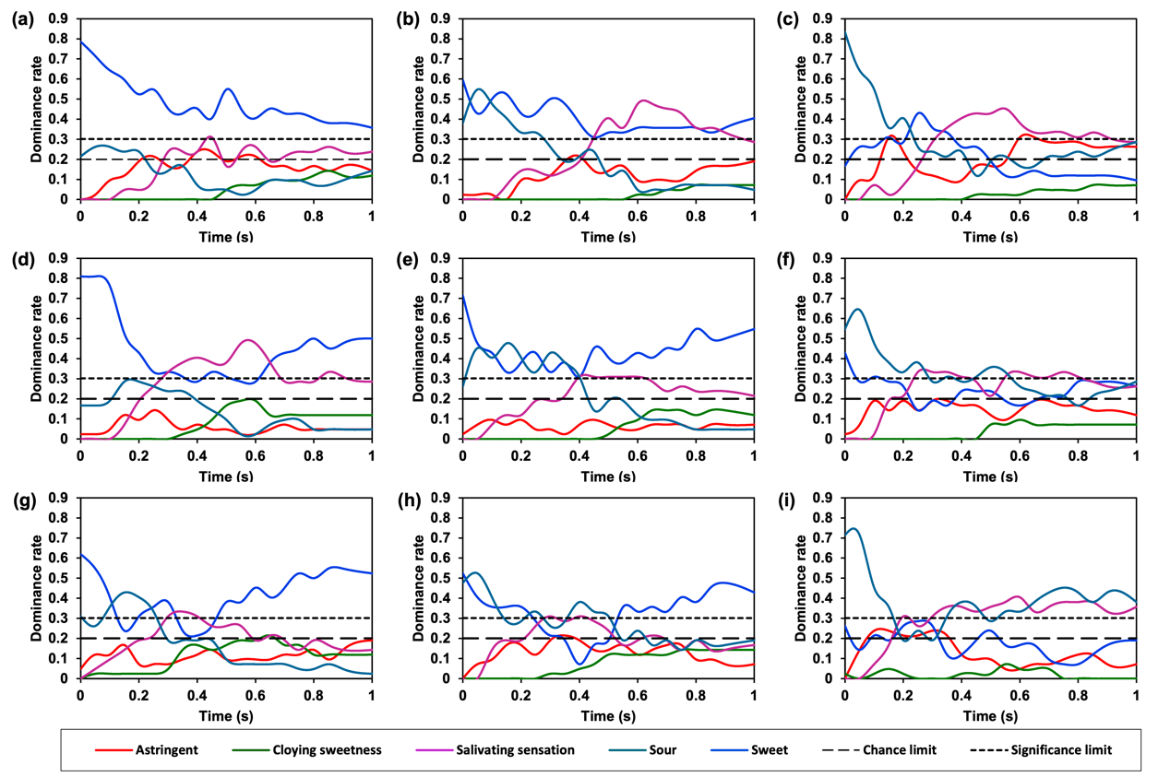
Supplementary Fig. 1 Standardized dynamic dominant sensations results for sucrose-citric acid mixtures: (a) 2% sucrose + 0.003% citric acid, (b) 2% sucrose + 0.006% citric acid, (c) 2% sucrose + 0.010% citric acid, (d) 6% sucrose + 0.010% citric acid, (e) 6% sucrose + 0.018% citric acid, (f) 6% sucrose + 0.030% citric acid, (g) 10% sucrose + 0.037% citric acid, (h) 10% sucrose + 0.068% citric acid, and (i) 10% sucrose + 0.112% citric acid.

Supplementary Fig. 2 Correlation analysis between the durations of dominant sensations and the total duration in sucrose - citric acid mixtures.

