Additional information
Extended Data
Extended Data Table 1| Major element compositions of chromite host and its exsolution lamellae (wt. %)
 | host | L1 |  |  |  |  |  | L2 | L3
 | chr  (7)* | SiO₂(3) | CF 1  (2) | CF 2  (4) | UP  (3) | Mw  (1) | am MgSiO₃ (1) | HPclen  (5) | sup-clen  (5)
SiO₂ | 0.02 | 88.04 | 23.97 | 23.46 | 2.23 | 1.90 | 42.42 | 61.44 | 57.85
Al₂O₃ | 25.18 | 2.24 | 15.80 | 18.90 | 11.05 | 0.75 | 10.56 | 1.66 | 1.17
Cr₂O₃ | 43.61 | 0.49 | 23.67 | 26.50 | 16.13 | 1.28 | 6.37 | 1.75 | 0.32
FeO_{t} | 15.13 | 1.32 | 18.31 | 14.11 | 60.38 | 64.24 | 8.40 | 3.49 | 2.92
MgO | 14.52 | 7.92 | 18.25 | 17.03 | 8.44 | 30.83 | 32.24 | 31.66 | 37.74
MnO | 0.14 | 0.00 | 0.00 | 0.00 | 0.00 | 0.99 | 0.00 | 0.00 | 0.00
TiO₂ | 0.33 | 0.00 | 0.00 | 0.00 | 1.77 | 0.00 | 0.00 | 0.00 | 0.00
CaO | 0.01 | N.d. | N.d. | N.d. | N.d. | N.d. | N.d. | N.d. | N.d.
Na₂O | 0.01 | N.d. | N.d. | N.d. | N.d. | N.d. | N.d. | N.d. | N.d.
K₂O | 0.00 | N.d. | N.d. | N.d. | N.d. | N.d. | N.d. | N.d. | N.d.
total | 98.95 | 100.00 | 100.00 | 100.00 | 100.00 | 100.00 | 100.00 | 100.00 | 100.00
Uncertainty %
SiO₂ | 0.01 | 0.52 | 0.18 | 3.83 | 0.45 | 0.03 | 0.19 | 0.26 | 0.78
Al₂O₃ | 0.56 | 0.16 | 0.28 | 3.28 | 2.13 | 0.03 | 0.17 | 0.07 | 0.19
Cr₂O₃ | 0.64 | 0.07 | 0.30 | 3.31 | 2.23 | 0.04 | 0.11 | 0.06 | 0.14
FeO_{t} | 0.64 | 0.04 | 0.13 | 1.84 | 5.62 | 0.18 | 0.07 | 0.04 | 0.14
MgO | 0.37 | 0.14 | 0.14 | 2.98 | 1.65 | 0.14 | 0.14 | 0.17 | 0.56
MnO | 0.03 | 0.00 | 0.00 | 0.00 | 0.00 | 0.48 | 0.00 | 0.00 | 0.00
TiO₂ | 0.03 | 0.00 | 0.00 | 0.00 | 0.31 | 0.00 | 0.00 | 0.00 | 0.00
CaO | 0.01 | - | - | - | - | - | - | - | -
Na₂O | 0.01 | - | - | - | - | - | - | - | -
K₂O | 0.00 | - | - | - | - | - | - | - | -
Cation number of per formula unit
O | 4.00 | 2.00 | 4.00 | 4.00 |  | 1.00 | 6.00 | 6.00 | 6.00
Si | 0.03 | 0.91 | 0.65 | 0.63 |  | 0.02 | 1.53 | 2.07 | 1.96
Al | 0.93 | 0.03 | 0.51 | 0.60 |  | 0.01 | 0.45 | 0.07 | 0.05
Mg | 0.72 | 0.12 | 0.74 | 0.68 |  | 0.43 | 1.74 | 1.59 | 1.90
Fe²⁺ | 0.32 | 0.01 | 0.42 | 0.32 |  | 0.50 | 0.25 | 0.10 | 0.08
Fe³⁺ | 0.06 | 0.00 | 0.00 | 0.00 |  | 0.00 | 0.00 | 0.00 | 0.00
Cr | 0.95 | 0.00 | 0.51 | 0.56 |  | 0.01 | 0.18 | 0.05 | 0.01
Mn | 0.00 | 0.00 | 0.00 | 0.00 |  | 0.01 | 0.00 | 0.00 | 0.00
Ti | 0.00 | 0.00 | 0.00 | 0.00 |  | 0.00 | 0.00 | 0.00 | 0.00
tot. cat. num. | 3.00 | 1.07 | 2.84 | 2.79 |  | 0.98 | 4.15 | 3.87 | 4.00
tot. cations | 8.03 | 3.99 | 7.98 | 8.00 |  | 2.02 | 11.99 | 12.02 | 11.98
Cr# | 54 | - | 50 | 48 |  | - | - | - | -
Mg# | 63 | - | 64 | 68 |  | 46 | 87 | 94 | 96
Si/(Si+Mg+Fe) | - | - | - |  |  | - | 0.44 | 0.55 | 0.50
*EPMA data. The data marked without a “*” are EDS data in TEM. Chr: magnesiochromite; CF: calcium ferrite structured magnesiochromite; UP: unknown phase; Mw: magnesiowüstite; am: amorphous; HPclen: high-pressure clinoenstatite; sup-clen: superlattice clinoenstatite; Cr# = 100xCr/(Cr+Al); Mg# = 100xMg/(Fe+Mg). The numbers in the brackets are the number of analyses with the compositions being average values.

Extended Data Table 2| The distances of crystal plane spacings (Å) of magnesiochromite, magnesiowüstite, high-pressure clinoenstatite and supelattice clinoenstatite measured from electron diffraction spots.
Chr |  | Mw |  | HPclen |  | sup-clen
d_{hk}l obs. | hkl | d_{hkl} obs. | hkl | d_{hkl} obs. | hkl | d_{hkl} obs. | hkl
2.91 | 2$\overline{2}$0 | 1.46 | 2$\overline{2}$0 | 4.60 | 200 | 9.21 | 100
1.71 | 22$\overline{4}$ | 0.85 | 22$\overline{4}$ | 4.34 | 020 | 2.48 | 002
2.51 | 31$\overline{1}$ |  |  | 6.15 | 110 | 32.25 | 001_{sup}
4.79 | 1$\overline{1}$1 |  |  | 3.82 | 202
4.30 | 200
SG:227 (Fd$\overline{3}$m) |  | SG:225 (Fm$\overline{3}$m) |  | SG:15(C2/c)

Extended Data Table 3| The distances of the crystal plane spacings (Å) and corresponding intensity of electron diffraction spots for chromite polymorphs.
 | d_{hkl} obs. | Int obs. | d_{hkl} cal. _{CF} | Int cal. _{CF} | hkl_{CF} | d_{hkl} cal. _{chr} | Int cal. _{chr} | hkl _{chr} | d_{hkl} cal. _{CT} | Int cal. _{CT} | hkl_{CT} | d_{hkl} cal. _{Mld} | Int cal. _{Mld} | hkl_{Mld}
spot 1 | 4.59 | 212 | 4.53 | 74544 | 200 | 4.78 | 1435932 | 111 | 4.89 | 44850 | 002 | 4.83 | 129 | 200
spot 2 | 2.30 | 40 | 2.27 | 13140 | 400 | 2.39 | 291914 | 222 | 2.44 | 43552 | 004 | 2.42 | 652407 | 400
spot 3 | 1.53 | 230 | 1.51 | 131440 | 600 | 1.59 | 389831 | 333 | 1.63 | 233825 | 006 | 1.61 | 48 | 600
spot 1 |  |  |  |  |  |  |  |  | 4.76 | 122 | 020 | 4.51 | 26794 | 210
spot 2 |  |  |  |  |  |  |  |  | 2.38 | 319984 | 040 | 2.25 | 1413 | 420
spot 3 |  |  |  |  |  |  |  |  | 1.59 | 427 | 060 | 1.50 | 55653 | 630
spot 1 |  |  |  |  |  |  |  |  | 4.28 | 18044 | 021
spot 2 |  |  |  |  |  |  |  |  | 2.14 | 67.1 | 042
spot 3 |  |  |  |  |  |  |  |  | 1.43 | 317470 | 0 6 3
Chr: magnesiochromite; CF: calcium ferrite structured magnesiochromite; CT: calcium titanate structured magnesiochromite; mLd: modified ludwigite-type Fe₂Cr₂O₅ phase

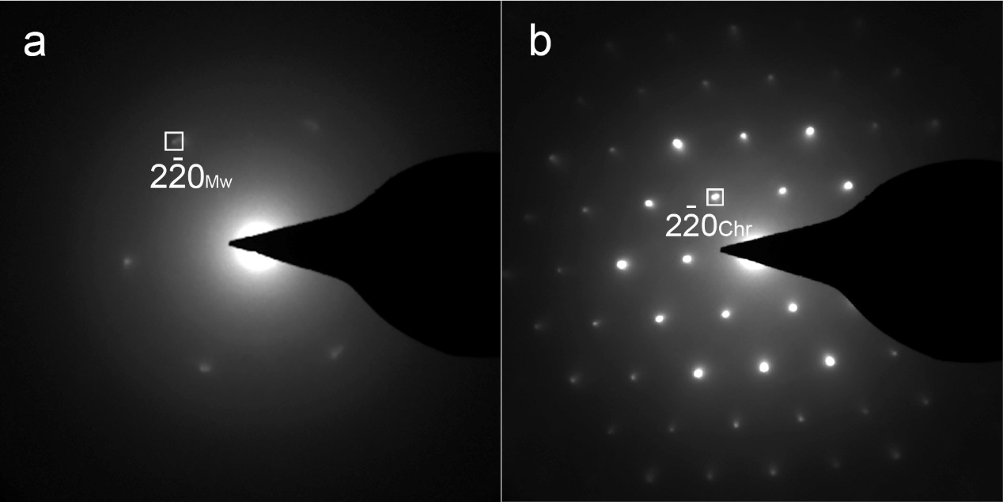
Extended Data Fig. 1| SAED patterns of phases shown in Fig. 2e of L1. a, magnesiowüstite (Mw); b, magnesiochromite (Chr). The diffraction spots within the white squares are indexed. Both magnesiowüstite (spacing group (SG): Fm$\overline{3}$m) and magnesiochromite (SG: Fd$\overline{3}$m) show similar ED patterns with [111] incidence. However, the crystal plane spacings (d-spacings) of the corresponding spots for magnesiowüstite are half those of magnesiochromite (e.g., d₂$\overline{2}$_{0Mw} ≈ 0.5d₂$\overline{2}$_{0chr}, Extended Data Table 2).

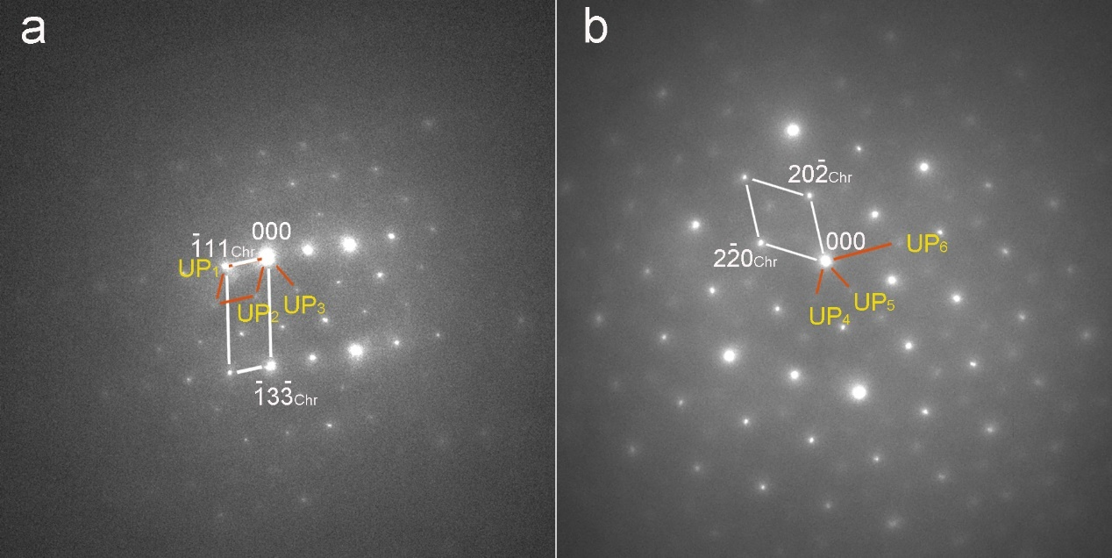
Extended Data Fig. 2| SAED patterns of the Fe-rich unknown phase (UP) in L1. a, SAED pattern obtained from UP and the Chr host along [321]_{chr}. The d-spacing values for UP₁, UP₂ and UP₃ are 0.47, 0.51, 0.47 nm, respectively. The angles between the crystal planes UP₁ and UP₂, as well as UP₂ and UP₃, are both 62°. The diffraction spots of ($\overline{1}$11)_{chr} and UP₁ overlap. b, SAED pattern obtained from UP and the chr host along [111]_{chr}. The d-spacing values for UP₄, UP₅ and UP₆ are 0.51, 0.51, and 0.25 nm, respectively. The angles between the crystal planes of UP₄ and UP₅, as well as UP₅ and UP₆, are both 60°.

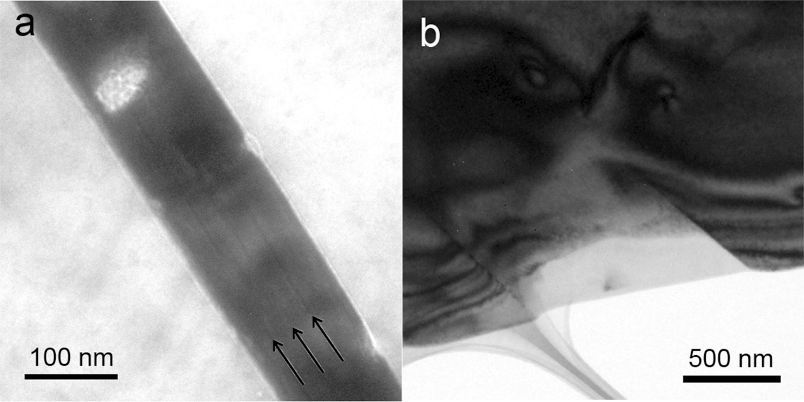
Extended Data Fig. 3| TEM images of L2 and L3. a, A FIB foil of L2 obtained by cutting perpendicular to the exposed lamella in the thin section. The lamella shows twinning boundaries, indicated by black arrows, parallel to (010)_{HPclen}. b, A FIB foil of L3 obtained by cutting parallel to the exposed lamella in the thin section. According to a and b, the MgSiO₃ lamellae are very thin lamellae.

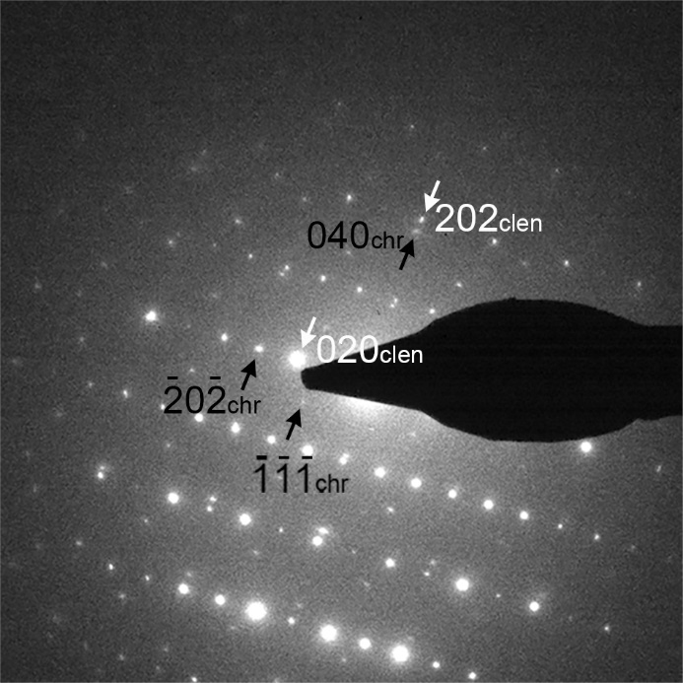
Extended Data Fig. 4| ED pattern obtained from L2 along [10$\overline{1}$]_{HPclen} and [10$\overline{1}$]_{chr}. The C-centered clinoenstatite (C2/c, HPclen) displays diffraction spots where h+k = 2n + 1, which appear due to double diffraction and diminish with decreasing beam intensity in the hkl plane, being weaker than the spots where h+k = 2n. The topotaxial relationship is given by [10$\overline{1}$]_{HPclen}//[10$\overline{1}$]_{chr}, (010)_{HPclen}//(101)_{chr} , (101)_{HPclen}//(010)_{chr}, respectively. Notably, d_{202chr} = d_{030clen} = 2.92 Å.

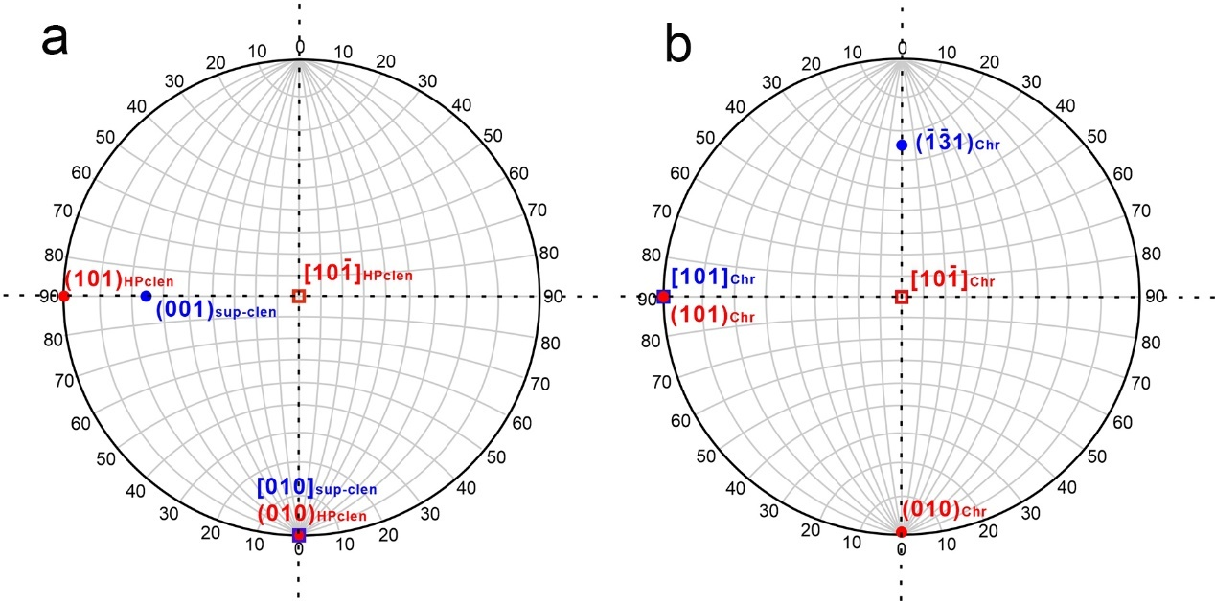
Extended Data Fig. 5| Stereographic projections of clinopyroxene lamellae and their magnesiochromite host. (a) Stereographic projections of L2 (HPclen) and L3 (sup-clen). (b) Stereographic projections of the magnesiochromite host. The topotaxy of the studied MgSiO₃ lamellae within the magnesiochromite host is consistent. The relationship are as follows: (1) L2: [10$\overline{1}$]_{HPclen}//[10$\overline{1}$]_{chr}, (010)_{HPclen}//(101)_{chr} , (101)_{HPclen}//(010)_{chr} (in red font). (2) L3: [010]_{sup-clen}//[101]_{chr}, (002)_{sup-clen}//($\overline{1}\overline{3}$1)_{chr} (in blue font). Squares indicate crystal axes, while spots indicate crystal planes.

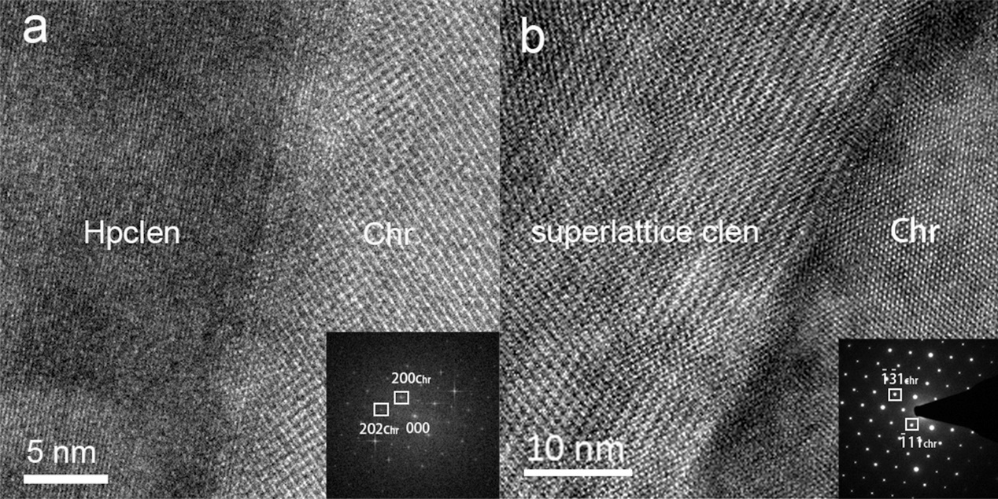
Extended Data Fig. 6| HRTEM images of the L2 and L3 and their host. (a) A HRTEM image of the phase boundary between the HPclen lamella in L2 and the magnesiochromite host, obtained along [001]_{chr}. The lattice fringes of (010)_{HPclen} are parallel to (202)_{chr}. The FFT image of magnesiochromite is shown in the lower right corner. (b) HRTEM image of the phase boundary between a sup-clen lamella in L3 and the magnesiochromite host, obtained along [010]_{clen} and [101]_{chr}. The ED pattern of magnesiochromite is inserted in the lower right corner. The phase boundary of the sup-clen lamella show a steplike attachment to the host, with the lamella exsolved on (010)_{sup-clen} and (001)_{sup-clen}. The diffraction spots within the white squares are indexed.

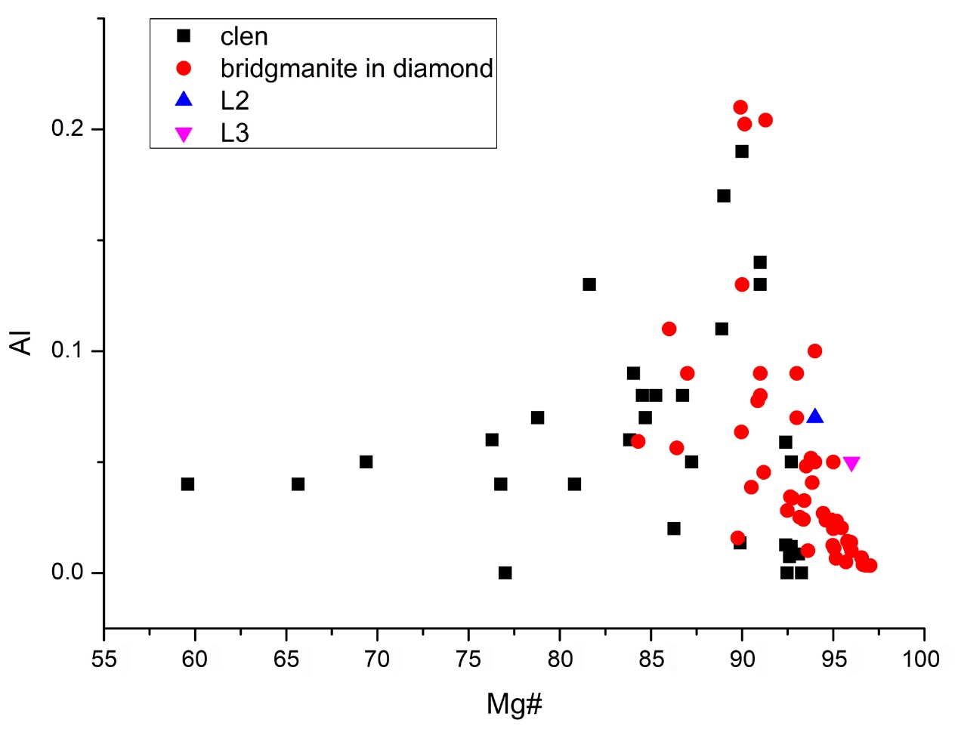
Extended Data Fig. 7| Comparison of chemical composition of clinoenstatite from upper mantle (black squares, data from references 23, 24, 51-54), retrogressed low-Al bridgmanite inclusions in kimberlitic diamonds (red spots, data from references 25, 30, 33, 55-66) and MgSiO₃ in L2 (blue triangle) and L3 (purple triangle).

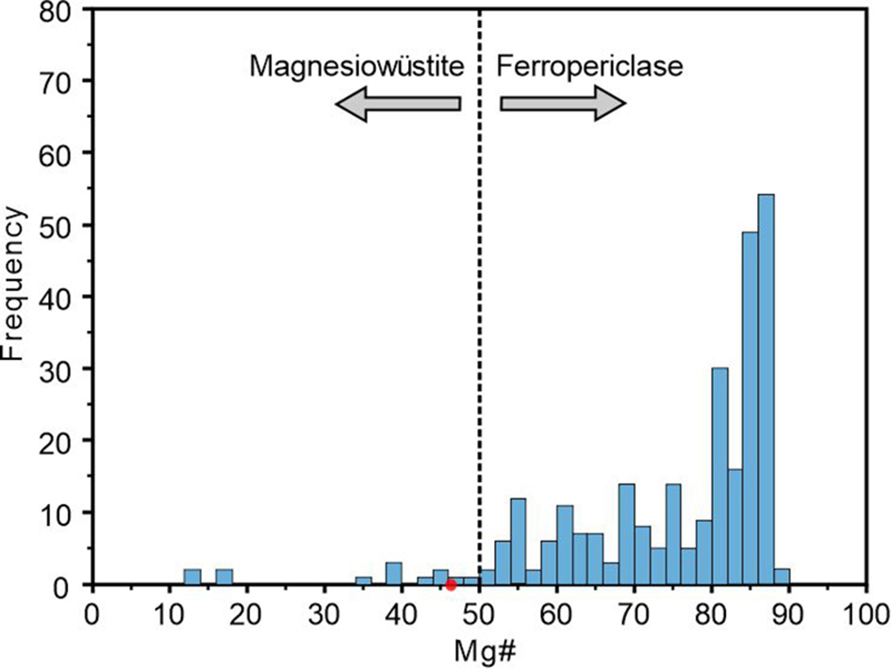
Extended Data Fig. 8| Mg# of (Fe,Mg)O inclusions in diamonds from various global localities (n=314). The red spot indicates the Mg# (46) of magnesiowüstite from L1. The figure is modified from ref. 27.

