Optimization of Extraction Parameters for Antidiabetic Bioactive Compounds from Cherry Stems (Prunus avium)
Beyza Tutku Bıçakcı¹, Candan Güzelkuş¹, Ayşenur Akgedik², Gizem Öder¹, Oguz Bayraktar¹*

¹Department of Bioengineering, Ege University, Bornova, 35040, Izmir, Turkey
²Department of Food Engineering, Ege University, Bornova, 35040, Izmir, Turkey

*Corresponding Author
Oguz Bayraktar
Email: oguz.bayraktar@ege.edu.tr

Supplemantary File

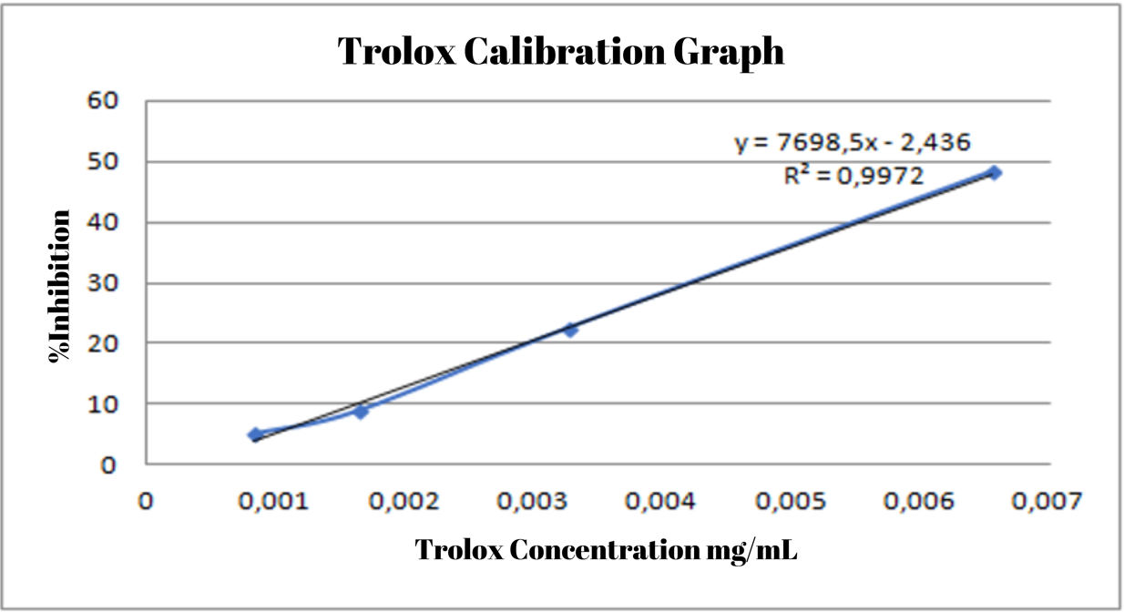
Figure S1 Trolox Calibration Graph

Figure S2 Gallic Acid Calibration Graph

Table S1 ANOVA table of extracttion yield
Source | Sum of Squares | df | Mean Square | F-value | p-value
Model | 4851.25 | 8 | 606.41 | 8.63 | 0.0085 | significant
A-Solid/Liquid Ratio | 800.20 | 1 | 800.20 | 11.38 | 0.0150
B-Solvent Type | 1344.47 | 1 | 1344.47 | 19.12 | 0.0047
C-Time | 245.09 | 1 | 245.09 | 3.49 | 0.1111
AB | 284.26 | 1 | 284.26 | 4.04 | 0.0911
AC | 371.91 | 1 | 371.91 | 5.29 | 0.0611
A² | 364.94 | 1 | 364.94 | 5.19 | 0.0629
B² | 33.49 | 1 | 33.49 | 0.4764 | 0.5159
C² | 1542.50 | 1 | 1542.50 | 21.94 | 0.0034
Residual | 421.82 | 6 | 70.30
Lack of Fit | 407.85 | 4 | 101.96 | 14.61 | 0.0651 | not significant
Pure Error | 13.96 | 2 | 6.98
Cor Total | 5273.06 | 14

Table S2 Fit statistics of extraction yield
Std. Dev. | 8.38 |  | R² | 0.9200
Mean | 25.29 |  | Adjusted R² | 0.8133
C.V. % | 33.16 |  | Predicted R² | 0.2207
 |  |  | Adeq Precision | 7.0936

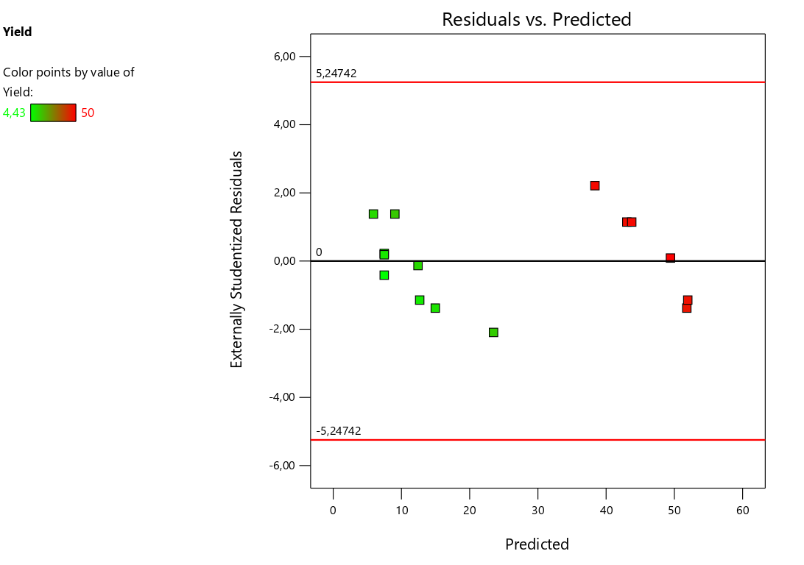
Figure S3 Prediction plot for extraction yield against residue
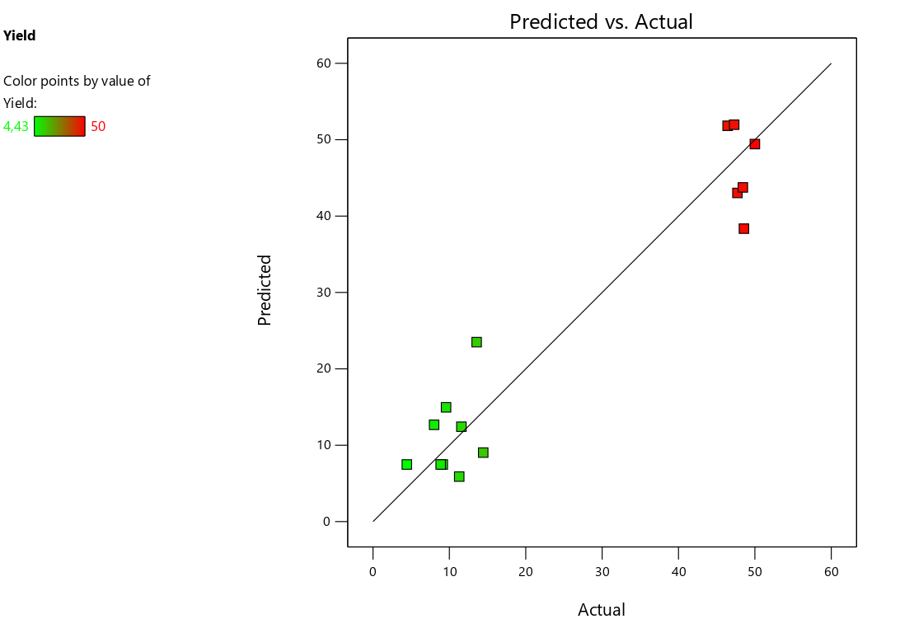
Figure S4 Plot for experimental values against predicted values for extraction yield

Table S3 ANOVA table of antioxidant capacity via ABTS method
Source | Sum of Squares | df | Mean Square | F-value | p-value
Model | 1014.89 | 9 | 112.77 | 54.15 | 0.0002 | significant
A-Solid/Liquid Ratio | 3.44 | 1 | 3.44 | 1.65 | 0.2550
B-Solvent Type | 419.78 | 1 | 419.78 | 201.57 | < 0.0001
C-Time | 2.67 | 1 | 2.67 | 1.28 | 0.3086
AB | 9.36 | 1 | 9.36 | 4.50 | 0.0875
AC | 38.63 | 1 | 38.63 | 18.55 | 0.0077
B² | 336.30 | 1 | 336.30 | 161.48 | < 0.0001
C² | 22.61 | 1 | 22.61 | 10.86 | 0.0216
A²C | 12.25 | 1 | 12.25 | 5.88 | 0.0597
AB² | 56.87 | 1 | 56.87 | 27.31 | 0.0034
Residual | 10.41 | 5 | 2.08
Lack of Fit | 5.71 | 3 | 1.90 | 0.8098 | 0.5938 | not significant
Pure Error | 4.70 | 2 | 2.35
Cor Total | 1025.30 | 14

Table S4 Fit statistics of antioxidant capacity via ABTS method
Std. Dev. | 1.44 |  | R² | 0.9898
Mean | 34.60 |  | Adjusted R² | 0.9716
C.V. % | 4.17 |  | Predicted R² | 0.7177
 |  |  | Adeq Precision | 23.5881

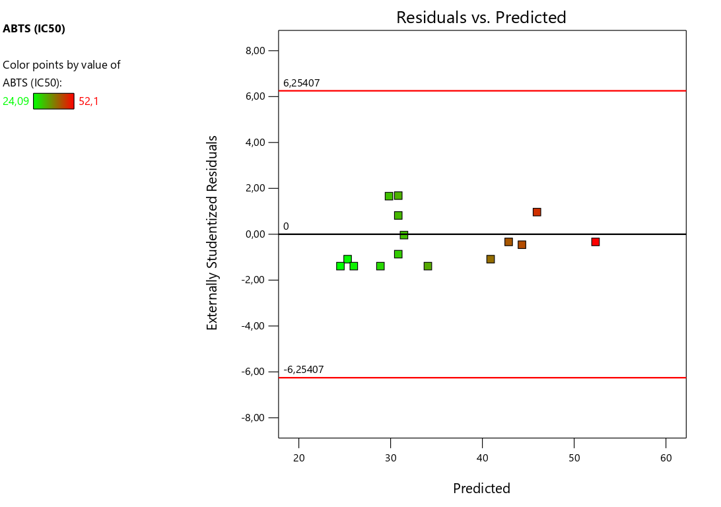
Figure S5 Prediction plot of antioxidant capacity (ABTS) against residue
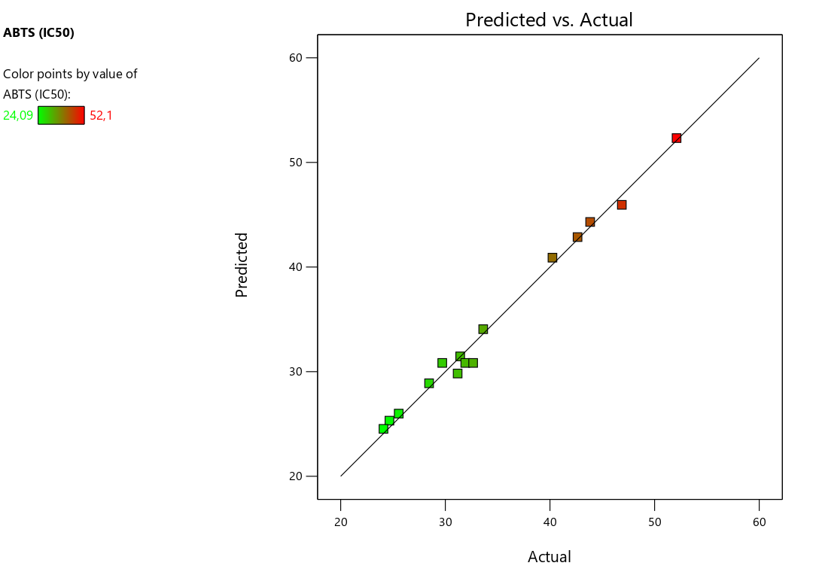
Figure S6 Plot for experimental values against predicted values for antioxidant capacity (ABTS)
Table S5 ANOVA table of antioxidant capacity via DPPH method
Source | Sum of Squares | df | Mean Square | F-value | p-value
Model | 1.558E+05 | 9 | 17306.05 | 7.22 | 0.0212 | significant
A-Solid/Liquid Ratio | 452.25 | 1 | 452.25 | 0.1888 | 0.6820
B-Solvent Type | 84402.97 | 1 | 84402.97 | 35.23 | 0.0019
C-Time | 24.33 | 1 | 24.33 | 0.0102 | 0.9236
AB | 2994.28 | 1 | 2994.28 | 1.25 | 0.3144
AC | 515.97 | 1 | 515.97 | 0.2154 | 0.6621
BC | 1470.72 | 1 | 1470.72 | 0.6140 | 0.4688
A² | 4923.01 | 1 | 4923.01 | 2.06 | 0.2111
B² | 57335.55 | 1 | 57335.55 | 23.93 | 0.0045
C² | 1423.57 | 1 | 1423.57 | 0.5943 | 0.4756
Residual | 11977.43 | 5 | 2395.49
Lack of Fit | 7926.77 | 3 | 2642.26 | 1.30 | 0.4616 | not significant
Pure Error | 4050.66 | 2 | 2025.33
Cor Total | 1.677E+05 | 14

Table S6 Fit statistics of antioxidant capacity via DPPH method
Std. Dev. | 48.94 |  | R² | 0.9286
Mean | 338.93 |  | Adjusted R² | 0.8001
C.V. % | 14.44 |  | Predicted R² | 0.1895
 |  |  | Adeq Precision | 7.9419

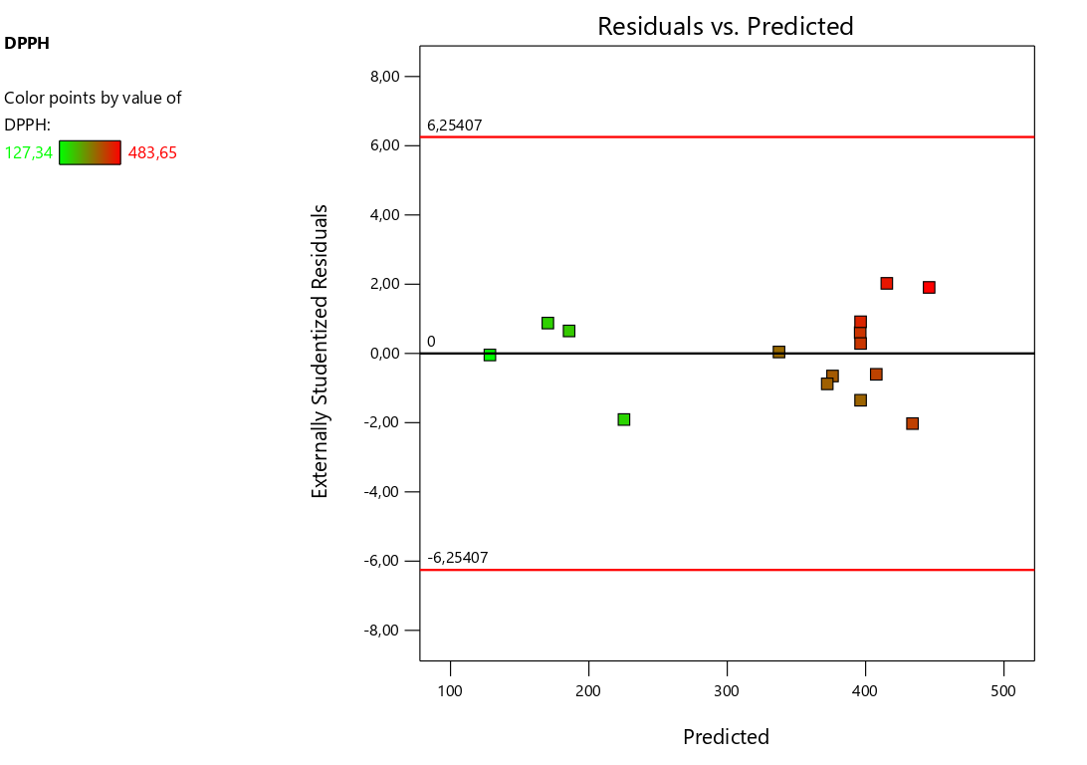
Figure S7 Prediction plot of antioxidant capacity (DPPH) against residue
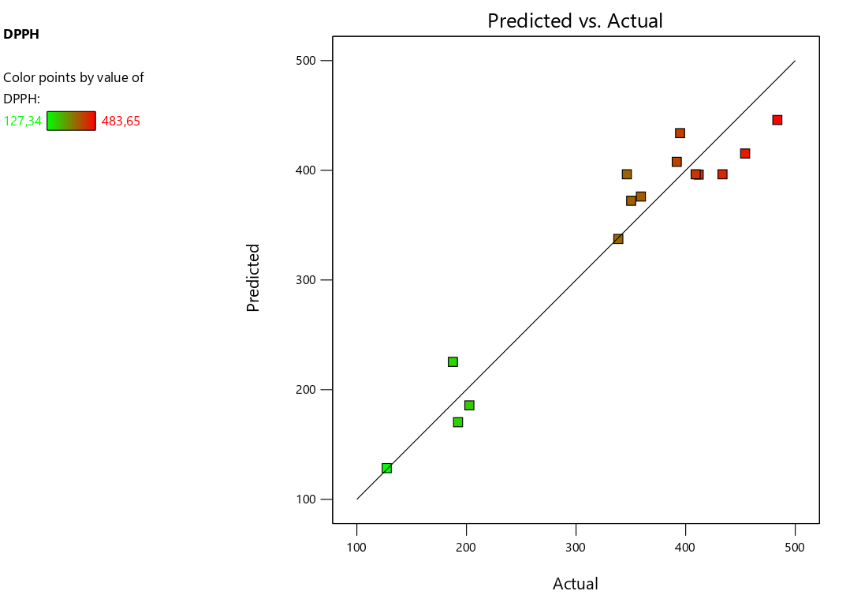
Figure S8 Plot for experimental values against predicted values for antioxidant capacity (DPPH)
Table S7 ANOVA table of total phenol content
Source | Sum of Squares | df | Mean Square | F-value | p-value
Model | 1.391E+05 | 9 | 15459.41 | 8.18 | 0.0162 | significant
A-Solid/Liquid Ratio | 2893.32 | 1 | 2893.32 | 1.53 | 0.2709
B-Solvent Type | 45390.84 | 1 | 45390.84 | 24.02 | 0.0045
C-Time | 98.98 | 1 | 98.98 | 0.0524 | 0.8280
AB | 7811.02 | 1 | 7811.02 | 4.13 | 0.0977
AC | 23.14 | 1 | 23.14 | 0.0122 | 0.9162
BC | 1246.09 | 1 | 1246.09 | 0.6595 | 0.4537
A² | 2783.35 | 1 | 2783.35 | 1.47 | 0.2791
B² | 75651.03 | 1 | 75651.03 | 40.04 | 0.0015
C² | 1493.83 | 1 | 1493.83 | 0.7906 | 0.4147
Residual | 9447.75 | 5 | 1889.55
Lack of Fit | 6607.44 | 3 | 2202.48 | 1.55 | 0.4151 | not significant
Pure Error | 2840.31 | 2 | 1420.15
Cor Total | 1.486E+05 | 14

Table S8 Fit statistics of total phenol content
Std. Dev. | 43.47 |  | R² | 0.9364
Mean | 284.47 |  | Adjusted R² | 0.8220
C.V. % | 15.28 |  | Predicted R² | 0.2455
 |  |  | Adeq Precision | 8.0924

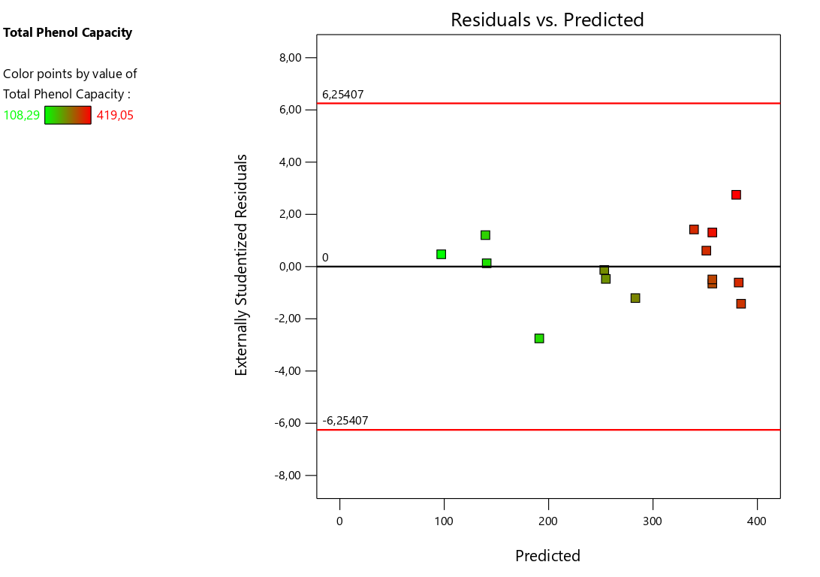
Figure S9 Prediction plot of total phenol content
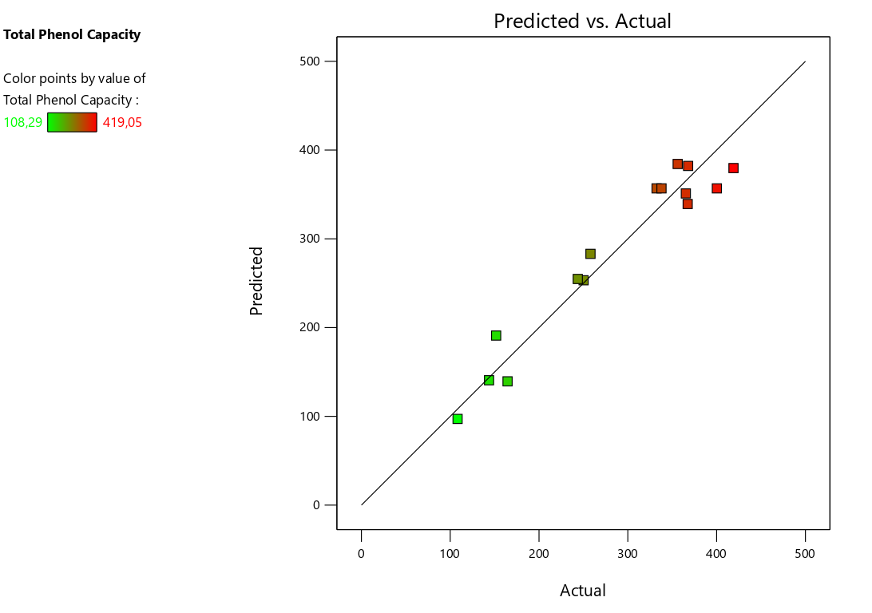
Figure S10 Plot for experimental values against predicted values for phenol content
Table S9 ANOVA table of alpha glucosidase inhibition
Source | Sum of Squares | df | Mean Square | F-value | p-value
Model | 6640.09 | 11 | 603.64 | 222.57 | 0.0004 | significant
A-Solid/Liquid Ratio | 5.45 | 1 | 5.45 | 2.01 | 0.2513
B-Solvent Type | 204.92 | 1 | 204.92 | 75.56 | 0.0032
C-Time | 73.87 | 1 | 73.87 | 27.24 | 0.0137
AB | 385.93 | 1 | 385.93 | 142.29 | 0.0013
BC | 103.12 | 1 | 103.12 | 38.02 | 0.0086
A² | 564.26 | 1 | 564.26 | 208.05 | 0.0007
B² | 753.15 | 1 | 753.15 | 277.69 | 0.0005
C² | 637.31 | 1 | 637.31 | 234.98 | 0.0006
A²B | 992.35 | 1 | 992.35 | 365.89 | 0.0003
A²C | 33.05 | 1 | 33.05 | 12.19 | 0.0397
AB² | 211.56 | 1 | 211.56 | 78.01 | 0.0031
Residual | 8.14 | 3 | 2.71
Lack of Fit | 0.0020 | 1 | 0.0020 | 0.0005 | 0.9842 | not significant
Pure Error | 8.13 | 2 | 4.07
Cor Total | 6648.22 | 14

Table S10 Fit statistics of alpha glucosidase inhibition
Std. Dev. | 1.65 |  | R² | 0.9988
Mean | 18.92 |  | Adjusted R² | 0.9943
C.V. % | 8.71 |  | Predicted R² | NA⁽¹⁾
 |  |  | Adeq Precision | 55.5397

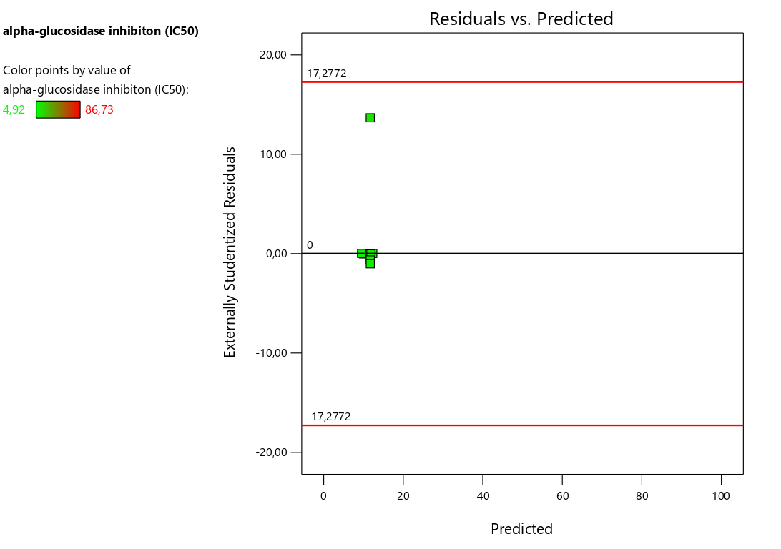
Figure S11 Prediction plot of alpha glucosidase inhibition
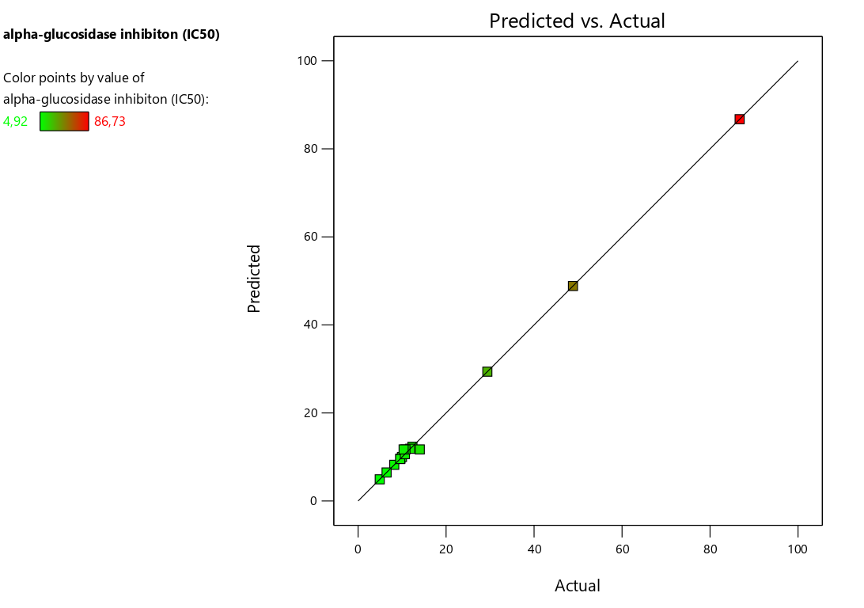
Figure S12 Expected values plot for experimental values against predicted values alpha-glucosidase inhibition

Figure S13 Correlation between the total phenol content and antioxidant capacity (ABTS and DPPH)
Table S11 IC₅₀ values of total antioxidant capacity (DPPH)
Run number | DPPH (IC50)  (μg/mL)
1 | 221.82
2 | 78.13
3 | 54.18
4 | 78.76
5 | 176.04
6 | 61.24
7 | 62.44
8 | 81.20
9 | 131.74
10
11 | 53.24
12 | 25.78
13 | 40.08
14 | 141.71
15 | 74.37

