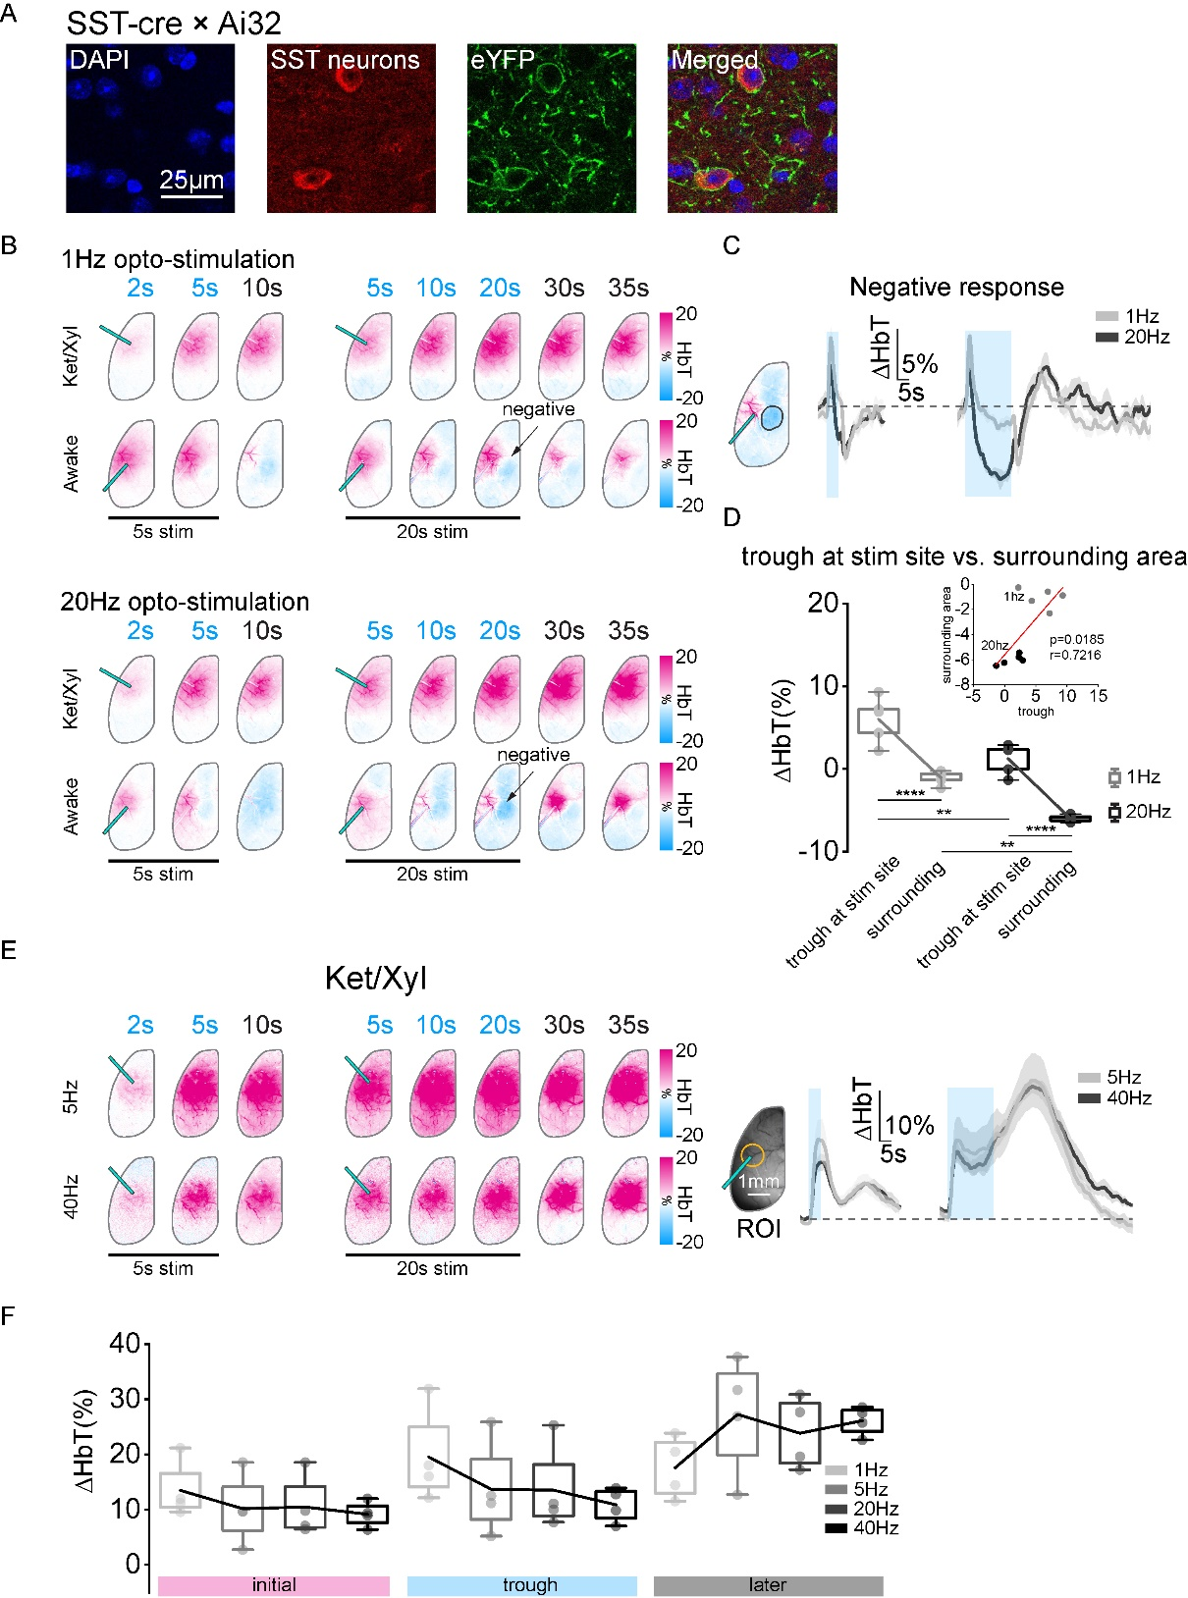

Extended Data Fig. 1: Frequency-dependent hemodynamic response to optogenetic stimulation of SST neurons under awake and anesthetized conditions. (A) Histology results confirming the ChR2 expression in SST neurons. To confirm expression of ChR2-eYFP in SST neurons, staining of SST neurons by SST antibodies (red) was compared to eYFP expression (green). (B) Activation maps from a single animal, showing the time-dependent changes in the total hemoglobin (HbT) in response to 1 Hz and 20 Hz optogenetic stimulation for 5 and 20 seconds under awake and Ket/Xyl conditions. Color bar indicates ∆HbT (%). (C) Timecourses extracted in the surrounding area showing negative response to 1 Hz and 20 Hz optogenetic stimulation for 5 and 20 seconds (n=5). Initial positive hemodynamic responses were followed by negative changes. (D) Correlation between the trough of the response in stimulation site and the negative response in surrounding area. one-way ANOVA test, multiple comparison with Bonferroni. (E) Activation maps from one representative animal, showing the time-dependent changes in HbT in response to 5 and 40 Hz optogenetic stimulation for 5 and 20 seconds under Ket/Xyl condition, along with corresponding time courses (n=4). (F) Quantification of the HbT response to 1-40 Hz optogenetic stimulation at 20 seconds under Ket/Xyl condition. The hemodynamic response to optogenetic stimulation was characterized by three phases as an initial peak (0-5s), a trough (5-15 s) and a later peak (35-40s) under Ket/Xyl condition. Data are presented as mean ± SEM.

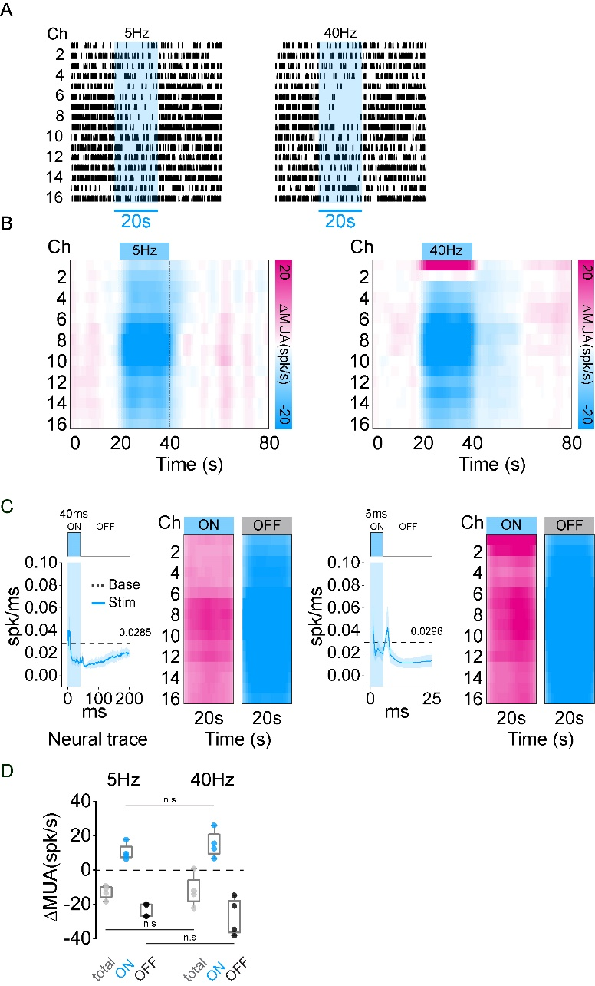

Extended Data Fig. 2: Local neuronal activity responding to 5 Hz and 40 Hz optogenetic activation of SST neurons. (A) Raster plots of a representive animal, responding to 5 Hz and 40 Hz optogenetic stimulation. (B) Heat maps of changes in multiunit activity (∆MUA) compared to baseline across the time series for 5 Hz and 40 Hz stimulation (n=4). (C) Averaged neural traces and ∆MUA heat maps for the laser pulse ON and OFF period, corresponding to 5 Hz and 40 Hz optogenetic activation of SST neurons. (D) ∆MUA during total, ON and OFF periods (one-way ANOVA repeated test, multiple comparison with Bonferroni). Data are presented as mean ± SEM.

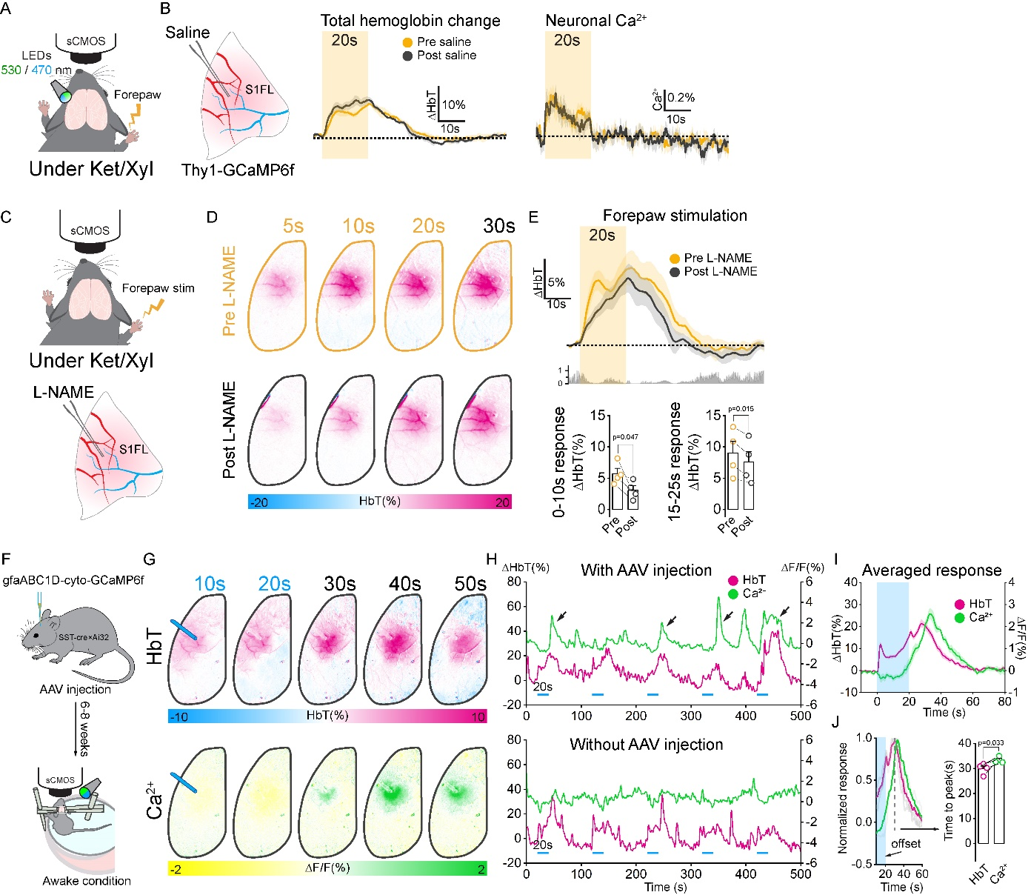

Extended Data Fig. 3: HbT and astrocytic Ca²⁺ activity in response to stimulation. (A-B) Hemodynamic and neuronal Ca²⁺ response to 20-s forepaw stimulation before and after the intracortical injection of saline (n=3). No significant changes were observed. (C-E) HbT responses in response to 20-s forepaw stimulation before and after nNOS inhibitor L-NAME infusion (n=4). An initial HbT peak was significantly reduced. (F) Schematic diagram of optical imaging under awake condition. (G) Activation maps of ∆HbT and astrocytic Ca²⁺ response to 20-s optogenetic stimulation in the mouse group with calcium-sensitive AAV virus injection. Delayed astrocytic calcium activity was observed. (H) ∆HbT and astrocytic Ca²⁺ time courses for 5 stimulation blocks in groups with and without AAV injection. (I-J) Averaged ∆HbT and astrocytic Ca²⁺ time course (n=4) for a stimulation block and their time to peak. Data are presented as mean ± SEM. Paired sample t-test.

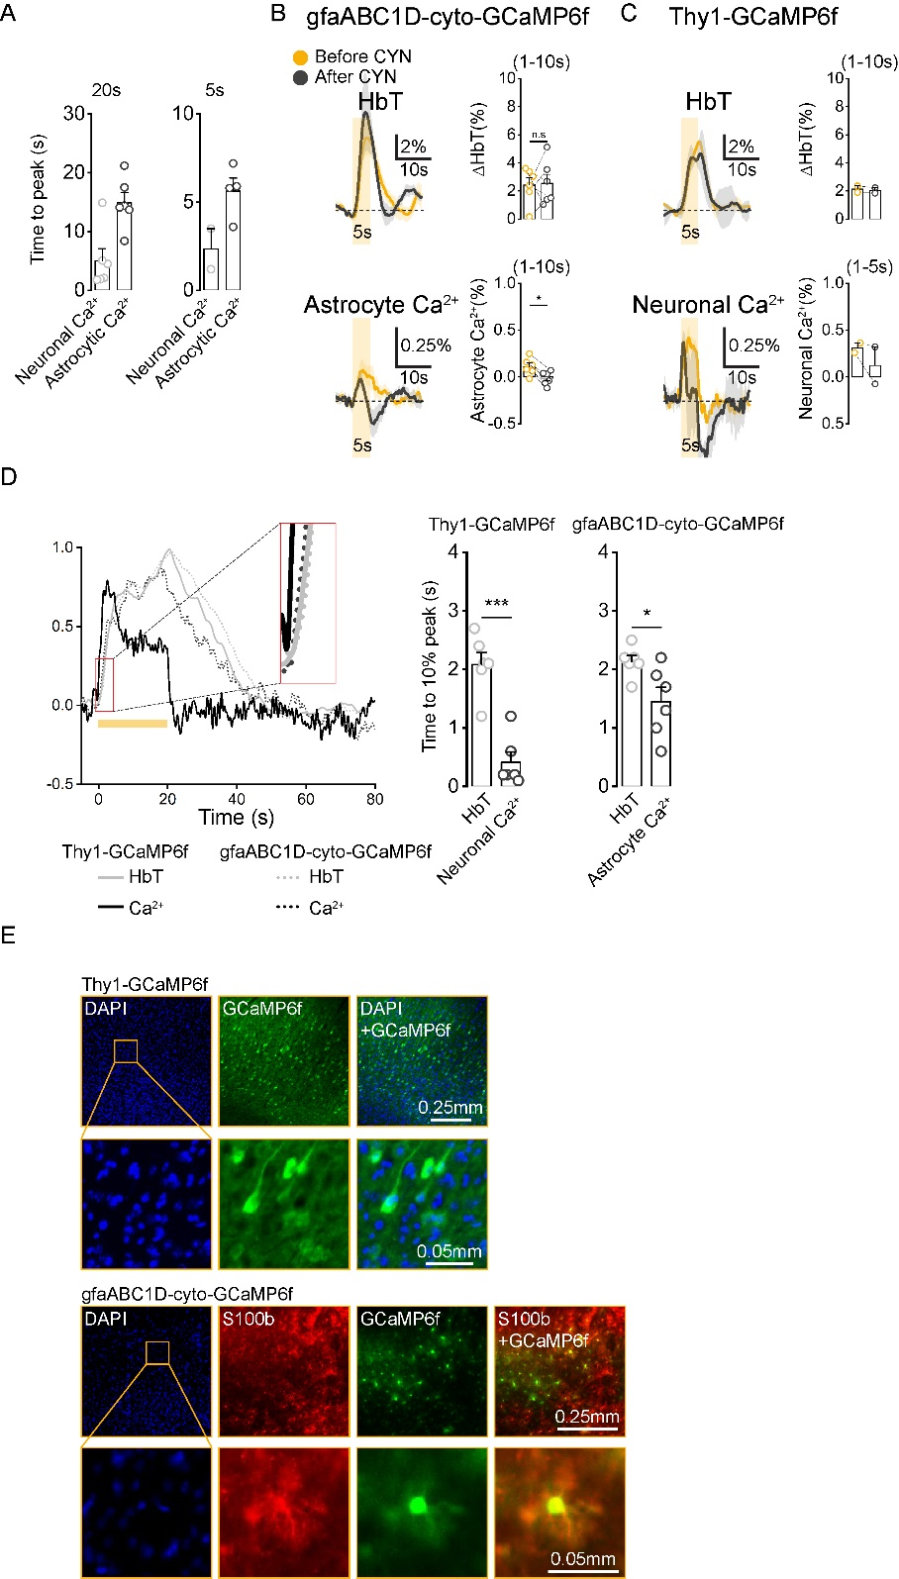

Extended Data Fig. 4: Astrocytic and neuronal Ca²⁺ response to 5-s sensory stimulation before and after the injection of the SSTR antagonist. (A) Time to peak of astrocytic (n=6) and neuronal Ca²⁺ (n=2 for 5 s-stimulation, n=6 for 20 s-stimulation) in response to 5-s and 20-s forepaw stimulation. (B) HbT and astrocytic Ca²⁺ response (astrocytic Ca²⁺ group) to 5-s forepaw stimulation before and after CYN 154806 infusion. (C) Same as (B) but for neuronal Ca²⁺ group. (D) Time to 10% peak of normalized HbT and Ca²⁺ response in both Thy1-GgaMP6f and gfaABC1D-cyto-GCaMP6f groups. (E) Histology data confirming the expression of GCaMP6f in excitatory neurons and astrocyte. For Thy1-GCaMP6f, GCaMP6f is highly expressed in excitatory neurons. To confirm expression of GCaMP6f in astrocyte, staining of astrocyte by S100b (red) was compared to GCaMP6f expression (green). Data are presented as mean ± SEM. n.s not significant; * p<0.05: ** p<0.01; *** p<0.001 (paired sample t-test).

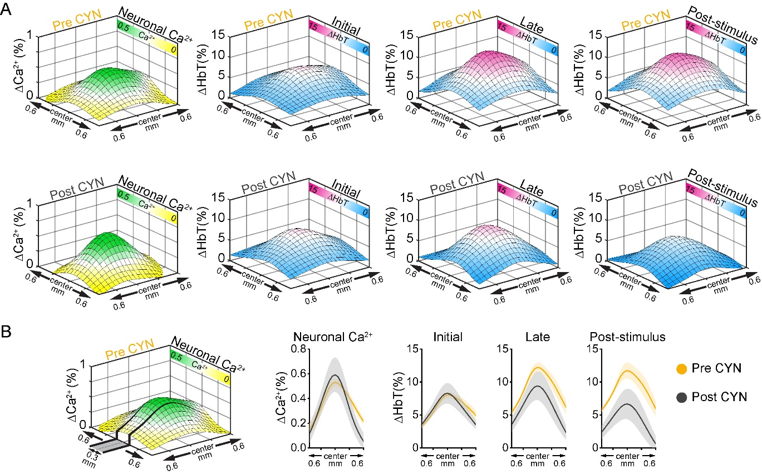

Extended Data Fig. 5: Spatial extent of neuronal calcium activity and hemodynamic responses before and after the injection of the SSTR antagonist. (A) Spatial extent of neuronal Ca²⁺ vs. ∆HbT response (initial, later and post-stimulus period) to 20-s forepaw stimulation before and after CYN 154806 infusion (n=6). (B) Spatial profiles of neuronal Ca²⁺ and ∆HbT responses at the initial (0-10 s), later (11-20 s) and post-stimulus periods of 20-s forepaw stimulation, averaged in a range of 0.3 mm width with the highest neuronal Ca²⁺ response.

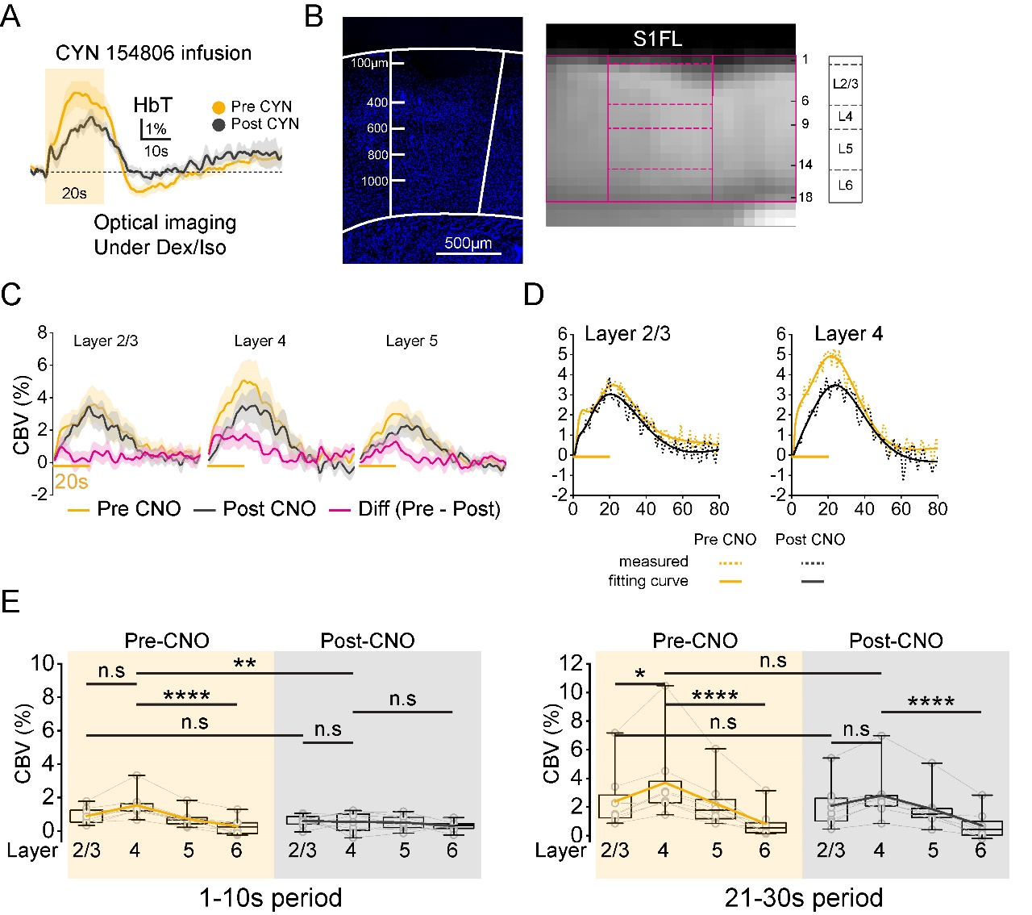

Extended Data Fig. 6: HbT and CBV-weighted fMRI response to 20-s forepaw stimulation under Dex/Iso anesthesia condition before and after SSTR antagonist CYN 1540806 infusion. (A) HbT response to 20-s forepaw stimulation imaged by widefield optical imaging (n=4) before and after CYN 1540806 infusion. (B) DAPI expression and distance across cortical layers and cortical flattening of the S1FL area. DAPI staining was used to compare cortical depth and validate the MRI layer definitions from Fig. 6. The highest DAPI density in S1FL (left) is between 400–600 µm, marking cortical layer 4, which corresponds to the 7th – 9th voxel-line in the MRI profile (right). (C) CBV time courses extracted from CBV-weighted fMRI within layer 2/3, 4 and 5 for pre-CNO, post-CNO and their difference (pre - post) conditions. (D) Gamma fitted curves for CBV-weighted fMRI responses at layer 2/3 and 4 before and after CNO injection. (E) Averaged CBV responses across cortical layers during the initial (1-10 s) and post-stimulus (21-30 s) period for forepaw stimulation before and after CNO injection. Data are presented as mean ± SEM. n.s not significant; * p<0.05: ** p<0.01; *** p<0.001; **** p<0.0001 (one-way ANOVA repeated test, multiple comparison with Turkey).

