The following Supporting Information is available for this article:
Supplementary Figure 1. Alleles of known miRNA pathway genes identified in our genetic screen. a Phenotypes of 1-month-old plants of the indicated genotypes. b Gene structures of miRNA pathway components including DCL1, AGO1, HYL1 and HEN1. New mutant alleles isolated from our screen are indicated.
Supplementary Figure 2. Phenotypes of the rbv-1 mutant in the Col background. a Phenotypes of 2-month-old Col (wild type) and rbv1-1 plants. b Siliques of Col and rbv1-1 plants. Bar = 1cm.
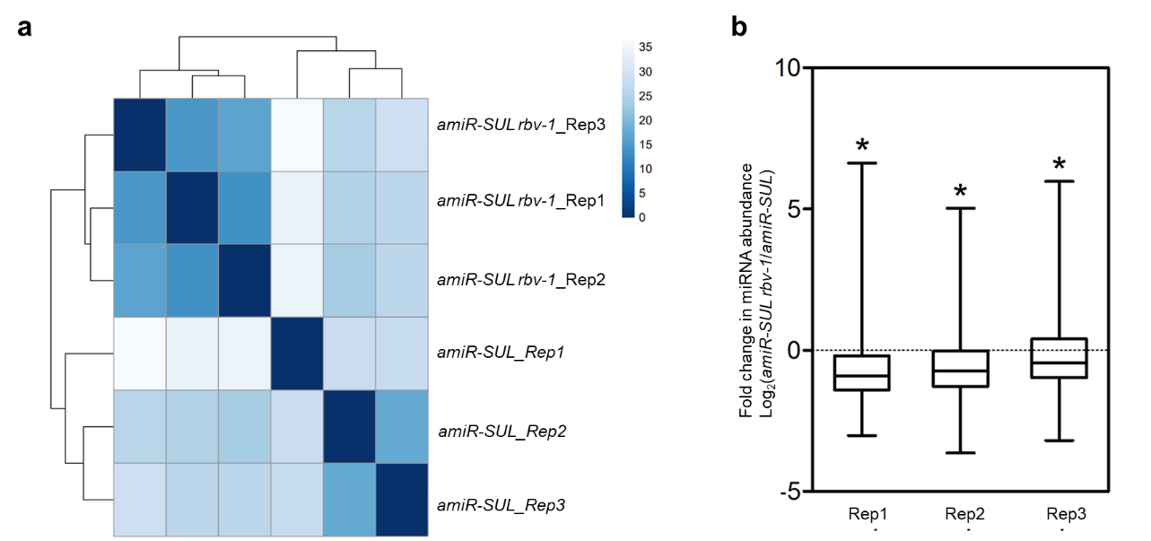
Supplementary Figure 3. Small-RNA sequencing of amiR-SUL and amiR-SUL rbv-1 seedlings (Supports Fig. 1). a Heatmaps showing reproducibility among amiR-SUL and amiR-SUL rbv-1 biological replicates. All mapped reads were used in the analysis. Sample-to-sample distances were calculated based on log2-transformed normalized read counts. The three biological replicates (Rep1, Rep2 and Rep3) for each genotype were highly reproducible. b Comparison of miRNA abundance between amiR-SUL and amiR-SUL rbv-1 in three biological replicates (Rep1, Rep2 and Rep3). A global reduction in miRNA accumulation was observed in amiRSUL rbv-1 relative to amiR-SUL (*Student’s t test: P<0.05).

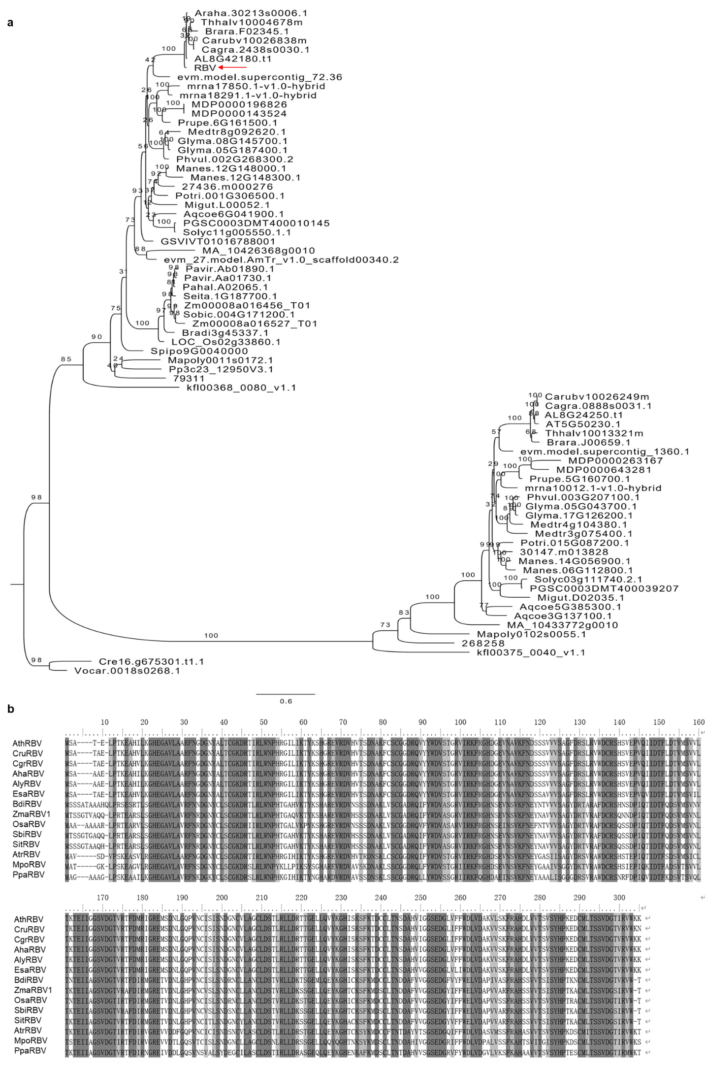
Supplementary Figure 4. Phylogenetic analysis of Arabidopsis RBV and its orthologs in different species. a A phylogenetic tree of Arabidopsis RBV orthologs in different species. The Arabidopsis RBV is indicated by the red arrow. b Amino acid sequence alignment of Arabidopsis thaliana RBV and its orthologs from various plants. Ath: A. thaliana; Cru: C. rubella; Cgr: C. grandiflora; Aha: A. helleri; Aly: A. lyrata; Esa: E. salsugineum; Bdi: B. distachyon; Zma: Z. mays; Osa: O. sativa; Sbi: S. bicolor; Sit: S. italica; Atr: A. trichopoda; Mpo: M. polymorpha; Ppa: P. patens. The dark grey color represents amino acids that are identical among all species; the light grey color denotes amino acids that are identical in at least 50% of the species.

Supplementary Figure 5. Genotypes and phenotypes of two lines with T-DNA insertions near At5g64730. a Gene structures of RBV (At5g64730) (white blocks, untranslated region; black blocks, exons; black lines, introns). The black arrows indicate the T-DNA insertion sites. Scale bar = 100bp. b Morphological phenotypes of 3-week-old Col, Salk_126634 and Salk_075672 plants. Scale bars = 1cm. c Genotyping of the two T-DNA mutants using LP (5’ genomic primer), RP (3’ genomic primer) and LBb1.3 (T-DNA left border primer) primers. d RT-PCR to detect RBV RNA from Col, Salk_126634 and Salk_075672 by amplifying the RBV full-length coding region. e RT-qPCR to determine RBV RNA levels from Col, Salk_126634 and Salk_075672. Three independent biological replicates were used for the calculation of standard deviation. (*Student’s t test, P < 0.05)

Supplementary Figure 6. The accumulation of miRNAs and the expression of known genes in the miRNA pathway in the rbv-1 mutant. a Northern blots showing moderately reduced miRNA accumulation in the rbv-1 mutant. U6 was used as an internal control. b Detection of transcript levels from genes involved in miRNA biogenesis in Col and rbv-1 by quantitative RT-PCR. Error bars represent SD of three biological replicates; Student’s t test was used for statistical analysis. c Detection of AGO1, HYL1 and SE proteins in Col and rbv-1 by western blotting. Two independent biological replicates were presented and GAPDH was used as a loading control.

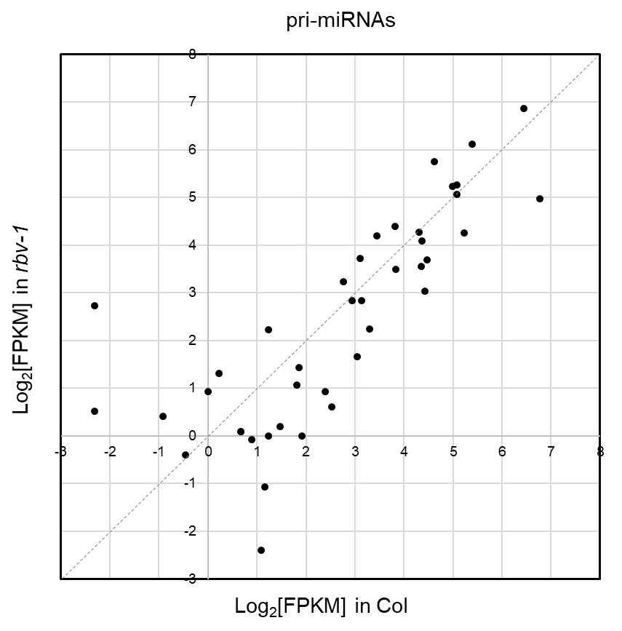
Supplementary Figure 7. RNA-Seq of WT and rbv-1 reveals global changes in pri-miRNAs. Scatterplots showing the abundance of pri-miRNAs in rbv-1 vs. Col. FPKM, Fragments Per Kilobase of transcript per Million mapped reads.

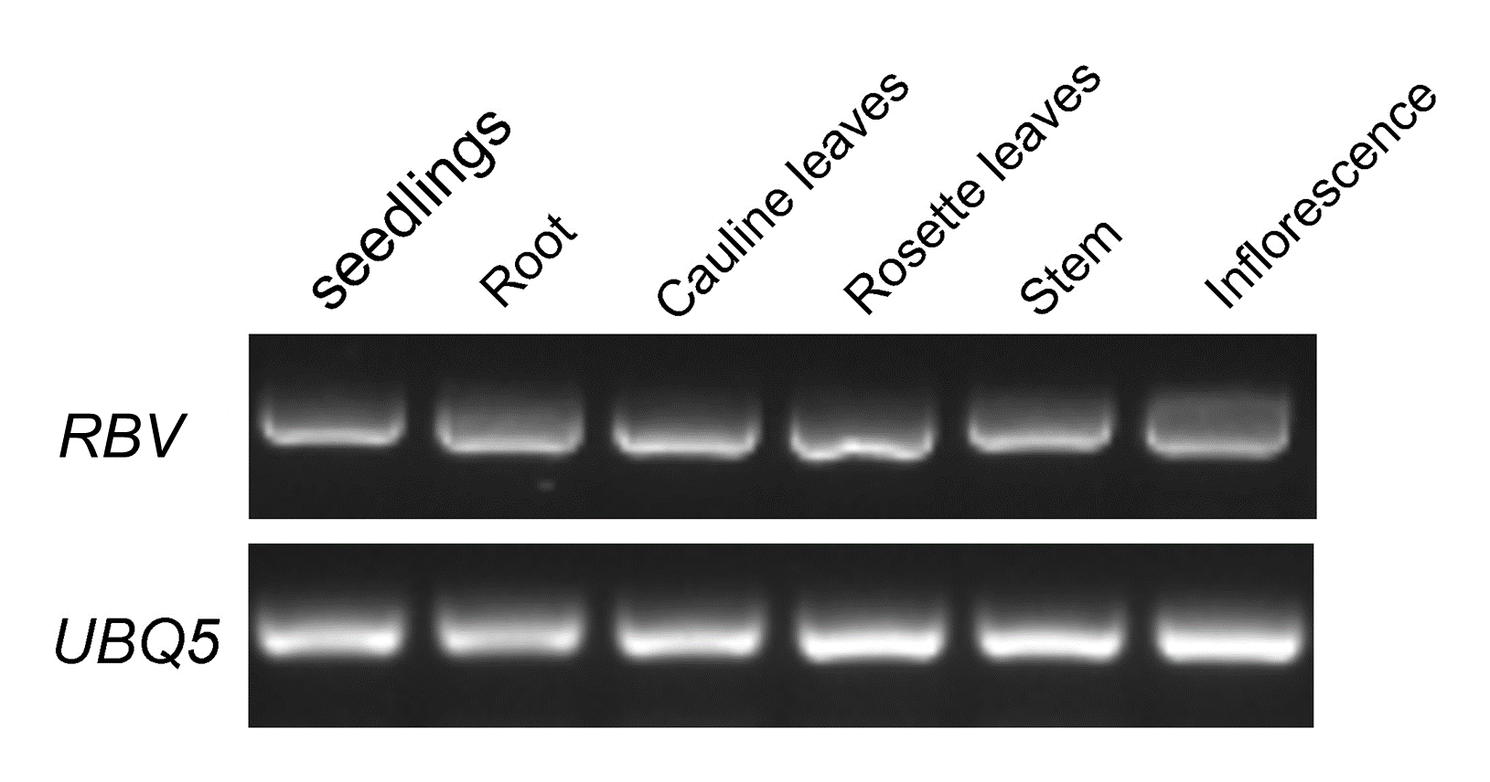
Supplementary Figure 8. RBV is expressed in all tissues as determined by RT-PCR. UBQ5 was used as an internal control.

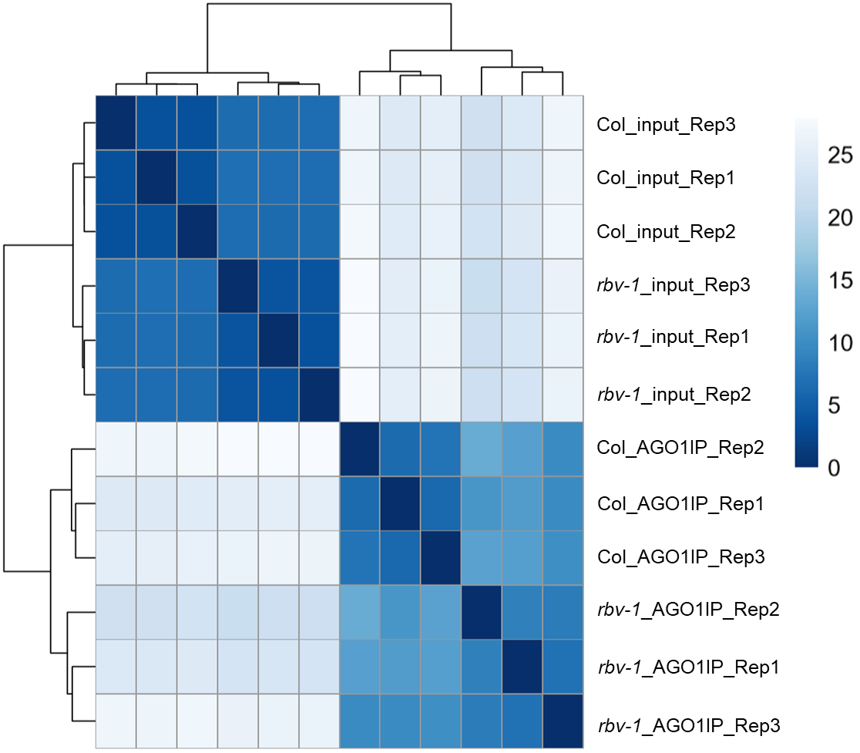
Supplementary Figure 9. Heatmaps showing small-RNA seq reproducibility among Col and rbv-1 biological replicates in both input and AGO1 IP samples. Sample-to-sample distances were calculated based on log2-transformed normalized read counts. “Input” is the sample before AGO1 IP. The three biological replicates (Rep1, Rep2 and Rep3) for each treatment were highly reproducible.

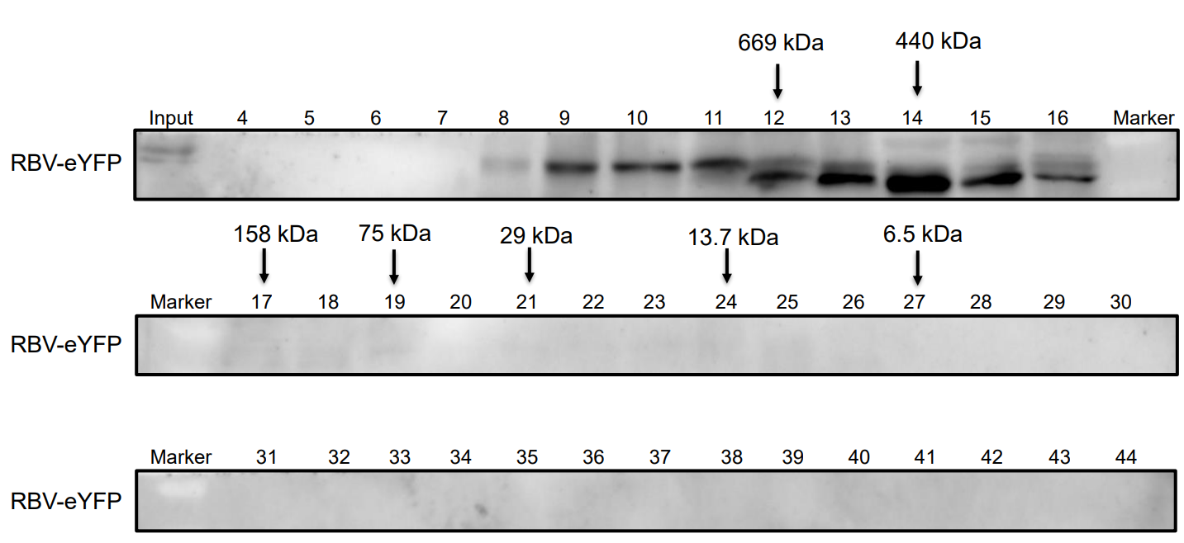
Supplementary Figure 10. Western blot of RBV-eYFP in gel filtration fractions. The pRBV: RBV-eYFP rbv-1 material was used for size exclusion chromatography. The western blot with anti-GFP antibodies shows that RBV-eYFP was detected in HMW fractions 9-16. The numbers above the lanes indicate fraction numbers. The fractions where the molecular weight standards were found are indicated.
Supplementary Figure 11. Mutation of RBV did not alter the tasiRNAs loading into AGO1. a,c,e,g Abundance of ta-siRNAs generated from TAS1A/TAS1B/TAS1C/TAS2 in rbv-1 input vs. Col input. All ta-siRNAs were normalized by total trimmed reads and Log2(RPM) value was used for plotting. b,d,f,h AGO1 loading efficiency of ta-siRNAs from TAS1A/TAS1B/TAS1C/TAS2 loci in rbv-1 vs. Col as determined by AGO1 IP small RNA-Seq. AGO1 loading efficiency is represented by the ratio of ta-siRNA abundance in AGO1 IP vs. input (*Student’s t test: P < 0.05). In a to h, the numbers on the X-axis indicate each 100-bp window. i miR173 abundance in rbv-1 input vs. Col input.

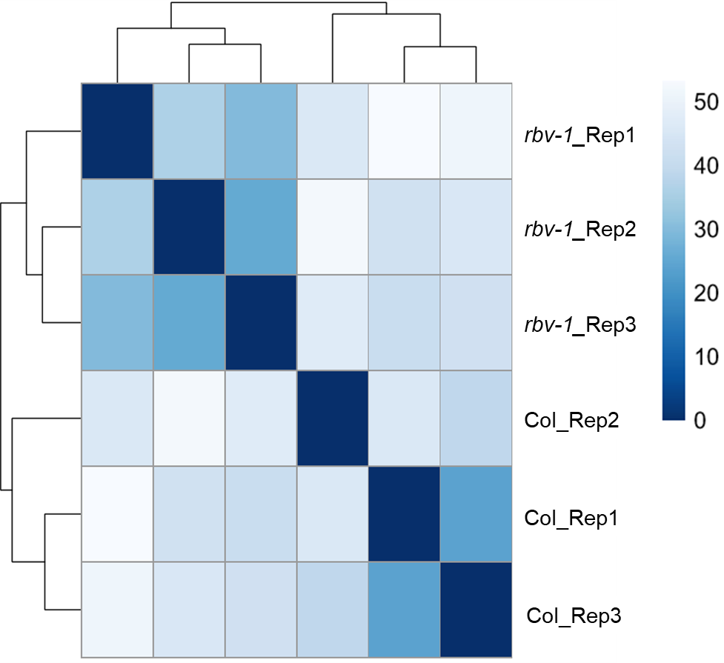
Supplementary Figure 12. Heatmaps showing the reproducibility of biological replicates of Col and rbv-1 RNA-seq. Sample-to-sample distances were calculated based on log2-transformed normalized read counts. The three biological replicates (Rep1, Rep2 and Rep3) for each genotype were highly reproducible.
Supplementary Figure 13. RNA-seq analyses of Col and rbv-1. a A scatter plot of transcript abundance from RNA-seq of rbv-1 and Col. Black dots, all genes; Blue dots, DEGs in rbv-1 vs. Col. All genes with fold-change >2 and P value <0.05 were identified as DEGs. b The top 20 GO terms for upregulated genes (hyper-DEGs) in the rbv-1 mutant. c The top 20 GO terms for downregulated genes (hypo-DEGs) in the rbv-1 mutant. d Transcript levels of 155 miRNA target genes and the corresponding miRNAs in rbv-1 vs. Col. Log2 (rbv-1/Col) values were used for heatmap plotting. Only transcripts with RPM >10 in either genotype (average of the three replicates) were included in the analysis. Only half of the miRNA targets showed increased expression in the rbv-1 mutant.

Supplementary Figure 14 Analysis of gene expression and intron retention. a A scatter plot showing the expression of genes with intron retention in rbv-1. Expression levels of genes with intron retention are similar between the rbv-1 mutant and Col. FPKM, Fragments Per Kilobase of transcript per Million mapped reads. b Intron-containing pri-miRNAs show no splicing defects in rbv-1. The splicing of some intron-containing pri-miRNAs (pri-miR156, 163 and 168) was examined by RT-PCR with intron-flanking primers. Reverse transcription was performed with an oligo dT primer. Genomic DNA (gDNA) from Col was included to indicate the expected sizes of intron-containing pri-miRNAs. The numbers represent different genotypes. 1, Col; 2, rbv-1; -RT, without reverse transcription.

Supplementary Table 1 Segregation analysis of rbv-1 crossed to amiR-SUL
F2 backcross (female×male) | Number of plants with amiR-SUL rbv-1 phenotype | Number of total F2 plants | Plants with amiR-SUL rbv-1 phenotype/total (expected) | χ² (P value) for 3:1
amiR-SUL × amiR-SUL rbv-1 | 141 | 614 | 23%（25%） | 1.357(0.244)

Supplementary Table 2. Sequences of oligonucleotides used in this study
Oligonucleotides | Sequence (5'-3')
Primers for cloning or genotyping
RBV_promoter_F_KpnI | CAGGGTACCAGATGTTTAATTTAACCGGG
RBV_promoter_R_SacI | AATGAGCTCCTCTCTCGCCTGAAACTTA
RBV_genome_F_KpnI | CAGGGTACCAGATGTTTAATTTAACCGGG
RBV_genome_R_SalI | CGGGTCGACTTTTTTCCAGACACGAAT
RBV_genotyping_F | AGCGGCGAGGTTTAACGGCCATG
RBV_genotyping_R | GGACTTCGCGGCCATGAGAT
RBV_CDS_F_BamHI | ACGGGATCCATGAGCGCGACGGAGCTG
RBV_CDS_R_SalI | AAGGTCGACTTTTTTCCAGACACGAAT
LP1 | ATGGCTCCACAACAATCTTTG
RP1 | CGATCGTTTATAGCTGCAAGC
LBb1.3 | ATTTTGCCGATTTCGGAAC
LP2 | CGATCGTTTATAGCTGCAAGC
RP2 | ATGGCTCCACAACAATCTTTG
Probes for small RNA northern blots
amiR-SUL_probe_Biotin | AGGGATTTCCGTGACACTTAA
miR156_probe_Biotin | GTGCTCACTCTCTTCTGTCA
miR159_probe_Biotin | TAGAGCTCCCTTCAATCCAAA
miR164_probe_Biotin | TGCACGTGCCCTGCTTCTCCA
miR167_probe_Biotin | TAGATCATGCTGGCAGCTTCA
miR166_probe_Biotin | GGGGAATGAAGCCTGGTCCGA
miR319_probe_Biotin | GGGAGCTCCCTTCAGTCCAA
miR390_probe_Biotin | GGCGCTATCCCTCCTGAGCTT
miR398_probe_Biotin | AAGGGGTGACCTGAGAACACA
miR845_probe_Biotin | CATCAATTGGTATCAGAGCCG
U6_probe_Biotin | AGGGGCCATGCTAATCTTCTCTG
Primers for quantitative RT-PCR detection of pri-miRNAs
qPCR-pri-miR156a-F | GAAAGAGTTGGGACAAGAGAAACG
qPCR-pri-miR156a-R | AGAGAACGAAGACAGGCCAAAGA
qPCR-pri-miR159a-F | TCTTTACAGTTTGCTTATGTCAGATCCA
qPCR-pri-miR159a-R | ACCCTGCTCAACTCATGTTTGAA
qPCR-pri-miR159b-F | TGCTTGGATCTCTAATGCTGTTCA
qPCR-pri-miR159b-R | TCACCCTGCTAAACCCTCCA
qPCR-pri-miR166a-F | AGATATATATTCAGAAACCCTAG
qPCR-pri-miR166a-R | GGTTCATTCACTGGATCTGAAAC
qPCR-pri-miR167a-F | TGATCTGCTACGGTGAAGTCTATGG
qPCR-pri-miR167a-R | GAAACTGCGAACATGATCTAATCGA
qPCR-pri-miR167b-F | TCTTTGGTTAAGAGATGAATGTGGAA
qPCR-pri-miR167b-R | ATTTTTCTTTCAATCGGCATGTG
qPCR-pri-miR319b-F | GTGCTTGTATGTATGCGTATATATAGT
qPCR-pri-miR319b-R | CTCAATTTGTCTCTCGCATCATTC
Primers for quantitative RT-PCR detection of miRNA targets
qSPL5_F | GGAGACGAAGACAAAAGGAAGA
qSPL5_R | CCTTTGCATGTACTTCACATAC
qPHB_F | TGACTGTTGCTGCTTTGAGACAT
qPHB_R | CCATTGGTGACCATCCATCAT
qPHV_F | ATCGTTGATCATGTGGACTTGGA
qPHV_R | CTATACTGGACTTCTCCACTAGT
qREV_F | ACTTTGGCAGAGTTCCTATCCAA
qREV_R | CGATCTTTGAGGATCTCTGCAA
qMYB33_F | AGTTGTTGTATCCTGGGTGTAGCA
qMYB33_R | CCGTTGGTGGTGGTGGAGAC
qARF8_F | AGATGTTTGCTATCGAAGGGTTGTTG
qARF8_R | CCATGGGTCATCACCAAGGAGAAG
qAGO1_F | GCCTTCATAGAGGCAAACCCT
qAGO1_R | GTACTTCCGGCGCATGTTTC
qSPL10_F | TGAGACAAAGCCTACACAGATGGA
qSPL10_R | GATGATGCAACCCGACTTTTTTATG
qSPL3_F | CTGGACACAACGAGAGAAG
qSPL3_R | TGGAGAAACAGACAGAGACA
qMYB65_F | AATCTGACTCCTCTACCTGCG
qMYB65_R | ATTCGTCTCATATGATGATGG
qCSD2_F | ACAGGACCACATTTCAACCCTAA
qCSD2_R | CATCGGCATTGGCATTTATG
qCUC2_F | GCACCAACACAACCGTCACAG
qCUC2_R | GAATGAGTTAACGTCTAAGCCCAAGG
qPCR-UBQ5_F | GGTGCTAAGAAGAGGAAGAA
qPCR-UBQ5_R | CTCCTTCTTTCTGGTAAACGT
Primers for quantitative RT-PCR detection of genes in miRNA biogenesis
qNRPB1_F | TGCTGCGGCTTATGCTGAGAC
qNRPB1_R | GTGCCTGACACTGGTGAACGA
qNRPB2_F | ACGTGGTGCAACTGTTGGTGTA
qNRPB2_R | AAGCAGCAGCCGGTGTATGAT
qDCL1_F | TGGAATGACTGCTTCGCCTGTT
qDCL1_R | ACTTGCTTGTGCCGCTTCTTCA
qHYL1_F | GCTCCCAACGCCTGTTTATG
qHYL1_R | CGACCTTCTGGCACTGATACA
qSE_F | AACCAGCCACGCAGCAATCT
qSE_R | CGTCCACCTCTATCATCCCTCA
qHEN1_F | GTTGACATCGGCACTTGCTTA
qHEN1_R | TGGGTTTCTGGTGTAGACCG
qDDL1_F | AAGAGGCTCTGGCAGCGAAGA
qDDL1_R | GGTGAAGGCAGAGTGGCTCATT
qCBP20_F | GGCAGCTCGTGGATTACGGTAC
qCBP20_R | CACCATCGTCATCGGAGTCACC
qCBP80_F | CAGCCGAATTGAGCAGGAAGGT
qCBP80_R | GCCATATCGCTCCAGGACAGTG
qCPL_F | TGACTTGCTTGCTCGCATCGT
qCPL_R | CCTCGGCTGATCCTTCTCATCC
qMOS2_F | TGGTGGTGATGCGGTTGAAGAG
qMOS2_R | CCATCAACGCAGCACCGAAAC
qHASTY_F | GAACACGACCTCTGCGACAACT
qHASTY_R | AGATTCACTTGCCTCGGCTTGT
qNOT2a_F | CCAACAACAAAATGGAAGTATTTCGAA
qNOT2a_R | CCAACCATATTCCCCATAGA
qNOT2b_F | CTAAGGCCAAGACCCTGTAG
qNOT2b_R | ATCCAAAATGAAGACTTTCC
qCDC5_F | ACTCCTGGTGGTGCTGGTCTT
qCDC5_R | GCTTCCTCTCGTCTCTGCCTCT
qTGH_F | GATGGCGGCGTGGTCATTCAAT
qTGH_R | AGCGAGTCGGGCGTTTCCTT
qPCR-UBQ5_F | GGTGCTAAGAAGAGGAAGAA
qPCR-UBQ5_R | CTCCTTCTTTCTGGTAAACGT
qPCR-RBV_F | TTTTAGCGGCGAGGTTTA
qPCR-RBV_R | GGCATTGTCTGAAGTAAC
Primers for quantitative RT-PCR detection of other genes
qPCR-SUL_F | GATCCAAAGATTGGTGGTGTTATG
qPCR-SUL_R | AACTTGCTCTCCTTTCTCAACTCT
qPCR-UBQ5_F | GGTGCTAAGAAGAGGAAGAA
qPCR-UBQ5_R | CTCCTTCTTTCTGGTAAACGT
qPCR-GUS_F | TCAGGAAGTGATGGAGCA
qPCR-GUS_R | AGAGCATTACGCTGCGAT
Primers for quantitative RT-PCR in CHIP
qPCR-MIR166a-Chip_F | TGGCTCTCTCCACTACTCAA
qPCR-MIR166a-Chip_R | GACAACAGTCCCCTCAAAA
qPCR-MIR167a-Chip_F | CGACCCTTAAACTCTCCATAA
qPCR-MIR167a-Chip_R | ACTTCACCGTAGCAGATCAA
qPCR-MIR171a-Chip_F | TGCTTTGGTAGTAGATGAGGTT
qPCR-MIR171a-Chip_R | CGTGTGTGGTCAGGTAAGAT
qPCR-Pol II-C1-F | AGTTCAATGGAGAGATGTCGAAATATG
qPCR-Pol II-C1-R | AAGAGGAAAAGAAAGAGATGGAGAGA

