COMPLEX HYDROGEN BONDING LEADS TO COOPERATIVITY BETWEEN ANTIPARALLEL POLYPROLINE II HELICES

Rubén López-Sánchez¹, Miguel Mompeán^{1,*} and Douglas V. Laurents^{1,*}

¹Instituto de Química Física “Blas Cabrera” - CSIC, Serrano 119, 28006 Madrid Spain
*Correspondence: dlaurents@iqfr.csic.es, mmompean@iqfr.csic.es

Supporting Material Contents

Additional Methods and Results: QTAIM analysis and SAPT methodology.
Table S1: Mean electron density of the BCPs(Ọ···H_{N}/H_{α}) for each H-bond between antiparallel PPII helices.
Table S2: Mean Laplacian of the electron density of the BCPs(Ọ···H_{N}/H_{α}) for each H-bond between antiparallel PPII helices.
Figure S1: Mean electron density of the BCPs(Ọ···H_{N}/H_{α}) and mean Laplacian of the electron density of the BCPs(Ọ···H_{N}/H_{α}) for each H-bond between antiparallel PPII helices.
Table S3: Mean distance between the BCPs(Ọ···H_{N}/H_{α}) and oxygen atoms for each H-bond between antiparallel PPII helices.
Table S4: Mean distance between the BCPs(Ọ···H_{N}/H_{α}) and hydrogen atoms for each H-bond between antiparallel PPII helices.
Figure S2: Mean distance between the BCPs(Ọ···H_{N}/H_{α}) and oxygen atoms and mean distance between the BCPs(Ọ···H_{N}/H_{α}) and hydrogen atoms for each H-bond between antiparallel PPII helices.
Table S5: Mean electrostatic component of the SAPT interaction energy between the molecules that reproduce each H-bond between antiparallel PPII helices.
Table S6: Mean induction component of the SAPT interaction energy between the molecules that reproduce each H-bond between antiparallel PPII helices.
Table S7: Mean dispersion component of the SAPT interaction energy between the molecules that reproduce each H-bond between antiparallel PPII helices.
Figure S3: Mean electrostatic, mean induction and mean dispersion components of the SAPT interaction energy between the molecules that reproduce each H-bond between antiparallel PPII helices.
Table S8: Mean exchange component of the SAPT interaction energy between the molecules that reproduce each H-bond between antiparallel PPII helices.
Table S9: Mean total SAPT interaction energy between the molecules that reproduce each H-bond between antiparallel PPII helices.
Figure S4: Mean exchange component of the SAPT interaction energy and mean total SAPT interaction energy between the molecules that reproduce each H-bond between antiparallel PPII helices.
Figure S5. Percentage of each attractive component to the total attractive SAPT energy for the molecules that reproduce the CO···HN H-bonds.
Figure S6. Percentage of each attractive component to the total attractive SAPT energy for the molecules that reproduce the CO···H_{α}C_{α} proximal H-bonds.
Figure S7. Percentage of each attractive component to the total attractive SAPT energy for the molecules that reproduce the CO···H_{α}C_{α} distal H-bonds.
Figure S8. Percentage of each attractive component to the total attractive SAPT energy for the molecules that reproduce the (CO)₂···(H_{α})₂C_{α} proximal+distal H-bonds.
Table S10: Mean variation of the HBS between the molecules that reproduce each H-bond, and occupancy of the σ*(NH/C_{α}H_{α}) orbitals, stabilization energy of the n(O)/σ(CO)/π(CO)→σ*(NH/C_{α}H_{α}) electron delocalization, electron density of the BCPs(Ọ···H_{N}/H_{α}) and Laplacian of the electron density of the BCPs(Ọ···H_{N}/H_{α}) for each H-bond between antiparallel PPII helices.
Table S11: Mean distance between oxygen and hydrogen atoms for each H-bond between antiparallel PPII helices.
Figure S9: Mean distance between oxygen and hydrogen atoms for each H-bond between antiparallel PPII helices.

Quantum Theory of Atoms in Molecules (QTAIM). Within the electron density (ρ) landscape in three-dimensional space, this quantum topological approach delineates four distinct critical points (CPs)^{1,2}. Among them, only the (3,-1) CP, also known as Bond Critical Point (BCP), which exists between two proximate atoms defining a bond, will be the focus of this discussion. The BCP represents a saddle point of ρ with maxima in the two spatial dimensions that form the interatomic boundary dividing the basins of the adjacent atoms, and a minimum in the orthogonal dimension. This results in the electron density at the BCP being maximal across the interatomic boundary and minimal along the axis connecting the nuclei. Then, the presence of a BCP in the path connecting a pair of nuclei signifies electronic charge accumulation between them. In QTAIM, the Laplacian of ρ, ∇²ρ, is essential to identify regions in which ρ exceeds or falls short of its neighboring average. In zones where ∇²ρ is negative, ρ exceeds its proximate average, indicating local concentration. Conversely, in regions with positive ∇²ρ, the electron density is below its immediate average, implying local depletion. The QTAIM framework postulates that covalent bonds are characterized by appreciable ρ values coupled with significantly negative ∇²ρ. In stark contrast, ionic bonds, van der Waals interactions, and H-bonds typically possess lesser ρ values and a positive ∇²ρ. Concerning protein secondary structures, H-bonds within an α-helix and those between antiparallel β-strands exhibit a slightly elevated ρ at the CO···HN BCP compared to the CO···H_{α}C_{α} BCP, with values roughly around 10⁻² and 10⁻³ au, respectively^{3,4}. For H-bonds between parallel β-strands, both the CO···HN and CO···H_{α}C_{α} BCPs have comparable ρ values on the order of 10⁻³ au^{3,4}. All these points have a positive ∇²ρ, aligning in magnitude with their respective ρ values. Our previous study shed light for the first time into the QTAIM analysis of the H-bonding between parallel PPII helices⁵. The ρ for the BCPs of CO···HN and CO···H_{α}C_{α} H-bonds showing cooperativity displays values of the order of 10⁻² au, while of the order of 10⁻³ au for CO···H_{α}C_{α} H-bonds not showing cooperativity. Regarding ∇²ρ of these BCPs, it was of the order of 10⁻¹ au for CO···HN H-bonds and of 10⁻² au for CO···H_{α}C_{α} regardless of their cooperative nature.

BCPs are found between the oxygens and hydrogens that give rise to the different H-bonds proposed in Figure 4A of the main text. The ρ (Table S1 and Figure S1A) and ∇²ρ (Table S2 and Figure S1B) values at these points correspond to those expected for H-bonds, small and positive, respectively. For CO···HN H-bonds between antiparallel PPII helices, the magnitude of ρ(BCP)_{CO···HN} (10⁻²) is on the same order of magnitude as in parallel PPII helices, α-helices and antiparallel β-sheets, but one order higher than in parallel β-sheets, while the magnitude of ∇²ρ(BCP)_{CO···HN} (10⁻¹) is of the same order as in parallel PPII helices, one order higher than in α-helices and antiparallel β-sheets, and two orders higher compared to parallel β-sheets (Table S1, Table S2 and Figure S1). Regarding CO···H_{α}C_{α} proximal H-bonds between antiparallel PPII helices, the magnitude of ρ(BCP)_{CO···HαCα} and ∇²ρ(BCP)_{CO···HαCα} (10⁻²) is of the same order as in cooperative non-canonical H-bonds between parallel PPII helices, that is, one order higher than in α-helices and both parallel and antiparallel β-sheets (Table S1, Table S2 and Figure S1). Finally, for CO···H_{α}C_{α} distal H-bonds between antiparallel PPII helices, the magnitude of ρ(BCP)_{CO···HαCα} (10⁻³) is on the same order as in α-helices and both parallel and antiparallel β-sheets, while the magnitude of ∇²ρ(BCP)_{CO···HαCα} (10⁻²) is one order higher relative to all of them. Then, these ρ(BCP)_{CO···HαCα} and ∇²ρ(BCP)_{CO···HαCα} magnitudes match with the ones for non-cooperative CO···H_{α}C_{α} H-bonds between parallel PPII helices (Table S1, Table S2 and Figure S1).

Going deeper into the QTAIM analysis, for CO···HN H-bonds, we observe that as antiparallel PPII helices are added to the bundle, the value of ρ(BCP)_{CO···HN} decreases (Table S1 and Figure S1A). This may seem contradictory at first, given that one might expect an increase in ρ(BCP)_{CO···HN} to correlate with the observed strengthening of these bonds through the increase of q(σ*_{NH}) (Table 2 and Figure 5A), E(2)_{n(O)/σ(CO)/π(CO)→σ*(NH)} (Table 3 and Figure 5B) and |HBS(CO···HN)| (Table 4 and Figure 6) in the main text. However, as explained in our previous study⁵, considering that BCPs move further from oxygen atoms (Table S3 and Figure S2A) and closer to hydrogen atoms (Table S4 and Figure S2B) as the bundle grows, these values align with a scenario where the electronic charge is increasingly displaced towards H_{N} and the subsequent CONH units, thereby strengthening the H-bond of the next interfaces (Table S1 and Figure S1A). The ∇²ρ(BCP)_{CO-···HN} follows a similar trend (Table S2 and Figure S1B), which is interpreted as that, although the ρ continues to be locally more depleted at that point because the ∇²ρ is positive, it does so to a lesser extent, becoming more concentrated and suggesting the strengthening of the canonical H-bonds. When it comes to CO···H_{α}C_{α} proximal H-bonds, adding PPII helices to the antiparallel assembly results in an increase in ρ(BCP)_{CO···HαCα} (Table S1 and Figure S1A), which may seem inconsistent with a cooperative situation as seen with CO···HN H-bonds. In the case of CO···HN H-bonds, the carbonyl oxygen contributing to the H-bond is always part of the existing PPII helix. As a result, the interface under investigation is the one from which the electronic charge begins to migrate to newly formed interfaces. This leads to a decrease in the initial ρ value as the antiparallel PPII helical bundle grows. On the other hand, for non-canonical CO···H_{α}C_{α} proximal H-bonds, the carbonyl oxygen comes from the newly added PPII helix. Therefore, the interface being studied in this case is the one receiving the newly added electronic charge, causing the final ρ value to increase as the assembly grows. On the other hand, the ∇²ρ(BCP)_{CO···HαCα} values show a slight decrease (Table S2 and Figure S1B), indicating that while these bonds do strengthen, they do so less robustly than CO···HN bonds. For these two cooperative H-bonds, larger variations in ρ and ∇²ρ are seen when the system is smaller. As the system grows, the value of the computational parameters remains constant or shows small variations with the addition of the rest of the antiparallel PPII helices (Table S1, Table S2 and Figure S1). Finally, CO···H_{α}C_{α} distal H-bonds show the lowest ρ(BCP)_{CO···HαCα} values (Table S1 and Figure S1A), which remain practically constant for every interface as the number of PPII helices increases, indicating non-cooperativity between these non-canonical H-bonds, what makes sense since they are competing with the more favored CO···H_{α}C_{α} proximal H-bonds as a result of sharing the H-donor atom, C_{α} (Figure 4A), as explained in the main text. Furthermore, ∇²ρ(BCP)_{CO···HαCα} for CO···H_{α}C_{α} distal H-bonds slightly increase (Table S2 and Figure S1B), while the tendency of this parameter for the other two H-bonds, whose cooperativity is not in doubt, is to decrease. It is also worth mentioning that in the same cases where this type of non-canonical H-bond was not detected by the NBO analysis of the main text, no BCP is found within the QTAIM analysis between the corresponding O and H_{α} atoms which supposedly give rise to CO···H_{α}C_{α} distal H-bonds for every third glycine. Therefore, we can affirm that this type of H-bond does not always exist and when it does, it is weak and non-cooperative.

Symmetry-Adapted Perturbation Theory (SAPT). SAPT is an advanced computational methodology that directly calculates noncovalent interactions between two molecules, bypassing the need for total energy calculations of the monomers and the dimer⁶. Through partitioning the Hamiltonian of the dimer, SAPT isolates contributions from each monomer and their interaction, providing a clear understanding of molecular association energetics. In this framework, the Hamiltonian is formulated as the sum of the monomers' usual Fock operators, F, the fluctuation potential of each monomer, W, and the interaction potential, V. The monomer Fock operators, F_{A} + F_{B}, are considered the zeroth-order Hamiltonian, and the interaction energy is evaluated through a perturbative expansion of V, W_{A}​ and W_{B}​:

$$H=F_{A}+W_{A}+F_{B}+W_{B}+V$$ | (1)

SAPT methodology breaks down the interaction energy into electrostatic (E_{elec}), induction (E_{ind}), dispersion (E_{disp}), and exchange (E_{ex}) components, offering detailed insights into the forces driving molecular interactions. For small systems, like the mimetic molecules for each H-bond type of this study, accurate interaction energies can be obtained through high-order SAPT computations, so we chose the SAPT2+3 method including the density-fitting (DF) approximation to improve efficiency⁷:

$$E=E_{elec}^{}+E_{ind}^{}+E_{disp}^{}+E_{ex}^{}$$ | (2)

where:

$$E_{elec}^{}=E_{elec}^{(10)}+E_{elec, resp}^{(12)}+E_{elec, resp}^{(13)}$$ | (3)
$$E_{ind}^{}=E_{ind, resp}^{(20)}+E_{ex-ind, resp}^{(20)}+E_{ind}^{(22)}+E_{ex-ind}^{(22)}+E_{ex-ind}^{(30)}+E_{ind, resp}^{(30)}+δ_{HF}^{(3)}$$ | (4)
$$E_{disp}^{}=E_{disp}^{(20)}+E_{ex-disp}^{(20)}+E_{disp}^{(21)}+E_{disp}^{(22)}+E_{disp}^{(30)}+E_{ex-disp}^{(30)}+E_{ind-disp}^{(30)}+E_{ex-ind-disp}^{(30)}$$ | (5)
$$E_{ex}^{}=E_{ex}^{(10)}+E_{ex}^{(11)}+E_{ex}^{(12)}$$ | (6)

E^{(vw)} defines the order in V and in W_{A}​ + W_{B}; the subscript “resp” indicates that orbital relaxation effects are included, and the δ_{HF}⁽³⁾ term takes into account higher-order induction effects. It is computed from the Hartree–Fock supermolecular interaction energy. Regarding the basis set, we employed the larger 6-311++G(d,p) instead of 6-31+G(d) since the main objective of these calculations is to show a more in-depth description of the different interactions studied here. That is, we are now using a triple split-valence basis set instead of a double one, which also includes polarization and diffuse functions not only for the heavy atoms but also for the hydrogens.

In order to dissect the cooperative nature of each interaction and check which component plays the primary stabilizing role^{8,9}, SAPT calculations were carried out on the mimetic molecules of the different interactions, which maintain the same position, and therefore distance, as in the complete PPII helices. Regarding canonical CO···HN H-bonds, represented by formamide molecules, for all layer-to-layer interfaces, we observe that the attractive electrostatic (Table S5 and Figure S3A), induction (Table S6 and Figure S3B), and dispersion (Table S7 and Figure S3C) terms far exceed the repulsive exchange term (Table S8 and Figure S4A), resulting in overall negative and therefore favorable interaction energies (Table S9 and Figure S4B). Furthermore, as the number of molecule layers in the stack increases, following the scheme in Figure 2 of the main text, we see that the electrostatic (Table S5 and Figure S3A), induction (Table S6 and Figure S3B), and exchange (Table S8 and Figure S4A) energy values decrease, i.e. the total interaction energy becomes more favorable as two attractive terms strengthen and the repulsive term weakens (Table S9 and Figure S4B), showing once again the cooperative nature of this H-bonding interaction. On the other hand, the values of the attractive dispersion component remain virtually unchanged across different interfaces as the size of the stack of molecules increases (Table S7 and Figure S3C). One of the best ways to understand these interactions from the point of view of the SAPT methodology is to calculate the percentage of the attractive interaction energy that each of the three attractive components represents. In this way, for CO···HN H-bonds the electrostatic term represents ≈ 62 %; induction, ≈ 23 %, and dispersion, ≈ 15 %. The electrostatic percentage becomes even higher at every layer-to-layer interface as the formamide stack grows (Table S5 and Figure S5), while the induction percentage remains almost constant (Table S6 and Figure S5) and the dispersion percentage declines (Table S7 and Figure S5).

In relation to the CO···H_{α}C_{α} proximal H-bonds, represented by N-methylformamide molecules, the repulsive term of the interaction energy is also exceeded by the attractive ones, but with a narrower margin compared to the canonical H-bonds as expected. The electrostatic (Table S5 and Figure S3A) and induction (Table S6 and Figure S3B) energy values also decrease like in the previous case as layers of molecules are added to the stack, with a gentler slope, but still making this interaction stronger (Table S9 and Figure S4B) even considering that the dispersion (Table S7 and Figure S3C) and exchange (Table S8 and Figure S4A) components experience just a little change this time. For these non-canonical proximal H-bonds, the electrostatic term represents ≈ 55 %; induction ≈ 16 %, and dispersion ≈ 29 %. Therefore, while it is true that for this type of interactions the main attractive component of the interaction energy is still by far the electrostatic one, it has lost some importance along with induction versus dispersion. compared to the canonical H-bonds. However, the trend of the percentage of the attractive components of the interaction energy at every layer-to-layer interface when the acetaldehyde stack grows is the same: the electrostatic component increases (Table S5 and Figure S8), the induction remains almost constant (Table S6 and Figure S8) and the dispersion decreases (Table S7 and Figure S8), what although in a less pronounced way, also reveals the cooperative nature of this H-bonding interaction.

With respect to the CO···H_{α}C_{α} distal H-bonds, represented by acetaldehyde molecules, it is necessary to indicate, as was done in the main text, that although this interaction takes place only in one of the three turns of each of the antiparallel PPII helices of the computational model, the corresponding interaction energy has been averaged since the objective of this section is to calculate the mean contribution, i.e. per turn, to the total interaction energy between complete, antiparallel PPII helices. The attractive components of the interaction energy once again surpass the repulsive ones, although with lower total interaction energy values compared to the analogous, more favorable non-canonical proximal H-bonds, as anticipated. When layers of acetaldehyde molecules are added to the stack, their electrostatic (Table S5 and Figure S3A) and induction (Table S6 and Figure S3B) components also decrease, while dispersion (Table S7 and Figure S5) and the exchange repulsive component (Table S8 and Figure S4A) display almost no variation as well. The global result is the total interaction energy (Table S9 and Figure S4B) becomes stronger. This could be interpreted as cooperativity, like in both of the previous cases even if these non-canonical distal H-bonds are found within an energy range that corresponds to weak interactions. The reader should remember that the energy value of this interaction taking place in only one of the three turns of the full-length PPII helices of the computational model has been averaged over the three existing ones, so these lower interaction energy values ​​do not fall within the error of the method. Nevertheless, as explained through the rest of the computational methods of this study, it is necessary to combine the atoms of the molecules that represent both the CO···H_{α}C_{α} proximal H-bonds with those of the molecules that represent the CO···H_{α}C_{α} distal H-bonds because of the common C_{α}, resulting in N-(2-oxoethyl)formamide to accurately represent these H-bonding interactions. In this way, the attractive components (Table S5, S6 and S7 and Figure S3) of the interaction energy now far outweigh the repulsive one (Table S8 and Figure S4A), resulting in total interaction energies that are truly considerable (Table S9 and Figure S4B), and stronger than the result of adding the values of the different components of both interactions, the proximal and the distal H-bonds, separately (Table S5, Table S6, Table S7, Table S8, Table S9 and Figure S3, Figure S4). When N-(2-oxoethyl)formamide molecule layers are added to the stack, the electrostatic (Table S5 and Figure S3A) and induction (Table S6 and Figure S3B) components diminish, dispersion (Table S7 and Figure S5) shows practically no variation and on this occasion the exchange component (Table S8 and Figure S4A) increases, revealing the cooperative nature of these (CO)₂···(H_{α})₂C_{α} proximal+distal H-bonding interaction taken as a whole. As previously shown by the NBO analysis of the main text and the QTAIM of the supplementary material this cooperativity arises from the proximal non-canonical H-bonds and not the distal ones. The electrostatic term for the isolated CO···H_{α}C_{α} distal H-bonds represents ≈ 49 %; induction, ≈ 13 %, and dispersion, ≈ 38 % of the total attractive energy. When considering (CO)₂···(H_{α})₂C_{α} proximal+distal H-bonds, the electrostatic term represents ≈ 51 %, induction ≈ 15 %, and dispersion ≈ 34 % of the total attractive energy, which is midway between the proximal non-canonical H-bonds and the distal ones. In both cases, the electrostatic percentage of the attractive energy increases across all interfaces as the molecular stack expands (Table S5 and Figure S10), the induction percentage barely changes (Table S6 and Figure S10), and the dispersion percentage decreases (Table S7 and Figure S10).

Finally, it is necessary to once again highlight that while the major contribution to the PPII bundle stability comes from canonical H-bonds, the non-canonical ones also make significant contributions. Using the same example for these SAPT calculations as in the main text for the DFT-D ones, in the interaction between two helices in our model before experiencing cooperativity, i.e., antiparallel helices a and b without considering c, d, and e, each CO···HN H-bond represented by two formamide molecules contributes 5.4 kcal/mol (Table S9 and Figure S4B). If we additionally consider the 2.6 kcal/mol arising from the (CO)₂···(H_{α})₂C_{α} proximal+distal H-bonds, represented by a pair of N-(2-oxoethyl)formamide molecules (Table S9 and Figure S4B), we reach an HBS of 8.0 kcal/mol per PPII helical turn, as opposed to the initial 5.4 kcal/mol corresponding only to the canonical H-bonds.

ρ(BCP) (10⁻² au) | Interface | Number of PPII helices
ρ(BCP) (10⁻² au) | Interface | 2 | 3 | 4 | 5
CO···HN | ab | 3.085 | 3.082 | 3.082 | 3.082
CO···HN | bc | - | 3.508 | 3.507 | 3.507
CO···HN | cd | - | - | 3.570 | 3.569
CO···H_{α}C_{α}  Proximal | ab | 1.341 | 1.343 | 1.343 | 1.343
CO···H_{α}C_{α}  Proximal | bc | - | 1.409 | 1.412 | 1.412
CO···H_{α}C_{α}  Proximal | cd | - | - | 1.411 | 1.414
CO···H_{α}C_{α}  Distal | ab | 0.867 | 0.869 | 0.869 | 0.868
CO···H_{α}C_{α}  Distal | bc | - | 0.913 | 0.914 | 0.913
CO···H_{α}C_{α}  Distal | cd | - | - | 0.901 | 0.901
Table S1. Mean electron density (ρ) of the corresponding BCPs(Ọ···H_{N}/H_{α}) for each CO···HN, CO···H_{α}C_{α} proximal and CO···H_{α}C_{α} distal H-bond between antiparallel PPII helices in the different interfaces.

∇²ρ(BCP) (10⁻² au) | Interface | Number of PPII helices
∇²ρ(BCP) (10⁻² au) | Interface | 2 | 3 | 4 | 5
CO···HN | ab | 12.241 | 12.176 | 12.168 | 12.165
CO···HN | bc | - | 14.140 | 14.063 | 14.051
CO···HN | cd | - | - | 14.388 | 14.309
CO···H_{α}C_{α}  Proximal | ab | 4.671 | 4.669 | 4.669 | 4.669
CO···H_{α}C_{α}  Proximal | bc | - | 4.913 | 4.910 | 4.910
CO···H_{α}C_{α}  Proximal | cd | - | - | 4.916 | 4.913
CO···H_{α}C_{α}  Distal | ab | 3.351 | 3.361 | 3.361 | 3.361
CO···H_{α}C_{α}  Distal | bc | - | 3.526 | 3.536 | 3.536
CO···H_{α}C_{α}  Distal | cd | - | - | 3.471 | 3.480
Table S2. Mean Laplacian of the electron density (∇²ρ) of the corresponding BCPs(Ọ···H_{N}/H_{α}) for each CO···HN, CO···H_{α}C_{α} proximal and CO···H_{α}C_{α} distal H-bond between antiparallel PPII helices in the different interfaces.

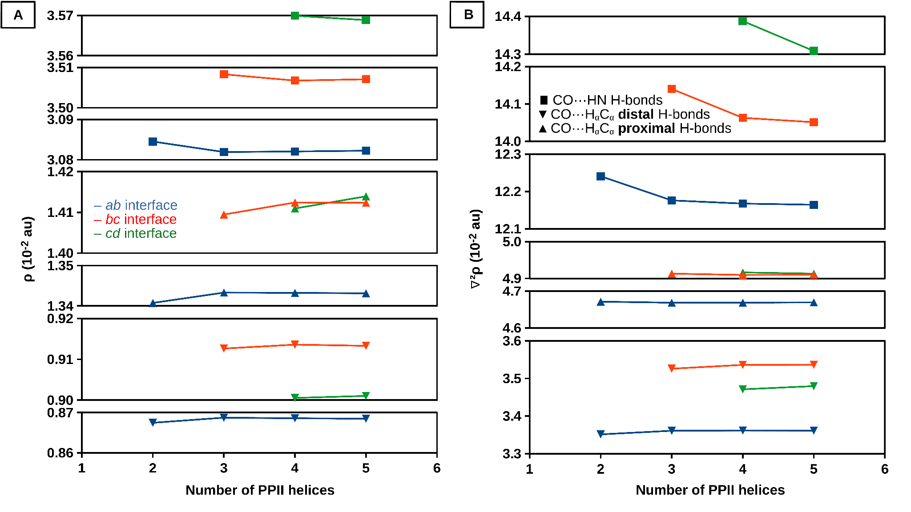Figure S1. A) Mean electron density (ρ) of the corresponding BCPs(Ọ···H_{N}/H_{α}) and B) mean Laplacian of the electron density (∇²ρ) of the corresponding BCPs(Ọ···H_{N}/H_{α}) for each CO···HN (squares), CO···H_{α}C_{α} proximal (triangles) and CO···H_{α}C_{α} distal (inverted triangles) H-bond between antiparallel PPII helices. The ab interface for the different systems is indicated in blue; the bc interface, in red, and the cd interface, in green.

d(O-BCP) (Å) | Interface | Number of PPII helices
d(O-BCP) (Å) | Interface | 2 | 3 | 4 | 5
CO···HN | ab | 1.1653 | 1.1666 | 1.1668 | 1.1669
CO···HN | bc | - | 1.1396 | 1.1409 | 1.1411
CO···HN | cd | - | - | 1.1351 | 1.1364
CO···H_{α}C_{α}  Proximal | ab | 1.3734 | 1.3743 | 1.3742 | 1.3741
CO···H_{α}C_{α}  Proximal | bc | - | 1.3585 | 1.3593 | 1.3593
CO···H_{α}C_{α}  Proximal | cd | - | - | 1.3582 | 1.3589
CO···H_{α}C_{α}  Distal | ab | 1.4758 | 1.4769 | 1.4769 | 1.4769
CO···H_{α}C_{α}  Distal | bc | - | 1.4584 | 1.4594 | 1.4593
CO···H_{α}C_{α}  Distal | cd | - | - | 1.4622 | 1.4630
Table S3. Mean distance between the corresponding BCPs(Ọ···H_{N}/H_{α}) and oxygen atoms for each CO···HN, CO···H_{α}C_{α} proximal and CO···H_{α}C_{α} distal H-bond between antiparallel PPII helices in the different interfaces.

d(H-BCP) (Å) | Interface | Number of PPII helices
d(H-BCP) (Å) | Interface | 2 | 3 | 4 | 5
CO···HN | ab | 0.6945 | 0.6933 | 0.6931 | 0.6931
CO···HN | bc | - | 0.6647 | 0.6636 | 0.6634
CO···HN | cd | - | - | 0.6595 | 0.6584
CO···H_{α}C_{α}  Proximal | ab | 0.9252 | 0.9245 | 0.9246 | 0.9247
CO···H_{α}C_{α}  Proximal | bc | - | 0.9122 | 0.9114 | 0.9115
CO···H_{α}C_{α}  Proximal | cd | - | - | 0.9119 | 0.9112
CO···H_{α}C_{α}  Distal | ab | 1.2754 | 1.2764 | 1.2767 | 1.2769
CO···H_{α}C_{α}  Distal | bc | - | 1.1776 | 1.1777 | 1.1779
CO···H_{α}C_{α}  Distal | cd | - | - | 1.1746 | 1.1749
Table S4. Mean distance between the corresponding BCPs(Ọ···H_{N}/H_{α}) and hydrogen atoms for each CO···HN, CO···H_{α}C_{α} proximal and CO···H_{α}C_{α} distal H-bond between antiparallel PPII helices in the different interfaces.

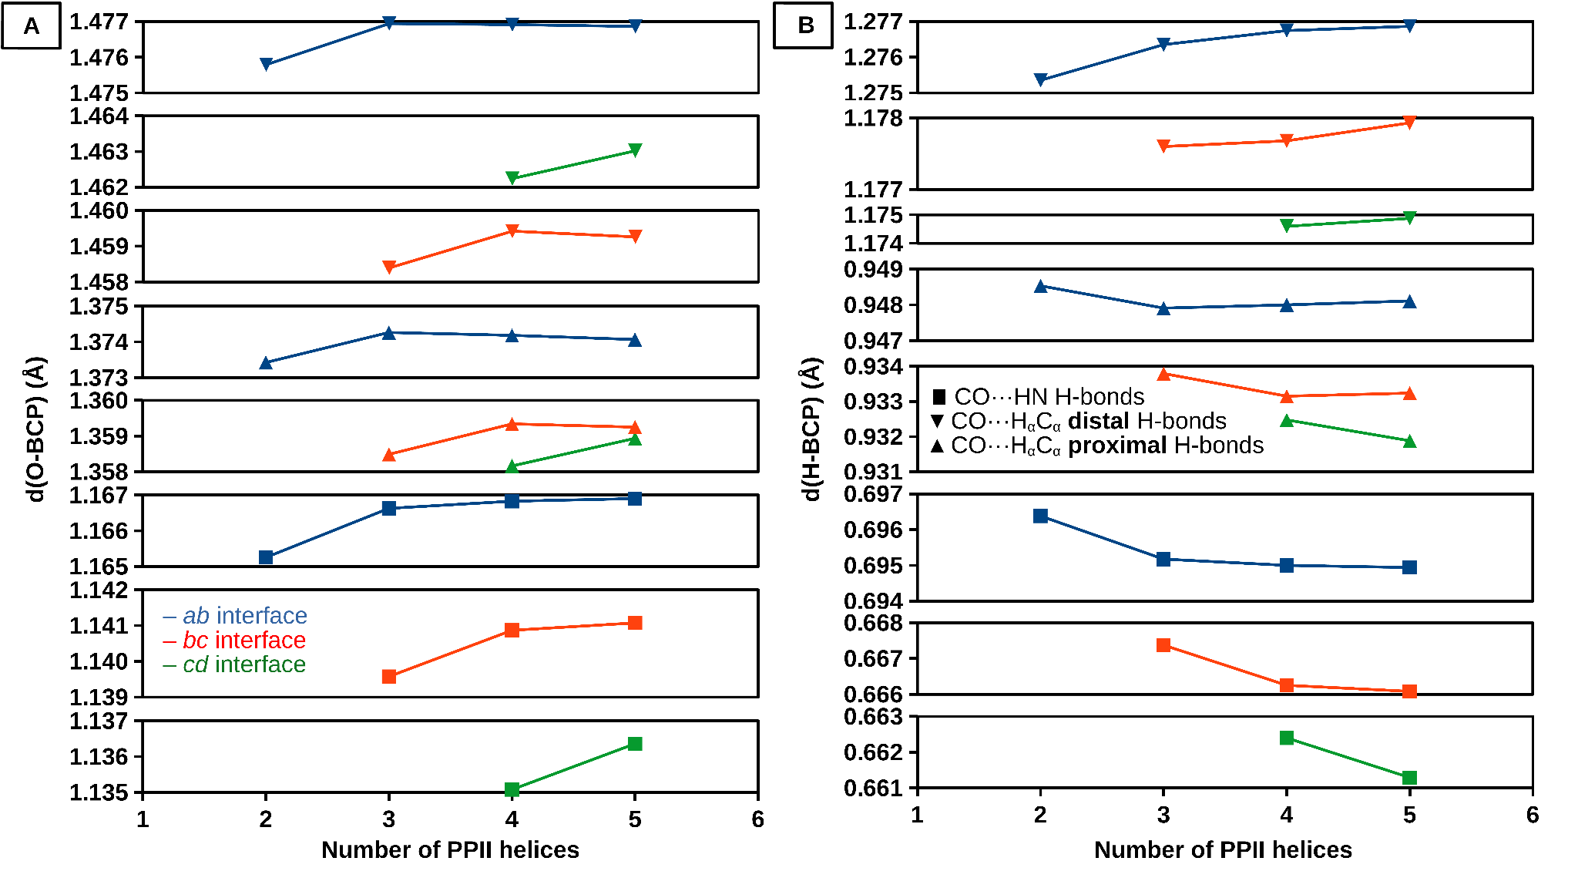Figure S2. A) Mean distance between the corresponding BCPs(Ọ···H_{N}/H_{α}) and oxygen atoms, and B) mean distance between the corresponding BCPs(Ọ···H_{N}/H_{α}) and hydrogen atoms for each CO···HN (squares), CO···H_{α}C_{α} proximal (triangles) and CO···H_{α}C_{α} distal (inverted triangles) H-bond between antiparallel PPII helices. The ab interface for the different systems is indicated in blue; the bc interface, in red, and the cd interface, in green.

Electrostatics (kcal/mol) | Interface | Number of Layers
Electrostatics (kcal/mol) | Interface | 2 | 3 | 4 | 5
CO···HN | ab | -10.74 (60.1 %) | -11.91 (61.6 %) | -12.30 (62.1 %) | -12.45 (62.2 %)
CO···HN | bc | - | -13.55 (60.7 %) | -15.31 (62.6 %) | -15.91 (63.2 %)
CO···HN | cd | - | - | -14.26 (61.0 %) | -16.27 (63.1 %)
CO···H_{α}C_{α}  Proximal | ab | -3.61 (55.0 %) | -3.65 (54.7 %) | -3.77 (55.3 %) | -3.78 (55.3 %)
CO···H_{α}C_{α}  Proximal | bc | - | -3.81 (54.9 %) | -4.03 (55.6 %) | -4.16 (56.2 %)
CO···H_{α}C_{α}  Proximal | cd | - | - | -3.97 (55.8 %) | -4.17 (56.4 %)
CO···H_{α}C_{α}  Distal | ab | -1.67 (46.1 %) | -1.82 (47.6 %) | -1.90 (48.5 %) | -1.93 (48.8 %)
CO···H_{α}C_{α}  Distal | bc | - | -1.75 (47.2 %) | -2.00 (49.8 %) | -2.10 (50.9 %)
CO···H_{α}C_{α}  Distal | cd | - | - | -1.87 (48.4 %) | -2.17 (51.3 %)
(CO)₂···(H_{α})₂C_{α} Proximal+Distal | ab | -4.64 [-5.27] (47.5 %) | -5.33 [-5.47] (49.6 %) | -5.61 [-5.67] (50.5 %) | -5.72 [-5.70] (50.8 %)
(CO)₂···(H_{α})₂C_{α} Proximal+Distal | bc | - | -5.54 [-5.56] (50.5 %) | -6.59 [-6.02] (53.4 %) | -7.01 [-6.26] (54.5 %)
(CO)₂···(H_{α})₂C_{α} Proximal+Distal | cd | - | - | -5.91 [-5.84] (51.8 %) | -7.09 [-6.34] (54.8 %)
Table S5. Mean electrostatic component of the SAPT2+3/6-311++G(d,p) interaction energy between the molecules that reproduce each CO···HN (formamide), CO···H_{α}C_{α} proximal (N-methylformamide), CO···H_{α}C_{α} distal (acetaldehyde) and (CO)₂···(H_{α})₂C_{α} proximal+distal (N-(2-oxoethyl)formamide) H-bond between antiparallel PPII helices. Shown in brackets is the HBS summation of the isolated CO···H_{α}C_{α} proximal and CO···H_{α}C_{α} distal H-bonds (for the (CO)₂···(H_{α})₂C_{α} proximal+distal H-bonds). Shown in parentheses is the percentage of the total attractive energy (i.e. electrostatics, induction and dispersion) that the electrostatic component represents for each H-bond type using the SAPT decomposition scheme.

Induction (kcal/mol) | Interface | Number of Layers
Induction (kcal/mol) | Interface | 2 | 3 | 4 | 5
CO···HN | ab | -4.11 (23.0 %) | -4.43 (22.9 %) | -4.53 (22.8 %) | -4.57 (22.8 %)
CO···HN | bc | - | -5.35 (24.0 %) | -5.74 (23.5 %) | -5.86 (23.3 %)
CO···HN | cd | - | - | -5.64 (24.1 %) | -6.05 (23.4 %)
CO···H_{α}C_{α}  Proximal | ab | -1.02 (15.5 %) | -1.06 (15.9 %) | -1.09 (15.9 %) | -1.09 (16.0 %)
CO···H_{α}C_{α}  Proximal | bc | - | -1.12 (16.1 %) | -1.17 (16.1 %) | -1.19 (16.1 %)
CO···H_{α}C_{α}  Proximal | cd | - | - | -1.14 (16.0 %) | -1.18 (15.9 %)
CO···H_{α}C_{α}  Distal | ab | -0.48 (13.2 %) | -0.50 (13.2 %) | -0.52 (13.2 %) | -0.52 (13.2 %)
CO···H_{α}C_{α}  Distal | bc | - | -0.49 (13.1 %) | -0.51 (12.8 %) | -0.53 (12.8 %)
CO···H_{α}C_{α}  Distal | cd | - | - | -0.50 (13.0 %) | -0.54 (12.8 %)
(CO)₂···(H_{α})₂C_{α} Proximal+Distal | ab | -1.39 [-1.50] (14.2 %) | -1.61 [-1.57] (14.9 %) | -1.68 [-1.61] (15.1 %) | -1.71 [-1.61] (15.2 %)
(CO)₂···(H_{α})₂C_{α} Proximal+Distal | bc | - | -1.58 [-1.60] (14.4 %) | -1.83 [-1.68] (14.9 %) | -1.92 [-1.72] (14.9 %)
(CO)₂···(H_{α})₂C_{α} Proximal+Distal | cd | - | - | -1.65 [-1.64] (14.4 %) | -1.91 [-1.72] (14.7 %)
Table S6. Mean induction component of the SAPT2+3/6-311++G(d,p) interaction energy between the molecules that reproduce each CO···HN (formamide), CO···H_{α}C_{α} proximal (N-methylformamide), CO···H_{α}C_{α} distal (acetaldehyde) and (CO)₂···(H_{α})₂C_{α} proximal+distal (N-(2-oxoethyl)formamide) H-bond between antiparallel PPII helices. Shown in brackets is the HBS summation of the isolated CO···H_{α}C_{α} proximal and CO···H_{α}C_{α} distal H-bonds (for the (CO)₂···(H_{α})₂C_{α} proximal+distal H-bonds). Shown in parentheses is the percentage of the total attractive energy (i.e. electrostatics, induction and dispersion) that the induction component represents for each H-bond type using the SAPT decomposition scheme.

Dispersion (kcal/mol) | Interface | Number of Layers
Dispersion (kcal/mol) | Interface | 2 | 3 | 4 | 5
CO···HN | ab | -3.01 (16.9 %) | -3.00 (15.5 %) | -2.99 (15.1 %) | -2.99 (14.9 %)
CO···HN | bc | - | -3.42 (15.3 %) | -3.40 (13.9 %) | -3.39 (13.5 %)
CO···HN | cd | - | - | -3.49 (14.9 %) | -3.47 (13.5 %)
CO···H_{α}C_{α}  Proximal | ab | -1.93 (29.4 %) | -1.96 (29.4 %) | -1.96 (28.8 %) | -1.96 (28.7 %)
CO···H_{α}C_{α}  Proximal | bc | - | -2.01 (29.0 %) | -2.04 (28.2 %) | -2.05 (27.7 %)
CO···H_{α}C_{α}  Proximal | cd | - | - | -2.01 (28.3 %) | -2.04 (27.7 %)
CO···H_{α}C_{α}  Distal | ab | -1.47 (40.7 %) | -1.50 (39.2 %) | -1.50 (38.3 %) | -1.50 (38.0 %)
CO···H_{α}C_{α}  Distal | bc | - | -1.47 (39.7 %) | -1.50 (37.4 %) | -1.50 (36.3 %)
CO···H_{α}C_{α}  Distal | cd | - | - | -1.49 (38.6 %) | -1.52 (36.0 %)
(CO)₂···(H_{α})₂C_{α} Proximal+Distal | ab | -3.74 [-3.40] (38.3 %) | -3.82 [-3.46] (35.5 %) | -3.82 [-3.46] (34.4 %) | -3.83 [-3.47] (34.0 %)
(CO)₂···(H_{α})₂C_{α} Proximal+Distal | bc | - | -3.84 [-3.48] (35.0 %) | -3.92 [-3.54] (31.7 %) | -3.93 [-3.55] (30.5 %)
(CO)₂···(H_{α})₂C_{α} Proximal+Distal | cd | - | - | -3.86 [-3.50] (33.8 %) | -3.94 [-3.56] (30.4 %))
Table S7. Mean dispersion component of the SAPT2+3/6-311++G(d,p) interaction energy between the molecules that reproduce each CO···HN (formamide), CO···H_{α}C_{α} proximal (N-methylformamide), CO···H_{α}C_{α} distal (acetaldehyde) and (CO)₂···(H_{α})₂C_{α} proximal+distal (N-(2-oxoethyl)formamide) H-bond between antiparallel PPII helices. Shown in brackets is the HBS summation of the isolated CO···H_{α}C_{α} proximal and CO···H_{α}C_{α} distal H-bonds (for the (CO)₂···(H_{α})₂C_{α} proximal+distal H-bonds). Shown in parentheses is the percentage of the total attractive energy (i.e. electrostatics, induction and dispersion) that the dispersion component represents for each H-bond type using the SAPT decomposition scheme.

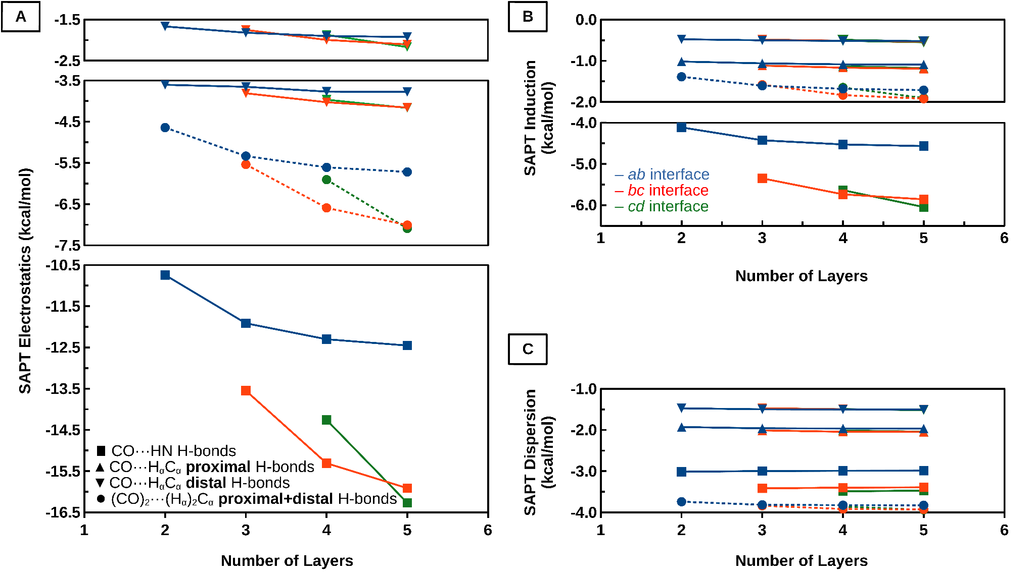Figure S3. A) Mean electrostatic, B) mean induction and C) mean dispersion components of the SAPT2+3/6-311++G(d,p) interaction energy between the molecules that reproduce each CO···HN (formamide, squares), CO···H_{α}C_{α} proximal (N-methylformamide, triangles), CO···H_{α}C_{α} distal (acetaldehyde, inverted triangles) and (CO)₂···(H_{α})₂C_{α} proximal+distal (N-(2-oxoethyl)formamide, circles and dashed line) H-bond between antiparallel PPII helices. The ab interface for the different systems is indicated in blue; the bc interface, in red, and the cd interface, in green.

Exchange (kcal/mol) | Interface | Number of Layers
Exchange (kcal/mol) | Interface | 2 | 3 | 4 | 5
CO···HN | ab | 12.51 | 12.23 | 12.18 | 12.16
CO···HN | bc | - | 15.34 | 15.02 | 14.95
CO···HN | cd | - | - | 15.78 | 15.46
CO···H_{α}C_{α}  Proximal | ab | 4.67 | 4.69 | 4.69 | 4.70
CO···H_{α}C_{α}  Proximal | bc | - | 4.94 | 4.96 | 4.97
CO···H_{α}C_{α}  Proximal | cd | - | - | 4.94 | 4.97
CO···H_{α}C_{α}  Distal | ab | 3.16 | 3.19 | 3.19 | 3.20
CO···H_{α}C_{α}  Distal | bc | - | 3.04 | 3.06 | 3.07
CO···H_{α}C_{α}  Distal | cd | - | - | 3.13 | 3.16
(CO)₂···(H_{α})₂C_{α} Proximal+Distal | ab | 7.20 [7.83] | 7.30 [7.87] | 7.33 [7.89] | 7.34 [7.89]
(CO)₂···(H_{α})₂C_{α} Proximal+Distal | bc | - | 7.40 [7.97] | 7.51 [8.03] | 7.54 [8.04]
(CO)₂···(H_{α})₂C_{α} Proximal+Distal | cd | - | - | 7.48 [8.08] | 7.59 [8.13]
Table S8. Mean exchange component of the SAPT2+3/6-311++G(d,p) interaction energy between the molecules that reproduce each CO···HN (formamide), CO···H_{α}C_{α} proximal (N-methylformamide), CO···H_{α}C_{α} distal (acetaldehyde) and (CO)₂···(H_{α})₂C_{α} proximal+distal (N-(2-oxoethyl)formamide) H-bond between antiparallel PPII helices. Shown in brackets is the HBS summation of the isolated CO···H_{α}C_{α} proximal and CO···H_{α}C_{α} distal H-bonds (for the (CO)₂···(H_{α})₂C_{α} proximal+distal H-bonds). The exchange component represents the repulsive energy for each H-bond type according to the SAPT decomposition scheme.

Total SAPT (kcal/mol) | Interface | Number of Layers
Total SAPT (kcal/mol) | Interface | 2 | 3 | 4 | 5
CO···HN | ab | -5.35 | -7.10 | -7.64 | -7.85
CO···HN | bc | - | -6.97 | -9.43 | -10.21
CO···HN | cd | - | - | -7.60 | -10.33
CO···H_{α}C_{α}  Proximal | ab | -1.89 | -1.99 | -2.13 | -2.14
CO···H_{α}C_{α}  Proximal | bc | - | -2.00 | -2.28 | -2.43
CO···H_{α}C_{α}  Proximal | cd | - | - | -2.17 | -2.42
CO···H_{α}C_{α}  Distal | ab | -0.46 | -0.64 | -0.73 | -0.75
CO···H_{α}C_{α}  Distal | bc | - | -0.67 | -0.94 | -1.06
CO···H_{α}C_{α}  Distal | cd | - | - | -0.74 | -1.07
(CO)₂···(H_{α})₂C_{α} Proximal+Distal | ab | -2.57 [-2.35] | -3.45 [-2.63] | -3.79 [-2.85] | -3.92 [-2.89]
(CO)₂···(H_{α})₂C_{α} Proximal+Distal | bc | - | -3.55 [-2.67] | -4.83 [-3.22] | -5.32 [-3.49]
(CO)₂···(H_{α})₂C_{α} Proximal+Distal | cd | - | - | -3.93 [-2.90] | -5.35 [-3.49]
Table S9. Mean total SAPT2+3/6-311++G(d,p) interaction energy between the molecules that reproduce each CO···HN (formamide), CO···H_{α}C_{α} proximal (N-methylformamide), CO···H_{α}C_{α} distal (acetaldehyde) and (CO)₂···(H_{α})₂C_{α} proximal+distal (N-(2-oxoethyl)formamide) H-bond between antiparallel PPII helices. Shown in brackets is the HBS summation of the isolated CO···H_{α}C_{α} proximal and CO···H_{α}C_{α} distal H-bonds (for the (CO)₂···(H_{α})₂C_{α} proximal+distal H-bonds).

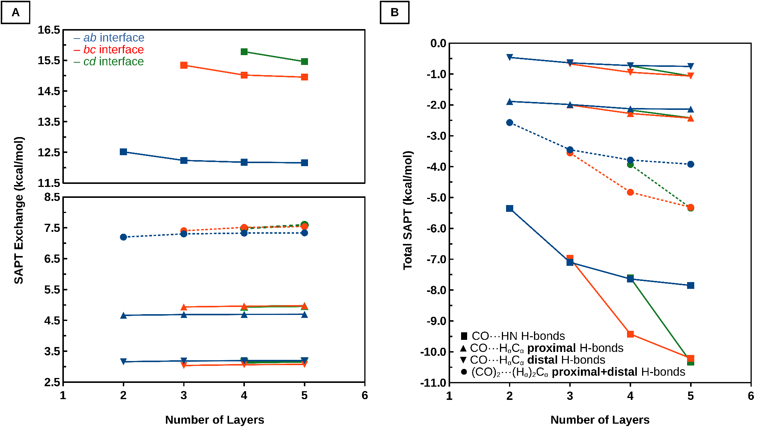Figure S4. A) Mean exchange component of the SAPT2+3/6-311++G(d,p) interaction energy and B) mean total SAPT2+3/6-311++G(d,p) interaction energy between the molecules that reproduce each CO···HN (formamide, squares), CO···H_{α}C_{α} proximal (N-methylformamide, triangles), CO···H_{α}C_{α} distal (acetaldehyde, inverted triangles) and (CO)₂···(H_{α})₂C_{α} proximal+distal (N-(2-oxoethyl)formamide, circles and dashed line) H-bond between antiparallel PPII helices. The ab interface for the different systems is indicated in blue; the bc interface, in red, and the cd interface, in green.
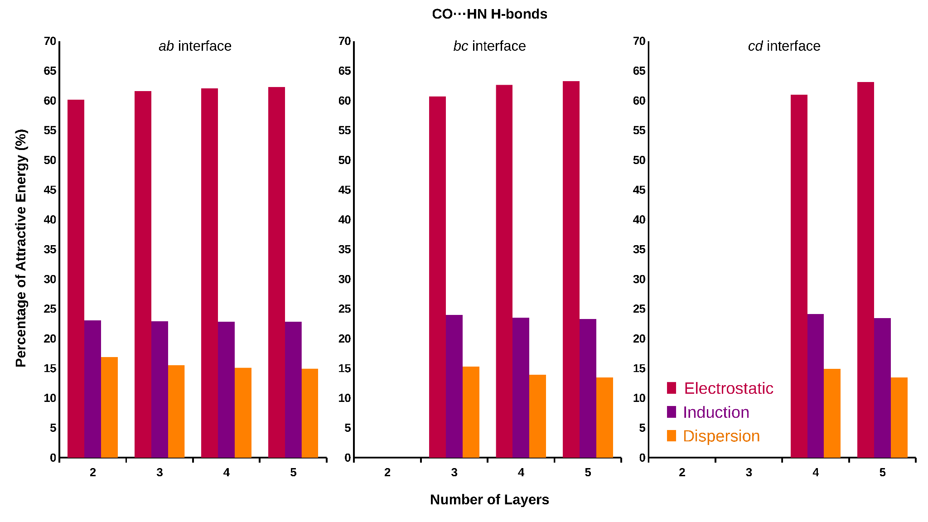Figure S5. Percentage of each attractive component to the total attractive energy, i.e. electrostatics (magenta), induction (purple), and dispersion (orange), for the molecules that reproduce the CO···HN H-bonds (formamide) at the SAPT2+3/6-311++G(d,p) computational level.

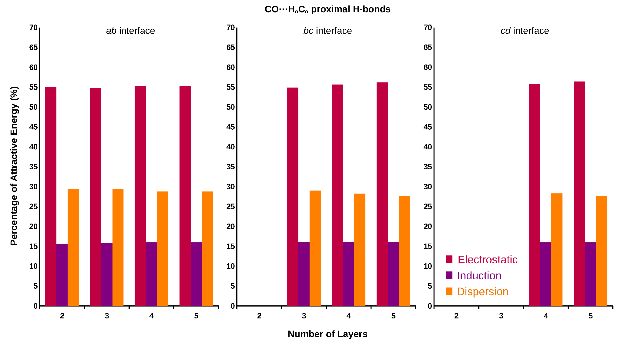Figure S6. Percentage of each attractive component to the total attractive energy, i.e. electrostatics (magenta), induction (purple), and dispersion (orange), for the molecules that reproduce the CO···H_{α}C_{α} distal H-bonds (acetaldehyde) at the SAPT2+3/6-311++G(d,p) computational level.

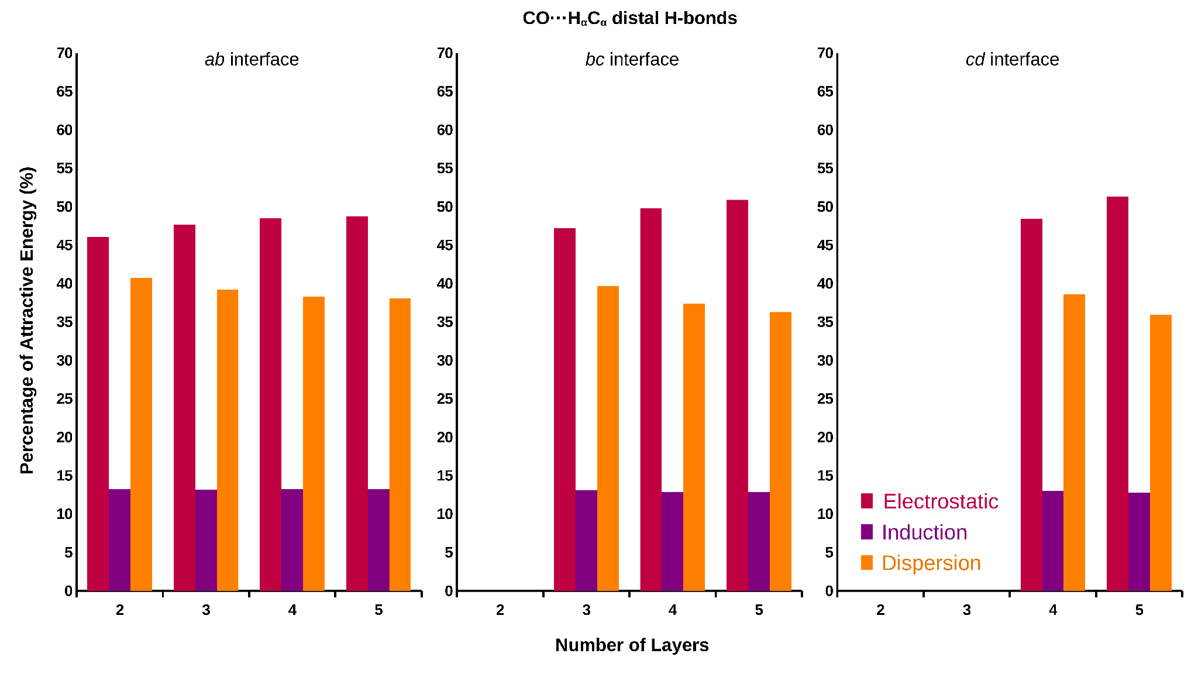Figure S7. Percentage of each attractive component to the total attractive energy, i.e. electrostatics (magenta), induction (purple), and dispersion (orange), for the molecules that reproduce the CO···H_{α}C_{α} distal H-bonds (acetaldehyde) at the SAPT2+3/6-311++G(d,p) computational level.

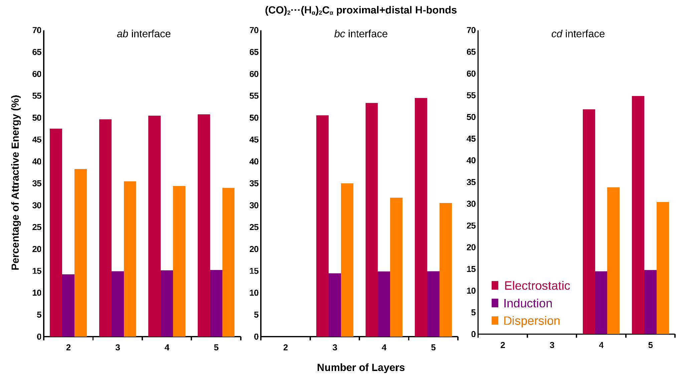Figure S8. Percentage of each attractive component to the total attractive energy, i.e. electrostatics (magenta), induction (purple), and dispersion (orange), for the molecules that reproduce the (CO)₂···(H_{α})₂C_{α} proximal+distal H-bonds (acetaldehyde) at the SAPT2+3/6-311++G(d,p) computational level.

Computational Parameter | H-Bonding Interaction | Mean Variation
HBS  (kcal/mol) | CO···HN | -3.12
HBS  (kcal/mol) | (CO)₂···(H_{α})₂C_{α} Proximal+Distal | -1.80
q(σ*)  (10⁻² electrons) | CO···HN | 0.056
q(σ*)  (10⁻² electrons) | CO···H_{α}C_{α} Proximal | 0.012
q(σ*)  (10⁻² electrons) | CO···H_{α}C_{α} Distal | -0.003
E(2)  (kcal/mol) | CO···HN | 0.311
E(2)  (kcal/mol) | CO···H_{α}C_{α} Proximal | 0.021
E(2)  (kcal/mol) | CO···H_{α}C_{α} Distal | -0.004
ρ(BCP)  (10⁻² au) | CO···HN | -0.002
ρ(BCP)  (10⁻² au) | CO···H_{α}C_{α} Proximal | 0.003
ρ(BCP)  (10⁻² au) | CO···H_{α}C_{α} Distal | 0.000
∇²ρ(BCP)  (10⁻² au) | CO···HN | -0.081
∇²ρ(BCP)  (10⁻² au) | CO···H_{α}C_{α} Proximal | -0.003
∇²ρ(BCP)  (10⁻² au) | CO···H_{α}C_{α} Distal | 0.008
Table S10. Mean variation of the HBS between the molecules that reproduce each CO···HN (formamide) and CO···(H_{α})₂C_{α} proximal+distal (N-(2-oxoethyl)formamide) H-bond, and occupancy (q) of the corresponding σ*(NH/C_{α}H_{α}) orbitals, stabilization energy (E(2)) of the corresponding n(O)/σ(CO)/π(CO)→σ*(NH/C_{α}H_{α}) electron delocalization, electron density (ρ) of the corresponding BCPs(Ọ···H_{N}/H_{α}) and Laplacian of the electron density (∇²ρ) of the corresponding BCPs(Ọ···H_{N}/H_{α}) for each CO···HN, CO···H_{α}C_{α} proximal and CO···H_{α}C_{α} distal H-bond between antiparallel PPII helices.

d(O-H) (Å) | Number of PPII helices
d(O-H) (Å) | 2 | 3 | 4 | 5
CO···HN | 1.83 | 1.77 | 1.76 | 1.77
CO···H_{α}C_{α} Proximal | 2.28 | 2.25 | 2.25 | 2.34
CO···H_{α}C_{α} Distal | 2.67 | 2.66 | 2.65 | 2.57
Table S11. Mean distance between oxygen and hydrogen atoms of CO···HN, CO···H_{α}C_{α} proximal and CO···H_{α}C_{α} distal H-bonds between antiparallel PPII helices.

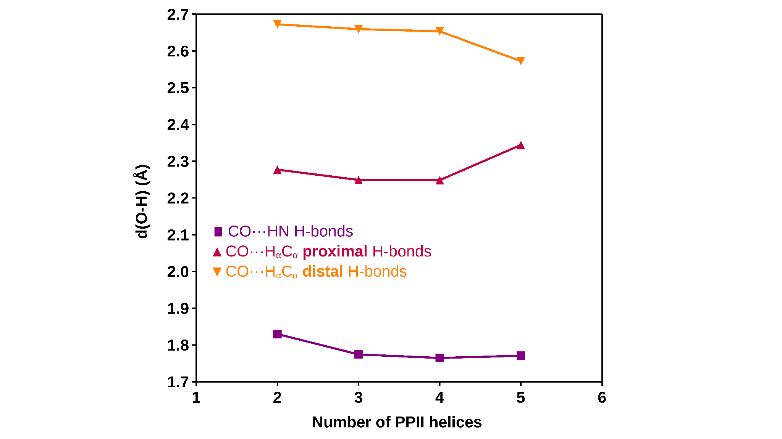Figure S9. Mean distance between oxygen and hydrogen atoms of CO···HN (squares, purple), CO···H_{α}C_{α} proximal (triangles, magenta) and CO···H_{α}C_{α} distal (inverted triangles, orange) H-bonds between antiparallel PPII helices.

BIBLIOGRAPHY

(1) Bader, R. F. W. Atoms in Molecules. Acc. Chem. Res. 1985, 18 (1), 9–15.
(2) Bader, R. F. W. Atoms in Molecules: A Quantum Theory; Clarendon Press, 1990.
(3) Parthasarathi, R.; Raman, S. S.; Subramanian, V.; Ramasami, T. Bader’s Electron Density Analysis of Hydrogen Bonding in Secondary Structural Elements of Protein. J. Phys. Chem. A 2007, 111 (30), 7141–7148.
(4) Arnold, W. D.; Oldfield, E. The Chemical Nature of Hydrogen Bonding in Proteins via NMR: J-Couplings, Chemical Shifts, and AIM Theory. J. Am. Chem. Soc. 2000, 122 (51), 12835–12841.
(5) López-Sánchez, R.; Laurents, D. V.; Mompeán, M. Hydrogen bonding patterns and cooperativity in polyproline II helical bundles. Commun. Chem., 2024 7(1), 191.
(6) Jeziorski, B.; Moszynski, R.; Szalewicz, K. Perturbation Theory Approach to Intermolecular Potential Energy Surfaces of van Der Waals Complexes. Chem. Rev. 1994, 94 (7), 1887–1930.
(7) Hohenstein, E. G.; Sherrill, C. D. Density Fitting of Intramonomer Correlation Effects in Symmetry-Adapted Perturbation Theory. J. Chem. Phys. 2010, 133 (1), 014101.
(8) Sánchez-Sanz, G.; Trujillo, C.; Alkorta, I.; Elguero, J. Understanding Regium Bonds and Their Competition with Hydrogen Bonds in Au2:HX Complexes. ChemPhysChem 2019, 20 (12), 1572–1580.
(9) Jezierska, A.; Panek, J. J. Cooperativity of Hydrogen Bonding Network in Microsolvated Biotin, the Ligand of Avidin Class Proteins. J. Mol. Model. 2019, 25 (12), 361.

