Table S1: Literature search strategy
1.Pubmed 197 results
Search number | Query | Results
#1 | "Cerebral Small Vessel Diseases"[Mesh] | 10326
#2 | (((((Cerebral Microangiopathies[Title/Abstract]) OR (Cerebral Microangiopathy[Title/Abstract])) OR (Microangiopathies, Cerebral[Title/Abstract])) OR (Microangiopathy, Cerebral[Title/Abstract])) OR (Cerebral Small Vessel Disease[Title/Abstract])) OR (subcortical ischemic vascular disease[Title/Abstract]) | 3730
#3 | ("Cerebral Small Vessel Diseases"[Mesh]) OR ((((((Cerebral Microangiopathies[Title/Abstract]) OR (Cerebral Microangiopathy[Title/Abstract])) OR (Microangiopathies, Cerebral[Title/Abstract])) OR (Microangiopathy, Cerebral[Title/Abstract])) OR (Cerebral Small Vessel Disease[Title/Abstract])) OR (subcortical ischemic vascular disease[Title/Abstract])) | 12280
#4 | "Cognitive Dysfunction"[Mesh] | 42815
#5 | ((((((((((((((((((Cognitive Dysfunctions[Title/Abstract]) OR (Cognitive Impairments[Title/Abstract])) OR (Cognitive Impairment[Title/Abstract])) OR (Mild Neurocognitive Disorder[Title/Abstract])) OR (Mild Neurocognitive Disorders[Title/Abstract])) OR (Cognitive Decline[Title/Abstract])) OR (Cognitive Declines[Title/Abstract])) OR (Mental Deterioration[Title/Abstract])) OR (Mental Deteriorations[Title/Abstract])) OR (cognitive defect[Title/Abstract])) OR (cognition disorder[Title/Abstract])) OR (cognition disorders[Title/Abstract])) OR (cognition disorders[Title/Abstract])) OR (cognitive deficit[Title/Abstract])) OR (cognitive disability[Title/Abstract])) OR (cognitive disorder[Title/Abstract])) OR (cognitive disorders[Title/Abstract])) OR (cognitive dysfunction[Title/Abstract])) OR (cognitive impairment[Title/Abstract]) | 152902
#6 | ("Cognitive Dysfunction"[Mesh]) OR (((((((((((((((((((Cognitive Dysfunctions[Title/Abstract]) OR (Cognitive Impairments[Title/Abstract])) OR (Cognitive Impairment[Title/Abstract])) OR (Mild Neurocognitive Disorder[Title/Abstract])) OR (Mild Neurocognitive Disorders[Title/Abstract])) OR (Cognitive Decline[Title/Abstract])) OR (Cognitive Declines[Title/Abstract])) OR (Mental Deterioration[Title/Abstract])) OR (Mental Deteriorations[Title/Abstract])) OR (cognitive defect[Title/Abstract])) OR (cognition disorder[Title/Abstract])) OR (cognition disorders[Title/Abstract])) OR (cognition disorders[Title/Abstract])) OR (cognitive deficit[Title/Abstract])) OR (cognitive disability[Title/Abstract])) OR (cognitive disorder[Title/Abstract])) OR (cognitive disorders[Title/Abstract])) OR (cognitive dysfunction[Title/Abstract])) OR (cognitive impairment[Title/Abstract])) | 159234
#7 | "Machine Learning"[Mesh] | 75532
#8 | (((((((((((((((((((((((Transfer Learning[Title/Abstract]) OR (Deep learning[Title/Abstract])) OR (Ensemble Learning[Title/Abstract])) OR (artificial intelligence[Title/Abstract])) OR (Prediction model[Title/Abstract])) OR (Risk Prediction[Title/Abstract])) OR (Risk-Prediction[Title/Abstract])) OR (random forest[Title/Abstract])) OR (neural network[Title/Abstract])) OR (neural networks[Title/Abstract])) OR (CNN[Title/Abstract])) OR (Support vector machine[Title/Abstract])) OR (SVM[Title/Abstract])) OR (Gradient Boosting Machine[Title/Abstract])) OR (GBM[Title/Abstract])) OR (Logistic[Title/Abstract])) OR (Nomogram[Title/Abstract])) OR (XGBoost[Title/Abstract])) OR (Decision tree[Title/Abstract])) OR (ResNet-50[Title/Abstract])) OR (ResNet[Title/Abstract])) OR (Naive Bayesian[Title/Abstract])) OR (Radiomics[Title/Abstract])) OR (radiomic[Title/Abstract]) | 816662
#9 | ("Machine Learning"[Mesh]) OR ((((((((((((((((((((((((Transfer Learning[Title/Abstract]) OR (Deep learning[Title/Abstract])) OR (Ensemble Learning[Title/Abstract])) OR (artificial intelligence[Title/Abstract])) OR (Prediction model[Title/Abstract])) OR (Risk Prediction[Title/Abstract])) OR (Risk-Prediction[Title/Abstract])) OR (random forest[Title/Abstract])) OR (neural network[Title/Abstract])) OR (neural networks[Title/Abstract])) OR (CNN[Title/Abstract])) OR (Support vector machine[Title/Abstract])) OR (SVM[Title/Abstract])) OR (Gradient Boosting Machine[Title/Abstract])) OR (GBM[Title/Abstract])) OR (Logistic[Title/Abstract])) OR (Nomogram[Title/Abstract])) OR (XGBoost[Title/Abstract])) OR (Decision tree[Title/Abstract])) OR (ResNet-50[Title/Abstract])) OR (ResNet[Title/Abstract])) OR (Naive Bayesian[Title/Abstract])) OR (Radiomics[Title/Abstract])) OR (radiomic[Title/Abstract])) | 828077
#10 | #3 and #6 and #9 | 197
2.Cochrane 240 results
Search number | Query | Results
#1 | MeSH descriptor: [Cerebral Small Vessel Diseases] explode all trees | 372
#2 | (‘Cerebral Microangiopathies’ OR ‘Cerebral Microangiopathy’ OR ‘Microangiopathies, Cerebral’ OR ‘Microangiopathy, Cerebral’ OR ‘Cerebral Small Vessel Disease’ OR ‘subcortical ischemic vascular disease’):ti,ab,kw | 517
#3 | #1 or #2 | 760
#4 | MeSH descriptor: [Cognitive Dysfunction] explode all trees | 4134
#5 | (‘Cognitive Dysfunctions’ OR ‘Cognitive Impairments’ OR ‘Cognitive Impairment’ OR ‘Mild Neurocognitive Disorder’ OR ‘Mild Neurocognitive Disorders’ OR ‘Cognitive Decline’ OR ‘Cognitive Declines’ OR ‘Mental Deterioration’ OR ‘Mental Deteriorations’ OR ‘cognitive defect ‘ OR ‘cognition disorder’ OR ‘cognition disorders’ OR ‘cognitive defects’ OR ‘cognitive deficit’ OR ‘cognitive disability’ OR ‘cognitive disorder’ OR ‘cognitive disorders’ OR ‘cognitive dysfunction’ OR ‘cognitive impairment’):ti,ab,kw  #5 MeSH descriptor: [Machine Learning] explode all trees | 70043
#6 | #4 or #5 | 70057
#7 | MeSH descriptor: [Machine Learning] explode all trees | 1009
#8 | (‘Transfer Learning’ OR ‘Deep learning’ OR ‘Ensemble Learning’ OR ‘artificial intelligence’ OR ‘Prediction model’ OR ‘Risk Prediction’ OR ‘Risk-Prediction’ OR ‘random forest’ OR ‘neural network’ OR ‘neural networks’ OR ‘CNN’ OR ‘Support vector machine’ OR ‘SVM’ OR ‘Gradient Boosting Machine’ OR ‘GBM’ OR ‘Logistic’ OR ‘Nomogram’ OR ‘XGBoost’ OR ‘Decision tree’ OR ‘ResNet-50’ OR ‘ResNet’ OR ‘Naive Bayesian’ OR ‘Radiomics’ OR ‘radiomic’):ti,ab,kw | 152869
#9 | #7 or #8 | 152973
#10 | #3 and #6 and #9 | 240
3.Embase 5137 results
Search number | Query | Results
#1 | 'cerebrovascular disease'/exp | 976501
#2 | 'cerebral microangiopathies':ab,ti OR 'cerebral microangiopathy':ab,ti OR 'cerebral small vessel disease':ab,ti OR 'subcortical ischemic vascular disease':ab,ti | 5245
#3 | #1 OR #2 | 976991
#4 | 'cognitive defect'/exp | 663851
#5 | 'cognitive dysfunctions':ti,ab,kw OR 'cognitive impairments':ti,ab,kw OR 'mild neurocognitive disorder':ti,ab,kw OR 'mild neurocognitive disorders':ti,ab,kw OR 'cognitive decline':ti,ab,kw OR 'cognitive declines':ti,ab,kw OR 'mental deterioration':ti,ab,kw OR 'mental deteriorations':ti,ab,kw OR 'cognition disorder':ti,ab,kw OR 'cognition disorders':ti,ab,kw OR 'cognitive defects':ti,ab,kw OR 'cognitive deficit':ti,ab,kw OR 'cognitive disability':ti,ab,kw OR 'cognitive disorder':ti,ab,kw OR 'cognitive disorders':ti,ab,kw OR 'cognitive dysfunction':ti,ab,kw OR 'cognitive impairment':ti,ab,kw | 227729
#6 | #4 OR #5 | 705327
#7 | 'machine learning'/exp | 1107269
#8 | 'transfer learning':ti,ab,kw OR 'deep learning':ti,ab,kw OR 'ensemble learning':ti,ab,kw OR 'artificial intelligence':ti,ab,kw OR 'prediction model':ti,ab,kw OR 'risk prediction':ti,ab,kw OR 'risk-prediction':ti,ab,kw OR 'random forest':ti,ab,kw OR 'neural network':ti,ab,kw OR 'neural networks':ti,ab,kw OR 'cnn':ti,ab,kw OR 'support vector machine':ti,ab,kw OR 'svm':ti,ab,kw OR 'gradient boosting machine':ti,ab,kw OR 'gbm':ti,ab,kw OR 'logistic':ti,ab,kw OR 'nomogram':ti,ab,kw OR 'xgboost':ti,ab,kw OR 'decision tree':ti,ab,kw OR 'resnet-50':ti,ab,kw OR 'resnet':ti,ab,kw OR 'naive bayesian':ti,ab,kw OR 'radiomics':ti,ab,kw OR 'radiomic':ti,ab,kw | 1398656
#9 | #7 OR #8 | 1089957
#10 | #7 AND #8 AND #9 | 5137
4.Web of science 29 results
Search number | Query | Results
#1 | TS=(Cerebral Small Vessel Diseases) OR AB=(Cerebral Microangiopathies OR Microangiopathies, Cerebral OR Microangiopathy, Cerebral OR Cerebral Microangiopathy OR Cerebral Small Vessel Disease OR subcortical ischemic vascular disease) | 473
#2 | TS=(Cognitive Dysfunction) OR AB=(Cognitive Impairments OR Cognitive Impairment OR Mild Neurocognitive Disorder OR Mild Neurocognitive Disorders OR Cognitive Decline OR Cognitive Declines OR Mental Deterioration OR Mental Deteriorations OR cognitive defect OR cognition disorder OR cognition disorders OR cognitive defects OR cognitive deficit OR cognitive disability OR cognitive disorder OR cognitive disorders OR cognitive dysfunction) | 127979
#3 | TS=(Machine Learning) OR AB=(Transfer Learning OR Deep learning OR Ensemble Learning OR artificial intelligence OR Prediction model OR Risk Prediction OR Risk-Prediction OR random forest OR neural network OR neural networks OR CNN OR Support vector machine OR SVM OR Gradient Boosting Machine OR GBM OR Logistic OR Nomogram OR XGBoost OR Decision tree OR ResNet-50 OR ResNet OR Naive Bayesian OR Radiomics OR radiomic) | 283496
#4 | #1 and #2 and #3 | 29

Table S2: Risk of bias assessment by PROBAST criteria
Study | ROB |  |  |  | Overall bias rating
Study | Participants | Predictors | Outcome | Analysis | Overall bias rating
Zhang, L (2022) | low | low | low | low | low
Huang (2024) | low | low | low | unclear | unclear
Zhang, Y (2024) | low | low | low | low | low
Li, N (2024) | low | unclear | high | unclear | high
Zhu (2024) | low | low | low | low | low
Chen (2024) | high | low | unclear | unclear | high
Liu, M (2022) | low | low | low | unclear | unclear
Li (2023) | high | low | low | low | high
Wang (2021) | low | low | high | unclear | high
Qin (2023) | low | low | low | unclear | unclear
Chen, X (2023) | low | low | low | unclear | unclear
Chen, H (2020) | low | low | high | unclear | high
Ciulli (2016) | low | low | low | unclear | unclear
* When a single study included multiple models, risk of bias and applicability concerns were assessed for each model. Overall ratings per study have been presented since any discrepancies or counter-intuitive case scenarios with contradictory ratings between models within any single study were not observed.

Table S3: Results of meta-regression
C-index | Coeff. | Std. Err. | t | p – value | [95%CI]
Country | -0.008 | 0.033 | -0.25 | 0.808 | (-0.08;0.06)
Year | 0.011 | 0.013 | 0.84 | 0.416 | (-0.02;0.04)
Study design | 0.025 | 0.026 | 0.97 | 0.353 | (-0.03;0.08)
ML method | 0.036 | 0.034 | 1.07 | 0.304 | (-0.04;0.11)
_cons | 0.718 | 0.068 | 10.56 | 0.000 | (0.57;0.87)
Tau-squared estimate = 0.001852
The meta-regression analysis showed that country where the data from, the published year, study design, and ML method did not affect the C-index (p>0.05).

Figure S1: Forest plots for subgroup analysis of C-index statistics by study design

Figure S2: Forest plots for subgroup analysis of C-index statistics by validation set generation method
Figure S3: Forest plots for subgroup analysis of C-index statistics by ML model type
ML: machine learning; LR: logistic regression; SVM: support-vector machine; Reg_Logistic: regularised logistic regression with elastic net penalty; GRLVQ: generalised relevance learning vector quantisation; GMLVQ: generalised matrix learning vector quantisation; DT: decision tree; DS-GAN: diffusion scalar generative adversarial network; KNN: k-nearest neighbors; CPM: connectome-based prediction model; GCN: graph convolutional network.

Figure S4: The C-index of sensitivity analysis
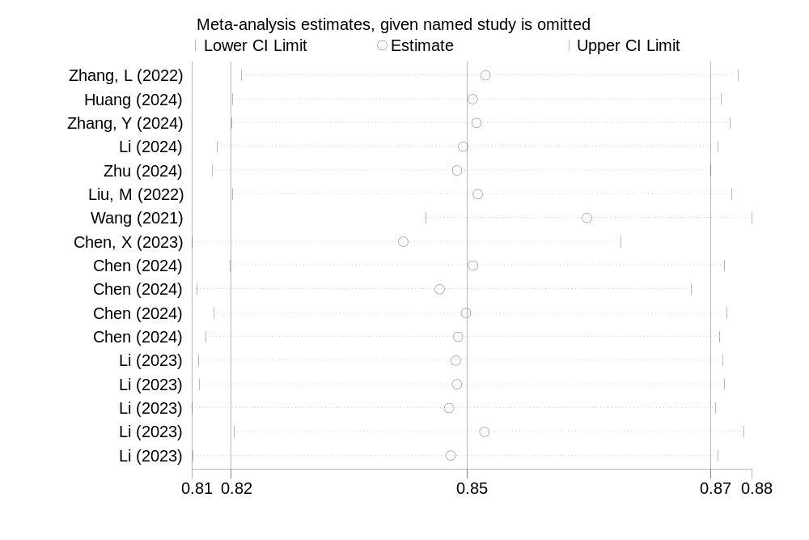
Figure S5: Funnel plot for assessing publication bias

