Table 2 Overview of the comprehensive intervention program (VIVIFRAIL(C)-RT)
Weekly | Reminiscence therapy | Vivifrail multicomponent exercise (C)
Weekly | Reminiscence therapy | endurance training | Strength training | Balance training | Flexibility training
Week1 | (i) Theme introduction: play music, do finger exercises.  (ii) Reviewing the past: The birth era and its characteristics.  (iii) Return to the present: Talking about their life situation in the current era.  (iv) Evaluating the past: The difficulties successfully overcome and the feelings at that time.  (v) Facing the present: Current moments of happiness and how to continue enjoying a beautiful life.  (vi) Summarise the main points: Resilient character in difficult times, the better life of the current era, the sense of happiness that comes through hardships. |   (walking)  2 × 10 min;  1 min rest between sets. | 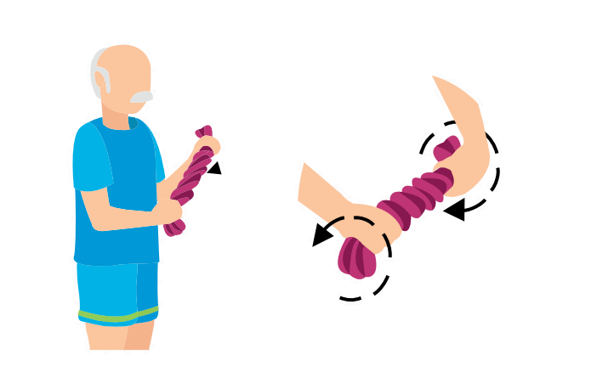  (twisting towels)  3 × 10 times;  1 min rest  between sets.  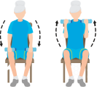  (lifting bottles)  3 × 10 times;  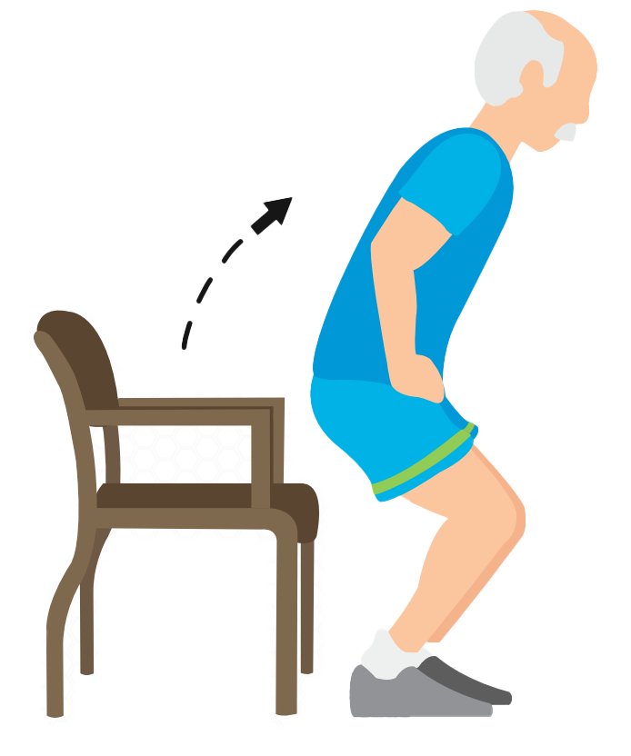  1 min rest between sets.(Single 0.5 kg)  (Stand up and down on chairs)  3 × 10 times;  1 min rest  between sets. |   (walking over obstacles)  8 × 5 steps;  1 min rest between sets  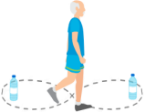  (Walking in figure-eight pattern)  8 × 5 steps;  1 min rest between sets.  (On the square) | 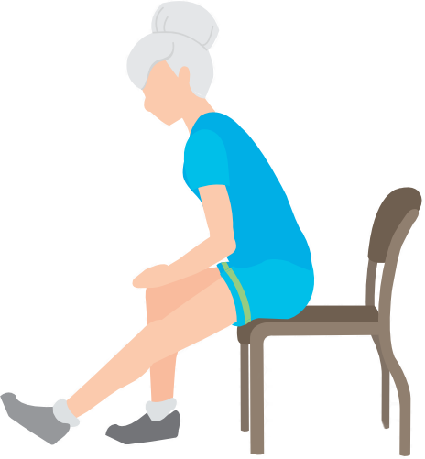  (leg stretches)  3 × 6 times;  1 min rest between sets.    (arm stretches)  3 × 6 times;  1 min rest between sets.  (Hold for 10-12 seconds at a time and rest for 5 seconds)
Week2 | /
Week3 | (i) Theme introduction: play music, do finger exercises, making dumplings.  (ii) Reviewing the past: Memorable festivals as well as the details.  (iii) Return to the present: The characteristics of current festivals with contemporary features.  (iv) Evaluating the past: The biggest feelings during past festivals.  (v) Facing the present: The festivals and events currently most looked forward to.  (vi) Summarise the main points: Family warmth, neighborhood support, solidarity.
Week4 | /
Note: Vivirail multi-component exercise (C) has consistent training intensity and frequency from weeks 1-4, weeks 5-8, and weeks 9-12

Table 2(Appendix) Overview of the comprehensive intervention program (VIVIFRAIL(C)-RT)

Weekly | Reminiscence therapy | Vivifrail multicomponent exercise (C)
Weekly | Reminiscence therapy | endurance training | Strength training | Balance training | Flexibility training
Week5 | (i) Theme introduction: play music, do finger exercises.  (ii) Reviewing the past: The most unforgettable happy moments in childhood.  (iii) Return to the present: Sharing what they are currently happy about.  (iv) Evaluating the past: Summarize the causes for happiness in the past.  (v) Facing the present: Consider how to maintain an optimistic life at present.  (vi) Summarise the main points: Dissect the source of happiness, reinforce the feeling of happiness, and remain hopeful. | (walking)  3 × 10 min;  1 min rest between sets. | (twisting towels)  3 × 12 times;  1 min rest  between sets.  (lifting bottles)  3 × 12 times;  1 min rest between sets.(Single 0.75 kg)  (Stand up and down on chairs)  3 × 12 times;  1 min rest  between sets. | (walking over obstacles)  8 × 5 steps;  1 min rest between sets  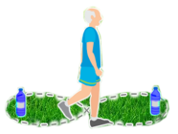  (Walking in figure-eight pattern)  8 × 5 steps;  1 min rest between sets.  (On the square) | (leg stretches)  3 × 8 times;  1 min rest between sets.  (arm stretches)  3 × 8 times;  1 min rest between sets.  (Hold for 10-12 seconds at a time and rest for 5 seconds)
Week6 | /
Week7 | (i) Theme introduction: play music, do finger exercises.  (ii) Reviewing the past: Past hobbies and their characteristics.  (iii) Return to the present: Discuss current hobbies or areas of interest.  (iv) Evaluating the past: The impact that past hobbies had on life or personal development.  (v) Facing the present: The influence of hobbies on later life and how to further develop them.  (vi) Summarise the main points: Tap one's advantages, cultivate love for life, and the significance of hobbies to life in old age.
Week8

Table 2(Appendix) Overview of the comprehensive intervention program (VIVIFRAIL(C)-RT)

Weekly | Reminiscence therapy | Vivifrail multicomponent exercise (C)
Weekly | Reminiscence therapy | endurance training | Strength training | Balance training | Flexibility training
Week9 | (i) Theme introduction: play music, do finger exercises.  (ii) Reviewing the past: The most fulfilling things in one's life.  (iii) Return to the present: Sharing the things that they feel most fulfilled at present.  (iv) Evaluating the past: The efforts they have made while achieving something.  (v) Facing the present: The impact of effort or achievement on the present.  (vi) Summarise the main points: Self-confidence, sense of achievement, their efforts and values, self-affirmation. | (walking)  3 × 15 min;  1 min rest between sets. | (twisting towels)  3 × 15 times;  1 min rest  between sets.  (lifting bottles)  3 × 15 times;  1 min rest between sets.(Single 1.0kg)  (Stand up and down on chairs)  3 × 15 times;  1 min rest  between sets. |   (walking over obstacles)  8 × 5 steps;  1 min rest between sets    (Walking in figure-eight pattern)  8 × 5 steps;  1 min rest between sets.  (On the square) | (leg stretches)  3 × 10 times;  1 min rest between sets.  (arm stretches)  3 × 10 times;  1 min rest between sets.  (Hold for 10-12 seconds at a time and rest for 5 seconds)
Week10 | /
Week11 | (i) Theme introduction: play music, do finger exercises.  (ii) Reviewing the past: Mark important events and people at appropriate places in past stages of the "River of Life".  (iii) Return to the present: Mark what they want to do and look forward to in the future stage of the "River of Life".  (iv) Evaluating the past: Introducing the past part of your life river.  (v) Facing the present: Sharing and transmitting one's regimen and one's expectations and wishes for the future.  (vi) Summarise the main points: self-confidence, the sense of achievement of the struggle, their efforts and value.
Week12 | /

