Supplementary Information

Interface Engineering to Regulate Oxidation Dynamics of Supported Nanoparticles

Shiyuan Chen^{1, 3}, Kai Zhang^{1, 3}, Yuhui Chen¹, Bo Shao¹, Chaobin Zeng², Wentao Yuan¹, Hangsheng Yang¹, Zhongkang Han^{1*}, Ying Jiang^{1*}, Ze Zhang¹ & Yong Wang^{1*}
¹Center of Electron Microscopy and State Key Laboratory of Silicon and Advanced Semiconductor Materials, School of Materials Science and Engineering, Zhejiang University, Hangzhou, 310027, China.
²Hitachi High-Technologies (Shanghai) Co., Ltd, Shanghai, 201203, China.
³These authors contributed equally.
Correspondence Email: hanzk@zju.edu.cn; yjiang0209@zju.edu.cn; yongwang@zju.edu.cn;

Movie. S1 and S2
Supplementary Table 1. The structure and interplanar spacing of Pd, PdO and Pd₂O
Pd (cubic) | PdO (tetragonal) | Pd₂O (cubic)
d_{Pd(111)}=2.2457 Å  d_{Pd(200)}=1.9449 Å | d_{PdO(100)}=3.0200 Å  d_{PdO(002)}=2.6550 Å | d_{Pd2O(110)}=3.0264 Å  d_{Pd2O(111)}=2.4711 Å
d_{Pd(220)}=1.3752 Å | d_{PdO(101)}=2.6251 Å | d_{Pd2O(200)}=2.1400 Å
 | d_{PdO(110)}=2.1354 Å
 | d_{PdO(102)}=1.9940 Å

Supplementary Table 2. The epitaxial mismatch between PdO low-index surfaces and CeO₂ (111) surface (all surface periodicities are unified into orthometric modeling; mismatch=(1-d_{smaller}/d_{bigger})×100%)
Mismatch | CeO₂ (111) d₁=3.88 Å | CeO₂ (111) d₂=6.72 Å
d_{1-PdO(001)}=3.10 Å  d_{2-PdO(001)}=3.10 Å  d_{1-PdO(100)}=3.10 Å  d_{2-PdO(100)}=5.41 Å  d_{1-PdO(110)}=5.41 Å  d_{2-PdO(110)}=4.39 Å  d_{1-PdO(111)}=4.39 Å  d_{2-PdO(111)}=5.83 Å  d_{3-PdO(111)}=4.11 Å  d_{4-PdO(111)}=6.23 Å  d_{1-PdO(101)}=6.23 Å | 20.1%  20.1%  20.1%  28.3%  28.3%  11.6%  11.6%  33.4%  5.60%  37.7%  37.7% | 53.9%  53.9%  53.9%  19.5%  19.5%  34.7%  34.7%  13.2%  38.8%  7.29%  7.29%
d_{2-PdO(101)}=3.10 Å | 20.1% | 53.9%

Supplementary Table 3. The cohesive interfacial energy in different interface system (all surface periodicities are unified into orthometric modeling; slab 1 is the substrate and slab 2 is the loaded layer)
Slab 1 | Slab 2 | interfacial energy (eV/Å²)
CeO₂(100)  CeO₂(100) R45°  CeO₂(100)  CeO₂(100) R45°  CeO₂(100)  CeO₂(100) R45°  CeO₂(100)  CeO₂(100)  CeO₂(100)-Full O  CeO₂(100)-Full O  MgO(100) R45° | Pd(100)  Pd(100)  Pd(110)  Pd(110)  Pd(111)  Pd(111)  PdO(001)  PdO(101)  PdO(001)  PdO(101)  Ni(110) | -0.076522187  -0.071297688  -0.093608573  -0.079873112  -0.077324574  -0.051109087  -0.050358646  -0.032735456  -0.081015621  -0.082257015  -0.024840681
MgO(100) R45° | Ni(111) | 0.007129554
MgO(100) | NiO(110) | -0.009193551
MgO(100) R45° | NiO(110) | -0.057884956
MgO(100) | NiO(111)-Full O | -0.026952707
MgO(100) | NiO(111)-Half O | -0.059671761
MgO(100) R45° | NiO(111)-Full O | -0.050957064
MgO(100) R45° | NiO(111)-Half O | -0.008853368
CeO₂(111) | Pd(100) | -0.063080309
CeO₂(111) R90° | Pd(100) | -0.064084722
CeO₂(111) | Pd(110) | -0.059539828
CeO₂(111) | Pd(111) | -0.058672059
CeO₂(111) R90° | Pd(111) | -0.059734565
CeO₂(111) R90° | PdO(100) | -0.048950027
CeO₂(111) | PdO(001)-Full O | -0.062319055
CeO₂(111) | PdO(001)-Half O | -0.064252301
CeO₂(111) | PdO(001)-Full O R45° | -0.049157622
CeO₂(111) | PdO(001)-Half O R45° | -0.079168143
CeO₂(111) | PdO(101) | -0.04501318
CeO₂(111) R90° | PdO(101) | -0.071266919
CeO₂(100) | PdO(100) | -0.129666628
MgO(100) | NiO(100) | -0.13385027
CeO₂(100) | Ru(001) | -0.1344277654
CeO₂(100) R45° | Ru(001) | -0.1250518085
CeO₂(100) | Ru(100) | -0.1501181809
CeO₂(100) R45° | Ru(100) | -0.1318406539
CeO₂(100) | Ru(110) | -0.1514797351
CeO₂(100) | RuO₂(100) | -0.0592805540
CeO₂(100) R45° | RuO₂(100) | -0.0923283196
CeO₂(100) | RuO₂(101) | -0.0779633336
CeO₂(100) R45° | RuO₂(101) | -0.0852717032

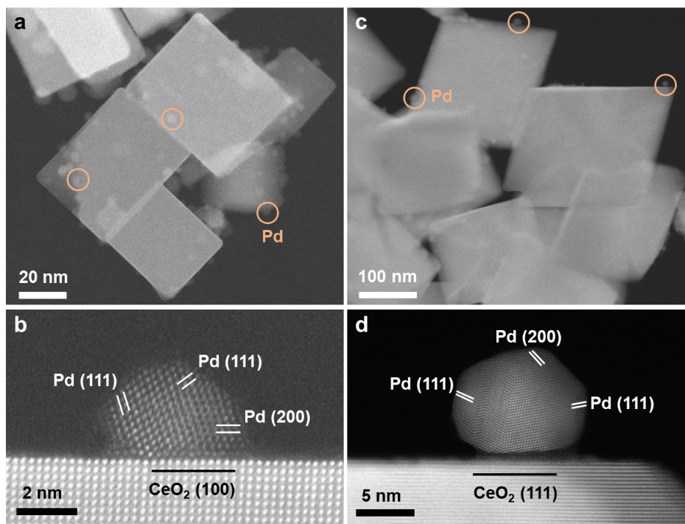
Supplementary Figure 1. Morphology and structure of Pd/CeO₂(100) and Pd/CeO₂(111) catalysts. Low- a, c and high- b, d magnification HAADF-STEM images of Pd/CeO₂(100) and Pd/CeO₂(111) catalysts.

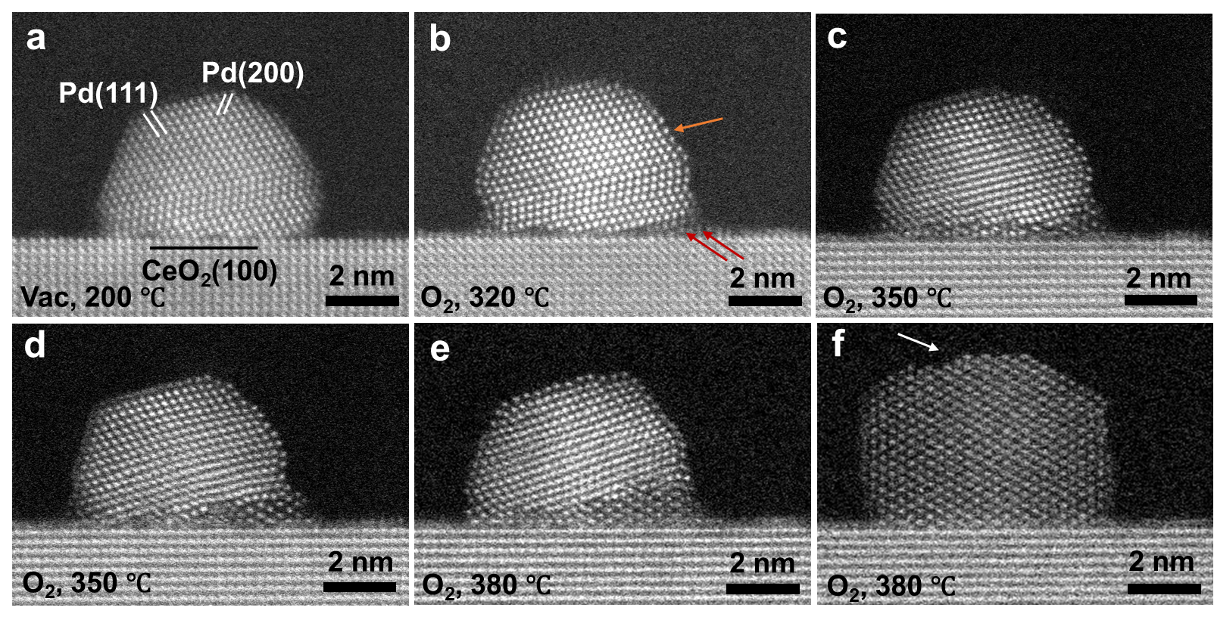
Supplementary Figure 2. In situ oxidation of Pd/CeO₂(100), labeled as P2, in 5 Pa oxygen with increasing temperatures.

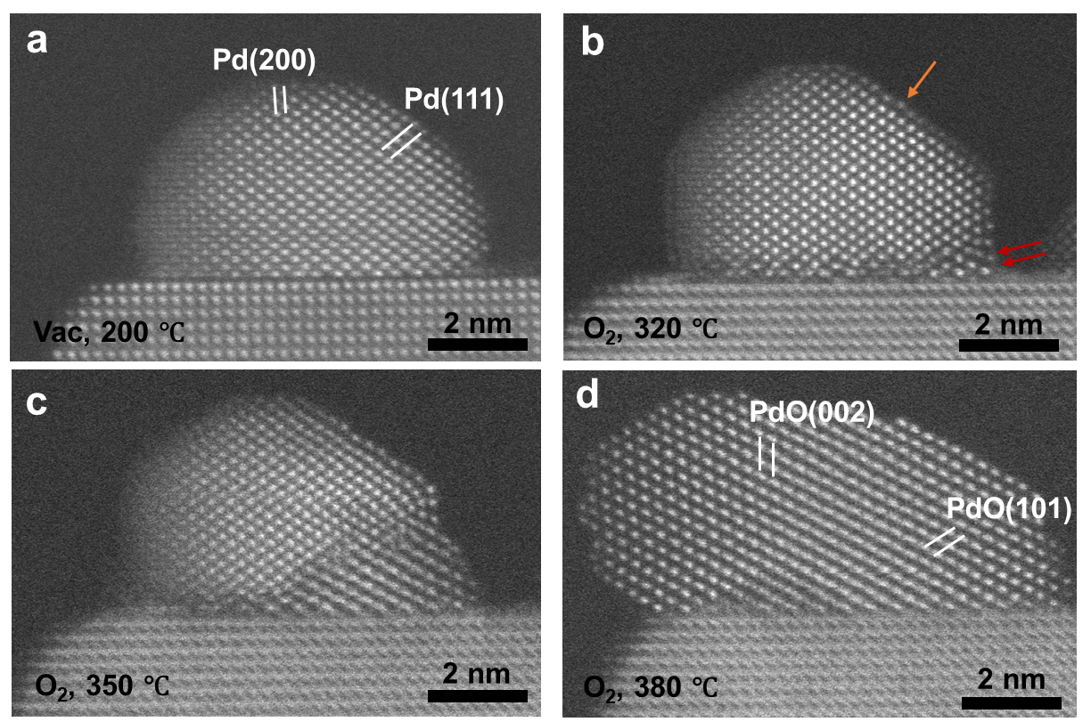
Supplementary Figure 3. In situ oxidation of Pd/CeO₂(100), labeled as P3, in 5 Pa oxygen with increasing temperatures.

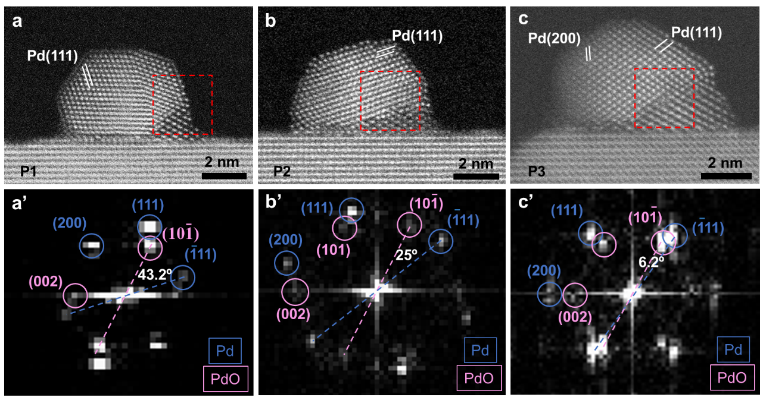
Supplementary Figure 4. Crystallographic relationships between Pd and PdO. a-c HAADF-ESTEM images of the intermediate states during the oxidation of the first NP (P1), second NP (P2) and third NP (P3). a’-c’ FFT patterns obtained from the dashed red squares in (a-c) showing the rotation angles between the Pd(-111) and PdO(10-1) reflections. Blue circles correspond to the Pd patterns and pink to the PdO patterns.

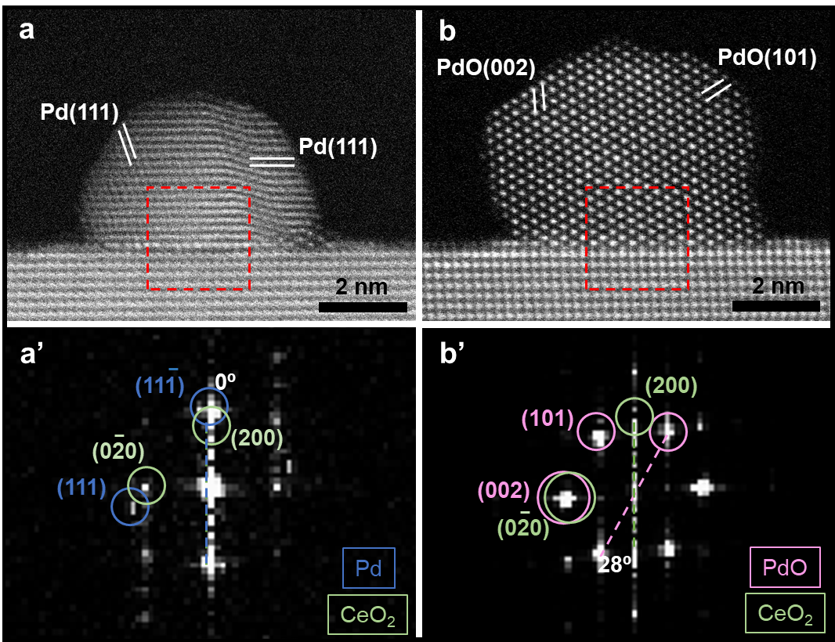
Supplementary Figure 5. Crystallographic relationships between Pd, PdO and CeO₂ in the first nanoparticle (P1). a-b HAADF-ESTEM images of the intermediate and final states during the oxidation of P1. a’-b’ FFT patterns obtained from the dashed red squares in a-b showing the rotation angles between the Pd(-111) and CeO₂(100), as well as PdO(10-1) and CeO₂(100) reflections. Blue circles correspond to the Pd patterns, pink to the PdO patterns, and green to the CeO₂ patterns.

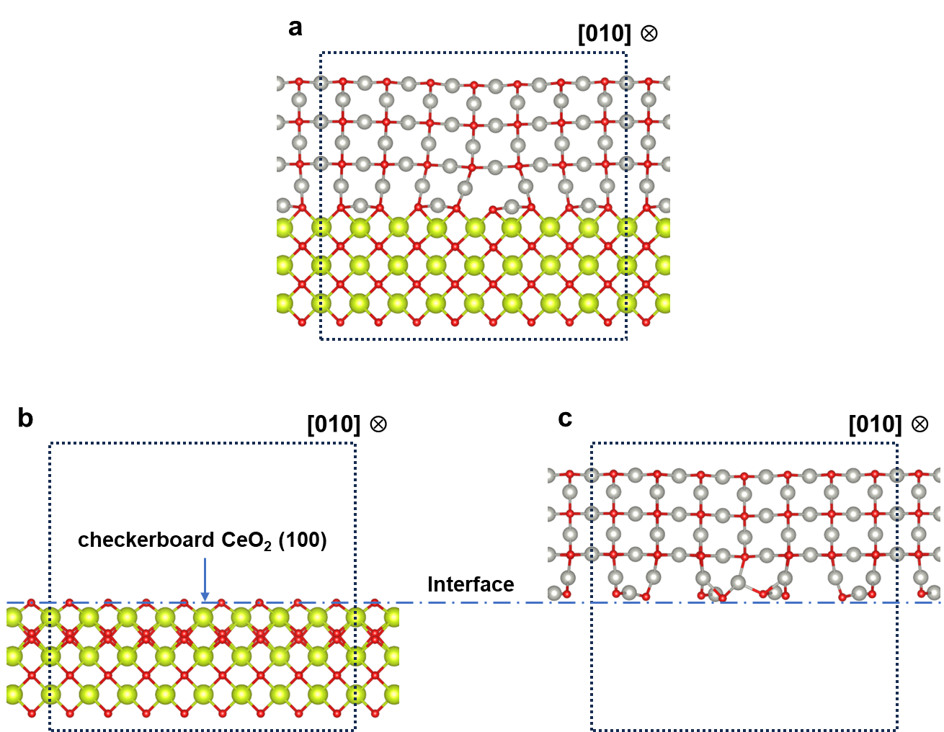
Supplementary Figure 6. The optimized model of calculating binding energy in PdO/CeO₂ (100) structure. a Model of PdO/CeO₂(100) heterojunction structure. b-c Model of isolated CeO₂ and PdO slab (grey balls: Pd atoms; yellow green balls: Ce atoms; red balls: O atoms; blue dashed line square: crystal period).

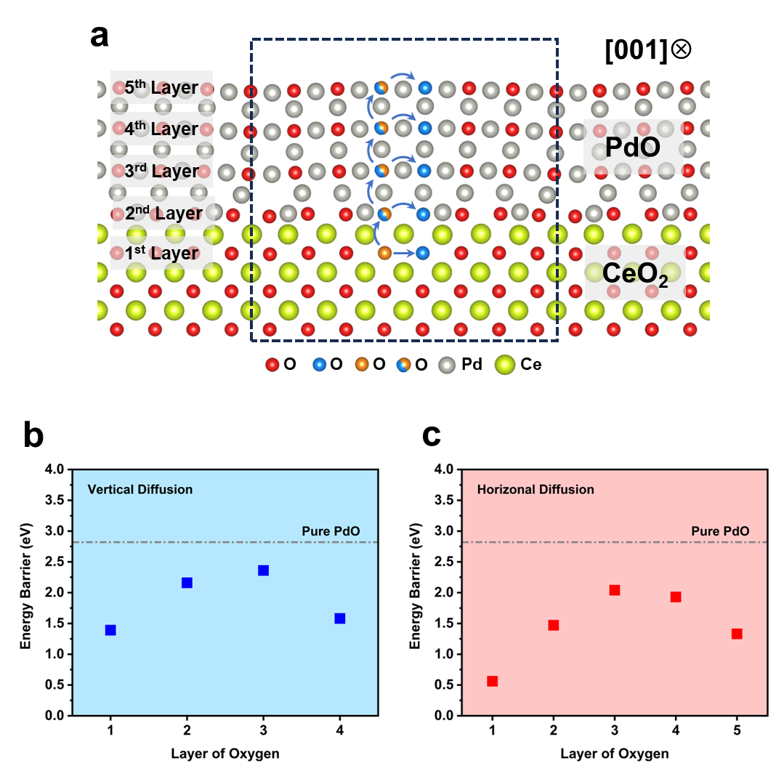
Supplementary Figure 7. Diffusion route and the energy barrier of oxygen in PdO/CeO₂ heterojunction structure. a Diffusion route of O oxygen in heterojunction structure in zone axis of CeO₂ [001] (grey balls: Pd atoms; red balls: O atoms; yellow green balls: Ce atoms; orange balls: O atoms at the start of diffusion; blue balls: O atoms at the end of diffusion). b-c The energy barrier of O diffusion in heterojunction structure with different directions (b: vertical diffusion; c: horizontal diffusion; x-axis: the start layer of oxygen atoms).

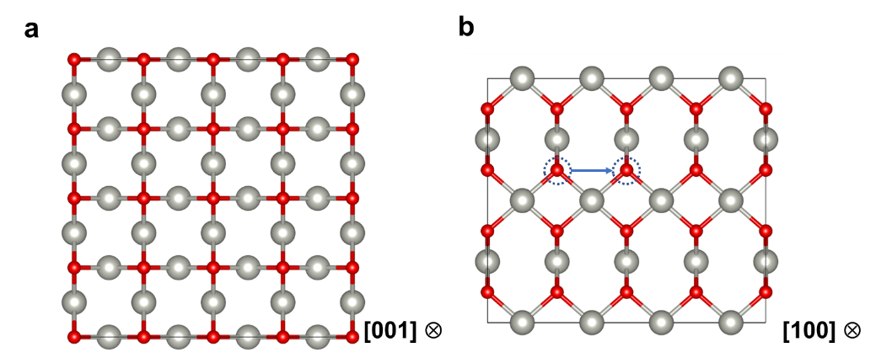
Supplementary Figure 8. Model of bulk PdO. a-b The projected image of the model in two zone axes (grey balls: Pd atoms; red balls: O atoms; dashed blue circles and blue arrow: the position of diffused oxygen atoms and the direction).

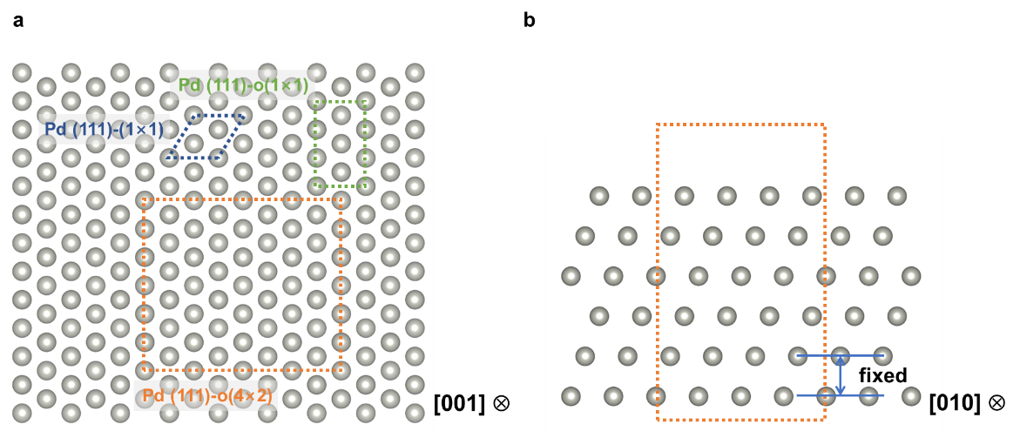
Supplementary Figure 9. Model of pure Pd (111) surface. a The top view of Pd (111) surface model (grey balls: Pd atoms; lattice in different colors: lattice in different crystal period); b the side view of Pd (111) surface model (silver balls: Pd atoms; orange dashed-lined rectangle: crystal period of the model).

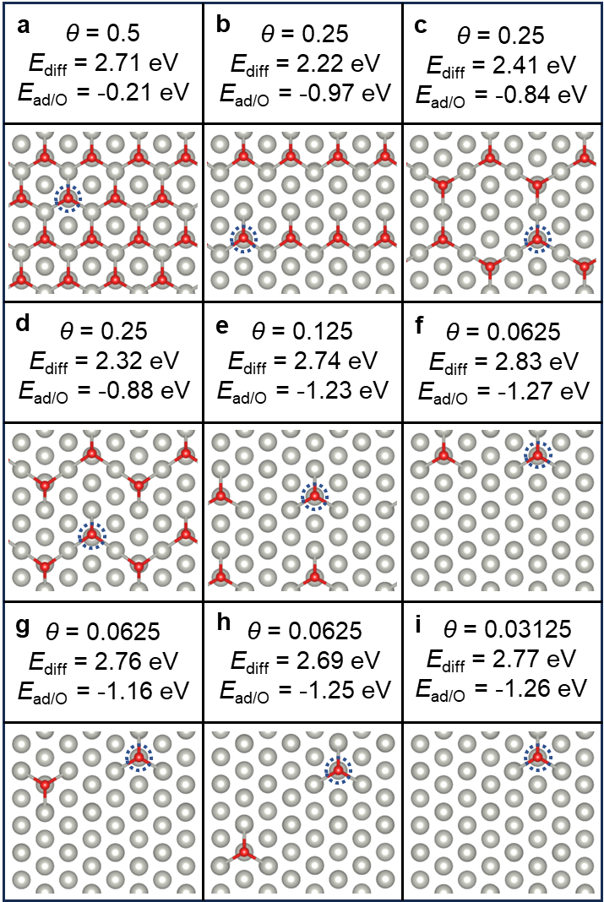
Supplementary Figure 10. The model of Pd (111) surface with adsorbed O atoms and their corresponding calculated energy data (grey balls: Pd atoms; red balls: O atoms; red balls with dashed blue circles: selected O atoms which diffused deeper).

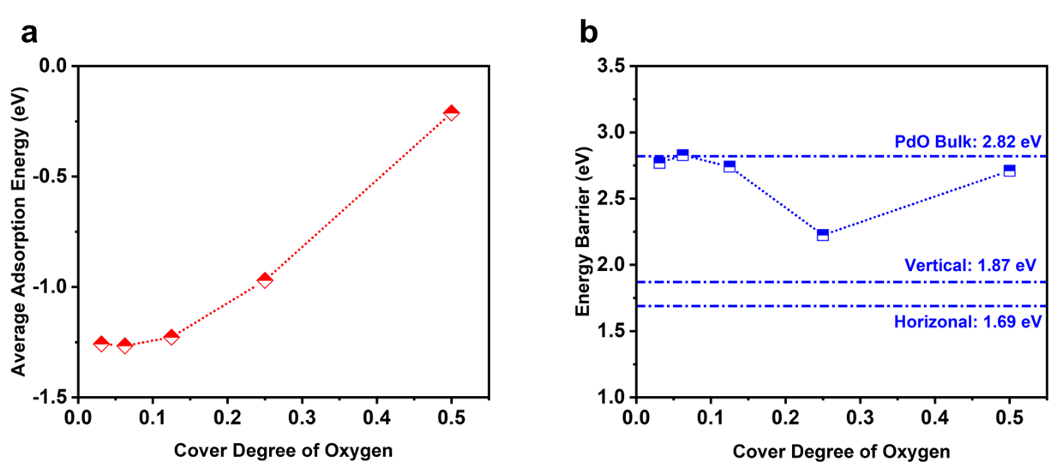
Supplementary Figure 11. The curve of calculated average adsorption energy of oxygen and corresponding energy barrier of oxygen diffusion changed with coverage of oxygen on Pd (111) surface. a Average adsorption energy of oxygen atom. b Diffusion energy barrier of oxygen on the Pd (111) with different oxygen coverage (dashed reference line: diffusion energy barrier in PdO bulk, average vertical and horizonal diffusion energy barrier in PdO/CeO₂ (100) heterostructure).

