Supplementary Materials for
A reduction-secretion system contributes to roxarsone (V) resistance in Brevundimonas sp. M20

Xuehui Zong^{a#}, Minghui Yu^{b#}, Jiahui Wang^{b}, Congcong Li ^{c}, Bing Wang ^{c}, Yongan Wang^{d}*
a, College of Biological and Environmental Engineering, Shandong University of Aeronautics, Binzhou256600, Shandong, China
b, Biomedical Sciences College & Shandong Medicinal Biotechnology Centre, Shandong First Medical University & Shandong Academy of Medical Sciences, Ji’nan 250117, Shandong, China
c, Shandong Quancheng Test & Technology Limited Company, Ji’nan 250101, Shandong, China
d, School of Laboratory Animal & Shandong Laboratory Animal Center, Shandong First Medical University & Shandong Academy of Medical Sciences, Ji’nan 250117, Shandong, China

This PDF file includes:

Supplementary Text
Figures. S1-S3
Tables S1 to S2

Table S1 Bacterial strains and plasmids used in this study
Strains or plasmids | Relevant description | Reference
Strains
Brevundimonas sp. M20 | Arsenic-resistant strain with an ars cluster and a met operon |  | This study
E. coli DH5α | Strain used for gene clone |  | Sangon
E. coli BL21(DE3) | Strain used for protein expression |  | Sangon
Plasmids
pMD18-T | General cloning vector |  | Takara
pET-15b | Plasmid for protein expression and purification |  | This lab

Table S2 Primers used in this study
Primer ID | Primer sequence (5′ →3′)
Pamp-F3 | GGTACCGACGAAAGGGCCTCGTGATAC
Pamp-R3 | GCCCAGATCGGTATCGGTCATACTCTTCCTTTTTCAATATTATTGAAGC
BsNtrA-F3 | GCTTCAATAATATTGAAAAAGGAAGAGTATGACCGATACCGATCTGGGC
BsNtrA-R3 | GATTGTGGAAGATCGTGATGGTCATCTAGAGCTTCCATTCAGTGATGGC
ArsC2-F3 | GCTTCAATAATATTGAAAAAGGAAGAGTATGACCGATACCGATCTGGGC
BsexpA-F3 | GAAAAGGTGCTGGACGTTCTCTAAATGACCTCCCCCCAGTCAG
BsExpA-R3 | TCTAGATCAAGGGGCCTGCGTCGTC
BsExpA-F1 | GCTTCAATAATATTGAAAAAGGAAGAGTATGACCTCCCCCCAGTCAG
ArsC2-F1 | GCTTCAATAATATTGAAAAAGGAAGAGTATGACCGATACCGATCTGGGC
ArsC2-R1 | TCTAGAttagagaacgtccagcaccttttc

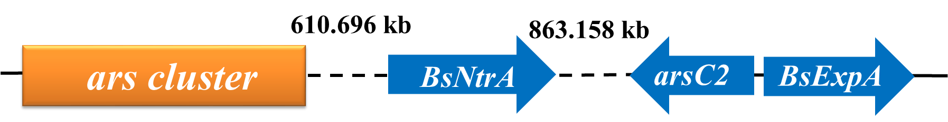

Fig. S1. Linear arrangement of Rox(V) resistance genes in Brevundimonas sp. M20. All block arrows indicate length and orientation. The numbers in each box represent the nucleotide sequence identity. The distance between ars cluster and Rox(V) resistance genes is indicated by the number of base pair.

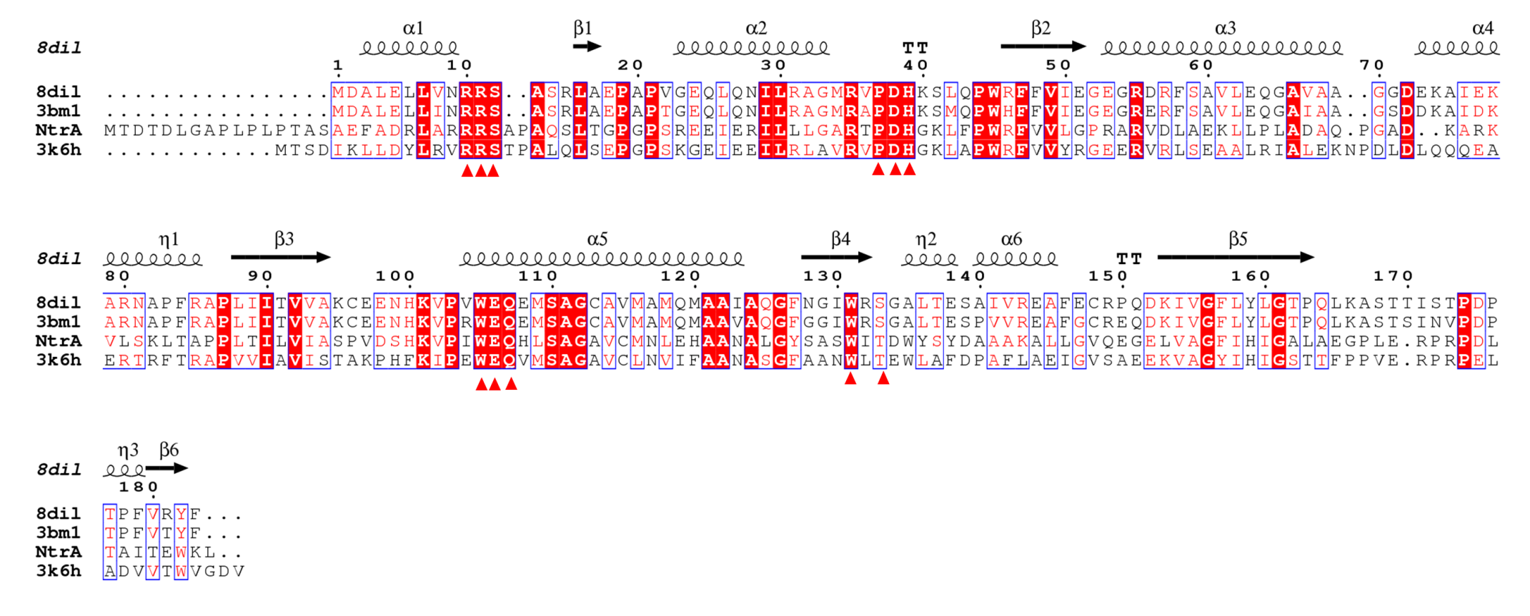

Fig. S2. Alignment of amino acid sequences of BsNtrA. The Red triangles represent the nucleotide sequence identity as FMN binding motif.

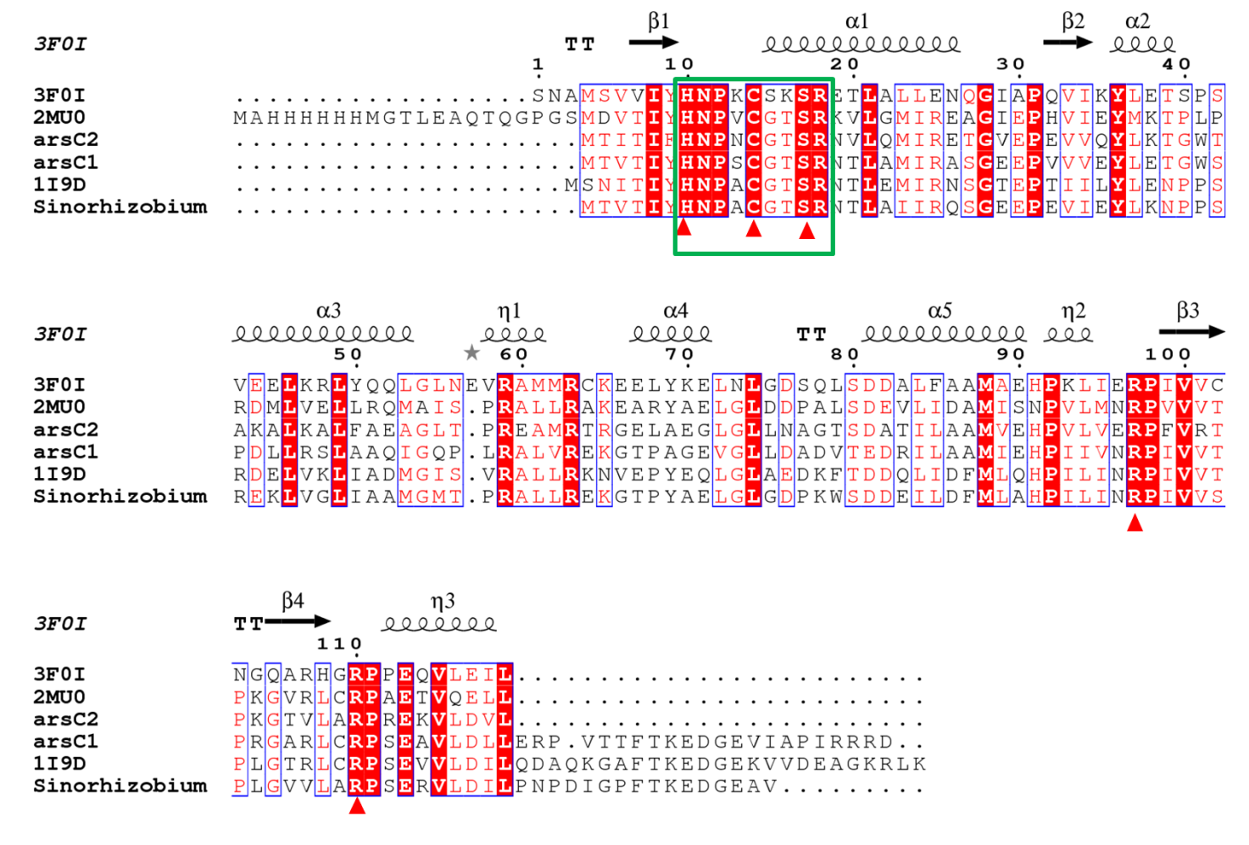
Fig. S3. Alignment of amino acid sequences of ArsC2. The green box represents the catalytic sequence motif. Red triangles represent key residues for reduction.

*Corresponding author: School of Laboratory Animal & Shandong Laboratory Animal Center, Shandong First Medical University & Shandong Academy of Medical Sciences, Ji’nan 250117, Shandong, China Email: wya668@163.com (Y.A. Wang). # Xuehui Zong and Minghui Yu have contributed equally.

