A Comparison of Routine [⁶⁸Ga]Ga-PSMA-11 Preparation using Locametz and Illuccix Kits
Supplementary Information

Author: Ivan E. Wang¹, Luke J. Morrissette², Ka Kit Wong², Allen F. Brooks², Marianna Dakanali,² Peter J. H. Scott^{1,2†}

1. Department of Medicinal Chemistry, College of Pharmacy, University of Michigan, Ann Arbor, MI 48109, USA
2. Department of Radiology University of Michigan, Ann Arbor, MI 48109, USA

†Corresponding Author: Peter J. H. Scott
Department of Radiology, University of Michigan, 2276 Medical Science 1, 1301 Catherine St. Ann Arbor, MI 48109-5610, USA. Email: pjhscott@umich.edu

Contents:
Table S1: Formulation, components of the Locametz and Illuccix kits, and necessary Gallium-68 chloride required to reconstitute kit.
Table S2: Disposable and Non-disposable Items Required for the Production of Locametz
Table S3: Disposable and Non-disposable Items Required for the Production of Illuccix
Table S4: Disposable and Non-disposable Items Required for Quality Control of Locametz or Illuccix

Preparation of TLC Eluent

Figure S1a: rTLC of Fractionation Approach using Locametz, initial
Figure S1b: rTLC of Fractionation Approach using Locametz, 4-hour stability
Figure S2a: rTLC of initial 3.7 GBq generator test using Locametz, initial
Figure S2b: rTLC of initial 3.7 GBq generator test using Locametz, 4-hour stability
Table S1: Formulation, components of the Locametz and Illuccix kits, and necessary Gallium-68 chloride required to reconstitute kit.
 | Locametz (gozetotide, PSMA-11)
 | Component | Use | mass  (μg) | mass (μmol) | volume (mL)
Gallium Generator | Gallium-68 chloride | Radioisotope | 0.00441 | 0.0000252 | -
Gallium Generator | 0.1 M HCl | Diluent | 18230 | 500 | qs 5.0
Ligand Vial (Vial 1) | Gozetotide (PSMA-11) | Ligand | 25 | 0.02640 | -
Ligand Vial (Vial 1) | Gentisic acid | Radioprotectant | 1000 | 6.4885 | -
Ligand Vial (Vial 1) | Sodium acetate trihydrate | Buffer (Acid) | 78000 | 573.2 | -
Ligand Vial (Vial 1) | Sodium Chloride | Formulation / osmolarity adjustment | 40000 | 684.5 | -

 | Illuccix (gozetotide, PSMA-11), Configuration A
 | Component |  | Use | mass  (μg) | mass  (μmol) | volume (mL)
Gallium  Generator | Gallium-68 chloride |  | Radioisotope | 0.00315 | 0.000018 | -
Gallium  Generator | 0.1 M HCl |  | Diluent | 18230 | 500 | qs 5.0
Vial 1 | Gozetotide (PSMA-11) |  | Ligand | 25 | 0.02640 | -
Vial 1 | D-mannose |  | Bulking agent / Stabilizer | 10 | 0.05551 | -
Vial 2A | Sodium acetate (anhydrous) |  | Buffer (Base) | 150000 | 1828.60 | -
Vial 2A | 0.292 M HCl | HCl | Diluent, Buffer (Acid) | 26615.8 | 730 | -
Vial 2A | 0.292 M HCl | SWFI | Diluent, Buffer (Acid) | - | - | qs 2.5
Vial 3 | Sterile Vacuumed Vial |  | Intermediate vial | - | - | -

 | Illuccix (gozetotide, PSMA-11), Configuration B
 | Component |  | Use | mass  (μg) | mass (μmol) | volume (mL)
Gallium Generator | Gallium-68 chloride |  | Radioisotope | 0.00315 | 0.000018 | -
Gallium Generator | 0.1 M HCl |  | Diluent | 4011 | 110 | qs 1.1
Vial 1 | Gozetotide (PSMA-11) |  | Ligand | 25 | 0.02640 | -
Vial 1 | D-mannose |  | Bulking agent / Stabilizer | 10 | 0.05551 | -
Vial 2B | Sodium acetate (anhydrous) |  | Buffer (Base) | 150000 | 1828.60 | -
Vial 2B | 0.175 M HCl | HCl | Diluent, Buffer (Acid) | 40835.2 | 1120 | -
Vial 2B | 0.175 M HCl | SWFI | Diluent, Buffer (Acid) | - | - | qs 6.4
Vial 3 | Sterile Vacuumed Vial |  | Intermediate vial | - | - | -
Generator produced [⁶⁸Ga]GaCl₃ gives specific activity of 102745 GBq/g. In bold are the components of the ⁶⁸Ge/⁶⁸Ga generator eluate which is added/eluted into the dose vial components. The quantity of Gallium-68 chloride is calculated using the maximum allowed activity. The maximum specific activity of [⁶⁸Ga]Ga-PSMA-11 is 64.75 GBq/g for Locametz and 46.25 GBq/g for Illuccix.

Table S2: Disposable and Non-disposable Items Required for the Production of Locametz
Item | Product Description | Product Number | Quantity | Use
Non-disposable Items
E&Z Germanium-68/Gallium-68 Generator | 1.85 GBq or 3.7 GBq E&Z generator | DMF #28741 | 1 | Source of [⁶⁸Ga]GaCl₃ for labeling
Generator Eluent | 0.1 M Ultrapure Sterile Hydrochloric Acid (HCl) | n/a, must use E&Z provided HCl | 6.2 mL | Solution used to elute generator
Lead or Tungsten Shielding | Lead or Tungsten Shielding appropriate for PET isotopes, fitting 10 mL vial | n/a | 2 | Shielding to attenuate ionizing radiation
Scale | Small electronic scale capable of measuring from 0.1 g to 100 g | n/a | 1 | Used to measure volume
Disposable Items
^{PEC}Locametz Kit | Advance Accelerator Applications, Novartis | 69488-017-61 | 1 kit/vial | Formulated Product vial
^{PEC}21 G 2” Needle | Becton Dickinson (BD) Needles, sterile, Green Hub | 305129 | 1 | Needle for sterile vent filter
^{PEC}Silicone coated 18 G 1½” Needle | B. Braun Medical Sterican® Needles, sterile, 1.20x40 mm short bevel, Pink Hub | 4665120 | 1 | Needle for sterile product filter (for [⁶⁸Ga]GaCl₃)
^{PEC}0.2 μm sterile vent filter | Millex®-FG, 25mm diameter, 0.2 μm hydrophobic PTFE membrane, sterile | SLFG025LS | 1 | Sterile filter for displaced gas to exhaust/vent out of the product vial
†^{PEC}0.22 μm sterile product filter | Cathivex®-GV, 25mm diameter, 0.22 μm hydrophilic PVDF membrane, sterile | SLGV0250S | 1 | Sterile filter for [⁶⁸Ga]GaCl₃ into the product vial
10 mL Organic Syringe | Norm-Ject®, 10 mL Luer Lock Tip Syringe, sterile, translucent plunger | NJ-4606728-02 | 1 | Syringe used to pull up generator eluent
†Items marked with this symbol, are not required if following state board of pharmacy/ package insert rules and regulations and not cGMP under a PET manufacturing facility following 21 CFR 212.
Items with a superscript “PEC” will be wiped with 70% isopropyl alcohol into a primary engineered control (PEC) for aseptic assembly of the final dose vial to be dispensed or sent to a radiopharmacy for subsequent dose drawing.
E&Z – Eckart and Ziegler, QC – quality control

Table S3: Disposable and Non-disposable Items Required for the Production of Illuccix
Item | Product Description | Product Number | Quantity | Use
Non-disposable Items
E&Z Germanium-68/Gallium-68 Generator | 1.85 GBq generator or decayed 3.7 GBq generator producing less than 1.85 GBq, E&Z generator | DMF #28741 | 1 | Source of [⁶⁸Ga]GaCl₃ for labeling
Generator Eluent | 0.1 M Ultrapure Sterile Hydrochloric Acid (HCl) | n/a, must use E&Z provided HCl | 6.2 mL | Solution used to elute generator
Lead or Tungsten Shielding | Lead or Tungsten Shielding appropriate for PET isotopes, fitting 10 mL vial | n/a | 2 | Shielding to attenuate ionizing radiation
Scale | Small electronic scale capable of measuring from 0.1 g to 100 g | n/a | 1 | Used to measure volume
Disposable Items
Illuccix Kit | ^{PEC}Telix Pharmaceuticals, Configuration A, Vial 1, Gozetotide vial, blue flip-off cap | 74725-101-25 | 1 vial | Formulated Product vial
Illuccix Kit | ^{PEC}Telix Pharmaceuticals, Configuration A, Vial 2, Acetate Buffer Vial, red flip-off cap | 74725-102-25 | 1 vial, 2.5 mL buffer | Buffer vial required to pH adjust the 0.1 M HCl
Illuccix Kit | Telix Pharmaceuticals, Configuration A, Vial 3, Sterile Vacuumed Reaction Vial, white flip-off-cap | n/a | 0 | Not used in procedure, but included in Illuccix Kit
^{PEC}21 G 2” Needle | Becton Dickinson (BD) Needles, sterile, Green Hub | 305129 | 1 | Needle for sterile vent filter
^{PEC}Silicone coated 18 G 1½” Needle | B. Braun Medical Sterican® Needles, sterile, 1.20x40 mm short bevel, Pink Hub | 4665120 | 2 | Needle for sterile product filter (for [⁶⁸Ga]GaCl₃)
^{PEC}0.2 μm sterile vent filter | Millex®-FG, 25mm diameter, 0.2 μm hydrophobic PTFE membrane, sterile | SLFG025LS | 1 | Sterile filter for displaced gas to exhaust/vent out of the product vial
†^{PEC}0.22 μm sterile product filter | Cathivex®-GV, 25mm diameter, 0.22 μm hydrophilic PVDF membrane, sterile | SLGV0250S | 1 | Sterile filter for [⁶⁸Ga]GaCl₃ into the product vial
10 mL Organic Syringe | Norm-Ject®, 10 mL Luer Lock Tip Syringe, sterile, translucent plunger | NJ-4606728-02 | 1 | Syringe used to pull up generator eluent
^{PEC}5 mL Organic Syringe | Norm-Ject®, 5 mL Luer Lock Tip Syringe, sterile, translucent plunger | NJ-4606710-02 | 1 | Syringe used to pull up buffer from Vial 2
†Items marked with this symbol, are not required if following state board of pharmacy/ package insert rules and regulations and not cGMP under a PET manufacturing facility following 21 CFR 212.
Items with a superscript “PEC” will be wiped with 70% isopropyl alcohol into a primary engineered control (PEC) for aseptic assembly of the final dose vial to be dispensed or sent to a radiopharmacy for subsequent dose drawing.
E&Z – Eckart and Ziegler, QC – quality control

Table S4: Disposable and Non-disposable Items Required for Quality Control of Locametz or Illuccix
Item | Product Description | Product Number | Quantity | Use
Non-disposable Items
Lead or Tungsten Shielding | Lead or Tungsten Shielding appropriate for PET isotopes, fitting 3 mL vial | n/a | 1 | Shielding to attenuate ionizing radiation
Dose Calibrator | Capintec CRC-15r, calibration code 416 | n/a | 1 | Activity Reading
TLC Chamber | Glass chamber or battery jar with lid, minimum 8 cm tall | n/a | 2 | Used to develop TLC plates and jar for filter integrity test
†TLC Plate Reader | BioScan AR200,  Model B-AR-2000-1 | n/a | 1 | Radiochemical purity analysis, reader of TLC plates
†Endosafe Endotoxin Reader | Charles River Laboratories, Endosafe® nexgen-PTSTM, Model PTS150 | ASM-00019 | 1 | Bacterial Endotoxin Test (BET)
†Vortex Mixer | Any vortex mixer will work | n/a | 1 | Used to mix sample for endotoxin
Multi-Channel Analyzer | Canberra MCA,  Model 727 | n/a | 1 | Radionuclidic Purity analysis
Disposable Items
†Used 0.22 μm sterile product filter | Cathivex®-GV, 25mm diameter, 0.22 μm hydrophilic PVDF membrane, sterile | SLGV0250S | 1 | Used filter from production used to determine filter integrity
Silicone coated 18 G 1½” Needle | B. Braun Medical Sterican® Needles, sterile, 1.20x40 mm short bevel, Pink Hub | 4665120 | 1 | Needle to pull up QC aliquot from dose vial
1 mL Organic Syringe | Norm-Ject®, 1 mL Luer Slip Tip Syringe, sterile, translucent plunger | NJ-9166017-02 | 1 | Syringe used to pull up QC sample
HPLC Vial | Chromacol,  300 μL fixed insert vial, 9 mm screw top | 03-FISV | 1 vial, ~ 0.1 mL sample | Vial used to hold QC sample
HPLC Vial Cap | SureStartTM, screw 9 mm yellow cap, white silicone, blue PTFE septa slit 1 mm | 6PSC9STS1Y | 1 cap | Vial cap for HPLC vial
TLC Plates | Agilent Technologies,  Glass microfiber chromatography paper impregnated with silica acid, 7 cm tall, spot sample 1 cm from bottom and develop to 1 cm from top | A120B12 | 2 plates, 1 μL sample/ plate | Used to analyze radiochemical purity
TLC Solution | 1:1 (1M) Ammonia Acetate (aqueous): methanol | n/a | ~ 6 mL | Solution used to develop TLC plates
pH indicator strips | Supelco, MQuant, non-bleeding, colorimetric pH indicator strips from 2.5 to 4.5 in 0.3 intervals | 109541 | 1 strip, 17.5 μL sample | pH indicator test
†Endosafe PTS Cartridge | Charles River Laboratories, The Endosafe®-PTS | PTS20F | 1, 1:300 dilution | Cartridge used to load samples
†8 mL Round-Bottom falcon tube | Falcon, 8 mL Polystyrene Round-Bottom Tube, 13x100 mm | 352027 | 1 | Used to hold sample in LAL water
†LAL reagent water | Charles River Laboratories,  Endosafe® LAL reagent water | W110 | 3.9 mL, 17.5 μL sample | Used to dilute sample to load into Endosafe cartridge
†Tryptic Soy Broth (TSB) | Tryptic Soy Broth  Acc EP+USP 3080r-100p | 1464320100 | 1 tube (9 mL), 250 μL sample | Used for sterility monitoring
†Fluid Thioglycollate Medium (FTM) | Thioglycollate Med.  Acc EP 2171r-100p | 1462200100 | 1 tube (9 mL), 250 μL sample | Used for sterility monitoring
†Items marked with this symbol, are not required if following state board of pharmacy/ package insert rules and regulations and not cGMP under a PET manufacturing facility.
LAL – Limulus amoebocyte lysate, QC- quality control, rTLC – (radio) thin layer chromatography

Preparation of TLC Eluent

To make a 1 L batch of the TLC solution (1:1 (1 M) ammonium acetate solution (aqueous): methanol), 38.54 g of ammonium acetate is added into a clean 1 L bottle. 500 mL of Milli-Q water is added into the bottle and swirled until the ammonium acetate is dissolved. 500 mL of methanol is then added into the 1 L bottle and the bottle is inverted to fully homogenize the solution.

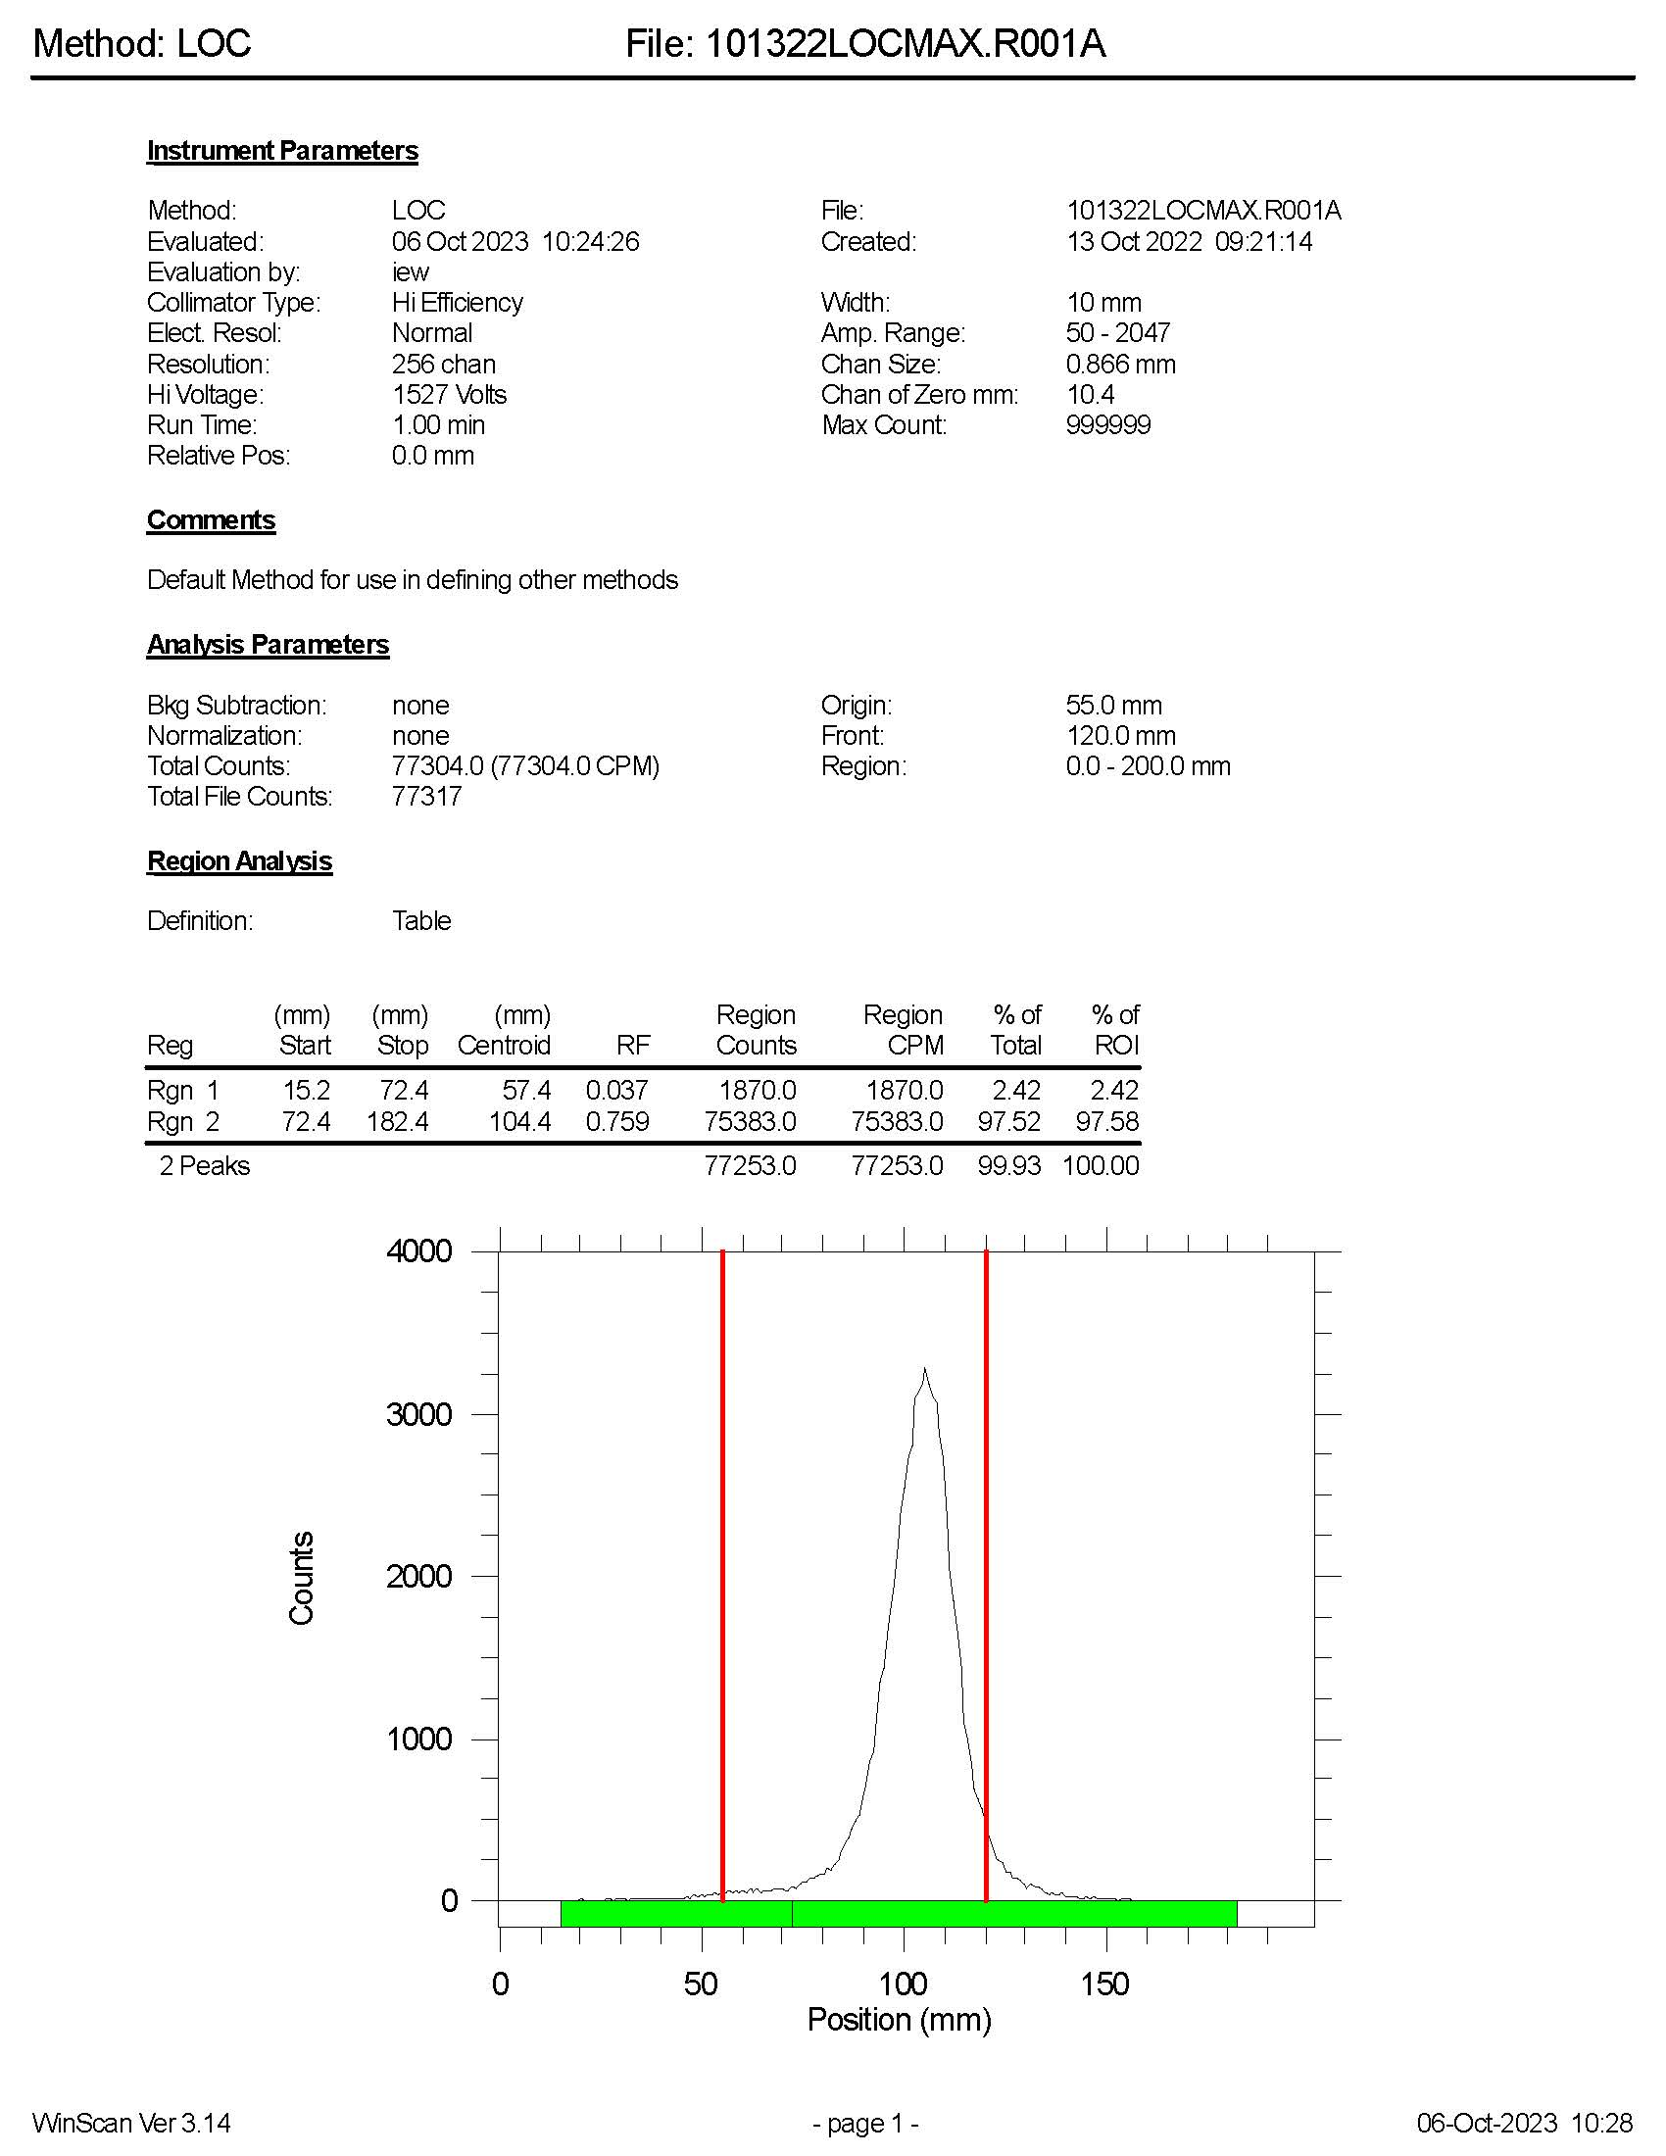
Figure S1a: rTLC of Fractionation Approach using Locametz, initial
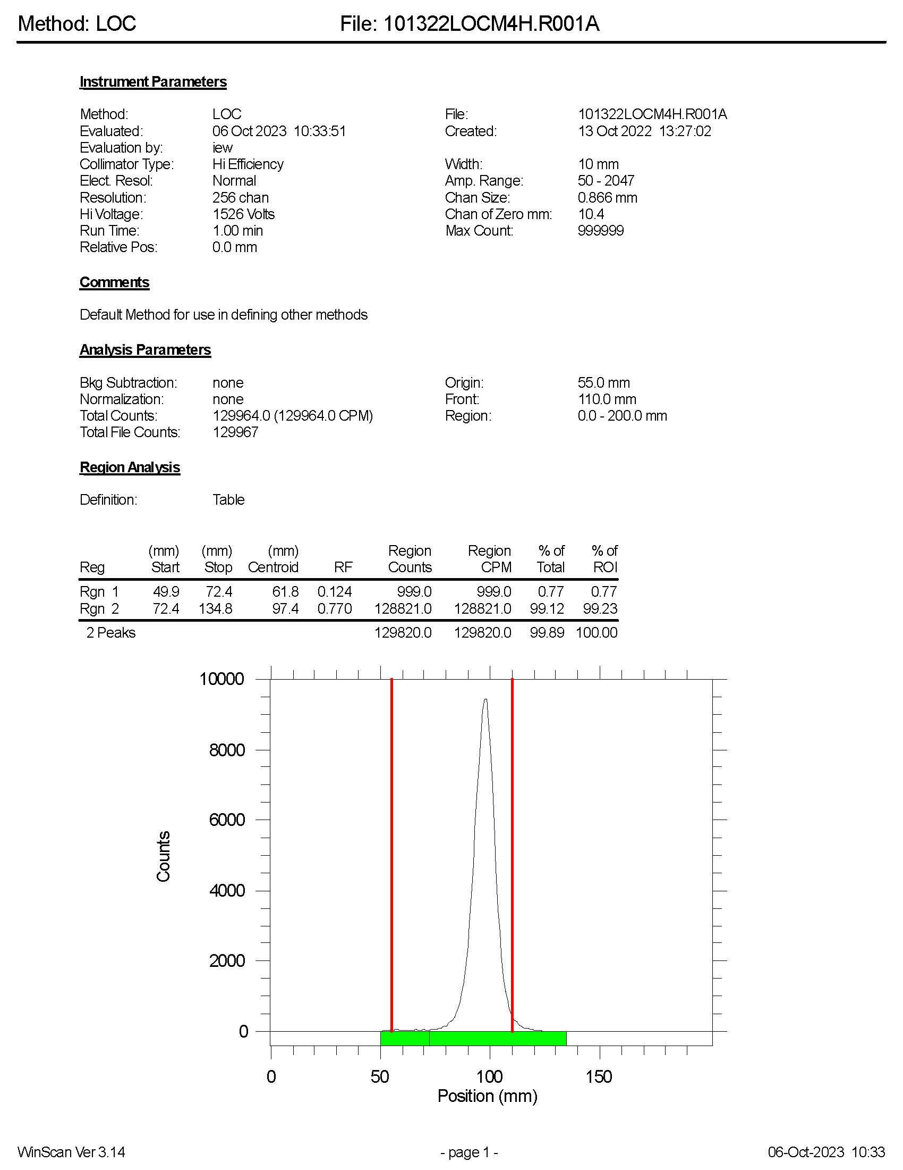
Figure S1b: rTLC of Fractionation Approach using Locametz, 4-hour stability
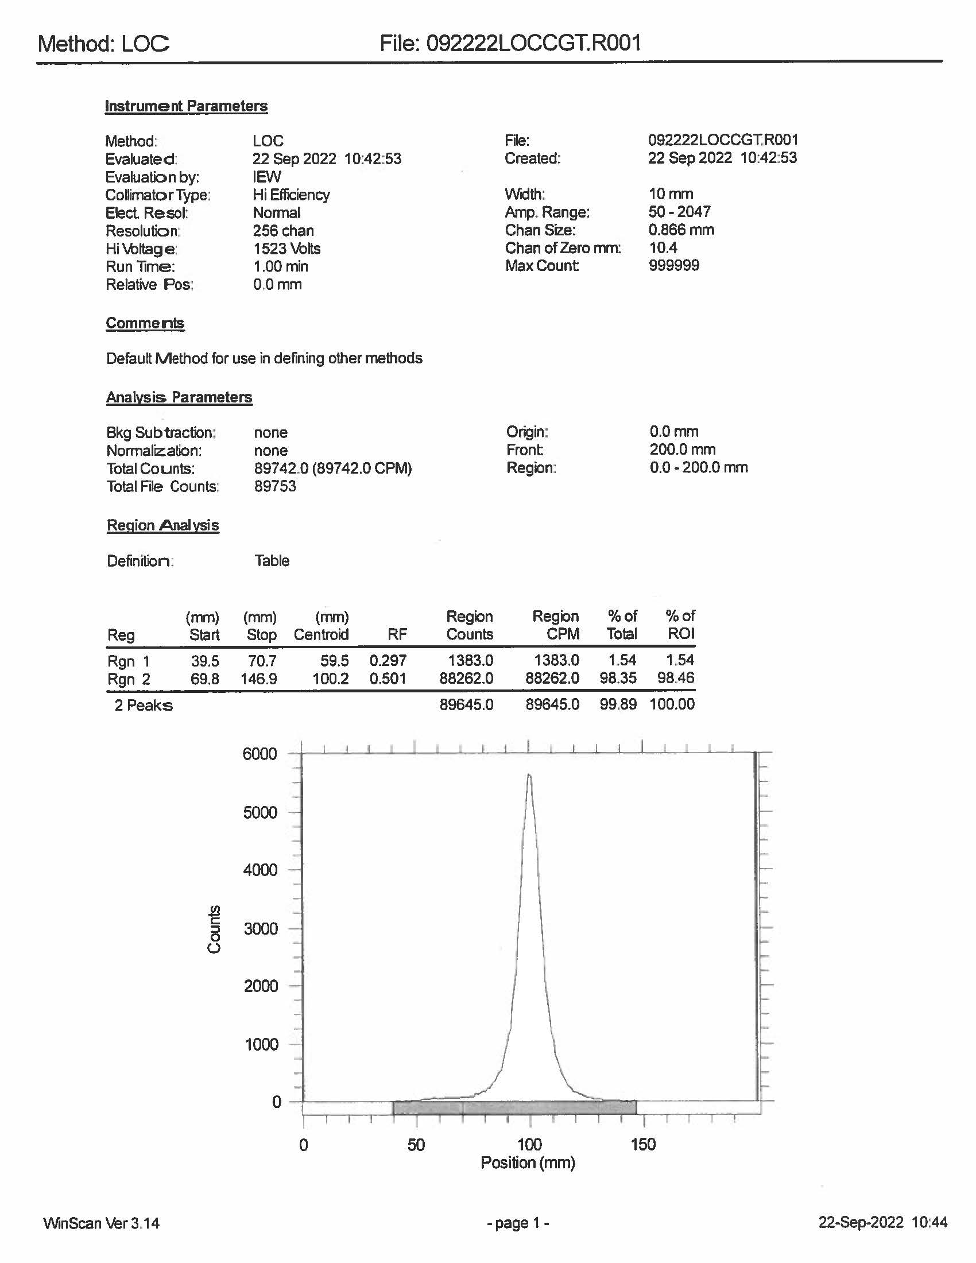
Figure S2a: rTLC of initial 3.7 GBq generator test using Locametz, initial
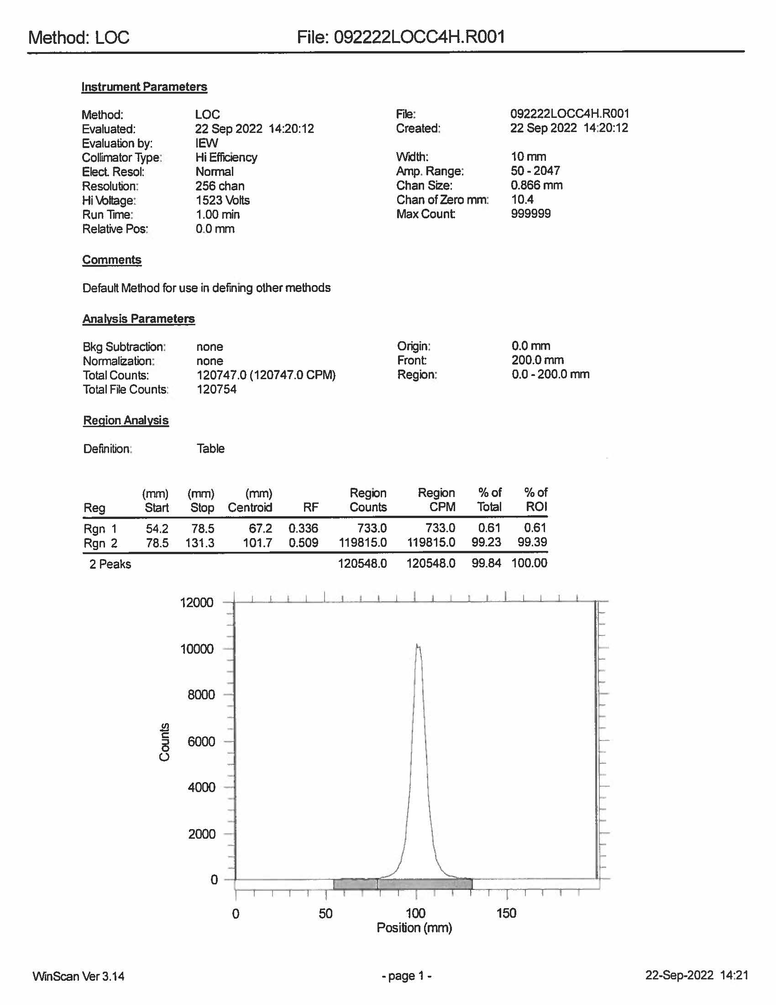
Figure S2b: rTLC of initial 3.7 GBq generator test using Locametz, 4-hour stability

