Online Resources

Online Resource 1. Word clouds regarding “Culture of Family Medicine” as reported by: A) MS1 students; B) MS3 students in the Family Medicine clerkship.

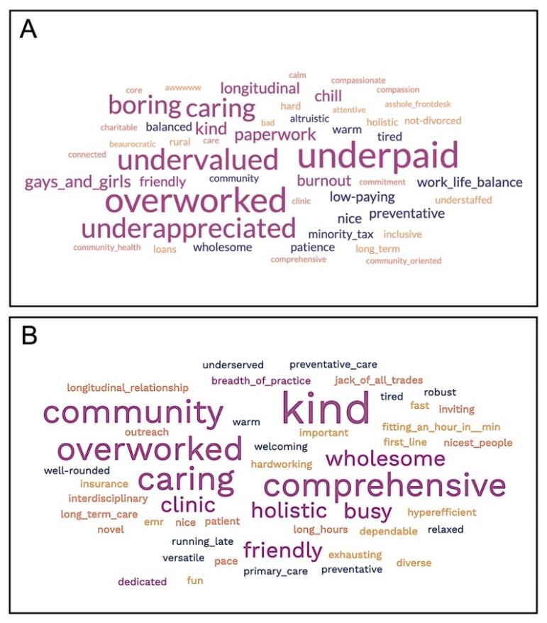

Online Resource 2. Top 5 most frequent words associated with “Culture of Family Medicine” and relative frequency among unique words submitted by MS1 and MS3 students.

MS1  SOM  Orientation | MS3  Family Medicine  Clerkship
Underpaid  (16.3) | Kind  (11.8)
Overworked  (15.4) | Comprehensive  (8.8)
Undervalued  (12.5) | Community  (8.8)
Underappreciated  (11.5) | Caring  (8.8)
Boring  (10.6) | Overworked  (8.8)

