Supplementary material
Vascular plant diversity and forest structure along an elevation gradient in a threatened Equatorial Pacific low montane cloud forest
Sari Roponenª, Alejandra Moscoso^{b}, Selene Báez^{b}, and Bertil Ståhl^{c}

Appendix 1. List of tree species found at Cerro Samama.
FAMILY | TAXA
Annonaceae | Annona cherimolioides Tr. & Pl.
Annonaceae | Annona conica Ruiz & Pav. ex G. Don
Annonaceae | Annona mucosa Jacq.
Annonaceae | Guatteria microcarpa R. & P. ex G. Don
Apocynaceae | Lacmellea speciosa Woodson
Araliaceae | Dendropanax caucanus (Harms) Harms
Araliaceae | Dendropanax arboreus (L.) Decne. & Planch.
Arecaceae | Attalea colenda (O.F. Cook) Balslev & A.J. Hend
Arecaceae | Bactris setulosa H. Karst.
Arecaceae | Pholidostachys occidentalis Henderson
Arecaceae | Phytelephas aequatorialis Spruce
Arecaceae | Prestoea ensiformis (R. & P.) H.E. Moore
Bignoniaceae | Tabebuia chrysantha (Jacq.) Nichols.
Caparaceae | Capparidastrum bonifazianum (Cornejo & Iltis) Cornejo & Iltis
Eleocarpaceae | Sloanea guianensis subsp. stipitata (Spruce ex Benth.) T.D. Penn.
Erythroxylaceae | Erythroxylum squamatum Sw.
Fabaceae | Abarema ganymedea Barneby & Grimes
Fabaceae | Brownea coccinea Jacq.
Fabaceae | Browneopsis disepala (Little) Klitgaard
Fabaceae | Dussia lehmannii Harms
Fabaceae | Erythrina megistophylla Diels
Fabaceae | Erythrina poeppigiana (Walp.) O.F. Cook
Fabaceae | Erythrina schimpffii Diels
Fabaceae | Erythrina smithiana Krukoff
Fabaceae | Inga carinata T.D. Penn.
Fabaceae | Inga coruscans Humb. & Bonpl.
Fabaceae | Inga edulis Mart.
Fabaceae | Inga lopadadenia Harms.
Fabaceae | Inga multicaulis Spruce ex Benth.
Fabaceae | Inga nobilis subsp. nobilis Willd.
Fabaceae | Inga oerstediana Benth. ex Seem.
Fabaceae | Inga pezizifera Benth.
Fabaceae | Inga punctata Willd.
Fabaceae | Inga silanchensis T. D. Penn.
Fabaceae | Inga vera Willd.
Fabaceae | Ormosia macrocalyx Ducke
Fabaceae | Senna reticulata (Willd.) H.S. Irwin & Barneby
Fabaceae | Senna scandens (R. & P. ex G. Don) H.S. Irwin & Barneby
Fabaceae | Senna dariensis (Britton & Rose) H.S. Irwin & Barneby
Fabaceae | Senna occidentalis (L.) Link
Fabaceae | Senna spectabilis (DC.) H.S. Irwin & Barneby
Fabaceae | Swartzia haughtii R.S. Cowan
Fabaceae | Zygia nubigena Ståhl, L.Rico & G.P.Lewis
Icacinaceae | Calatola costaricensis Standl.
Icacinaceae | Citronella melliodora (Sleumer) R.A. Howard
Lamiaceae | Aegiphila alba Moldenke
Lamiaceae | Vitex gigantea Kunth
Lauraceae | Beilschmiedia costaricensis (Mez & Pittier) C.K. Allen
Lauraceae | Nectandra acutifolia (Ruiz & Pavon) Mez
Lauraceae | Ocotea cernua (Nees) Mez
Lauraceae | Ocotea insularis (Meissner) Mez
Lauraceae | Ocotea pacifica van der Werff
Lauraceae | Ocotea sodiroana Mez
Lauraceae | Ocotea whitei Woodson
Lauraceae | Pleurothyrium obscurinerve van der Werff
Lecythidaceae | Eschweilera caudiculata R. Knuth
Lecythidaceae | Eschweilera rimbachii Standl.
Lecythidaceae | Grias ecuadorica Cornejo & Mori
Lecythidaceae | Grias peruviana Miers
Lecythidaceae | Gustavia angustifolia Benth.
Lecythidaceae | Gustavia dodsonii Mori
Lecythidaceae | Gustavia pubescens R. & P. ex Berg
Lecythidaceae | Gustavia serrata Mori
Malvaceae | Matisia giacomettoi Romero
Malvaceae | Matisia palenquiana (A. Robyns) W.S. Alverson
Malvaceae | Ochroma lagopus Sw.
Malvaceae | Pachira patinoi (Dugand & A. Robyns) Fern. Alonso
Malvaceae | Psudobombax millei (Standl.) A. Robyns
Malvaceae | Quararibea grandifolia (Little) Cuatrec.
Melastomataceae | Conostegia cuatrecasii Gleason
Melastomataceae | Conostegia subcrustulata (Beurl.) Triana
Melastomataceae | Conostegia centronioides Markgraf
Meliaceae | Cedrela odorata L.
Meliaceae | Guarea glabra Vahl.
Meliaceae | Guarea kunthiana A. Juss.
Meliaceae | Guarea macrophylla subsp. pendulispica (C. DC.) T.D. Penn.
Meliaceae | Ruagea glabra Tr. & Pl.
Meliaceae | Trichilia elegans A. Juss.
Meliaceae | Trichilia martiana C. DC.
Meliaceae | Trichilia pallida Sw.
Moraceae | Castilla elastica subsp. gummifera (Miq.) C.C. Berg
Moraceae | Ficus apollinaris Dugand
Moraceae | Ficus brevibracteata W.C. Burger
Moraceae | Ficus caldasiana Dugand
Moraceae | Ficus calimana Dugand
Moraceae | Ficus carchiana C.C. Berg
Moraceae | Ficus cervantesiana Standl.
Moraceae | Ficus citrifolia Mill.
Moraceae | Ficus cotopaxiensis C.C. Berg
Moraceae | Ficus cuatrecasiana Dugand
Moraceae | Ficus macbridei Standl.
Moraceae | Ficus maxima Mill.
Moraceae | Ficus mutisii Dugand
Moraceae | Ficus obtusifolia Kunth
Moraceae | Ficus tonduzii Standl.
Moraceae | Helicostylis tovarensis (Kl. & Karst.) C.C. Berg
Moraceae | Maquira guianensis subsp. costaricana (Standl.) C.C. Berg
Moraceae | Poulsenia armata (Miq.) Standl.
Moraceae | Pseudolmedia rigida subsp. eggerssii (Standl.) C.C. Berg
Moraceae | Sorocea sarcocarpa Lanj. & Wessels Boer
Moraceae | Sorocea trophoides W.C. Burger
Myristicaceae | Otoba novogranatensis Moldenke
Myristicaceae | Virola sebifera Aubl.
Myrtaceae | Eugenia oerstediana O. Berg
Polygonaceae | Coccoloba peruviana Lindau
Polygonaceae | Coccoloba mollis Casaretto
Polygonaceae | Coccoloba obovata Kunth
Polygonaceae | Triplaris cumingiana Fischer & Meyer ex C.A. Meyer
Proteaceae | Panopsis megistosperma C. Bonifaz & Cornejo
Rubiaceae | Cinchona pubescens Vahl
Rubiaceae | Genipa americana L.
Rubiaceae | Ladenbergia pavonii (Lambert) Standl.
Rubiaceae | Pentagonia orthoneura Standl.
Rubiaceae | Pentagonia sprucei Standl.
Rubiaceae | Posoqueria latifolia (Rudge) Schult.
Rubiaceae | Psychotria gentryi (Dwyer) C.M. Taylor
Rubiaceae | Randia carlosiana K. Krause
Salicaceae | Hasseltia floribunda Kunth
Salicaceae | Neosprucea pedicellata Little
Sapotaceae | Chrysophyllum argenteum Jacq. subsp. panamense (Pittier) T.D. Penn.
Sapotaceae | Chrysophyllum venezuelanense (Pierre) T.D. Penn.
Siparunaceae | Siparuna croatii Renner & Hausner
Siparunaceae | Siparuna lepidota (Kunth) A. DC.
Theophrastaceae | Clavija eggersiana Mez
Urticaceae | Cecropia litoralis Snethl.
Urticaceae | Cecropia obtusifolia Bertol.
Urticaceae | Cecropia reticulata Cuatr.
Urticaceae | Cecropia angustifolia Trécul.
Urticaceae | Coussapoa contorta Cuatr.
Urticaceae | Coussapoa herthae Mildbr.
Urticaceae | Coussapoa villosa P. & E.
Urticaceae | Pourouma bicolor subsp. scobina (Benoist) C.C. Berg & van Heusden
Urticaceae | Trema integerrima (Beurl.) Standl.
Zamiaceae | Zamia lindenii Regel ex André

Appendix 2. List of non-tree species found at Cerro Samama.
FAMILY | TAXA | FUNCTIONAL GROUP
Aspleniaceae | Asplenium auriculatum Sw. | Epiphytic fern
Aspleniaceae | Asplenium purpurascens Mett. ex Kuhn | Herbaceous fern
Aspleniaceae | Asplenium hallii Hook. | Epiphytic fern
Aspleniaceae | Asplenium hastatum Kl. ex Kunze | Epiphytic fern
Aspleniaceae | Asplenium holophlebium Baker | Epiphytic fern
Aspleniaceae | Asplenium junglandifolium Lam. | Epiphytic fern
Aspleniaceae | Asplenium kunzeanum Kl. ex. Rosenst. | Epiphytic fern
Aspleniaceae | Asplenium pteropus Kaulf. | Epiphytic fern
Aspleniaceae | Asplenium volubile Murakami & R.C. Moran | Epiphytic fern
Cyatheaceae | Cyathea multiflora J.E. Sm. | Herbaceous fern
Dennstaedtiaceae | Saccoloma inaequale (Kuntze.) Mett | Herbaceous fern
Dryopteridaceae | Didymochlaena truncatula (Sw,) J. Sm. | Herbaceous fern
Dryopteridaceae | Diplazium cf. centripetale (Baker) Maxon | Herbaceous fern
Dryopteridaceae | Diplazium cristatum (Desr.) Alston | Herbaceous fern
Dryopteridaceae | Diplazium rivale (Baker) Diels | Herbaceous fern
Dryopteridaceae | Diplazium sp. | Herbaceous fern
Dryopteridaceae | Diplazium striastrum (L.) Presl | Herbaceous fern
Dryopteridaceae | Elaphoglossum ciliatum (C. Presl) T. Moore | Epiphytic fern
Dryopteridaceae | Elaphoglossum cuspidatum (Willd.) T. Moore | Epiphytic fern
Dryopteridaceae | Elaphoglossum omissum Mickel | Epiphytic fern
Dryopteridaceae | Elaphoglossum pygmaeum (Mett. ex Kuhn) H. Christ. | Epiphytic fern
Dryopteridaceae | Lomariopsis japurensis (Mart.) J. Sm | Hemi-Epiphyte fern
Dryopteridaceae | Megalastrum sp. 1 | Herbaceous fern
Dryopteridaceae | Megalastrum sp. 2 | Herbaceous fern
Dryopteridaceae | Microgramma fuscopunctata (Hook.) Vareschi | Epiphytic fern
Dryopteridaceae | Microgramma lycopodioides (L.) Copel. | Epiphytic fern
Dryopteridaceae | Microgramma reptans (Cav.) A.R. Sm. | Epiphytic fern
Dryopteridaceae | Polybotrya osmundacea Willd. | Hemi-Epiphyte fern
Dryopteridaceae | Polybotrya sp. | Hemi-Epiphyte fern
Dryopteridaceae | Tectaria cf. draconoptera (D.C. Eaton) Copel. | Herbaceous fern
Hymenophyllaceae | Trichomanes diaphanum Kunth | Epiphytic fern
Hymenophyllaceae | Trichomanes kraussii Hook. & Grev. | Epiphytic fern
Hymenophyllaceae | Trichomanes radicans Sw. | Epiphytic fern
Hymenophyllaceae | Trichomanes reptans Sw. | Epiphytic fern
Marattiaceae | Danaea ertecta H. Toumisto & R.C. Moran | Herbaceous fern
Marattiaceae | Danaea longicaudata H. Toumisto | Herbaceous fern
Polypodiaceae | Campyloneurum repens (Aubl.) K. Presl | Epiphytic fern
Polypodiaceae | Campyloneurum vulpinum (Lindm.) Ching | Epiphytic fern
Polypodiaceae | Dicranoglossum polypodioides (Hook.) Lell. | Epiphytic fern
Polypodiaceae | Marginariopsis cf. wiesbaurii (Sodiro) C. Chr. | Epiphytic fern
Polypodiaceae | Pecluma divaricata (Fourn.) Mickel & Beitel | Epiphytic fern
Polypodiaceae | Pecluma sp. | Epiphytic fern
Polypodiaceae | Polypodium remotum Desv. | Epiphytic fern
Selaginellaceae | Selaginella bombycina Spring. | Herbaceous fern
Selaginellaceae | Selaginella sp. 1 | Herbaceous fern
Thelypteridaceae | Thelypteris gigantea (Mett.) Tryon | Herbaceous fern
Vittariaceae | cf. Antrophyum | Epiphytic fern
Vittariaceae | Radiovittaria remota (Fée) E.H. Crane | Epiphytic fern
Vittariaceae | Vittariaceae sp. 1 | Epiphytic fern
Vittariaceae | Vittariaceae sp. 3 | Epiphytic fern
Vittariaceae | Vittariaceae sp. 4 | Epiphytic fern
Acanthaceae | Pseuderanthemum leptorhachis Lindau | Herb
Amaranthaceae | Pleuropetalum sprucei (Hook. f.) Standl. | Shrub
Annonaceae | Annonaceae sp. | Treelet
Annonaceae | Annona cherimolioides Triana & Planch. | Treelet
Apocynaceae | Tabernaemontana columbiensis (L. Allorge) Leeuwenberg | Shrub
Apocynaceae | Apocynaceae sp. 1 | Shrub
Apocynaceae | Apocynaceae sp. 3 | Climber
Apocynaceae | Apocynaceae sp. 4 | Climber
Araceae | Anthurium argyrostachyum Sodiro | Epiphyte
Araceae | Anthurium guayaquilense Engl. | Epiphyte
Araceae | Anthurium furcatum Sodiro | Epiphyte
Araceae | Anthurium incomtum Madison | Epiphyte
Araceae | Anthurium marmoratum Sodiro | Epiphyte
Araceae | Anthurium microspadix Schott | Epiphyte
Araceae | Anthurium obscurinervium Croat | Epiphyte
Araceae | Anthurium pallidiflorum Engl. | Epiphyte
Araceae | Anthurium quayaguilense Engl. | Epiphyte
Araceae | Anthurium scandens (Aubl.) Engl. | Epiphyte
Araceae | Anthurium sp. 11 | Epiphyte
Araceae | Anthurium sp. 3 | Epiphyte
Araceae | Anthurium cf. giganteum Engl. | Epiphyte
Araceae | Anthurium cf marmoratum Sodiro | Epiphyte
Araceae | Anthurium umbricola Engl. | Epiphyte
Araceae | Chlorospatha sp. | Epiphyte
Araceae | Monstera adansonii (Schott) Madison | Hemi-Epiphyte
Araceae | Philodendrom sect. pteromischum | Hemi-Epiphyte
Araceae | Philodendron acuminatissimum Engl. | Hemi-Epiphyte
Araceae | Philodendron clarkei Croat | Epiphyte
Araceae | Philodendron hoverii Croat & Grayum | Hemi-Epiphyte
Araceae | Philodendron inaequilateum Liebm. | Hemi-Epiphyte
Araceae | Philodendron poconocaule Madison | Hemi-Epiphyte
Araceae | Philodendron rhodoaxis G.S. Bunting subsp. lewisii Croat & Grayum | Hemi-Epiphyte
Araceae | Philodendron subhastatum Engl. & K. Krause | Hemi-Epiphyte
Araceae | Philodendron sulcatum K. Krause | Hemi-Epiphyte
Araceae | Philodendron tenue K. Koch | Hemi-Epiphyte
Araceae | Philodendron tenuipes Engler | Hemi-Epiphyte
Araceae | Philodendron verrucosum Mathieu | Hemi-Epiphyte
Araceae | Rhodospatha sp. | Hemi-Epiphyte
Araceae | Stenospermation densiovulatum Engl. | Epiphyte
Araceae | Syngonium crassifolium Engl | Hemi-Epiphyte
Araceae | Syngonium litense Croat | Hemi-Epiphyte
Araceae | Xanthosoma daguense Engl. | Herb
Araceae | Araceae sp. 1 | Hemi-Epiphyte
Araceae | Araceae sp. 3 | Epiphyte
Araceae | Araceae sp. 4 | Epiphyte
Araceae | Araceae sp. 6 | Epiphyte
Araceae | Araceae sp. 8 | Herb
Araliaceae | Dendropanax sp. | Treelet
Araliaceae | Sciadophyllum sp. | Treelet
Arecaceae | Bactris setulosa H. Karsten | Treelet
Arecaceae | Prestoea ensiformis (Ruiz & Pav.) H.E. Moore | Treelet
Arecaceae | Synechanthus warscewiczianus H. Wendl. | Treelet
Asteraceae | Sciadocephala sp. | Herb
Begoniaceae | Begonia dodsonii L.B Sm. & Wassh. | Herb
Begoniaceae | Begonia glabra Aubl. | Herb
Begoniaceae | Begonia harlingii L.B Sm, & Wassh. | Herb
Bignoniaceae | Calliclamys sp. | Climber
Bignoniaceae | Schlegelia sulfurea Diels | Climber
Bignoniaceae | Bignoniaceae sp. 2 | Treelet
Bignoniaceae | Bignoniaceae sp. 3 | Climber
Bignoniaceae | Bignoniaceae sp. 4 | Climber
Boraginaceae | cf. Tournefourtia sp. | Shrub
Bromeliaceae | Guzmania scherzeriana Mez | Epiphyte
Bromeliaceae | Guzmania sp. 1 | Epiphyte
Bromeliaceae | Guzmania sp. 2 | Epiphyte
Bromeliaceae | Guzmania sp. 3 | Epiphyte
Bromeliaceae | Tillandsia narthecioides C. Presl | Epiphyte
Bromeliaceae | Tillandsia scaligera Mez & Sodiro | Epiphyte
Bromeliaceae | Bromeliaceae sp. 2 | Epiphyte
Capparidaceae | Podandrogyne brevepedunculata Cochrane | Herb
Clusiaceae | Clusia sp. 2 | Epiphyte
Clusiaceae | Clusia sp. 3 | Epiphyte
Cucurbitaceae | Cucurbitaceae sp. 5 | Climber
Cucurbitaceae | Cucurbitaceae sp. 6 | Climber
Cucurbitaceae | Cucurbitaceae sp. 7 | Climber
Cucurbitaceae | Cucurbitaceae sp. 8 | Climber
Cyclanthaceae | Asplundia clementinae Harl. | Herb
Cyclanthaceae | Asplundia sp. 1 | Hemi-Epiphyte
Cyclanthaceae | Asplundia sp. 2 | Hemi-Epiphyte
Cyclanthaceae | Cyclanthus bipartitus Poit. | Herb
Cyclanthaceae | Dicranopygium sp. | Hemi-Epiphyte
Ericaceae | Psammisia cf. guianensis Klotzsch | Shrub
Ericaceae | Psammisia sp. 1 | Climber
Ericaceae | Sphyrospermum buxifolium Poepp & Endl. | Epiphyte
Fabaceae | Erythrina schimpffii Diels | Treelet
Fabaceae | Inga silanchensis T.D. Penn. | Treelet
Fabaceae | Inga sp. 1 | Treelet
Fabaceae | Inga sp. 2 | Treelet
Fabaceae | Inga sp. 3 | Treelet
Fabaceae | Inga sp. 4 | Treelet
Fabaceae | Inga sp. 6 | Treelet
Fabaceae | Vigna sp. 1 | Climber
Fabaceae | Vigna sp. 2 | Climber
Gesneriaceae | Alloplectus sp. 1 | Epiphyte
Gesneriaceae | Alloplectus sp. 3 | Epiphyte
Gesneriaceae | Columnea cf. eburnea (Wiehler) L.P. Kvist & L.E. Skog | Epiphyte
Gesneriaceae | Columnea medicinalis (Wiehler) L.E. Kvist & L.P. Skog | Epiphyte
Gesneriaceae | Columnea minor (Hook.) Hanst. | Epiphyte
Gesneriaceae | Columnea sp. | Epiphyte
Gesneriaceae | Gastenrathus cf. oncogastrus (Hanst.) Wiehler | Herb
Gesneriaceae | Gasteranthus sp. 1 | Herb
Gesneriaceae | Gasteranthus timidus (C.V. Morton) Wiehler | Herb
Gesneriaceae | Gasteranthus sp. 3 | Herb
Heliconiaceae | Heliconia sp. 1 | Herb
Heliconiaceae | Heliconia sp. 2 | Herb
Heliconiaceae | Heliconia sp. 3 | Herb
Icacinaceae | Calatola costaricensis Standl. | Treelet
Lamiaceae | Aegiphila alba Moldenke | Treelet
Lauraceae | Lauraceae sp. 13 | Treelet
Lauraceae | Pleurothyrium obscurinerve van der Werff | Treelet
Lecythidaceae | Eschweilera caudiculata R. Kunth | Treelet
Lecythidaceae | Eschweilera rimbachii Standl. | Treelet
Lecythidaceae | Grias ecuadorica Cornejo & Mori | Treelet
Lecythidaceae | Grias peruviana Miers | Treelet
Lecythidaceae | Gustavia dodsonii Mori | Treelet
Lecythidaceae | Gustavia serrata Mori | Treelet
Lobeliaceae | Burmeistera crispiloba Zahlbr. | Epiphyte
Loganiaceae | Strychnos toxifera R. H. Schomb. ex benth. | Shrub
Malvaceae | Matisia sp. 1 | Treelet
Malvaceae | Matisia sp. 2 | Treelet
Malvaeae | Pavonia | Shrub
Maranthaceae | Calathea sp. 1 | Herb
Maranthaceae | Calathea sp. 2 | Herb
Maranthaceae | Calathea sp. 3 | Herb
Margraviaceae | Marcgravia sp. 2 | Climber
Melastomataceae | Clidemia | Shrub
Melastomataceae | Clidemia epiphytica (Triana) Cogn. | Hemi-Epiphyte
Melastomataceae | Conostegia centronioides Markgraf var. centronioides | Treelet
Melastomataceae | Conostegia cuatrecasii Gleason | Treelet
Melastomataceae | Ossaea micrantha (Sw.) Macf. | Treelet
Melastomataceae | Triolena pustulata Triana | Herb
Meliaceae | Guarea kunthiana H. Juss. | Treelet
Meliaceae | Guarea sp. | Treelet
Meliaceae | Trichilia martiana C. DC. | Treelet
Meliaceae | Trichilia sp. 1 | Treelet
Meliaceae | Trichilia sp. 3 | Treelet
Meliaceae | Trichilia sp. 4 | Treelet
Menispermaceae | Cissampelos sp. 1 | Climber
Moraceae | Castilla elastica Sessé subsp. gummifera (Miq.) C.C. Berg | Treelet
Moraceae | Ficus apollinaris Dugand | Treelet
Moraceae | Ficus cervantesiana Standley | Treelet
Moraceae | Ficus macbridei Standley | Treelet
Moraceae | Ficus mutisii Dugand | Treelet
Moraceae | Maquira guianensis Aubl. subsp. costaricana (Standl.) C.C. Berg | Treelet
Moraceae | Poulsenia armata (Miq.) Standley | Treelet
Moraceae | Sorocea sarcocarpa Lanj. & W. Boer. | Treelet
Moraceae | Sorocea trophoides W. Burger | Treelet
Myristicaceae | Otoba sp. | Treelet
Myrsinaceae | Cybianthus simplex (Hook. f.) G. Agostini | Shrub
Myrsinaceae | Geissanthus longistamineus (A.C. Sm.) Pipoly | Shrub
Olacaceae | Heisteria acuminata Kunth. | Shrub
Orchidaceae | Dichaea riopalenquensis Dodson | Epiphyte
Orchidaceae | cf. Oncidium sp. 1 | Epiphyte
Orchidaceae | Orchidaceae sp. 1 | Epiphyte
Orchidaceae | Orchidaceae sp. 12 | Epiphyte
Orchidaceae | Orchidaceae sp. 16 | Epiphyte
Orchidaceae | Orchidaceae sp. 17 | Epiphyte
Orchidaceae | Orchidaceae sp. 5 | Epiphyte
Orchidaceae | Orchidaceae sp. 8 | Epiphyte
Orchidaceae | Ornithocephalus sp. | Epiphyte
Orchidaceae | Pleurotallis sp. | Epiphyte
Orchidaceae | Sievekingia sp. | Epiphyte
Orchidaceae | Stelis sp. | Epiphyte
Orchidaceae | Vanilla sp. | Climber
Oxalidaceae | Oxalis sp. | Herb
Piperaceae | Peperomia ciliaris C. DC. | Epiphyte
Piperaceae | Peperomia emarginella (Sw. ex. Wikstr.) C. DC. | Epiphyte
Piperaceae | Peperomia jamesoniana C. DC. | Epiphyte
Piperaceae | Peperomia pellucida (L.) Kunth | Herb
Piperaceae | Peperomia pernambucuensis Miq. | Epiphyte
Piperaceae | Peperomia serpens (Sw.) Loudon | Epiphyte
Piperaceae | Peperomia stilifera Yunck. | Herb
Piperaceae | Peperomia lancifolia Hook. | Epiphyte
Piperaceae | Peperomia sp. 1 | Epiphyte
Piperaceae | Peperomia sp. 3 | Herb
Piperaceae | Peperomia verticillatispica Trel. & Yunck. | Epiphyte
Piperaceae | Piper bullosum C. DC. | Hemi-Epiphyte
Piperaceae | Piper sp. 10 | Shrub
Piperaceae | Piper sp. 12 | Hemi-Epiphyte
Piperaceae | Piper sp. 14 | Shrub
Piperaceae | Piper sp. 3 | Hemi-Epiphyte
Piperaceae | Piper sp. 4 | Hemi-Epiphyte
Piperaceae | Piper sp. 5 | Hemi-Epiphyte
Piperaceae | Piper sp. 6 | Shrub
Piperaceae | Piper sp. 9 | Hemi-Epiphyte
Polygonaceae | Coccoloba sp. | Treelet
Rubiaceae | Palicourea gibbosa Dwyer | Shrub
Rubiaceae | Palicourea guianensis Aubl. subsp. occidentalis Steyerm. | Shrub
Rubiaceae | Posoqueria sp. | Treelet
Rubiaceae | Psychotria hazenii Standl. | Shrub
Rubiaceae | Psychotria macrophylla R. & P. | Shrub
Rubiaceae | Psychotria sp. | Shrub
Rubiaceae | Psychotria trichotoma H. Martens & Galeotti | Shrub
Rubiaceae | Randia carlosiana K. Krause | Shrub
Rutaceae | cf. Fagara | Treelet
Sabiaceae | Meliosma sp. | Treelet
Salicaceae | cf. Casearia sp. | Shrub
Salicaceae | cf. Hasseltia sp. 2 | Treelet
Sapindaceae | Allophylus sp. | Treelet
Sapindaceae | Paullinia sp. 1 | Climber
Sapindaceae | Paullinia sp. 2 | Climber
Sapindaceae | Paullinia sp. 3 | Climber
Sapindaceae | Paullinia sp. 4 | Climber
Sapotaceae | Cornuella venezuelanense Pierre | Treelet
Sapotaceae | Pouteria sp. 1 | Treelet
Smilaceae | Smilax sp. | Climber
Solanaceae | Cestrum sp. | Shrub
Solanaceae | Solanum sp. | Shrub
Staphyleaceae | Huertea glandulosa R. & P. | Treelet
Tropaeolaceae | Tropaeolum sparrei Ståhl | Climber
Urticaceae | Cecropia angustifolia Trécul | Treelet
Urticaceae | Cecropia cf. reliculata Cuatrec. | Treelet
Urticaceae | Pouzolzia sp. | Climber
Urticaceae | Pilea sp. 1 | Epiphyte
Urticaceae | Pouruma bicolor Mart. | Treelet
Urticaceae | Urera caracasana (Jacq.) Griseb. | Treelet
Zingiberaceae | Costus sp. 1 | Herb
Zingiberaceae | Renealmia oligosperma K. Schum. | Herb
Unknown family | sp. 8 | Shrub
Unknown family | sp. 9 | Treelet
Unknown family | sp. 16 | Treelet
Unknown family | sp. 17 | Shrub
Unknown family | sp. 18 | Shrub
Unknown family | sp. 22 | Climber
Unknown family | sp. 24 | Climber
Unknown family | sp. 26 | Climber
Unknown family | sp. 27 | Climber
Unknown family | sp. 28 | Climber
Unknown family | sp. 29 | Herb
Unknown family | sp. 34 | Climber
Unknown family | sp. 35 | Climber
Unknown family | sp. 36 | Climber
Unknown family | sp. 38 | Herb
Unknown family | sp. 39 | Herb

Appendix 3. Summary statistics of trees in forest structural features in 25 permanent plots measuring 50 x 4 m distributed between 400 and 900 m in the Andean foothills of western Ecuador.
Group | Altitude  (m) | Plot | Mean DBH (cm)  (min-max) | Mean height (m)  (min-max) | Total basal area (m²)  (min-max) | Number of individuals | Number of species
b | 410 | 16 | 0.16 (0.11 - 0.27) | 16 (6 - 35) | 0.29 (0.01 - 0.06) | 14 | 11
b | 435 | 17 | 0.18 (0.11 - 0.37) | 17.82 (11 - 35) | 0.32 (0.01 - 0.11) | 11 | 9
b | 460 | 18 | 0.16 (0.11 - 0.28) | 16.9 (7 - 32) | 0.23 (0.01 - 0.06) | 10 | 10
a | 470 | 1 | 0.18 (0.1 - 0.57) | 14.87 (7.6 - 35) | 0.35 (0.01 - 0.26) | 8 | 8
b | 485 | 19 | 0.15 (0.12 - 0.21) | 16.43 (8 - 40) | 0.12 (0.01 - 0.03) | 7 | 5
b | 510 | 20 | 0.18 (0.1 - 0.33) | 19.22 (12 - 40) | 0.23 (0.01 - 0.09) | 9 | 8
a | 515 | 2 | 0.22 (0.1 - 0.43) | 13.12 (6 - 25) | 0.58 (0.01 - 0.15) | 12 | 9
b | 535 | 21 | 0.17 (0.1 - 0.27) | 20.36 (7 - 40) | 0.26 (0.01 - 0.06) | 11 | 8
a | 540 | 3 | 0.26 (0.1 - 0.66) | 15.58 (6 - 33) | 0.83 (0.01 - 0.34) | 11 | 9
a | 550 | 10 | 0.19 (0.11 - 0.59) | 15.42 (6 - 35) | 0.51 (0.01 - 0.27) | 13 | 10
b | 560 | 22 | 0.21 (0.11 - 0.47) | 26.17 (12 - 40) | 0.27 (0.01 - 0.17) | 6 | 5
a | 565 | 4 | 0.33 (0.12 - 0.6) | 22.83 (7.5 - 35) | 1.09 (0.01 - 0.28) | 9 | 8
b | 585 | 23 | 0.2 (0.1 - 0.3) | 18.58 (4 - 40) | 0.22 (0.01 - 0.07) | 6 | 6
a | 590 | 5 | 0.2 (0.12 - 0.3) | 15.56 (9 - 30) | 0.3 (0.01 - 0.07) | 10 | 9
b | 610 | 24 | 0.15 (0.11 - 0.22) | 13.9 (7 - 40) | 0.19 (0.01 - 0.04) | 10 | 7
a | 615 | 6 | 0.27 (0.11 - 0.65) | 17.82 (3.5 - 35) | 0.9 (0.01 - 0.33) | 11 | 10
b | 635 | 25 | 0.13 (0.11 - 0.22) | 8.5 (5 - 17) | 0.16 (0.01 - 0.04) | 10 | 6
a | 640 | 7 | 0.15 (0.11 - 0.18) | 9.62 (5 - 15) | 0.14 (0.01 - 0.02) | 8 | 8
a | 665 | 8 | 0.2 (0.11 - 0.69) | 13.8 (8 - 35) | 0.53 (0.01 - 0.38) | 10 | 7
b | 675 | 15 | 0.16 (0.1 - 0.48) | 13.91 (3 - 35) | 0.33 (0.01 - 0.18) | 11 | 10
a | 690 | 9 | 0.18 (0.1 - 0.72) | 11.14 (7 - 23) | 0.63 (0.01 - 0.4) | 14 | 7
b | 700 | 14 | 0.22 (0.1 - 0.91) | 16.36 (7 - 30) | 0.82 (0.01 - 0.66) | 11 | 10
b | 730 | 13 | 0.18 (0.11 - 0.32) | 12.77 (3 - 20) | 0.34 (0.01 - 0.08) | 13 | 10
b | 755 | 12 | 0.13 (0.1 - 0.24) | 11.89 (3.5 - 30) | 0.26 (0.01 - 0.04) | 18 | 8
b | 780 | 11 | 0.19 (0.11 - 0.57) | 14.23 (7 - 30) | 0.51 (0.01 - 0.25) | 13 | 10
Mean |  |  | 0.19 | 15.71 | 0.42 | 10.64 | 8.32
SE |  |  | 0.01 | 0.78 | 0.05 | 0.54 | 0.34

Appendix 4. Taxonomic attributes of trees along elevation gradient of Cerro Samama in the Andean foothills of western Ecuador. These results were obtained using inter- and extrapolation analysis (iNEXT). Sample coverage (SC) estimates range between 0 to 1. Values of q in brackets correspond to lower and upper limits; q= 0 is species richness and q=1, Shannon diversity index.

 |  | Elevation (m a.s.l.)
 |  | 410 | 435 | 460 | 470 | 485 | 510 | 515 | 535 | 540 | 550 | 560 | 565 | 585 | 590 | 610 | 615 | 635 | 640 | 665 | 675 | 690 | 700 | 730 | 755 | 780 | mean ± SD
Taxonomic characteristics
Number of species |  | 11 | 11 | 10 | 8 | 6 | 10 | 9 | 9 | 10 | 10 | 8 | 8 | 7 | 9 | 7 | 10 | 9 | 8 | 7 | 11 | 7 | 11 | 10 | 8 | 10 | 8.96 ± 1.49
Number of genera |  | 11 | 10 | 7 | 8 | 4 | 8 | 8 | 8 | 9 | 8 | 5 | 7 | 6 | 9 | 7 | 10 | 8 | 7 | 6 | 11 | 6 | 9 | 9 | 8 | 9 | 7.92 ± 1.73
Number of families |  | 8 | 6 | 6 | 6 | 4 | 8 | 7 | 5 | 6 | 7 | 5 | 6 | 6 | 7 | 6 | 8 | 6 | 6 | 6 | 10 | 5 | 8 | 9 | 7 | 8 | 6.64 ± 1.38
Sample coverage estimate (SC) |  | 0.46 | 0.33 | 0.02 | 0.04 | 0.56 | 0.20 | 0.54 | 0.66 | 0.36 | 0.44 | 0.25 | 0.44 | 0.49 | 0.22 | 0.43 | 0.20 | 0.54 | 0.04 | 0.66 | 0.24 | 0.58 | 0.24 | 0.50 | 0.73 | 0.40 | 0.38 ± 0.2
Species richness non-parametric (Hill numbers, 95% CI) ª
q=0 | Observed values | 11.0 | 11.0 | 10.0 | 8.0 | 6.0 | 10.0 | 9.0 | 9.0 | 10.0 | 10.0 | 8.0 | 8.0 | 7.0 | 9.0 | 7.0 | 10.0 | 9.0 | 8.0 | 7.0 | 11.0 | 7.0 | 11.0 | 10.0 | 8.0 | 10.0 | 8.96 ± 1.49
q=0 | Estimator values | 20.9 [11, 49.3] | 29.7 [11, 63.3] | 50.5 [25, 76] | 32.5 [16.3, 48.7] | 9.5 [6, 19.5] | 46.8 [13.8, 79.9] | 14.5 [9, 30] | 11.9 [9, 23.3] | 24.7 [10, 56.3] | 39.7 [10, 72.6] | 29.8 [9.6, 50] | 16.1 [8, 32.4] | 12.6 [7, 27.2] | 37.8 [11.9, 63.7] | 20.5 [7, 35] | 46.8 [15.9, 77.7] | 31.9 [9, 55.8] | 32.5 [17.3, 47.7] | 9.4 [7, 17.8] | 52.5 [19.1, 86] | 20.9 [7, 37.6] | 52.5 [12.5, 92.6] | 17.5 [10, 40.3] | 13.9 [8, 28.8] | 39.5 [11.8, 67.3] | 28.6 ± 14.17
q=1 | Observed values | 10.4 | 10.5 | 10 | 8 | 5.7 | 9.7 | 8.5 | 8.5 | 9.5 | 8.5 | 7.7 | 7.6 | 6.6 | 8.7 | 5.7 | 9.7 | 6.7 | 8.0 | 6.6 | 10.1 | 4.3 | 10.1 | 9.4 | 5.1 | 9.1 | 8.19 ± 1.77
q=1 | Estimator values | 23.3 [0, 50.9] | 31.8 [0, 65.8] | 66.9 [29, 104.9] | 44.3 [19.1, 69.4] | 10.7 [0.6, 20.8] | 48.2 [3.2, 93.2] | 16.5 [3.7, 29.3] | 14.1 [6.8, 21.4] | 26.6 [0, 60.9] | 26.1 [0, 57.1] | 30.9 [1.8, 60.1] | 17.7 [0, 35.8] | 14 [0, 31.2] | 39.1 [4.1, 74.1] | 14.9 [0.1, 29.7] | 48.2 [6.8, 89.6] | 16.1 [0, 32.7] | 44.3 [20.4, 68.1] | 11 [4.3, 17.7] | 45.7 [7.9, 83.6] | 8.5 [0, 17.7] | 45.7 [0, 92.8] | 19.8 [0, 39.7] | 7.7 [2, 13.4] | 30.2 [3.1, 57.3] | 28.09 ± 15.88
ª Chao and Jost (2015)

Appendix 5. Taxonomic attributes of all non-tree plant community along the elevation gradient of Cerro Samama in Cerro Samama in the western Andean foothills of Ecuador. These results were obtained using Inter- and extrapolation analysis (iNEXT). Sample coverage estimate range between 0 to 1. Values of q estimated include on brackets the corresponding lower and upper limits; q= 0 corresponds to species richness and q=1 to Shannon diversity.
 |  | Elevation (m a.s.l.)
 |  | 405 | 455 | 505 | 550 | 595 | 675 | 730 | 780 | mean ± SD
Taxonomic characteristics
Number of species |  | 63 | 81 | 95 | 106 | 103 | 83 | 105 | 110 | 93.25 ± 16.25
Number of families |  | 31 | 31 | 35 | 42 | 44 | 37 | 38 | 40 | 37.25 ± 4.77
Sample coverage estimate (SC) |  | 0.93 | 0.93 | 0.91 | 0.94 | 0.94 | 0.91 | 0.93 | 0.94 | 0.93 ± 0.01
Species richness non-parametric (Hill numbers, 95% CI) ª
q=0 | Observed values | 63.0 | 81.0 | 95.0 | 106.0 | 103.0 | 83.0 | 105.0 | 110.0 | 93.25 ± 16.25
q=0 | Estimator values | 148.2 [63, 234.4] | 113.0 [81.0, 149.9] | 131.1 [102.5, 159.8] | 165.9 [119.8, 212.1] | 167.4 [119.5, 215.4] | 171.0 [110.3, 231.7] | 156.8 [121.4, 192.2] | 176.6 [130.3, 222.8] | 153.75 ± 21.93
q=1 | Observed values | 18.5 | 31.9 | 44.2 | 44.8 | 37.5 | 26.1 | 41.6 | 56.4 | 37.625 ± 11.92
q=1 | Estimator values | 21.4 [17.8, 25.0] | 36.8 [32, 41.6] | 52.3 [45.4, 59.2] | 51.3 [44.4, 58.2] | 42.4 [37.2, 47.5] | 31.4 [26.1, 36.7] | 47.8 [42.2, 53.5] | 65.2 [58.8, 71.6] | 43.575 ± 13.67

Appendix 6. Taxonomic attributes of non-tree plant groups along the elevation gradient of Cerro Samama in the western Andean foothills of Ecuador. These results were obtained using Inter- and extrapolation analysis (iNEXT). Sample coverage estimate range between 0 to 1. Values of q estimated include on brackets the corresponding lower and upper limits; q= 0 corresponds to species richness and q=1 to Shannon diversity.
 |  | Growth form | Elevation (m a.s.l.)
 |  | Growth form | 405 | 455 | 505 | 550 | 595 | 675 | 730 | 780 | mean ± SD
Taxonomic characteristics
Number of species |  | Climbers | 8 | 13 | 12 | 11 | 9 | 6 | 11 | 9 | 9.88 ± 2.3
Number of species |  | Epiphytes | 6 | 13 | 17 | 23 | 21 | 22 | 31 | 30 | 20.38 ± 8.35
Number of species |  | Epiphytic ferns | 3 | 6 | 11 | 14 | 12 | 7 | 13 | 15 | 10.13 ± 4.29
Number of species |  | Hemi-epiphytes | 12 | 14 | 19 | 13 | 19 | 11 | 16 | 18 | 15.25 ± 3.2
Number of species |  | Herbaceous ferns | 2 | 3 | 5 | 7 | 6 | 8 | 5 | 6 | 5.25 ± 1.98
Number of species |  | Herbs | 8 | 7 | 8 | 10 | 13 | 10 | 11 | 12 | 9.88 ± 2.1
Number of species |  | Shrubs | 6 | 9 | 7 | 10 | 7 | 4 | 6 | 4 | 6.63 ± 2.13
Number of species |  | Treelets | 18 | 16 | 16 | 18 | 16 | 15 | 12 | 16 | 15.88 ± 1.89
Number of families |  | Climbers | 5 | 7 | 8 | 10 | 5 | 5 | 4 | 6 | 6.25 ± 1.98
Number of families |  | Epiphytes | 3 | 5 | 7 | 6 | 8 | 8 | 7 | 9 | 6.63 ± 1.92
Number of families |  | Epiphytic ferns | 3 | 4 | 4 | 5 | 5 | 3 | 5 | 4 | 4.13 ± 0.83
Number of families |  | Hemi-epiphytes | 3 | 4 | 5 | 5 | 5 | 4 | 5 | 4 | 4.38 ± 0.74
Number of families |  | Herbaceous ferns | 2 | 2 | 2 | 4 | 4 | 3 | 3 | 4 | 3 ± 0.93
Number of families |  | Herbs | 6 | 7 | 6 | 7 | 10 | 7 | 7 | 8 | 7.25 ± 1.28
Number of families |  | Shrubs | 5 | 5 | 4 | 7 | 3 | 4 | 6 | 3 | 4.63 ± 1.41
Number of families |  | Treelets | 13 | 11 | 10 | 12 | 14 | 12 | 10 | 12 | 11.75 ± 1.39
Sample coverage estimate (SC) |  | Climbers | 0.96 | 0.88 | 0.81 | 0.84 | 0.84 | 0.33 | 0.88 | 0.97 | 0.81 ± 0.2
Sample coverage estimate (SC) |  | Epiphytes | 0.92 | 0.9 | 0.87 | 0.88 | 0.93 | 0.83 | 0.94 | 0.94 | 0.9 ± 0.04
Sample coverage estimate (SC) |  | Epiphytic ferns | 0.33 | 0.82 | 0.9 | 0.85 | 0.93 | 0.97 | 0.96 | 0.95 | 0.84 ± 0.21
Sample coverage estimate (SC) |  | Hemi-epiphytes | 1 | 1 | 0.99 | 0.99 | 0.97 | 0.96 | 0.96 | 0.97 | 0.98 ± 0.02
Sample coverage estimate (SC) |  | Herbaceous ferns | 0.97 | 0.96 | 0.93 | 0.98 | 0.98 | 0.96 | 0.97 | 0.92 | 0.96 ± 0.02
Sample coverage estimate (SC) |  | Herbs | 1 | 0.92 | 1 | 0.96 | 0.97 | 0.96 | 0.98 | 0.95 | 0.97 ± 0.03
Sample coverage estimate (SC) |  | Shrubs | 0.66 | 0.54 | 0.82 | 0.96 | 0.88 | 1 | 0.63 | 1 | 0.81 ± 0.18
Sample coverage estimate (SC) |  | Treelets | 0.3 | 0.68 | 0.5 | 0.65 | 0.42 | 0.57 | 0.43 | 0.61 | 0.52 ± 0.13
Hill numbers (estimates and 95% CI)ª
q=0 | Observed values | Climbers | 8 | 13 | 12 | 11 | 9 | 6 | 11 | 9 | 9.88 ± 2.3
q=0 | Observed values | Epiphytes | 6 | 13 | 17 | 23 | 21 | 22 | 31 | 30 | 20.38 ± 8.35
q=0 | Observed values | Epiphytic ferns | 3 | 6 | 11 | 14 | 12 | 7 | 13 | 15 | 10.13 ± 4.29
q=0 | Observed values | Hemi-epiphytes | 12 | 14 | 19 | 13 | 19 | 11 | 16 | 18 | 15.25 ± 3.2
q=0 | Observed values | Herbaceous ferns | 8 | 7 | 8 | 10 | 13 | 10 | 11 | 12 | 9.88 ± 2.1
q=0 | Observed values | Herbs | 2 | 3 | 5 | 7 | 6 | 8 | 5 | 6 | 5.25 ± 1.98
q=0 | Observed values | Shrubs | 6 | 9 | 7 | 10 | 7 | 4 | 6 | 4 | 6.63 ± 2.13
q=0 | Observed values | Treelets | 18 | 16 | 16 | 18 | 16 | 15 | 12 | 16 | 15.88 ± 1.89
q=0 | Estimator values | Climbers | 15.93 [7.62,8] | 17.06 [8.06,13] | 17.81 [9.81,12] | 20.67 [8.79,11] | 11.56 [5.39,9] | 16.71 [6.36,6] | 12.93 [3.72,11] | 9.16 [2.31,9] | 15.23 ± 3.74
q=0 | Estimator values | Epiphytes | 11.88 [4.16,6] | 14.95 [5.46,13] | 23.01 [9.04,17] | 36.32 [17.46,23] | 31.57 [11.61,21] | 41.86 [23.4,22] | 51.05 [16.25,31] | 65.83 [36.56,30] | 34.56 ± 18.31
q=0 | Estimator values | Epiphytic ferns | 5 [1.44,3] | 10.22 [3.61,6] | 13.6 [5.21,11] | 25.99 [13.12,14] | 19.85 [6.97,12] | 8.97 [2.7,7] | 15.22 [6.56,13] | 22.89 [6.4,15] | 15.22 ± 7.25
q=0 | Estimator values | Hemi-epiphytes | 12 [0.14,12] | 14.25 [2.35,14] | 21.24 [4.42,19] | 13.5 [1.84,13] | 25.22 [9.02,19] | 18.92 [7.8,11] | 33.88 [15.09,16] | 22.14 [6.87,18] | 20.14 ± 7.24
q=0 | Estimator values | Herbaceous ferns | 9.96 [2.55,8] | 9.96 [2.2,7] | 9.46 [3.39,8] | 17.95 [7.79,10] | 27.94 [9.06,13] | 16.2 [7.44,10] | 13.64 [4.29,11] | 24.29 [10.73,12] | 16.18 ± 6.93
q=0 | Estimator values | Herbs | 2 [0.29,2] | 3.45 [1.15,3] | 5 [0.72,5] | 8.96 [3.08,7] | 6.99 [1.16,6] | 10.95 [2.76,8] | 5.49 [1.51,5] | 7.95 [2.38,6] | 6.35 ± 2.95
q=0 | Estimator values | Shrubs | 11.45 [4.7,6] | 14.5 [6.35,9] | 14.64 [5.78,7] | 10.98 [2.75,10] | 9.16 [3.33,7] | 4 [0.67,4] | 11.4 [5.33,6] | 4 [0.51,4] | 10.02 ± 4.13
q=0 | Estimator values | Treelets | 53.71 [35.57,18] | 32.13 [20.44,16] | 27.52 [16.67,16] | 32.64 [15.2,18] | 33.1 [16.99,16] | 44.04 [26.87,15] | 24.6 [18.05,12] | 69.04 [26.68,16.75] | 39.6 ± 15.13
q=1 | Observed values | Climbers | 1.87 | 9.7 | 7.48 | 8.89 | 6.14 | 5.74 | 7.71 | 8.42 | 6.99 ± 2.46
q=1 | Observed values | Epiphytes | 1.96 | 9.79 | 11.74 | 16.48 | 13.6 | 15.37 | 16.89 | 15.25 | 12.63 ± 4.94
q=1 | Observed values | Epiphytic ferns | 3 | 4.53 | 6.72 | 8.57 | 8.97 | 4.35 | 7.83 | 11.27 | 6.9 ± 2.79
q=1 | Observed values | Hemi-epiphytes | 6.21 | 8.2 | 10.13 | 8.28 | 8.99 | 3.94 | 6.26 | 8.87 | 7.61 ± 2
q=1 | Observed values | Herbaceous ferns | 4.6 | 2.46 | 3.36 | 3.95 | 4.44 | 2.19 | 3.29 | 6.95 | 3.91 ± 1.5
q=1 | Observed values | Herbs | 1.82 | 2.23 | 3.63 | 3.16 | 2.64 | 3.1 | 2.39 | 3.41 | 2.8 ± 0.63
q=1 | Observed values | Shrubs | 4.92 | 8.49 | 4.53 | 7.45 | 4.55 | 3.44 | 5.17 | 2.34 | 5.11 ± 2
q=1 | Observed values | Treelets | 17.23 | 12.22 | 15.1 | 15.03 | 15.16 | 11.75 | 11.37 | 13.24 | 13.89 ± 2.06
q=1 | Estimator values | Climbers | 2.01 [1.46,2.56] | 12.27 [8.22,16.32] | 10.21 [5.12,15.3] | 12.44 [6.17,18.71] | 7.95 [4.46,11.44] | 17.62 [0.22,35.02] | 9.72 [6.6,12.83] | 10.14 [7.89,12.39] | 10.29 ± 4.42
q=1 | Estimator values | Epiphytes | 2.21 [1.31,3.1] | 12.15 [8.26,16.03] | 14.95 [11.15,18.75] | 21.08 [15.18,26.99] | 15.79 [12.74,18.83] | 21.29 [14.25,28.33] | 19.68 [16.04,23.33] | 17.52 [14.45,20.58] | 15.58 ± 6.26
q=1 | Estimator values | Epiphytic ferns | 7.18 [2.47,11.9] | 6.22 [2.96,9.47] | 8.13 [4.96,11.3] | 11.33 [6.88,15.78] | 10.75 [7.79,13.71] | 4.7 [3.58,5.81] | 8.73 [6.3,11.17] | 13.05 [10.56,15.54] | 8.76 ± 2.8
q=1 | Estimator values | Hemi-epiphytes | 6.37 [5.4,7.34] | 8.46 [7.5,9.43] | 10.69 [9.23,12.14] | 8.57 [7.66,9.49] | 9.65 [7.68,11.61] | 4.33 [2.95,5.7] | 6.9 [5.44,8.37] | 9.61 [7.76,11.46] | 8.07 ± 2.08
q=1 | Estimator values | Herbaceous ferns | 5.01 [3.72,6.3] | 2.62 [1.86,3.39] | 3.83 [2.33,5.33] | 4.15 [3.4,4.91] | 4.68 [3.92,5.44] | 2.34 [1.71,2.97] | 3.5 [2.68,4.32] | 8.41 [5.4,11.42] | 4.32 ± 1.89
q=1 | Estimator values | Herbs | 1.97 [1.34,2.59] | 2.58 [1.01,4.15] | 3.89 [2.93,4.85] | 3.47 [2.28,4.66] | 2.78 [2.16,3.4] | 3.37 [2.31,4.43] | 2.53 [1.72,3.35] | 3.78 [2.53,5.04] | 3.05 ± 0.68
q=1 | Estimator values | Shrubs | 8.36 [2.19,14.53] | 16.53 [7.65,25.41] | 6.22 [2.6,9.84] | 8.23 [6.62,9.85] | 5.55 [3.1,8] | 3.83 [2.81,4.85] | 9.25 [0,18.91] | 2.41 [1.83,2.99] | 7.55 ± 4.32
q=1 | Estimator values | Treelets | 57.22 [0.35,114.1] | 20.87 [8.12,33.63] | 31.39 [14.62,48.16] | 26.47 [15.95,37] | 36.7 [15.81,57.59] | 26.08 [3.82,48.35] | 27.19 [0,58.35] | 32.01 [9.24,54.77] | 32.24 ± 11.15

Appendix 7. Linear regressions testing the effects of elevation on abundance and richness of non-tree plant functional groups in Cerro Samama, Ecuador. Bold values indicate statistically significant relations at p <0.05.
Functional grows form | Abundance |  |  | Richness estimated |  |  | Shannon estimated
Functional grows form | Estimate | R² | P | Estimate | R² | p | Estimate | R² | p
Climbers | -0.15 | 0.44 | 0.07 | -0.02 | 0.39 | 0.1 | 0.01 | 0.17 | 0.31
Epiphytes | 0.41 | 0.75 | 0.01 | 0.13 | 0.95 | < 0.001 | 0.03 | 0.52 | 0.04
Epiphytic ferns | 0.19 | 0.93 | < 0.001 | 0.03 | 0.23 | 0.23 | 0.01 | 0.17 | 0.32
Hemi-epiphytes | -0.25 | 0.65 | 0.02 | 0.04 | 0.49 | 0.05 | 0.00 | 0.01 | 0.84
Herbaceous ferns | 0.11 | 0.39 | 0.1 | 0.01 | 0.42 | 0.08 | 0.00 | 0.18 | 0.3
Herbs | 0.09 | 0.03 | 0.67 | 0.03 | 0.34 | 0.13 | 0.01 | 0.13 | 0.37
Shrubs | 0.04 | 0.11 | 0.43 | -0.02 | 0.52 | 0.04 | -0.02 | 0.34 | 0.13
Treelets | -0.01 | 0.03 | 0.71 | 0.03 | 0.06 | 0.55 | -0.03 | 0.15 | 0.34

Appendix 8. Relationship between elevation on rarefaction and extrapolation tree species richness at Cerro Samama, Ecuador. The plots were obtained using Inter- and extrapolation analysis (iNEXT); q= 0 corresponds to species richness and q=1 to Shannon diversity index.
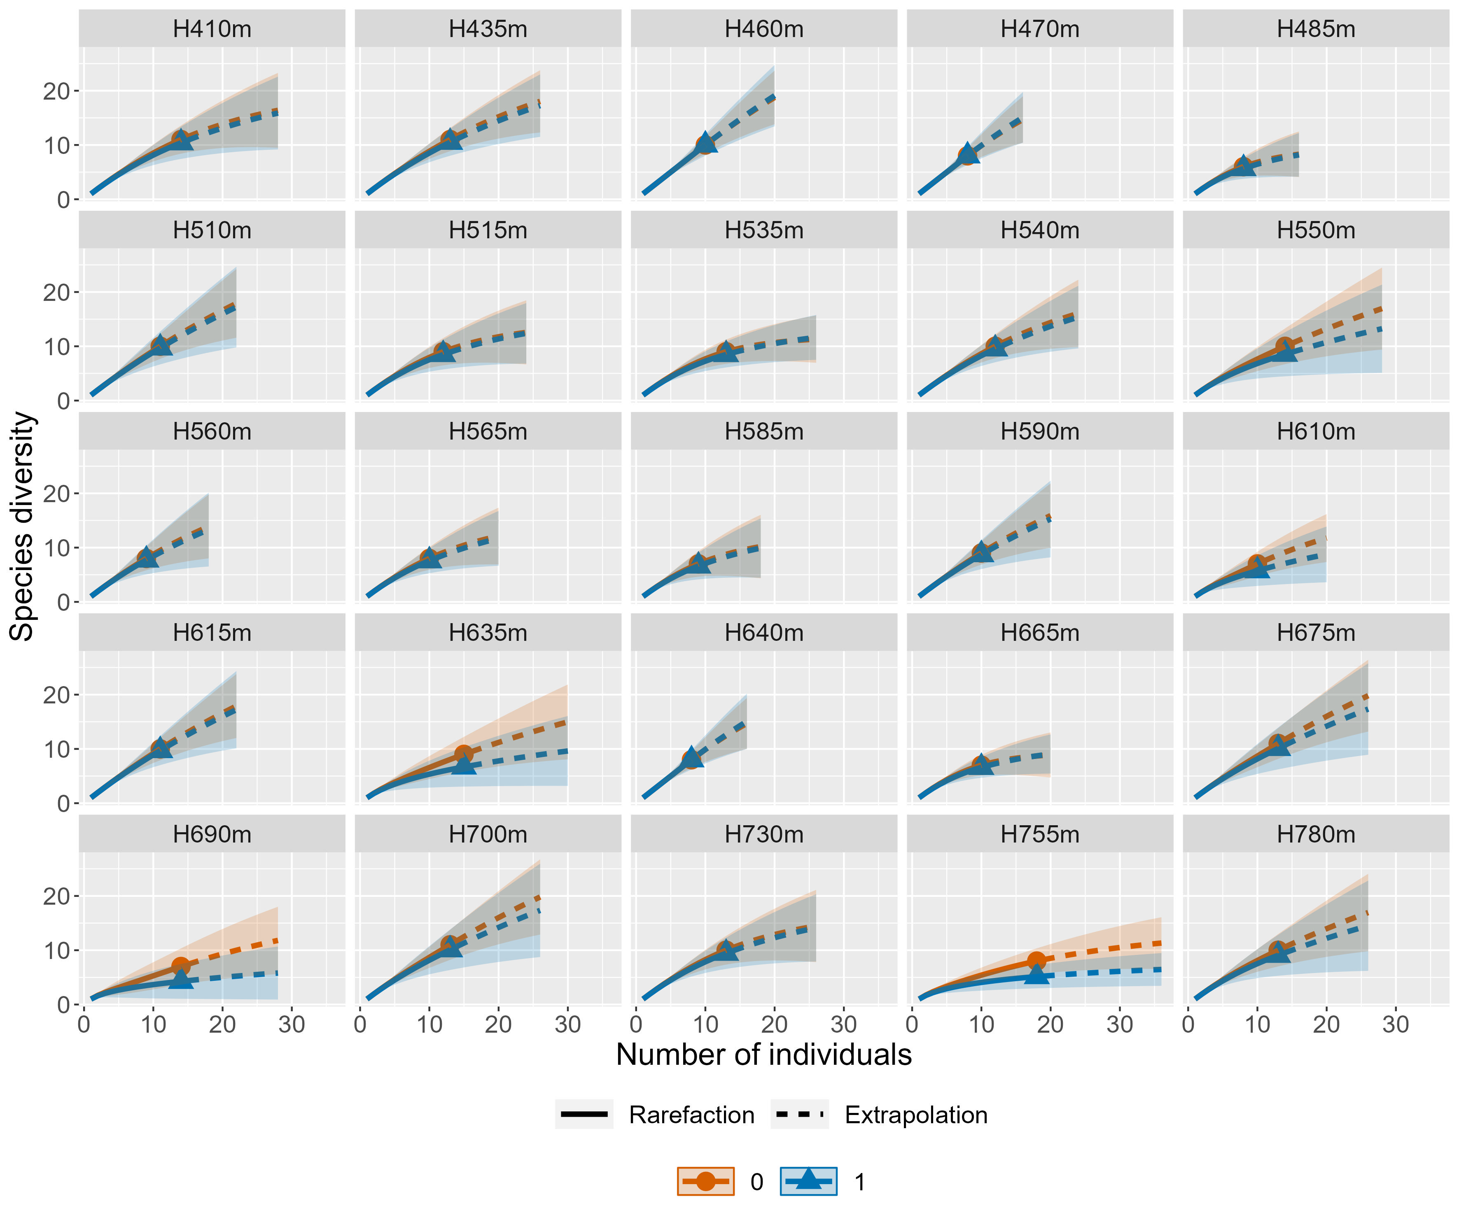

Appendix 9. Relationship between elevation on rarefaction and extrapolation of the community of non-tree plant functional species richness at Cerro Samama, Ecuador. The plots were obtained using Inter- and extrapolation analysis (iNEXT); q= 0 corresponds to species richness and q=1 to Shannon diversity index.
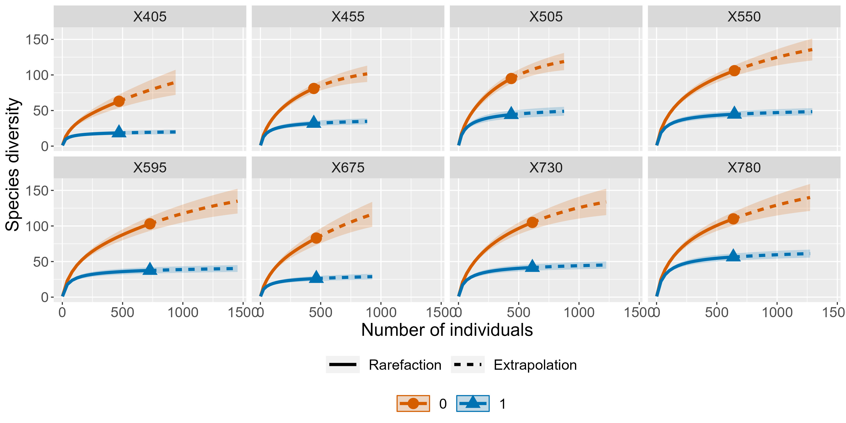

Appendix 10. Relationship between elevation on rarefaction and extrapolation species richness in different non-tree plant functional groups at Cerro Samama, Ecuador. The plots were obtained using Inter- and extrapolation analysis (iNEXT); q= 0 corresponds to species richness and q=1 to Shannon diversity index.

Climbers
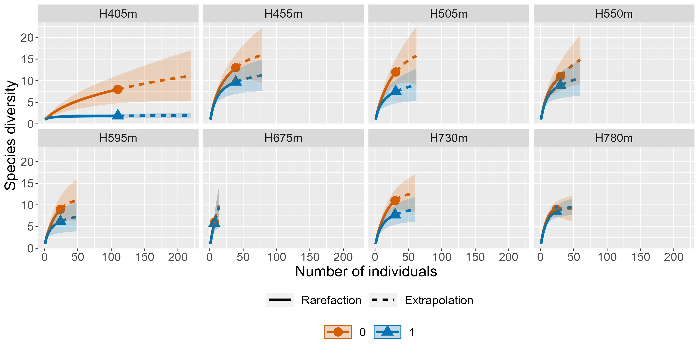
Epiphytes
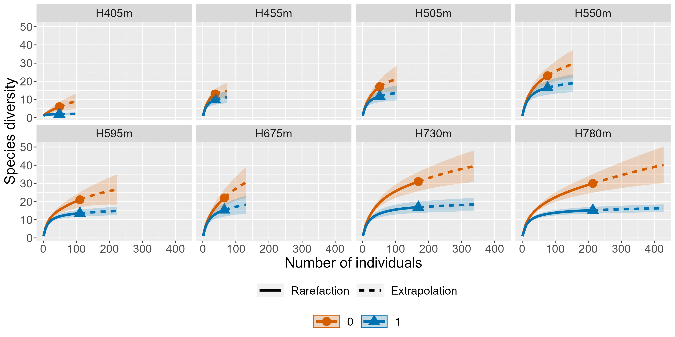
Epiphytic ferns
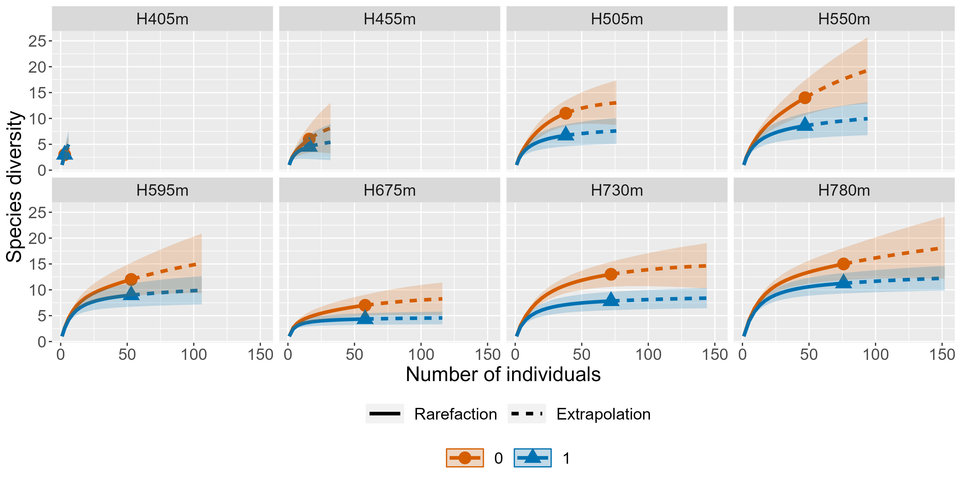
Hemi-epiphytes
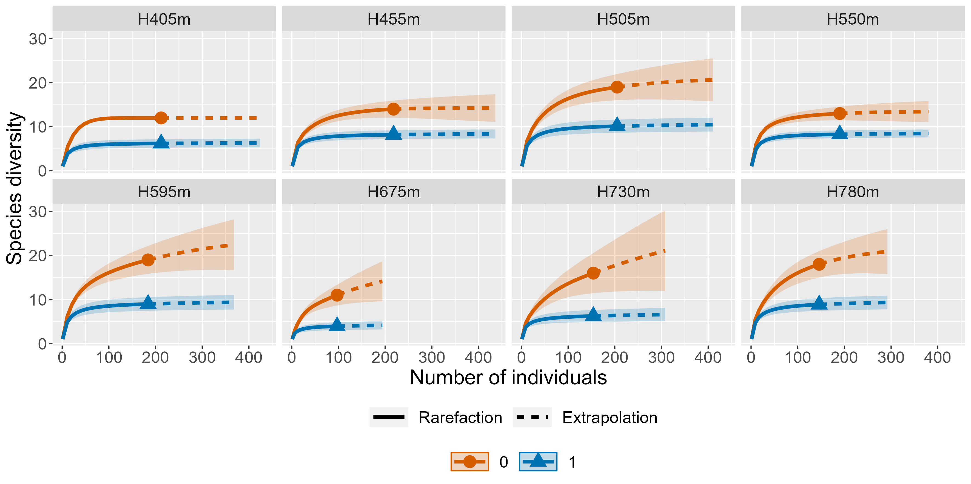
Herbaceous ferns
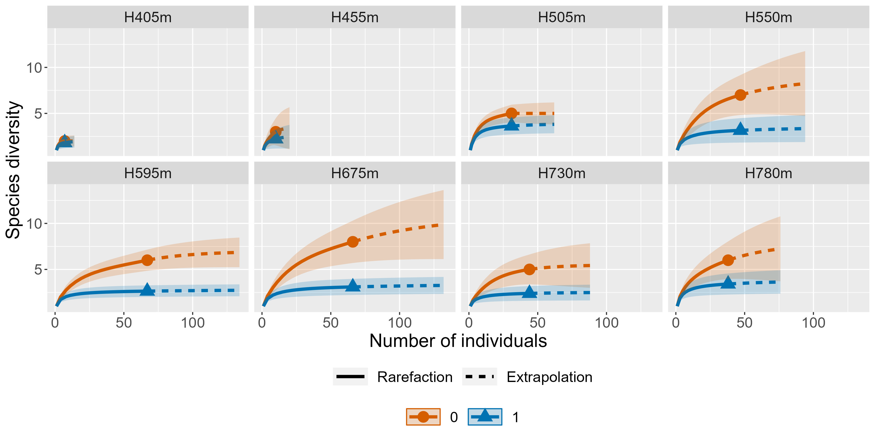
Herbs
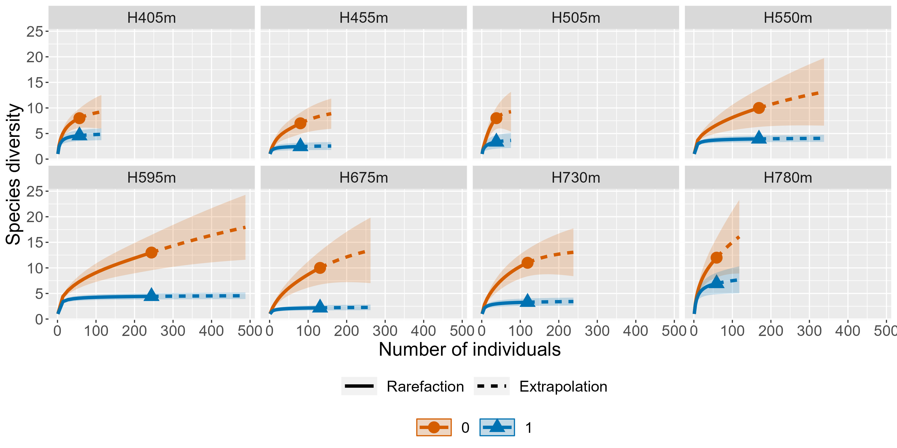
Shrubs
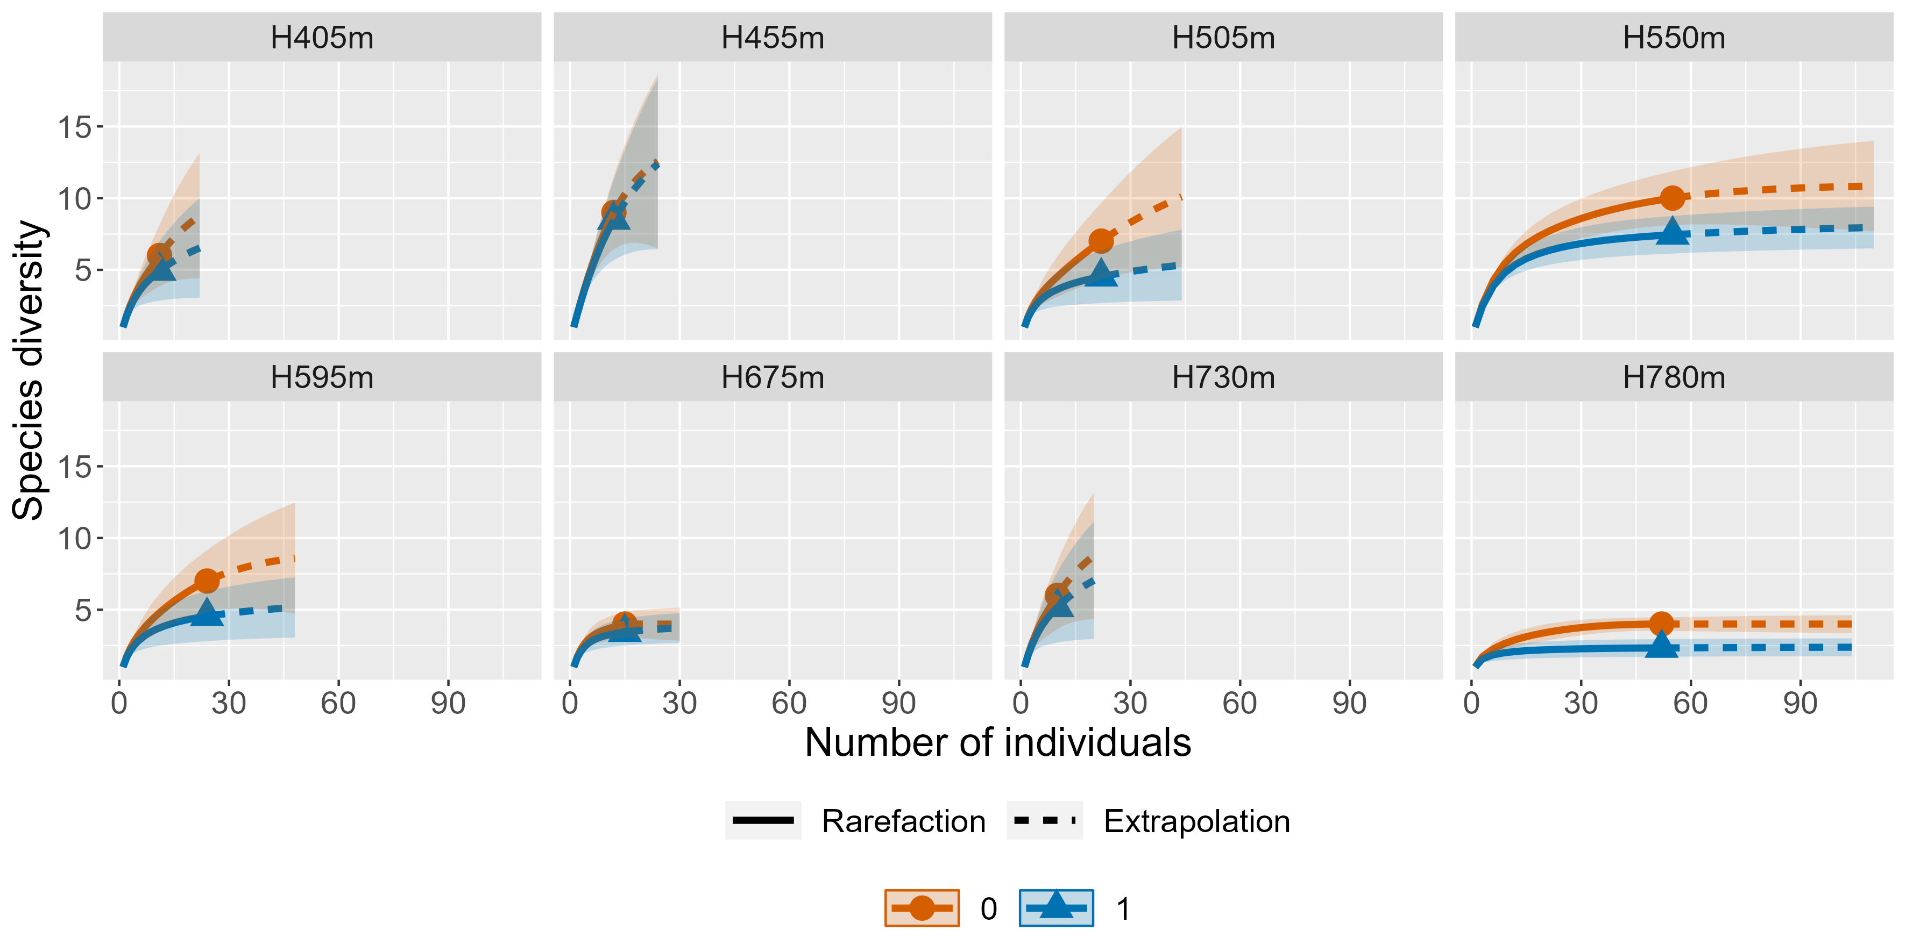Treelets
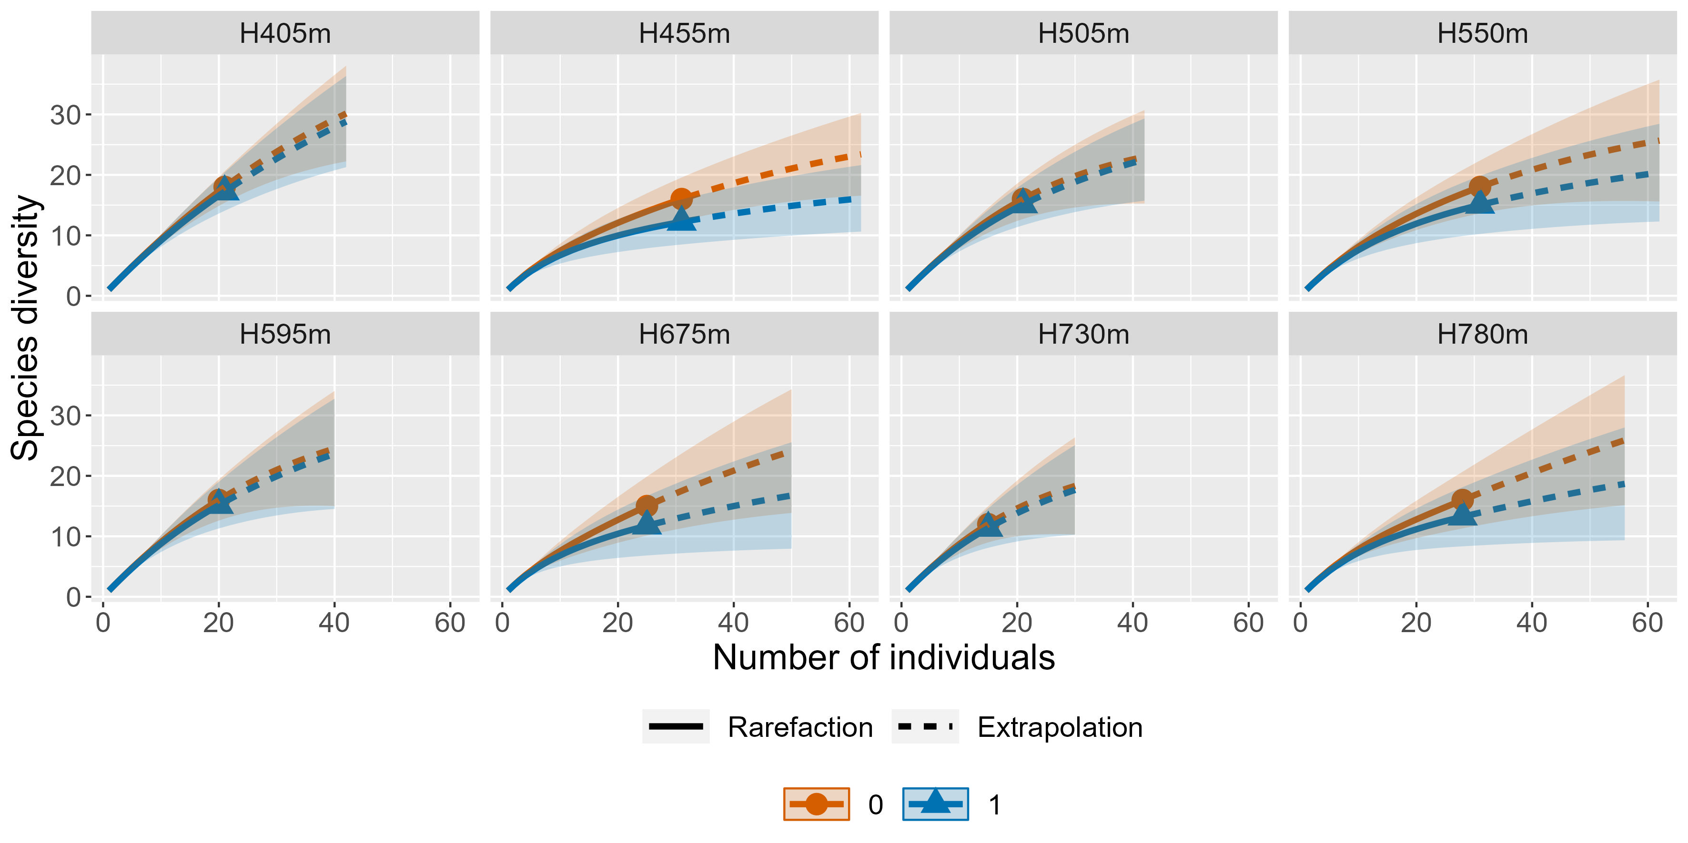

Appendix 11. Results of envﬁt function to test the eﬀects of elevation of each plant functional group, including trees. Bold values indicate statistically significant relations at p <0.05.
Plant functional groups |  | r2 |  | P
Climbers |  | 0.67 |  | 0.08
Epiphytes |  | 0.67 |  | 0.066
Epiphytic ferns |  | 0.86 |  | 0.01
Herbaceous ferns |  | 0.72 |  | 0.042
Herbs |  | 0.89 |  | 0.007
Hemi-epiphytes |  | 0.78 |  | 0.032
Shrubs |  | 0.94 |  | 0.004
Treelets |  | 0.93 |  | 0.003
All community of non-tree plant functional groups |  | 0.96 |  | 0.002
Trees |  | 0.53 |  | 0.001

