Supplementary Information

Mechanism of Quiescent Nanoplastic Formation from Semicrystalline Polymers

Nicholas F. Mendez,¹ Vivek Sharma,² Michele Valsecchi,¹ Vighnesh Pai,¹ Johnny K. Lee,¹ Linda Schadler,³ Alejandro J. Müller^{4,5}, Shelby Watson-Sanders,⁶ Mark Dadmun,⁶ Guruswamy Kumaraswamy,^{2*} Sanat K. Kumar¹*

¹ Department of Chemical Engineering, Columbia University, New York, New York, 10027, USA.
² Department of Chemical Engineering, Indian Institute of Technology Bombay, Mumbai, 400076, India.
³Department of Mechanical Engineering, University of Vermont, Burlington, VT
⁴ POLYMAT and Department of Advanced Polymers and Materials: Physics, Chemistry and Technology, Faculty of Chemistry, University of the Basque Country UPV/EHU, Paseo Manuel de Lardizabal 3, 20018 Donostia-San Sebastián, Spain
⁵ IKERBASQUE, Basque Foundation for Science, Plaza Euskadi 5, Bilbao 48009, Spain
⁶Department of Chemistry, University of Tennessee Knoxville, Knoxville TN

Table of Contents

Note 1: Details of oxidative degradation 3
Figure S1: Free radical generation from oxidative degradation 4
Figure S2-4: Electron microscopy of NPL and droplets 5
Figure S5: EDS scans of PP and PS 7
Figure S6: Tensile curves for PET 9
Figure S7: Tensile Curves for iPP 10
Figure S8: Tensile Properties of PET at 100 °C 11
Figure S9: X-ray scattering of native and degraded PET films 12
Figure S10: DSC of native and degraded PET films 12
Figure S11: DSC of native iPP and sPS 13
Figure S12: ATR-FTIR of native and degraded PET films 14
Figure S13-16: Terephthalic acid characterization 15
Figure S17-19: ATR-FTIR spectra of NPL 18
Figure S20: TGA of all PET samples 21
Figure S21-22: DSC of additional PET NPL samples 22
Figure S23-24: Addition PLOM Images from melting and recrystallization of NPL 23
Figure S25-26: X-ray scattering of additional NPL samples, larger scattering mass 24
Figure S27-30: Autocorrelation function and interface distribution function analysis 25
Note 2: Details of SAXS analysis 26
Figure S31: PET NPL SAXS Results 28
Note 3: PET NPL SAXS Results 28
Figure S32: WAXS analysis of PET 29
Figure S33: Summarized crystallinities of bulk PET from different methods 30
Note 4: Details of WAXS analysis 30
Figure S34-36: Size distributions of PET NPL 31
Figure S37-38: Characterization of Amorphous PET (prior to recrystallization) 33
Note 5: Molecular Weight Determination for iPP, aPP, sPS, and aPS 34
Figure S40: Further details on SEM image analysis 36
Note 6: Methods for SI that are not in Main Text 36
References 38

Note 1: Details of oxidative degradation
K₂S₂O₈ decomposes upon heating in water following the reaction:
$K_{2}S_{2}O_{8}+2H_{2}O→K_{2}SO_{4}+ H_{2}SO_{4}+2{\left[OH\right]}^{∙-}$ [1]
Therefore, as K₂S₂O₈ decomposes, it forms free radicals and H₂SO₄, resulting in a pH decrease. Equation [1] shows that the number of free radicals generated is double the amount of acid formed. Therefore, the rate of free radical generation can be estimated by measuring the change in pH (Figure S1). We observe that the rate of K₂S₂O₈ decomposition (viz. free radical generation) is pH dependent and is highly accelerated when the pH decreases below 1 (viz. after about 3 hours for 4 g K₂S₂O₈ in 100 mL water at 70 °C, Figure S1). After about 6 hours, as pH decreases to ~ 0.7 and beyond, the rate of free radical generation decreases. We note that, at this point, only about 50% of the K₂S₂O₈ originally added is decomposed. Addition of base (KOH) to this reaction mixture neutralizes the acid and increases the pH, allowing decomposition of the K₂S₂O₈ to resume following a similar cycle.

Figure S1: Free radical generation from oxidative degradation
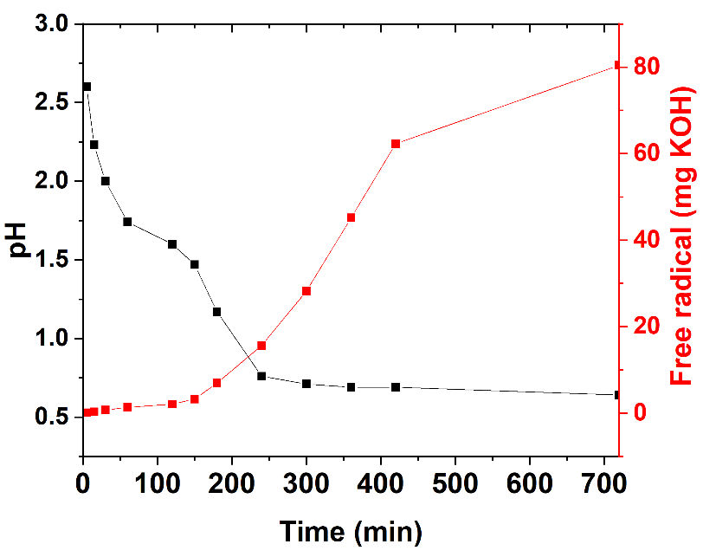
Figure S1: Variation of pH and concentration of free radicals (in units of mg KOH added to neutralize the acid formed, estimated in aliquots extracted from the reaction mixture) over time for decomposition of 4 g K₂S₂O₈ in 100 mL water at 70 °C.

Figure S2-4: Electron microscopy of NPL and droplets
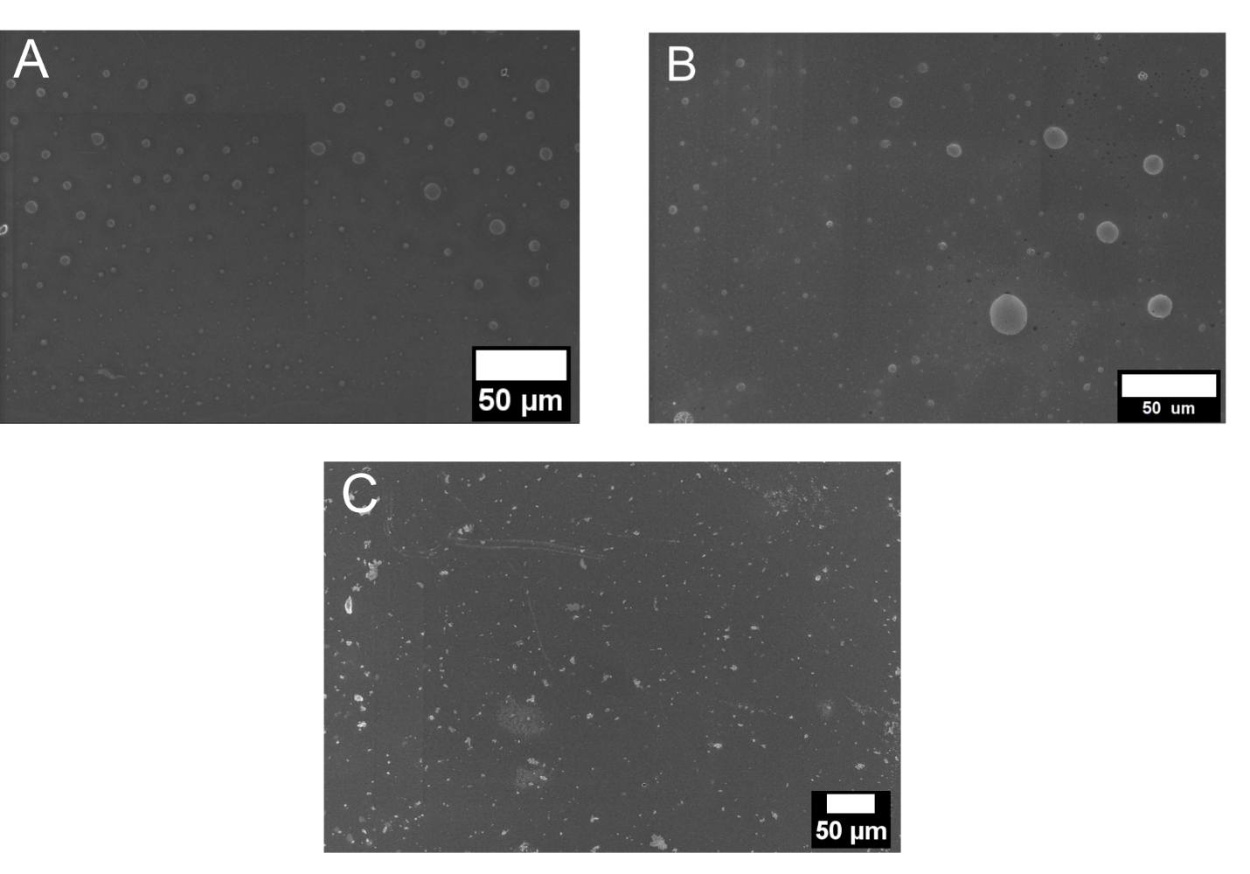
Figure S2: Low magnification SEM of condensed oligomeric products created from oxidative degradation of A) aPS and B) aPP solutions after 2 days of degradation. C) Low magnification SEM of NPL produced from oxidative degradation of iPP after 2 days of degradation for comparison.

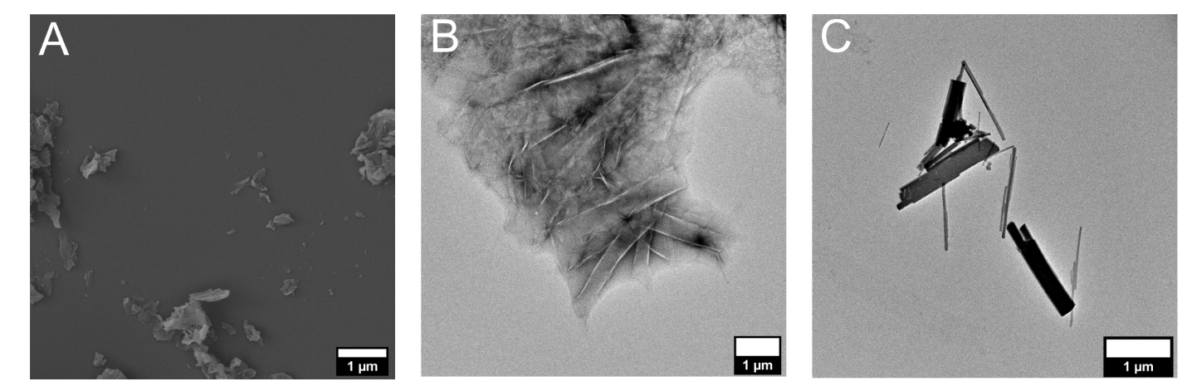
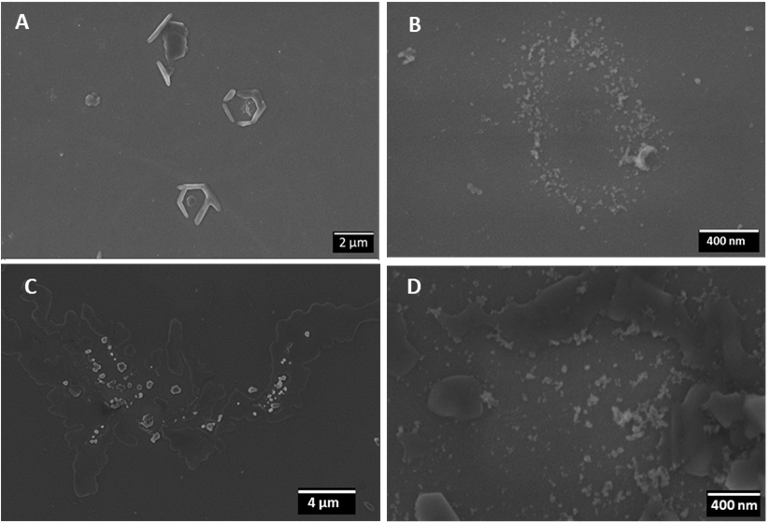
Figure S3: A) SEM and B, C) TEM imaging of PET NPL formed through neutral water hydrolysis at 110 °C after 7 days.
Figure S4: SEM micrographs of sPS (A, B) and iPP (C, D) at day 2 (A, C) and for continued degradation without the bulk films for 2 additional days (B, D).

Figure S5: EDS scans of PP and PS
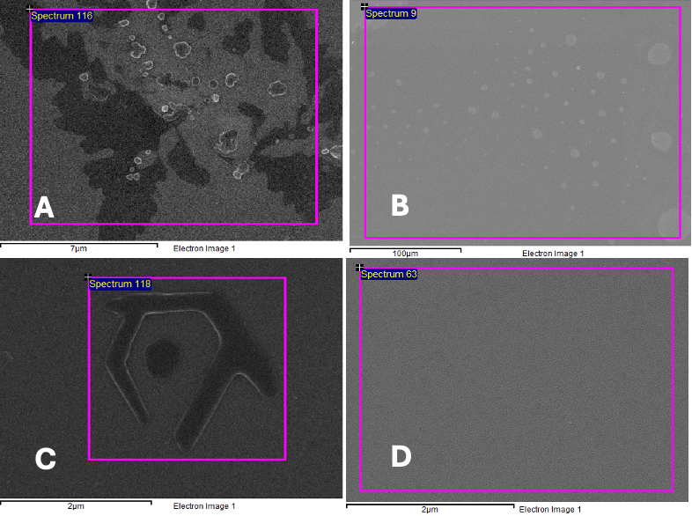
Figure S5: SEM images for EDX analysis of (a) iPP, (b) aPP, (c) sPS and, (d) aPS. Analysis of the elements was carried out with EDX using an OXFORD X-MAX system equipped to ZEISS Ultra-55 SEM, results in Table S1.

Table S1: Elemental weight fraction for the PP and PS samples obtained from EDS. SEM images for EDS analysis of (a) iPP, (b) aPP, (c) sPS and, (d) aPS. Analysis of the elements was carried out by EDS analysis using an OXFORD X-MAX system equipped to ZEISS Ultra-55 SEM. Potassium is selected in addition to C and O, to distinguish between the K2SO4/K2S2O8 and the NPL.
 | iPP | aPP | sPS | aPS
Element | Weight% | Weight% | Weight% | Weight%
Carbon | 72.62 | 51.58 | 73.55 | 69.37
Oxygen | 11.28 | 42.88 | 11.53 | 22.73
Potassium | 16.10 | 5.54 | 14.93 | 7.90
Totals | 100.00 | 100.00 | 100.00 | 100.00

Figure S6: Tensile curves for PET
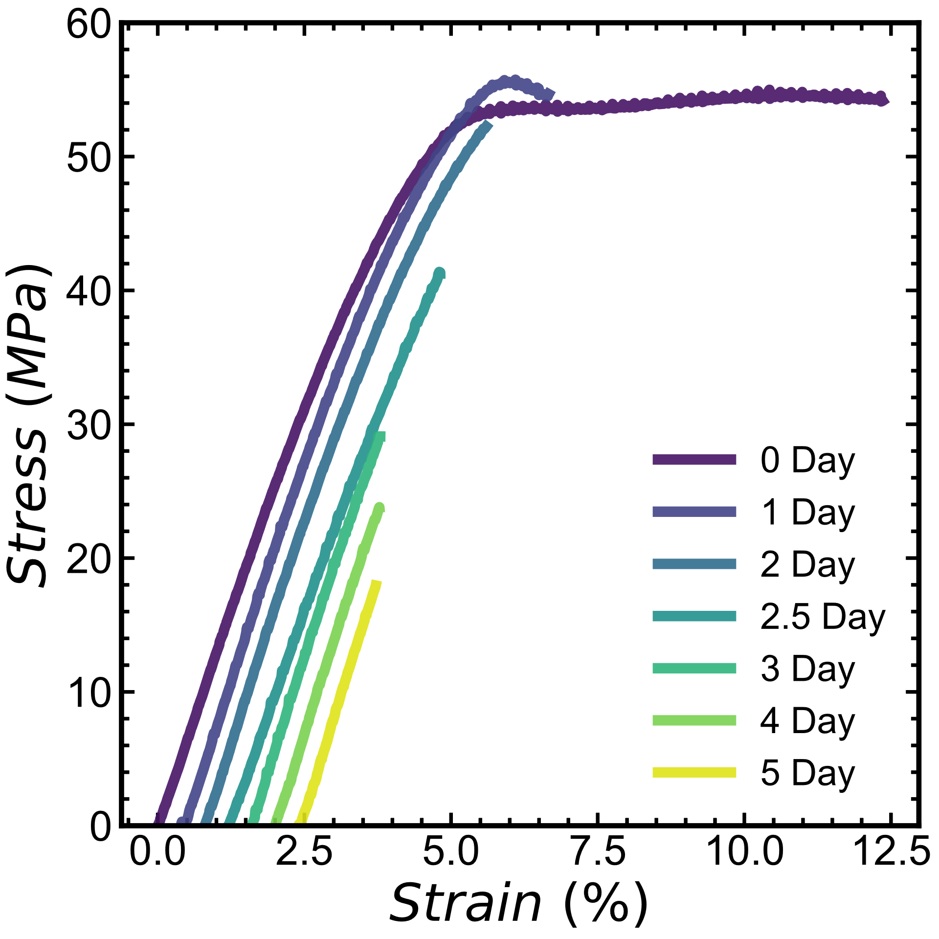
Figure S6: Stress vs. strain for PET samples degraded in neutral water at 110 °C. Curves are offset in strain for clarity.
The tensile behavior of the semicrystalline PET initially shows uniform drawing with no necking behavior, which is consistent with the behavior expected for PET with crystallinities similar to those tested ¹. Upon degrading the modulus remains approximately the same while the maximum stress and strain at yield continually decrease.

Figure S7: Tensile Curves for iPP
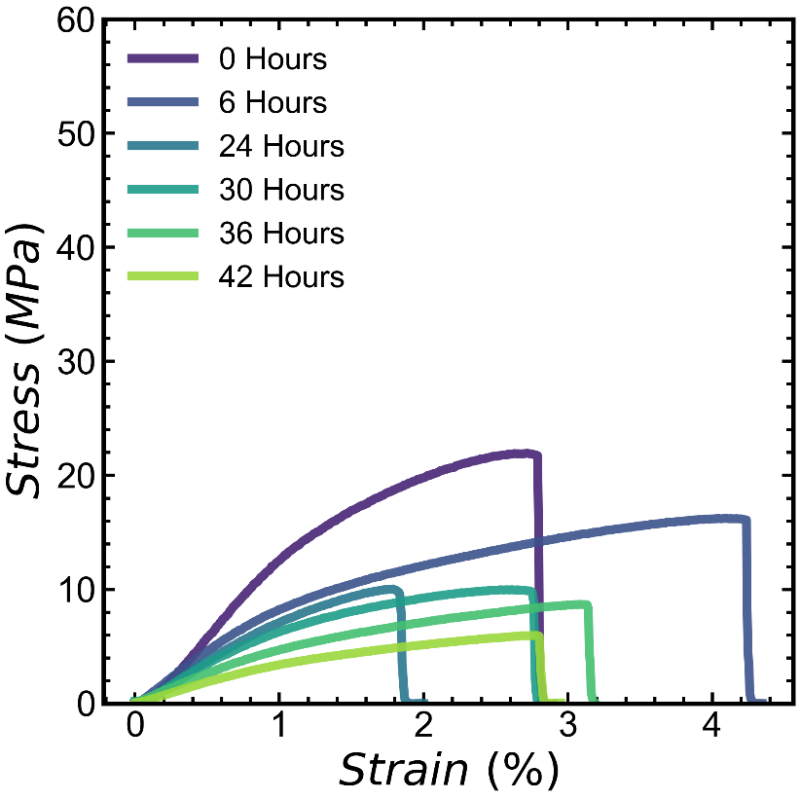
Figure S7: Stress vs. strain curves for iPP after undergoing oxidative degradation.

Figure S8: Tensile Properties of PET at 100 °C
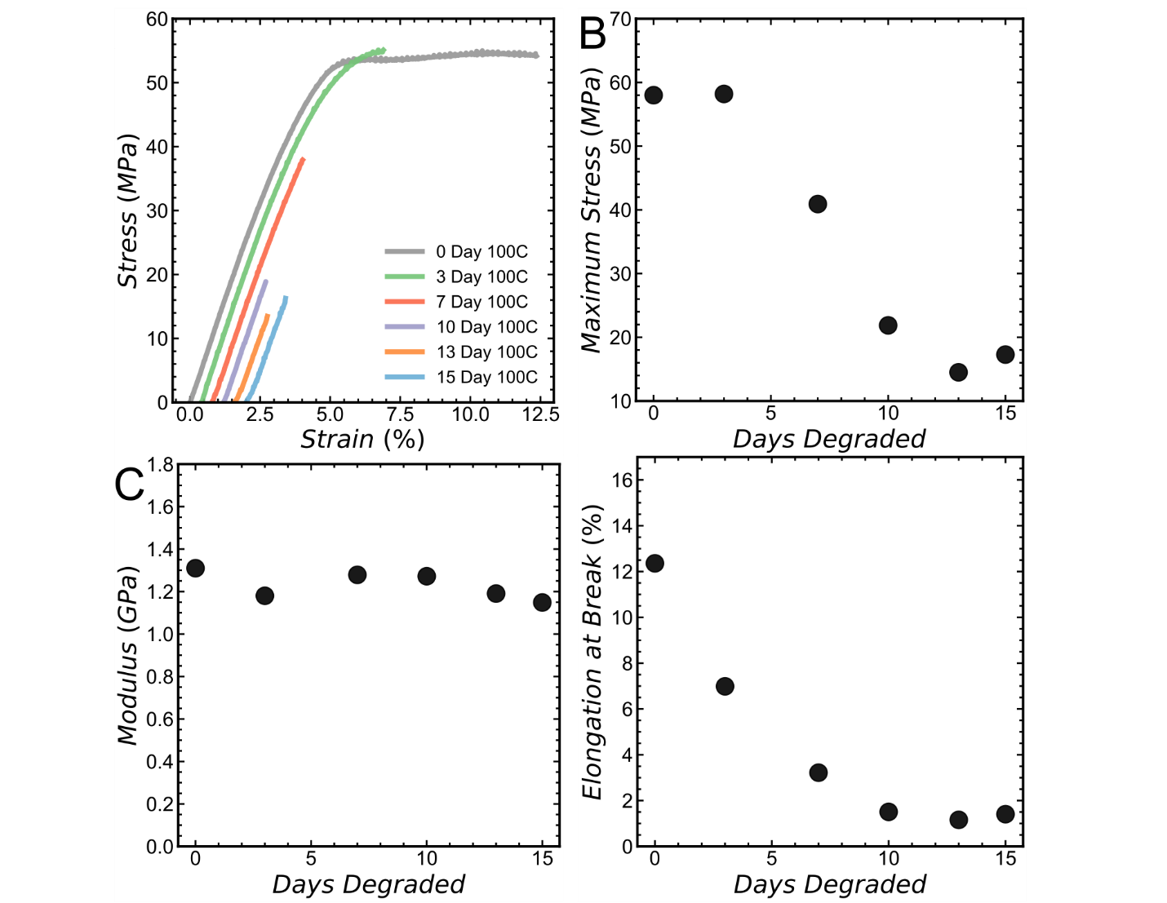
Figure S8: Summarized tensile properties of PET hydrolyzed at 100 °C A) Stress-strain curves that have been horizontally offset by 0.2% strain. B) Maximum Stress at failure C) Modulus taken from linear regime at early strains D) Elongation at break.

Figure S9: X-ray scattering of native and degraded PET films
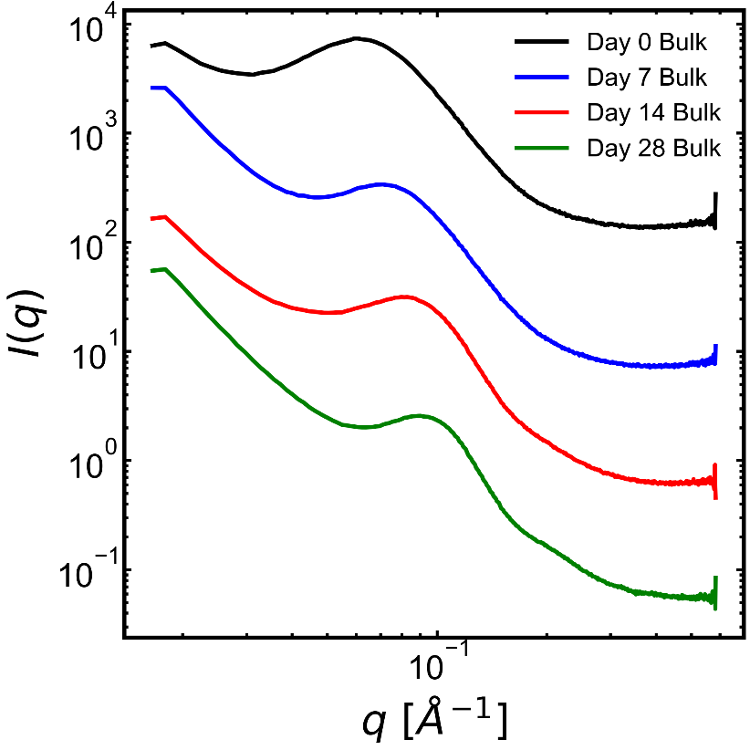
Figure S9: 1D SAXS intensity as a function of wavevector, $q$, for bulk PET samples degraded through neutral water hydrolysis at 110 °C. Curves are vertically shifted for clarity.

Figure S10: DSC of native and degraded PET films
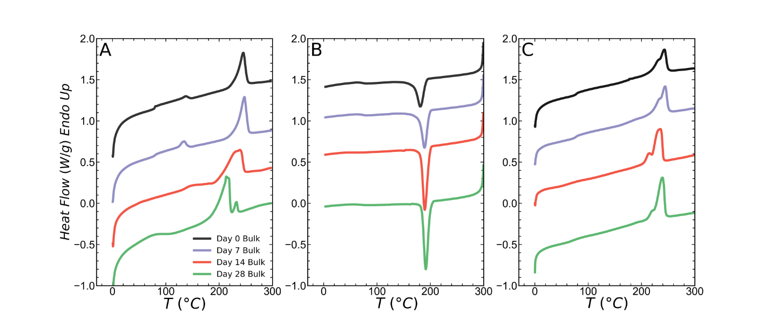
Figure S10: DSC curves for bulk PET samples degraded through neutral water hydrolysis at 110 °C. All experiments are conducted with temperature ramps of 10 °C/min. A) first heat up to 300 °C. B) first cool to 0 °C C) second heat to 300 °C. Curves are shifted vertically for clarity.

The heating endotherms of PET show a main melting peak at around 240 °C while smaller peaks can be observed at much lower temperatures. Ronkay et al. discuss the multiple melting endotherms in PET in detail ². From Figure S10 we observe that during the first heating the bulk material melts at a slightly lower temperature relative to the second heating. This feature is also observed in other degraded semicrystalline polymers, a behavior that is commonly interpreted as a result of chemi-crystallization ^{3–5}.

Figure S11: DSC of native iPP and sPS
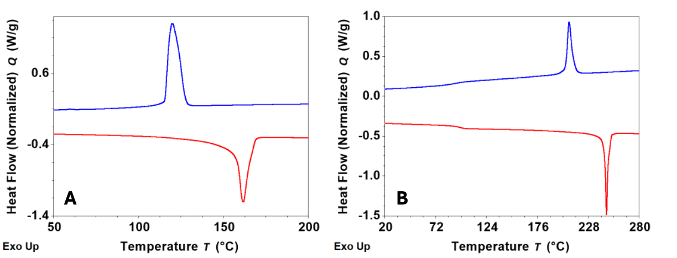
Figure S11: Non-isothermal DSC of the as prepared films of A) iPP and, B) sPS. The blue line represents cooling after 1st heating to 250 °C (iPP) and, 300 °C (sPS). The red line is for the second heating cycle. The DSC experiments were done at a heating/cooling rate of 10 °C /min.

Figure S12: ATR-FTIR of native and degraded PET films
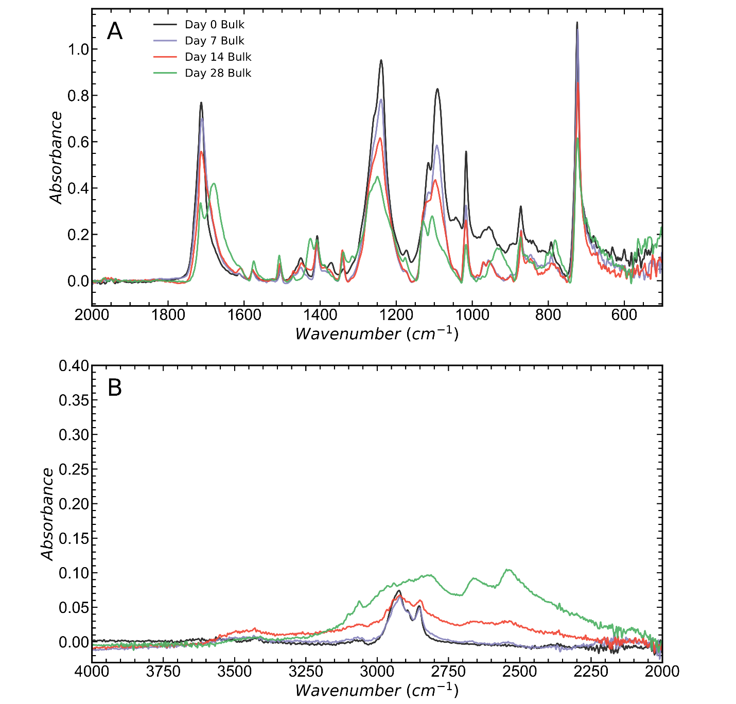
Figure S12: ATR-FTIR spectra for bulk PET samples degraded through neutral water hydrolysis at 110 °C. A) low wavenumbers B) high wavenumbers.

Figure S13-16: Terephthalic acid characterization
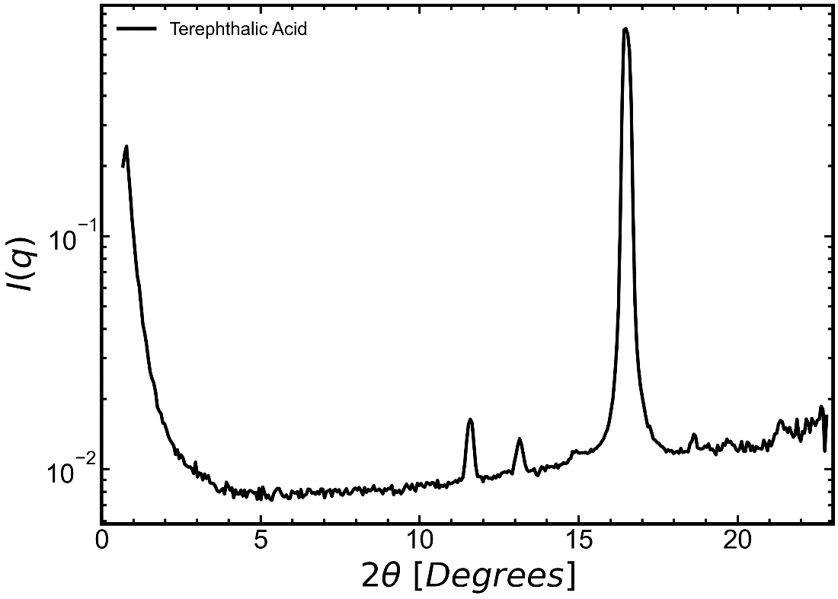
Figure S13: WAXS intensity as a function of scattering angle for pure terephthalic acid.
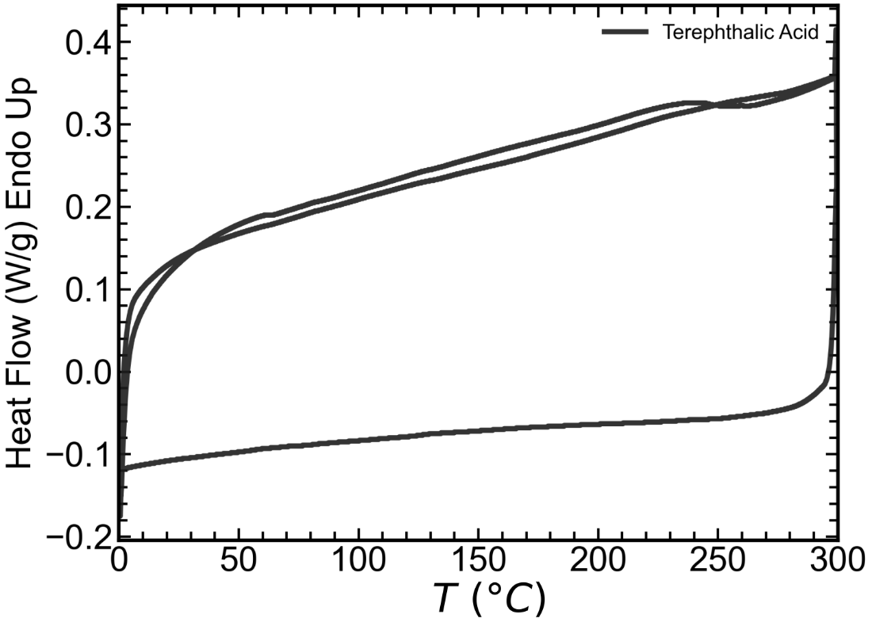
Figure S14: DSC heat-cool-heat scan of pure terephthalic acid conducted at 10 °C/min.
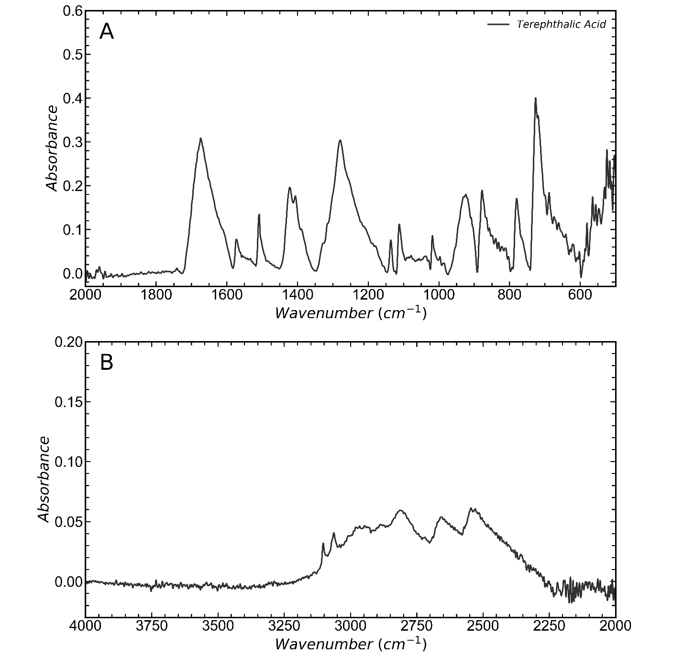
Figure S15: ATR-FTIR spectrum for pure terephthalic acid. A) low wavenumbers B) high wavenumbers.
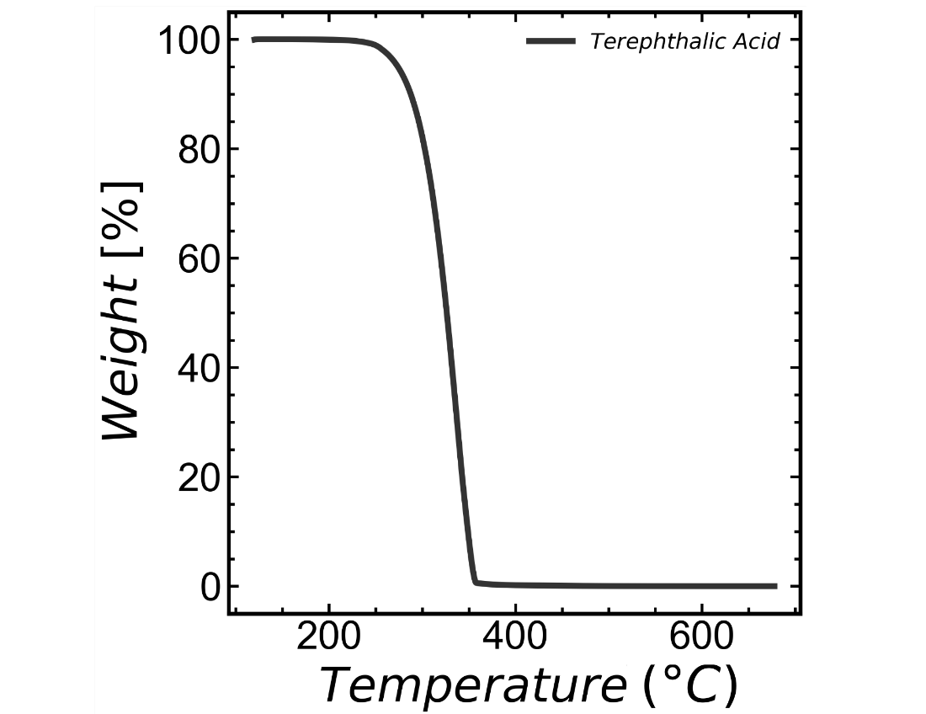
Figure S16: Thermal degradation of pure terephthalic acid under nitrogen atmosphere at a ramp rate of 30 °C/min.

Figure S17-19: ATR-FTIR spectra of NPL
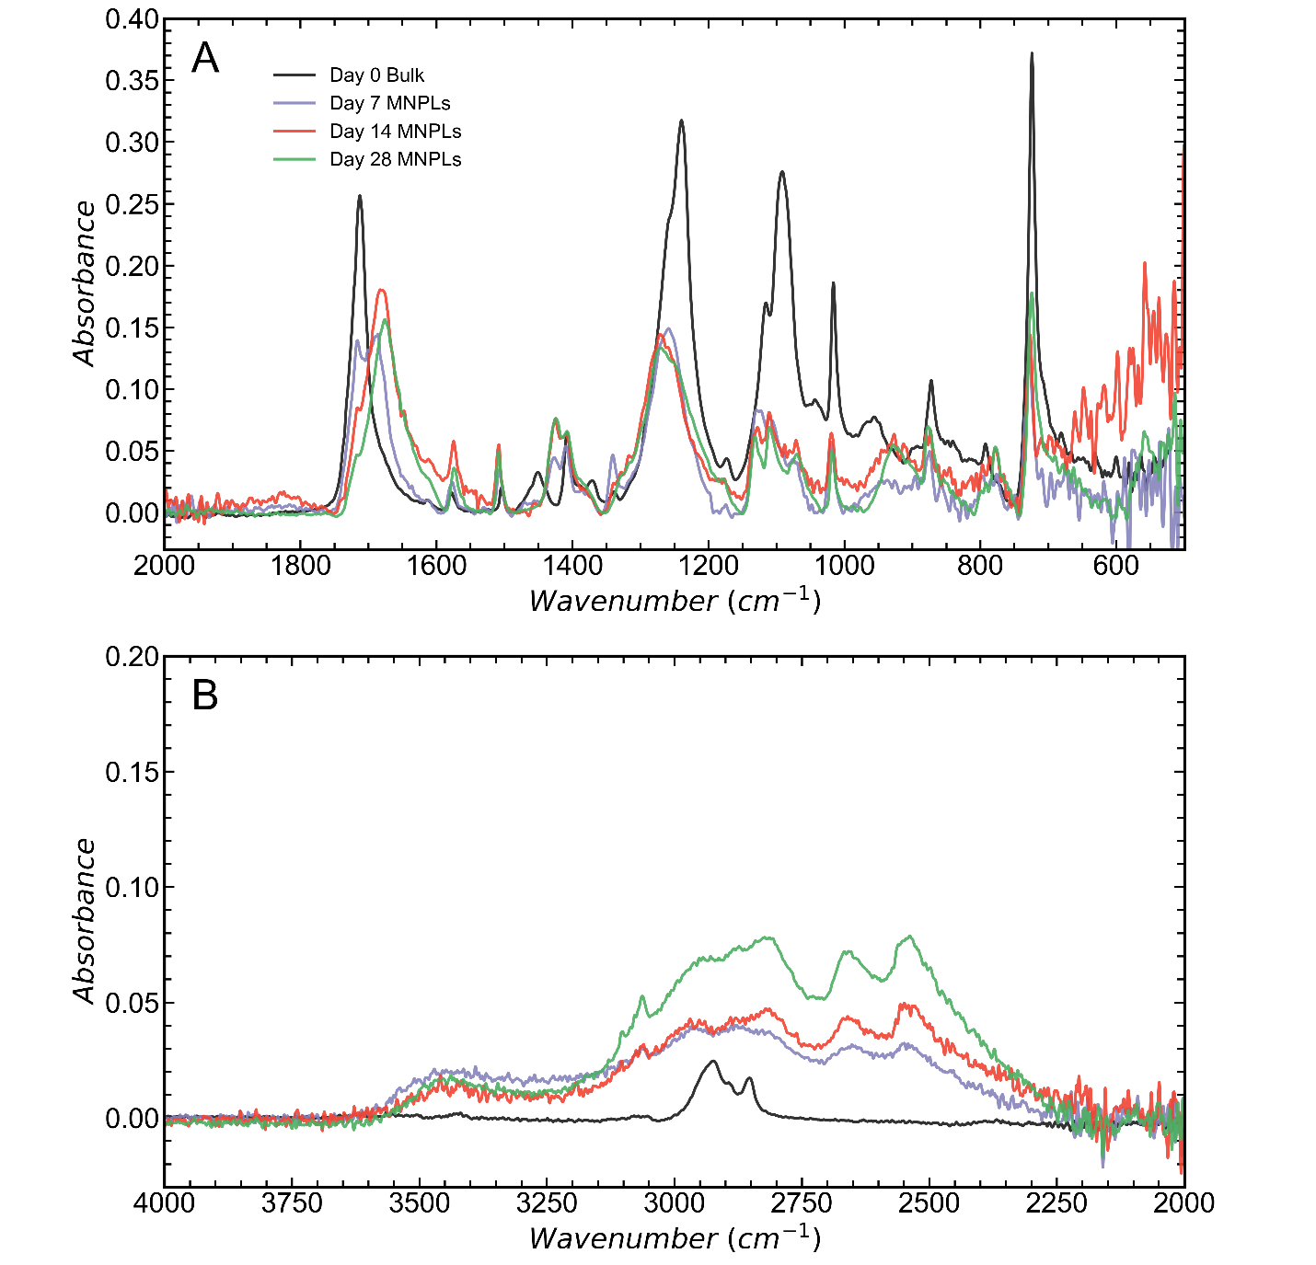
Figure S17: ATR-FTIR spectra for all PET NPL samples from neutral water hydrolysis at 110 °C. The native film’s spectrum is provided as a reference. A) low wavenumbers B) high wavenumbers.
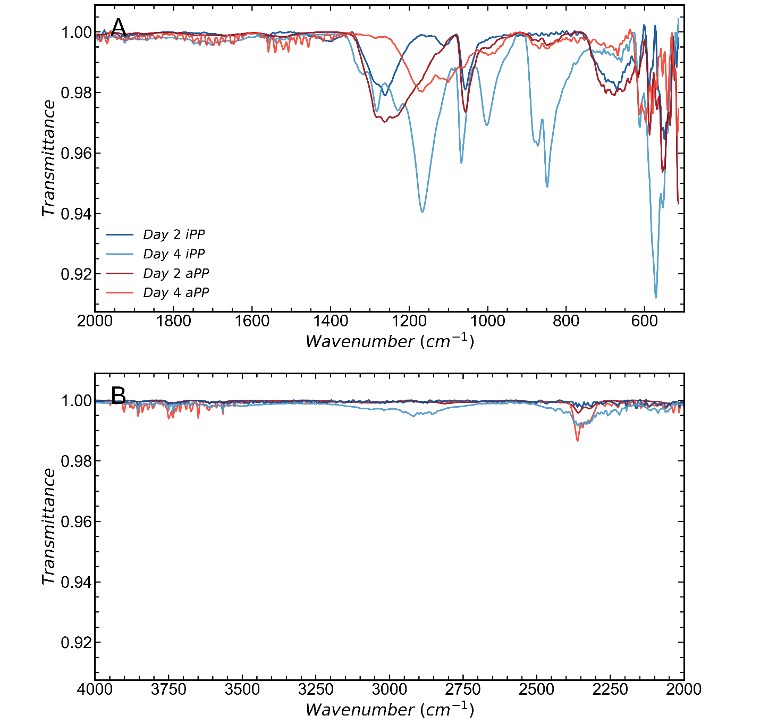
Figure S18: ATR-FTIR spectrum for iPP NPL from oxidative degradation and dried aPP solution. A) low wavenumbers B) high wavenumbers.
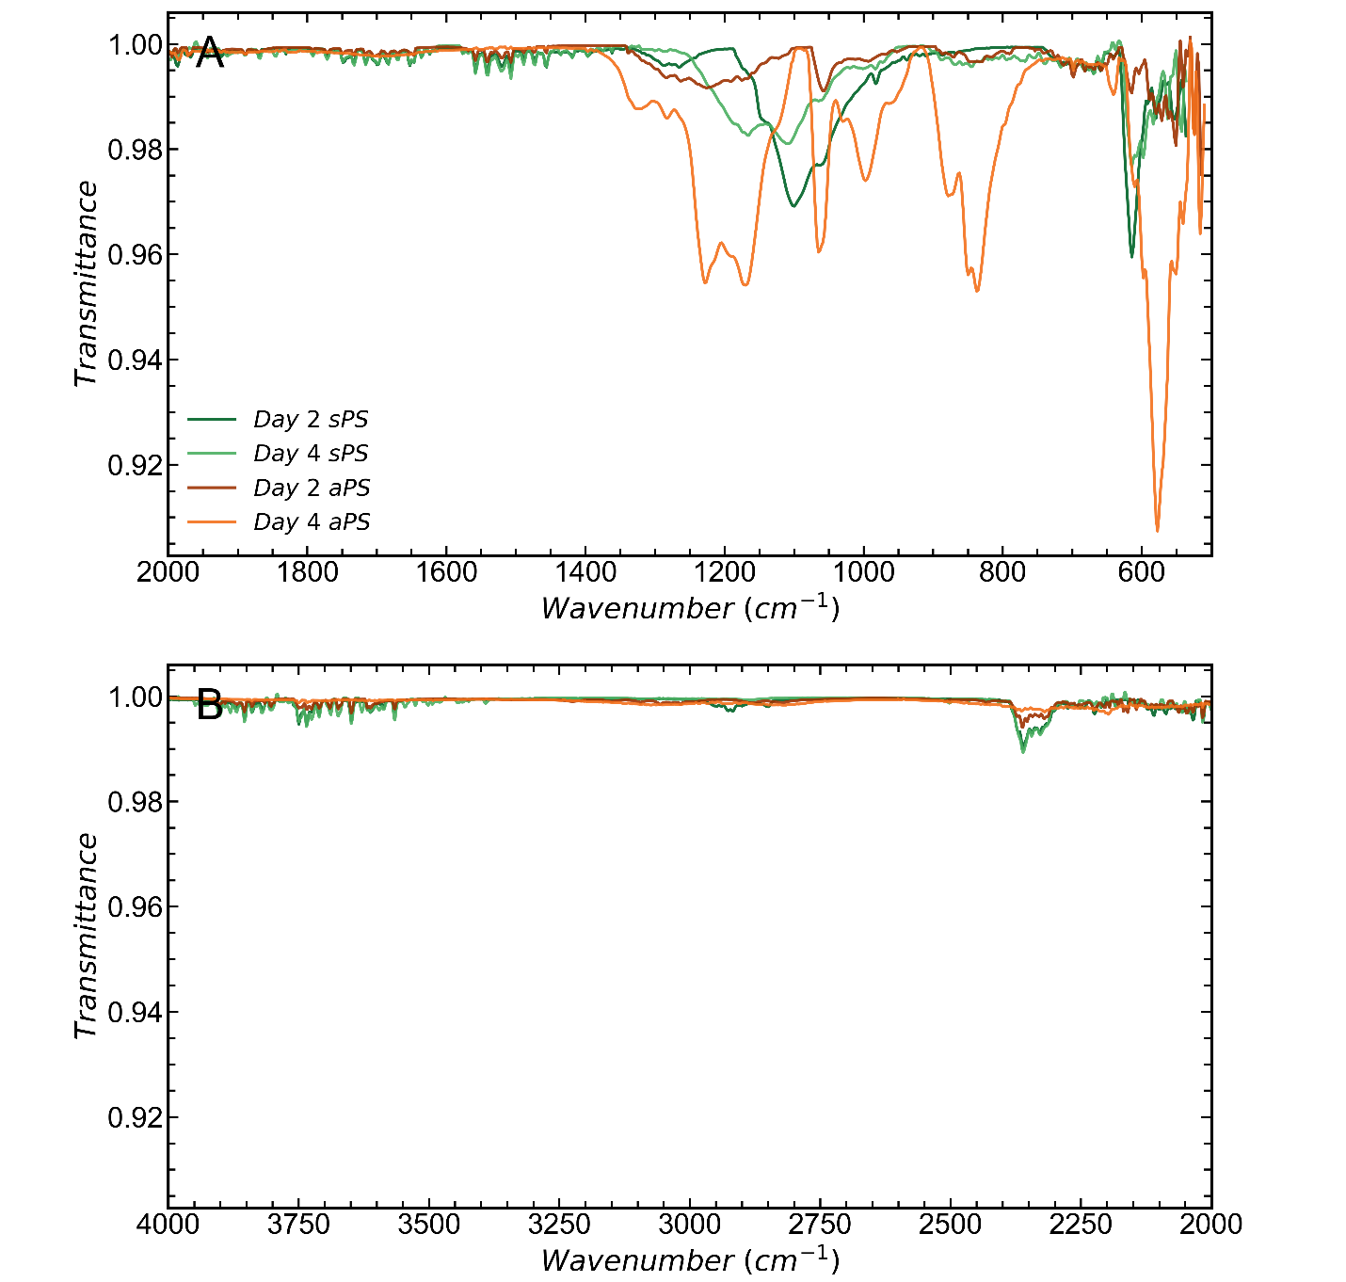
Figure S19: ATR-FTIR spectrum for sPS NPL from oxidative degradation and dried aPS solution. A) low wavenumbers B) high wavenumbers.

Figure S20: TGA of all PET samples
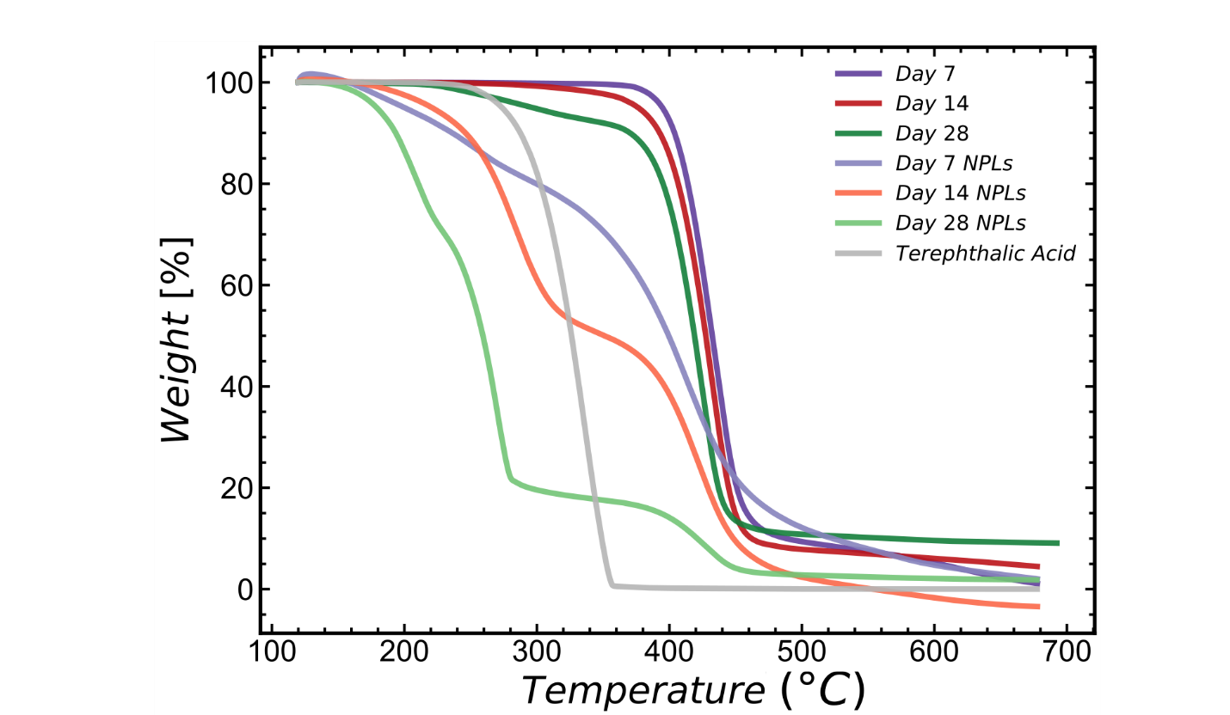
Figure S20: TGA of all PET samples degraded by neutral water hydrolysis at 110 °C. Measurements done under nitrogen atmosphere using a 30 °C/min ramp rate.

Figure S21-22: DSC of additional PET NPL samples
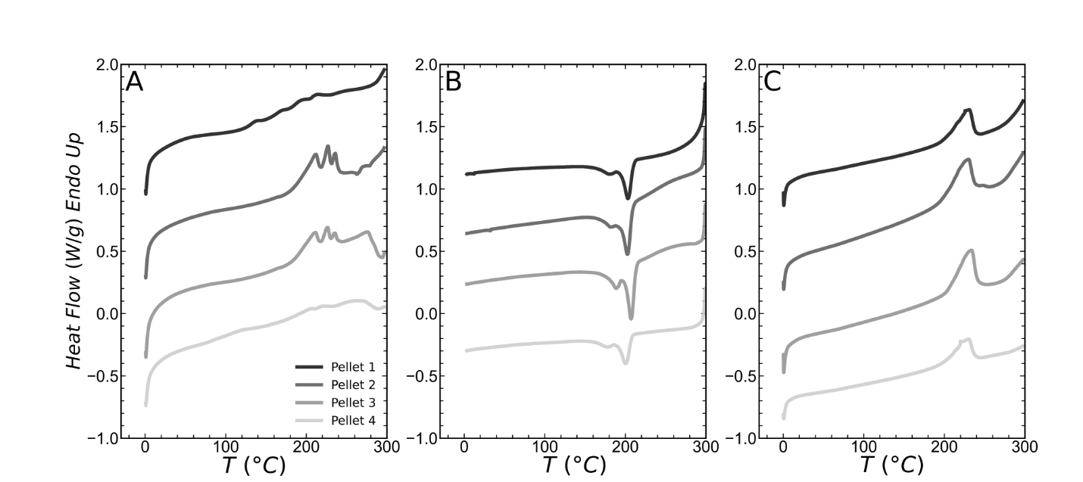
Figure S21: Additional DSC A) heat B) cool C) heat scans for PET NPL pellets created after 14 days of degradation (pellets are created from pressing centrifuged and dried NPL powder) at 110 °C. The DSC runs are conducted at 10 °C/min. Curves are shifted vertically for clarity.
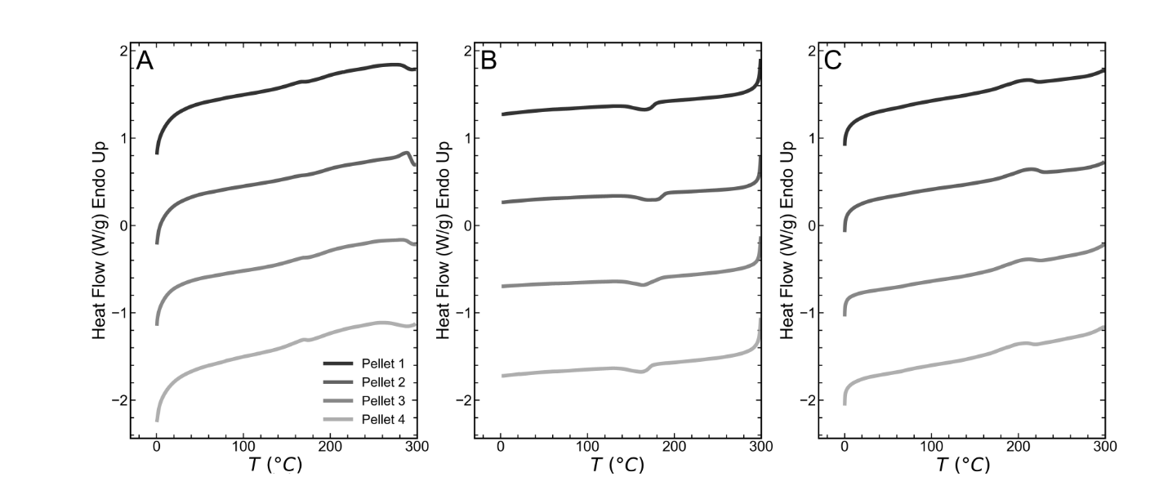
Figure S22: Additional DSC A) heat B) cool C) heat scans for PET NPL pellets created after 28 days of degradation (pellets are created from pressing centrifuged and dried NPL powder) at 110 °C. The DSC runs are conducted at 10 °C/min. Curves are shifted vertically for clarity.

Figure S23-24: Addition PLOM Images from melting and recrystallization of NPL
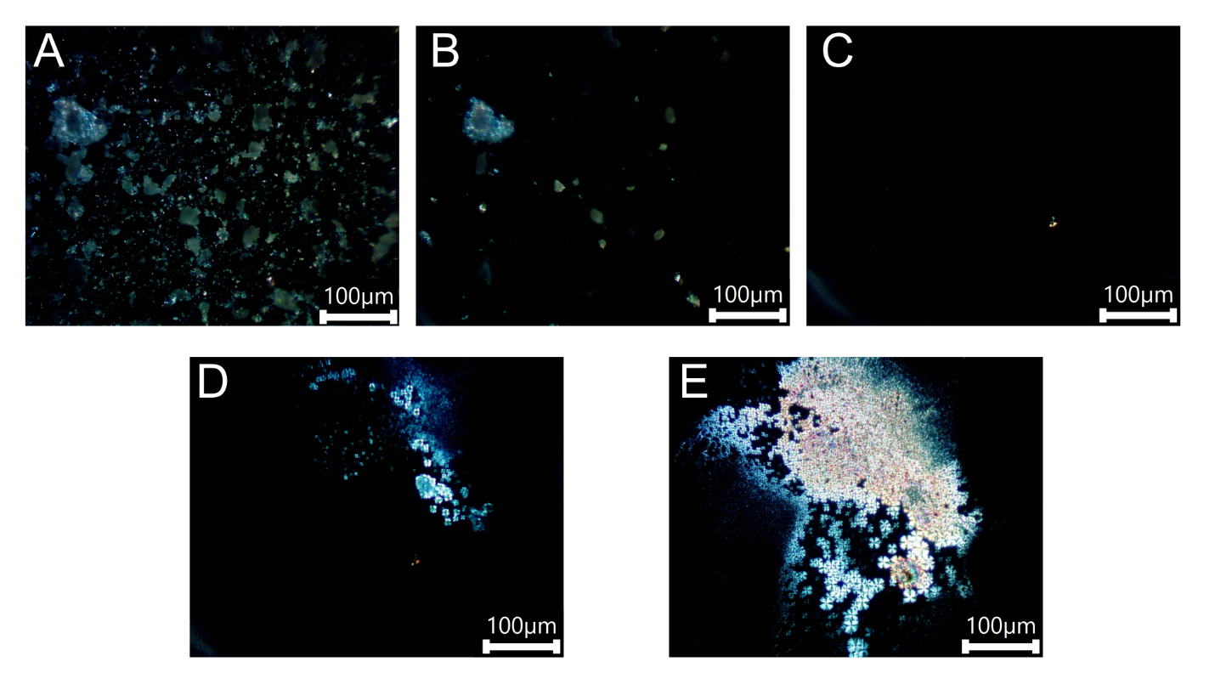
Figure S23: Additional PLOM images from a heat-cool protocol conduced on a Linkam stage using 90 ° cross polarizers at a ramp rate of 10 °C/min (same as DSC). Images correspond to different temperatures during the protocol A) 30 °C; B) 230 °C; C) 300 °C (all heat); D) 215 °C (cooling); E) 100 °C (cooling).
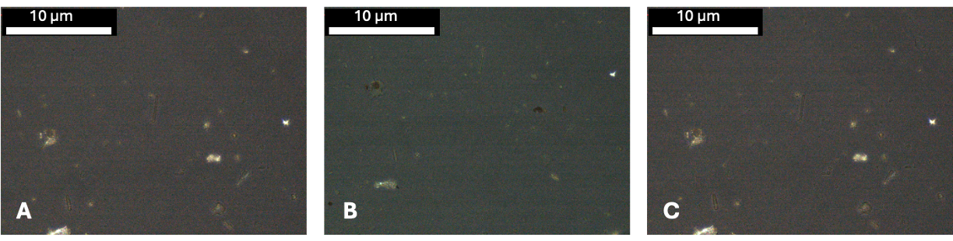
Figure S24: PLOM images of iPP from heat-cool protocol conducted on a Linkam stage using 90°cross polarizers at a 10 °C /min ramp rate. Samples were prepared by drying solutions containing the NPL and dissolved salt (from the oxidation process) on a glass cover slip. The stage temperature was calibrated under experimental conditions using an external standard. A) 100 °C (prior to melting), B) 200 °C (melted), and C) 130 °C (recrystallized) (rapid cooling at 20ºC/min). The bright spot to the right of the image corresponds to potassium salt that was not spatially separated during sample preparation.

Figure S25-26: X-ray scattering of additional NPL samples, larger scattering mass
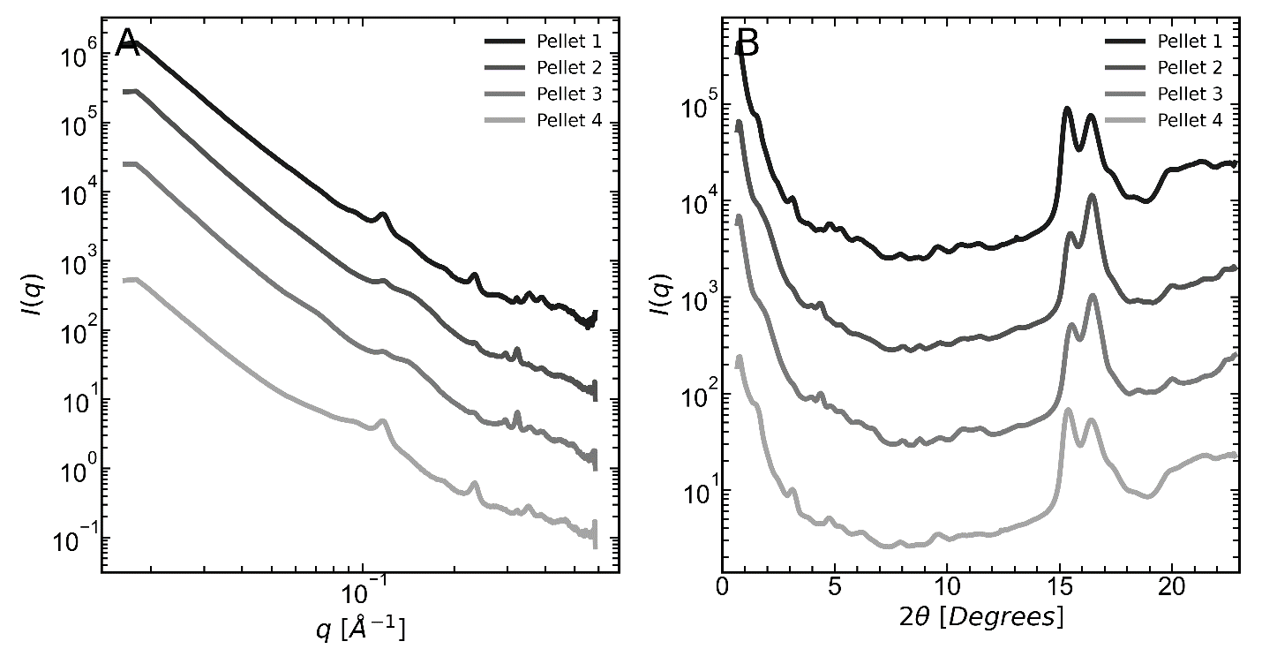
Figure S25: A) SAXS and B) WAXS intensities as a function of q of PET NPL pellets created after 14 days of degradation at 110 °C measured on pellets (created from pressing centrifuged and dried NPL powder). The spectra reported in the main text were obtained from smaller scattering volumes that are drop-cast on a SiN substrate.

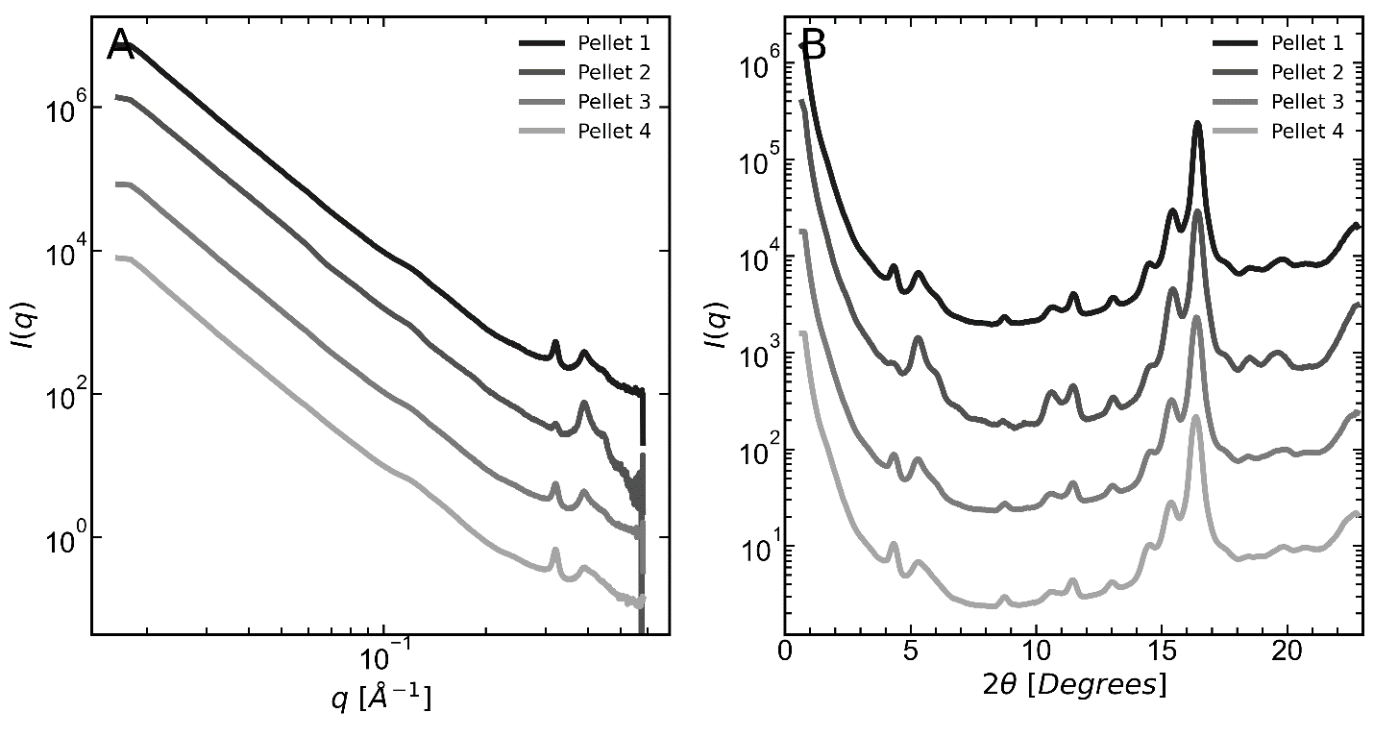
Figure S26: A) SAXS and B) WAXS intensities as a function of q of PET NPL pellets created after 28 days of degradation at 110 °C measured on pellets (created from pressing centrifuged and dried NPL powder). The spectra reported in the main text were obtained from smaller scattering volumes that are drop-cast on an SiN substrate.

Figure S27-30: Autocorrelation function and interface distribution function analysis
Figure S27: Representative 1D scattering data depicting the procedure for background subtraction. The slope of a plot of Iq⁴ v q⁴ represents the constant background that needs to be subtracted from all q values. A) spectrum before baseline removal B) spectrum after removal. Dashed black lines represent the area where the constant slope background was fit.

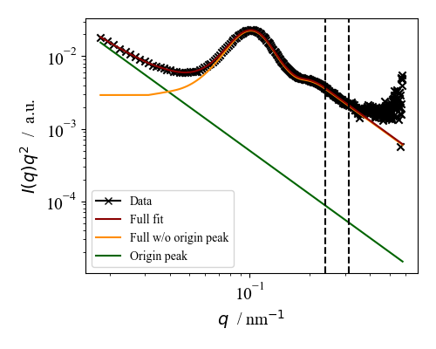
Figure S28: After background subtraction, the origin peak at low q is also removed as depicted in this figure. The black dashed lines represent the regime where the constant background was removed. The green solid line shows the origin peak fitting which is subtracted to give the yellow curve used for the autocorrelation analysis.

Note 2: Details of SAXS analysis
Here we outline the procedures used to analyze the scattering data. We also discuss additional results. The first step performed is removing a constant background from the data by requiring Porod scaling ($I ∝ K_{p}q^{-4}$) in the high q region, where $K_{p}$ is Porod’s constant. This process is shown in Figure S27. After this, an origin peak is removed from the low q region to ensure that the resulting 1D power spectral density (PSD) approaches a small positive constant as q $→$0 (the subsequent analysis is not affected by the choice of this constant). The origin peak takes the form of $I_{origin}\sim C_{origin}q^{-4}$. Figure S28 shows the origin peak removal. After performing these corrections to the data, we calculate the autocorrelation function $R_{LS}(ξ)$ as the real part of the Fourier transform of the Lorenz-corrected scattering data (yellow curve in Figure S28), following the methods of Strobl and Schneider ⁶. The autocorrelation functions for a series of bulk samples and for NPL samples are presented in Figure S29. The first maximum in $R_{LS}\left(ξ\right)$ provides an estimate of the long period. We go a step further to calculate the second derivative of the autocorrelation function ${R''}_{LS}(ξ)$ [also known as interface distribution function (IDF)] as the real part of the (one-dimensional) Fourier transform of ($K_{p}-I\left(q\right)q^{4})$. We follow the work and interpretations of Albrecht and Strobl ⁷ and present the IDFs for the same set of samples in Figure S30. The first maximum in the IDF provides an estimate of the shortest length scale (in our system this is the lamellar thickness), while the first minimum provides an estimate of the long period. Note, however, that our calculated IDF functions only display one maximum before the first minimum suggesting that a more precise estimate of the short length scales can be obtained via peak deconvolution or direct model fitting. The behavior of the IDF can be used to analyse the validity of the 1D lamellar stack model as its IDF should be 0 (a.u.) at $ξ=$0 Å. Our results indicate that the IDF at $ξ=$ 0 Å is $∼$0 (a.u.) for the undegraded sample and increases with degradation time, potentially indicating an increase in the density of lateral lamellar surfaces ^{7,8} (presumably generated by fragmentation of the lamellae). Here, we note that this procedure is notoriously sensitive to the details of the analysis and hence this conclusion should be treated with some caution.
Figure S29: Calculated autocorrelation functions for A) bulk samples and B) NPL samples.

Figure S30: Calculated interface distribution functions for A) bulk samples and B) NPL samples.

Figure S31: PET NPL SAXS Results
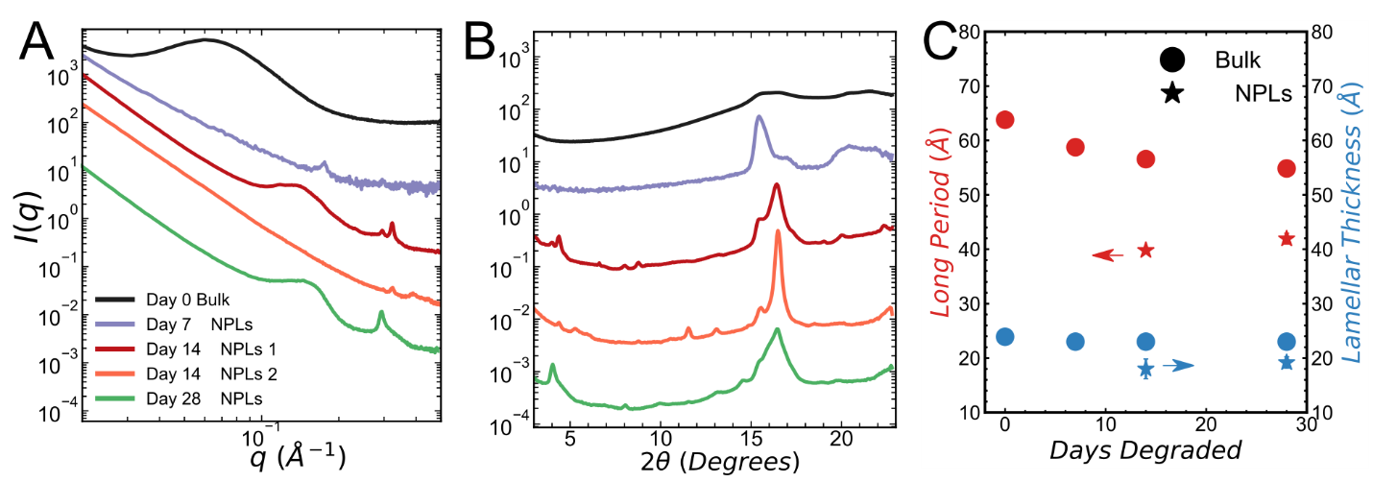
Figure S31: A) SAXS and B) WAXS of NPL samples with a bulk reference sample. Curves are shifted vertically for clarity. C) Long period and lamellar thickness of bulk and NPL with a long period peak calculated from the interface distribution function.

Note 3: PET NPL SAXS Results
Figure S31 displays the one-dimensional SAXS intensity for the NPL compared to the undegraded film. The scattering traces from NPL released after 14 and 28 days have significant variability and a strong dependence on the sampling volume; here, we show two representative data sets (data from larger scattering volumes are presented in Figures S25-26, except for the day 7 sample where there was not enough material). As seen in Figure S31A, one sample obtained after 14 days (termed “Day 14 NPL 1”) displays a SAXS pattern similar to that of the undegraded film, while another one (termed “Day 14 NPL 2”) shows no SAXS peaks. The presence of the crystalline peak in WAXS spectra (Figure S31B) along with the disappearance of the amorphous halo (commonly seen in the bulk), suggest that NPL possess a higher crystallinity than the starting material. This could be due to preferential degradation of the amorphous phase, chemi-crystallization, or potential differences in the microstructure between the skin (where NPL originate from) and the bulk of the material.
The WAXS reflections observed for PET correspond to the ($0\overline{1}1$), ($010$), and ($\overline{1}11$) at 2θ angles of 15.5°, 16.5°, and 22°, respectively for thermally crystallized PET ⁹. Meanwhile, the predominant WAXS reflections observed for TPA overlaps with PET at 16.5° (Figure S13). Several small peaks in the baseline are also observed and these could not be assigned to known products and may be the result of additives or small molecules that are released during degradation.

Figure S32: WAXS analysis of PET
Figure S32: Demonstrating WAXS peak deconvolution for A) a PET film and B) an NPL sample.

Figure S33: Summarized crystallinities of bulk PET from different methods
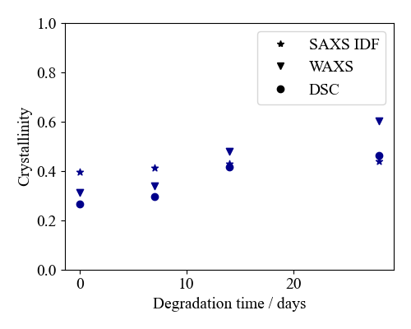
Figure S33: Crystallinities of PET films calculated from different methods and techniques.

Note 4: Details of WAXS analysis
Analysis of WAXS data is performed to estimate the crystallinity of the bulk samples and compare it to DSC and IDF (SAXS) estimates. This quantity can be estimated through a comparison of peak areas calculated through fitting pseudo-Voigt functions to the data. Figure S32 demonstrates the peak fitting process for two representative samples. Peak 1 represents the ($0\overline{1}1$) reflection in PET while peak 2 represents the ($010$) reflection of PET (and terephthalic acid in the case of NPL samples). Peak 3 represents the amorphous halo and peaks 4/5 are fitting tools to account for the high q behaviour (information in this region is not interpreted as the full azimuthal intensity is not present at high q values due to the limited detector size). While performing this analysis on the NPL samples it is observed that either no amorphous halo is present in the NPL samples or it is completely covered by the TPA peak, preventing an effective estimation of crystallinity. Figure S33 summarizes the crystallinity information for bulk samples from WAXS, IDF of SAXS data (where volumetric crystallinity is converted to a mass crystallinity), and DSC. We find that WAXS and DSC suggest increases in crystallinity while the IDF analysis suggests a less significant increase.

Figure S34-36: Size distributions of PET NPL
The size distributions for PET NPL represent measurements from collections of images that have been measured by hand. In the case of neutral water hydrolysis terephthalic acid crystallizes in solution and cannot be effectively removed without potentially altering the formed NPL. The PET and TPA crystals could not be distinguished from each other using electron diffraction patterns. Therefore, we measure what was observed in samples that are primarily PET (7 and 14-day degraded samples) and report the resulting distributions acknowledging that some of the objects may be terephthalic acid (that forms on a similar size scale to the measured PET). Since the NPL formed by PET have a natural tendency to aggregate we focus our measurements on NPL which we can unequivocally identify as individual particles. This procedure introduces a bias in our measurements where larger NPL (> 1-10 μm depending on the scale of the image) may not be considered as they could be large aggregates.
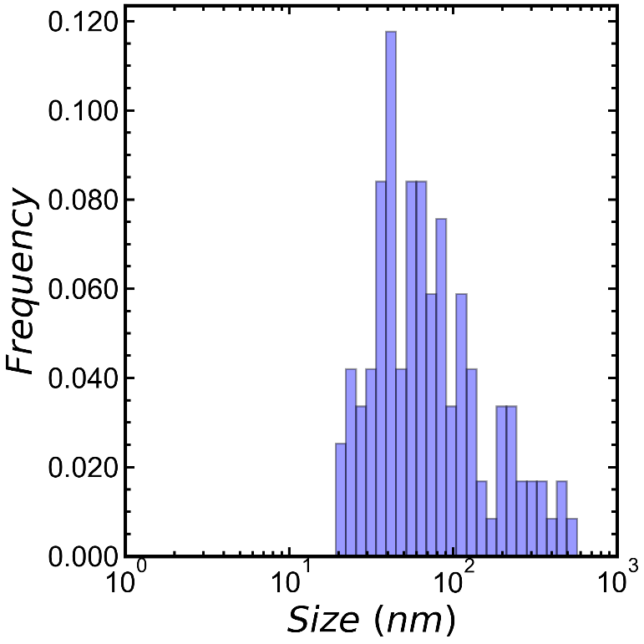
Figure S34: Size distribution measured from TEM images of a dilute sample of PET NPL degraded in neutral water for 7 days at 110 °C. This size distribution measures planar objects across their short axis.
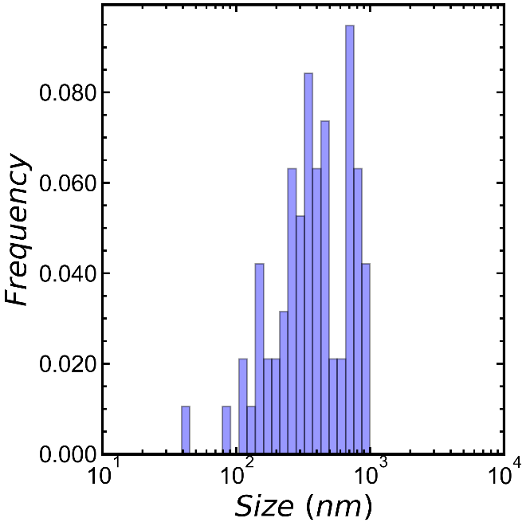
Figure S35: Size distribution measured from TEM images of a dilute sample of PET NPL degraded in neutral water for 7 days at 110 °C. This size distribution measures planar objects across their long axis.

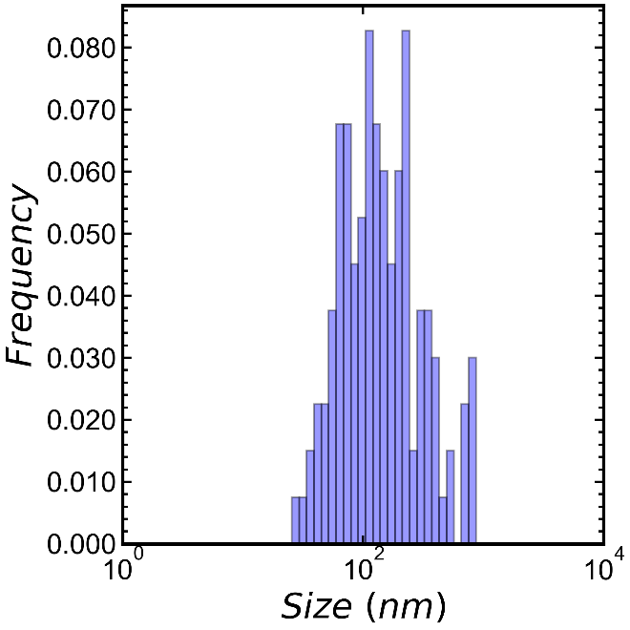
Figure S36: Size distribution measured from SEM images of a dried sample of PET NPL degraded in neutral water for 14 days at 110 °C.

Figure S37-38: Characterization of Amorphous PET (prior to recrystallization)
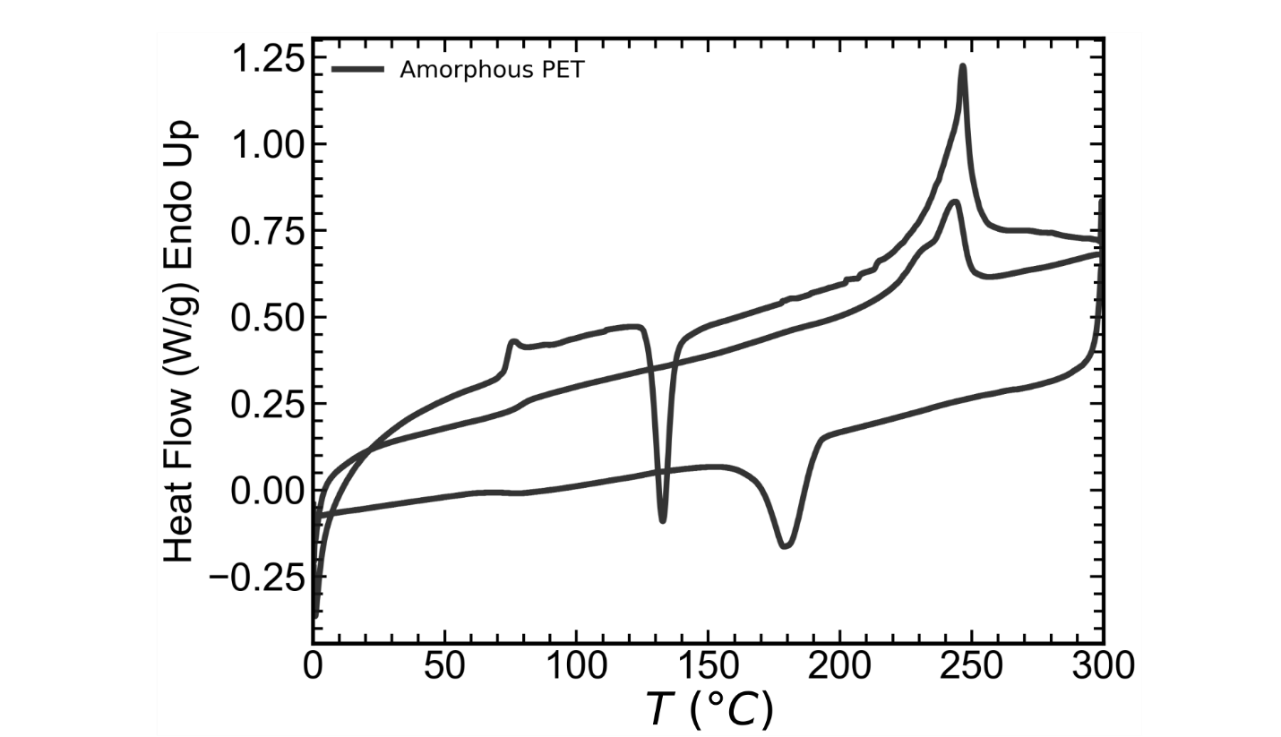
Figure S37: Heat-cool-heat DSC scan of amorphous PET at a ramp rate of 10 °C/min.

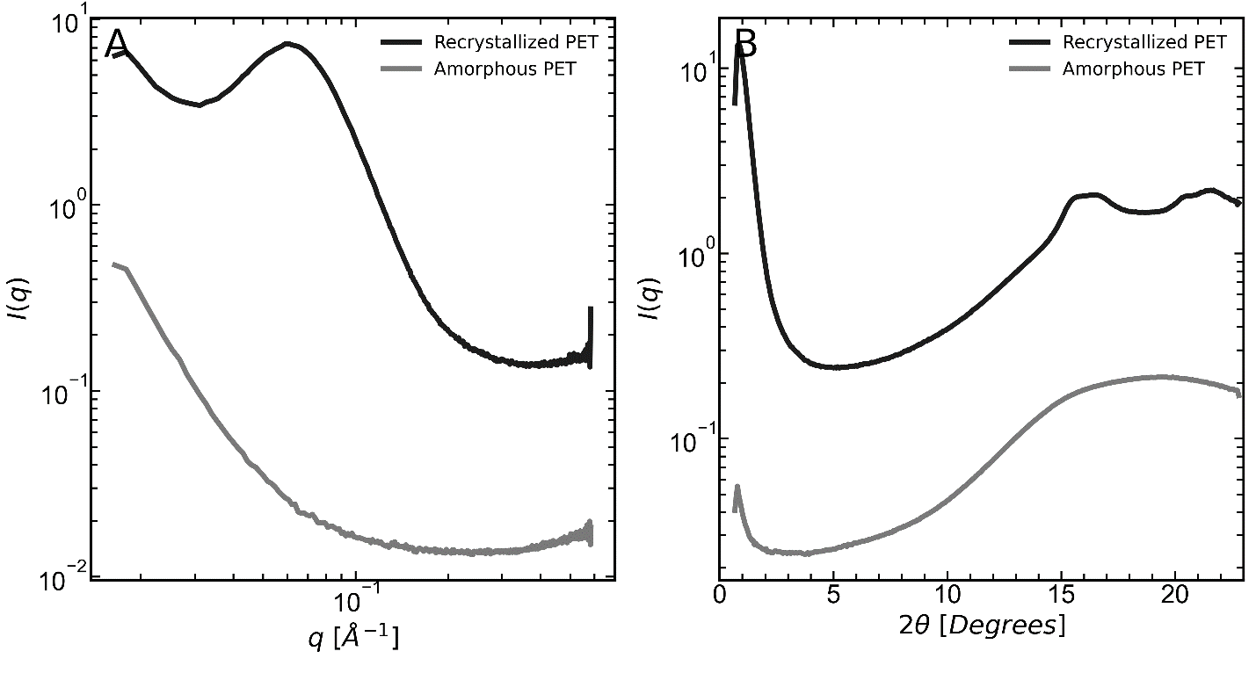
Figure S38: A) SAXS and B) WAXS spectra of amorphous and recrystallized PET. PET was recrystallized at 120 °C for 30 min.

Note 5: Molecular Weight Determination for iPP, aPP, sPS, and aPS
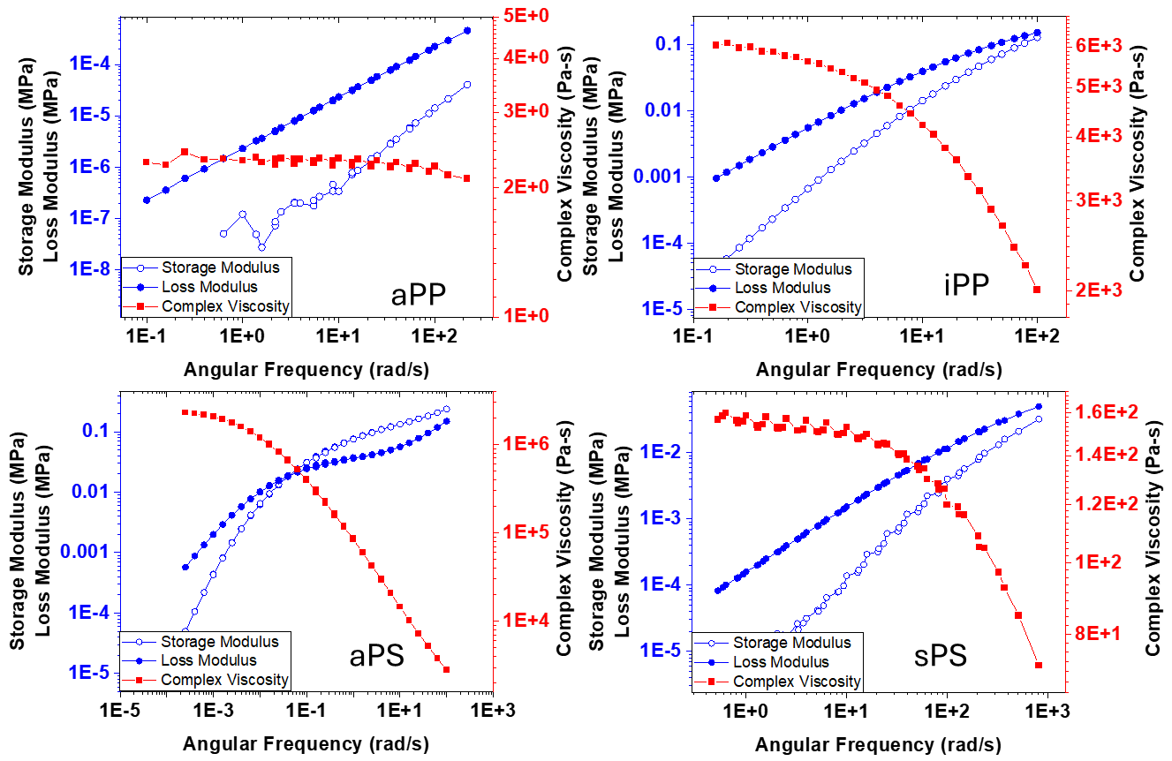
Figure S39: Master curve generated from frequency sweep data presented at the reference temperature (a) aPP (Tref = 160°C), (b) iPP (200°C), (c) aPS (140°C) and, (d) sPS (300°C).

Inverting the dynamic mechanical rheology data to obtain the molecular weight distribution is an ill-posed problem and we observed that the values obtained are very sensitive to the parameters used for the fits. Therefore, we obtain an estimate for the weight average molecular weight (M_{w}) from the low frequency Newtonian plateau in the viscosity. We use literature values for the zero shear viscosity (ZSV) and flow activation energy (E_{a}) of samples of known molecular weight as shown below.
Polymer | E_{a} (J/mol) | T (K) | ZSV (Pa.s) | MW (kg/mol) | Reference
aPP | 40,000 | 503 | 30,000 | 30 | ^{10–12}
iPP | 40,000 | 503 | 30,000 | 399 | ^{10–12}
aPS | 97,000 | 553 | 739 | 274 | ¹³
sPS | 54,000 | 553 | 783 | 178 | ¹³

We estimate the Mw for our samples as:
$$M_{W}= {M_{w}}_{ref}{\left(\frac{ZSV}{{ZSV}_{ref}}\right)}^{1/}$$
The scaling exponents for the ZSV dependence of M_{w}, α are taken from literature (3.64 and 3.33 for sPS and aPS, respectively, and 3.4 for iPP and aPP) ^{10,13}. Based on this, we estimate the molecular weight of our samples as: 29.83, 399.56, 274.07, and 178.27 kg/mol, for aPP, iPP, aPS and sPS respectively.

Figure S40: Further details on SEM image analysis
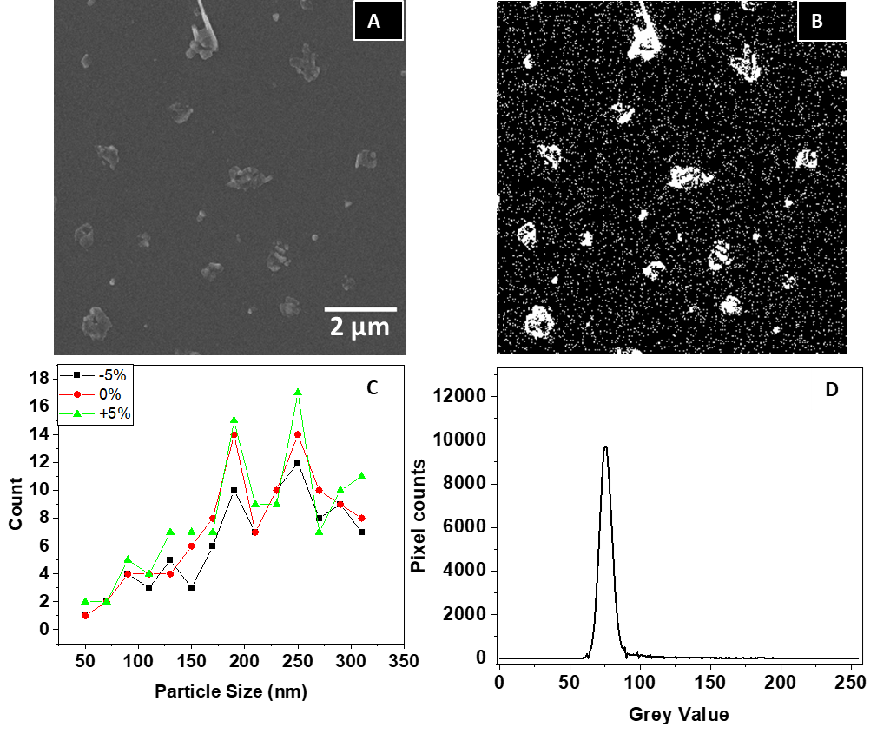Figure S40: A) SEM micrograph of day 2 iPP. B) SEM micrograph after thresholding (threshold value 77). C) Variation in counts with respect to particle size distribution when the threshold is changed by ±5%. We note that the typical change in particle count at any size is less than ±2, and that there is no qualitative change in the shape of the particle size distribution. D) Pixel histogram plot against grey values suggesting the highest pixel counts at 76.580 threshold value, matching with the auto threshold selected.

Note 6: Methods for SI that are not in Main Text
X-Ray Scattering: X-ray scattering (small and wide angle) is performed on a SAXSLAB instrument in the Columbia University Soft Matter Laboratory equipped with a Cu Kα source with a photon energy of 8.04 keV (λ = 1.54 Å). A moving Pilatus 300k detector is used with a variable sample-to-detector distance covering a wavevector, $q$, range of 0.004 – 1.2 $Å^{-1}$. Scattering measurements are performed with 3600 second exposure times, under vacuum, at room temperature. Scattering was performed using no substrate when applicable and a SiN substrate for measurements of NPL. Air and substrate blanks are subtracted from the sample scattering intensity. The resulting 2D detector images are processed and integrated to a 1D intensity profile, $I\left(q\right)$, using SAXSLAB’s SAXSGUI software.
Transmission Electron Microscopy (TEM): TEM is performed on a FEI F200X Talos TEM with a 200 kV accelerating voltage. TEM samples are prepared by drop-casting NPL from dilute aqueous solution before staining the samples for 30 s using uranyl acetate. 200 mesh copper TEM grids with a carbon film are used.
Rheology: Rheological Measurements are performed on an ARES G2 rheometer (TA Instruments/Waters) using a 25 mm parallel plate geometry. All measurements are done under a nitrogen blanket. Temperature is maintained using a forced convection oven. The film samples of aPP, iPP, aPS, and sPS are melted by heating them above their melting temperature. Amplitude Sweep is performed at a frequency of 1 rad/s to determine the linear viscoelastic range. Based on the amplitude sweep, a strain value is chosen within the LVE range to perform a frequency sweep. Frequency sweeps are performed at different temperatures (140-160 °C for aPP, 200-220 °C for iPP, 140-200 °C for aPS and 240-300 °C for sPS) over a frequency range of 0.1 - 100 rad/s. A master curve is generated by shifting the frequency sweep data to a reference temperature (aPP 160 °C, iPP 200 °C, aPS 140 °C and sPS 300 °C).
Differential Scanning Calorimetry of iPP and sPS: Differential scanning calorimetry (DSC) is performed using DSC250 (TA Instruments), operated under nitrogen atmosphere. For the film samples, 1–3 mg of the film is sealed in a standard aluminium pan. The experiments are done at a heating/cooling rate of 10 °C/min.

References
1. Lu, X. F. & Hay, J. N. Isothermal crystallization kinetics and melting behaviour of poly(ethylene terephthalate). Polymer (Guildf) 42, 9423–9431 (2001).
2. Ronkay, F. et al. Melting temperature versus crystallinity: new way for identification and analysis of multiple endotherms of poly(ethylene terephthalate). Journal of Polymer Research 27, 372 (2020).
3. Rabello, M. S. & White, J. R. Crystallization and melting behaviour of photodegraded polypropylene — I. Chemi-crystallization. Polymer (Guildf) 38, 6379–6387 (1997).
4. Nakatani, H., Ohshima, Y., Uchiyama, T. & Motokucho, S. Degradation and fragmentation behavior of polypropylene and polystyrene in water. Sci Rep 12, 18501 (2022).
5. Craig, I. H., White, J. R. & Kin, P. C. Crystallization and chemi-crystallization of recycled photo-degraded polypropylene. Polymer (Guildf) 46, 505–512 (2005).
6. Strobl, G. R. & Schneider, M. Direct evaluation of the electron density correlation function of partially crystalline polymers. Journal of Polymer Science: Polymer Physics Edition 18, 1343–1359 (1980).
7. Albrecht, T. & Strobl, G. Temperature-Dependent Crystalline-Amorphous Structures in Linear Polyethylene: Surface Melting and the Thickness of the Amorphous Layers. Macromolecules 28, 5827–5833 (1995).
8. Albrecht, T. & Strobl, G. Temperature-dependent crystalline-amorphous structures in isotactic polypropylene: small-angle X-ray scattering analysis of edge-bounded two-phase systems. Macromolecules 28, 5267–5273 (1995).
9. Bornschlegl, E. & Bonart, R. Small angle X-ray scattering studies of poly(ethylene terephthalate) and poly(butylene terephthalate). Colloid Polym Sci 258, 319–331 (1980).
10. Eckstein, A., Friedrich, C., Lobbrecht, A., Spitz, R. & Mülhaupt, R. Comparison of the viscoelastic properties of syndio‐ and isotactic polypropylenes. Acta Polymerica 48, 41–46 (1997).
11. Thomas, D. P. The influence of molecular weight on the melt rheology of polypropylene. Polym Eng Sci 11, 305–311 (1971).
12. Gahleitner, M. Melt rheology of polyolefins. Prog Polym Sci 26, 895–944 (2001).
13. Huang, C.-L., Chen, Y.-C., Hsiao, T.-J., Tsai, J.-C. & Wang, C. Effect of Tacticity on Viscoelastic Properties of Polystyrene. Macromolecules 44, 6155–6161 (2011).

