Figure 1s - Effects of Surgical Revisions of Weight Loss (%WL) After Sleeve Gastrectomy: Comparison of No Revision, Gastric Bypass and Mini Bypass

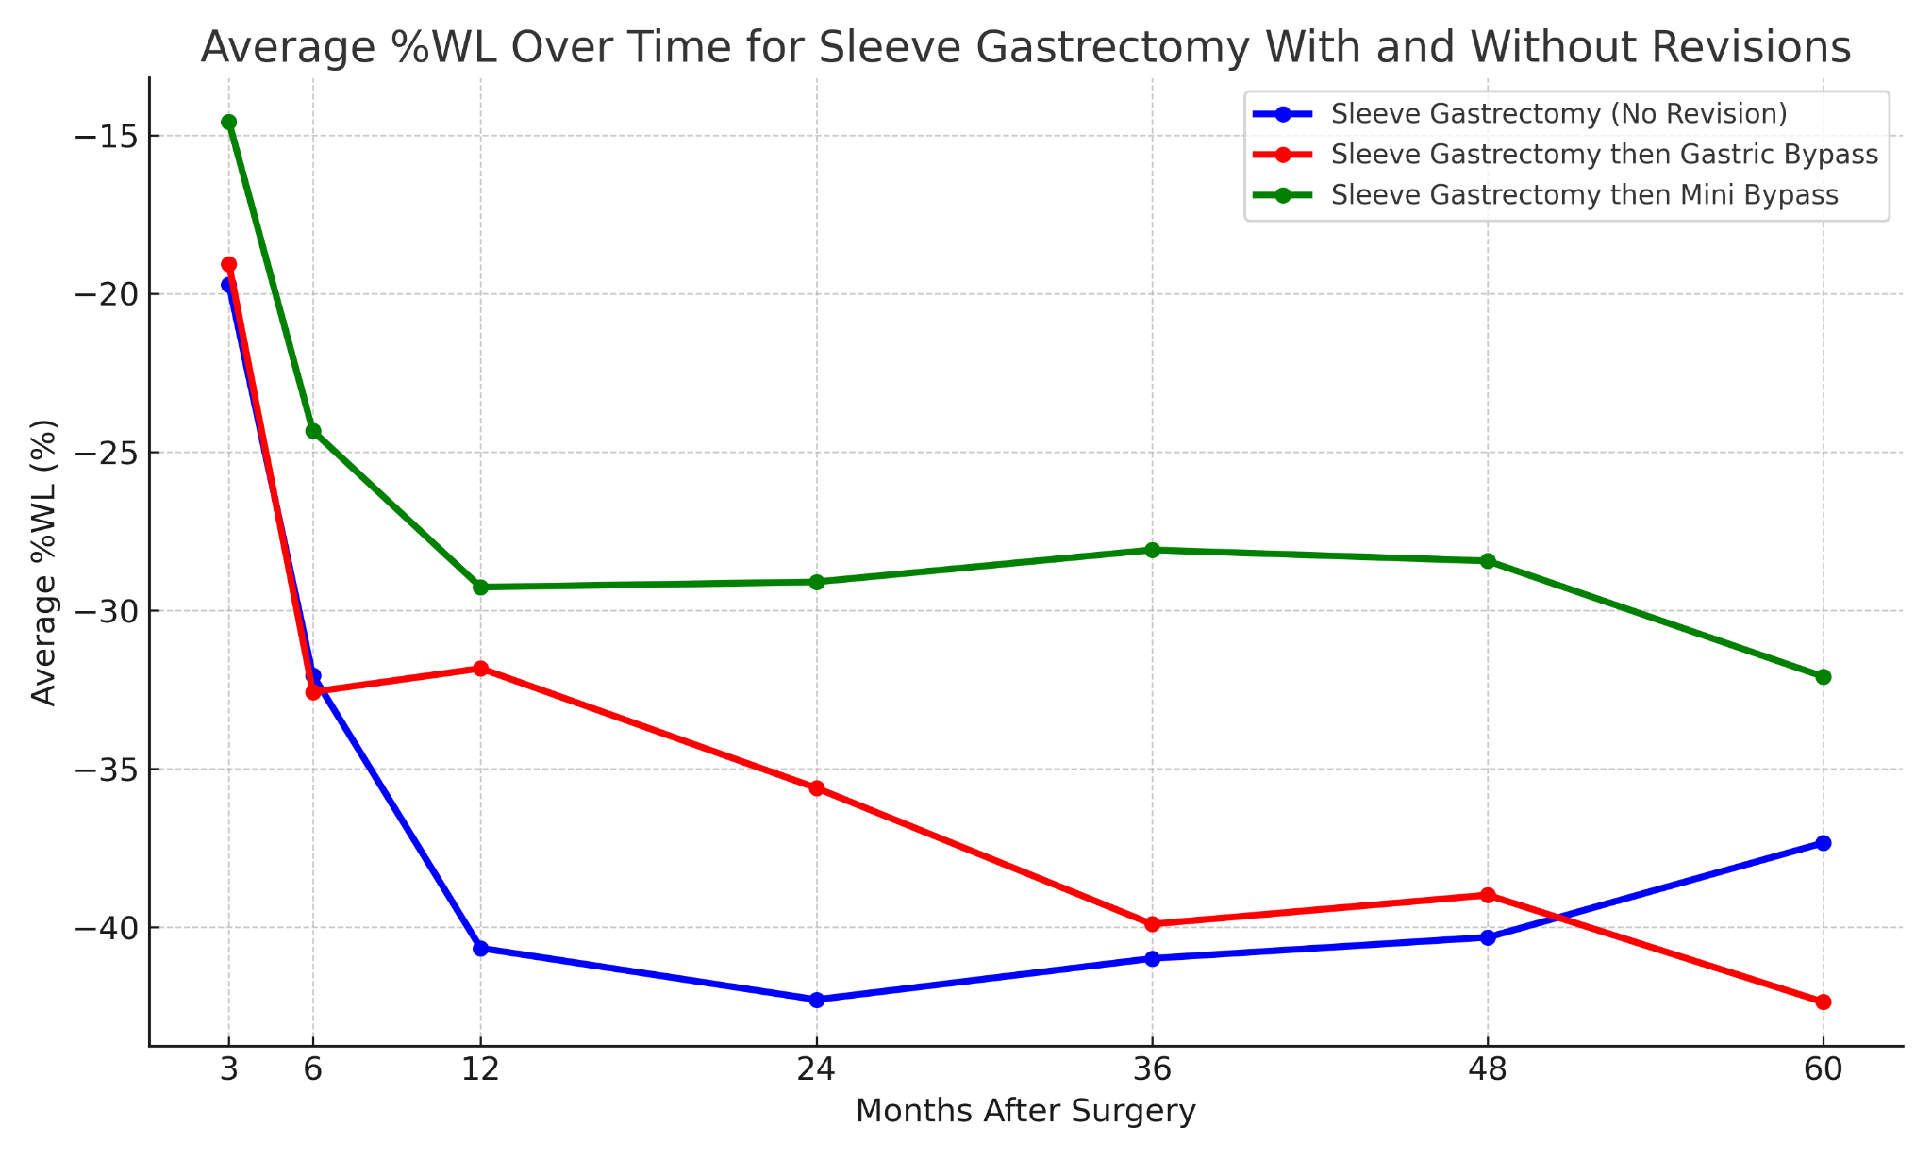
Caption Figure 1s - Graph of the mean trajectory of the percentage weight loss (%WL) for patients who underwent LSG without revision, followed by RYGB and MGB, at 3, 6, 12, 24, 36, 48 and 60 months after surgery. The p-values for differences between surgery groups at each time point were calculated using one-way ANOVA: 3 months (p = 0.085), 6 months (p = 0.070), 12 months (p < 0.001), 24 months (p = 0.002), 36 months (p = 0.006), 48 months (p = 0.029), and 60 months (p = 0.142).

Figure 2S - Comparison of Weight Loss (%WL) Over Time Between Revised and Non-Revised RYGB Patients
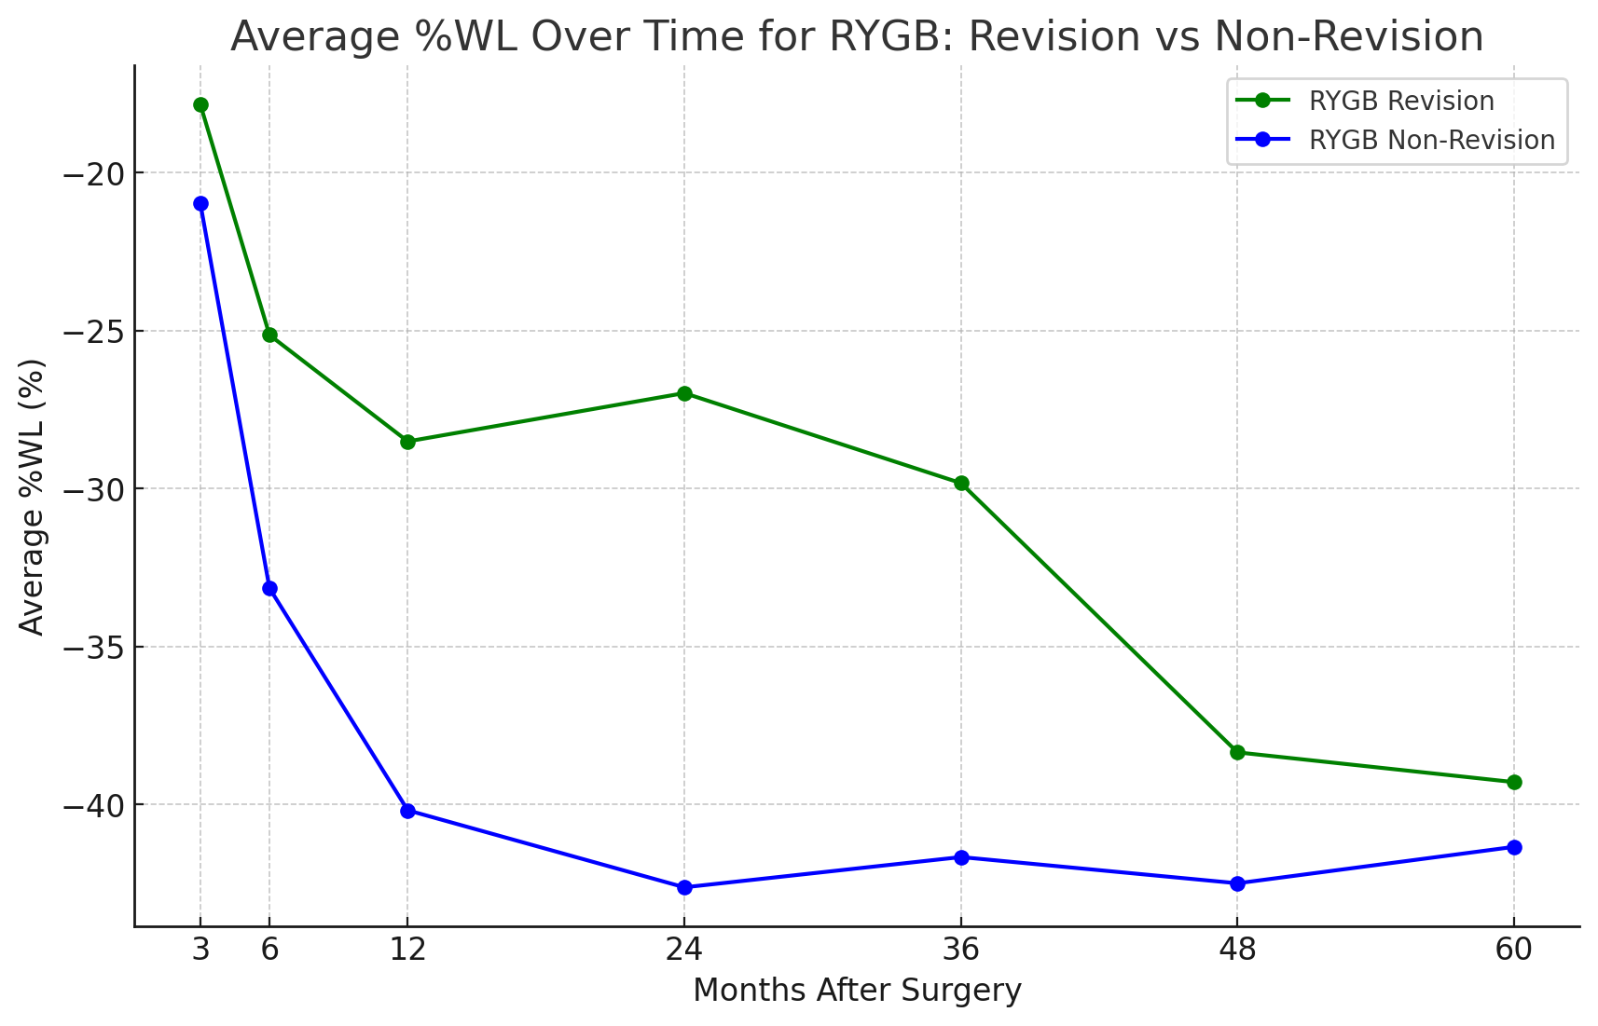

Figure 2S – Graph of the mean percentage weight loss (%WL) for patients who underwent Roux-en-Y gastric bypass (RYGB) with and without revisions at 3, 6, 12, 24, 36, 48, and 60 months after surgery. Statistical analysis using a t-test revealed significant differences between the two groups at multiple time points: 3 months (p = 0.126), 6 months (p = 0.025), 12 months (p = 0.033), 24 months (p = 0.003), 36 months (p = 0.011), 48 months (p = 0.347), and 60 months (p = 0.662).

Table 1S - Nutrient Deficiencies Post-Bariatric Surgery

 |  | Supplements use | Patients with Long Term deficiencies that do not take supplements | Nutrient | Short-Term Deficiency - 1 year  (%) | Long-Term Deficiency - from the 2nd year  (%) | New deficiency  (long-term)
AGB | without revision (6) | 16.7% | 16.7% | Iron | 16.7% | 0% | 0%
 |  |  |  | Potassium | 0 | 16.7% | 16.7%
AGB | with revision (10) | 80% | 0% | Iron | 10% | 20% | 20%
RYGB | without revision (43) | 84% | 2.3% | Iron | 18.6% | 9.3% | 4,7%
 |  |  |  | Vitamin D | 18.6% | 14% | 11.6%
 |  |  |  | Folic Acid | 2.3% | 4.7% | 2.3%
 |  |  |  | Vitamin B12 | 7% | 7% | 4,7%
 |  |  |  | Gruppo B | 4.7% | 0% | 0%
 |  |  |  | Vitamin E | 2.3% | 0% | 0%
 |  |  |  | Protein | 4.7% | 0 | 0%
RYGB | with revision (6) | 83.3% | 0% | Iron | 66% | 50% | 33%
 |  |  |  | Vitamin D | 50% | 50% | 33%
 |  |  |  | Folic Acid | 16.7% | 50% | 0%
 |  |  |  | Potassium | 16.7% | 0% | 0%
MGB | without revision (53) | 90.6% | 0% | Iron | 13.2% | 11.3% | 5,7%
 |  |  |  | Vitamin D | 11.3% | 7.5 % | 7.5 %
 |  |  |  | Calcio | 1.9% | 1.9% | 1.9%
 |  |  |  | Potassio | 1.9% | 0% | 0%
 |  |  |  | Vitamin B12 | 0% | 1.9% | 1.9%
 |  |  |  | Vitamin C | 0% | 1.9% | 1.9%
MGB | with revision (1) | 0% | 100% | Iron | 100% | 100% | 100%
 |  |  |  | Vitamin B12 | 100% | 0% | 0%
LSG | without revision (97) | 54.7% | 11.3% | Iron | 17.7% | 9.4% | 5.1%
 |  |  |  | Vitamin D | 12.5 % | 6.3% | 2.1%
 |  |  |  | Calcio | 1% | 1% | 1%
 |  |  |  | Copper | 1% | 0% | 0%
 |  |  |  | Vitamin A | 1% | 0% | 0%
 |  |  |  | Protein | 2.1% | 0% | 0%
 |  |  |  | Vitamin C | 1% | 0% | 0%
 |  |  |  | Zinc | 1% | 1% | 1%
 |  |  |  | Group B Vitamins | 0% | 1% | 1%
 |  |  |  | Folic Acid | 1% | 0% | 0%
LSG | with revision (21) | 88.2% | 0% | Iron | 41.2% | 41.2% | 14.3%
 |  |  |  | Vitamin D | 23.5% | 17.6% | 4.7%
 |  |  |  | Vitamin B12 | 5.9% | 11.8% | 4.7%
 |  |  |  | Calcium | 5.9% | 0% | 0%
 |  |  |  | Proteins | 5.9% | 0% | 0%
 |  |  |  | Folic Acid | 0% | 5.9% | 4.7%
 |  |  |  | Zinc | 0% | 5.9% | 4.7%
 |  |  |  | Potassium | 0% | 5.9% | 0%

Caption Table 1S - The table compares nutrient deficiencies across different types of bariatric surgeries, both with and without revision, over short-term (1 year) and long-term periods (from the 2nd year onward). It highlights the prevalence of deficiencies in key nutrients. For revisions, AGB saw 5 conversions to MGB and 1 to LSG, 4 to RYGB; RYGB revisions included 5 to MGB and 1 to another RYGB. LSG revisions involved 52.9% to bypass, 35.3% to mini bypass, 5.9% to resleeve, and 5.9% to Roux-en-Y esophago-jejunostomy.

