Title Page
Manuscript title: A study of the effects of fresh and processed fish oils of Tenualosa ilisha, Mystus bleekeri, and Puntius sophore on Experimental Model on Atherosclerosis
Sanchari Goswami¹, Asis Bala², Kumaraswamy Gandla¹, Bikash Debnath³, Waikhom Somraj Singh³, Kuntal Manna^{*4}
¹Chaitanya Deemed to be University, Gandipet, Himayatnagar, Hyderabad -500075.Telangana.
²Institute of Advanced Study in Science and Technology, Guwahati, Assam, India-781035
3Institute of Pharmacy, Assam Don Bosco University, Tapesia Gardens, Sonapur, Assam.
⁴Department of Pharmacy, Tripura University (A Central University), Agartala, Tripura, India-799022.

Correspondence: k_manna2002@yahoo.com, Tel: +91381-2379404, Fax: +91381-2374803

Authors 1: Sanchari Goswami
Authors Affiliation: Assistant Professor, Department of Pharmacy, Chaitanya Deemed to be University, Gandipet, Himayatnagar, Hyderabad -500075.Telangana, India
Email: sancharig89@gmail.com. ORCID ID: 0000-0003-1362-195X

Authors 2: Asis Bala
Authors Affiliation: Associate Professor-I (Division of Life Sciences), Institute of Advanced Study in Science and Technology, Guwahati, Assam, India-781035
Email: asisbala@iasst.gov.in ORCID ID: 0000-0002-2148-2331

Authors 3: Kumaraswamy Gandla
Authors Affiliation: Professor and Head Department of Pharmacy Chaitanya Deemed to be University, Gandipet, Himayatnagar, Hyderabad -500075.Telangana., India
Email: kumaraswamy_pharm@chaitanya.edu.in ORCID ID: 0000-0003-3138-5647

Authors 4: Bikash Debnath
Authors Affiliation: Assistant Professor, Institute of Pharmacy, Assam Don Bosco University, Tapesia Gardens, Sonapur, Assam, India
Email: bikashrips2014@gmail.com. ORCID ID: 0000-0001-9698-0012

Authors 5: Waikhom Somraj Singh
Authors Affiliation: Assistant Professor, Institute of Pharmacy, Assam Don Bosco University, Tapesia Gardens, Sonapur, Assam, India
Email: somraj.1986@gmail.com. ORCID ID: 0000-0001-8128-169X

Authors 6: Kuntal Manna* (correspondence author)
Authors Affiliation: Professor, Department of Pharmacy, Tripura University (A Central University), Suryamaninagar, Tripura, India-799022.
Email: k_manna2002@yahoo.com ORCID ID: 0000-0001-5327-365X

Declarations

ETHICS APPROVAL AND CONSENT TO PARTICIPATE
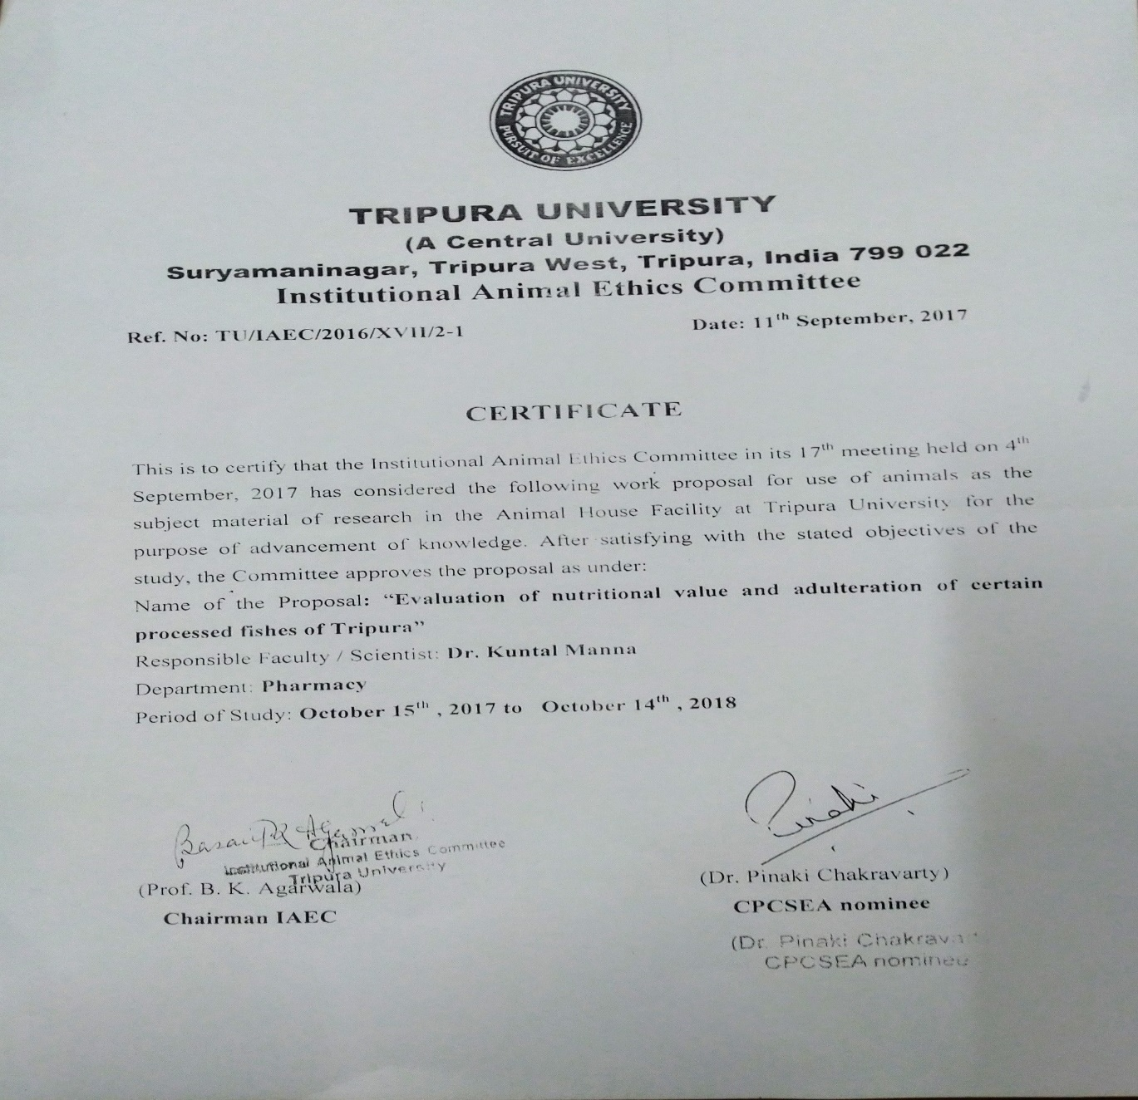

Declarations

- Funding: This research was not funded by any public, commercial, or not-for-profit organizations
- Institutional Animal Ethics Committee: Applicable with Ref. No. TU/IAEC/2016/XVII/2-1/CPCSEA date :11th September ,2017.
The manuscript does not contain studies involving human participants or human data. All experiments were performed in accordance with the National Institute of Health Guide for the Care and Use of Laboratory Animals, and approved by the Institutional Animal Care and Use Committee of the Tripura Central University, Suryamaninagar Tripura West, Tripura India-799022. (TU/IAEC/2016/XVII/2-1/CPCSEA.
- Informed Consent Statement: Not applicable.
- Conflicts of Interest: The authors declare no conflicts of interest
- Competing interests: The authors declare that they have no competing interest.
- Data availability: Data sharing is not applicable to this article as no datasets were generated or analyzed during the current study.

Authors’ contributions
SM: Helped with the creation of the abstract, obtention of the medical records to write the case presentation and helped to build the discussion. Participated with the health care of the patient. SG: Helped with the redaction and research to write the abstract, introduction, discussion and conclusions. LR: Helped with the obtention of the images shown in the article and correction of mistakes in the case presentation. MS: Participated with the health care of the patient. GN: Helped with the obtention of information to build the case and correction of mistakes in the discussion. Participated with the health care of the patient. All authors read and approved the final manuscript. GKS: assisted in editing and proofreading the manuscript and gave final approval for its submission.

ACKNOWLEDGMENT
The authors are grateful to University Grant Commission (UGC), Govt. of India, for providing Startup Grant for newly recruited faculty and as financial support. We are also acknowledging Department of Science and Technology (DST), Govt. of India. The authors are grateful to New Jersey Feed Lab Inc., 1686 Fifth St, Trenton NJ 08638, USA for providing instrument facility. The authors are also grateful for State Biotech Hub, Tripura Central University-799022, for providing working facility. The authors are also grateful for Tripura State Pollution Control Board, Kunjaban, Gorkhabasti, Agartala-799006, providing the instrumental facility for analysis of minerals. The authors are also indebted to Mr. W. Somraj Singh, and Mr. Bikash Debnath, Research Scholar, Department of Pharmacy; Tripura Central University for editing the manuscript.

