Supplemental Materials

Table S1: Details for all sites included within our study. Site names were given based on locations across Southern California with latitude and longitude coordinates given as decimal degrees. Foundation corresponds to the dominant shrub species observed in each site while aridity corresponds to each site’s calculated De Martonne aridity index.

site | longitude | latitude | foundation | aridity
Antelope_valley | -118.602041 | 34.87623299 | Ephedra californica | 5.32
Avenal | -120.101809 | 36.062187 | Ephedra californica | 6.19
Carrizo_1 | -119.72495 | 35.20177 | Ephedra californica | 6.15
Cuyama_1 | -119.483117 | 34.84872602 | Ephedra californica | 5.67
Kelso_5 | -115.664356 | 35.061279 | Larrea tridentata | 4.73
Mojave_1 | -116.0472333 | 35.25608333 | Larrea tridentata | 4.99
Panoche_1 | -120.7972 | 36.69533 | Ephedra californica | 7.31
Panoche_silvercreek | -120.688315 | 36.585782 | Ephedra californica | 6.71
Semitropic | -119.6072509 | 35.65927718 | Ephedra californica | 6.01
Tecopa_open | -116.17866 | 35.85474 | none | 5.48

Table S2: Models of best fit with linear and second order polynomial curves contrasted using the compare_performance function from the ‘performance’ R package.

response | model | Nagelkerke's R2 | RMSE
observations hourly | linear | 0.975 | 6.11
 | second-order polynomial | 0.99 | 5
richness per hour sampled | linear | 0.07 | 0.097
 | second-order polynomial | 0.52 | 0.07
evenness | linear | 0.05 | 0.094
 | second-order polynomial | 0.5 | 0.07

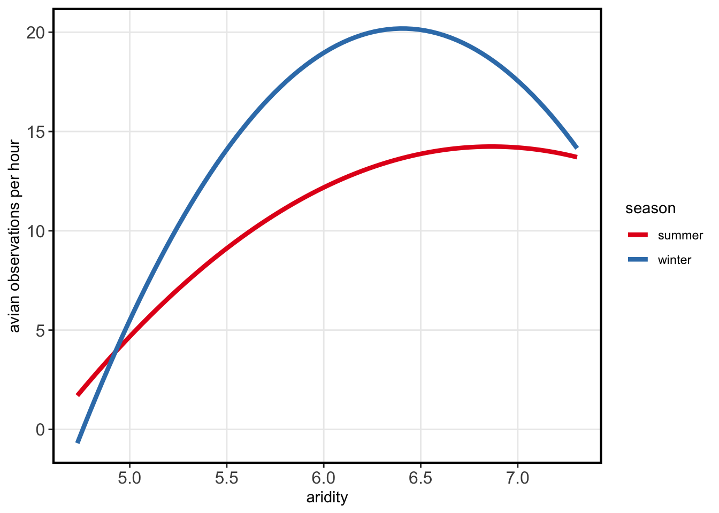
Figure S1. The relative importance of the long-term site-level aridity estimate on avian observations per hour. All observation data was collected from eBird and combined with aridity measurements. Observations were separated by season observed; summer (red) and winter (blue).

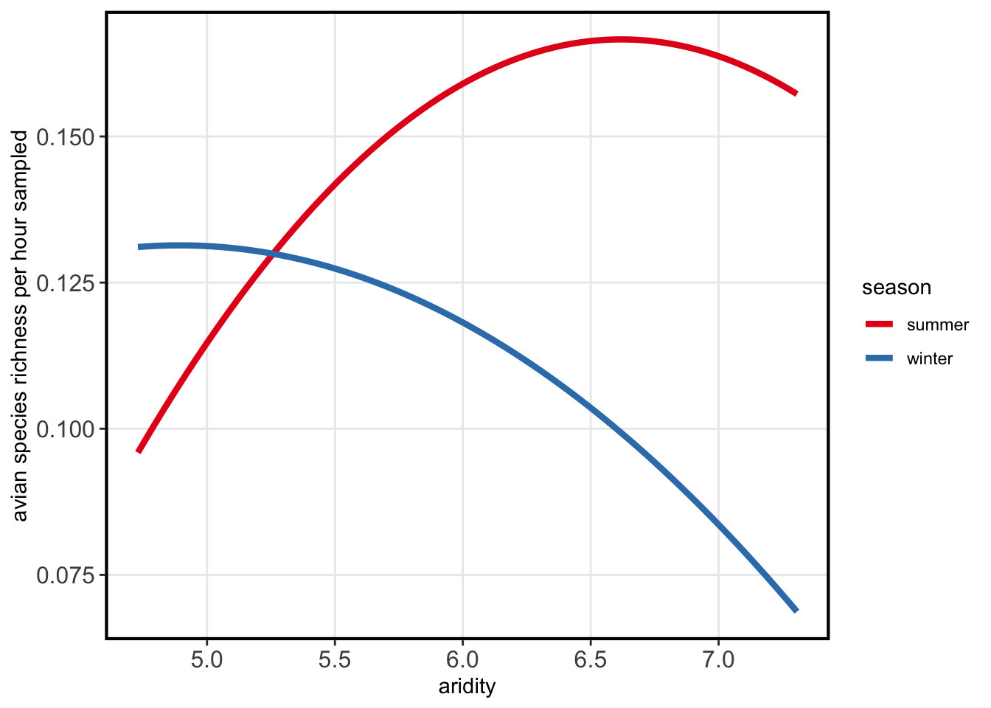
Figure S2: The relative importance of the long-term site-level aridity estimate on avian richness per hour sampled. All observation data was collected from eBird and combined with aridity measurements. Observations were separated by season observed; summer (red) and winter (blue).

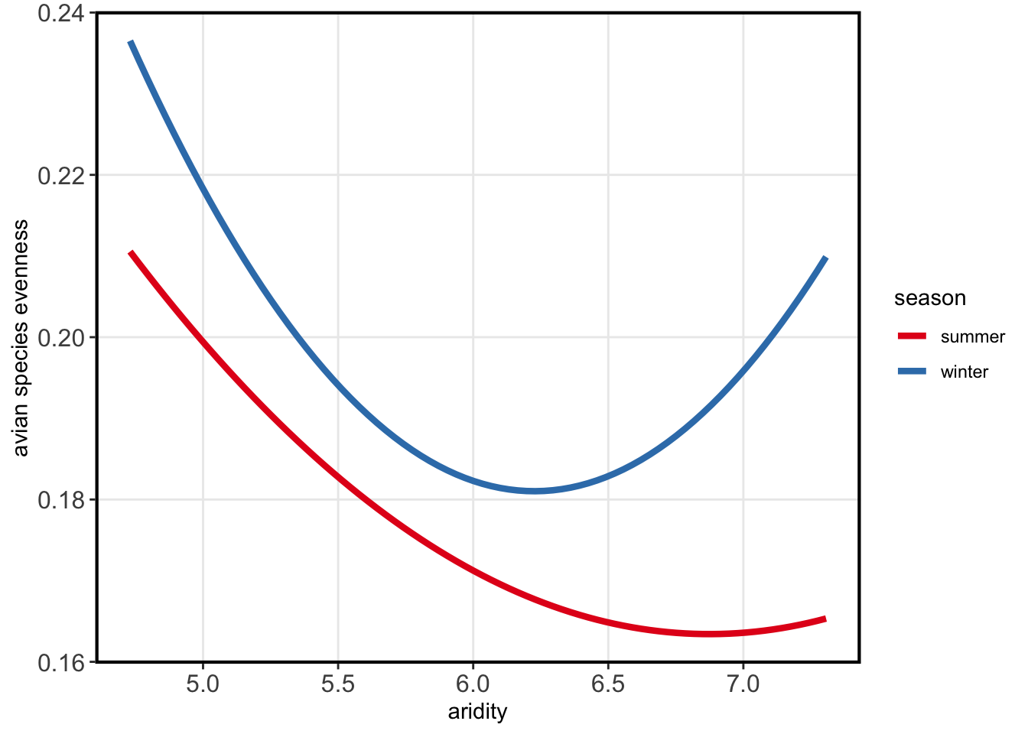
Figure S3: The relative importance of the long-term site-level aridity estimate on avian species evenness. All observation data was collected from eBird and combined with aridity measurements. Observations were separated by season observed; summer (red) and winter (blue).

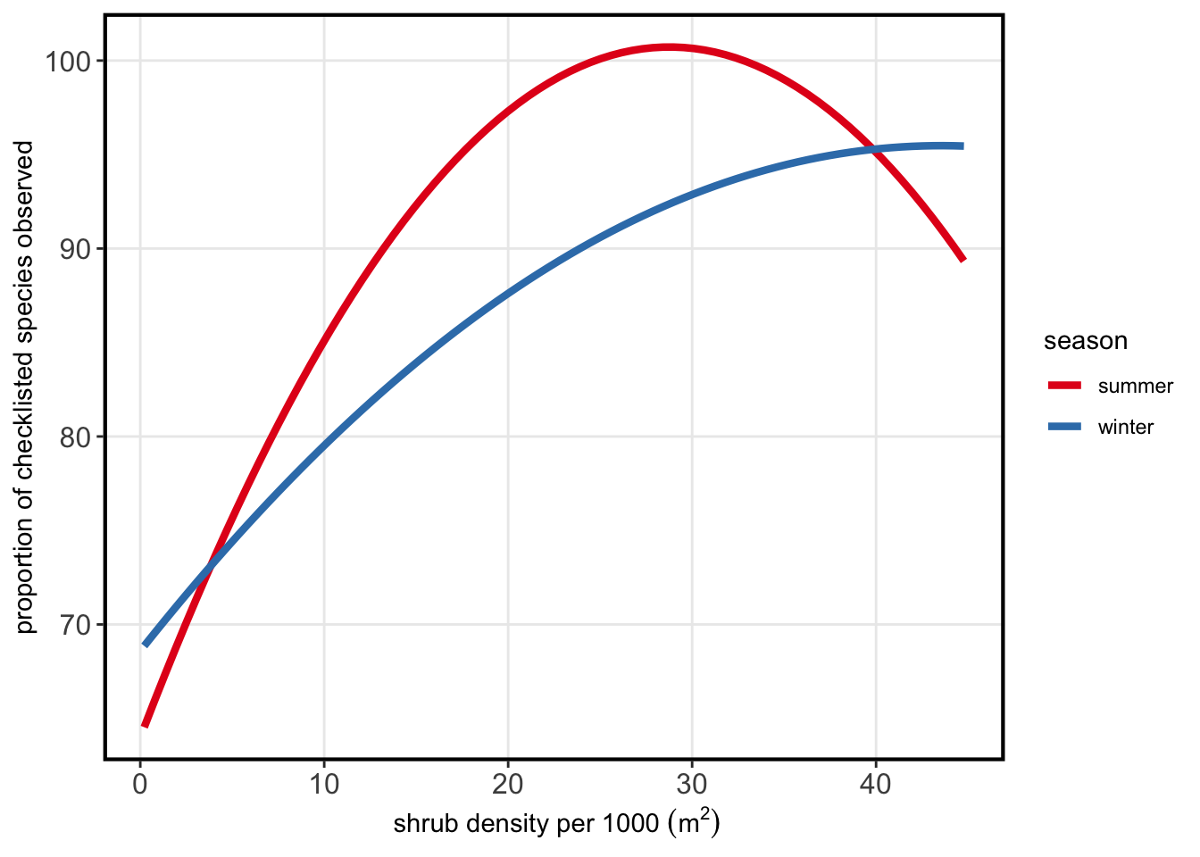 Figure S4: The relative importance of shrub density per site per season on the proportion of species observed relative to checklists for each instance. There was a significant interaction between shrub density and aridity for this response variable (GLM, Chi-sq = 0.07, df = 13, p = 0.01). Shrub density is the total number of shrub individuals within 1000 m², and proportion observed is the proportion of species observed per checklist.

