Supplementary materials
Figure 1s demonstrates the relationship between the EIA crest (NmF2) and its corresponding height (hmF2) only over the African sector for both the north and the south in the upper and the lower rows respectively. Columns from left to right corresponding to the morning, noon and dusk times. Black, blue, green and red corresponding to the autumn, winter, spring and summer months, respectively. It’s clearly shown that during noon and dusk time hours the NmF2 is significantly enhanced with respect to altitudes until 350 km, but at more higher altitudes the NmF2 saturates until 450 km which subsequently decreases again. The abrupt enhancement of the dusk time NmF2 at 350 is independent of season. It is also prominent during spring months in both hemispheres. The morning NmF2 demonstrates a linear correlation with respect to the hmF2, as it smoothly increases with heights.
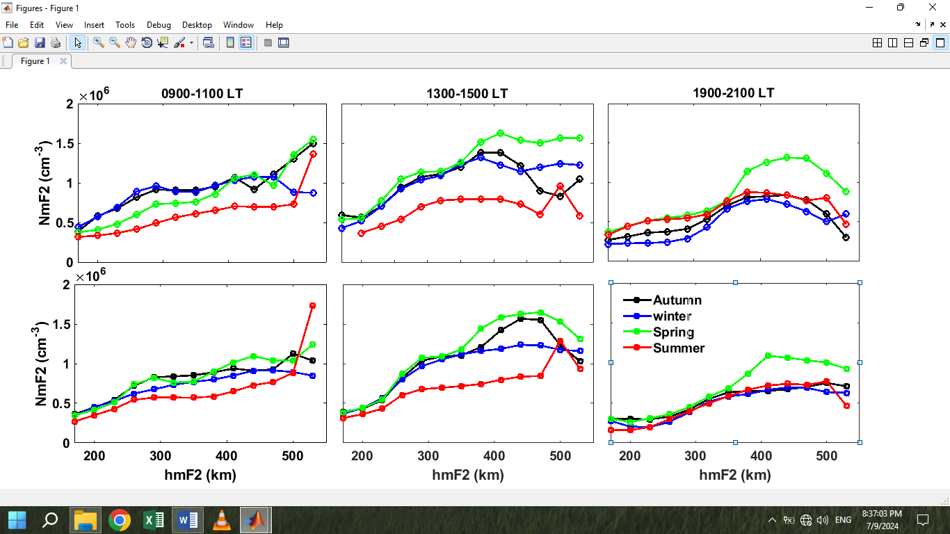

Fig. 1s. The NmF2 versus hmF2 solar flux over the African sector (20º-50ºE) for northern (13º-25ºN) and southern (13º-25ºS) hemisphere in the upper and lower row respectively. Columns from left to right corresponding to morning (0900-1100) the noon 13:00-15:00 and evening (1900-2100) local times respectively. Winter spring, summer and autumn in blue, green, summer and autumn, respectively.

Figure 2s demonstrates the daily and monthly F10 solar flux along the whole period of observation 2006-2023 in black and red lines respectively in the left panel. The linear fitting between the F107 and the electron density data in the left panel for the different seasons. It shows that however the higher solar flux during summer months the density is always lower, while during equinoxes the density is the highest as it has indicated through the linear fit lines in the right panel. At higher solar flux levels, the data points are highly scattered. Therefore, the solar flux F107 index capable to interpret the NmF2 solar cycle dependence only at low solar activity, while at higher levels the NmF2 should have additional driving mechanisms that has the capability to interpret such saturation(non-linearity). Figure 3s shows that all sparse points at high F107, are observed the crest of the 24 solar cycle 24 during the year 2014. Which confirms the non-linearity in hmF2 and NmF2 exist at higher solar activity levels

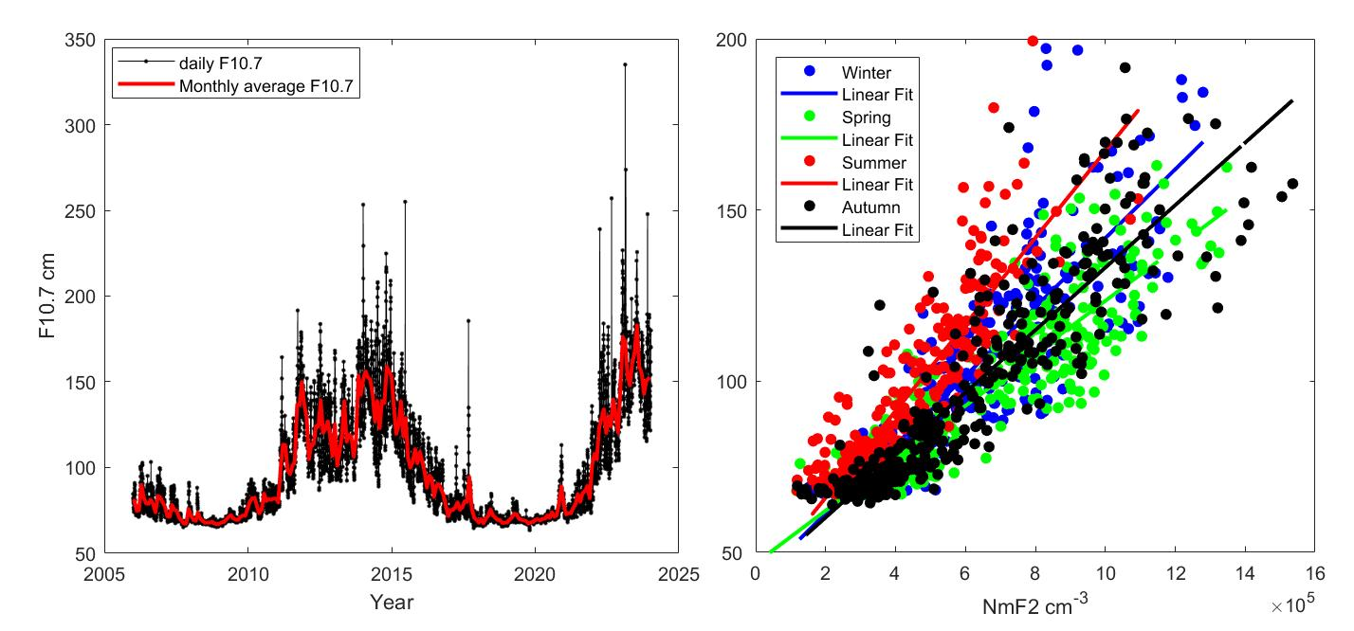
Fig.2s. a) The daily and its monthly average in black and red lines respectively with respect to year. The linear fitting between the noon time NmF2 and the solar flux for winter, spring, summer and autumn season in blue, green, red and black color respectively.

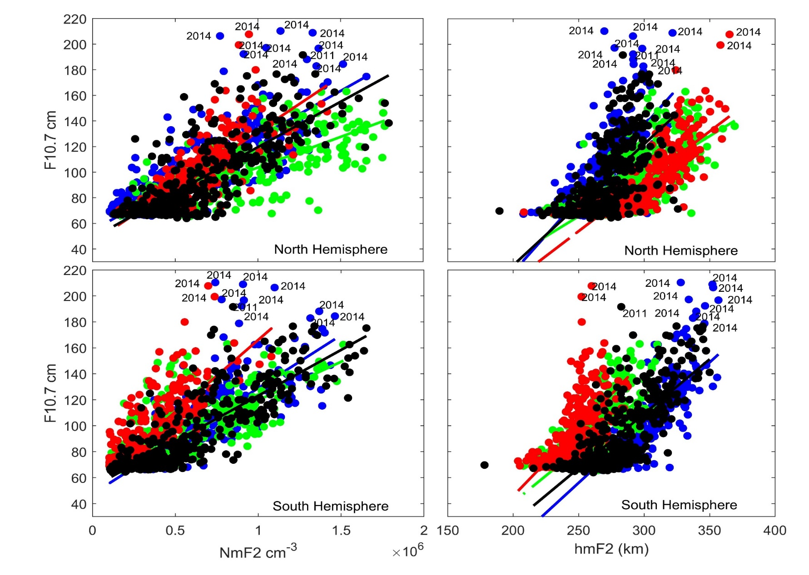
Fig.3s. a) A scatter plot of the relationship between the solar flux index F10.7 and the NmF2 in north and south hemisphere in upper and lower panel of the left columns respectively. Similarly, the right column, but for the F10.7 w.R.t the hmF2. Winter, spring, summer and autumn season in blue, green, red and black color respectively.

