Supplementary Figures

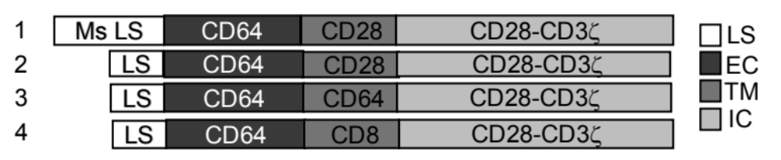

Figure 1 S. Schematic representation of CD64-CR constructs. All CD64 chimeric constructs (1-4) shared the extracellular region of the human CD64 and the intracellular signaling motifs CD28/CD3ζ. Construct 1 and 2 included CD28 transmembrane domain while construct 3 and 4 had CD64 and CD8 transmembrane domains, respectively. Construct 1 carried a CD64 mouse leader sequence. Ms LS= CD64 mouse leader sequence, LS= CD64 human leader sequence, EC= extracellular, TM: transmembrane, IC: intracellular.

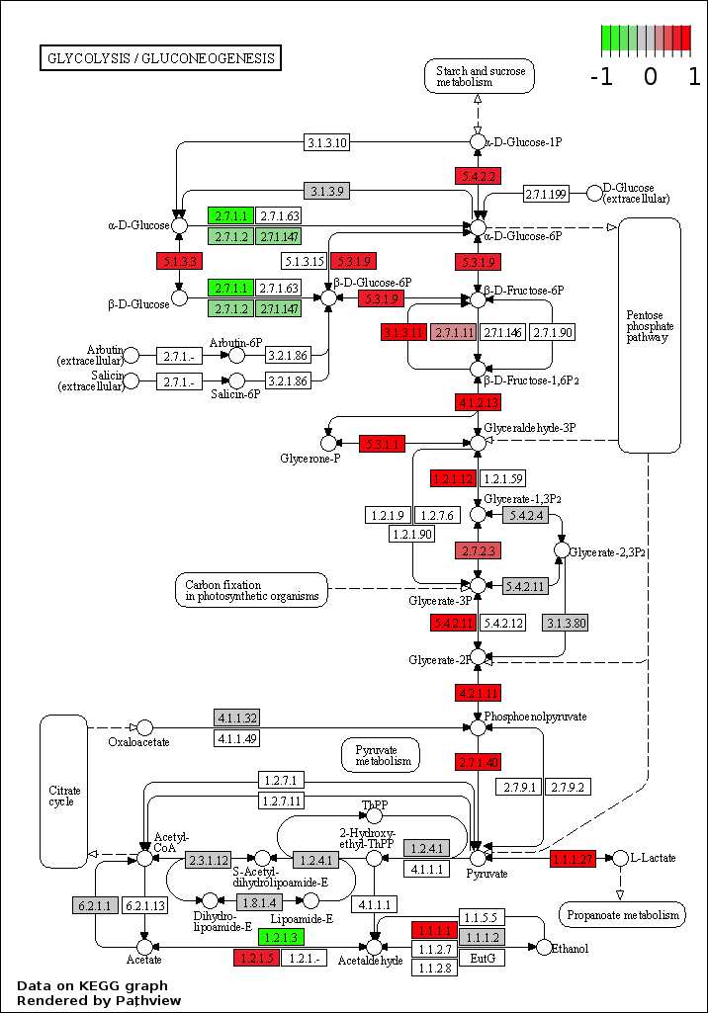

Figure 2 S.
Pathview KEGG plot showing the expression levels as fold changes of the genes coding for the main enzymes or enzymatic complexes involved in the Glycolysis/Gluconeogenesis metabolic pathway of CD64-CR T cells and NT T cells.
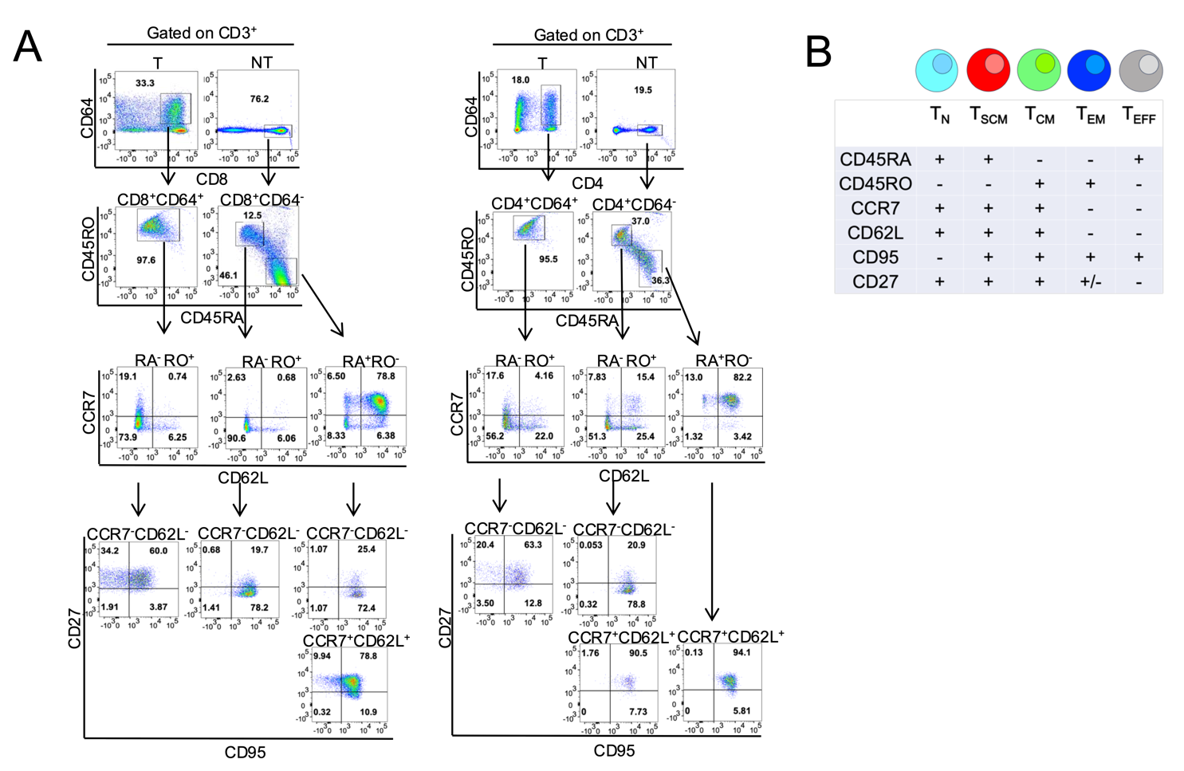
Figure 3 S. Gating strategy of flow cytometry analysis of CD64-CR T cells at 22 days post-transduction. (A) Dot plots are shown as a representative example of the gating strategy used for identifying the frequency of stem cell memory (scm) T cells, central memory (cm) T cells, (em) effector memory T cells, and effector (eff) T cells in the CD64+CD3+ cells. (B) Panel of T cell differentiation markers used for identifying different subsets of T cells.

