Box 1. Plants with fruits used in human consumption that stood out in terms of their invasion potential and also the number of occurrences as invasive, representing different domestication degrees.
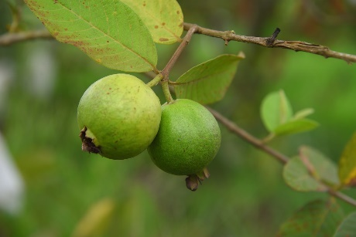  Guava (Psidium guajava)  Domestication degree: 12 (fully domesticated)  Invasion potential: 0.33 | Origin: Uncertain, probably originated in the savannas and semi-deciduous forests of South America (Landrum & Mitra 2021) or in the humid Chaco and/or Cerrado (Arévalo-Marín et al. 2021). Brazilian Amazonia is the probable center of domestication (Arévalo-Marín et al. 2024).  Global Distribution & Invasion: Widely cultivated and considered invasive in tropical and subtropical regions globally. Its spread was likely aided by human activities (Arévalo-Marín et al. 2021). Can form dense stands that displace native vegetation (Leão et al. 2011; Landrum & Mitra 2021).  Fruit characteristics: Soft, yellow fruit with pink or white flesh, 25–100 mm in diameter. Each fruit contains up to 570 small seeds (3–5 mm) (Jordaan et al. 2011).  Seed Dispersal: Antropochory and zoochory, which ingestion by birds accelerate dispersal and enhance seed germination (Jordaan et al. 2011).
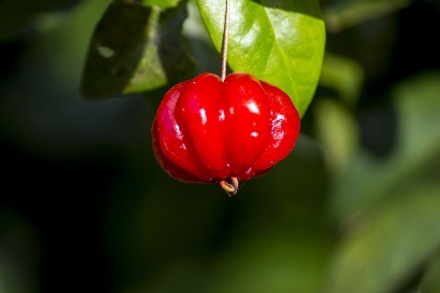  Surinam cherry (Eugenia uniflora)  Domestication degree: 7 (incipient)  Invasion potential: 0.38 | Origin: Native to South America (Campagnoli and Christianini 2024).  Global Distribution & Invasion: Introduced in many tropical and subtropical regions worldwide for its valuable fruit and ornamental use, has become invasive in many countries (Campagnoli and Christianini 2024).  Fruit characteristics: Depressed-globose berries with 6–8 longitudinal ribs, dark red to black when ripe, 1.29 ± 0.24 cm in diameter, and 1.02 ± 0.45 g in fresh weight. Each fruit contains a single sub-globose seed, 6–8 mm in diameter.  Seed Dispersal: Dispersed primarily by birds and mammals, including Tegu lizards. Gut-passed seeds tend to germinate faster, and lizards can carry seeds over considerable distances (Campagnoli and Christianini 2024).
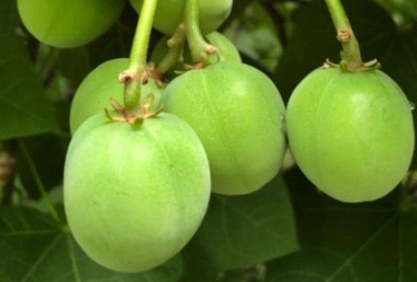  Physic nut (Jatropha curcas)  Domestication degree: 9 (semi-domesticated)  Invasion potential: 0.13 | Origin: Likely originated in Mexico and Central America, although the exact origin is debated (Achten et al. 2010).  Global Distribution & Invasion: Widespread throughout arid and semi-arid tropical regions of the world (Mariod et al. 2017).  Fruit characteristics: Capsule, each containing 2–3 oblong seeds that mature as the capsule changes from green to yellow. Seeds are dark brown, with an average weight of about 705 mg when dry (Thomas et al. 2008).  Seed Dispersal: Primarily dispersed via zoochory and myrmecochory (Guerrero 2014).

