Supplementary Material
Low degree of domestication can be an indicator of high potential of biological invasion
Brisa Marciniak^{1, 2,3}, Michele S. Dechoum^{1,3}, Carolina Levis^{2,3}, Gustavo Lemes^{2,3}, Nivaldo Peroni^{2,3}
¹Laboratório de Ecologia de Invasões Biológicas, Manejo e Conservação, Universidade Federal de Santa Catarina, Departamento de Ecologia e Zoologia, Florianópolis, Brazil
²Laboratório de Ecologia Humana e Etnobotânica, Universidade Federal de Santa Catarina, Departamento de Ecologia e Zoologia, Florianópolis, Brazil
³ Programa de pós-graduação em Ecologia, Universidade Federal de Santa Catarina, Departamento de Ecologia e Zoologia, Florianópolis, Brazil
*Corresponding Author brisamarciniak@gmail.com

TableS1. Plants with fruits for human food use that presented information on occurrences of invasive populations (invasive), total number of presences as introduced but not invasive (introduced), total checklists present (total), domestication categories (cat_degree), degree of domestication (degree) and invasion potential (IP). The species are in descending order with regard to invasion potential (IP).
Species | invasive | introduced | total | degree | cat_degree | IP
Passiflora alata | 1 | 1 | 2 | 2 | Wild | 0.50
Eugenia uniflora | 14 | 23 | 37 | 7 | Incipient | 0.38
Psidium guajava | 31 | 62 | 93 | 12 | Fully | 0.33
Schinus terebinthifolia | 10 | 20 | 30 | 7 | Incipient | 0.33
Chrysobalanus icaco | 3 | 6 | 9 | 6 | Incipient | 0.33
Diospyros virginiana | 1 | 2 | 3 | 11 | Fully | 0.33
Pouteria campechiana | 1 | 2 | 3 | 5 | Wild | 0.33
Passiflora edulis | 11 | 36 | 47 | 11 | Fully | 0.23
Passiflora ligularis | 2 | 7 | 9 | 7 | Incipient | 0.22
Mammea americana | 1 | 4 | 5 | 10 | Semi | 0.20
Porophyllum ruderale | 1 | 4 | 5 | 8 | Semi | 0.20
Psidium guineense | 2 | 10 | 12 | 8 | Semi | 0.17
Spondias purpurea | 1 | 5 | 6 | 14 | Fully | 0.17
Jatropha curcas | 12 | 81 | 93 | 9 | Semi | 0.13
Schinus molle | 3 | 21 | 24 | 9 | Semi | 0.13
Syagrus romanzoffiana | 1 | 7 | 8 | 3 | Wild | 0.13
Annona muricata | 3 | 23 | 26 | 11 | Fully | 0.12
Sicyos edulis | 2 | 15 | 17 | 10 | Semi | 0.12
Chrysophyllum cainito | 1 | 8 | 9 | 11 | Fully | 0.11
Helianthus annuus | 4 | 42 | 46 | 13 | Fully | 0.09
Capsicum annuum | 3 | 30 | 33 | 12 | Fully | 0.09
Solanum betaceum | 1 | 10 | 11 | 7 | Incipient | 0.09
Physalis peruviana | 6 | 68 | 74 | 9 | Semi | 0.08
Solanum lycopersicum | 4 | 49 | 53 | 13 | Fully | 0.08
Anacardium occidentale | 2 | 24 | 26 | 11 | Fully | 0.08
Capsicum frutescens | 2 | 22 | 24 | 10 | Semi | 0.08
Carica papaya | 2 | 26 | 28 | 12 | Fully | 0.07
Persea americana | 2 | 27 | 29 | 12 | Fully | 0.07
Manilkara zapota | 1 | 13 | 14 | 8 | Semi | 0.07
Passiflora quadrangularis | 1 | 14 | 15 | 11 | Fully | 0.07
Ananas comosus | 1 | 15 | 16 | 13 | Fully | 0.06
Annona reticulata | 1 | 27 | 28 | 10 | Semi | 0.04
Annona squamosa | 1 | 43 | 44 | 11 | Fully | 0.02
Acrocomia aculeata | 0 | 1 | 1 | 8 | Semi | 0.00
Annona emarginata | 0 | 1 | 1 | 4 | Wild | 0.00
Annona macroprophyllata | 0 | 1 | 1 | 8 | Semi | 0.00
Annona mucosa | 0 | 2 | 2 | 11 | Fully | 0.00
Arachis hypogaea | 0 | 25 | 25 | 13 | Fully | 0.00
Araucaria angustifolia | 0 | 3 | 3 | 6 | Incipient | 0.00
Attalea speciosa | 0 | 1 | 1 | 6 | Incipient | 0.00
Brosimum alicastrum | 0 | 3 | 3 | 6 | Incipient | 0.00
Byrsonima crassifolia | 0 | 4 | 4 | 11 | Fully | 0.00
Canavalia ensiformis | 0 | 12 | 12 | 11 | Fully | 0.00
Capsicum baccatum | 0 | 2 | 2 | 12 | Fully | 0.00
Capsicum chinense | 0 | 3 | 3 | 12 | Fully | 0.00
Casimiroa edulis | 0 | 1 | 1 | 13 | Fully | 0.00
Cucurbita maxima | 0 | 23 | 23 | 12 | Fully | 0.00
Cucurbita moschata | 0 | 10 | 10 | 12 | Fully | 0.00
Cucurbita pepo | 0 | 29 | 29 | 13 | Fully | 0.00
Diospyros nigra | 0 | 6 | 6 | 11 | Fully | 0.00
Eugenia stipitata | 0 | 1 | 1 | 8 | Semi | 0.00
Euterpe edulis | 0 | 1 | 1 | 1 | Wild | 0.00
Euterpe oleracea | 0 | 1 | 1 | 10 | Semi | 0.00
Feijoa sellowiana | 0 | 4 | 4 | 8 | Semi | 0.00
Garcinia brasiliensis | 0 | 1 | 1 | 6 | Incipient | 0.00
Genipa americana | 0 | 1 | 1 | 11 | Fully | 0.00
Hymenaea courbaril | 0 | 2 | 2 | 6 | Incipient | 0.00
Inga edulis | 0 | 6 | 6 | 12 | Fully | 0.00
Inga laurina | 0 | 3 | 3 | 6 | Incipient | 0.00
Lagenaria siceraria | 0 | 25 | 25 | 11 | Fully | 0.00
Lecythis pisonis | 0 | 1 | 1 | 6 | Incipient | 0.00
Malpighia emarginata | 0 | 2 | 2 | 7 | Incipient | 0.00
Malpighia glabra | 0 | 3 | 3 | 5 | Wild | 0.00
Pachyrhizus tuberosus | 0 | 1 | 1 | 11 | Fully | 0.00
Phaseolus vulgaris | 0 | 23 | 23 | 14 | Fully | 0.00
Plinia cauliflora | 0 | 1 | 1 | 8 | Semi | 0.00
Pouteria caimito | 0 | 1 | 1 | 11 | Fully | 0.00
Pouteria sapota | 0 | 1 | 1 | 10 | Semi | 0.00
Psidium friedrichsthalianum | 0 | 3 | 3 | 7 | Incipient | 0.00
Solanum furcatum | 0 | 2 | 2 | 10 | Semi | 0.00
Solanum muricatum | 0 | 1 | 1 | 10 | Semi | 0.00
Solanum tuberosum | 0 | 32 | 32 | 12 | Fully | 0.00
Spondias mombin | 0 | 12 | 12 | 12 | Fully | 0.00
Zea mays | 0 | 36 | 36 | 15 | Fully | 0.00

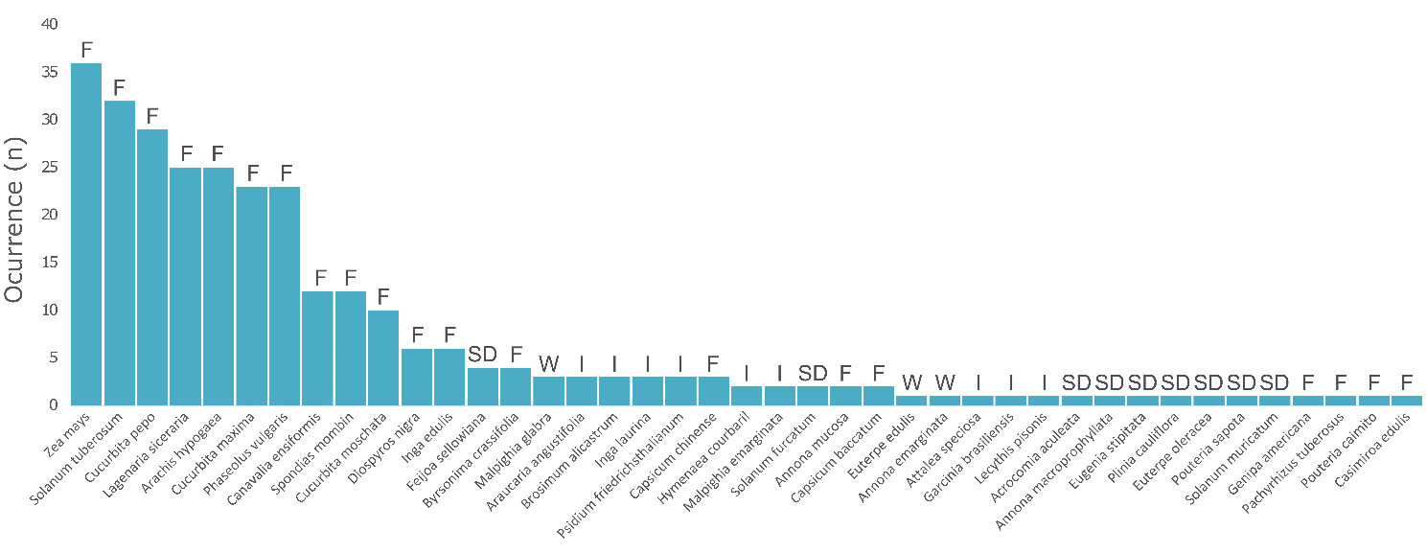
Figure S1. Total number of presences in non-native species checklists (blue) for domesticated plants native from Americas used for human consumption. The domestication degree is shown accordingly: W (wild), I (incipient), SD (semi-domesticated), and F(fully).

