Materials and methods

Materials
Food-grade maize starch (BUFFALO® 034010, IngredionTM; Ardion SA Complejo Empresarial, Munro, Buenos Aires, Argentina) was purchased from a local distributor (Distribuidora NICCO, Córdoba, Argentina). The chemical composition (AACC, 2000): moisture (13%), carbohydrates (86.4%), proteins (0.30%), lipids (0.10%), ash (0.20%). The amylose content was 27.51±0.56% (w/w) (Gibson et al. [1]) using Megazyme amylose/amylopectin kit (Megazyme International, Wicklow, Ireland)).

Treatments
To evaluate the contribution of thermal and mechanical energy produced by UT on starch properties, three experiments (A, B and C) were performed (Table 4). Starch suspensions (30% (w/v) were prepared and homogenized by stirring distilled water and maize starch. Suspensions were treated using an Ultrasonic Homogeneizer Model 150 (BioLogics, Inc., USA) with a titanium stepped micro tip (4 mm tip diameter, 300 μL-15 mL processing volume), working with a power ultrasonic of 150 W nominal power, 20 kHz output frequency produced by the transductor and amplitude was regulated to 40%. The continuous mode was selected for all experiences.

Table 4.
Description of experiences realized to segregate the different effects that are caused by ultrasound over maize starch suspension.
Experiment | Treatment | ¹Sample | Time (min) | Characteristics
A  (Mechanical  + Thermal) | Ultrasound | U3 | 3 | Treatment with ultrasonic tip, continuous mode
A  (Mechanical  + Thermal) | Ultrasound | U5 | 5 | Treatment with ultrasonic tip, continuous mode
B  (Mechanical) | Ultrasound with controlled temperature | R3 | 3 | Treatment with ultrasonic tip, continuous mode with controlled temperature
B  (Mechanical) | Ultrasound with controlled temperature | R12 | 12
B  (Mechanical) | Ultrasound with controlled temperature | R24 | 24
C  (Thermal) | Thermal effect | C3 | 3 | Heating ramp (Experience A)
C  (Thermal) | Thermal effect | C5 | 5 | Heating ramp (Experience A)
Nomenclature samples used to identify, and treatment time applied to each one. ¹U3, US treatment for 3 min; U5, US treatment for 5 min; R3, US treatment with controlled temperature for 3 min; R12, US treatment with controlled temperature for 12 min; R24, US treatment with controlled temperature for 24 min; C3, heated without US 3 min.

Experiment A: Starch suspensions were treated in a continuous mode without temperature control for 5 min.

Experiment B: Starch suspensions were treated in a continuous mode with temperature control for 24 min. A cold-water bath was used to control the temperature of suspensions avoiding the system-temperature rise over lower 25 °C. This technique allowed us to evaluate the mechanical effect of ultrasound separately from the heating of the suspension due to the application of ultrasound waves.
Experiment C: Starch suspensions were heated using a stirred water bath simulating the heating ramp in Experiment A (The temperature was recorded each minute during Experiment A, Figure 2) in order to evaluate temperature raising on the UT experiment.

Figure 2.
Relationship between time and temperature in an UT for a maize starch suspension. Linear fit is represented by the equation y=25.2+8.24x with a R-Square=0.99.

The temperature was monitored by type K thermocouples (1 mm diameter) in the three experiments. Treatments were made in duplicated at least. After each experiment, starch suspensions were centrifuged at 3000 rpm for 20 min. The precipitates were dried for 48 h at 45 °C and stored at room temperature for assays.

Starch Characterization

Particle size distribution (PSD)
Samples were water-dispersed and analyzed by Dynamic Light Scattering (DLS) with a HORIBA Particle LA-960 (Horiba, Japan). The parameters determined were D [4,3] (mean), D50 (median), D10 and D90 (10% and 90% cumulative volume of particles respectively), mode and span index [2].

Pasting Properties
The pasting properties of the samples were determined using a Rapid Visco Analyzer (RVA series 4500, Perten instruments, USA) following the Standard 1 method profile [3]. Peak viscosity (PV), final viscosity (FV), breakdown (BD) and setback (SB) were obtained from the pasting curves. Analyses were performed in duplicate.

Scanning electron microscopy (SEM)
The morphology of the starch was determined by Field Emission Scanning Electron Microscopy (FE-SEM Σigma, Carl Zeiss) with InLens detector at 5 kV. The dried samples were metalized with a 20 nm-layer of Au. The samples images were obtained at magnifications of 1000x and 5000x.

Differential scanning calorimetrical (DSC)
Thermal properties (starch gelatinization) of the samples were analyzed using a differential scanning calorimeter DSC 823e (Mettler Toledo, Switzerland). The thermal analysis was performed according to Piloni et al. [4]. Onset temperature (Tonset), peak temperature (Tpeak) and conclusion temperature (Tendset), as well as the enthalpy of starch gelatinization (ΔHg, J/g Dry starch) were determined. Analyses were performed in duplicate.

X-ray diffraction (XRD)
XRD pattern of selected samples was determined by a Philips PW1800 (USA) Diffractometer. The patterns were obtained with Cu kα radiation (λ = 0.154 nm); the operated conditions and crystallinity grade were established following the procedure of Palavecino et al. [2].

Water and oil adsorption capacity of starch samples
The water and oil adsorption capacity of the samples was determined according to Han et al. [5]. Samples (0.5 g) were suspended in the respective solvents (8 mL) at room temperature, shaken for 30 min and then centrifuged. WA has expressed in percentage. as $WA=\frac{M_{2}-M_{1}}{M_{1}}$, where M1 is the starch dry mass placed at the begging and M2 the mass of starch after to be centrifuged and dried the tube. Samples were evaluated by triplicated.

Statistical Analysis

The data were statistically analyzed by variance analysis (ANOVA). The means were compared by DGC test at a significance level of 0.05 using Infostat Statistical Software [6]. Graphics were plotted using OriginPro 9.0 (2012 version, OriginLab).\

Results and discussion

Particle size distribution

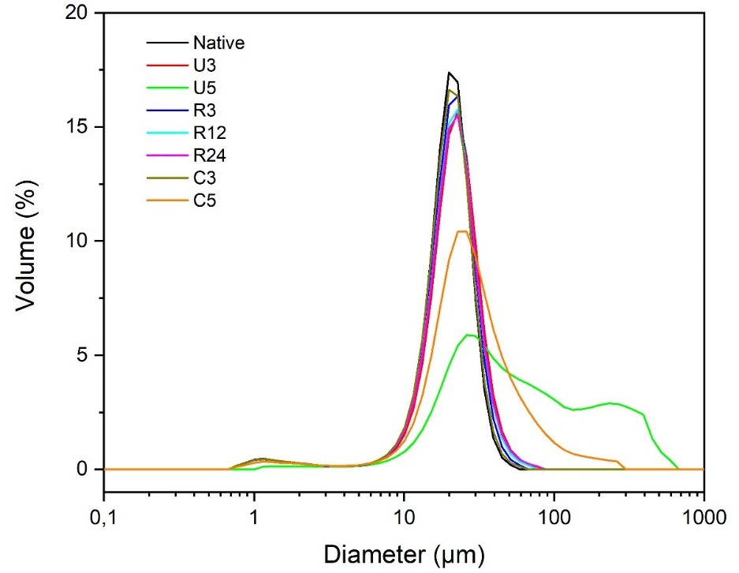
Figure 3.
Particle size distribution by DLS for native starch maize and UT samples

Pasting properties

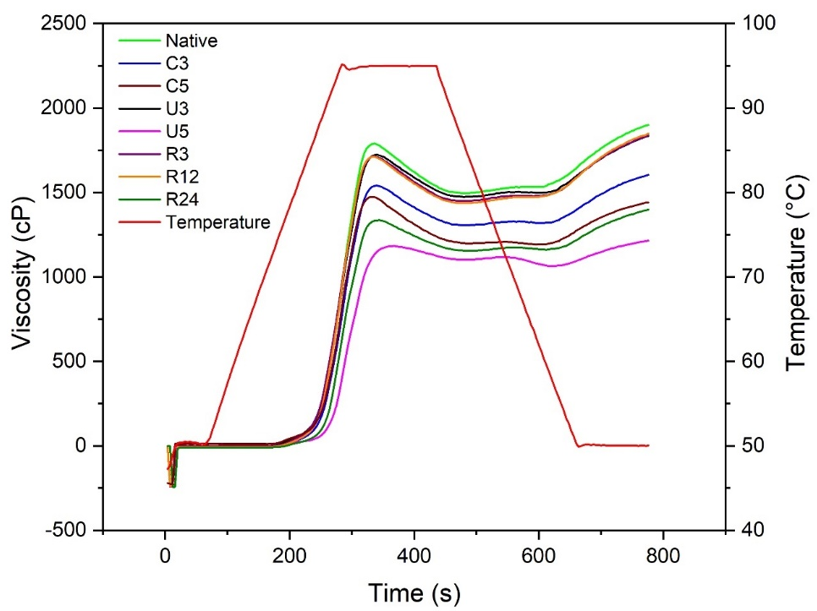
Figure 4.
RVA curves for native maize starch and samples treated with US.

XRD patterns

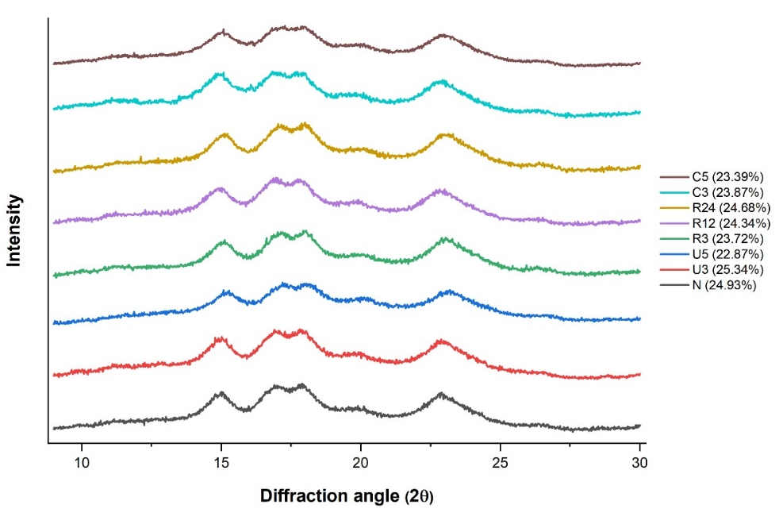
Figure 5.
X-ray patterns and crystalline degree of native corn starch and samples of experiences A, B and C. Native, N; U3, US treatment for 3 min; U5, US treatment for 5 min; R3, US treatment with controlled temperature for 3 min; R12, US treatment with controlled temperature for 12 min; R24, US treatment with controlled temperature for 24 min; C3, heated without US 3 min; C5, heated without US 5 min.

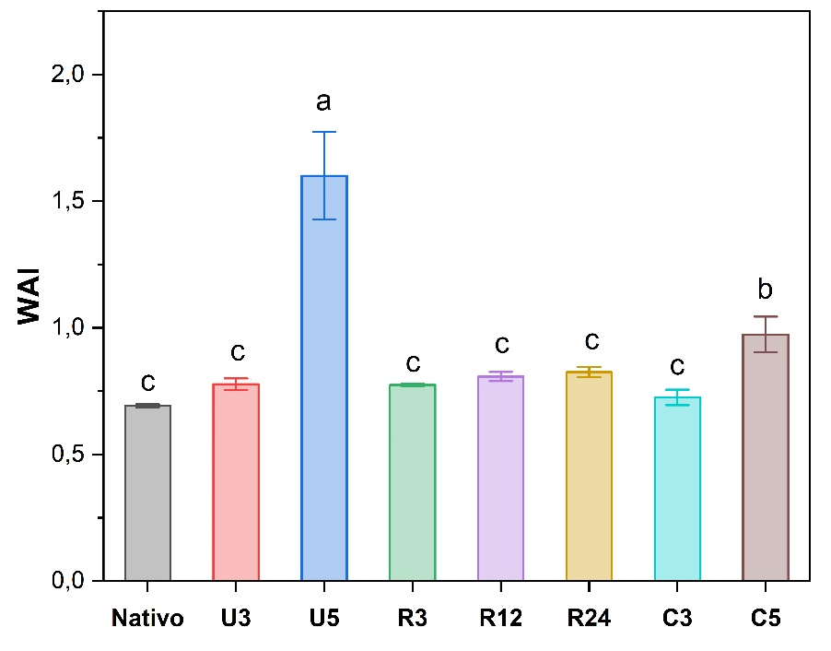
Water and oil absorption capacity

Figure 6.
Water absorption for native corn starch and samples of experience A, B and C. Native, N; U3, US treatment for 3 min; U5, US treatment for 5 min; R3, US treatment with controlled temperature for 3 min; R12, US treatment with controlled temperature for 12 min; R24, US treatment with controlled temperature for 24 min; C3, heated without US 3 min; C5, heated without US 5 min. Means ± standard deviation. DGC Test. Equal letters do not represent difference significates (p > 0,05).

References
[1] Gibson TS, Solah VA, McCleary BV. A Procedure to Measure Amylose in Cereal Starches and Flours with Concanavalin A. J Cereal Sci 1997;25:111–9. https://doi.org/10.1006/jcrs.1996.0086.
[2] Palavecino PM, Penci MC, Ribotta PD. Effect of planetary ball milling on physicochemical and morphological properties of sorghum flour. J Food Eng 2019;262:22–8. https://doi.org/10.1016/j.jfoodeng.2019.05.007.
[3] Teobaldi AG, Barrera GN, Ribotta PD. Effect of Damaged Starch and Wheat-Bran Arabinoxylans on Wheat Starch and Wheat Starch–Gluten Systems. Foods 2024;13:689. https://doi.org/10.3390/foods13050689.
[4] Piloni RV, Bordón MG, Barrera GN, Martínez ML, Ribotta PD. Porous Microparticles of Corn Starch as Bio-Carriers for Chia Oil. Foods 2022;11. https://doi.org/10.3390/foods11244022.
[5] Han X, Wen H, Luo Y, Yang J, Xiao W, Ji X, et al. Effects of α-amylase and glucoamylase on the characterization and function of maize porous starches. Food Hydrocoll 2021;116. https://doi.org/10.1016/j.foodhyd.2021.106661.
[6] Rienzo JD, Balzarini M, Gonzalez L. InfoStat versión 2020 2015.

