Table S1. Estimated peak values for each alpha metric and age (months) at which they occurred.

 | Month (95% CI) | Log values (95% CI) | Original scale (95% CI)
Chao | 45 (41-49) | 6.7 (6.6-6.9) | 830 (732-937)
Shannon | 45 (42-48) | 1.2 (1.15-1.27) | 3.33(3.14-3.51)
InvSimpson | 43 (39-48) | 2.3 (2.2-2.5) | 10.4 (5.6-15.3)

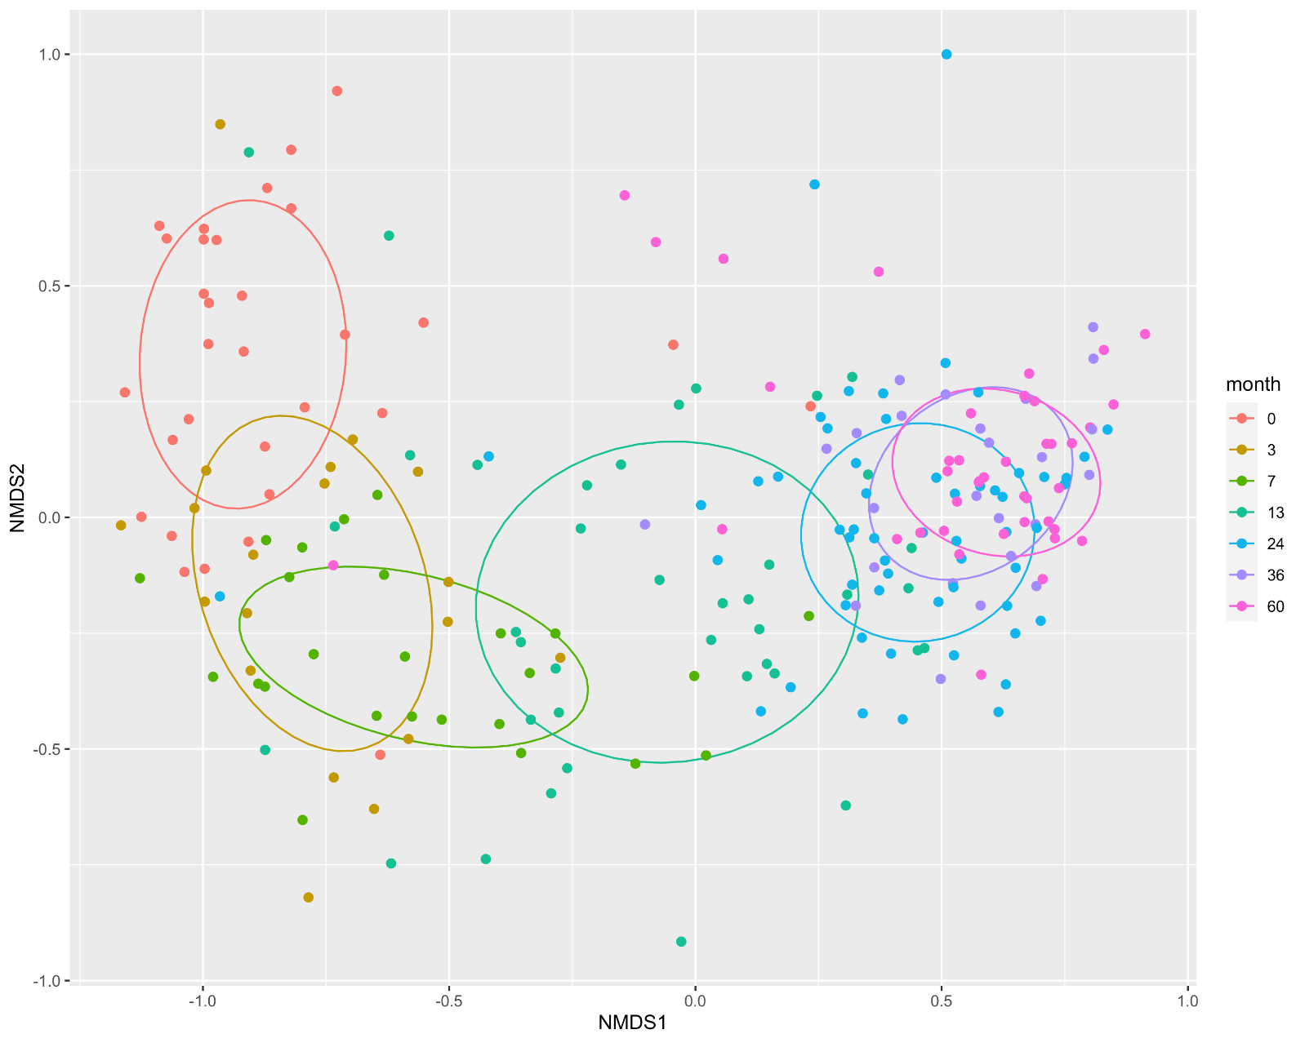

Figure S1. Two-dimensional non-metric multidimensional scaling (NMDS) plot of bacterial communities. Ellipses represent the mean of variation within each age group.

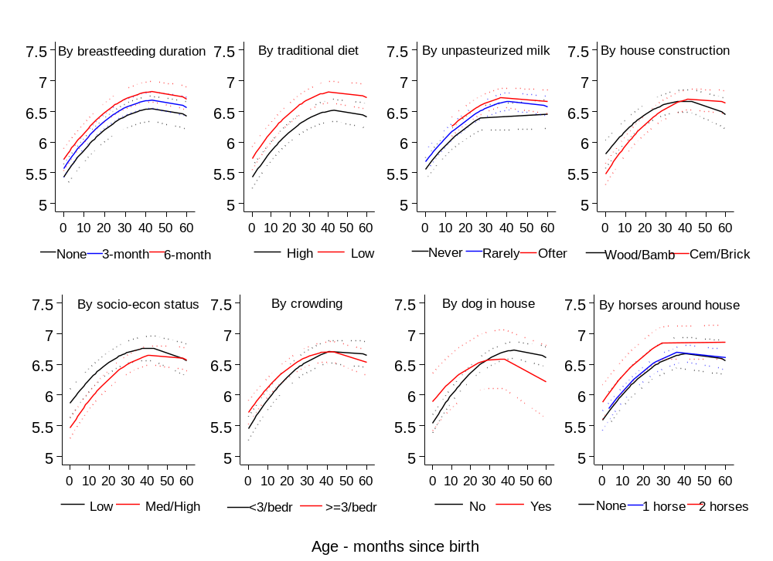
Figure S2. Individual exposures significantly associated with age-dependent Chao scores (log scale).

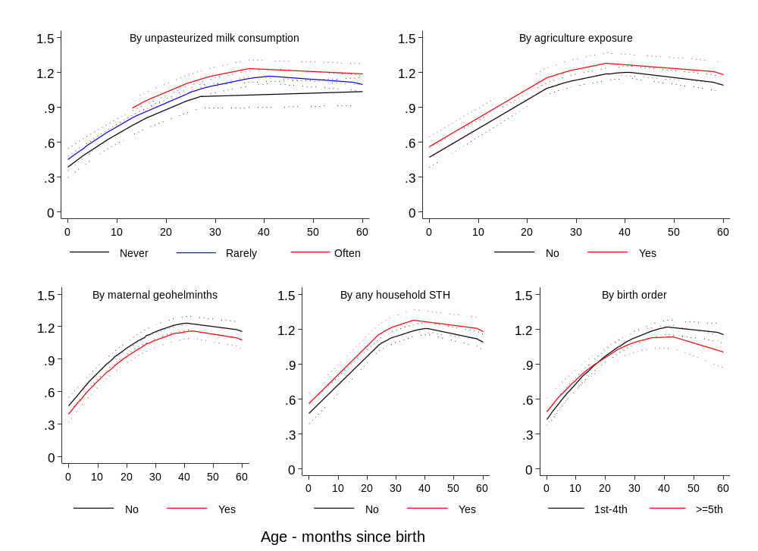
Figure S3. Individual exposures significantly associated with age-dependent Shannon scores (log scale).

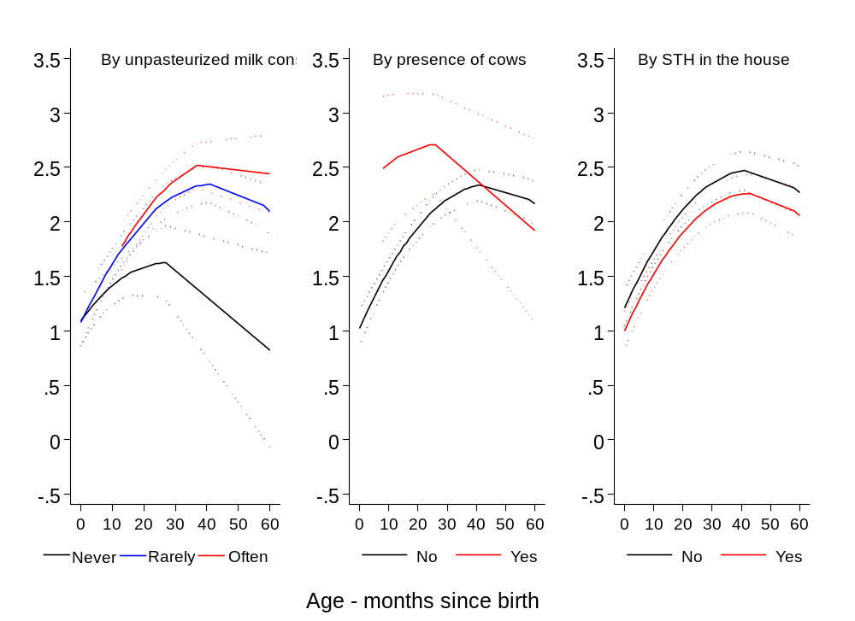
Figure S4 Individual exposures significantly associated with age-dependent InvSimpson scores (log scale).

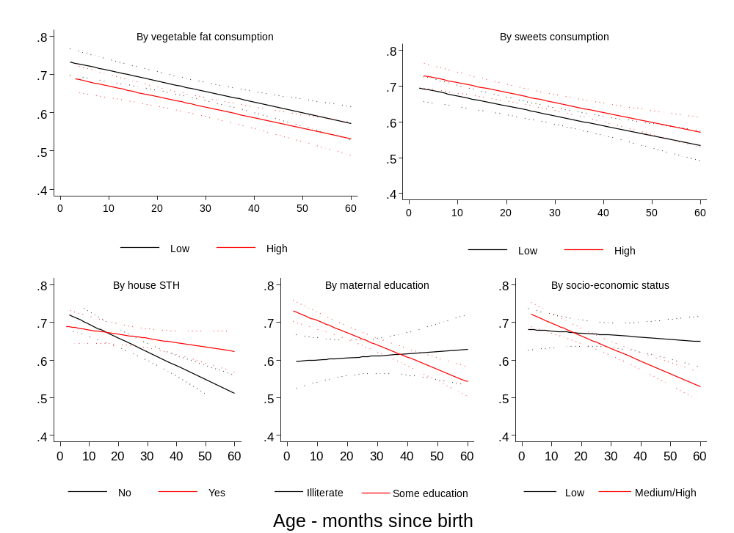
Figure S5. Individual exposures significantly associated with monthly changes in beta diversity, adjusted for age at first measurement. Predictions are made for birth as age when the sampling started.

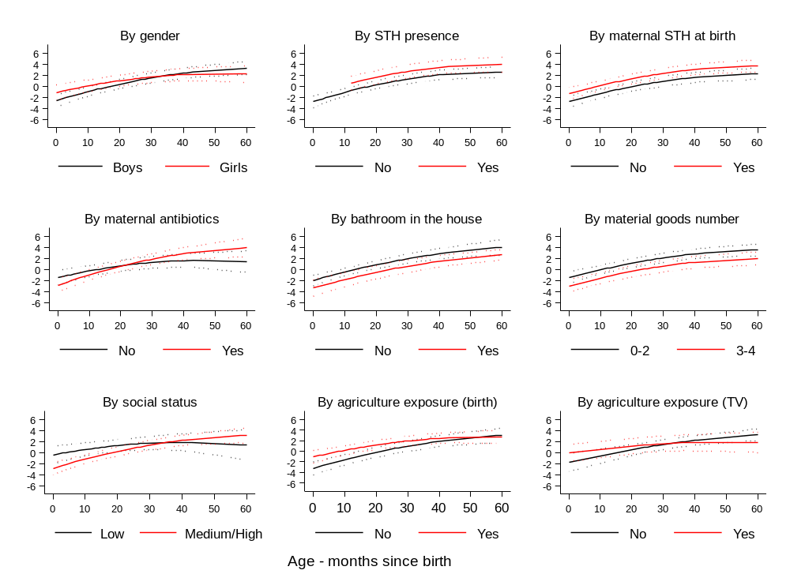
Figure S6 – Individual exposures significantly associated with age-dependent Prevotella/Bacteroidetes ratio (log scale).

