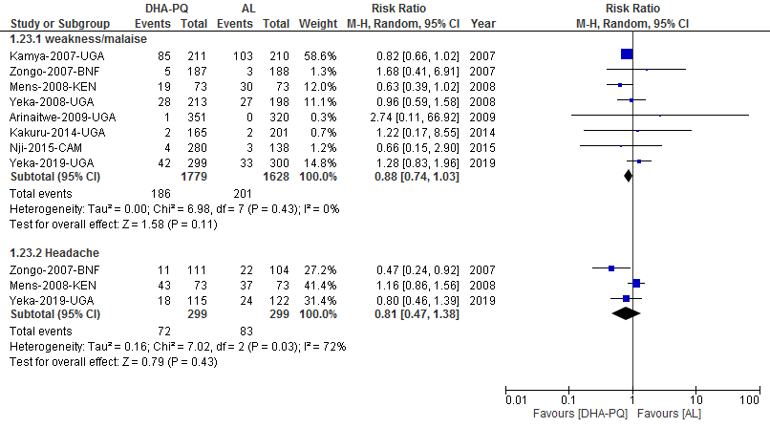
Additional file S17: Forest plot of comparison: dihydroartemisinin-piperaquine versus artemether-lumefantrine for treatment of uncomplicated plasmodium falciparum malaria in African children, outcome: Neuropsychiatry adverse event.

