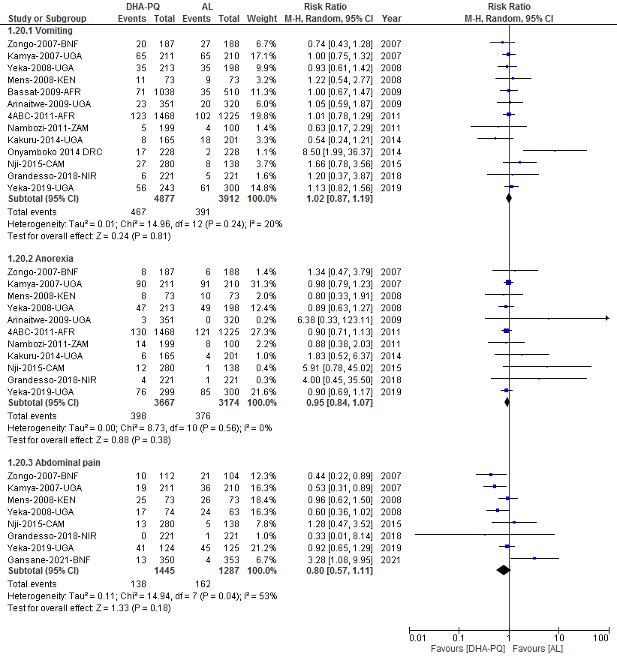

Additional file S15: Forest plot of comparison: dihydroartemisinin-piperaquine versus artemether-lumefantrine for treatment of uncomplicated plasmodium falciparum malaria in African children, outcome: Gastrointestinal adverse events.

