Supplementary information for
Efficient and stable blue perovskite light-emitting diodes through I-III-VI quantum dot solids as hole transport layer
Zheng et al.

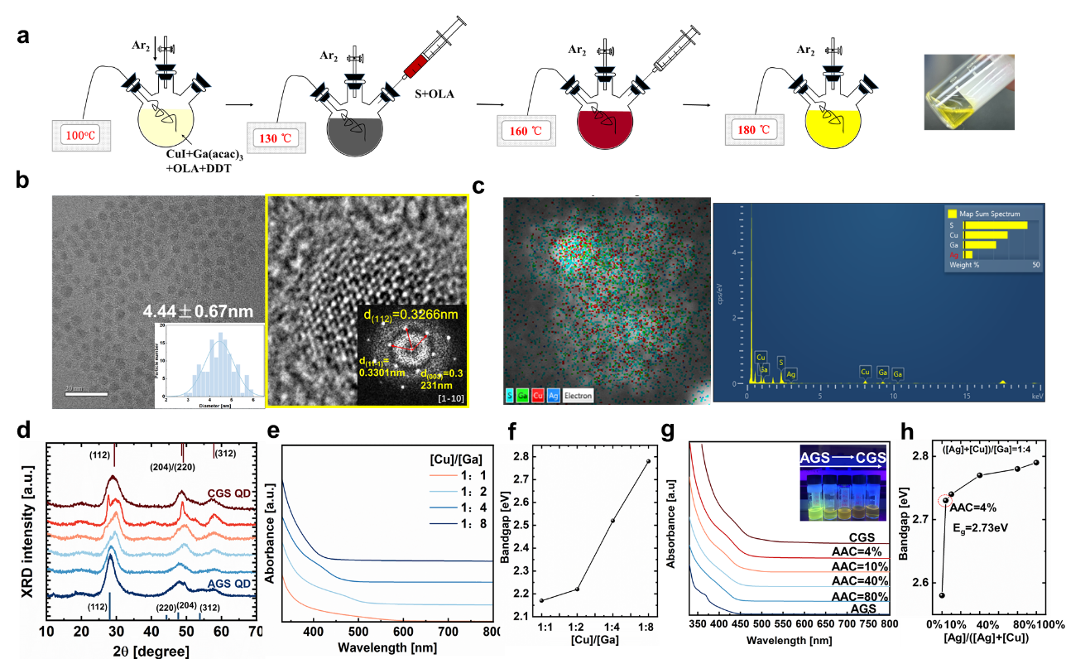
Supplementary Figure 1|Synthesis and characterizations of chalcopyrite QD synthesized in this work¹. (a) Schematic synthesis of CGS QD using hot-injection method; the right-hand side picture represent CGS QD dispersed in octane after purification. (b) High-resolution TEM (HRTEM) image of purified CGS QD. Inset shown is the corresponding fast Fourier transformation (FFT) images viewed in [1-10] zone axis. Specific diffraction plane is denoted in yellow, and the lattice spacing of (112) plane is 0.3266 nm, consistent with XRD results. (c) Elemental compositional mapping measured by STEM-EDX of ACGS QD. The AAC, ACG ratio, and [S]/([Cu]+[Ga]) feed ratio used in the precursor is 10%, 1:4, and 2:1 respectively. (d) Evolution of XRD patterns of CGS QD with increased AAC ratio while keeping ACGS as constant of 1:4, from the top to the bottom; red and blue bar at the top and bottom highlight standard data of tetragonal phase of CuGaS₂ (PDF# 25-0279) and AgGaS₂ (PDF# 27-0615), respectively. (e) Absorption features of CGS QD synthesized with varied [Cu]/[Ga] ratios in the precursor. (f) Dependence of E_{g} of ACGS QD on the [Cu]/[Ga] ratio in the precursor. The E_{g} values are estimated from intersection of linear approximation plot of (αhγ)² ~hγ to x-axis (y=0) based on Beer-Lambert Law. (g) Absorption features of ACGS QD with increased AAC ratio from the top to the bottom. Inset of shows photographs of purified QDs dispersed in under UV-violet excitation at 365nm, in which yellow luminescence could be observed for AGS QD. (h) Dependence of E_{g} of ACGS QD on the AAC ratio in the precursor while keeping ([Ag]+[Cu])/[Ga] ratio of 1:4. E_{g} reaches 2.73 eV while AAC is increased from 0 to 4%, highlighted with red-dotted circles.

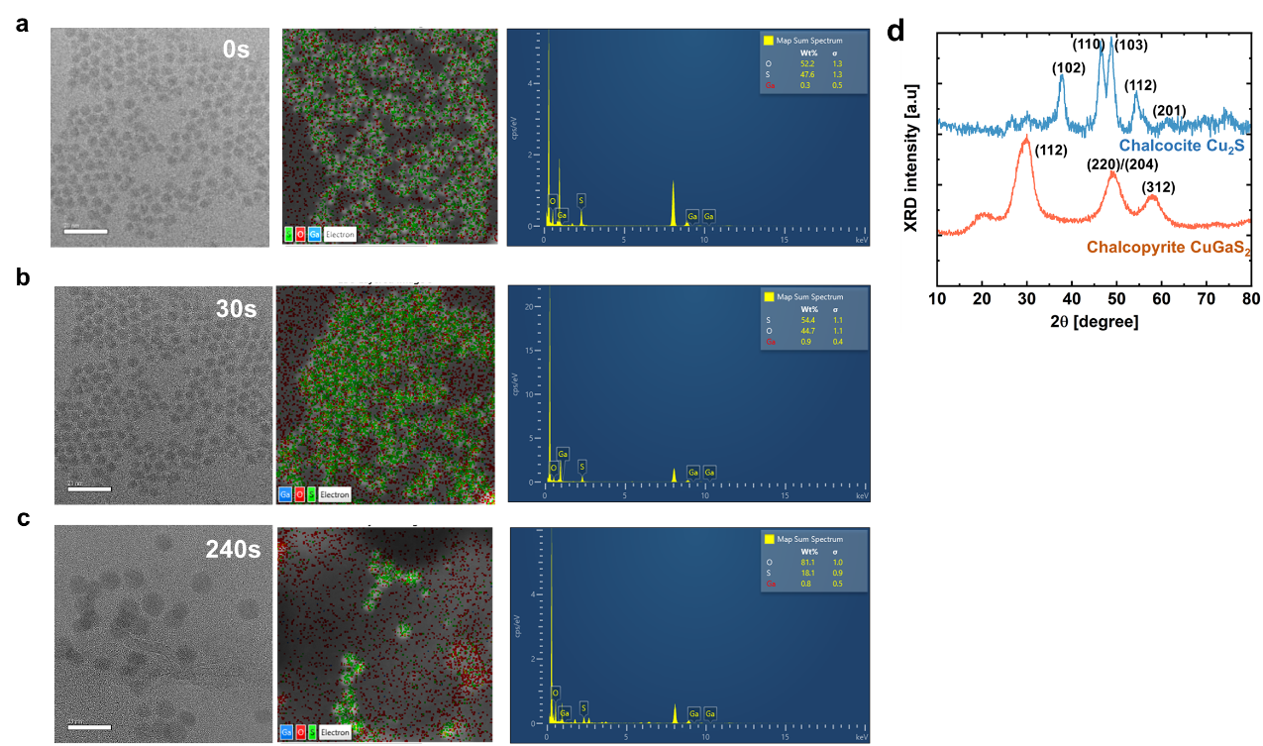

Supplementary Figure 2|Analysis of morphology, chemical composition and crystallography of CGS QD synthesized when the [Cu]/[Ga] ratio in the precursor is 1:1. (a)-(c) TEM images and corresponding chemical composition mapping of CGS QD, sampled at varied duration at 0s (a), 30s (b) and 240s (c) under the reaction temperature of 180°C measured with STEM-EDX; the blue, green and red color mapping respectively represent Ga, S and O element. Detection of oxygen indicates surface oxidation of QD during sample transport, but the Ga content will not be influenced. (d) XRD patterns of purified CGS QD powder after purifications. The diffraction patterns are consistent with the hexagonal chalcocite Cu₂S (JCPDS No.26-1116). Also shown is representative chalcopyrite CuGaS₂ crystals (JCPDS No. 25-0279) obtained while [Cu]/[Ga] ratio is 1:4 in the metal precursor.

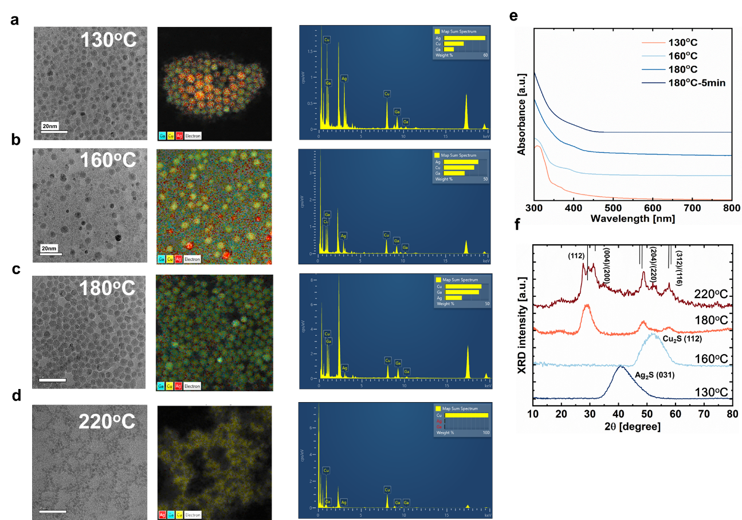

Supplementary Figure 3|Understandings of nucleation and growth kinetics of ACGS QD. (a)-(d) Morphology and corresponding chemical composition mapping of ACGS QD sampled at varied temperatures from 130ºC to 220ºC measured with TEM and STEM-EDX. In the EDX mapping images, to clearly demonstrate the cation variations, sulfur is intentionally removed from analysis; the red, yellow and cyan color mapping respectively represent Ag, Cu and Ga. The ACG and AAC ratio used in the precursor during synthesis is 1:4 and 20%, respectively. (e) Absorption features (f) and XRD patterns of ACGS QD sampled at varied temperatures. Detailed summary of elemental atomic concentration is provided in Supplementary Table 2. Immediately after sulfur injection at 130ºC, crystalline Ag₂S QD is formed, confirmed by XRD diffraction patterns and long-wavelength absorption. As temperature rises up to 160 ºC, small QDs were dissolved into monomers, accompanied by decreased Ag, increased Cu and Ga content, transforming into crystalline Cu₂S phase as the start of nucleation process of quaternary phase. The absorption cut-off point slightly-shift to low-wavelength region, due to higher bandgap energy of quaternary ACGS compared to Ag₂S. Afterwards, otswald ripening growth scheme takes place, continuous Ga in-diffusion and Ag out-diffusion lead to uniformly-distributed ACGS QD at 180ºC, and the growth of ACGS QDs induce red-shift of absorption spectrum.

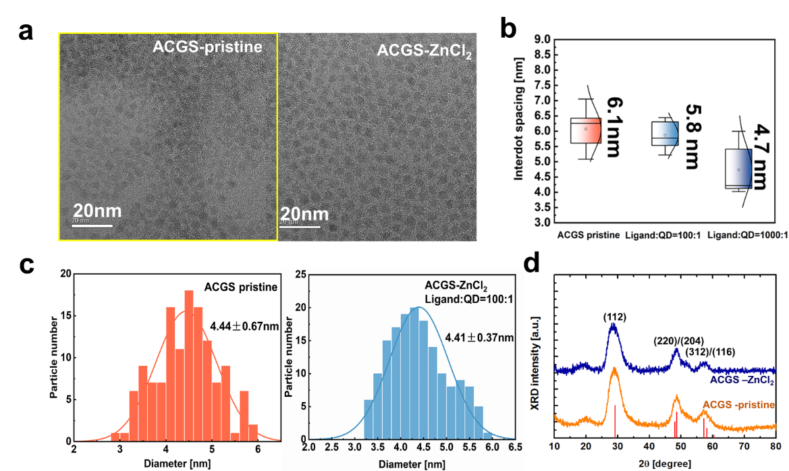
Supplementary Figure 4|Effects on morphology, inter-dot spacing and size distributions of ACGS QD of ZnCl₂ ligand exchange. (a) TEM images of ACGS QD before (ACGS-pristine) and after ZnCl₂ ligand exchange (ACGS-ZnCl₂). The AAC and ACG ratio used in the precursor is 10% and 1:4, respectively. The ligand density is evaluated as ligand:QD molar ratio . (b) Box plot of inter-dot spacing for ACGS-pristine and ACGS-ZnCl₂ QD with varied ligand density. (c) Particle size distribution of ACGS- pristine and ACGS-ZnCl₂ with ligand:QD ratio of 100:1. (d) XRD patterns of ACGS-pristine and ACGS-ZnCl₂ QD.

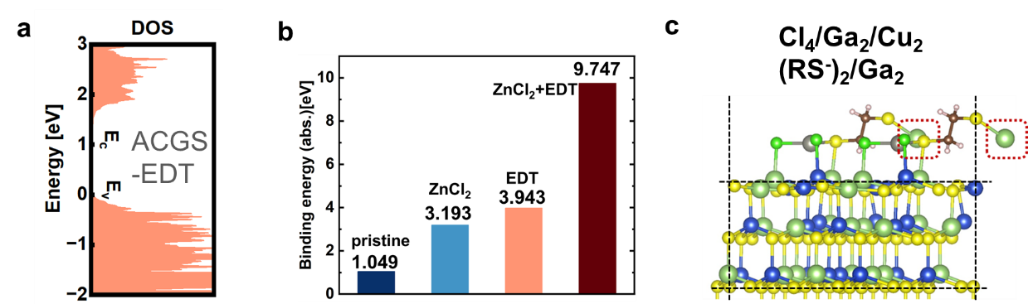
Supplementary Figure 5| DFT simulations of CGS QD with varied surface ligands. (a) DOS plot of ACGS QDs with EDT treatment. Effective eliminations of mid-gap states could be confirmed. (b) Calculated ligand binding energy on QD surface of ACGS-pristine, ACGS-ZnCl₂, ACGS-EDT and ACGS-ZnCl₂-EDT. Hybrid ligand exchange result in highest ligand binding energy, suggesting improved coordination of halide and thiolates ligand. (c) Relaxed configurations of ACGS QDs with hybrid ligand exchange using Cl⁻ and RS⁻. EDT molecules embedding two RS⁻ groups could bind strongly to Ga ions from neighboring QD (highlighted with red circles), which enhances the electrical coupling of ACGS QD effectively.

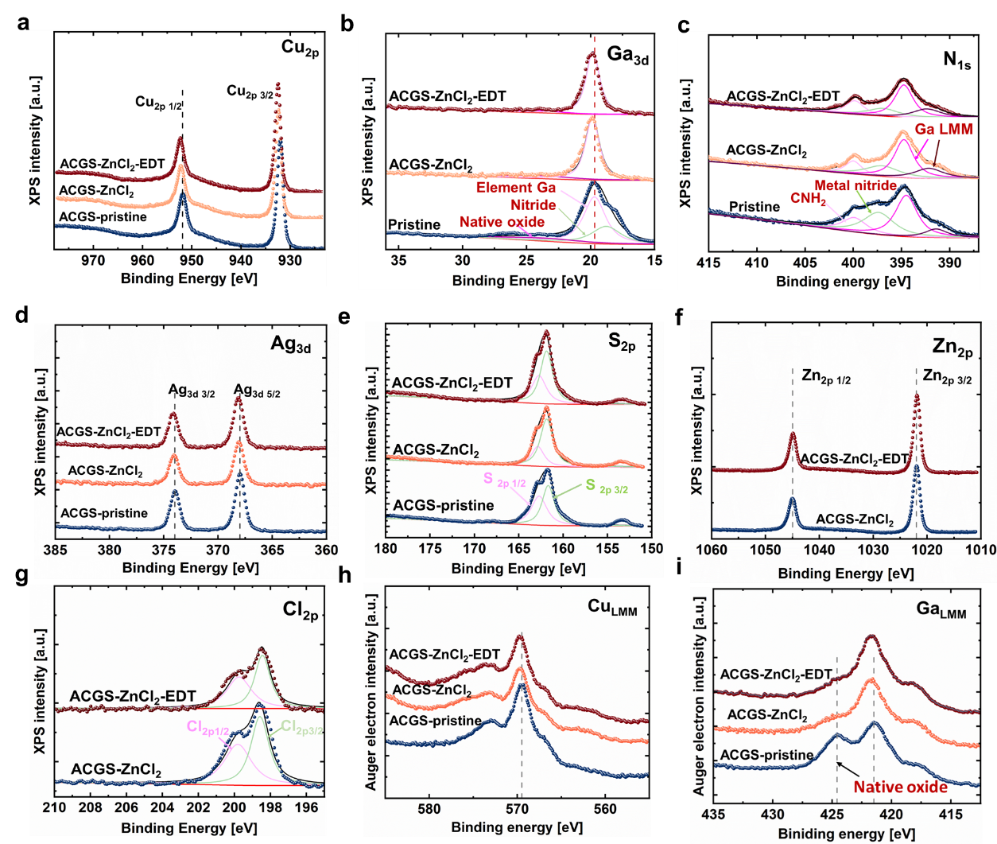

Supplementary Figure 6| Influence of surface ligand on chemical state and bonding of ACGS QD measured by high-resolution XPS. (a) Cu _{2p} (b) Ga _{3d} (c) N _{1s} (d) Ag _{3d} (e) S _{2p} (f) Zn _{2p} (g) Cl _{2p} core emission of ACGS-pristine, ACGS-ZnCl₂ and ACGS-ZnCl₂-EDT QD. Auger electron emission of Cu _{LMM} (h) and Ga _{LMM} (i) are also provided to verify chemical environment changes. In Ga _{3d,} N _{1s} , S _{2p} and Cl _{2p} emission spectrum, the red solid lines indicate shirley background that was subtracted from original spectrum. Light pink, pinkish purple and green solid lines indicate convoluted emission from different species, as specified in the figure. The spherical dot and black solid lines indicate measured raw data, and the sum of individual convoluted spectrum. Accurate analysis on emission peaks, as well as elemental concentrations is summarized in Supplementary Table 3&4.

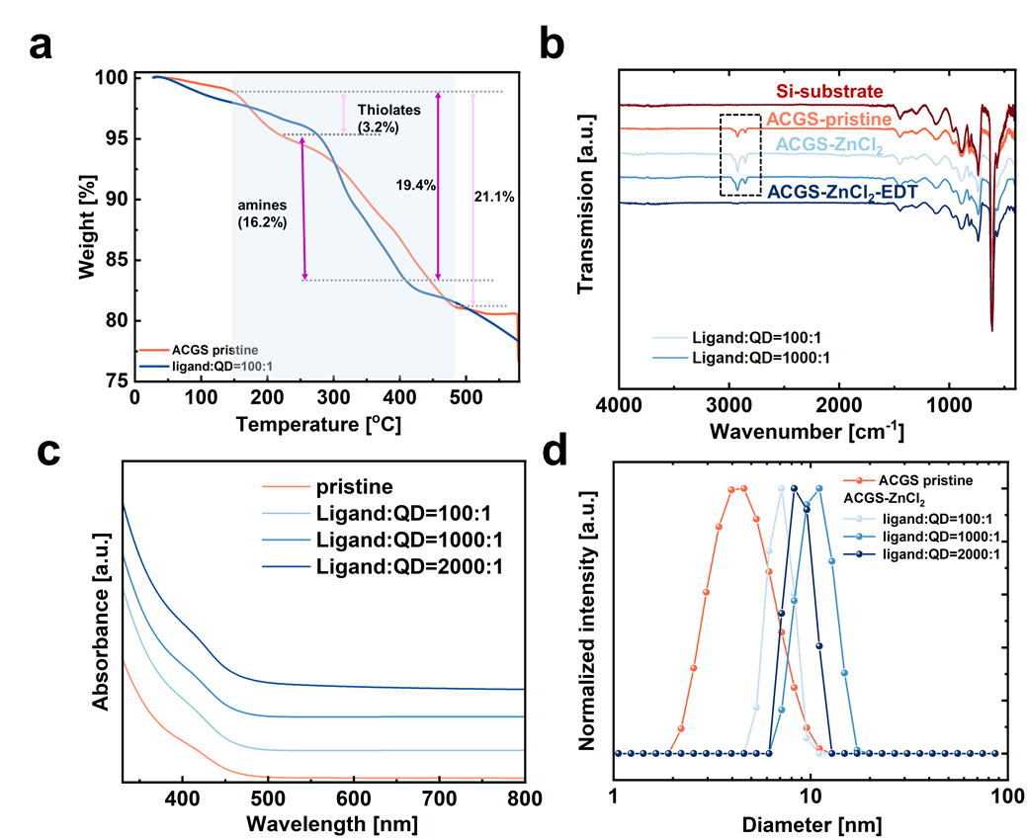

Supplementary Figure 7| characterizations of ACGS QD with hybrid ligand exchange using ZnCl₂ and EDT. (a) Thermogravimetric analysis (TGA) of ACGS-pristine and ACGS-ZnCl₂ with ligand density of 100:1. (b) Infrared transmission spectrum of ACGS QD with varied ligand measured with FTIR. The transmission spectrum of intrinsic silicon wafer substrate is plot in dark blue. (c) Particle size distribution of ACGS-pristine and ACGS-ZnCl₂ with varied ligand density measured with dynamic light scattering (DLS). (d) Absorption characteristics of ACGS-pristine and ACGS-ZnCl₂ with varied ligand density.

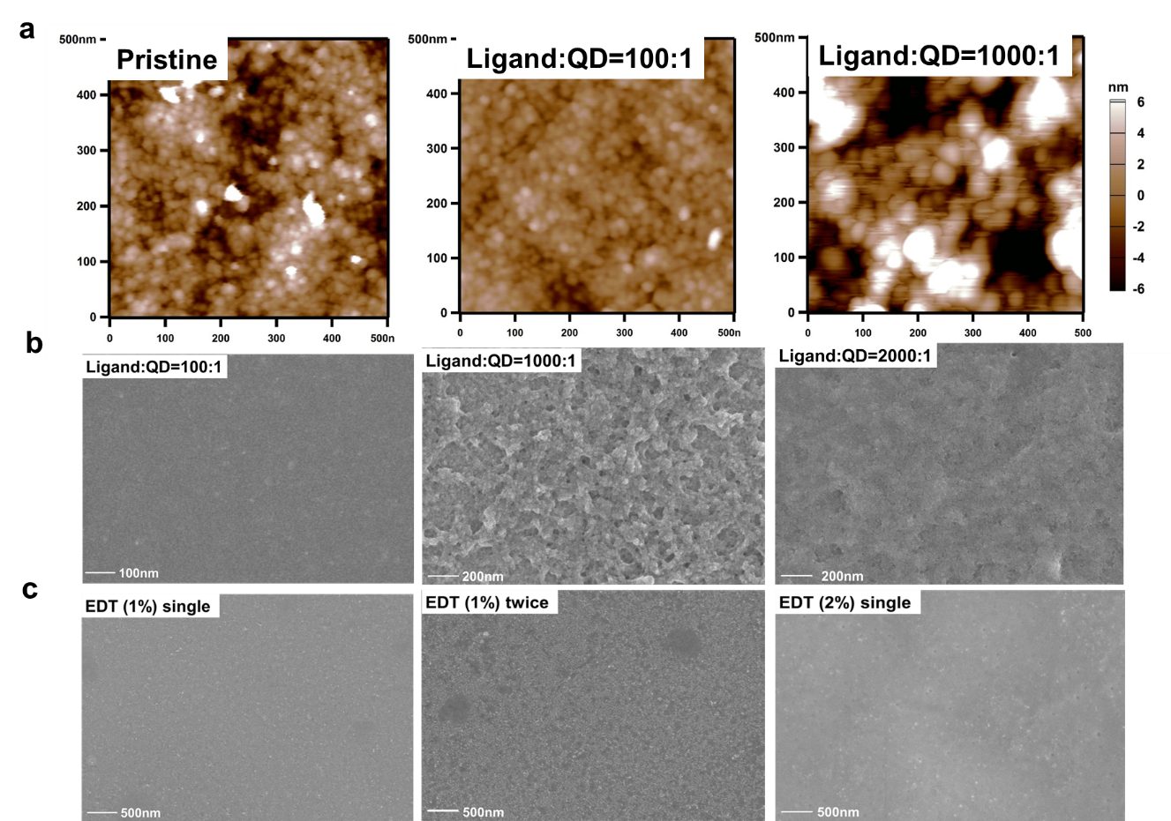
Supplementary Figure 8| Surface morphology analysis of ACGS QD solids after ligand exchange with ZnCl₂ and EDT. (a) Film morphology of ACGS-pristine, ACGS-ZnCl₂ QD solids with varied ligand density measured with AFM; as ligand density increases to 1000:1, obvious aggregation of QD leads to rough film surface with pinholes. (b) SEM images of ACGS-pristine, ACGS-ZnCl₂ QD solids with varied ligand density. (c) SEM images of ACGS-ZnCl₂-EDT QD solids with various concentration and coating times in term of solid-phase EDT treatment. All QD thin-films were deposited via spin-coating at 3000rpm for 30s, followed by 60°C annealing for 20min. To achieve uniform and bright QD solids for PeLEDs applications, optimized ligand treatment include solution-phase ZnCl₂ (ligand density 100:1) followed by solid-phase EDT (1 volume% in acetonitrile and single coating time).

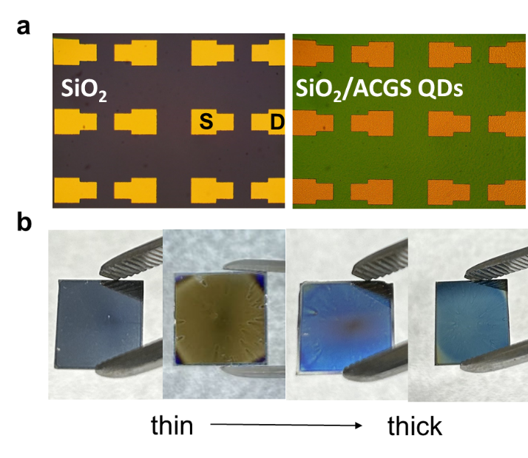

Supplementary Figure 9| Thin-film transistor based on QD solids (QD-TFT). (a) Microscopic images of QD thin-films. Left: atomic layer deposited SiO₂ thin-films on silicon substrate; the thickness of SiO₂ is 200 nm. Right: ACGS QD deposited on SiO₂ substrate. (b) Picture of QD thin-films deposited on highly-doped p-type silicon substrate with varied thickness. From left to right: the film is thickened by increasing the concentration of QD solution, as the color appears from dark grey to yellow, to sky blue and dark blue.

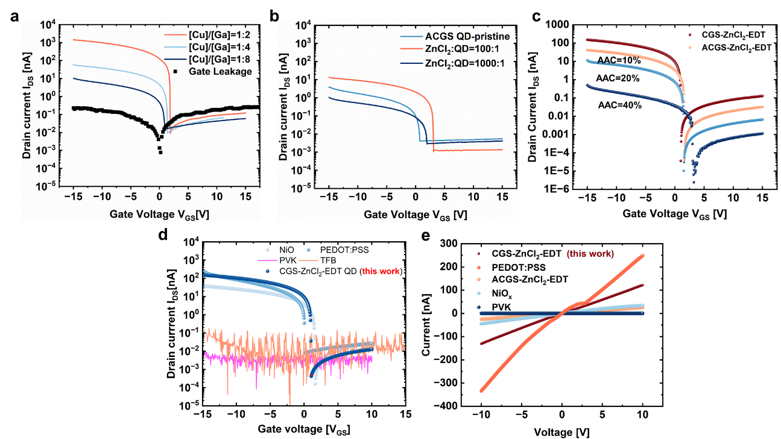

Supplementary Figure 10| Transfer characteristics of QD-LED. Effects of (a) [Cu]/[Ga] precursor ratio, (b) ZnCl₂ ligand density, (c) AAC ratio in precursor on I_{DS}-V_{GS} plot of CGS QD solids. (d) Comparisons of transfer characteristics of other conventional hole transport material including NiO_{x}, PEDOT:PSS, TFB (orange solid lines), and PVK (pink solid lines) with CGS-ZnCl₂-EDT (dark blue dot) prepared in this work. (e) Corresponding current-voltage (I-V) curves of two-terminal device for hole concentration extraction. The I-V curves for TFB and PVK are similar; therefore only the I-V characteristics of PVK are shown here.

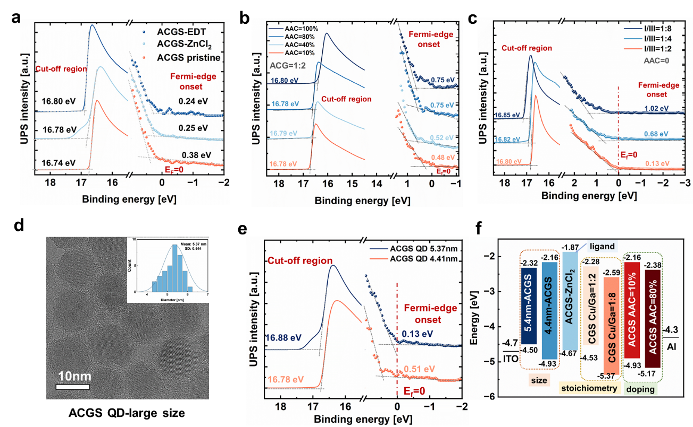
Supplementary Figure 11| Estimations on band structure of chalcopyrite QDs modified by chemical composition, size and surface ligand through UPS measurement. (a) UPS spectra of ACGS-pristine, ACGS-ZnCl₂ and ACGS-EDT. (b) UP spectra of ACGS QD with varied AAC ratio in the precursor, while keeping ACG ratio of 1:2. (c) UPS spectra CGS QD with varied [Cu]/[Ga] ratio in the precursor. (d) TEM images of larger-sized ACGS QD synthesized with chloride precursors; the inset shows the histogram plot of size distribution, which are collected from 50 individual dots. (e) UPS spectra of ACGS QDs subject to quantum confinement effects. (f) Summary of the energy band diagram of ACGS QD susceptible to stoichiometry, doping, size effect, and surface ligand.
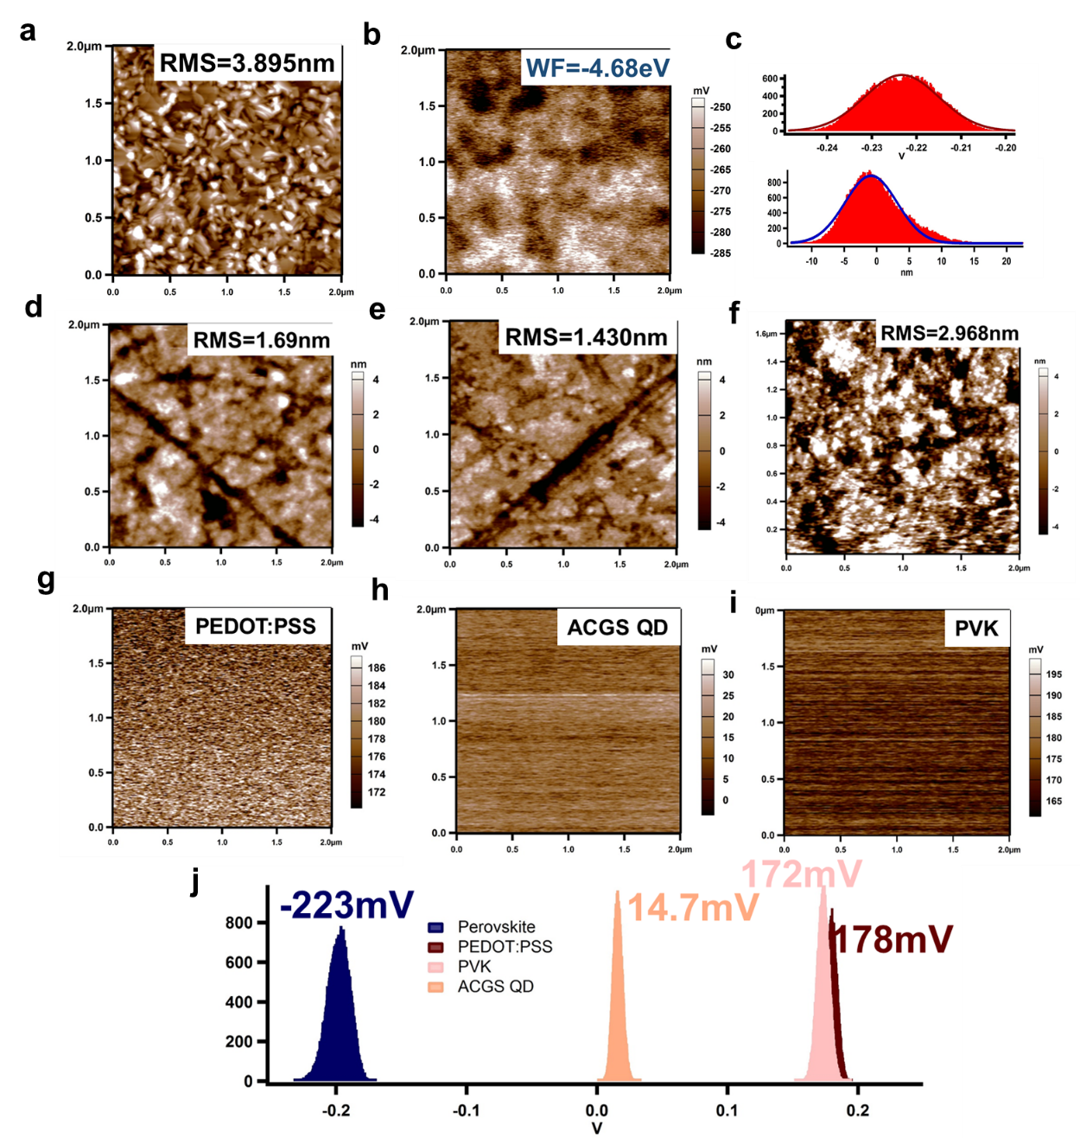
Supplementary Figure 12 |Microscopic work function analysis of quasi-2D perovskite films and various hole transport layer using kelvin probe microscopy (KPFM). Surface morphology (a), and contact potential difference (CPD) mappings (b) of quasi-2D perovskite layer deposited on glass substrate. (c) Corresponding histogram plot of surface roughness and CPD for perovskite layer fitted by Gaussian distribution curves. Surface morphology (d) and CPD mappings (g) of PEDOT:PSS films. Surface morphology (e) and CPD mappings (h) of ACGS QD solids; surface morphology (f) and CPD mappings (i) of PVK films. (j) Histogram plot fitted by Gaussian distribution for perovskite (dark blue), PEDOT:PSS (dark red), ACGS QD solids (pink) and PVK (orange), respectively. All thin-films are deposited on glass substrate. The surface roughness is pointed out in each morphology images, indicated as RMS.
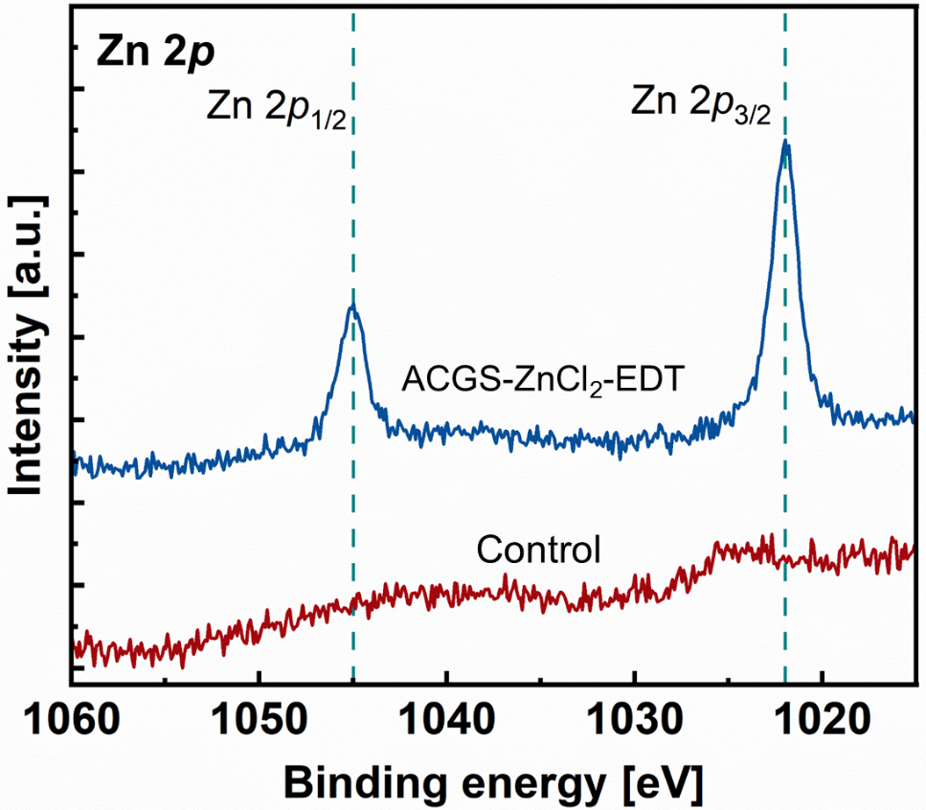
Supplementary Figure 13 |High-resolution XPS spectra of Zn 2p in quasi-2D perovskites deposited on PEDOT:PSS substrate (control), and ACGS-ZnCl₂-EDT QD solids substrate. The diffusion of Zn²⁺ from the surface of ACGS QD into the perovskite films can be confirmed.

Supplementary Figure 14 | TRPL decay curves of quasi-2D perovskites deposited on quartz glass, quartz glass/ACGS-pristine QD solids, and quartz glass/ACGS-ZnCl₂-EDT QD solids.

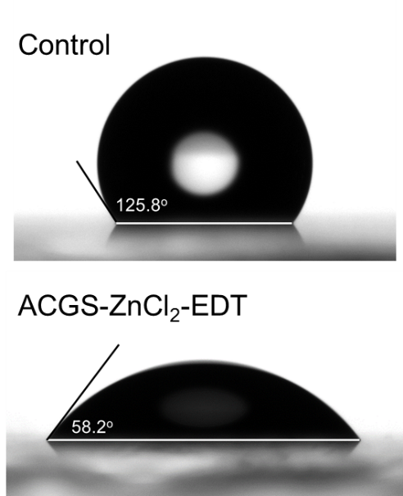
Supplementary Figure 15 | Contact angle measurement of deionized water drops on PEDOT:PSS (control) and ACGS-ZnCl₂-EDT QD solids substrate.

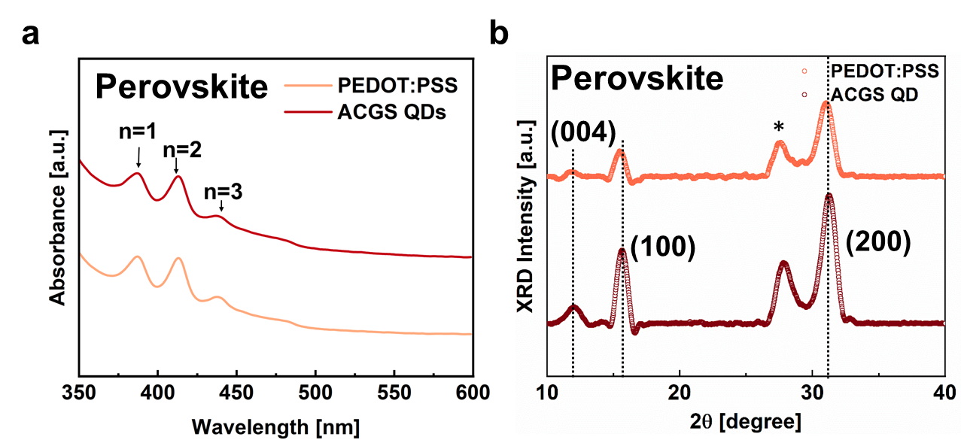
Supplementary Figure 16 | Influences of ACGS QD solids on the absorption and crystallography of quasi-2D perovskites. (a) Absorption features and (b) XRD patterns of quasi-2D perovskite films deposited on PEDOT:PSS and ACGS QD solids substrate. Excitonic absorption peaks located at 387nm, 413nm, 438nm, and 475nm corresponds to phases with n=1, n=2, n=3 and n≥4, respectively. The diffraction peaks attributed to 3D CsPb(Br,Cl)₃ perovskite are denoted with miller index as (100) and (200) with dashed lines, located at 31.3º and 15.6º respectively . The diffraction peaks at 12.8º is indicated as (004) planes for pure 2D perovskite phase. The peak marked with * represent the peaks corresponding to quasi-2D perovskite. From UV-vis and XRD measurement, it is concluded that ACGS QD solids exert trivial influences on low-n phases of quasi-2D perovskite.

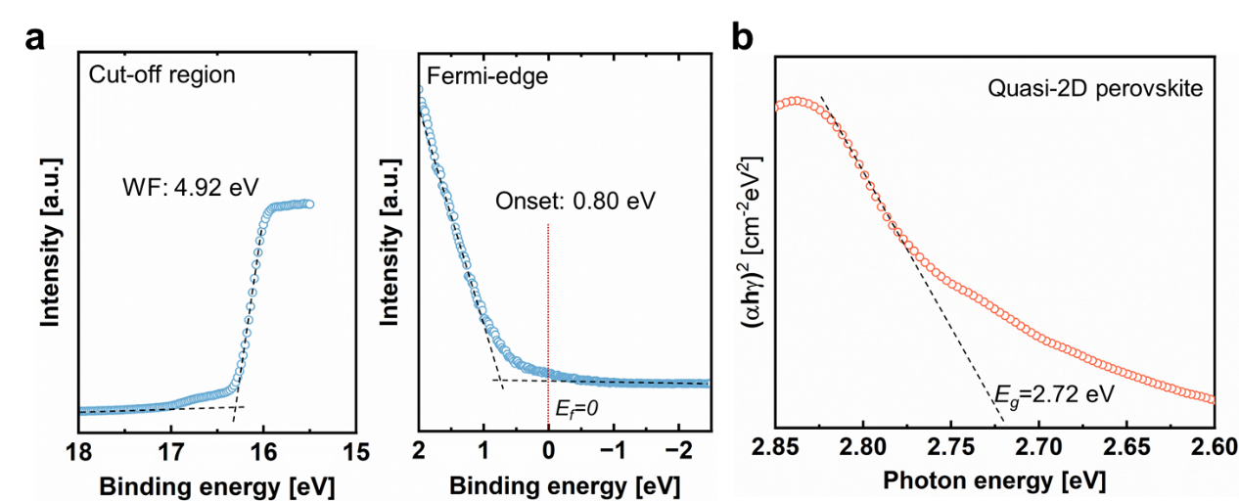
Supplementary Figure 17 | UPS spectra and Tauc plots of perovskite films. (a) UPS spectra of Fermi edge regions and high binding energy secondary-electron cut-off region of quasi-2D perovskite film prepared in this work. (b) Tauc plots of quasi-2D perovskite film. The WF and VBM of perovskite are estimated to be -4.92 eV and -5.72 eV, respectively. Thus, the CBM energy level ofr perovskite is -3.0 eV.
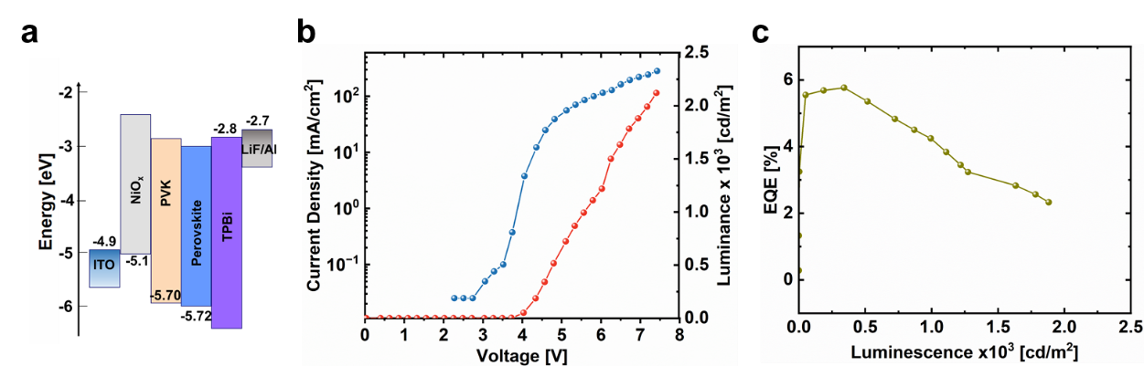
Supplementary Figure 18| Device architecture and champion performance of NiO_{x}-based PeLEDs. (a) Schematic of band diagram of device D. J-V-L (b) and EQE-L (c) characteristics of NiO_{x}-based PeLEDs.

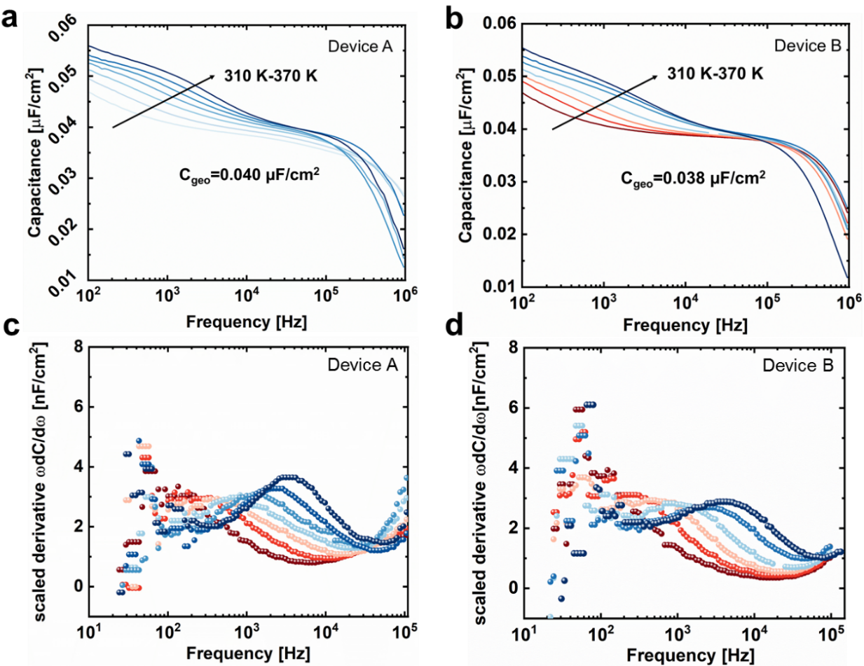

Supplementary Figure 19 |Defect physics analysis of PeLEDs, measured by TAS spectroscopy. (a-b) Capacitance-frequency characteristics of device A and device B, and (c-d) corresponding scaled derivative plot.

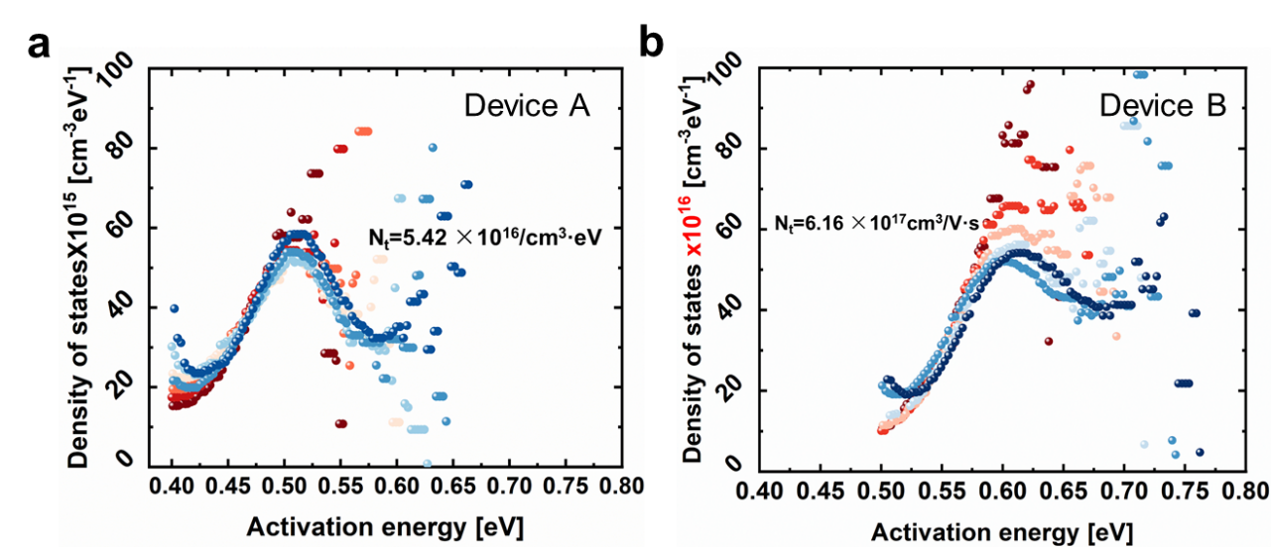

Supplementary Figure 20| Defect density of states (DOS) plot as a function of energy level of (a) device A and (b) device B. The averaged maximum DOS of deep-level defects is indicated as N_{t} in the figure, which was as calculated to be 5.42×10¹⁶ cm^{-3·}eV⁻¹, and 6.16×10¹⁷ cm^{-3·}eV⁻¹, in device A and device B respectively.

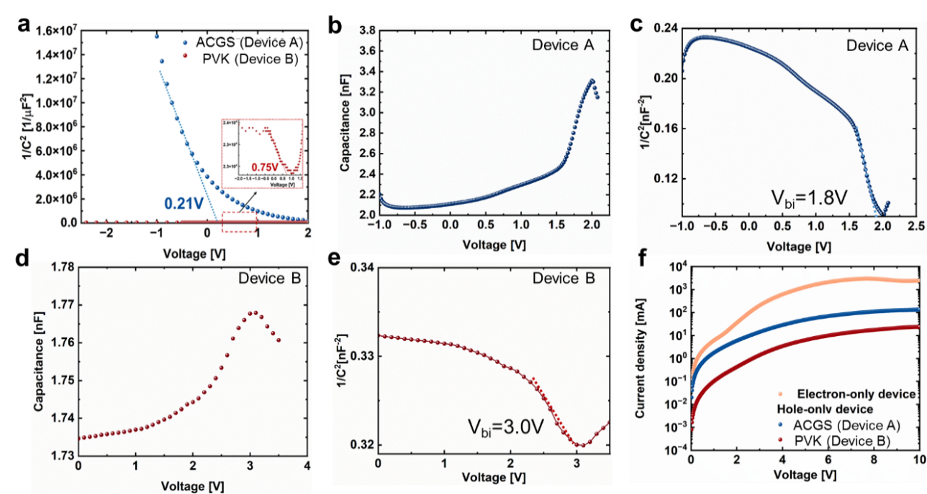
Supplementary Figure 21| Capacitance-voltage (C-V) characteristics and Mott-Schottky (MS) analysis of HOD devices and PeLEDs. (a) MS plot of hole-only devices based on ACGS QD (device A) and PVK (device B). The inset explains interpolation of 1/C²-V curves to x-axis to extract the built-in potential (V_{bi}) of device B. (b) C-V and (c) MS plot of device A. (d) C-V and (e) MS plot of device B. V_{bi} is indicated in the figure, which is 1.8 V and 3.0 V for device A and device B, respectively. (f) Current-voltage (J-V) characteristics of single carrier devices. The measured hole current of device A and device B are compared.

Supplementary Figure 22| Transmittance spectrum of NiO_{X} thin-films, and ACGS-ZnCl₂-EDT QD solids in the wavelength range of 400-800 nm.

Supplementary Table 1| Chemical composition analysis for ACGS-pristine, ACGS-ZnCl₂ and ACGS-ZnCl₂-EDT estimated from STEM-EDX. The QD with varied ligand density (ligand : QD ratio) was synthesized with ACG and AAC ratio of 1:4, and 10%, respectively.
Atomic ratio [%] | Ag | Cu | Ga | S | Zn | Cl | N | AAC | ACG
ACGS-pristine | 3.16 | 27.28 | 24.86 | 42.55 | 0 | 0 | 4.15 | 10.4% | 1.22
ACGS-ZnCl₂  Ligand: QD=100:1 | 1.99 | 16.65 | 18.46 | 40.46 | 9.43 | 10.17 | 2.84 | 10% | 1.00
ACGS-ZnCl₂  Ligand: QD=1000:1 | 1.54 | 18.59 | 14.02 | 40.47 | 12.74 | 9.21 | 3.42 | 7.6% | 1.43
ACGS-ZnCl₂  Ligand: QD=2000:1 | 0.74 | 5.14 | 7.58 | 17.21 | 28.3 | 28.63 | 12.4 | 12% | 0.77

Supplementary Table 2| Elemental composition of aliquot sampled at different temperatures during the CGS QD synthesis from STEM-EDX measurement.
Atomic concentration [%] | Ag | Cu | Ga | AAC | I/III
130ºC | 0.53 | 0.43 | 0.20 | 0.55 | 4.8
160ºC | 0.37 | 0.55 | 0.35 | 0.40 | 2.62
180ºC | 0.16 | 0.60 | 0.61 | 0.22 | 1.36
220ºC | 0 | 1.55 | 0 | 0 | -

Supplementary Table 3| Quantitative analysis on XPS fine scan on N 1s and Ga 3d core-level photoemissions. of ACGS QD. Summary of binding energy (B.E.), FWHM and XPS intensity for ACGS-pristine, ACGS-ZnCl₂ and ACGS-ZnCl₂-EDT QD.
Sample | Element | Attributions | B.E. [eV] | FWHM [eV] | Intensity [a.u.] | ratio
ACGS- pristine | N_{1s} | C-NH₂ | 398.99 | 4.39 | 22085.7 | 0.51
ACGS- pristine | N_{1s} | Metal nitride | 396.8 | 3.68 | 20997.23 | 0.49
ACGS- pristine | Ga_{3d} | Ga-Ga | 19.87 | 1.82 | 35533.18 | 0.64
ACGS- pristine | Ga_{3d} | Ga-N | 25.68 | 1.61 | 13172.97 | 0.24
ACGS- pristine | Ga_{3d} | Ga-O | 18.2 | 3.5 | 6305.737 | 0.11
ACGS-ZnCl₂ | N_{1s} | C-NH₂ | 399.74 | 2.96 | 18895.97 | 0.50
ACGS-ZnCl₂ | N_{1s} | Metal nitride | 395.96 | 3.07 | 18694.14 | 0.50
ACGS-ZnCl₂ | Ga_{3d} | Ga-Ga | 19.95 | 1.27 | 27394.82 | 0.91
ACGS-ZnCl₂ | Ga_{3d} | Ga-N | - | - | 0 | 0
ACGS-ZnCl₂ | Ga_{3d} | Ga-O | 24.75 | 3.6 | 2585.837 | 0.19
ACGS-ZnCl₂-EDT | N_{1s} | C-NH₂ | 399.85 | 2.29 | 13621.29 | 0.51
ACGS-ZnCl₂-EDT | N_{1s} | Metal nitride | 396.29 | 3.83 | 13071.32 | 0.49
ACGS-ZnCl₂-EDT | Ga_{3d} | Ga-Ga | 19.98 | 1.33 | 22913.85 | 0.95
ACGS-ZnCl₂-EDT | Ga_{3d} | Ga-N | - | - | 0 | 0
ACGS-ZnCl₂-EDT | Ga_{3d} | Ga-O | 24.59 | 7.47 | 1047.56 | 0.05

Supplementary Table 4| Chemical composition analysis for ACGS-pristine, ACGS-ZnCl₂ and ACGS-ZnCl₂-EDT estimated from XPS survey scan.
Atomic ratio [%] | Ag | Cu | Ga | S | Zn | Cl | N | AAC | ACG
ACG-pristine | 2.30 | 27.02 | 24.10 | 45.23 | - | - | 1.35 | 8.7% | 1.2
ACGS-ZnCl₂ | 2.09 | 18.01 | 14.69 | 42.39 | 13.35 | 8.17 | 1.30 | 10.3% | 1.36
ACG-ZnCl₂-EDT | 1.84 | 18.97 | 15.30 | 43.5 | 12.62 | 6..16 | 1.60 | 8.8% | 1.36

Supplementary Table 5| Summary of carrier concentration and hole mobility of various hole transport and injection material. ACGS QD and CGS QD denote QD solids after hybrid ligand exchange process developed in this work. Specifically, both ACGS and CGS QD were synthesized with the ratio between group I and group III in the precursor of 1:4, and AAC ratio is 10% in ACGS QDs. NiO_{x} was spun-coated on ITO glass substrate using commercially-available NiO_{x} nanoparticle ink.
Hole functional material | Carrier concentration [1/cm³] | Hole mobility [cm²/V·s]
TFB | 1.15×10¹⁶ | 6.95×10⁻⁵
PVK | 5.65×10¹⁵ | 1.34×10⁻⁵
ACGS QD* | 3.35×10¹⁵ | 0.191
CGS QD* | 5.81×10¹⁵ | 0.546
NiO | 8.57×10¹⁵ | 0.127
PEDOT:PSS | 7.97×10¹⁵ | 0.465

Supplementary Table 6| Summary of carrier lifetime of quasi-2D perovskites on PEDOT:PSS substrate from exponential fit to TRPL measurement.
 | A₁ | τ₁(ns) | A₂ | τ₂(ns) | τ_{avg}(ns)
Control* | 0.50 | 0.90 | 0.50 | 7.16 | 6.46
ACGS-pristine# | 0.75 | 0.33 | 0.25 | 1.88 | 1.26
ACGS-ZnCl₂-EDT | 0.81 | 0.45 | 0.19 | 3.98 | 2.83
*Control samples refer to perovskite deposited on PEDOT:PSS substrate
＃ACGS-pristine refer to perovskite deposited on PEDOT:PSS/ACGS pristine QD solids.

Supplementary Table 7| Summary of carrier lifetime of qusi-2D perovskites on quartz glass substrate from exponential fit to TRPL measurement.
 | A₁ | τ₁(ns) | A₂ | τ₂(ns) | τ_{avg}(ns)
Control* | 0.57 | 0.61 | 0.43 | 9.89 | 9.19
ACGS-pristine# | 0.67 | 0.36 | 0.33 | 1.98 | 1.54
ACGS-ZnCl₂-EDT | 0.72 | 0.57 | 0.28 | 5.15 | 4.13

*Control samples refer to perovskite deposited on quartz glass substrate
＃ACGS-pristine refer to perovskite deposited on quartz glass /ACGS pristine QD solids.

Assuming uniform generation of excess charge carriers across the film thickness, and Auger recombination, and photon recycling process is negligible, the PL amplitudes and decay time are evaluated using a bi-exponential equation (1):
$$f\left(t\right)=\sum_{i}^{ }{A_{i}exp\left(-t/τ_{i}\right)}+C (i=1, 2) (1)$$where A_{i} is the decay amplitude, τ_{i} the decay time and C is a constant for the base-line offset. The average PL decay times (τ_{ave}) are obtained from the fitted curve data in Table S6 according to equation (2) ¹:
$$τ_{ave}=\frac{∑A_{i}τ_{i}^{2}}{∑A_{i}τ_{i}} (2)$$

Supplementary Table 8|Summary of luminescent performances of PeLEDs prepared in this work with various hole functional materials. Device A: glass/ indium tin oxide (ITO)/PEDOT:PSS/ACGS QD/perovskite/TPBi/LiF/Al; device B: glass/ indium tin oxide (ITO)/PEDOT:PSS/PVK/perovskite/TPBi/LiF/Al; device C: glass/ACGS QD/perovskite/TPBi/LiF/Al; device D: glass/ indium tin oxide (ITO)/NiO_{x}/PVK/perovskite/TPBi/LiF/Al. Higher luminance of device D achieved is mainly due to higher transmission of NiO_{x} thin films compared to ACGS QD solids in the wavelength range of 450-550 nm (Supplementary Fig. 22).
Hole functional layer | V_{on} [V] | Peak EQE [%] | Peak luminescence [cd/m²]
Device A | 3.3 | 10.85 | 1450
Device B | 2.9 | 4.26 | 1118
Device C | 3.5 | 3.01 | 352
Device D | 3.7 | 5.76 | 2119

Supplementary Table 9| Device performances of Pe-LEDs emitting from 460nm to 475nm.The data is collected from 2021 till now. Unless specified, the perovskite emitter refers to quasi-2D films.
Perovskite emitter | HTL | Peak emission [nm] | Maximum EQE [%] | CIE | Lifetime  (T₅₀@100nit) | ref
Rb:CsPb(Br_{x}/Cl_{1−x})₃  NC | PEDOT:PFI/PF8Cz | 475 | 24.3 | 0.105,0.128 | Not available | 2
Rb:CsPb(Br_{x}/Cl_{1−x})₃  NC | PEDOT:PFI/PF8Cz | 470 | 21.3 | 0.115,0.103
Rb:CsPb(Br_{x}/Cl_{1−x})₃  NC | PEDOT:PFI/PF8Cz | 465 | 16.7 | 0.127,0.069
Rb:CsPb(Br_{x}/Cl_{1−x})₃  NC | PEDOT:PFI/PF8Cz | 460 | 12 | 0.138,0.045
CsPbCl_{3–x}Br_{x} QD | PEDOT/TFB/Poly-TPD+TCTA | 475 | 20.7 | Not available | 66min | 3
Cs_{0.75}MDA_{0.125}Pb(Br/Cl)₃ | PEDOT*/PVK | 475 | 14.2 | 0.11, 0.13 | 2min | 4
p-F-PEA₂(CsPb(Br_{0.55}Cl_{0.45})₃) | PEDOT/TFB/PVK | 468 | 11.9 | 0.141, 0.051 | 23min | 5
CsPbBr3 QD | PEDOT:PFI/PVK | 463 | 11.9 | 0.132, 0.069 | 17min | 6
CsPbBr3 QD | PEDOT/PVK | 469 | 10.3 | 0.13, 0.08 | T50@115nit=25h | 7
CsPbBr3 QD | PEDOT/PVK | 465 | 10.3 | 0.13, 0.06 | 120min | 8
PEA-Rb_{x}Cs_{1−x}PbBr_{3−y}Cl_{y} | PEDOT | 475 | 10.1 | 0.113 ,0.115 | 100s | 9
CsPbCl_{x}Br_{3−x} | PEDOT | 468 | 4.6 | 0.131, 0.055 | - | 10
FARbCsPbCl_{x}Br_{3−x} | NiO/PVK/PVP | 467 | 5.5 | 0.130, 0.059 | 3min | 11
CsPbBr3 QD | TFB/PFI | 471 | 6.3 | 0.129, 0.087 | 99s | 12
PEA₂Cs_{n−1}Pb_{n}(Br_{0.55}Cl_{0.45})_{3n+1} | PEDOT:ETA/TMAB | 474 | 6.7 | 0.11, 0.11 | T₅₀@160nit=180s | 13
PEA-CsPbBr_{3−y}Cl_{y} | PEDOT/ACGS QDs | 471 | 10.85 | 0.13, 0.08 | 78 min | This work

*PEDOT is short for PEDOT:PSS.

References
1. Kim J-H. et al. A near-ideal color rendering white solid-state lighting device copackaged with two color-separated Cu–X–S (X = Ga, In) quantum dot emitters. J. Mater. Chem. C 5, 6755-6761 (2017).
2. Nong, Y. et al. Gradient Hole Injection Inducing Efficient Exciton Recombination in Blue (475 nm) Perovskite QLEDs. Nano Lett. Online (2024)
2. Gao, Y. et al. Highly efficient blue light-emitting diodes based on mixed-halide perovskites with reduced chlorine defects. Sci. Adv. 10, eado5645 (2024).
3. Zhang, L. et al. Manipulating Local Lattice Distortion for Spectrally Stable and Efficient Mixed-halide Blue Perovskite LEDs. Angew. Chem. Int. Ed. 62, e202302184, (2023).
4. Liu, Y. et al. A Multifunctional Additive Strategy Enables Efficient Pure-Blue Perovskite Light-Emitting Diodes. Adv. Mater. 35, 2302161 (2023).
5. Wang, Y.-K. et al. Self-assembled monolayer–based blue perovskite LEDs. Sci. Adv. 9, eadh2140, (2023).
6. Bi, C. et al. Suppressing Auger Recombination of Perovskite Quantum Dots for Efficient Pure-Blue-Light-Emitting Diodes. ACS Energy Lett. 8, 731-739 (2023).
7. Jiang, Y. et al. Synthesis-on-substrate of quantum dot solids. Nature 612, 679-684, (2022).
8. Yang, Y. et al. Highly Efficient Pure-Blue Light-Emitting Diodes Based on Rubidium and Chlorine Alloyed Metal Halide Perovskite. Adv. Mater. 33, 2100783, (2021).
9. Tong, Y. et al. In Situ Halide Exchange of Cesium Lead Halide Perovskites for Blue Light-Emitting Diodes. Adv. Mater. 35, 2207111, (2023).
10. Karlsson, M. et al. Mixed halide perovskites for spectrally stable and high-efficiency blue light-emitting diodes. Nat. Commun. 12, 361, (2021).
11. Zheng, X. et al. Chlorine Vacancy Passivation in Mixed Halide Perovskite Quantum Dots by Organic Pseudohalides Enables Efficient Rec. 2020 Blue Light-Emitting Diodes. ACS Energy Lett. 5, 793-798 (2020).
12. Ye, F. et al. Interface Engineering with Quaternary Ammonium-Based Ionic Liquids toward Efficient Blue Perovskite Light-Emitting Diodes. ACS Appl. Mater. Inter. 14, 50393-50400 (2022).

