Supplementary figures
Fig_{suppl}.1: Negative control for VIC (brown) and FAM (blue)
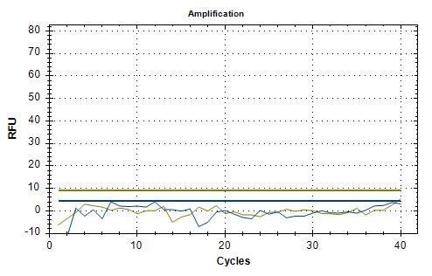
Fig_{suppl}.2: Wild homozygous prototype (FAM)
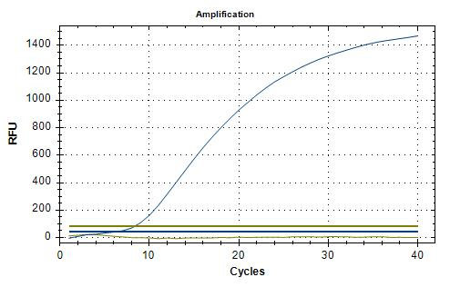

Fig_{suppl}.3: Variant homozygous prototype (VIC)
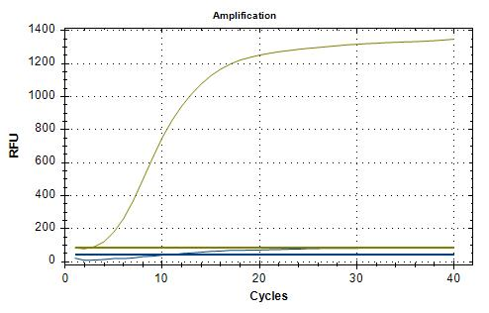

Fig_{suppl}.4: Heterozygous prototype (FAM & VIC)
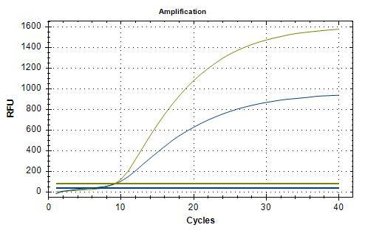

Fig_{suppl}.5- Allelic discrimination plot of the genotypes
