Supplymentary Figure 1

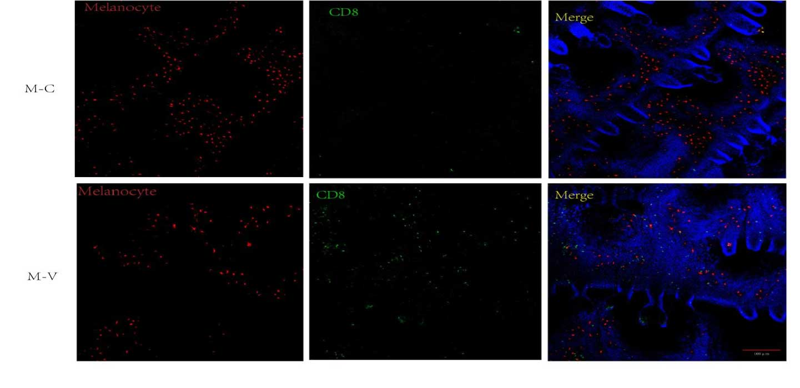
Supplymentary Figure 1 . The whole-mount immunofluorescence staining showed a decrease in the percentage of melanocytes and an increase in CD8+ T lymphocyte cell infiltration in the epidermis, indicating vitiligo development .

Supplymentary Figure 2

Supplymentary Figure 2. The concentration of the three inducers determined by CCK8 experiment.

Supplementary Fig. 3
Supplementary Fig. 3. CCK8 experiment detected the effection on cell viability of SRT501 and EX527.

