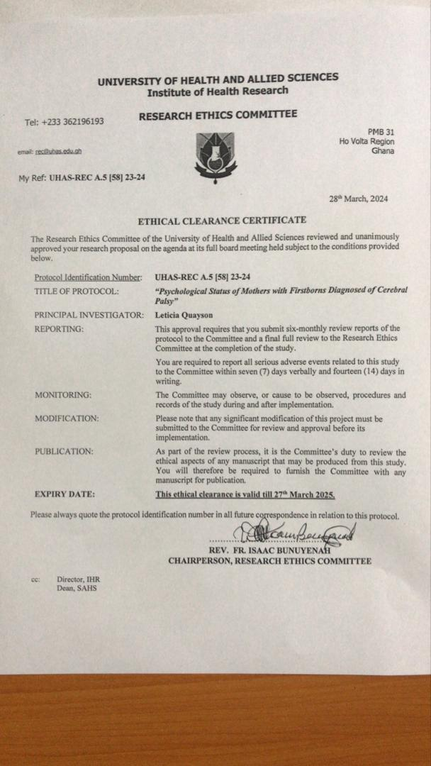


RESEARCH OPERATIONS OFFICE 
INSTITUTE OF HEALTH RESEARCH
UNIVERSITY OF HEALTH AND ALLIED SCIENCES
RESEARCH ETHICS COMMITTEE (REC)
PROTOCOL CONSENT FORM

Section A- BACKGROUND INFORMATION

Title of Study: | Psychological status of mothers with firstborns diagnosed of cerebral palsy
Principal Investigator: | Leticia Quayson
Certified Protocol Number | UHAS- REC A.5[58] 23-24

Section B– CONSENT TO PARTICIPATE IN RESEARCH

General Information about Research
As part of the partial fulfilment of the requirements to obtain a Bachelor of Science Degree in Physiotherapy, I am being supervised by Mr. Dennis Assibey to undertake a research project titled “Psychological status of mothers with firstborns diagnosed of cerebral palsy”. The aim of this research is to evaluate the level of depression, anxiety and stress among these mothers. As part of this study, you are kindly requested to complete the attached questionnaire and demographic details at your own comfort and convenience. Please take your time and respond to each question and be sincere as possible.

Benefits/Risks of the study
There is no risk associated with participating in this study. The study's outcomes could contribute to raising awareness within the community and among healthcare providers about the distinctive challenges faced by mothers of firstborns with cerebral palsy.
Confidentiality
Your identity as a participant will not be disclosed and any data obtained will be kept confidential throughout the study.
Compensation
As there is no risk in this study, there will be no direct compensation. However, I will cater for the cost of your transportation and refreshment the day you are called upon to take part in the study.
Withdrawal from Study
Participation in this study is voluntary and refusal to participate has no negative effects. You may choose to discontinue participation at any time without any consequences. You will not need to provide a reason for stopping to participate.
What happens after study or when the participant changes his/her mind
The findings of the study will be made available to you on request at no cost. The findings will also be shared to the four physiotherapy centers involved in the study (Korle Bu Teaching Hospital, 37 Military Hospital, RIDGE Hospital and Princess Marie Louise children's hospital). If in the process you discontinue participation, data collected from you will be automatically destroyed. All data collected from the study will be discarded 3 months after the completion of the study.
Contact for Additional Information
- Participants may get in touch with the researcher if they have any queries regarding the study at any time or if they are harmed while participating in it (+233241873922)
- If you have any questions about your rights as a research participant in this study you may contact the Administrator of the Research Ethics Committee, IHR, University of Health and Allied Sciences at rec@uhas.edu.gh or +233- 362-196-193.

Section C- PARTICIPANT AGREEMENT
"I have read or have had someone read all of the above, asked questions, received answers regarding participation in this study, and am willing to give consent for me to participate in this study. I will not have waived any of my rights by signing this consent form. Upon signing this consent form, I will receive a copy for my personal records."

__________________________
Name of Participant

__________________________ _______________________
Signature or mark of Participant Date

If participant cannot read and or understand the form themselves, a witness must sign here:
I was present while the benefits, risks and procedures were read to the volunteer. All questions were answered and the volunteer has agreed to take part in the research.
_____________________
Name of witness

_____________________ _______________________
Signature of witness/Mark Date

I certify that the nature and purpose, the potential benefits, and possible risks associated with participating in this research have been explained to the above individual.

________________________________
Name of Person who Obtained Consent

___________________________________ ______________________
Signature of Person Who Obtained Consent Date

