Supplementary material S1 for

Trogloregions: delimiting subterranean faunistic identities in Afrotropics and Neotropics

By Alvarenga, D. A., Souza-Silva, M. & Ferreira, R. L. (2020)

Supplementary figures
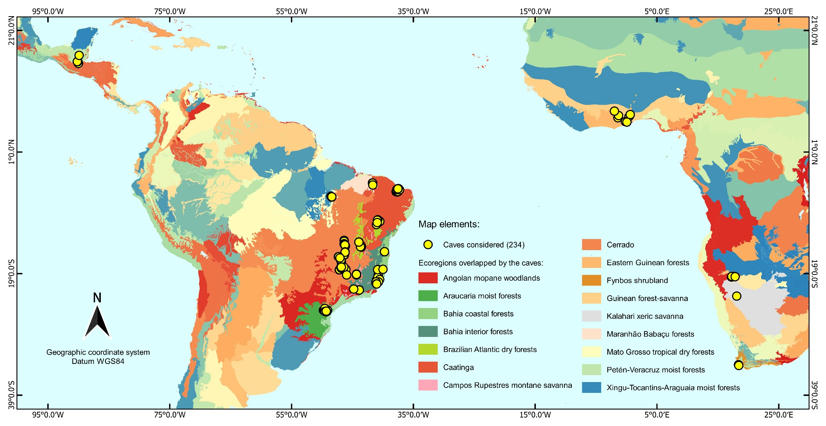
Supplementary figure 1: Map with the 234 caves considered in the database of invertebrate families and the 16 ecoregions in which their locations overlap.
Supplementary figure 2: CLUSTER and SIMPROF analyses testing the faunistic similarity of fauna attributed to the 37 cave groups (number of caves in parentheses) resulting from the hierarchical combination of factors: drainage basin-ecoregion-biome-lithology-biogeographical domain. The SIMPROF analysis indicated the formation of 17 "supergroups" (table on the right) with different faunistic compositions, evidenced by the black lines (p<1% after 999 permutations. Sørensen–Dice index).
Supplementary figure 3: CLUSTER and SIMPROF analyses testing the faunistic similarity of fauna attributed to the 37 cave groups (number of caves in parentheses) resulting from the hierarchical combination of factors: drainage basin-ecoregion-biome-lithology-biogeographical domain. The SIMPROF analysis indicated the formation of 17 "supergroups" (table on the right) with different faunistic compositions, evidenced by the black lines (p<5% after 999 permutations. Jaccard index).
Supplementary figure 4: CLUSTER and SIMPROF analyses testing the faunistic similarity of fauna attributed to the 37 cave groups (number of caves in parentheses) resulting from the hierarchical combination of factors: drainage basin-ecoregion-biome-lithology-biogeographical domain. The SIMPROF analysis indicated the formation of 17 "supergroups" (table on the right) with different faunistic compositions, evidenced by the black lines (p<1% after 999 permutations. Jaccard index).

Supplementary tables

Supplementary table 1: PERMANOVA results with the factors tested separately and combined, analyzing only strictly terrestrial families, excluding singletons and testing only families with aquatic habits.
TERRESTRIAL
Source | df | SS | MS | Pseudo-F | P(perm) | Unique perms.
Biogeographic realm | 1 | 30953 | 30953 | 11,812 | 0,0001 | 9886
Lithology | 2 | 16979 | 8489,4 | 3,1531 | 0,0001 | 9868
Biome | 4 | 66236 | 16559 | 6,6216 | 0,0001 | 9836
Ecoregion | 15 | 217540 | 14503 | 7,5031 | 0,0001 | 9657
Drainage basin | 25 | 237840 | 9513,7 | 4,9339 | 0,0001 | 9619
Nested design | 36 | 69392 | 4081,9 | 2,3548 | 0,0001 | 9659
EXCLUDING SINGLETONS
Source | df | SS | MS | Pseudo-F | P(perm) | Unique perms.
Biogeographic realm | 1 | 30954 | 30954 | 11,622 | 0,0001 | 9907
Lithology | 2 | 17551 | 8775,5 | 3,211 | 0,0001 | 9875
Biome | 4 | 68219 | 17055 | 6,7262 | 0,0001 | 9833
Ecoregion | 15 | 220160 | 14677 | 7,4635 | 0,0001 | 9618
Drainage basin | 25 | 238630 | 9545 | 4,8396 | 0,0001 | 9563
Nested design | 36 | 70116 | 4124,5 | 2,3385 | 0,0001 | 9675
AQUATIC
Source | df | SS | MS | Pseudo-F | P(perm) | Unique perms.
Biogeographic realm | 1 | 17872 | 17872 | 5,0431 | 0,0001 | 9937
Lithology | 2 | 23006 | 11503 | 3,2554 | 0,0001 | 9922
Biome | 4 | 50942 | 12735 | 3,7488 | 0,0001 | 9891
Ecoregion | 15 | 138980 | 9265 | 3,0473 | 0,0001 | 9806
Drainage basin | 22 | 151340 | 6879,2 | 2,2145 | 0,0001 | 9759
Nested design | 32 | 72009 | 5143,5 | 1,8371 | 0,0001 | 9825

Supplementary table 2: ANOSIM results with the factors tested separately and combined, analyzing only strictly terrestrial families, excluding singletons and testing only families with aquatic habits.
TERRESTRIAL
Factor | Levels | p | Global_R
Biogeographic realm | 2 | 0,001 | 0,701
Lithology | 3 | 0,076 | 0,068
Biome | 5 | 0,001 | 0,25
Ecoregion | 16 | 0,001 | 0,641
Drainage basin | 26 | 0,001 | 0,5
Nested design | 37 | 0,001 | 0,727
EXCLUDING SINGLETONS
Factor | Levels | p | Global_R
Biogeographic realm | 2 | 0,001 | 0,698
Lithology | 3 | 0,112 | 0,06
Biome | 5 | 0,001 | 0,256
Ecoregion | 16 | 0,001 | 0,636
Drainage basin | 26 | 0,001 | 0,494
Nested design | 37 | 0,001 | 0,728
AQUATIC
Factor | Levels | p | Global_R
Biogeographic realm | 2 | 0,001 | 0,298
Lithology | 3 | 0,115 | 0,05
Biome | 5 | 0,001 | 0,125
Ecoregion | 16 | 0,001 | 0,229
Drainage basin | 26 | 0,001 | 0,21
Nested design | 37 | 0,001 | 0,299

Suplementary table 3: Distance Based Linear Models (DistLM) results testing the influence of spatial autocorrelation exhibited by the invertebrate communities from the caves evaluated. The results correspond to a simple regression between the similarity matrix (Sørensen–Dice Index) with the geographic distance matrix.
DistLM - Spatial autocorrelation test
Dataset | R^2 | SS(trace) | Pseudo-F | P | Prop. | Cumul. | res.df | regr.df
Full dataset | 0,088565 | 58177 | 11,223 | 0,0001 | 0,088565 | 0,088565 | 231 | 3
Terrestrial | 0,092655 | 59199 | 11,795 | 0,0001 | 0,092655 | 0,092655 | 231 | 3
Excluding singletons | 0,09125 | 59209 | 11,598 | 0,0001 | 0,09125 | 0,09125 | 231 | 3
Aquatic | 0,041803 | 23858 | 3,3811 | 0,0001 | 0,041803 | 0,041803 | 155 | 3

Supplementary table 4: Attributes referring to each Trogloregion with the respective shapefile, showing the combinations of factors resulting from the analyses carried out for their delimitation.
Trogloregion | Biogeographic realm | Lithology | Biome | Ecoregion | Drainage basin
Kalahari | Afrotropic | carbonatic | Deserts & Xeric Shrublands | Kalahari xeric savanna | dr3
Kumasi | Afrotropic | carbonatic | Tropical & Subtropical Moist Broadleaf Forests | Eastern Guinean forests | dr22
Acra | Afrotropic | carbonatic | Tropical & Subtropical Grasslands, Savannas & Shrublands | Guinean forest-savanna | dr24
Lake Volta | Afrotropic | carbonatic | Tropical & Subtropical Moist Broadleaf Forests | Eastern Guinean forests/Guinean forest-savanna | dr23
Cape Town | Afrotropic | siliciclastic | Mediterranean Forests, Woodlands & Scrub | Fynbos shrubland | dr25/dr26
Areia Branca | Neotropic | carbonatic | Tropical & Subtropical Dry Broadleaf Forests | Caatinga | dr5
Upper Ribeira | Neotropic | carbonatic | Tropical & Subtropical Moist Broadleaf Forests | Araucaria moist forests | dr21
Atlantic Highlands | Neotropic | carbonatic/siliciclastic | Tropical & Subtropical Moist Broadleaf Forests | Bahia interior forests/Campos Rupestres montane savanna | dr1/dr10/dr9
Lower Rio Pardo | Neotropic | carbonatic | Tropical & Subtropical Moist Broadleaf Forests | Bahia coastal forests | dr20
Upper Paraná | Neotropic | carbonatic | Tropical & Subtropical Grasslands, Savannas & Shrublands | Cerrado | dr9
Espirito Santo | Neotropic | carbonatic/granitoid | Tropical & Subtropical Moist Broadleaf Forests | Bahia interior forests/Bahia coastal forests | dr14/dr15/dr16/dr17/dr18/dr19
Eastern Amazon | Neotropic | carbonatic/siliciclastic | Tropical & Subtropical Moist Broadleaf Forests | Mato Grosso tropical dry forests/Xingu-Tocantins-Araguaia moist forests | dr8
Petén-Veracruz | Neotropic | carbonatic | Tropical & Subtropical Moist Broadleaf Forests | Peten-Veracruz moist forests | dr11/dr12/dr13
Lower São Francisco | Neotropic | carbonatic | Tropical & Subtropical Dry Broadleaf Forests | Caatinga | dr1
Etosha | Afrotropic | carbonatic | Tropical & Subtropical Grasslands, Savannas & Shrublands | Angolan mopane woodlands | dr2
Central Brazil | Neotropic | carbonatic | Tropical & Subtropical Grasslands, Savannas & Shrublands | Cerrado/Brazilian Atlantic dry forests | dr1/dr8
Lower Parnaíba | Neotropic | siliciclastic | Tropical & Subtropical Dry Broadleaf Forests | Maranhao Babacu forests | dr7
Apodi-Mossoró | Neotropic | carbonatic | Tropical & Subtropical Dry Broadleaf Forests | Caatinga | dr4/dr6

